**Principles Used to Design Microservice Architecture**

The principles used to design Microservices are as follows:

1. Independent & Autonomous Services
2. Scalability
3. Decentralization
4. Resilient Services
5. Real-Time Load Balancing
6. Availability
7. Continuous delivery through DevOps Integration
8. Seamless API Integration and Continuous Monitoring
9. Isolation from Failures
10. Auto -Provisioning

**Design Patterns of Microservices**

* 1. [Aggregator](https://www.edureka.co/blog/microservices-design-patterns#Aggregator)
  2. [API Gateway](https://www.edureka.co/blog/microservices-design-patterns#APIGateway)
  3. [Chained or Chain of Responsibility](https://www.edureka.co/blog/microservices-design-patterns#Chained)
  4. [Asynchronous Messaging](https://www.edureka.co/blog/microservices-design-patterns#AsynchronousMessaging)
  5. [Database or Shared Data](https://www.edureka.co/blog/microservices-design-patterns#Database)
  6. [Event Sourcing](https://www.edureka.co/blog/microservices-design-patterns#EventSourcing)
  7. [Branch](https://www.edureka.co/blog/microservices-design-patterns#Branch)
  8. [Command Query Responsibility Segregator](https://www.edureka.co/blog/microservices-design-patterns#CQRS)
  9. [Circuit Breaker](https://www.edureka.co/blog/microservices-design-patterns#CircuitBreaker)
  10. [Decomposition](https://www.edureka.co/blog/microservices-design-patterns#Decomposition)

**Aggregator Pattern**

Aggregator in the computing world refers to a website or program that collects related items of data and displays them. So, even in Microservices patterns, Aggregator is a basic web page which invokes various services to get the required information or achieve the required functionality.

Also, since the source of output gets divided on breaking the monolithic architecture to microservices, this pattern proves to be beneficial when you need an output by combining data from multiple services. So, if we have two services each having their own database, then an aggregator having a unique transaction ID, would collect the data from each individual microservice, apply the business logic and finally publish it as a [REST](https://www.edureka.co/blog/what-is-rest-api/) endpoint. Later on, the data collected can be consumed by the respective services which require that collected data.

The Aggregate Design Pattern is based on the DRY principle. Based on this principle, you can abstract the logic into a composite microservices and aggregate that particular business logic into one service.

[[](https://www.edureka.co/microservices-architecture-training?utm_source=blogbanner&utm_campaign=curriculum)](https://www.edureka.co/microservices-architecture-training?utm_source=blogbanner&utm_campaign=curriculum" \t "_blank)

**[Microservices Certification Training Course](https://www.edureka.co/microservices-architecture-training?utm_source=blogbanner&utm_campaign=curriculum" \t "_blank)**

[Explore Curriculum](https://www.edureka.co/microservices-architecture-training?utm_source=blogbanner&utm_campaign=curriculum" \t "_blank)

So, for example, if you consider two services: Service A and B, then you can individually scale these services simultaneously by providing the data to the composite microservice.

**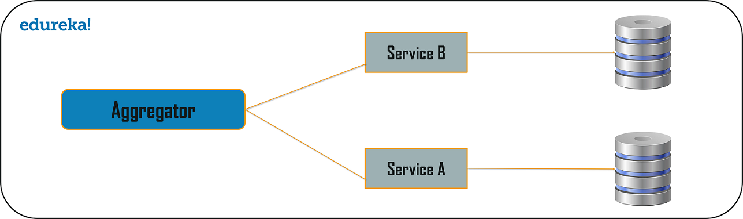**

**API Gateway Design Pattern**

Microservices are built in such a way that each service has its own functionality. But, when an application is broken down into small autonomous services, then there could be few problems that a developer might face. The problems could be as follows:

1. How can I request information from multiple microservices?
2. Different UI require different data to respond to the same backend database service
3. How to transform data according to the consumer requirement from reusable Microservices
4. How to handle multiple protocol requests?

Well, the solution to these kinds of problems could be the API Gateway Design Pattern.  The API Gateway Design Pattern address not only the concerns mentioned above but it solves many other problems. This microservice design pattern can also be considered as the proxy service to route a request to the concerned microservice. Being a variation of the Aggregator service, it can send the request to multiple services and similarly aggregate the results back to the composite or the consumer service. API Gateway also acts as the entry point for all the microservices and creates fine-grained APIs’ for different types of clients.

With the help of the API Gateway design pattern, the API gateways can convert the protocol request from one type to other. Similarly, it can also offload the authentication/authorization responsibility of the microservice.

So, once the client sends a request, these requests are passed to the API Gateway which acts as an entry point to forward the clients’ requests to the appropriate microservices. Then, with the help of the load balancer, the load of the request is handled and the request is sent to the respective services. Microservices use Service Discovery which acts as a guide to find the route of communication between each of them. Microservices then communicate with each other via a stateless server i.e. either by HTTP Request/Message Bus.

**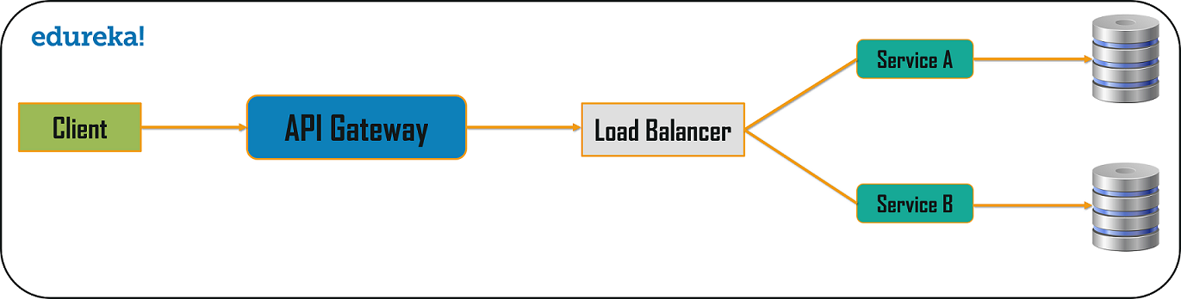**

**Chained or Chain of Responsibility Pattern**

Chained or Chain of Responsibility Design Patterns produces a single output which is a combination of multiple chained outputs. So, if you have three services lined up in a chain, then, the request from the client is first received by Service A. Then, this service communicates with the next Service B and collects data. Finally, the second service communicates with the third service to generate the consolidated output. All these services use synchronous HTTP request or response for messaging. Also, until the request passes through all the services and the respective responses are generated, the client doesn’t get any output. So, it is always recommended to not to make a long chain, as the client will wait until the chain is completed

One more important aspect which you need to understand, is that the request from Service A to Service B may look different from Service B to Service C. Similarly the response from Service C to Service B may look completely different from Service B to Service A.

**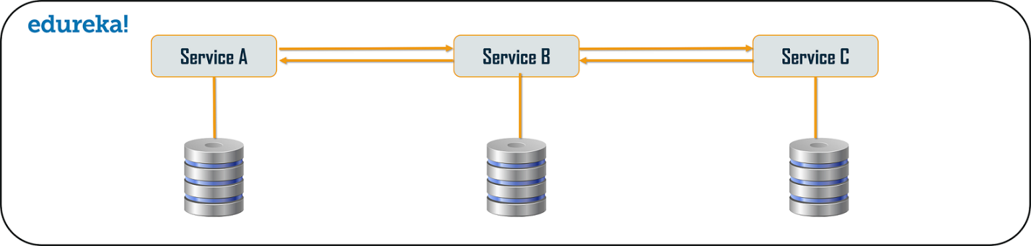**

**Asynchronous Messaging Design Pattern**

From the above pattern, it is quite obvious that the client gets blocked or has to wait for a long time in synchronous messaging. But, if you do not want the consumer, to wait for a long time, then you can opt for the Asynchronous Messaging. In this type of microservices design pattern, all the services can communicate with each other, but they do not have to communicate with each other sequentially. So, if you consider 3 services: Service A, Service B, and Service C. The request from the client can be directly sent to the Service C and Service B simultaneously. These requests will be in a queue. Apart from this, the request can also be sent to Service A whose response need not have to be sent to the same service through which request has come.

**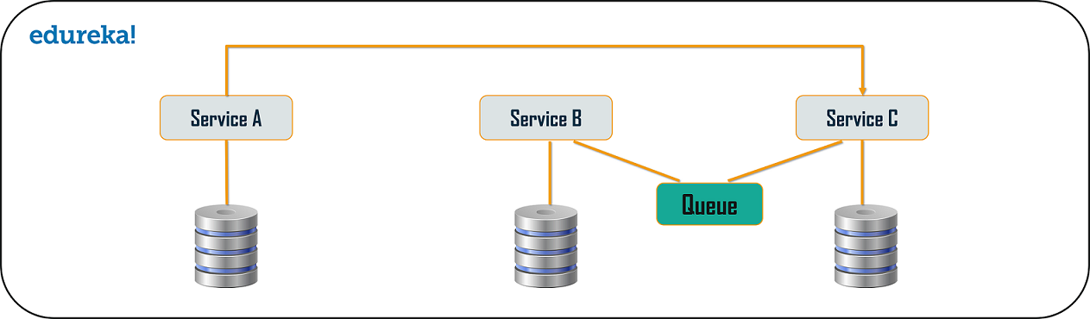**

**Database or Shared Data Pattern**

For every application, there is humongous amount of data present. So, when we break down an application from its monolithic architecture to microservices, it is very important to note that each microservice has sufficient amount of data to process a request. So, either the system can have a database per each service or it can have shared database per service.  You can use database per service and shared database per service to solve various problems.  The problems could be as follows:

* Duplication of data and inconsistency
* Different services have different kinds of storage requirements
* Few business transactions can query the data, with multiple services
* De-normalization of data

Well, to solve the first three problems, I think you can go for database per service, as it will be then accessed by the microservice API itself. So, each microservice will have its own database ID,  which thereafter prevents the other services in the system to use that particular database. Apart from this, to solve the issue of de-normalization, you can choose shared databases per service,  to align more than one database for each microservice. This will help you gather data, for the monolithic applications which are broken down into microservices. But, you have to keep in mind that, you have to limit these databases to 2-3 microservices; else, scaling these services will be a problem.

**Cloud Computing Training**

**[AWS SOLUTIONS ARCHITECT CERTIFICATION TRAINING COURSE](https://www.edureka.co/aws-certification-training?utm_source=blogbanner&utm_campaign=trending_course" \o "AWS Solutions Architect Certification Training Course" \t "_blank)**

**[AWS Solutions Architect Certification Training Course](https://www.edureka.co/aws-certification-training?utm_source=blogbanner&utm_campaign=trending_course" \o "AWS Solutions Architect Certification Training Course" \t "_blank)**

*[Reviews](https://www.edureka.co/aws-certification-training?utm_source=blogbanner&utm_campaign=trending_course" \o "AWS Solutions Architect Certification Training Course" \t "_blank)*

**[5](https://www.edureka.co/aws-certification-training?utm_source=blogbanner&utm_campaign=trending_course" \o "AWS Solutions Architect Certification Training Course" \t "_blank)**[(150661)](https://www.edureka.co/aws-certification-training?utm_source=blogbanner&utm_campaign=trending_course" \o "AWS Solutions Architect Certification Training Course" \t "_blank)

**[SALESFORCE TRAINING COURSE: ADMINISTRATOR AND APP BUILDER CERTIFICATION](https://www.edureka.co/salesforce-administrator-and-developer-training?utm_source=blogbanner&utm_campaign=trending_course" \o "Salesforce Training Course: Administrator and App Builder Certification" \t "_blank)**

**[Salesforce Training Course: Administrator and App Builder Certification](https://www.edureka.co/salesforce-administrator-and-developer-training?utm_source=blogbanner&utm_campaign=trending_course" \o "Salesforce Training Course: Administrator and App Builder Certification" \t "_blank)**

*[Reviews](https://www.edureka.co/salesforce-administrator-and-developer-training?utm_source=blogbanner&utm_campaign=trending_course" \o "Salesforce Training Course: Administrator and App Builder Certification" \t "_blank)*

**[5](https://www.edureka.co/salesforce-administrator-and-developer-training?utm_source=blogbanner&utm_campaign=trending_course" \o "Salesforce Training Course: Administrator and App Builder Certification" \t "_blank)**[(36540)](https://www.edureka.co/salesforce-administrator-and-developer-training?utm_source=blogbanner&utm_campaign=trending_course" \o "Salesforce Training Course: Administrator and App Builder Certification" \t "_blank)

**[MICROSOFT AZURE ARCHITECT CERTIFICATION TRAINING COURSE (AZ-305)](https://www.edureka.co/microsoft-certified-azure-solution-architect-certification-training?utm_source=blogbanner&utm_campaign=trending_course" \o "Microsoft Azure Architect Certification Training Course (AZ-305)" \t "_blank)**

**[Microsoft Azure Architect Certification Training Course (AZ-305)](https://www.edureka.co/microsoft-certified-azure-solution-architect-certification-training?utm_source=blogbanner&utm_campaign=trending_course" \o "Microsoft Azure Architect Certification Training Course (AZ-305)" \t "_blank)**

*[Reviews](https://www.edureka.co/microsoft-certified-azure-solution-architect-certification-training?utm_source=blogbanner&utm_campaign=trending_course" \o "Microsoft Azure Architect Certification Training Course (AZ-305)" \t "_blank)*

**[5](https://www.edureka.co/microsoft-certified-azure-solution-architect-certification-training?utm_source=blogbanner&utm_campaign=trending_course" \o "Microsoft Azure Architect Certification Training Course (AZ-305)" \t "_blank)**[(17169)](https://www.edureka.co/microsoft-certified-azure-solution-architect-certification-training?utm_source=blogbanner&utm_campaign=trending_course" \o "Microsoft Azure Architect Certification Training Course (AZ-305)" \t "_blank)

**[GOOGLE CLOUD PLATFORM (GCP) CERTIFICATION TRAINING](https://www.edureka.co/google-cloud-architect-certification-training?utm_source=blogbanner&utm_campaign=trending_course" \o "Google Cloud Platform (GCP) Certification Training" \t "_blank)**

**[Google Cloud Platform (GCP) Certification Training](https://www.edureka.co/google-cloud-architect-certification-training?utm_source=blogbanner&utm_campaign=trending_course" \o "Google Cloud Platform (GCP) Certification Training" \t "_blank)**

*[Reviews](https://www.edureka.co/google-cloud-architect-certification-training?utm_source=blogbanner&utm_campaign=trending_course" \o "Google Cloud Platform (GCP) Certification Training" \t "_blank)*

**[5](https://www.edureka.co/google-cloud-architect-certification-training?utm_source=blogbanner&utm_campaign=trending_course" \o "Google Cloud Platform (GCP) Certification Training" \t "_blank)**[(16296)](https://www.edureka.co/google-cloud-architect-certification-training?utm_source=blogbanner&utm_campaign=trending_course" \o "Google Cloud Platform (GCP) Certification Training" \t "_blank)

**[MICROSERVICES CERTIFICATION TRAINING COURSE](https://www.edureka.co/microservices-architecture-training?utm_source=blogbanner&utm_campaign=trending_course" \o "Microservices Certification Training Course" \t "_blank)**

**[Microservices Certification Training Course](https://www.edureka.co/microservices-architecture-training?utm_source=blogbanner&utm_campaign=trending_course" \o "Microservices Certification Training Course" \t "_blank)**

*[Reviews](https://www.edureka.co/microservices-architecture-training?utm_source=blogbanner&utm_campaign=trending_course" \o "Microservices Certification Training Course" \t "_blank)*

**[5](https://www.edureka.co/microservices-architecture-training?utm_source=blogbanner&utm_campaign=trending_course" \o "Microservices Certification Training Course" \t "_blank)**[(12763)](https://www.edureka.co/microservices-architecture-training?utm_source=blogbanner&utm_campaign=trending_course" \o "Microservices Certification Training Course" \t "_blank)

**[MICROSOFT AZURE DEVOPS CERTIFICATION TRAINING COURSE (AZ-400)](https://www.edureka.co/microsoft-azure-devops-solutions-training?utm_source=blogbanner&utm_campaign=trending_course" \o "Microsoft Azure DevOps Certification Training Course (AZ-400)" \t "_blank)**

**[Microsoft Azure DevOps Certification Training Course (AZ-400)](https://www.edureka.co/microsoft-azure-devops-solutions-training?utm_source=blogbanner&utm_campaign=trending_course" \o "Microsoft Azure DevOps Certification Training Course (AZ-400)" \t "_blank)**

*[Reviews](https://www.edureka.co/microsoft-azure-devops-solutions-training?utm_source=blogbanner&utm_campaign=trending_course" \o "Microsoft Azure DevOps Certification Training Course (AZ-400)" \t "_blank)*

**[5](https://www.edureka.co/microsoft-azure-devops-solutions-training?utm_source=blogbanner&utm_campaign=trending_course" \o "Microsoft Azure DevOps Certification Training Course (AZ-400)" \t "_blank)**[(3869)](https://www.edureka.co/microsoft-azure-devops-solutions-training?utm_source=blogbanner&utm_campaign=trending_course" \o "Microsoft Azure DevOps Certification Training Course (AZ-400)" \t "_blank)

**[MICROSOFT AZURE ADMINISTRATOR CERTIFICATION TRAINING: AZ-104](https://www.edureka.co/microsoft-azure-administrator-certification-training?utm_source=blogbanner&utm_campaign=trending_course" \o "Microsoft Azure Administrator Certification Training: AZ-104" \t "_blank)**

**[Microsoft Azure Administrator Certification Training: AZ-104](https://www.edureka.co/microsoft-azure-administrator-certification-training?utm_source=blogbanner&utm_campaign=trending_course" \o "Microsoft Azure Administrator Certification Training: AZ-104" \t "_blank)**

*[Reviews](https://www.edureka.co/microsoft-azure-administrator-certification-training?utm_source=blogbanner&utm_campaign=trending_course" \o "Microsoft Azure Administrator Certification Training: AZ-104" \t "_blank)*

**[5](https://www.edureka.co/microsoft-azure-administrator-certification-training?utm_source=blogbanner&utm_campaign=trending_course" \o "Microsoft Azure Administrator Certification Training: AZ-104" \t "_blank)**[(7868)](https://www.edureka.co/microsoft-azure-administrator-certification-training?utm_source=blogbanner&utm_campaign=trending_course" \o "Microsoft Azure Administrator Certification Training: AZ-104" \t "_blank)

**[AWS DEVELOPER CERTIFICATION TRAINING](https://www.edureka.co/aws-developer-certification-training?utm_source=blogbanner&utm_campaign=trending_course" \o "AWS Developer Certification Training" \t "_blank)**

**[AWS Developer Certification Training](https://www.edureka.co/aws-developer-certification-training?utm_source=blogbanner&utm_campaign=trending_course" \o "AWS Developer Certification Training" \t "_blank)**

*[Reviews](https://www.edureka.co/aws-developer-certification-training?utm_source=blogbanner&utm_campaign=trending_course" \o "AWS Developer Certification Training" \t "_blank)*

**[4](https://www.edureka.co/aws-developer-certification-training?utm_source=blogbanner&utm_campaign=trending_course" \o "AWS Developer Certification Training" \t "_blank)**[(11896)](https://www.edureka.co/aws-developer-certification-training?utm_source=blogbanner&utm_campaign=trending_course" \o "AWS Developer Certification Training" \t "_blank)

**[MIGRATING APPLICATIONS TO AWS TRAINING](https://www.edureka.co/migrating-to-aws?utm_source=blogbanner&utm_campaign=trending_course" \o "Migrating Applications to AWS Training" \t "_blank)**

**[Migrating Applications to AWS Training](https://www.edureka.co/migrating-to-aws?utm_source=blogbanner&utm_campaign=trending_course" \o "Migrating Applications to AWS Training" \t "_blank)**

*[Reviews](https://www.edureka.co/migrating-to-aws?utm_source=blogbanner&utm_campaign=trending_course" \o "Migrating Applications to AWS Training" \t "_blank)*

**[5](https://www.edureka.co/migrating-to-aws?utm_source=blogbanner&utm_campaign=trending_course" \o "Migrating Applications to AWS Training" \t "_blank)**[(5986)](https://www.edureka.co/migrating-to-aws?utm_source=blogbanner&utm_campaign=trending_course" \o "Migrating Applications to AWS Training" \t "_blank)

Next

**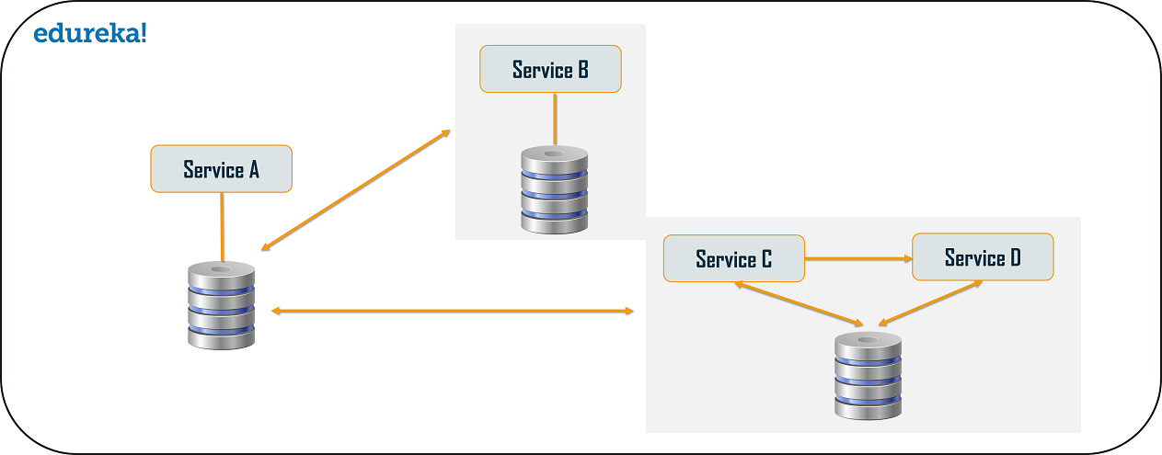**

**Event Sourcing Design Pattern**

The event sourcing design pattern creates events regarding the changes in the application state. Also, these events are stored as a sequence of events to help the developers track which change was made when. So, with the help of this, you can always adjust the application state to cope up with the past changes. You can also query these events, for any data change and simultaneously publish these events from the event store. Once the events are published, you can see the changes of the application state on the presentation layer.

**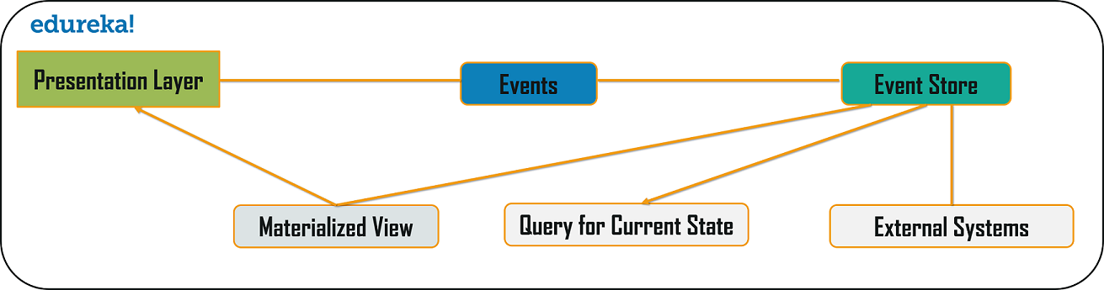**

**Branch Pattern**

Branch microservice design pattern is a design pattern in which you can simultaneously process the requests and responses from  two or more independent microservices. So, unlike the chained design pattern, the request is not passed in a sequence, but the request is passed to two or more mutually exclusive microservices chains. This design pattern extends the Aggregator design pattern and provides the flexibility to produce responses from multiple chains or single chain. For example, if you consider an e-commerce application, then you may need to retrieve data from multiple sources and this data could be a collaborated output of data from various services. So, you can use the branch pattern, to retrieve data from multiple sources.

**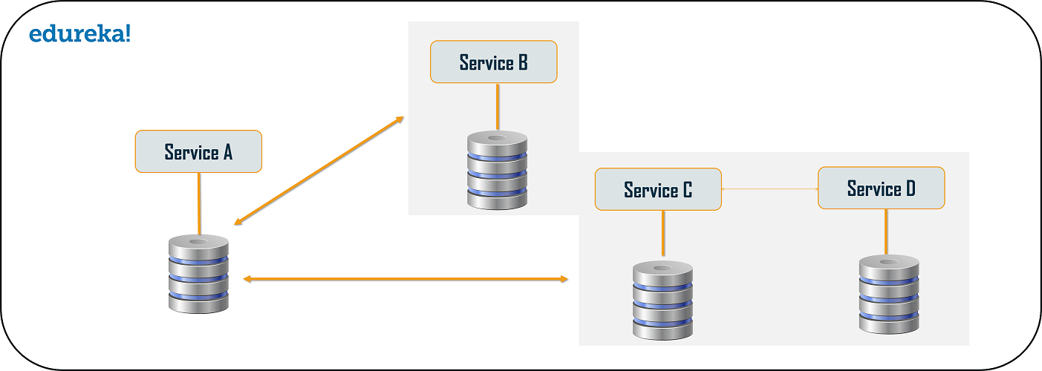**

**Command Query Responsibility Segregator (CQRS) Design Pattern**

Every microservices design has either the database per service model or the shared database per service. But, in the database per service model, we cannot implement a query as the data access is only limited to one single database. So, in such scenario you can use the CQRS pattern. According to this pattern, the application will be divided into two parts: Command and Query. The command part will handle all the requests related to CREATE, UPDATE, DELETE while the query part will take care of the materialized views. The materialized views are updated through a sequence of events which are creating using the event source pattern discussed above.

**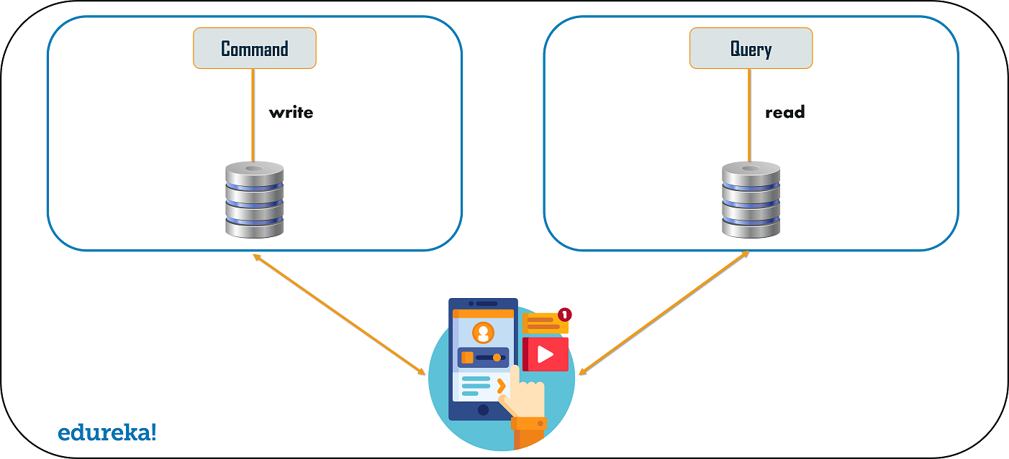**

**Circuit Breaker Pattern**

As the name suggests, the Circuit Breaker design pattern is used to stop the process of request and response if a service is not working. So, for example, let’s say a client is sending a request to retrieve data from multiple services. But, due to some issues, one of the services is down. Now, there are mainly two problems you will face: first, since the client will not have any knowledge about a particular service being down, the request will be continuously sent to that service. The second problem is that the network resources will be exhausted with low performance and bad user experience.

So, to avoid such problems, you can use the Circuit Breaker Design Pattern. With the help of this pattern, the client will invoke a remote service via a proxy. This proxy will basically behave as a circuit barrier. So, when the number of failures crosses the threshold number, the circuit breaker trips for a particular time period. Then, all the attempts to invoke the remote service will fail in this timeout period. Once that time period is finished, the circuit breaker will allow a limited number of tests to pass through and if those requests succeed, the circuit breaker resumes back to the normal operation. Else, if there is a failure, then the time out period begins again.

**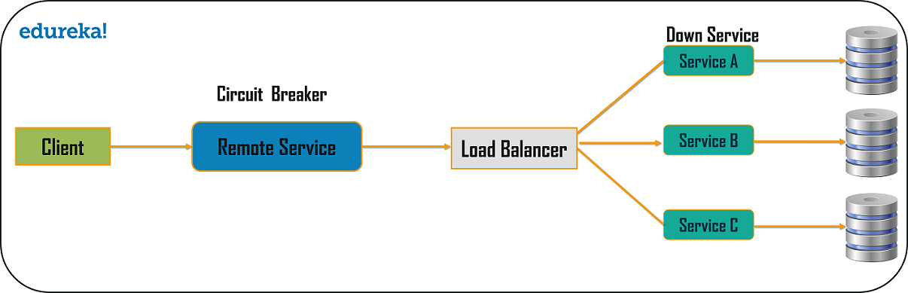**

**Decomposition Design Pattern**

Microservices are developed with an idea on developers mind to create small services, with each having their own functionality. But, breaking an application into small autonomous units has to be done logically. So, to decompose a small or big application into small services, you can use the Decomposition patterns.

With the help of this pattern, either you can decompose an application based on business capability or on based on the sub-domains. For example, if you consider an e-commerce application, then you can have separate services for orders, payment, customers, products if you decompose by business capability.

But, in the same scenario, if you design the application by decomposing the sub-domains, then you can have services for each and every class. Here, in this example, if you consider the customer as a class, then this class will be used in customer management, customer support, etc. So, to decompose, you can use the Domain-Driven Design through which the whole domain model is broken down into sub-domains. Then, each of these sub-domains will have their own specific model and scope(bounded context).  Now, when a developer designs microservices, he/she will design those services around the scope or bounded context.

Though these patterns may sound feasible to you, they are not feasible for big monolithic applications. This is because of the fact that identifying sub-domains and business capabilities is not an easy task for big applications. So, the only way to decompose big monolithic applications is by following the Vine Pattern or the Strangler Pattern.

**Strangler Pattern or Vine Pattern**

The Strangler Pattern or the Vine Pattern is based on the analogy to a vine which basically strangles a tree that it is wrapped around. So, when this pattern is applied on the web applications, a call goes back and forth for each URI call and the services are broken down into different domains. These domains will be hosted as separate services.

[[](https://www.edureka.co/microservices-architecture-training?utm_source=blogbanner&utm_campaign=batches)](https://www.edureka.co/microservices-architecture-training?utm_source=blogbanner&utm_campaign=batches" \t "_blank)

**[Microservices Certification Training Course](https://www.edureka.co/microservices-architecture-training?utm_source=blogbanner&utm_campaign=batches" \t "_blank)**

[Weekday / Weekend BatchesSee Batch Details](https://www.edureka.co/microservices-architecture-training?utm_source=blogbanner&utm_campaign=batches" \t "_blank)

According to the strangler pattern, two separate applications will live side by side in the same URI space, and one domain will be taken in to account at an instance of time. So, eventually, the new refactored application wraps around or strangles or replaces the original application until you can shut down the monolithic application

So, folks, with this we come to an end to this article on Microservices Design Patterns. I hope you have understood the top patterns to design Microservices. *If you wish to learn Microservices and build your own applications, then check out our*[***Microservices Certification Training***](https://www.edureka.co/microservices-architecture-training)*which comes with instructor-led live training and real-life project experience. This training will help you understand Microservices in-depth and help you achieve mastery over the subject.*

*Got a question for us? Please mention it in the comments section of ”****Microservices Design Patterns****” and I will get back to you.*

* Sservice collaboration patterns:
  + [Saga](https://microservices.io/patterns/data/saga.html), which implements a distributed command as a series of local transactions
  + [Command-side replica](https://microservices.io/patterns/data/cqrs.html), which replicas read-only data to the service that implements a command
  + [API composition](https://microservices.io/patterns/data/api-composition.html), which implements a distributed query as a series of local queries
  + [CQRS](https://microservices.io/patterns/data/cqrs.html), which implements a distributed query as a series of local queries
* The [Messaging](https://microservices.io/patterns/communication-style/messaging.html) and [Remote Procedure Invocation](https://microservices.io/patterns/communication-style/rpi.html) patterns are two different ways that services can communicate.
* The [Database per Service pattern](https://microservices.io/patterns/data/database-per-service.html) describes how each service has its own database in order to ensure loose coupling.
* The [API Gateway pattern](https://microservices.io/patterns/apigateway.html) defines how clients access the services in a microservice architecture.
* The [Client-side Discovery](https://microservices.io/patterns/client-side-discovery.html) and [Server-side Discovery](https://microservices.io/patterns/server-side-discovery.html) patterns are used to route requests for a client to an available service instance in a microservice architecture.
* Testing patterns: [Service Component Test](https://microservices.io/patterns/testing/service-component-test.html) and [Service Integration Contract Test](https://microservices.io/patterns/testing/service-integration-contract-test.html)
* [Circuit Breaker](https://microservices.io/patterns/reliability/circuit-breaker.html)
* [Access Token](https://microservices.io/patterns/security/access-token.html)
* Observability patterns:
  + [Log aggregation](https://microservices.io/patterns/observability/application-logging.html)
  + [Application metrics](https://microservices.io/patterns/observability/application-metrics.html)
  + [Audit logging](https://microservices.io/patterns/observability/audit-logging.html)
  + [Distributed tracing](https://microservices.io/patterns/observability/distributed-tracing.html)
  + [Exception tracking](https://microservices.io/patterns/observability/exception-tracking.html)
  + [Health check API](https://microservices.io/patterns/observability/health-check-api.html)
  + [Log deployments and changes](https://microservices.io/patterns/observability/log-deployments-and-changes.html)
* UI patterns:
  + [Server-side page fragment composition](https://microservices.io/patterns/ui/server-side-page-fragment-composition.html)
  + [Client-side UI composition](https://microservices.io/patterns/ui/client-side-ui-composition.html)
* The [Single Service per Host](https://microservices.io/patterns/deployment/single-service-per-host.html) and [Multiple Services per Host](https://microservices.io/patterns/deployment/multiple-services-per-host.html) patterns are two different deployment strategies.
* Cross-cutting concerns patterns: [Microservice chassis pattern](https://microservices.io/patterns/microservice-chassis.html) and [Externalized configuration](https://microservices.io/patterns/externalized-configuration.html)

## **Known uses**

## 10 Essential Microservice Design Patterns and Principles

Now that you know what is Microservice architecture and why you need to consider Microservice architecture to build applications that can stand the test of time and are scalable enough to handle real-world traffic, let's now go through the fundamental principle of Microservices and [design pattern](https://javarevisited.blogspot.com/2018/02/top-5-java-design-pattern-courses-for-developers.html) which you can use to solve common problem associate with microservice architecture.

Let's look at the principles in which the microservice architecture has been built.

 1. Scalability  
 2. Flexibility  
3. Independent and autonomous  
4. Decentralized governance  
5. Resiliency  
6. Failure isolation.  
7. Continuous delivery through the DevOps

while adhering to the above principles, there may have some other pitfalls that developers might befall and to avoid this, we can use the design patterns in a microservice architecture.

In this article, we are going to discuss 10 main design patterns which are mentioned below.

**1. Database per Microservice  
        2. Event Sourcing  
        3. CQRS  
        4. Saga  
        5. BFF  
        6. API Gateway  
        7. Strangler  
        8. Circuit Breaker  
        9. Externalized Configuration  
        10. Consumer-Driven Contract Tracing**

So first start with the Database per Microservice design pattern.

[](https://www.java67.com/2021/04/5-free-microservice-courses-for-java.html)

### 1. Database per Microservice Pattern

Database design is rapidly evolving, and there are numerous hurdles to overcome while developing a microservices-based solution. Database architecture is one of the most important aspects of microservices.

What is the best way to store data and where should it be stored?

There should are two main options for organizing the databases when using the microservice architecture.

* Database per service
* Shared database

**1.1 Database per service.**

The concept is straightforward. There is a data store for each microservice (whole schema or a table). Other services are unable to access data repositories that they do not control. A solution like this has a lot of advantages.

Individual data storage, on the other hand, is easy to scale. Furthermore, the microservice encapsulates the domain's data. As a result, understanding the service and its data as a whole is much easier. It's especially crucial for new development team members.

It will take them less time and effort to properly comprehend the area for which they are responsible. The main drawback of this database service is that there is a need for a failure protection mechanism in case the communication fails.

[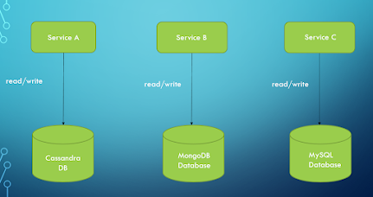](https://1.bp.blogspot.com/-R6zVCzRsEFU/YUYS26TwExI/AAAAAAAAC7s/1Sdp3r8g38oI0X0Z40d49AVCd3DuGqRwwCLcBGAsYHQ/s1175/ppp.PNG)

**1.2 Shared Database**

The use of a shared database is an anti-pattern. It is, however, questionable. The issue is that when microservices use a shared database, they lose their key features of scalability, robustness, and independence. As a result, Microservices rarely employ a shared [database](https://javarevisited.blogspot.com/2018/05/top-5-sql-and-database-courses-to-learn-online.html).

When a common database appears to be the best solution for a microservices project, we should reconsider if microservices are truly necessary. Perhaps the monolith is the better option. Let's have a look at how a shared database works.

Using a shared database with microservices isn't a frequent scenario. A temporary state could be created while moving a monolith to microservices. Transaction management is the fundamental advantage of a shared database versus a per-service database. There's no need to spread transactions out across services.

[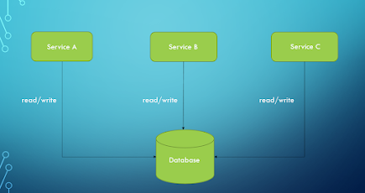](https://1.bp.blogspot.com/-zGWNZBUGeH8/YUYUsHl4SjI/AAAAAAAAC70/VKF2tXSfqM4gNcFXdURT6SuErgyV7IAGQCLcBGAsYHQ/s1214/qqqqq.PNG)

### 2. Event Sourcing Pattern

The event sourcing is responsible for giving a new ordered sequence of events. The application state can be reconstructed using querying the data and in order to do this, we need to reimage every change to the state of the application. *Event Sourcing* is based on the idea that any change in an entity's state should be captured by the system.

The persistence of a business item is accomplished by storing a series of state-changing events. A new event is added to the sequence of events every time an object's state changes. It's essentially atomic because it's one action. By replaying the occurrences of an entity, its current state can be reconstructed.

An event store is used to keep track of all of your events. The event store serves as a message broker as well as a database of events. It gives services the ability to subscribe to events via an API. The event store sends all interested subscribers information about each event that is saved in the database. In an event-driven microservices architecture, the event store is the foundation.

This pattern can be used in the following scenarios,

* It's important to keep the existing data storage.
* There should be no changes to the existing data layer codebase.
* Transactions are critical to the application's success.

So as from the above discussion, it is clearly indicated that the event sourcing addresses a challenge of implementing an event-driven architecture. Microservices with shared databases can't easily scale. The database will also be a single point of failure. Changes to the database could have an influence on a number of services.

[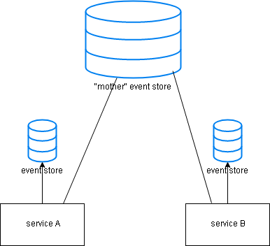](https://1.bp.blogspot.com/-lKRHSNX5WUs/YUYJet7xdzI/AAAAAAAAC7k/oXhcXzM5RSgkmdkKZ4y8XmvKlfSkG246wCLcBGAsYHQ/s386/BpTt6.png)

### 3. Command Query Segmentation (CQRS)  Pattern

In the above, we have discussed what is event sourcing. In this topic, we are going to discuss what is CQRS? We can divide the topic into two parts with commands and queries.

 Commands - Change the state of the object or entity.

 Queries -  Return the state of the entity and will not change anything.

In traditional data management systems, there are some issues,

   1. Risk of data contention

   2. Managing performance and security is complex as objects are exposed to both reading and writing applications.

So in order to solve these problems, the CQRS comes to the big picture. The CQRS is responsible for either change the state of the entity or return the result.

benefits of using the CQRS are discussed below.

   1. The complexity of the system is reduced as the query models and commands are separated.

   2. Can provide multiple views for query purposes.

   3. Can optimize the read side of the system separately from the write side.

The write side of the model handles the event's persistence and acting as a source of information to the read side. The system's read model generates materialized views of the data, which are often highly denormalized views.

[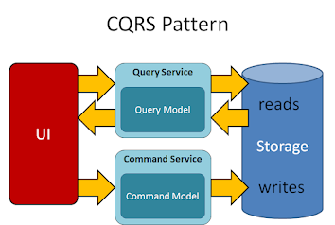](https://1.bp.blogspot.com/-9NGW2zgCoeE/YUMhdQdpq7I/AAAAAAAAC6Q/Rixpf2gPswUlSHsVxEvhK74XolJQgvEGwCLcBGAsYHQ/s864/cqsr_pattern-e1560327720529.png)

### 4. SAGA

SAGA is one of the best solutions to keep consistency with data in distributed architecture without having the ACID principles. SAGA is responsible for committing multiple commentary transactions by giving rollback opportunities.

There are two ways to achieve the saga's

1. Choreography

2. Orchestration.

In this choreography saga, there is no central orchestration. Each service in the Saga carries out its transaction and publishes events. The other services respond to those occurrences and carry out their tasks. In addition, depending on the scenario, they may or may not publish additional events.

In the Orchestration saga, each service participating in the saga performs their transactions and publish events. The other services respond to those events and complete their tasks.

#### Advantage of using SAGA

1. Can be used to maintain the data consistency across multiple services without tight coupling.

#### The disadvantage of using SAGA

1. Complexity of the SAGA design pattern is high from the programmer's point of view and developers are not well accustomed to writing sagas as traditional transactions.

### 5. Backend For Frontend (BFF)

This pattern is used to identify how the data is fetched between the server and clients. Ideally, the frontend team will be responsible for managing the BFF.

A single BFF is responsible for handling the single UI and it will help us to keep the frontend simple and see a unified view data through the backend.

#### Why BFF needs in our microservice application?

The goal of this architecture is to decouple the front-end apps from the backend architecture.  
As a scenario, think about you have an application that consists of the mobile app, web app and needs to communicate with the backend services in a microservices architecture.

This can be done successfully but if you want to make a change to one of the frontend services, you need to deploy a new version instead of stick to updating the one service.

So here comes the [microservice architecture](https://javarevisited.blogspot.com/2019/03/5-courses-programmers-can-join-to-learn.html) and this is able to understand what our apps need and how to handle the services.

This is a big improvement in microservice architecture as this allows to isolate the backend of the application from the frontend. One other advantage that we can get from this BFF is that we can reuse the code as this allows all clients to use the code from the backend.

Between the client and other external APIs, services, and so on, BFF functions similarly to a proxy server. If the request must pass through another component, the latency will undoubtedly increase.

[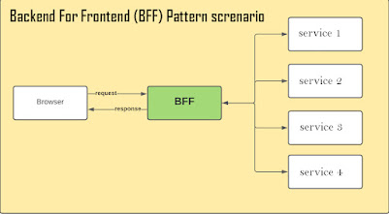](https://1.bp.blogspot.com/-dHoPBbMRC3o/YUQz56N4uzI/AAAAAAAAC6k/jcvc9Qg3LSo8jte9spDQM1Q6YvtRlVs1wCLcBGAsYHQ/s1160/1_2BaGJecjJNBk0gGCUQJO2wdfdf.jpg)

### 6. API Gateway

This microservice architecture pattern is really good for large applications with multiple client apps and it is responsible for giving a single entry point for a certain group of microservices.

API gateway sits between the client apps and the microservices and it serves as a reverse proxy, forwarding client requests to services. [Authentication](https://javarevisited.blogspot.com/2018/01/how-http-basic-authentication-works-in.html#axzz6hhgr3Uqg), SSL termination, and caching are some of the other cross-cutting services it can provide.

Why do we consider the API Gateway architecture instead of using direct client-to-microservice communication? We will discuss this with the following examples,

**1. Security issues** - All microservices must be exposed to the "external world" without a gateway, increasing the attack surface compared to hiding internal microservices that aren't directly accessed by client apps.

**2. Cross-cutting concerns** - Authorization and SSL must be handled by each publicly published microservice. Those problems might be addressed in a single tier in many cases, reducing the number of internal microservices.

**3. Coupling**- Client apps are tied to internal microservices without the API Gateway pattern. Client apps must understand how microservices decompose the application's various sections.

Last but not least, the microservices API gateway must be capable of handling partial failures. The failure of a single unresponsive microservice should not result in the failure of the entire request.

A microservices API gateway can deal with partial failures in a variety of ways, including:

* Use data from a previous request that has been cached.
* For time-sensitive data that is the request's major focus, return an error code.
* Provide an empty value
* Rely on hardware top 10 value.

|  |
| --- |
| [API Gateway Microservice Pattern explained](https://1.bp.blogspot.com/-_LUpP4X_A9s/YURZnUy7g5I/AAAAAAAAC68/pejt_yTXFIciqAtHcr24jRavMIY1svQ1QCLcBGAsYHQ/s709/api_gateway_nginx.png) |
| [API Gateway](https://www.java67.com/2021/04/5-free-microservice-courses-for-java.html) |

### 7. Strangler

The strangler design pattern is a popular design pattern to incrementally transform your monolithic application to microservices by replacing old functionality with a new service.  Once the new component is ready, the old component is strangled and a new one is put to use.

The facade interface, which serves as the primary interface between the legacy system and the other apps and systems that call it, is one of the most important components of the strangler pattern.

External apps and systems will be able to identify the code associated with a certain function, while the underlying historical system code will be obscured by the [facade interface](http://javarevisited.blogspot.sg/2015/01/adapter-vs-decorator-vs-facade-vs-proxy-pattern-java.html). The strangler design addresses this by requiring developers to provide a façade interface that allows them to expose individual services and functions when they break them free from the monolith.

You need to understand the quality and reliability of your system, whether you're working with legacy code, starting the process of "strangling" your old system, or running a newly containerized application. When anything goes wrong, you need to know how the system got there and why it went down that road.

|  |
| --- |
| [Strangle Microservice Pattern explained](https://1.bp.blogspot.com/--vWviH2WkeA/YUVNfYjTM7I/AAAAAAAAC7I/zxyciN-Bd083XgEPUK8lXOEJpA6F9eeRACLcBGAsYHQ/s1080/55555.jpg) |
| Moving from Monolithic to microservice architecture stages. |

### 8. Circuit Breaker Pattern

The circuit breaker is the solution for the failure of remote calls or the hang without a response until some timeout limit is reached. You can run out of critical resources if you having many callers with an unresponsive supplier and this will lead to failure across the multiple systems in the applications.

So here comes the circuit breaker pattern which is wrapping up a protected function call in a circuit breaker object which monitors for failure. When the number of failures reaches a specific level, the circuit breaker trips, and all subsequent calls to the circuit breaker result in an error or a different service or default message, rather than the protected call being made at all.

#### Different states in the circuit break pattern

**Closed**- When everything works well according to the normal way, the circuit breaker remains in this closed state.

**Open**-  When the number of failures in the system exceeds the maximum threshold, this will lead to open up the open state. This will give the error for calls without executing the function.

**Open**-Half - After having run the system several times, the circuit breaker will go on to the half-open state in order to check the underlying problems are still exist.

Here, we will have an example code that is built using the [Netflix hystrix.](https://javarevisited.blogspot.com/2018/04/top-5-spring-cloud-courses-for-java.html)

import org.springframework.boot.SpringApplication;  
import org.springframework.boot.autoconfigure.SpringBootApplication;  
import org.springframework.web.bind.annotation.RestController;  
import org.springframework.web.bind.annotation.RequestMapping;  
  
@RestController  
@SpringBootApplication  
public class StudentApplication {  
  
 @RequestMapping(value = "/student")  
 public String studentMethod(){  
 return "Calling the studentMethod";  
 }  
  
 public static void main(String[] args) {  
 SpringApplication.run(StudentApplication.class, args);  
 }  
}

So the client application code will call the studentMethod() and if the calling API, /student is not given any response back in time, then there is an alternative method calling the fallback. It is mentioned in the below code.

import java.net.URI;  
import org.springframework.stereotype.Service;  
import org.springframework.web.client.RestTemplate;  
import com.netflix.hystrix.contrib.javanica.annotation.HystrixCommand;  
  
@Service  
public class StudentService {  
  
 private final RestTemplate restTemplate;  
  
 public StudentService(RestTemplate rest) {  
 this.restTemplate = rest;  
 }  
  
 @HystrixCommand(fallbackMethod = "reliable")  
 public String studentMethodCalling() {  
 URI uri = URI.create("http://localhost:8000/student");  
 return this.restTemplate.getForObject(uri, String.class);  
 }  
  
 public String reliable() {  
 return "This is calling if the studentMethod is falling to respond on time";  
 }  
  
}

So you can use the circuit breaker pattern to improve the fault tolerance and resilience of the [microservice architecture](https://medium.com/javarevisited/top-5-courses-to-learn-software-architecture-in-2020-best-of-lot-5d34ebc52e9) and also prevent the cascading of failure to other microservices.

### 9. Externalized Configuration

Often services need to be run in different environments. Environment-specific configuration is required, such as secret keys, database credentials, and so on. Changing the service for each environment has a number of drawbacks. So how we can enable a service to run in multiple environments without modification?

Here comes the Externalized configuration pattern as this enables the externalization of all application configurations including the database credentials and network location.

For example, the [Spring Boot framework](https://javarevisited.blogspot.com/2018/05/top-5-courses-to-learn-spring-boot-in.html) enables externalized configuration, which allows you to read configuration from many sources and potentially change previously specified configuration settings based on the reading order. FastAPI, thankfully, has built-in support for externalized configuration.

[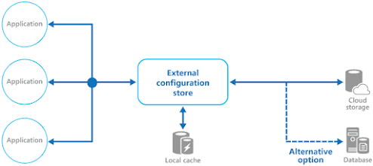](http://www.java67.com/2018/06/5-best-courses-to-learn-spring-boot-in.html)

Open up the ConfigServerApplication class and activate the discovery client and the configuration server by using the following annotation.

@SpringBootApplication  
@EnableConfigServer  
@EnableDiscoveryClient  
public class ConfigServerApplication {  
  
}

Remove the application.properties file and create a new application.yml file with the following content.

server.port: 8001  
  
spring:  
 application.name: config-server  
 cloud.config.server.git.uri:

https:*//github.com/alejandro-du/vaadin-microservices-demo-config.git*

eureka:  
 client:  
 serviceUrl:  
 defaultZone: http:*//localhost:7001/eureka/* registryFetchIntervalSeconds: 1  
 instance:  
 leaseRenewalIntervalInSeconds: 1

This sets the port (8001) and name (config-server) of the application, as well as the URI

[Spring Cloud Config](https://www.java67.com/2021/01/spring-cloud-interview-questions-with-answers-java.html) should use to read the configuration from. On GitHub, we have a Git

repository. The configuration files for all of the example application's microservices can

be found in this repository. The admin-applicationmicroservic uses the admin-application.yml

file, for example.

### 10. Consumer-Driven Contract Tracing

When a team is constructing multiple related services at the same time as part of a modernization effort, and your team knows the “domain language” of the bounded context but not the individual properties of each aggregate and event payload, the consumer driven contracts approach may be effective.

[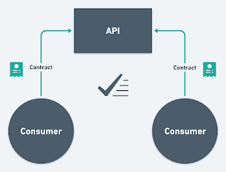](https://1.bp.blogspot.com/-Q35kmhh-b_Q/YUXCdcdYCNI/AAAAAAAAC7c/_dD1lE-1wTMhLN_IWlu9wU8AhwVx-g61gCLcBGAsYHQ/s1320/1_s-ujrGQyZszBcSdY3PCybw.png)

This microservice pattern is useful in legacy application which contains a large data model and existing service surface area. This [design patterns](https://medium.com/javarevisited/7-best-online-courses-to-learn-object-oriented-design-pattern-in-java-749b6399af59) will address the following issues,

 1. How can you add to an API without breaking downstream clients.

 2. How to find out who is using their service.

3. How to make short release cycles with the continuous delivery.

In an event driven architecture, many microservices expose two kinds of API's,

 1. RESTful API over HTTP

 2. HTTP and a message-based API The [RESTful API](https://javarevisited.blogspot.com/2018/02/top-5-restful-web-services-with-spring-courses-for-experienced-java-programmers.html) allows for synchronous integration with these services as well as extensive querying capabilities for services that have received events from a service.

In summary, a consumer-driven approach is sometimes used when breaking down a monolithic legacy

application.

That's all about the **top 10 Microservice Design patterns and principles**. In this tutorial, we have also discussed what is microservice architecture and its most important design patterns. Microservice architecture and cloud computing go hand-in-hand because Microservice architecture makes development and deployment into the cloud easier.

It's also easier to scale a Microservice using [Docker](https://javarevisited.blogspot.com/2018/02/10-free-docker-container-courses-for-Java-Developers.html#axzz63ewnlq5p)and [Kubernetes](https://javarevisited.blogspot.com/2020/06/top-5-courses-to-learn-kubernetes-for-devops-and-certification.html) and that's why more and more companies are switching to Microservice architecture. At the same time, it's not easy to create a Microservice solution that can stand the test of time in production and that's where knowledge of these popular Microservice patterns and principles helps.

Read more: <https://javarevisited.blogspot.com/2021/09/microservices-design-patterns-principles.html#ixzz88RW4jXSi>

# **Top 60+ Angular Interview Questions and Answers for 2023**

Lesson 13 of 13[By Chinmayee Deshpande](https://www.simplilearn.com/authors/chinmayee-deshpande)

Last updated on Jul 12, 2023171162706



[Previous](https://www.simplilearn.com/tutorials/angular-tutorial/angular-project)

## **Table of Contents**

[Most Asked Angular Interview Questions](https://www.simplilearn.com/tutorials/angular-tutorial/angular-interview-questions#most_asked_angular_interview_questions)

[Angular Interview Questions For Beginners](https://www.simplilearn.com/tutorials/angular-tutorial/angular-interview-questions#angular_interview_questions_for_beginners)

[Angular Interview Questions For Advanced Level](https://www.simplilearn.com/tutorials/angular-tutorial/angular-interview-questions#angular_interview_questions_for_advanced_level)

[Angular Interview Questions for Experienced](https://www.simplilearn.com/tutorials/angular-tutorial/angular-interview-questions#angular_interview_questions_for_experienced)

[Angular Scenario Based Interview Questions](https://www.simplilearn.com/tutorials/angular-tutorial/angular-interview-questions#angular_scenario_based_interview_questions)

View More

Angular is a robust front-end JavaScript framework that is widely used for app development. With the increased popularity, there is a high demand for Angular developers. This article on Angular Interview Questions will present some commonly asked questions and how to answer them. The questions are bifurcated into two levels, beginner and advanced.

To brush up your basics, check out our [videos on YouTube](https://www.youtube.com/watch?v=TC1oVXlVE3M&list=PLEiEAq2VkUUIzcMkvJKwXLf13SqV8lPes). You could also refer to our articles for better clarity. Now, without further ado, let's begin with the top Angular interview questions and answers you must be prepared for.

## **Most Asked Angular Interview Questions**

### 1. What is Angular? Why was it introduced?

[Angular was introduced](https://www.simplilearn.com/tutorials/angular-tutorial/what-is-angular) to create Single Page applications. This framework brings structure and consistency to web applications and provides excellent scalability and maintainability.

Angular is an open-source, JavaScript framework wholly written in [TypeScript.](https://www.simplilearn.com/tutorials/programming-tutorial/advanced-typescript) It uses HTML's syntax to express your application's components clearly.

### 2. What is TypeScript?

TypeScript is a superset of JavaScript that offers excellent consistency. It is highly recommended, as it provides some syntactic sugar and makes the code base more comfortable to understand and maintain. Ultimately, TypeScript code compiles down to [JavaScript](https://www.simplilearn.com/tutorials/javascript-tutorial/introduction-to-javascript) that can run efficiently in any environment.

### 3. What is data binding? Which type of data binding does Angular deploy?

[Data binding](https://www.simplilearn.com/tutorials/angular-tutorial/angular-data-binding) is a phenomenon that allows any internet user to manipulate Web page elements using a Web browser. It uses dynamic HTML and does not require complex scripting or programming. We use data binding in web pages that contain interactive components such as forms, calculators, tutorials, and games. Incremental display of a webpage makes data binding convenient when pages have an enormous amount of data.

Angular uses the two-way binding. Any changes made to the user interface are reflected in the corresponding model state. Conversely, any changes in the model state are reflected in the UI state. This allows the framework to connect the DOM to the Model data via the controller. However, this approach affects performance since every change in the DOM has to be tracked.

#### **Become a Skilled Web Developer in Just 9 Months!**

Caltech PGP Full Stack Development[EXPLORE PROGRAM](https://www.simplilearn.com/pgp-full-stack-web-development-certification-training-course?source=GhPreviewCTABanner)



### 4. What are Single Page Applications (SPA)?

Single-page applications are web applications that load once with new features just being mere additions to the user interface. It does not load new HTML pages to display the new page's content, instead generated dynamically. This is made possible through JavaScript's ability to manipulate the DOM elements on the existing page itself. A SPA approach is faster, thus providing a seamless user experience.

### 5. Differentiate between Angular and AngularJS

The following table depicts the aspects of Angular vs AngularJS in detail:

|  |  |  |
| --- | --- | --- |
| Feature | AngularJS | Angular |
| Language | JavaScript | TypeScript |
| Architecture | Supports Model-View-Controller design | Uses components and directives |
| Mobile support | Not supported by mobile browsers | Supports all popular mobile browsers |
| Dependency Injection | Doesn’t support | Supports |
| Routing | @routeProvider is used to provide routing information | @Route configuration is used to define routing information |
| Management | Difficult to manage with an increase in source code size | Better structured, easy to create and manage bigger applications |

### 6. What are decorators in Angular?

Decorators are a design pattern or functions that define how Angular features work. They are used to make prior modifications to a class, service, or filter. Angular supports four types of decorators, they are:

1. Class Decorators
2. Property Decorators
3. Method Decorators
4. Parameter Decorators

### 7. Mention some advantages of Angular.

Some of the common advantages of Angular are -

1. [MVC architecture](https://www.simplilearn.com/tutorials/dot-net-tutorial/mvc-architecture) - Angular is a full-fledged MVC framework. It provides a firm opinion on how the application should be structured. It also offers bi-directional data flow and updates the real DOM.
2. Modules: Angular consists of different design patterns like components, directives, pipes, and services, which help in the smooth creation of applications.
3. [Dependency injection](https://www.simplilearn.com/tutorials/angular-tutorial/angular-dependency-injection): Components dependent on other components can be easily worked around using this feature.
4. Other generic advantages include clean and maintainable code, unit testing, reusable components, data binding, and excellent responsive experience.

#### **Prepare Yourself to Answer All Questions!**

Automation Testing Masters Program[EXPLORE PROGRAM](https://www.simplilearn.com/automation-testing-masters-program-certification-training-course?source=GhPreviewCTABanner)



### 8. What are the new updates with Angular10?

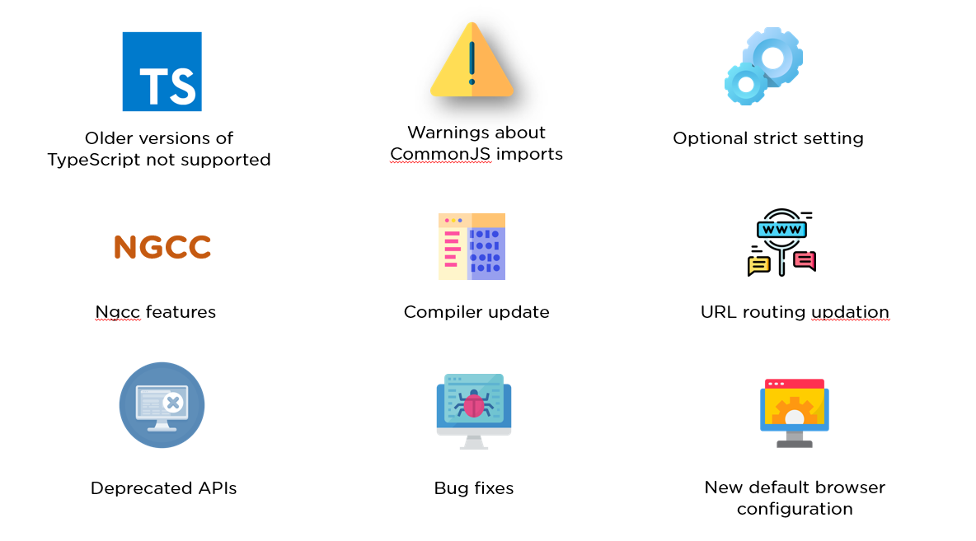

* Older versions of TypeScript not supported - Previous versions of Angular supported typescript 3.6, 3.7, and even 3.8. But with Angular 10, TypeScript bumped to TypeScript 3.9.
* Warnings about CommonJS imports - Logging of unknown property bindings or element names in templates is increased to the "error" level, which was previously a "warning" before.
* Optional strict setting - Version 10 offers a stricter project setup when you create a new workspace with ng new command.

ng new --strict

NGCC Feature - Addition of NGCC features with a program based entry point finder.

* Updated URL routing
* Deprecated APIs - Angular 10 has several deprecated APIs.
* Bug fixes - With this Angular 10 version, there have been a number of bug fixes, important ones being the compiler avoiding undefined expressions and the core avoiding a migration error when a nonexistent symbol is imported.
* New Default Browser Configuration - Browser configuration for new projects has been upgraded to outdo older and less used browsers.

### 9. What are Templates in Angular?

Angular Templates are written with HTML that contains Angular-specific elements and attributes. In combination with the model and controller's information, these templates are further rendered to provide a dynamic view to the user.

### 10. What are Annotations in Angular?

Annotations in Angular are used for creating an annotation array. They are the metadata set on the class that is used to reflect the Metadata library.

## **Angular Interview Questions For Beginners**

### 11. What are Directives in Angular?

Directives are attributes that allow the user to write new HTML syntax specific to their applications. They execute whenever the Angular compiler finds them in the DOM. Angular supports three types of directives.

1. Component Directives
2. Structural Directives
3. Attribute Directives

### 12. What is an AOT compilation? What are its advantages?

The Ahead-of-time (AOT) compiler converts the Angular HTML and TypeScript code into JavaScript code during the build phase, i.e., before the browser downloads and runs the code.

Some of its advantages are as follows.

1. Faster rendering
2. Fewer asynchronous requests
3. Smaller Angular framework download size
4. Quick detection of template errors
5. Better security

### 13. What are Components in Angular?

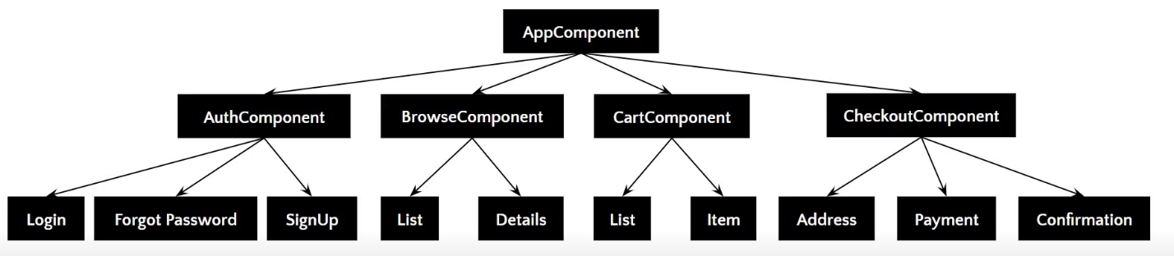

[Components](https://www.simplilearn.com/tutorials/angular-tutorial/angular-components) are the basic building blocks of the user interface in an Angular application. Every component is associated with a template and is a subset of directives. An Angular application typically consists of a root component, which is the AppComponent, that then branches out into other components creating a hierarchy.

#### **Here's How to Land a Top Software Developer Job**

Full Stack Development-MEAN[EXPLORE PROGRAM](https://www.simplilearn.com/full-stack-web-developer-mean-stack-certification-training?source=GhPreviewCTABanner)



### 14. What are Pipes in Angular?

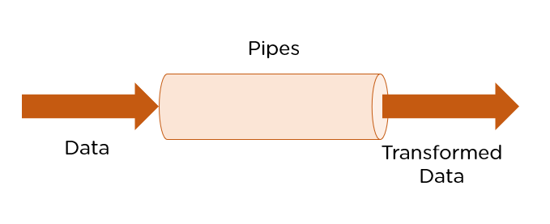

[Pipes are simple functions](https://www.simplilearn.com/tutorials/angular-tutorial/angular-pipes) designed to accept an input value, process, and return as an output, a transformed value in a more technical understanding. Angular supports several built-in pipes. However, you can also create custom pipes that cater to your needs.

Some key features include:

1. Pipes are defined using the pipe “|” symbol.
2. Pipes can be chained with other pipes.
3. Pipes can be provided with arguments by using the colon (:) sign.

### 15. What is the PipeTransform interface?

As the name suggests, the interface receives an input value and transforms it into the desired format with a transform() method. It is typically used to implement custom pipes.

import { Pipe, PipeTransform } from '@angular/core';

@Pipe({

name: 'demopipe'

})

export class DemopipePipe implements PipeTransform {

transform(value: unknown, ...args: unknown[]): unknown {

return null;

}

}

### 16. What are Pure Pipes?

These pipes are pipes that use pure functions. As a result of this, a pure pipe doesn't use any internal state, and the output remains the same as long as the parameters passed stay the same. Angular calls the pipe only when it detects a change in the parameters being passed. A single instance of the pure pipe is used throughout all components.

### 17. What are Impure Pipes?

For every change detection cycle in Angular, an impure pipe is called regardless of the change in the input fields. Multiple pipe instances are created for these pipes. Inputs passed to these pipes can be mutable.

By default, all pipes are pure. However, you can specify impure pipes using the pure property, as shown below.

@Pipe({

name: 'demopipe',

pure : true/false

})

export class DemopipePipe implements PipeTransform {

### 18. What is an ngModule?

NgModules are containers that reserve a block of code to an application domain or a workflow. @NgModule takes a metadata object that generally describes the way to compile the template of a component and to generate an injector at runtime. In addition, it identifies the module's components, directives, and pipes, making some of them public, through the export property so that external components can use them.

### 19. What are filters in Angular? Name a few of them.

Filters are used to format an expression and present it to the user. They can be used in view templates, controllers, or services. Some inbuilt filters are as follows.

* date - Format a date to a specified format.
* filter - Select a subset of items from an array.
* Json - Format an object to a JSON string.
* limitTo -  Limits an array/string, into a specified number of elements/characters.
* lowercase - Format a string to lowercase.

### 20. What is view encapsulation in Angular?

View encapsulation defines whether the template and styles defined within the component can affect the whole application or vice versa. Angular provides three encapsulation strategies:

1. Emulated - styles from the main HTML propagate to the component.
2. Native - styles from the main HTML do not propagate to the component.
3. None - styles from the component propagate back to the main HTML and therefore are visible to all components on the page.

### 21. What are controllers?

AngularJS controllers control the data of AngularJS applications. They are regular JavaScript Objects. The ng-controller directive defines the application controller.

### 22. What do you understand by scope in Angular?

The scope in Angular binds the HTML, i.e., the view, and the JavaScript, i.e., the controller. It as expected is an object with the available methods and properties. The scope is available for both the view and the controller. When you make a controller in Angular, you pass the $scope object as an argument.

### 23. Explain the lifecycle hooks in Angular

In Angular, every component has a lifecycle. Angular creates and renders these components and also destroys them before removing them from the DOM. This is achieved with the help of lifecycle hooks. Here's the list of them -

1. ngOnChanges() - Responds when Angular sets/resets data-bound input properties.
2. ngOnInit() - Initialize the directive/component after Angular first displays the data-bound properties and sets the directive/component's input properties/
3. ngDoCheck() - Detect and act upon changes that Angular can't or won't detect on its own.
4. ngAfterContentInit() - Responds after Angular projects external content into the component's view.
5. ngAfterContentChecked() - Respond after Angular checks the content projected into the component.
6. ngAfterViewInit() - Respond after Angular initializes the component's views and child views.
7. ngAfterViewChecked() - Respond after Angular checks the component's views and child views.
8. ngOnDestroy - Cleanup just before Angular destroys the directive/component.

#### **Become a Skilled Web Developer in Just 9 Months!**

Caltech PGP Full Stack Development[EXPLORE PROGRAM](https://www.simplilearn.com/pgp-full-stack-web-development-certification-training-course?source=GhPreviewCTABanner)



### 24. What is String Interpolation in Angular?

String Interpolation is a one-way data-binding technique that outputs the data from TypeScript code to HTML view. It is denoted using double curly braces. This template expression helps display the data from the component to the view.

{{ data }}

### 25. What are Template statements?

Template statements are properties or methods used in HTML for responding to user events. With these template statements, the application that you create or are working on, can have the capability to engage users through actions such as submitting forms and displaying dynamic content.

For example,

<button (click)="deleteHero()">Delete hero</button>

The template here is deleteHero. The method is called when the user clicks on the button.

## **Angular Interview Questions For Advanced Level**

### 26. What is the difference between AOT and JIT?

Ahead of Time (AOT) compilation converts your code during the build time before the browser downloads and runs that code. This ensures faster rendering to the browser. To specify AOT compilation, include the --aot option with the ng build or ng serve command.

The Just-in-Time (JIT) compilation process is a way of compiling computer code to machine code during execution or run time. It is also known as dynamic compilation. JIT compilation is the default when you run the ng build or ng serve CLI commands.

### 27. Explain the @Component Decorator.

TypeScript class is one that is used to create components. This genre of class is then decorated with the "@Component" decorator. The decorato’s purpose is to accept a metadata object that provides relevant information about the component.

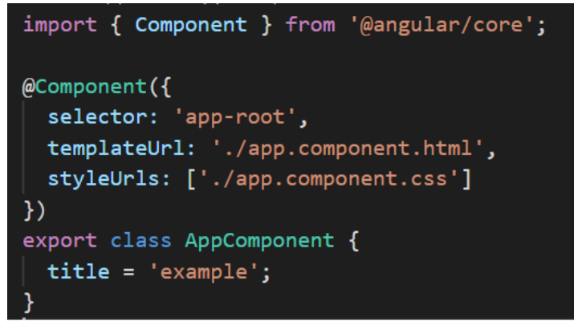

The image above shows an App component - a pure TypeScript class decorated with the “@Component” decorator. The metadata object that gets accepted by the decorator provides properties like templateUrl, selector, and others, where the templateUrL property points to an HTML file defining what you see on the application.

### 28. What are Services in Angular?

[Angular Services](https://www.simplilearn.com/tutorials/angular-tutorial/angular-service) perform tasks that are used by multiple components. These tasks could be data and image fetching, network connections, and database management among others. They perform all the operational tasks for the components and avoid rewriting of code. A service can be written once and injected into all the components that use that service.

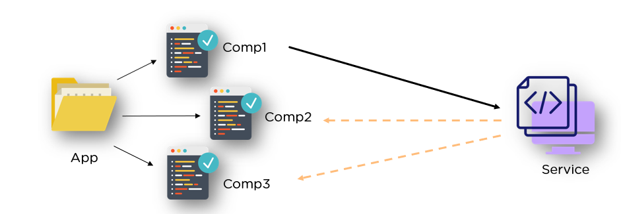

### 29. What are Promises and Observables in Angular?

While both the concepts deal with Asynchronous events in Angular, Promises handle one such event at a time while observables handle a sequence of events over some time.

Promises - They emit a single value at a time. They execute immediately after creation and are not cancellable. They are Push errors to the child promises.

Observables - They are only executed when subscribed to them using the subscribe() method. They emit multiple values over a period of time. They help perform operations like forEach, filter, and retry, among others. They deliver errors to the subscribers. When the unsubscribe() method is called, the listener stops receiving further values.

### 30. What is ngOnInit? How is it defined?

ngOnInit is a lifecycle hook and a callback method that is run by Angular to indicate that a component has been created. It takes no parameters and returns a void type.

export class MyComponent implements OnInit {

  constructor() { }

  ngOnInit(): void {

    //....

  }

}

#### **Know What It Takes to Build a UI/UX Career in 2023**

Free Webinar | 22nd August, Tuesday | 8 PM IST[REGISTER NOW](https://www.simplilearn.com/build-ui-ux-career-webinar?utm_source=webinarpromo&utm_medium=FRS-banner&utm_campaign=Aug)



### 31. How to use ngFor in a tag?

The ngFor directive is used to build lists and tables in the HTML templates. In simple terms, this directive is used to iterate over an array or an object and create a template for each element.

<ul>

      <li \*ngFor = "let items in itemlist"> {{ item }} </li>

    </ul>

1. “Let item” creates a local variable that will be available in the template
2. “Of items” indicates that we are iterating over the items iterable.
3. The \* before ngFor creates a parent template.

### 32. What are Template and Reactive forms?

Template-driven approach

* In this method, the conventional form tag is used to create [forms](https://www.simplilearn.com/tutorials/angular-tutorial/angular-forms). Angular automatically interprets and creates a form object representation for the tag.
* Controls can be added to the form using the NGModel tag. Multiple controls can be grouped using the NGControlGroup module.
* A form value can be generated using the “form.value” object. Form data is exported as JSON values when the submit method is called.
* Basic HTML validations can be used to validate the form fields. In the case of custom validations, directives can be used.
* Arguably, this method is the simplest way to create an Angular App.

Reactive Form Approach

* This approach is the programming paradigm oriented around data flows and propagation of change.
* With Reactive forms, the component directly manages the data flows between the form controls and the data models.
* Reactive forms are code-driven, unlike the template-driven approach.
* Reactive forms break from the traditional declarative approach.
* Reactive forms eliminate the anti-pattern of updating the data model via two-way data binding.
* Typically, Reactive form control creation is synchronous and can be unit tested with synchronous programming techniques.

### 33. What is Bootstrap? How is it embedded into Angular?

Bootstrap is a powerful toolkit. It is a collection of HTML, CSS, and JavaScript tools for creating and building responsive web pages and web applications.

There are two ways to embed the bootstrap library into your application.

1. [Angular Bootstrap](https://www.simplilearn.com/tutorials/angular-tutorial/angular-bootstrap) via CDN - Bootstrap CDN is a public Content Delivery Network. It enables you to load the CSS and JavaScript files remotely from its servers.
2. Angular Bootstrap via NPM - Another way to add Bootstrap to your [Angular project](https://www.simplilearn.com/tutorials/angular-tutorial/angular-project) is to install it into your project folder by using NPM (Node Package Manager).

npm install bootstrap

npm install jquery

### 34. What is Eager and Lazy loading?

Eager loading is the default module-loading strategy. Feature modules under Eager loading are loaded before the application starts. This is typically used for small size applications.

Lazy loading dynamically loads the feature modules when there's a demand. This makes the application faster. It is used for bigger applications where all the modules are not required at the start of the application.

### 35. What type of DOM does Angular implement?

DOM (Document Object Model) treats an XML or HTML document as a tree structure in which each node is an object representing a part of the document.

Angular uses the regular DOM. This updates the entire tree structure of HTML tags until it reaches the data to be updated. However, to ensure that the speed and performance are not affected, Angular implements Change Detection.

With this, you have reached the end of the article. We highly recommend brushing up on the core concepts for an interview. It’s always an added advantage to write the code in places necessary.

### 36. Why were client-side frameworks like Angular introduced?

Client-side frameworks like Angular were introduced to provide a more responsive user experience. By using a framework, developers can create web applications that are more interactive and therefore provide a better user experience.

Frameworks like Angular also make it easier for developers to create single-page applications (SPAs). SPAs are web applications that only need to load a single HTML page. This makes them much faster and more responsive than traditional web applications.

Overall, client-side frameworks like Angular were introduced in order to improve the user experience of web applications. By making web applications more responsive and easier to develop, they provide a better experience for both developers and users.

### 37. How does an Angular application work?

An Angular application is a Single Page Application, or SPA. This means that the entire application lives within a single page, and all of the resources (HTML, CSS, JavaScript, etc.) are loaded when the page is first loaded. Angular uses the Model-View-Controller, or MVC, architecture pattern to manage its data and views. The Model is the data that the application uses, the View is what the user sees, and the Controller is responsible for managing communication between the Model and the View.

When a user interacts with an Angular application, the Angular framework will automatically update the View to reflect any changes in the data. This means that Angular applications are very responsive and fast, as the user does not need to wait for the page to reload in order to see updated data.

Angular applications are also very scalable, as they can be divided into small modules that can be loaded independently of each other. This means that an Angular application can be easily extended with new functionality without having to rewrite the entire application.

Overall, Angular applications are very fast, responsive, and scalable. They are easy to develop and extend, and provide a great user experience.

The following is is an example of coding from an angular.json file:

 "build": {

        "builder": "@angular-devkit/build-angular:browser",

        "options": {

          "outputPath": "dist/angular-starter",

          "index": "src/index.html",

          "main": "src/main.ts",

          "polyfills": "src/polyfills.ts",

          "tsConfig": "tsconfig.app.json",

          "aot": false,

          "assets": [

            "src/favicon.ico",

            "src/assets"

          ],

          "styles": [

            "./node\_modules/@angular/material/prebuilt-themes/deeppurple-amber.css",

            "src/style.css"

          ]

        }

      }

### 38. Explain components, modules and services in Angular.

Components, modules and services are the three fundamental building blocks in Angular. Components are the smallest, self-contained units in an Angular application. They are typically used to represent a view or UI element, such as a button or a form input field.

Code example:

import { Component, OnInit } from '@angular/core';

     @Component({

       selector: 'app-test',

       templateUrl: './test.component.html',

       styleUrls: ['./test.component.css']

     })

     export lass TestComponent implements OnInit {

       constructor() {}

       ngOnInit() {

       }

     }

Modules are larger units that group together one or more related components. Services are singleton objects that provide specific functionality throughout an Angular application, such as data access or logging.

Code example:

import { BrowserModule } from '@angular/platform-browser';

      import { NgModule } from '@angular/core';

      import { AppComponent } from './app.component';

      import { TestComponent } from './test/text.component';

      @NgModule({

        declarations: [

          AppComponent,

          TestComponent

        ],

        imports: [

          BrowserModule

        ],

        providers: [],

        bootstrap: [AppComponent]

      })

      export class AppModule { }

Each component in Angular has its own isolated scope. This means that a component's dependencies (services, other components, etc.) are not accessible to any other component outside of its own scope. This isolation is important for ensuring modularity and flexibility in an Angular application.

Services, on the other hand, are not isolated and can be injected into any other unit in an Angular application (component, module, service, etc.). This makes them ideal for sharing data or functionality across the entire app.

Code example:

import { Injectable } from '@angular/core';

      @Injectable({

        providedIn: 'root'

      })

      export class TestServiceService {

        constructor() { }

      }

When designing an Angular application, it is important to keep these three building blocks in mind. Components should be small and self-contained, modules should group together related components, and services should provide shared functionality across the entire app. By following this design principle, you can create an Angular application that is modular, flexible, and easy to maintain.

#### **Here's How to Land a Top Software Developer Job**

Full Stack Development-MEAN[EXPLORE PROGRAM](https://www.simplilearn.com/full-stack-web-developer-mean-stack-certification-training?source=GhPreviewCTABanner)



### 39. How are Angular expressions different from JavaScript expressions?

One major difference between Angular expressions and JavaScript expressions is that Angular expressions are compiled while JavaScript expressions are not. This means that Angular expressions are more efficient since they're already pre-processed. Additionally, Angular expressions can access scope properties while JavaScript expressions cannot. Finally, Angular expressions support some additional features such as filters and directives which aren't available in JavaScript expressions.

Javascript expression example:

<!DOCTYPE html>

      <html lang="en">

      <head>

          <meta charset="UTF-8">

          <meta name="viewport" content="width=device-width, initial-scale=1.0">

          <title>JavaScript Test</title>

      </head>

      <body>

          <div id="foo"><div>

      </body>

      <script>

          'use strict';

          let bar = {};

          document.getElementById('foo').innerHTML = bar.x;

      </script>

      </html>

Angular expression example:

import { Component, OnInit } from '@angular/core';

      @Component({

        selector: 'app-new',

        template: `

            <h4>{{message}}</h4>

        `,

        styleUrls: ['./new.component.css']

      })

      export class NewComponent implements OnInit {

        message:object = {};

        constructor() { }

        ngOnInit() {

        }

      }

### 40. Angular by default, uses client-side rendering for its applications.

This means that the Angular application is rendered on the client-side — in the user's web browser. Client-side rendering has a number of advantages, including improved performance and better security. However, there are some drawbacks to using client-side rendering, as well. One of the biggest drawbacks is that it can make your application more difficult to debug.

Client-side rendering is typically used for applications that are not heavily data-driven. If your application relies on a lot of data from a server, client-side rendering can be very slow. Additionally, if you're using client-side rendering, it's important to be careful about how you load and cache your data. If you're not careful, you can easily end up with an application that is very slow and difficult to use. When rendered on the server-side, this is called Angular Universal.

### 41. How do you share data between components in Angular?

Sharing data between components in Angular is simple and easy. To share data, all you need to do is use the Angular CLI to generate a new service. This service can be injected into any component and will allow the components to share data.

To generate a new service, use the following Angular CLI command:

ng generate service my-data-service

This will create a new service file called my-data-service.ts in the src/app folder.

Inject the service into any component that needs to share data:

import { MyDataService } from './my-data.service';

constructor(private myDataService: MyDataService) { }

Once injected, the service will be available in the component as this.myDataService.

To share data between components, simply use the setData() and getData() methods:

this.myDataService.setData('some data');

const data = this.myDataService.getData();

#### **Become a Skilled Web Developer in Just 9 Months!**

Caltech PGP Full Stack Development[EXPLORE PROGRAM](https://www.simplilearn.com/pgp-full-stack-web-development-certification-training-course?source=GhPreviewCTABanner)



### 42. Explain the concept of dependency injection.

Dependency injection is a technique used to create loosely coupled code. It allows pieces of code to be reused without the need for hard-coded dependencies. This makes code more maintainable and easier to test. Dependency injection is often used in frameworks like AngularJS, ReactJS, and VueJS. It is also possible to use dependency injection in vanilla JavaScript. To use dependency injection in JavaScript, you need a dependency injection library. There are many different libraries available, but they all work in basically the same way.

The first step is to create a dependency injection container. This is a simple object that will hold all of the dependencies that your code needs. Next, you need to register all of the dependencies that your code will need with the container. The registration process will vary depending on the library you are using, but it is usually just a matter of providing the dependency's name and constructor function.

Once all of the dependencies have been registered, you can then inject them into your code. The injection process will again vary depending on the library you are using, but it is usually just a matter of providing the dependency's name. The library will then take care of instantiating the dependency and passing it to your code.

Dependency injection can be a great way to make your code more modular and easier to maintain. It can also make it easier to unit test your code, as you can inject mock dependencies instead of the real ones. If you are using a framework that supports dependency injection, then it is probably already being used in your code. If you are not using a framework, then you can still use dependency injection by choosing a library and following the steps outlined above.

Code example:

import { Injectable } from '@angular/core';

     @Injectable({

       providedIn: 'root'

     })

     export class TestService {

       importantValue:number = 42;

       constructor() { }

       returnImportantValue(){

         return this.importantValue;

       }

     }

The injectable dependencies are created after adding the @Injectable decorator to a class. The dependency above is then injected into the following component:

import { TestService } from './../test.service';

      import { Component, OnInit } from '@angular/core';

      @Component({

        selector: 'app-test',

        templateUrl: './test.component.html',

        styleUrls: ['./test.component.css']

      })

      export class TestComponent implements OnInit {

        value:number;

        constructor(private testService:TestService) { }

        ngOnInit() {

          this.value = this.testService.returnImportantValue();

        }

      }

### 43. Explain MVVM architecture.

MVVM architecture is an architectural pattern used mainly in software engineering. It stands for Model-View-ViewModel. MVVM is a variation of the traditional MVC (Model-View-Controller) software design pattern. The main difference between the two is that MVVM separates the user interface logic from the business logic, while MVC separates the data access logic from the business logic. This separation of concerns makes it easier to develop, test, and maintain software applications.

The Model layer in MVVM architecture is responsible for storing and managing data. It can be a database, a web service, or a local data source. The View layer is responsible for displaying data to the user. It can be a graphical user interface (GUI), a command-line interface (CLI), or a web page. The ViewModel layer is responsible for handling user input and updating the View layer accordingly. It contains the business logic of the application.

MVVM architecture is often used in conjunction with other software design patterns, such as Model-View-Presenter (MVP) and Model-View-Controller (MVC). These patterns can be used together to create a complete software application.

MVVM architecture is a popular choice for modern software applications. It allows developers to create applications that are more responsive and easier to maintain. Additionally, MVVM architecture can be used to create applications that can be easily ported to different platforms.

## **Angular Interview Questions for Experienced**

### 44. What are RxJs in Angular?

RxJs is a library that provides reactive programming support for Angular applications. It allows you to work with asynchronous data streams and handle events over time. RxJs is based on Observables, which are data streams that can be subscribed to and processed using operators. It provides a powerful and flexible way to handle complex asynchronous operations in Angular.

#### **Here's How to Land a Top Software Developer Job**

Full Stack Development-MEAN[EXPLORE PROGRAM](https://www.simplilearn.com/full-stack-web-developer-mean-stack-certification-training?source=GhPreviewCTABanner)



### 45. What exactly is a parameterized pipe?

A parameterized pipe in Angular is a pipe that accepts one or more arguments, also known as parameters. Pipes transform data in Angular templates, and parameterized pipes allow you to customize the transformation based on specific requirements. By passing parameters to a pipe, you can modify its behavior and apply different transformations to the data.

### 46. What are class decorators?

Class decorators in Angular are a type of decorator that can be applied to a class declaration. They are used to modify the behavior of the class or add additional functionality. Class decorators are defined using the @ symbol followed by the decorator name and are placed immediately before the class declaration. They can be used for various purposes, such as adding metadata, applying mixins, or extending the functionality of a class.

### 47. What are Method decorators?

Method decorators in Angular are decorators that can be applied to methods within a class. They are used to modify the behavior of the method or add additional functionality. Method decorators are defined using the @ symbol followed by the decorator name and are placed immediately before the method declaration. They can be used for tasks like logging, caching, or modifying the method's behavior based on specific conditions.

### 48. What are property decorators?

Property decorators in Angular are decorators that can be applied to class properties. They are used to modify the behavior of the property or add additional functionality. Property decorators are defined using the @ symbol followed by the decorator name and are placed immediately before the property declaration. They can be used for tasks like validation, memoization, or accessing metadata associated with the property.

### 49. What are router links?

Router links in Angular are used for navigation within an application. They are defined using the routerLink directive and provide a way to navigate to different routes or components. Router links can be used in HTML templates and are typically placed on anchor (<a>) tags or other clickable elements. By specifying the destination route or component, router links allow users to navigate between different parts of an Angular application.

### 50. What exactly is the router state?

The router state in Angular represents the current state of the Angular router. It contains information about the current route, including the URL, route parameters, query parameters, and other related data. The router state can be accessed and manipulated using the Angular Router service. It provides a way to programmatically navigate, retrieve information about the current route, and handle route changes in Angular applications.

### 51. What does Angular Material mean?

Angular Material is a UI component library for Angular applications. It provides a set of pre-built and customizable UI components, such as buttons, forms, navigation menus, and dialog boxes, that follow the Material Design guidelines. Angular Material simplifies the process of building consistent and visually appealing user interfaces in Angular. It offers a range of features and styles that can be easily integrated into Angular projects.

### 52. What is transpiling in Angular?

Transpiling in Angular refers to the process of converting TypeScript code into JavaScript code that web browsers can execute. Angular applications are built using TypeScript, a superset of JavaScript that adds static typing and additional features to the language. Since browsers can only run JavaScript, the TypeScript code needs to be transpiled into JavaScript before it can be executed. This is typically done using the TypeScript compiler (tsc) or build tools like Angular CLI.

### 53. What are HTTP interceptors?

HTTP interceptors in Angular are a feature that allows you to intercept HTTP requests and responses globally. Interceptors provide a way to modify or handle HTTP requests and responses at a centralized location before they reach the server or client. This can be useful for logging requests, adding authentication headers, handling errors, or modifying request/response data. Interceptors can be registered in the Angular module and are executed in a specific order based on the request/response pipeline.

### 54. What is Change Detection, and how does the Change Detection Mechanism work?

Change Detection in Angular is a mechanism that determines when and how to update the user interface based on changes in the application's data model. Angular uses a tree of change detectors to track changes in component properties and update the DOM accordingly. When a change occurs, Angular performs a process called change detection, which involves checking each component's properties for changes and updating the DOM if necessary. The change detection mechanism is responsible for keeping the UI in sync with the application's data.

#### **Become a Skilled Web Developer in Just 9 Months!**

Caltech PGP Full Stack Development[EXPLORE PROGRAM](https://www.simplilearn.com/pgp-full-stack-web-development-certification-training-course?source=GhPreviewCTABanner)



### 55. What is a bootstrapping module?

A bootstrapping module in Angular is the main entry point of an Angular application. It is responsible for starting the application and initializing the root component. The bootstrapping module is typically defined in the main.ts file and is configured in the Angular AppModule. It sets up the necessary environment, loads required modules, and invokes the Angular platform to start the application. The bootstrapping module plays a crucial role in the Angular application's lifecycle.

## **Angular Scenario Based Interview Questions**

### 56. How do you choose anc from a component template?

You can use various techniques to choose an element from a component template in Angular. One common approach is to use template reference variables. The template defines these variables using the # symbol followed by a name. You can then reference the element using the variable name in your component code. Another approach is to use Angular directives like ViewChild or ViewChildren to query for elements based on CSS selectors or component types. These directives provide more flexibility and control when selecting elements from the component template.

### 57. How do you deal with errors in observables?

When dealing with errors in observables in Angular, catchError operator can be used to handle and recover from errors. This operator allows you to provide a fallback value or execute alternative logic when an error occurs. You can chain the catchError operator after the observable that might produce an error and define a callback function to handle the error. Within the callback function, you can perform error handling tasks such as logging the error, displaying an error message to the user, or initiating a retry mechanism.

### 58. How to include SASS into an Angular project?

To include SASS (Syntactically Awesome Style Sheets) into an Angular project, you need to install the required dependencies and configure the project accordingly. Follow these steps:

* Install the node-sass package by running the command npm install node-sass --save-dev.
* Update the angular.json file in your project's root directory.
* Locate the styles property under architect > build > options.
* Change the file extension from .css to .scss to indicate that you are using SASS.
* Rename your existing CSS files to SCSS files (e.g., styles.css to styles.scss).
* Restart the Angular development server for the changes to take effect.

Once SASS is included in your Angular project, you can write your styles using SASS syntax, which provides additional features like variables, mixins, and nested selectors.

### 59. What happens when we use the script tag within a template?

Using the script tag within an Angular template is not a recommended practice. Angular templates are intended for defining the structure and layout of the user interface, and including scripts directly within the template goes against the separation of concerns principle. When a script tag is used within a template, the browser treats it as part of the HTML content and attempts to execute it. However, Angular's template compiler does not process or execute scripts within templates. Instead, scripts should be placed in separate JavaScript files and included using the appropriate Angular mechanisms, such as component logic or Angular modules.

### 60. Write a code to share data from the Parent to Child Component?

To share data from a parent component to a child component in Angular, you can make use of input properties. Input properties allow you to pass data from a parent component to a child component. Here's an example:

Parent Component:

typescript

Copy code

import { Component } from '@angular/core';

@Component({

  selector: 'app-parent',

  template: `

    <app-child [message]="parentMessage"></app-child>

  `,

})

export class ParentComponent {

  parentMessage = 'Hello from parent';

}

Child Component:

typescript

Copy code

import { Component, Input } from '@angular/core';

@Component({

  selector: 'app-child',

  template: `

    <p>{{ message }}</p>

  `,

})

export class ChildComponent {

  @Input() message: string;

}

In this example, the parent component (ParentComponent) defines a property parentMessage that holds the data to be shared with the child component (ChildComponent). The parent component then passes this data to the child component using the input property [message]. The child component receives the data through the @Input() decorator and can use it within its template or logic.

### 61. Create a TypeScript class with a constructor and a function.

Here's an example of a TypeScript class with a constructor and a function:

typescript

Copy code

class Person {

  name: string;

  age: number;

  constructor(name: string, age: number) {

    this.name = name;

    this.age = age;

  }

  sayHello() {

    console.log(`Hello, my name is ${this.name} and I'm ${this.age} years old.`);

  }

}

// Usage

const person = new Person('John', 30);

person.sayHello();

In this example, the Person class represents a person with a name and an age property. The constructor is used to initialize these properties when creating an instance of the class. The sayHello function is a method of the class that logs a greeting message using the person's name and age. Finally, an instance of the Person class is created, and the sayHello function is called to output the greeting message.

## **Next Steps**

We hope that this article on Angular Interview Questions helped you understand the type of questions asked and how to answer them. But, if you wish to learn Angular and perhaps make a career out of it, certification will come in handy.

You can also explore and get familiar with interview questions related to other frontend languages like Angular, CSS or [ReactJS interview questions](https://www.simplilearn.com/tutorials/reactjs-tutorial/reactjs-interview-questions).

Simplilearn's Angular Certification Training Course helps you master front-end web [development with Angular](https://www.simplilearn.com/how-to-become-an-angular-developer-article). You will learn the knack of creating applications with the help of concepts like facilitating the development of single-page web applications, components, typescript, dependency injection, and directives with this course. The course also includes a real-time project to test your skills.

If you are looking to enhance your software development skills, we recommend you check Simplilearn's [Post Graduate Program in Full Stack Web Development](https://www.simplilearn.com/pgp-full-stack-web-development-certification-training-course?source=GhPreviewCoursepages). This course, in collaboration with Caltech CTME, can help you hone the right skills and make you job-ready.

Do you have any questions for us? If you have feedback or questions, drop us a comment in the comments section of this Angular interview questions tutorial. Our experts will get back to you as soon as possible!

## **FAQs**

### 1. What are the key concepts of Angular?

Some key concepts of Angular include components, modules, templates, data binding, services, dependency injection, and routing. These concepts form the foundation of Angular development and help in building dynamic and scalable web applications.

### 2. What is Angular coding language?

Angular itself is not a coding language. It is a framework for building web applications using TypeScript. TypeScript is a superset of JavaScript that adds static typing and additional features to JavaScript. Angular leverages TypeScript to provide a more structured and scalable approach to web development.

### 3. What is a service in Angular interview questions?

In Angular, a service is a class that is used to share data or functionality across different components. Services are responsible for providing specific functionality that can be used by multiple components in an application. They promote reusability, modularity, and maintainability in Angular projects.

### 4. What is the full form of ng in Angular?

In Angular, "ng" stands for "Angular". It is a convention used in Angular to prefix directives, components, and other Angular-specific entities. For example, ngFor is a built-in Angular directive used for rendering lists based on an array, and ngModel is a directive used for two-way data binding between an input element and a component property. The "ng" prefix helps to distinguish Angular-specific entities from regular HTML elements and attributes.

### What is Angular?

Angular is a TypeScript-based front-end web application framework. It targets both the browser and the server. [**Angular**](https://www.interviewbit.com/angular-cheat-sheet/) is one of the most popular frameworks for UI design today, with hundreds of thousands of developers worldwide contributing to its community project. Its compelling features and performance have made it an essential tool for any web developer to have in their toolbox. It is maintained by Google, and its primary function is to design single-page applications. Angular has significant advantages as a framework, while also providing a common [**architecture**](https://www.interviewbit.com/blog/angular-architecture/) for developers to work with.  It allows developers to create large, maintainable applications.

## Angular Interview Questions for Freshers

### 1. Why were client-side frameworks like Angular introduced?

Back in the day, web developers used VanillaJS and jQuery to develop dynamic websites but, as the logic of one's website grew, the code became more and more tedious to maintain. For applications that use complex logic, developers had to put in extra effort to maintain the separation of concerns for the app. Also, jQuery did not provide facilities for data handling across views.

For tackling the above problems, [**client-side frameworks like Angular**](https://www.scaler.com/topics/angular/) came into the picture, which made life easier for the developers by handling the separation of concerns and dividing code into smaller bits of information (In the case of Angular, called Components).

Client-side frameworks allow one to develop advanced web applications like Single-Page-Application. Not that we cannot develop SPAs using VanillaJS, but by doing so, the development process becomes slower.

### 2. How does an Angular application work?

Every Angular app consists of a file named **angular.json**. This file will contain all the configurations of the app. While building the app, the builder looks at this file to find the entry point of the application. Following is an image of the angular.json file:

"build": {

"builder": "@angular-devkit/build-angular:browser",

"options": {

"outputPath": "dist/angular-starter",

"index": "src/index.html",

"main": "src/main.ts",

"polyfills": "src/polyfills.ts",

"tsConfig": "tsconfig.app.json",

"aot": false,

"assets": [

"src/favicon.ico",

"src/assets"

],

"styles": [

"./node\_modules/@angular/material/prebuilt-themes/deeppurple-amber.css",

"src/style.css"

]

}

}

 Inside the build section, the main property of the options object defines the entry point of the application which in this case is **main.ts**.

The main.ts file creates a browser environment for the application to run, and, along with this, it also calls a function called **bootstrapModule**, which bootstraps the application. These two steps are performed in the following order inside the main.ts file:

import { platformBrowserDynamic } from '@angular/platform-browser-dynamic';

platformBrowserDynamic().bootstrapModule(AppModule)

In the above line of code, **AppModule** is getting bootstrapped.

The AppModule is declared in the app.module.ts file. This module contains declarations of all the components.

Below is an example of app.module.ts file:

import { BrowserModule } from '@angular/platform-browser';

import { NgModule } from '@angular/core';

import { AppComponent } from './app.component';

@NgModule({

declarations: [

AppComponent

],

imports: [

BrowserModule

],

providers: [],

entryComponents: [],

bootstrap: [AppComponent]

})

export class AppModule { }

 As one can see in the above file, **AppComponent** is getting bootstrapped.

This component is defined in **app.component.ts** file. This file interacts with the webpage and serves data to it.

Below is an example of app.component.ts file:

import { Component } from '@angular/core';

@Component({

selector: 'app-root',

templateUrl: './app.component.html',

styleUrls: ['./app.component.css']

})

export class AppComponent {

title = 'angular';

}

 Each component is declared with three properties:

* **Selector** - used for accessing the component
* **Template/TemplateURL** - contains HTML of the component
* **StylesURL** - contains component-specific stylesheets

After this, Angular calls the **index.html** file. This file consequently calls the root component that is **app-root**. The root component is defined in **app.component.ts**. This is how the index.html file looks:

<!doctype html>

<html lang="en">

<head>

<meta charset="utf-8">

<title>Angular</title>

<base href="/">

<meta name="viewport" content="width=device-width, initial-scale=1">

</head>

<body>

<app-root></app-root>

</body>

</html>

 The HTML template of the root component is displayed inside the <app-root> tags.

This is how every angular application works.

### 3. What are some of the advantages of Angular over other frameworks?

* **Features that are provided out of the box -** Angular provides a number of built-in features like routing, state management, rxjs library and http servicesstraight out of the box. This means that one does not need to look for the above-stated features separately. They are all provided with angular.
* **Declarative UI -**Angular uses HTML to render the UI of an application. HTML is a declarative language and is much easier to use than JavaScript.
* **Long-term Google support -**Google announced Long-term support for Angular. This means that Google plans to stick with Angular and further scale up its ecosystem.

**You can download a PDF version of Angular Interview Questions.**

[**Download PDF**](javascript:void(0))

### 4. What are the advantages of Angular over React?

Angular vs React: [**Check out the differences**](https://www.interviewbit.com/blog/angular-vs-react/)

| **Angular** | **React** |
| --- | --- |
| Angular supports bidirectional data binding as well as mutable data. | React only supports unidirectional and immutable data binding. |
| The biggest benefit of Angular is that it enables dependency injection. | React allows us to either accomplish it ourselves or with the aid of a third-party library. |
| Angular can be used in both mobile and web development. | React can only be used in UI development only. |
| Angular features a wide wide range of tools, libraries, frameworks, plugins, and so on that make development faster and more fun. | In React we can use third-party libraries for any features. |
| Angular uses Typescript. | React uses Javascript. |

### 5. List out differences between AngularJS and Angular?

Check out the differences between AngularJS and Angular below. For More Information, [**Click here**](https://www.interviewbit.com/blog/difference-between-angular-and-angularjs/).

| **Features** | **AngularJS** | **Angular** |
| --- | --- | --- |
| **Architecture** | AngularJS uses MVC or Model-View-Controller architecture, where the Model contains the business logic, the Controller processes information and the View shows the information present in the Model. | Angular replaces controllers with Components. Components are nothing but directives with a predefined template. |
| **Language** | AngularJS uses JavaScript language, which is a dynamically typed language. | Angular uses TypeScript language, which is a statically typed language and is a superset of JavaScript. By using statically typed language, Angular provides better performance while developing larger applications. |
| **Mobile Support** | AngularJS does not provide mobile support. | Angular is supported by all popular mobile browsers. |
| **Structure** | While developing larger applications, the process of maintaining code becomes tedious in the case of AngularJS. | In the case of Angular, it is easier to maintain code for larger applications as it provides a better structure. |
| **Expression Syntax** | While developing an AngularJS application, a developer needs to remember the correct ng-directive for binding an event or a property. | Whereas in Angular, property binding is done using "[ ]" attribute and event binding is done using "( )" attribute. |

### 6. How are Angular expressions different from JavaScript expressions?

The first and perhaps, the biggest difference is that Angular expressions allow us to write JavaScript in HTML which is not the case when it comes to JavaScript expressions.

Next, Angular expressions are evaluated against a **local** scope object whereas JavaScript expressions are against a **global** window object. Let's understand that better with an example :

Consider the following component named test:

import { Component, OnInit } from '@angular/core';

@Component({

selector: 'app-test',

template: `

<h4>{{message}}</h4>

`,

styleUrls: ['./test.component.css']

})

export class TestComponent implements OnInit {

message:string = “Hello world”;

constructor() { }

ngOnInit() {

}

}

As one can see that Angular expression is used to display the **message** property of a component. Since we are using Angular expressions, in the present template, we cannot access a property outside of its local scope, which in this case is **TestComponent**.

This proves that Angular expressions are always evaluated based on the **scope** object rather than the global object.

The next difference is how Angular expressions handle **null** and **undefined**.

Consider the following JavaScript example:

<!DOCTYPE **html**>

<**html** lang="en">

<**head**>

<**meta** charset="UTF-8">

<**meta** name="viewport" content="width=device-width, initial-scale=1.0">

<**title**>JavaScript Test</**title**>

</**head**>

<**body**>

<**div** id="foo"><**div**>

</**body**>

<**script**>

'use strict';

**let** bar = {};

document.getElementById('foo').innerHTML = bar.x;

</**script**>

</**html**>

If you run the above code, you will see **undefined** displayed on the screen. Although it’s not ideal to leave any property undefined, the user does not need to see this.

Now consider the following Angular example:

import { Component, OnInit } from '@angular/core';

@Component({

selector: 'app-new',

template: `

<h4>{{message}}</h4>

`,

styleUrls: ['./new.component.css']

})

export class NewComponent implements OnInit {

message:object = {};

constructor() { }

ngOnInit() {

}

}

If you render the above component, you will **not** see undefined being displayed on the screen.

Next, in Angular expressions, one **cannot** use loops, conditionals and exceptions.

The difference which makes Angular expressions quite beneficial is the use of **pipes**. Angular uses pipes(called filters in AngularJS), which can be used to format data before displaying it. Let’s see one predefined pipe in action:

  import { Component, OnInit } from '@angular/core';

@Component({

selector: 'app-new',

template: `

<h4>{{message | lowercase}}</h4>

`,

styleUrls: ['./new.component.css']

})

export class NewComponent implements OnInit {

message:string = "HELLO WORLD";

constructor() { }

ngOnInit() {

}

}

In the above code, we have used a predefined pipe called **lowercase**, which transforms all the letters in lowercase. Therefore, if you render the above component, you will see “hello world” being displayed.  
  
In contrast, JavaScript does not have the concept of **pipes.**

### 7. What are Single Page Applications (SPA)?

Single page applications are web based applications that only need to be loaded once, with new functionality consisting of only minor changes to the user interface. It does not load new HTML pages to display the content of the new page, but rather generates it dynamically. This is made feasible by JavaScript's ability to alter DOM components on the current page. A Single Page Application method is speedier, resulting in a more consistent user experience.

### 8. What are templates in Angular?

A template is a kind of HTML that instructs Angular about how to display a component. An Angular HTML template, like conventional HTML, produces a view, or user interface, in the browser, but with far more capabilities. Angular API evaluates an HTML template of a component, creates HTML, and renders it.

**There are two ways to create a template in an Angular component:**

* Inline Template
* Linked Template

**Inline Template:**The component decorator's template config is used to specify an inline HTML template for a component. The Template will be wrapped inside the single or double quotes.

**Example:**

@Component({

   selector: "app-greet",

   template: `<div>

       <h1> Hello {{name}} how are you ? </h1>

       <h2> Welcome to interviewbit ! </h2>

   </div>`

})

**Linked Template:**A component may include an HTML template in a separate HTML file. As illustrated below, the templateUrl option is used to indicate the path of the HTML template file.

**Example:**

@Component({

   selector: "app-greet",

   templateUrl: "./component.html"

})

### 9. What are directives in Angular?

A directive is a class in Angular that is declared with a **@Directive** decorator.

Every directive has its own behaviour and can be imported into various components of an application.

**When to use a directive?**

Consider an application, where multiple components need to have similar functionalities. The norm thing to do is by adding this functionality individually to every component but, this task is tedious to perform. In such a situation, one can create a **directive** having the required functionality and then, import the directive to components which require this functionality.

**Types of directives:**

**1. Component directives**

These form the main class in directives. **Instead** of @Directive decorator we use **@Component** decorator to declare these directives. These directives have a view, a stylesheet and a selector property.

**2. Structural directives**

* These directives are generally used to manipulate DOM elements.
* Every structural directive has a ‘ \* ’ sign before them.
* We can apply these directives to any DOM element.

Let’s see some built-in structural directives in action:

<**div** \*ngIf="isReady" class="display\_name">

{{name}}

</**div**>

<**div** class="details" \*ngFor="let x of details" >

<**p**>{{x.name}}</**p**>

<**p**> {{x.address}}</**p**>

<**p**>{{x.age}}</**p**>

</**div**>

 In the above example, we can \*ngIf and \*ngFor directives being used.

\*ngIf is used to check a boolean value and if it’s truthy,the div element will be displayed.

\*ngFor is used to iterate over a list and display each item of the list.

**3. Attribute Directives**

These directives are used to change the look and behaviour of a DOM element. Let’s understand attribute directives by creating one:

**How to create a custom directive?**

We’re going to create an attribute directive:

In the command terminal, navigate to the directory of the angular app and type the following command to generate a directive: ng g directive blueBackground

The following directive will be generated. Manipulate the directive to look like this:

import { Directive, ElementRef } from '@angular/core';

@Directive({

selector: '[appBlueBackground]'

})

export class BlueBackgroundDirective {

constructor(el:ElementRef) {

el.nativeElement.style.backgroundColor = "blue";

}

}

Now we can apply the above directive to any DOM element:  <p appBlueBackground>Hello World!</p>

### 10. Explain Components, Modules and Services in Angular

For better understanding, I would like you to create an Angular application by running the following inside the command terminal: ng new angularApp

The above command will create an angular application in the directory.

Next, let's move on to understand Components, Modules, and Services.

* **Components**

In Angular, components are the basic building blocks, which control a part of the UI for any application.

A component is defined using the **@Component** decorator. Every component consists of three parts, the template which loads the view for the component, a stylesheet which defines the look and feel for the component, and a class that contains the business logic for the component.

For creating a component, inside the command terminal, navigate to the directory of the application created, and run the following command: ng generate component testOr ng g c test

One can see the generated component inside src/app/test folder. The component will be defined inside test.component.ts and this is how it looks:

import { Component, OnInit } from '@angular/core';

@Component({

selector: 'app-test',

templateUrl: './test.component.html',

styleUrls: ['./test.component.css']

})

export lass TestComponent implements OnInit {

constructor() {}

ngOnInit() {

}

}

As we can see in the above image, our component is defined with **@Component** decorator.

* **Modules**

A module is a place where we can group components, directives, services, and pipes. Module decides whether the components, directives, etc can be used by other modules, by exporting or hiding these elements. Every module is defined with a @NgModule decorator.

By default, modules are of two types:

* Root Module
* Feature Module

Every application can have only one root module whereas, it can have one or more feature modules.

A root module imports **BrowserModule**, whereas a feature module imports **CommonModule**.

In the application that we created before, one can see that the root module is defined inside **app.module.ts** and this is how it looks:

import { BrowserModule } from '@angular/platform-browser';

import { NgModule } from '@angular/core';

import { AppComponent } from './app.component';

import { TestComponent } from './test/text.component';

@NgModule({

declarations: [

AppComponent,

TestComponent

],

imports: [

BrowserModule

],

providers: [],

bootstrap: [AppComponent]

})

export class AppModule { }

We can see in the above image that the component we created earlier is already imported in the declarations array.

To create a feature module, run the following command: ng g m test-module

The module is created inside the src/app/test-module/test-module.module.ts file:

import { NgModule } from '@angular/core';

import { CommonModule } from '@angular/common';

@NgModule({

declarations: [],

imports: [

CommonModule

]

})

export class TestModuleModule { }

 As one can see, **CommonModule** is imported since this is a feature module.

* **Services**

Services are objects which get instantiated only once during the lifetime of an application. The main objective of a service is to share data, functions with different components of an Angular application.

A service is defined using a **@Injectable** decorator. A function defined inside a service can be invoked from any component or directive.

To create a service, run the following command: ng g s test-service

The service will be created inside src/app/test-service.service.ts:

import { Injectable } from '@angular/core';

@Injectable({

providedIn: 'root'

})

export class TestServiceService {

constructor() { }

}

 Any method/function defined inside the TestServiceService class can be directly used inside any component by just importing the service.

### 11. What is the scope?

In Angular, a scope is an object that refers to the application model. It is a context in which expressions can be executed. These scopes are grouped hierarchically, comparable to the DOM structure of the application. A scope aids in the propagation of various events and the monitoring of expressions.

### 12. What is data binding in Angular?

Data binding is one of the most significant and effective elements for creating communication between the DOM and the component. It makes designing interactive apps easier by reducing the need to worry about data pushing and pulling between the component and the template.

**There are Four types of Data binding in Angular:**

* Property Binding
* Event Binding
* String Interpolation
* Two way data binding

**Property Binding:**One method of data binding is called property binding. In property binding, we connect a DOM element's property to a field that is a declared property in our TypeScript component code. In reality, Angular transforms string interpolation into property binding internally.

**Event Binding:**Using event binding, you may respond to DOM events like button clicks and mouse movements. When a DOM event (such as a click, change, or keyup) occurs, the component's designated method is called.

**String Interpolation:**In order to export data from TypeScript code to an HTML template( view ), String Interpolation is a one way data binding approach. The data from the component is shown to the view using the template expression enclosed in double curly braces. The value of a component property is added by using string interpolation.

### 13. What is two way data binding in Angular?

Data sharing between a component class and its template is referred to as two-way data binding. If you alter data in one area, it will immediately reflate at the other end. This happens instantly and automatically, ensuring that the HTML template and TypeScript code are always up to date. Property binding and event binding are coupled in two-way data binding.

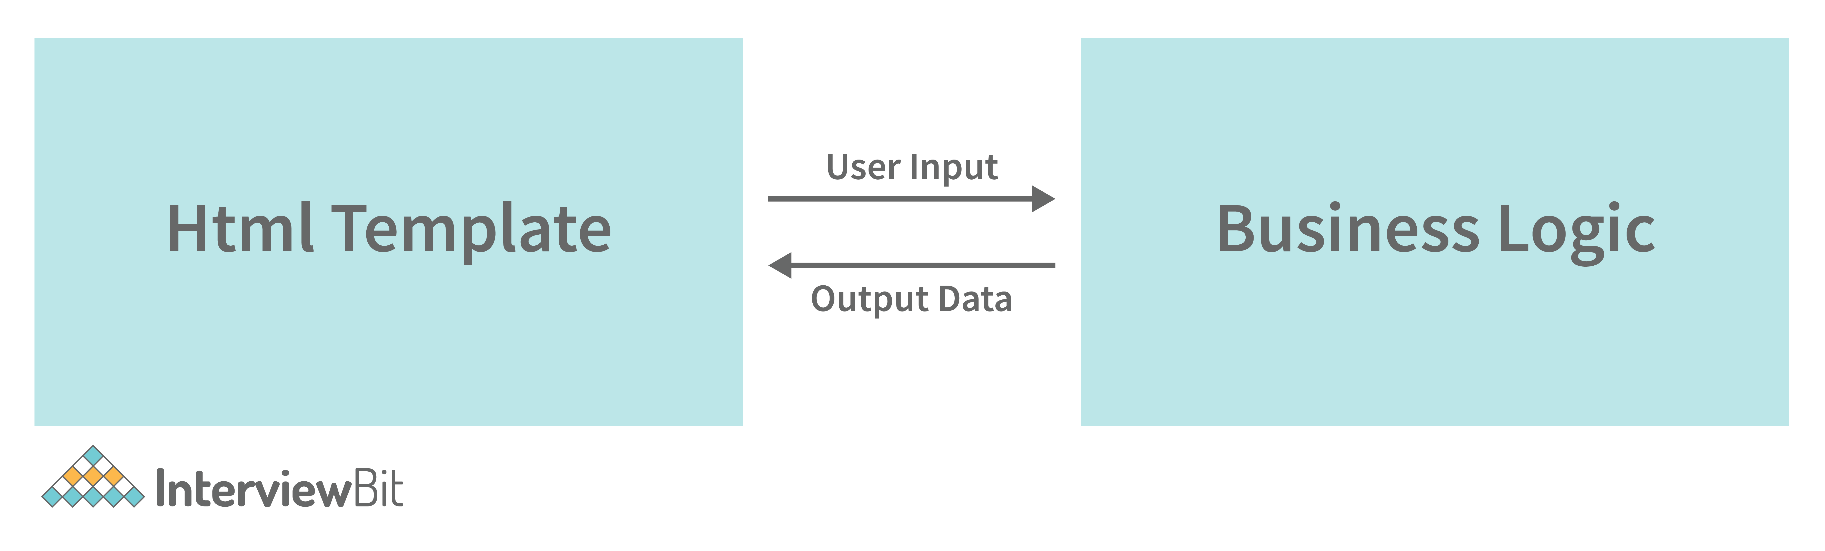

**Example:**

**app.component.ts**

import { Component } from "@angular/core";

@Component({

selector: "app",

templateUrl: "./app.component.html",

})

export class AppComponent {

data = "This is an example component of two way data binding.";

}

**app.component.html**

<input [(ngModel)]="data"  type="text">

<br> <br>

<h2> You entered the data:  {{data}}</h2>

**app.module.ts**

import { NgModule } from "@angular/core";

import { BrowserModule } from "@angular/platform-browser";

import { FormsModule } from "@angular/forms";

import { AppComponent } from "./app.component";

@NgModule({

imports: [BrowserModule, FormsModule],

declarations: [AppComponent],

bootstrap: [AppComponent],

})

export class AppModule {}

### 14. What are Decorators and their types in Angular?

Decorators are a fundamental concept in TypeScript, and because Angular heavily relies on TypeScript, decorators have become an important element of Angular as well.

Decorators are methods or design patterns that are labeled with a prefixed @ symbol and preceded by a class, method, or property. They enable the modification of a service, directive, or filter before it is utilized. A decorator, in essence, provides configuration metadata that specifies how a component, class, or method should be processed, constructed, and used at runtime. Angular includes a number of decorators which attach various types of metadata to classes, allowing the system to understand what all these classes signify and how they should function.

**Types of decorators:**

* **Method Decorator:**Method decorators, as the name implies, are used to add functionality to the methods defined within our class.
* **Class Decorator:**Class Decorators are the highest-level decorators that determine the purpose of the classes. They indicate to Angular that a specific class is a component or module. And the decorator enables us to declare this effect without having to write any code within the class.
* **Parameter Decorator:**The arguments of your class constructors are decorated using parameter decorators.
* **Property Decorator:**These are the second most popular types of decorators. They enable us to enhance some of the properties in our classes.

### 15. What are annotations in Angular ?

These are language features that are hard-coded. Annotations are merely metadata that is set on a class to reflect the metadata library. When a user annotates a class, the compiler adds an annotations property to the class, saves an annotation array in it, and then attempts to instantiate an object with the same name as the annotation, providing the metadata into the constructor. Annotations in AngularJs are not predefined, therefore we can name them ourselves.

### 16. What are pure Pipes?

These are pipelines that only employ pure functions. As a result, a pure pipe does not employ any internal state, and the output remains constant as long as the parameters provided remain constant. Angular calls the pipe only when the parameters being provided change. A single instance of the pure pipe is utilized in all components.

### 17. What are impure pipes?

Angular calls an impure pipe for each change detection cycle, independent of the change in the input fields. For each of these pipes, several pipe instances are produced. These pipes' inputs can be altered.

By default, all pipelines are pure. However, as demonstrated below, you can specify impure pipes using the pure property.

**Example:**

@Pipe({

   name: 'impurePipe',

   pure: false/true

})

export class ImpurePipe {}

### 18. What is Pipe transform Interface in Angular?

An interface used by pipes to accomplish a transformation. Angular calls the transform function with the value of a binding as the first argument and any arguments as the second parameter in list form. This interface is used to implement custom pipes.

**Example:**

import { Pipe, PipeTransform } from '@angular/core';

@Pipe({

name: 'tranformpipe'

})

export class TranformpipePipe implements PipeTransform {

transform(value: unknown, ...args: unknown[]): unknown {

   return null;

 }

}

### 19. Write a code where you have to share data from the Parent to Child Component?

You have to share the data amongst the components in numerous situations. It may consist of unrelated, parent-child, or child-parent components.

The @Input decorator allows any data to be sent from parent to child.

// parent component

import { Component } from '@angular/core';

@Component({

selector: 'app-parent',

template: `

<app-child [childMessage]="parentMessage"></app-child>

`,

styleUrls: ['./parent.component.css']

})

export class ParentComponent{

parentMessage = "message from parent"

constructor() { }

}

// child component

import { Component, Input } from '@angular/core';

@Component({

selector: 'app-child',

template: `Say {{ childMessage }}`,

styleUrls: ['./child.component.css']

})

export class ChildComponent {

 @Input() childMessage: string;

constructor() { }

}

### 20. Create a TypeScript class with a constructor and a function.

class IB {

name: string;

constructor(message: string) {

this.name = message;

}

greet() {

return "Hello, " + this.name + "How are you";

}

}

let msg = new IB("IB");

## Angular Interview Questions for Experienced

### 21. Angular by default, uses client-side rendering for its applications.

Can one make an angular application to render on the server-side?

Yes, angular provides a technology called **Angular Universal**, which can be used to render applications on the server-side.

The advantages of using Angular Universal are:

* First time users can instantly see a view of the application. This benefits in providing **better user experience**.
* Many search engines expect pages in plain HTML, thus, Universal can make sure that your content is available on every search engine, which leads to **better SEO**.
* Any server-side rendered application **loads faster** since rendered pages are available to the browser sooner.

### 22. What is Eager and Lazy loading?

* **Loading:**The eager loading technique is the default module-loading strategy. Eager loading feature modules are loaded before the program begins. This is primarily utilized for small-scale applications.
* **Lazy Loading:**Lazy loading loads the feature modules dynamically as needed. This speeds up the application. It is utilized for larger projects where all of the modules are not required at the start.

### 23. What is view encapsulation in Angular?

View encapsulation specifies if the component's template and styles can impact the entire program or vice versa.

**Angular offers three encapsulation methods:**

* **Native:**The component does not inherit styles from the main HTML. Styles defined in this component's @Component decorator are only applicable to this component.
* **Emulated (Default):**The component inherits styles from the main HTML. Styles set in the @Component decorator are only applicable to this component.
* **None:**The component's styles are propagated back to the main HTML and therefore accessible to all components on the page. Be wary of programs that have None and Native components. Styles will be repeated in all components with Native encapsulation if they have No encapsulation.

### 24. What are RxJs in Angular ?

RxJS is an acronym that stands for Reactive Extensions for JavaScript. It is used to enable the use of observables in our JavaScript project, allowing us to do reactive programming. RxJS is utilized in many popular frameworks, including Angular since it allows us to compose our asynchronous or callback-based code into a sequence of operations executed on a data stream that releases values from a publisher to a subscriber. Other programming languages, such as Java and Python, offer packages that allow them to develop reactive programs utilizing observables.

Most of the time, rxJs is used in HTTP calls with angular. Because http streams are asynchronous data, we can subscribe to them and apply filters to them.

**Example:**The following is a simple example of how RxJs can be utilized with HTTP calls.

let  stream1 = httpc.get("https://www.example.com/somedata");

let stream2 = stream1.pipe(filter(x=>x>3));

stream2.subscribe(res=>this.Success(res),res=>this.Error(res));

### 25. Explain string interpolation and property binding in Angular.

* String interpolation and property binding are parts of **data-binding** in Angular.
* Data-binding is a feature in angular, which provides a way to communicate between the component(Model) and its view(HTML template).
* Data-binding can be done in two ways, **one-way** binding and **two-way** binding.
* In Angular, data from the component can be inserted inside the HTML template. In one-way binding, any changes in the component will directly reflect inside the HTML template but, vice-versa is not possible. Whereas, it is possible in two-way binding.
* String interpolation and property binding allow only one-way data binding.
* String interpolation uses the double curly braces **{{ }}** to display data from the component. Angular automatically runs the expression written inside the curly braces, for example, {{ 2 + 2 }} will be evaluated by Angular and the output 4, will be displayed inside the HTML template. Using property binding, we can bind the DOM properties of an HTML element to a component's property. Property binding uses the square brackets **[ ]** syntax.

### 26. How are observables different from promises?

The first difference is that an Observable is **lazy** whereas a Promise is **eager**.

| **Promise** | **Observable** |
| --- | --- |
| Emits a single value | Emits multiple values over a period of time |
| Not Lazy | Lazy. An observable is not called until we subscribe to the observable |
| Cannot be cancelled | Can be cancelled by using the unsubscribe() method |
|  | Observable provides operators like map, forEach, filter, reduce, retry, retryWhen etc. |

Consider the following Observable:

const observable = rxjs.Observable.create(observer => {

console.log('Text inside an observable');

observer.next('Hello world!');

observer.complete();

});

console.log('Before subscribing an Observable');

observable.subscribe((message)=> console.log(message));

 When you run the above Observable, you can see messages being displayed in the following order:

Before subscribing an Observable

Text inside an observable

Hello world!

As you can see, observables are lazy. Observable runs only when someone subscribes to them hence, the message “Before subscribing…” is displayed ahead of the message inside the observable.

Now let’s consider a Promise:

const promise = new Promise((resolve, reject) => {

console.log('Text inside promise');

resolve('Hello world!');

});

console.log('Before calling then method on Promise');

greetingPoster.then(message => console.log(message));

Running the above promise, the messages will be displayed in the following order:

Text inside promise

Before calling then method on Promise

Hello world!

As you can see the message inside Promise is displayed first. This means that a promise runs before the **then** method is called. Therefore, promises are **eager**.

The next difference is that Promises are always **asynchronous**. Even when the promise is immediately resolved. Whereas an Observable, can be both **synchronous** and **asynchronous**.

The above example of an observable is the case to show that an observable is synchronous. Let’s see the case where an observable can be asynchronous:

const observable = rxjs.Observable.create(observer => {

setTimeout(()=>{

observer.next('Hello world');

observer.complete();

},3000)

});

console.log('Before calling subscribe on an Observable');

observable.subscribe((data)=> console.log(data));

console.log('After calling subscribe on an Observable');

The messages will be displayed in the following order:

Before calling subscribe on an Observable

After calling subscribe on an Observable

Hello world!

You can see in this case, observable runs asynchronously.

The next difference is that Observables can emit **multiple** values whereas Promises can emit only one value.

The biggest feature of using observables is the use of **operators**. We can use multiple operators on an observable whereas, there is no such feature in a promise.

### 27. Explain the concept of Dependency Injection?

Dependency injection is an application design pattern which is implemented by Angular.

It also forms one of the core concepts of Angular.

**So what is dependency injection in simple terms?**

Let’s break it down, dependencies in angular are nothing but services which have functionality. The functionality of a service, can be needed by various components and directives in an application. Angular provides a smooth mechanism by which we can inject these dependencies into our components and directives.

So basically, we are just making dependencies which are injectable across all components of an application.

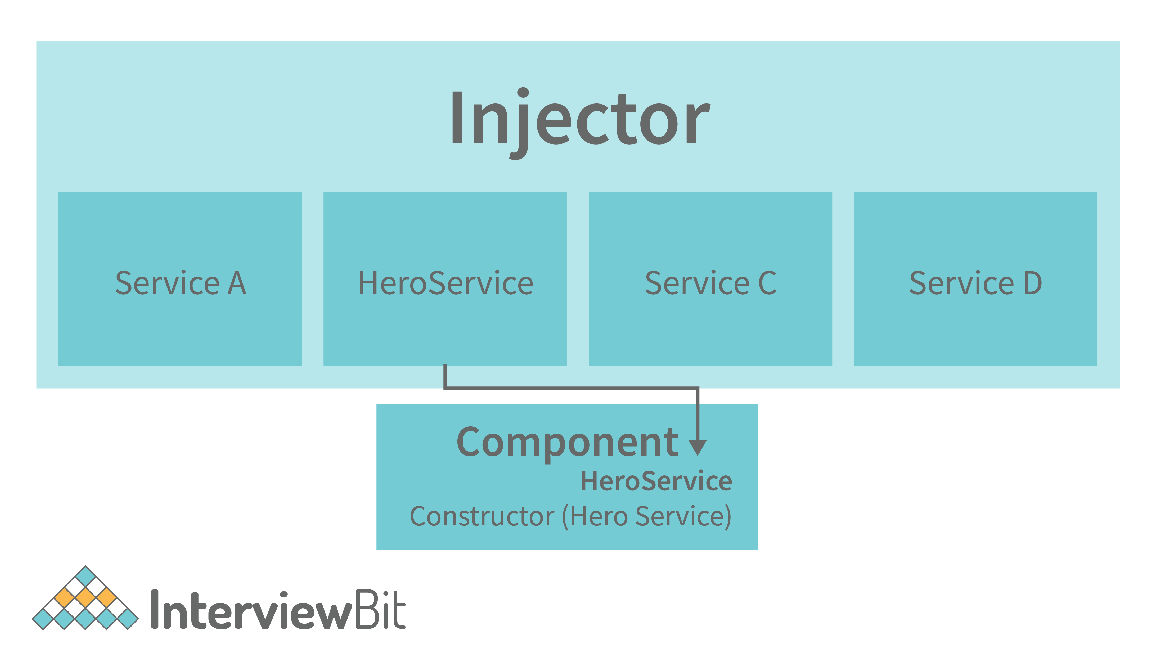

Let’s understand how DI (Dependency Injection) works:

Consider the following service, which can be generated using: ng g service test

import { Injectable } from '@angular/core';

@Injectable({

providedIn: 'root'

})

export class TestService {

importantValue:number = 42;

constructor() { }

returnImportantValue(){

return this.importantValue;

}

}

 As one can notice, we can create injectable dependencies by adding the **@Injectable** decorator to a class.

We inject the above dependency inside the following component:

import { TestService } from './../test.service';

import { Component, OnInit } from '@angular/core';

@Component({

selector: 'app-test',

templateUrl: './test.component.html',

styleUrls: ['./test.component.css']

})

export class TestComponent implements OnInit {

value:number;

constructor(private testService:TestService) { }

ngOnInit() {

this.value = this.testService.returnImportantValue();

}

}

 One can see we have imported our TestService at the top of the page. Then, we created an instance inside the constructor of the component and implemented the **returnImportantValue** function of the service.

From the above example, we can observe how angular provides a smooth way to inject dependencies in any component.

### 28. What are pipes in Angular explain with an example?

Pipes are functions that simplify the process of wiring up your JavaScript expressions and transforming them into their desired output. They can be compared to, say, string functions in other programming languages. Pipes also allow you to combine multiple expressions together, whether they're all values or some values and some declarations.

**For example:**

var css = myTheme.color | "red" ;

This line would assign a value to css , and it's equivalent to writing out the following code:

Pipes have several built-in functions that allow you to transform data, such as value and extract. We can also create our own custom pipes.

Pipes are data transformers that execute on an Angular Component's output. They take in data and return transformed data. For example, if you have an expression such as number | 1000, the number pipe will take data from the output and transform it into 1000. In Angular, there are many built-in pipes that you can use. You can also create your own custom pipes by implementing the PipeTransform interface in a class.

Pipes receive an input which can be a value expression, a function returning an expression, or even a component property., that outputs a number with a value of 1,000. With a pipe, you can transform this output into a formatted string of "1,000" or "1.000".

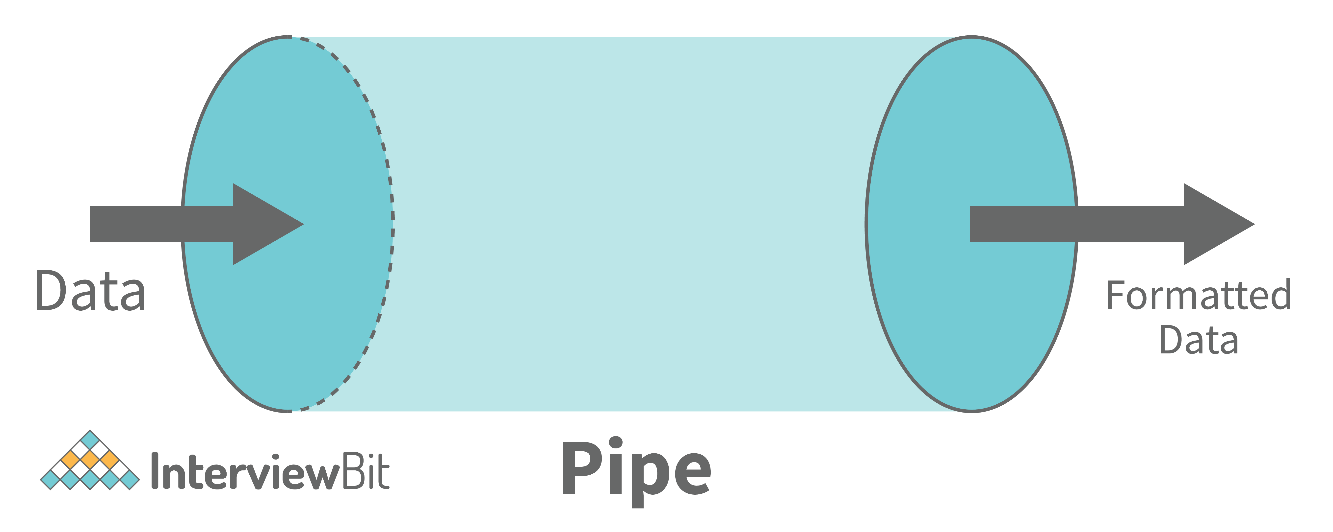

**Example:**

import { Component } from '@angular/core';

@Component({

selector: 'app-root',

template: `{{ title | uppercase}}`,

styleUrls: ['./app.component.css']

})

export class AppComponent {

title = 'this is an example of custom pies in angular';

}

**Output:**

**THIS IS AN EXAMPLE OF CUSTOM PIPES IN ANGULAR**

### 29. What exactly is a parameterized pipe?

To fine-tune its output, a pipe can receive any number of optional parameters. The parameterized pipe is constructed by first stating the pipe name followed by a colon (:) and then the parameter value. If the pipe supports several arguments, use colons to separate the values.

**Example:**Let's look at a birthday with a certain format (dd/MM/yyyy):

import { Component } from '@angular/core';

   @Component({

     selector: 'app-example',

     template: `<p>Birthday is {{ birthday | date:'dd/MM/yyyy'}}</p>`

   })

   export class ExampleComponent {

     birthday = new Date(2000, 7, 15);

   }

### 30. What are class decorators?

Class Decorators are the highest-level decorators that determine the purpose of the classes. They indicate to Angular that a specific class is a component or module. And the decorator enables us to declare this effect without having to write any code within the class.

**Example:**

import { NgModule, Component } from '@angular/core';

@Component({

selector: 'class-component',

template: '<div> This is a class component ! </div>',

})

export class ClassComponent {

constructor() {

   console.log('This is a class component!');

 }

}

@NgModule({

imports: [],

declarations: [],

})

export class ClassModule {

constructor() {

   console.log('This is a class module!');

 }

}

It is a component or module in which no code in the class is required to tell Angular. We only need to design it, and Angular will take care of the rest.

### 31. What are Method decorators?

Method decorators, as the name implies, are used to add functionality to the methods defined within our class.

**Example:**@HostListener, is a good example of method decorators.

import { Component, HostListener } from '@angular/core';

@Component({

selector: 'method-component',

template: '<div> This is a test method component ! </div>',

})

export class MethodComponent {

 @HostListener('click', ['$event'])

   onHostClick(event: Event) {

   console.log('clicked now this event is available !');

   }

}

The @HostListener decorator is used before the onHostClick () method in the above example code.

### 32. What are property decorators?

These are the second most popular types of decorators. They enable us to enhance some of the properties in our classes. We can certainly understand why we utilize any certain class property by using a property decorator.

There are many property decorators available for example @Input(), @Output, @ReadOnly(), @Override()

**Example:**

import { Component, Input } from '@angular/core';

@Component({

selector: 'prop-component',

template: '<div> This is a test component ! </div>'

})

export class PropComponent {

 @Input()

exampleProperty: string;

}

The input binding would be sent via a component property binding:

<prop-component

[propProperty]="propData">

</prop-component>

### 33. What is the Component Decorator in Angular?

TypeScript classes are used to create components. This class genre is then decorated with the "@Component" decorator. The decorator's function is to take a metadata object holding component information and decorate it.

A Decorator is always preceded by @. The Decorator must come before the class definition. We can also make our own decorators.

**Example:**The example below shows us a Class decorated with the @Component decorator.

import {Component} from '@angular/core';

@Component({

   selector: 'app-root',

   templateUrl: './app.component.html',

   styleUrls: ['./app.component.css']

})

export class AppComponent {

   title = 'Example component';

}

The metadata object received by the decorator has values such as templateUrl, selector, and others, with the templateUrL property pointing to an HTML file that defines what you see on the application.

### 34. What are lifecycle hooks in Angular? Explain a few lifecycle hooks.

Every component in Angular has a lifecycle, and different phases it goes through from the time of creation to the time it's destroyed. Angular provides **hooks** to tap into these phases and trigger changes at specific phases in a lifecycle.

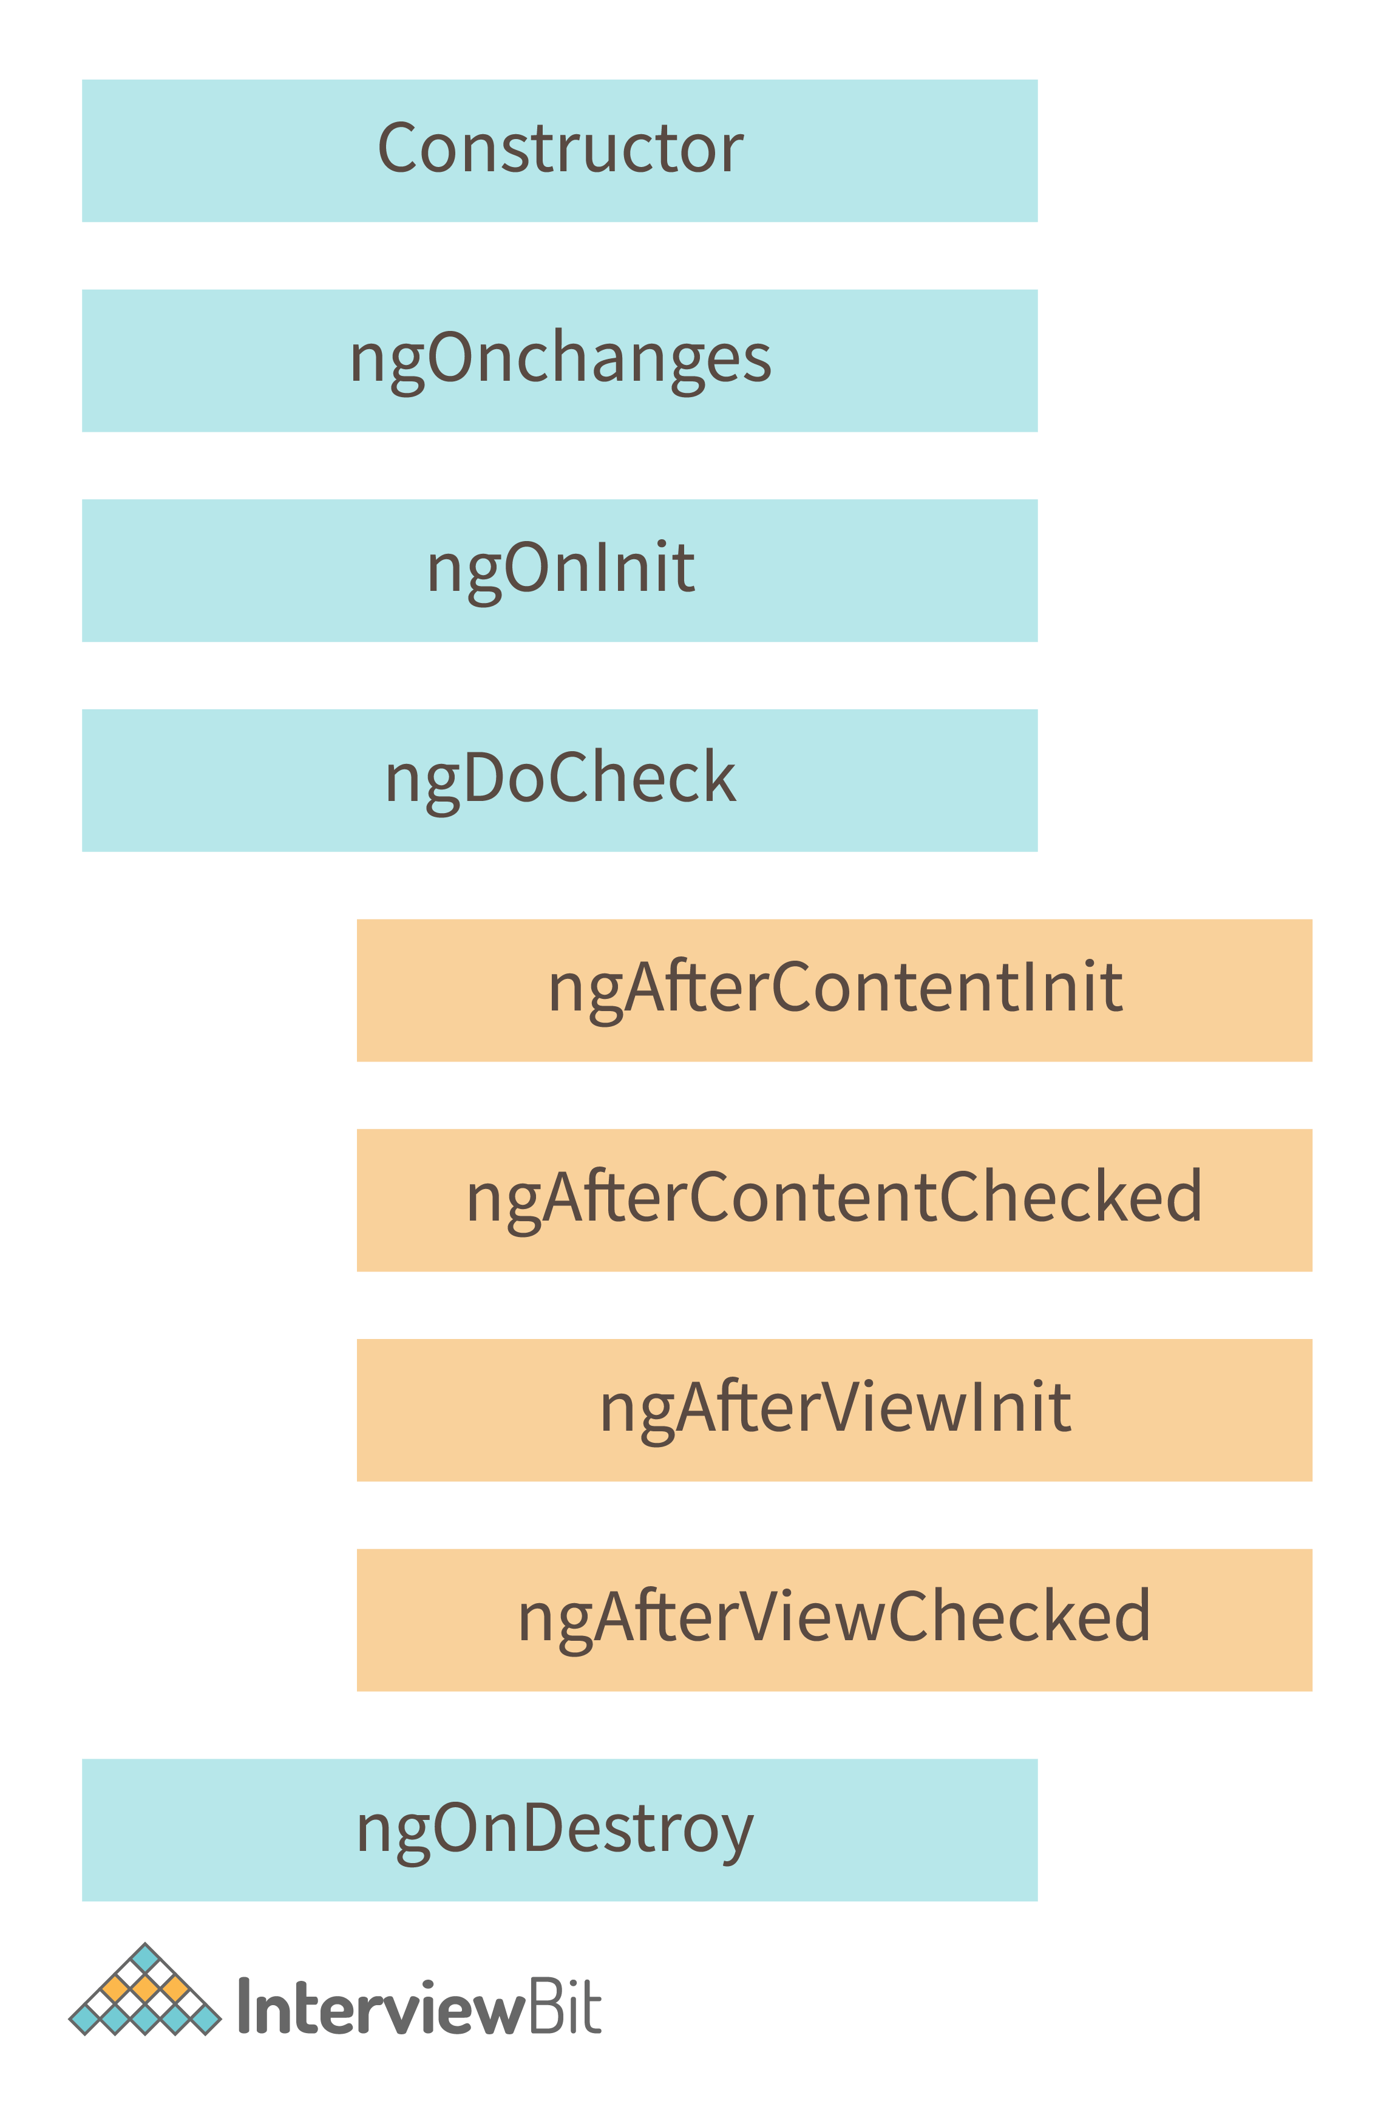

* **ngOnChanges( )** This hook/method is called before ngOnInit and whenever one or more input properties of the component change.  
  This method/hook receives a SimpleChanges object which contains the previous and current values of the property.
* **ngOnInit( )** This hook gets called once, after the ngOnChanges hook.  
  It initializes the component and sets the input properties of the component.
* **ngDoCheck( )** It gets called after ngOnChanges and **ngOnInit** and is used to detect and act on changes that cannot be detected by Angular.  
  We can implement our change detection algorithm in this hook. **ngAfterContentInit( )** It gets called after the first **ngDoCheck** hook. This hook responds after the content gets projected inside the component.
* **ngAfterContentChecked( )** It gets called after **ngAfterContentInit** and every subsequent **ngDoCheck**. It responds after the projected content is checked.
* **ngAfterViewInit( )** It responds after a component's view, or a child component's view is initialized.
* **ngAfterViewChecked( )** It gets called after **ngAfterViewInit**, and it responds after the component's view, or the child component's view is checked.
* **ngOnDestroy( )** It gets called just before Angular destroys the component. This hook can be used to clean up the code and detach event handlers.

Let’s understand how to use **ngOnInit** hook, since it’s the most often used hook. If one has to process a lot of data during component creation, it’s better to do it inside **ngOnInit** hook rather than the constructor:

import { Component, OnInit } from '@angular/core';

@Component({

selector: 'app-test',

templateUrl: './test.component.html',

styleUrls: ['./test.component.css']

})

export class TestComponent implements OnInit {

constructor() { }

ngOnInit() {

this.processData();

}

processData(){

// Do something..

}

}

 As you can see we have imported OnInit but we have used **ngOnInit** function. This principle should be used with the rest of the hooks as well.

### 35. What are router links?

RouterLink is an anchor tag directive that gives the router authority over those elements. Because the navigation routes are set.

**Example:**As seen below, you may pass string values to the router-link directive.

<h1>Example of an Angular Router</h1>

<nav>

<a routerLink="/home" >Home Page of our website</a>

<a routerLink="/about-us" >About us</a>

</nav>

<router-outlet></router-outlet>

### 36. What exactly is the router state?

RouterState is a route tree. This tree's nodes are aware of the "consumed" URL segments, retrieved arguments, and processed data. You may use the Router service and the routerState property to get the current RouterState from anywhere in the application.

**Example:**

@Component({templateUrl:'example.html'})

class MyComponent {

constructor(router: Router) {

   const state: RouterState = router.routerState;

   const root: ActivatedRoute = state.root;

   const child = root.firstChild;

   const id: Observable<string> = child.params.map(p => p.id);

   //...

 }

}

### 37. What does Angular Material means?

Angular Material is a user interface component package that enables professionals to create a uniform, appealing, and fully functioning websites, web pages, and web apps. It does this by adhering to contemporary web design concepts such as gentle degradation and browser probability.

### 38. What is ngOnInit?

ngOnInit is a lifecycle hook and callback function used by Angular to mark the creation of a component. It accepts no arguments and returns a void type.

**Example:**

export class MyComponent implements OnInit {

constructor() { }

   ngOnInit(): void {

       //....

   }

}

### 39. What is transpiling in Angular ?

Transpiling is the process of transforming the source code of one programming language into the source code of another. Typically, in Angular, this implies translating TypeScript to JavaScript. TypeScript (or another language like as Dart) can be used to develop code for your Angular application, which is subsequently transpiled to JavaScript. This occurs naturally and internally.

### 40. What are HTTP interceptors ?

Using the HttpClient, interceptors allow us to intercept incoming and outgoing HTTP requests. They are capable of handling both HttpRequest and HttpResponse. We can edit or update the value of the request by intercepting the HTTP request, and we can perform some specified actions on a specific status code or message by intercepting the answer.

**Example:**In the following example we will set the Authorization header Bearer for all the requests:

token.interceptor.ts

import { Injectable } from '@angular/core';

import { HttpInterceptor, HttpRequest, HttpHandler, HttpEvent } from '@angular/common/http';

import { Observable } from 'rxjs/Observable';

@Injectable()

export class TokenInterceptor implements HttpInterceptor {

   public intercept(req: HttpRequest<any>, next: HttpHandler): Observable<HttpEvent<any>> {

   const token = localStorage.getItem('token') as string;

       if (token) {

       req = req.clone({

           setHeaders: {

           'Authorization': `Bearer ${token}`

           }

       });

       }

       return next.handle(req);

   }

}

We have to register the interceptor as singleton in the module providers

app.module.ts

import { NgModule } from '@angular/core';

import { BrowserModule } from '@angular/platform-browser';

import { HTTP\_INTERCEPTORS } from '@angular/common/http';

import { AppComponent } from './app.component';

import { TokenInterceptor } from './token.interceptor';

@NgModule({

imports: [

   BrowserModule

],

declarations: [

   AppComponent

],

bootstrap: [AppComponent],

providers: [{

   provide: HTTP\_INTERCEPTORS,

   useClass: TokenInterceptor,

   multi: true

}]

})

export class AppModule {}

### 41. What is AOT compilation? What are the advantages of AOT?

Every Angular application consists of components and templates that the browser cannot understand. Therefore, all the Angular applications need to be compiled first before running inside the browser.

Angular provides two types of compilation:

* JIT(Just-in-Time) compilation
* AOT(Ahead-of-Time) compilation

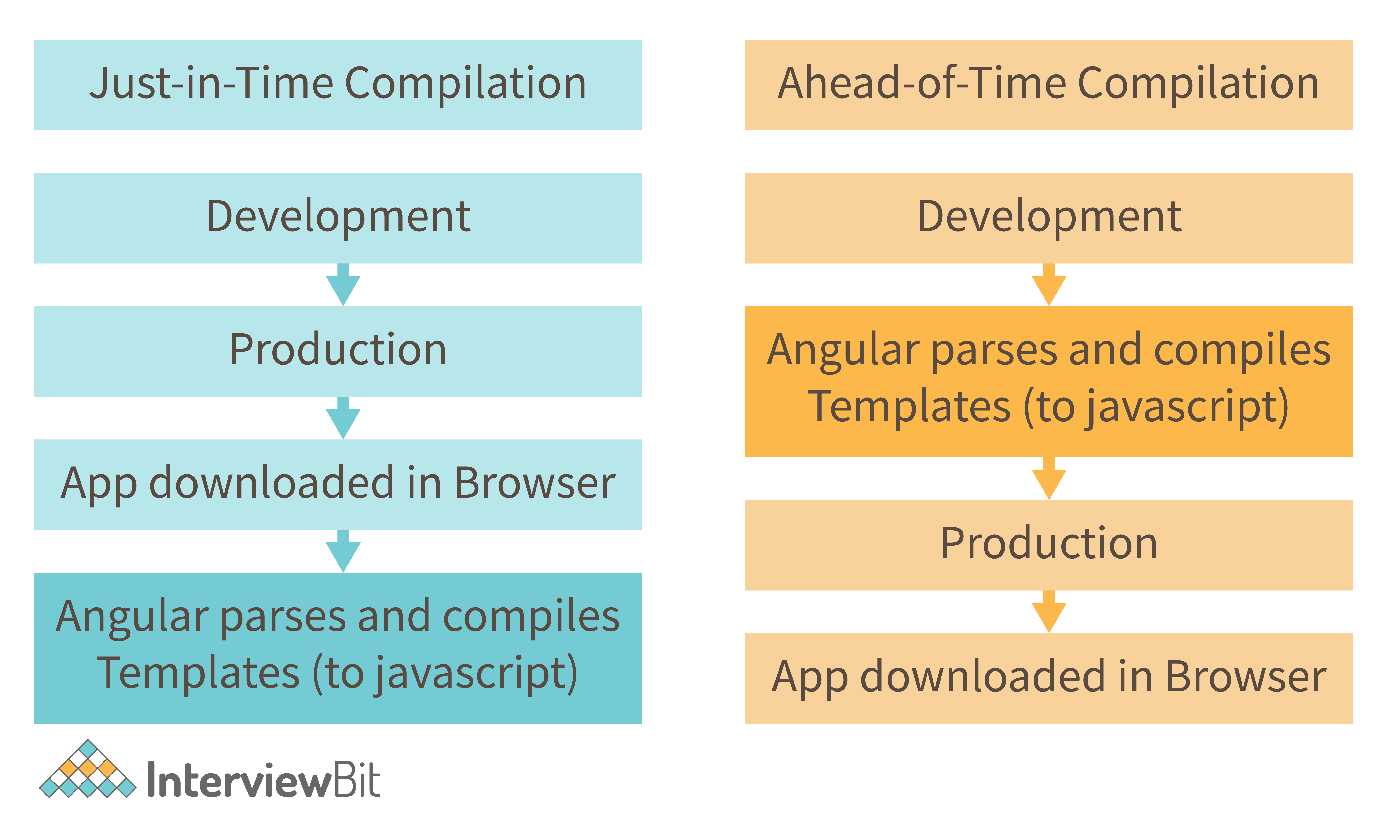

In JIT compilation, the application compiles inside the browser during runtime. Whereas in the AOT compilation, the application compiles during the build time.

The advantages of using AOT compilation are:

* Since the application compiles before running inside the browser, the browser loads the executable code and renders the application immediately, which leads to **faster rendering**.
* In AOT compilation, the compiler sends the external HTML and CSS files along with the application, eliminating separate AJAX requests for those source files, which leads to **fewer ajax requests**.
* Developers can detect and handle errors during the building phase, which helps in **minimizing errors**.
* The AOT compiler adds HTML and templates into the JS files before they run inside the browser. Due to this, there are no extra HTML files to be read, which provide **better security** to the application.

By default, angular builds and serves the application using JIT compiler:

ng build

ng serve

For using AOT compiler following changes should be made:

ng build --aot

ng serve --aot

### 42. What is Change Detection, and how does the Change Detection Mechanism work?

The process of synchronizing a model with a view is known as Change Detection. Even when utilizing the ng Model to implement two-way binding, which is syntactic sugar on top of a unidirectional flow. Change detection is incredibly fast, but as an app's complexity and the number of components increase, change detection will have to do more and more work.

Change Detection Mechanism-moves only ahead and never backward, beginning with the root component and ending with the last component. This is what one-way data flow entails. The tree of components is the architecture of an Angular application. Each component is a child, but the child is not a parent. A $digest loop is no longer required with the one-way flow.

### 43. What is a bootstrapping module?

Every application contains at least one Angular module, which is referred to as the bootstrapping module. AppModule is the most popular name for it.

**Example:** The following is the default structure of an AngularCLI-generated AppModule:

import { BrowserModule } from '@angular/platform-browser';

import { NgModule } from '@angular/core';

import { FormsModule } from '@angular/forms';

import { HttpClientModule } from '@angular/common/http';

import { AppComponent } from './app.component';

@NgModule({

declarations: [

   AppComponent

 ],

imports: [

   BrowserModule,

   FormsModule,

   HttpClientModule

 ],

providers: [],

bootstrap: [AppComponent]

})

export class AppModule { }

### 44. Explain MVVM architecture

MVVM architecture consists of three parts:

1. Model
2. View
3. ViewModel

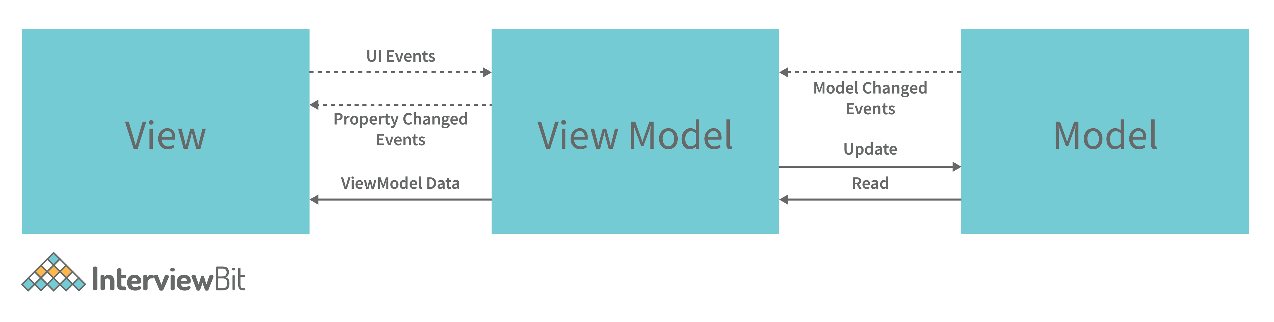

* **Model** contains the structure of an entity. In simple terms it contains data of an object.
* **View** is the visual layer of the application. It displays the data contained inside the Model. In angular terms, this will be the HTML template of a component.
* **ViewModel** is an abstract layer of the application. A viewmodel handles the logic of the application. It manages the data of a model and displays it in the view.

**View and ViewModel** are connected with data-binding (two-way data-binding in this case). Any change in the view, the viewmodel takes a note and changes the appropriate data inside the model.

## Angular Scenario Based Interview Questions

### 45. How do you choose an element from a component template?

To directly access items in the view, use the @ViewChild directive. Consider an input item with a reference.

<input #example>

and construct a view child directive that is accessed in the ngAfterViewInit lifecycle hook

@ViewChild('example') input;

ngAfterViewInit() {

console.log(this.input.nativeElement.value);

}

### 46. How does one share data between components in Angular?

Following are the commonly used methods by which one can pass data between components in angular:

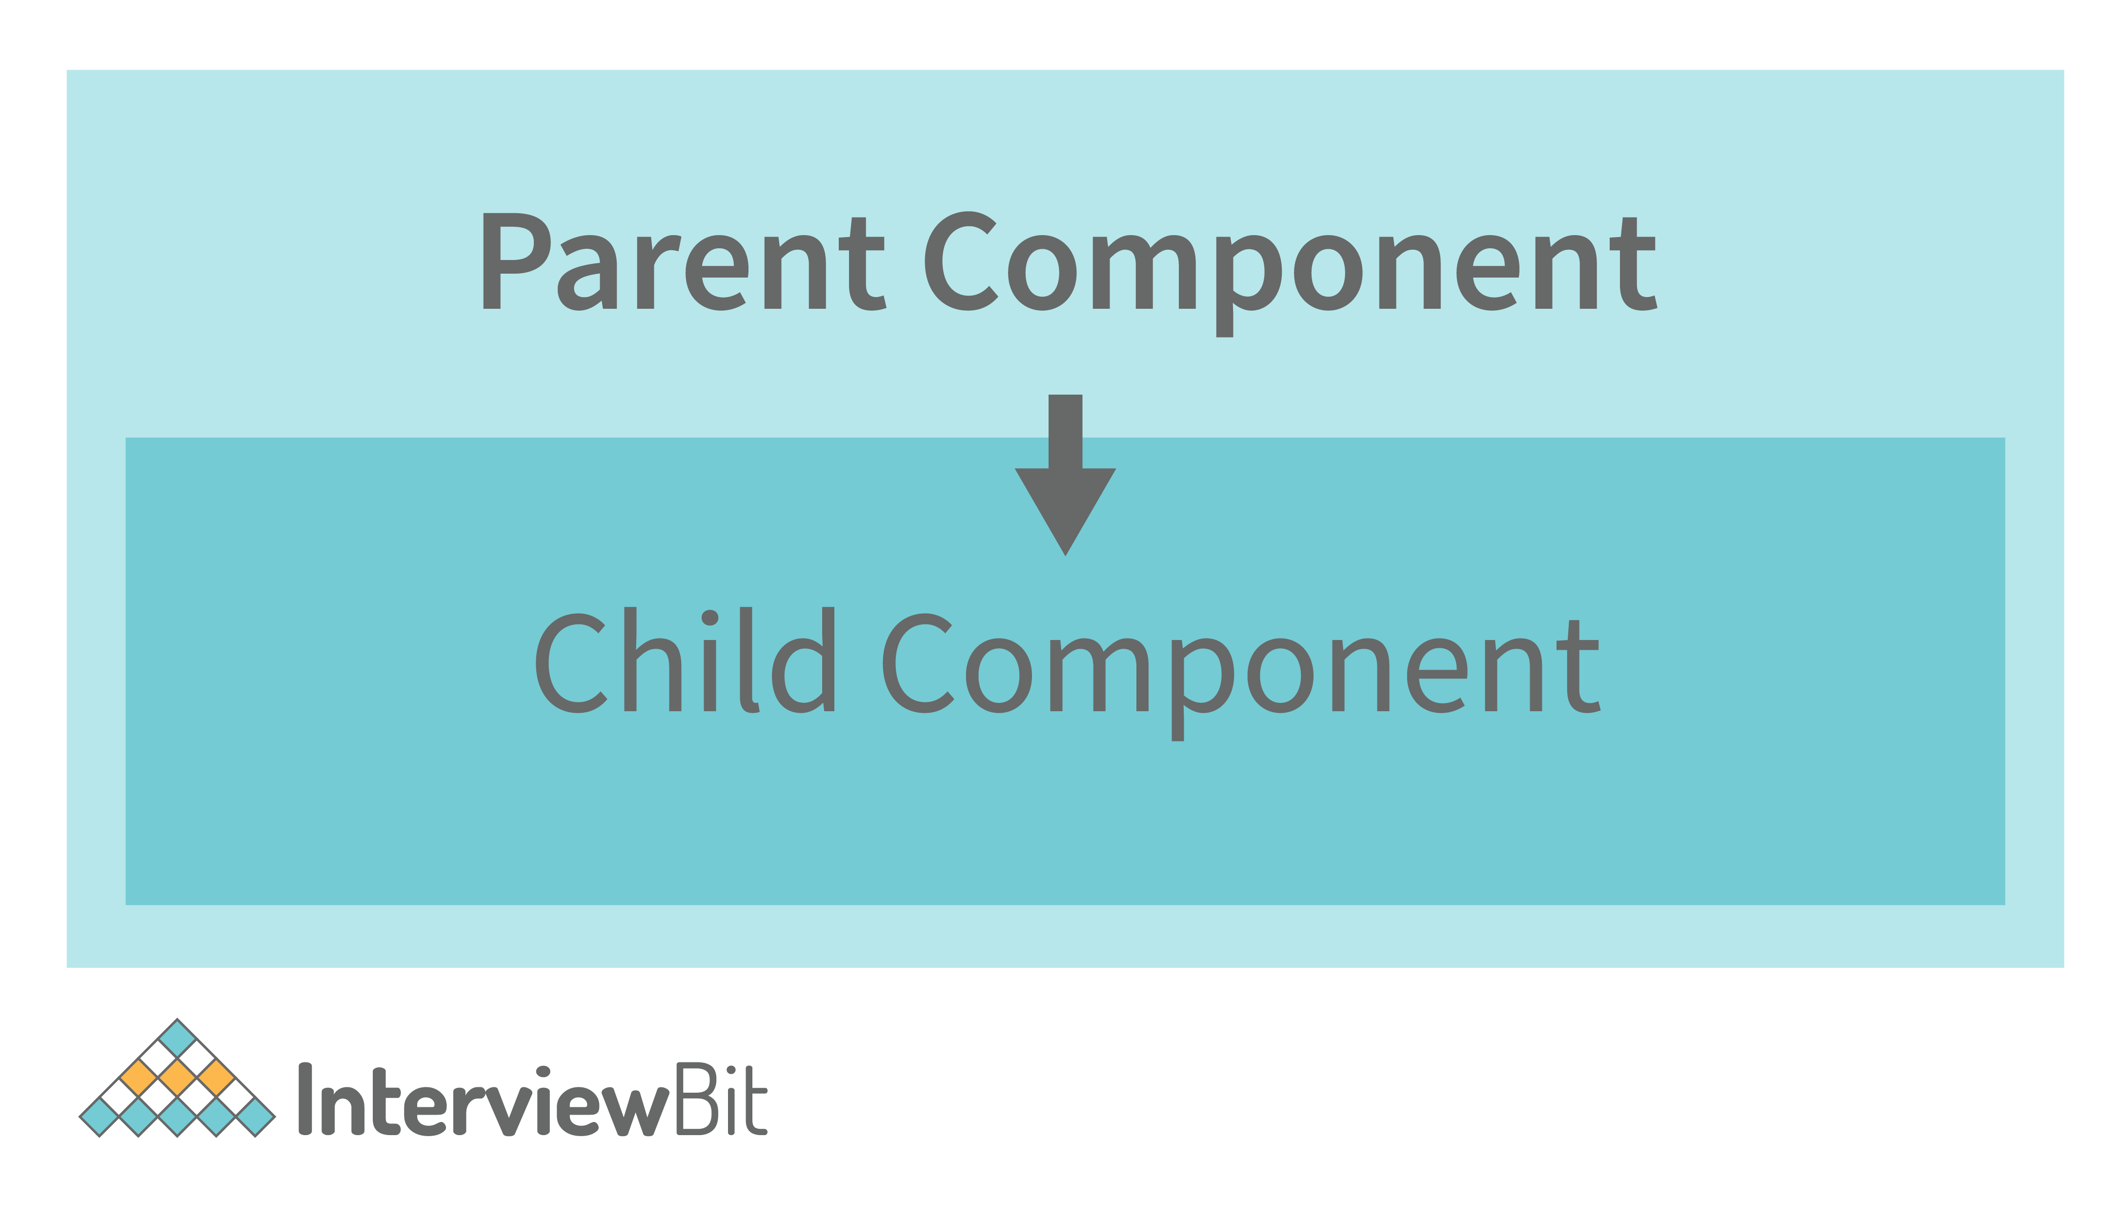

* **Parent to child using @Input decorator**

Consider the following parent component:

@Component({

selector: 'app-parent',

template: `

<app-child [data]=data></app-child>

` ,

styleUrls: ['./parent.component.css']

})

export class ParentComponent{

data:string = "Message from parent";

constructor() { }

}

In the above parent component, we are passing “data” property to the following child component:

import { Component, Input} from '@angular/core';

@Component({

selector: 'app-child',

template:`

<p>{{data}}</p>

`,

styleUrls: ['./child.component.css']

})

export class ChildComponent {

@Input() data:string

constructor() { }

}

In the child component, we are using @Input decorator to capture data coming from a parent component and using it inside the child component’s template.

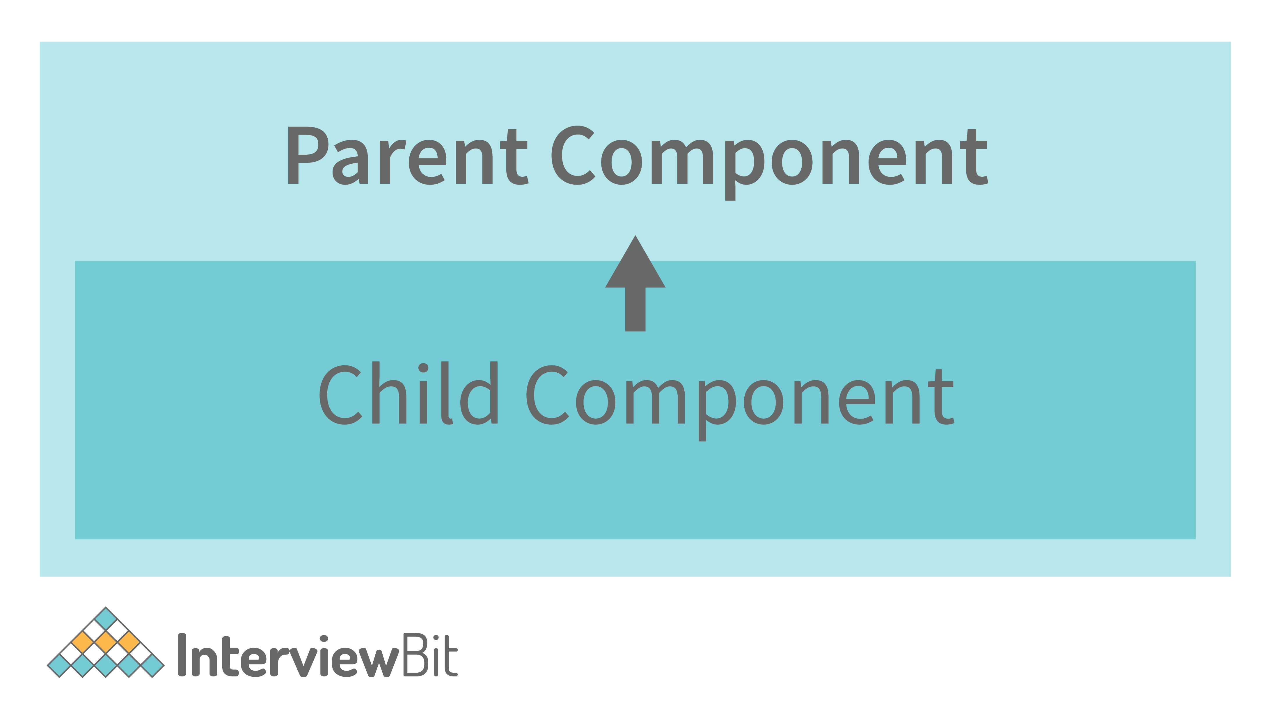

* **Child to parent using @ViewChild decorator**

**Child component:**

import {Component} from '@angular/core';

@Component({

selector: 'app-child',

template:`

<p>{{data}}</p>

`,

styleUrls: ['./child.component.css']

})

export class ChildComponent {

data:string = "Message from child to parent";

constructor() { }

}

**Parent Component**

import { Component,ViewChild, AfterViewInit} from '@angular/core';

import { ChildComponent } from './../child/child.component';

@Component({

selector: 'app-parent',

template: `

<p>{{dataFromChild}}</p>

` ,

styleUrls: ['./parent.component.css']

})

export class ParentComponent implements AfterViewInit {

dataFromChild: string;

@ViewChild(ChildComponent,{static:false}) child;

ngAfterViewInit(){

this.dataFromChild = this.child.data;

}

constructor() { }

}

In the above example, a property named “data” is passed from the child component to the parent component.

**@ViewChild** decorator is used to reference the child component as “child” property.

Using the **ngAfterViewInit** hook, we assign the child’s data property to the messageFromChild property and use it in the parent component’s template.

* **Child to parent using @Output and EventEmitter**

In this method, we bind a DOM element inside the child component, to an event ( **click** event for example ) and using this event we emit data that will captured by the parent component:

**Child Component:**

import {Component, Output, EventEmitter} from '@angular/core';

@Component({

selector: 'app-child',

template:`

<button (click)="emitData()">Click to emit data</button>

`,

styleUrls: ['./child.component.css']

})

export class ChildComponent {

data:string = "Message from child to parent";

@Output() dataEvent = new EventEmitter<string>();

constructor() { }

emitData(){

this.dataEvent.emit(this.data);

}

}

 As you can see in the child component, we have used **@Output** property to bind an **EventEmitter**. This event emitter emits data when the button in the template is clicked.

In the parent component’s template we can capture the emitted data like this:

<app-child (dataEvent)="receiveData($event)"></app-child>

 Then inside the receiveData function we can handle the emitted data:

receiveData($event){

this.dataFromChild = $event;

}

### 47. How do you deal with errors in observables?

Instead of depending on try/catch, which is useless in an asynchronous context, you may manage problems by setting an error callback on the observer.

**Example:**You may create an error callback as shown below.

myObservable.subscribe({

   next(number) { console.log('Next number: ' + number)},

   error(err) { console.log('An error received ' + err)}

 });

### 48. How can I include SASS into an Angular project?

You may use the ng new command while building your project using angular CLI. All of your components are generated using preset sass files.

ng new <Your\_Project\_Name> --style = sass

If you want to change the style of your project, use the ng set command.

ng set defaults.styleExt scss

### 49. What happens when you use the script tag within a template?

Angular detects the value as unsafe and sanitizes it automatically, removing the script tag but retaining safe material such as the script tag's text content. This reduces the potential of script injection attacks. If you continue to use it, it will be disregarded, and a warning will display in the browser console.

**Example:**Consider the case of innerHtml property binding, which results in an XSS vulnerability.

export class InnerHtmlBindingComponent {

   // For example, a attacker-controlled value from a URL using malicious scripts.

   htmlSnippet = 'Template <script>alert("You are hacked !!!!")</script> <b>Syntax</b>';

}

### Conclusion

For new applicants for the role of Angular developer, theoretical and fundamental ideas are required, but for an experienced individual, both applied and practical concepts are essential. Many of the Angular interview questions for experienced candidates will be about your prior project. This article contains a collection of frequently asked job interview questions that apply to all of Angular's modules. An applicant who hopes to land a position as an Angular developer should review these questions once again before arriving at their interview.

### Additional Interview Resources

* <https://www.interviewbit.com/angular-8-interview-questions/>
* <https://www.interviewbit.com/angularjs-interview-questions/>
* <https://www.interviewbit.com/full-stack-developer-interview-questions/>
* <https://www.interviewbit.com/typescript-interview-questions/>
* <https://www.interviewbit.com/react-interview-questions/>
* <https://www.interviewbit.com/ionic-interview-questions/>
* <https://www.interviewbit.com/blog/angular-js-projects/>
* <https://www.interviewbit.com/blog/best-front-end-frameworks/>
* <https://www.interviewbit.com/blog/web-development-frameworks/>
* <https://www.interviewbit.com/angular-mcq/>

## Angular MCQ questions

1.

Which of the following syntaxes is appropriate for AngularJS when applying multiple filters?

{{ expression - {filter1} - {filter2} - ... }

{{ expression | filter1 | filter2 | ... }}}

{{ expression | {filter1} | {filter2} | ... }}

{{ {filter1} | {filter2} | ...-expression}}

2.

In AngularJS, a module is created using which of the following syntax?

var myModule= new Module();

var myModule= angular.module();

module("app", []);

None of the above

3.

Which of the following is true about $routeProvider?

It is a component.

It is a service.

It is a module.

None of the above

4.

Which of the following is an acceptable AngularJS expression?

{(7+5)}

{7+5}

{{7+5}}

None of the above

5.

What is the purpose of the @Output decorator?

Share data from a child component to a parent

Use event binding

Share data from a parent component to a child

Use a service

6.

What is Form Builder?

Class for generating template-driven forms in run-time

Function for generating template-driven forms in run-time

Function for generating reactive forms in run-time

Class for generating reactive forms in run-time

7.

Which architectures does angular use?

Components Based Architecture

MVVM

MVC

All of the above

8.

Which type of binding uses the banana box [()]

Interpolation Binding

Property Binding

Two way Binding

Directive Binding

9.

AngularJS is perfect for

Create Web Services

Create Single Page Applications

Creating a Desktop Application

None of these

10.

Which prefix is used with the AngularJS directives?

aj-

ng-

ag-

All of the above

## Angular Interview Questions and Answers

Angular is one of the most popular JavaScript single-page application frameworks. It is also quite vast and difficult to navigate. Even more difficult is to get answers to the interview questions on Angular as it is very confusing to know which parts of the Angular framework you should familiarize yourself with. Hence, we have come up with a compilation of the most frequently asked Angular interview questions and answers.

[1. Angular Basic Interview Questions](https://intellipaat.com/blog/interview-question/angular-interview-questions/#11)

[2. Angular Intermediate Interview Questions](https://intellipaat.com/blog/interview-question/angular-interview-questions/#12)

[3. Angular Advanced Interview Questions](https://intellipaat.com/blog/interview-question/angular-interview-questions/#13)

### ****Most-Asked Angular Interview Questions and Answers****

[Q1. What is Angular?](https://intellipaat.com/blog/interview-question/angular-interview-questions/#1)  
[Q2. What are the technologies used in Angular?](https://intellipaat.com/blog/interview-question/angular-interview-questions/#2)  
[Q3. Why were client-side frameworks like Angular introduced?](https://intellipaat.com/blog/interview-question/angular-interview-questions/#3)  
[Q4. How does an Angular application work?](https://intellipaat.com/blog/interview-question/angular-interview-questions/#4)  
[Q5. What is TypeScript?](https://intellipaat.com/blog/interview-question/angular-interview-questions/#5)  
[Q6. Write a pictorial diagram of Angular architecture?](https://intellipaat.com/blog/interview-question/angular-interview-questions/#6)  
[Q7. What is metadata?](https://intellipaat.com/blog/interview-question/angular-interview-questions/#7)  
[Q8. What is the difference between constructor and ngOnInit?](https://intellipaat.com/blog/interview-question/angular-interview-questions/#8)  
[Q9. How is Dependency Hierarchy formed?](https://intellipaat.com/blog/interview-question/angular-interview-questions/#9)  
[Q10. What is the purpose of the async pipe?](https://intellipaat.com/blog/interview-question/angular-interview-questions/#10)

[](https://www.youtube.com/user/intellipaaat?sub_confirmation=1)

**Check out the Full Stack Web Development Course video to learn more about its concepts**

**×**

## Angular Basic Interview Questions

Let’s start with the basic Angular interview questions and answers for freshers.

### ****1. What is Angular?****

[**Angular**](https://intellipaat.com/blog/what-is-angular/) is an open-source web application development framework created by Google. It is used to build front-end and single-page applications that run on JavaScript. It is a full-fledged framework, i.e, it takes care of many aspects of front–end web applications such as HTTP requests, routing, layout, forms, reactivity, validation, etc.

### ****2. What are the technologies used in Angular?****

Angular is a modern front-end JavaScript framework developed by Google. Angular itself makes use of several technologies for several reasons to accomplish certain tasks easily as well as to allow developers to have a better experience while developing applications with it. Angular uses TypeScript, which is a superscript of JavaScript. So, any valid JavaScript is a valid TypeScript. However, TypeScript allows us to write JavaScript as a strongly typed language, and we can define our own types as well, which makes catching bugs much easier. It also uses RxJS, which allows developers to better deal with asynchronous operations.

### ****3. Why were client-side frameworks like Angular introduced?****

Before JavaScript-based client-side frameworks, the way dynamic websites worked was by taking a template that is nothing but HTML code with spaces left empty for feeding data and content into those templates. This data was usually fetched from a database. After combining the template and data, we would serve the generated HTML content back to the user. As you can see, it was a bit complicated, and in some cases, it took a lot of processing.

To overcome these issues, people came up with another approach in which they send the necessary data to render a page from their web servers to the web browsers and let JavaScript combine this data with a predefined template. Even mobile phones are now powerful enough to do this kind of processing, so the servers can now just send the data to a client over the internet in a recognizable format, i.e., JSON, XML, etc. This drastically reduces the processing done on the servers and improves performance.

**Want to learn Angular 6? Check out our**[**Angular 6 Tutorial**](https://intellipaat.com/blog/tutorial/angular-6-tutorial/)**!**

### ****4. How does an Angular application work?****

The working of Angular is based on its components. So the working of the Angular application starts with the configuration file **ANGULAR.JSON**. The builder refers to this file to find the paths, configurations and the main file. Now the process finally starts. Next comes the **MAIN.TS** file that acts as the entry point for the configuration file. It basically helps in creating the browser environment that enables it to run the application.

An Angular application operates according to the principles of a client-side web framework. Upon loading the application in a web browser, the following sequence of steps takes place:

* Initialization: The Angular framework initiates the application by bootstrapping the root component, which serves as the entry point.
* Component Rendering: Angular renders components based on their predefined templates. Each component contains a template that describes the structure and layout of the user interface (UI).
* Data Binding: Angular enables data binding, which facilitates the synchronization of data between the component’s model and the view. This synchronization allows for dynamic updates in real time, ensuring that the view consistently and accurately represents the current state of the data.
* Component Interaction: Components communicate with one another through input and output properties, as well as services, facilitating the exchange of data and functionality across different parts of the application.
* Event Handling: Angular manages user interactions, such as button clicks or form submissions, by capturing and responding to events. These events trigger specific actions or updates within the application.
* Dependency Injection: Angular utilizes dependency injection to handle the application’s dependencies and promote modularity. This simplifies the integration of services and reusable code modules that provide specific functionality to components.
* Routing: Angular incorporates a router module that enables navigation within the application. Routes are defined, determining which components are displayed based on the current URL or user actions.
* Compilation and Bundling: Before deployment, an Angular application is typically compiled and bundled. This process optimizes performance by reducing file sizes and merging multiple files into a single bundle.
* Deployment: Following bundling, the application can be deployed to a web server or hosting service, making it accessible to users.

**Get 100% Hike!**

Master Most in Demand Skills Now !

Top of Form





 By providing your contact details, you agree to our [Terms of Use](https://intellipaat.com/terms-of-use/) & [Privacy Policy](https://intellipaat.com/terms-of-use-and-privacy-policy/)

Bottom of Form

### ****5. What is TypeScript?****

The [TypeScript](https://intellipaat.com/blog/what-is-typescript/) feature offered by Angular is preferred by a majority of Front-End Developers. TypeScript helps in efficiently detecting bugs and helps in easy compilation by its automatic populating functionality. Also, it offers rich interfaces, access modifiers, hybrid types etc. All these combined lead to reduction in the developing time.

### ****6. Write a pictorial diagram of Angular architecture?****

**The architecture of Angular comprises the following elements. The pictorial representation of the same is given below:**

* Components and Templates
* Ng Modules
* Metadata
* Data Binding
* Directives
* Services
* Dependency Injection

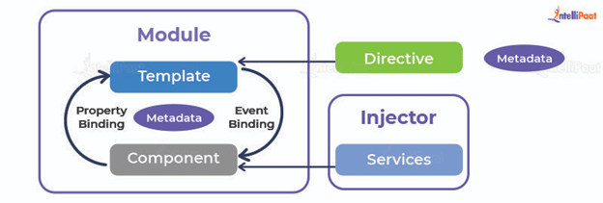

### ****7. What is metadata?****

Using metadata is how we tell Angular how to process a class. When we use a component, it acts as a class unless we tell that it’s a component, and we do this with the help of metadata. Metadata is attached in TypeScript using a decorator. Decorators are functions that know the configuration of classes and how they are supposed to work.

### ****8. What is the difference between constructor and ngOnInit?****

The difference between constructor and ngOnInit is given below:

|  |  |  |
| --- | --- | --- |
| **Basis** | **Constructor** | **ngOnInit** |
| Objective. | The objective of a Constructor is to start class members | |  | | --- | | **ngOnInit** is used in case of startup/announcement and avoids things to work in builders. | |
| Usage | A Constructor should be used to set up Dependency Injection, Initialization of class fields, etc. | |  | | --- | | **ngOnInit** is used to write the work code that  executes as soon as the class is instantiated. | |

**Career Transition**

### ****9. How is Dependency Hierarchy formed?****

In Angular, the formation of a Dependency Hierarchy is established through the Angular Dependency Injection (DI) system. The DI system manages the dependencies between different components within an Angular application.

The process of forming a Dependency Hierarchy in Angular involves the following steps:

* **Dependency Definition:** Components, services, or other Angular constructs declare their dependencies in their respective constructor parameters. These dependencies are specified using TypeScript types or Angular-specific decorators.
* **Provider Registration:** In Angular, providers assume the responsibility of generating and overseeing instances of dependencies. These providers are enlisted within the dependency injection container of the Angular application, which serves as a repository for available providers.
* **Dependency Resolution:** When a component or service is requested, Angular’s DI system resolves its dependencies by examining the constructor parameters. It then looks up the corresponding providers from the dependency injection container.

**Hierarchical Dependency Injection:** Angular’s DI system follows a hierarchical approach for resolving dependencies. Each component or service has its own injector, which contains providers specific to that component or service. If a requested dependency is not found in the current injector, Angular recursively searches the parent injectors until it finds a matching provider or reaches the top-level injector.

**Check out these**[**Web Development Courses**](https://intellipaat.com/course-cat/website-development-courses/)**to get an in-depth understanding of Web Development!**

### ****10. What is the purpose of the async pipe?****

The async pipe’s purpose is to mark the components that need to be checked for changes. It subscribes to an Observable or Promise and returns the latest value it has emitted. Once this new value is emitted, the components are marked by the async pipe. When any component is destroyed, the async pipe detaches or unsubscribes automatically. Similarly, if the expression reference of the component changes, the async pipe detaches or unsubscribes from the old Observable or Promise and subscribes to a new one.

### ****11. What is the option to choose between inline and external templates?****

Usually, inline templates are used for small codes and external templates are used for comparatively bigger views. However, the choice of inline or external templates is sometimes based on organizational policy, situations etc.

### ****12. What is the purpose of the ‘ngFor’ directive?****

The purpose of the ‘ngFor’ directive in Angular is to iterate over a collection or an array and generate repetitive HTML elements or components based on each item in the collection. It allows for dynamic rendering of content by repeating a template block for each item in the specified collection. The ‘ngFor’ directive is commonly used to display lists, tables, or any other structured data where repetitive rendering is required. It provides a convenient way to handle and manipulate collections of data in Angular templates.

### ****13. What is the purpose of the ngIf directive?****

The purpose of the ngIf directive is to remove or recreate a part of the DOM tree in alignment to an expression. If the **ngIf** directive finds the expression being evaluated to be false, the element is removed from the tree, else a matching element is inserted into the DOM tree.

### ****14. What happens if you use the script tag inside the template?****

If we use script tag inside template, Angular marks the value as unsafe and automatically initiates the process of sanitizing it. This eradicates the script tag, but the content is kept safe, i.e. the text element. This entire process results in eliminating the risk of injection attacks.

### ****15. What are template expressions?****

A template expression in Angular is an expression that is represented in double curly braces **‘{{ }}’** and produces a value. The template expression is executed by Angular and is assigned to a property of a binding target. Now, the binding target can be any of these- an HTML element, a directive or even a component.

**Courses you may like**

[](https://intellipaat.com/advanced-certification-data-science-artificial-intelligence-iit-madras/)

[](https://intellipaat.com/post-graduate-certification-full-stack-web-development/)

[](https://intellipaat.com/pg-certification-business-analysis-project-management-mnit/)

### ****16. What are template statements?****

The methods or properties in Angular that are used in HTML in response to user events are called template statements. These template statements allow your application to engage users through actions like dynamic content display or form submissions etc.

### ****17. What is the difference between Angular and AngularJS?****

Following are some of the major and significant differences between [**Angular and AngularJS**](https://intellipaat.com/blog/angularjs-vs-angular-2-vs-angular-4-difference/):

|  |  |  |
| --- | --- | --- |
| **Features** | **Angular** | **AngularJS** |
| Architecture | It makes use of directives and components | It supports the Model-View-Controller or MVC model |
| Language | It uses TypeScript language, a superset of JavaScript that is typed statistically | It uses JavaScript, a dynamically typed language |
| Expression Syntax | |  | | --- | | Angular uses **()** to bind an event while **[]** to bind a property | | |  | | --- | | It requires professionals to use the correct **ng** directive to bind a property or an event | |
| Mobile Support | Angular offers mobile support | Unlike Angular, AngularJS does not offer mobile support |
| Routing | |  | | --- | | It uses **@RouteConfig{(…)}** | | |  | | --- | | It uses **$routeprovider.when()** | |
| Dependency Injection | It supports hierarchical dependency injection, along with a unidirectional tree-based change direction | It does not support dependency injection |
| Structure | Its simplified structure makes it easy for professionals to develop and maintain large applications easily | It is comparatively less manageable |

### ****18. What are some advantages of using Angular?****

**Using Angular has several advantages, which are listed below:**

* Angular is built using TypeScript, which allows developers to write strongly typed code that will get transpiled into JavaScript. The benefits of a strongly typed code are that it is easy to read, maintainable, and less prone to errors. Also, it provides better tooling with type hints and code completion.
* Angular allows us to separate our code into modules, which can be used to wrap functionalities related to a specific task such as HTTP communication, data validation, routing, etc.
* Angular has a large ecosystem of tools, libraries, frameworks, plugins, etc. that make the whole development experience much faster and enjoyable. These tools and libraries include Angular CLI, RxJS, NgRx, etc.

### ****19. How do you categorize data binding types?****

**To categorize data binding in Angular, it is divided into various types. Data Binding in Angular is categorized into following types:**

* One Way Data Binding
* Two-Way Data Binding

In One way data binding, the changes in the state affect the view from component to view template. On the contrary it is also possible that the change in the view affects the state by changing it from view template to component.

Now, coming to Two-way Data Binding, the changes in the view can lead to change in the model. Similarly, any changes in the model can change the view from component to view template.

**The various types of Two-Way Data Binding are:**

* **Interpolation**
* Property binding
* Class binding
* Style binding
* Attribute binding
* Event binding
* Two-way binding

### ****20. What is a parameterized pipe?****

In Angular, pipes are used to transform raw data into the required format before the final display to the end-users. These pipes are broadly categorized into 2 categories:

1- Built-in Pipes,

2- Custom Pipes

Built-in Pipes are further divided into 2 types – Parameterized Pipes and Chaining Pipes.

Parameterized Pipes refer to the pipes that carry parameters. We can use these pipes to pass n number of parameters by giving a colon (:) in the command.

### ****21. What are custom elements?****

A custom element is used to extend HTML, wherein you can define a tag whose content is created and controlled by JavaScript code.

### ****22. Do I need to bootstrap custom elements?****

No, you do not need to bootstrap custom elements as they are bootstrapped automatically when added to the DOM. Also, the custom elements in Angular get automatically destroyed when removed from the DOM.

### ****23. How do you define typings for custom elements?****

Defining typings for custom elements in Angular can be done by using NgElement and WithProperties exported from @angular/elements. The following component is a simple container with input property:

@Component(…)

class MyDialog {

@Input() content: string;

}

### ****24. Explain how custom elements work internally?****

**Let us understand, in steps, the internal working of custom elements:**

* **Registration of the custom elements:**Angular registers custom elements using the createCustomElement() function. This function converts a component into a class that can be registered with the browser as a custom element.
* **Addition of the custom element to DOM**: The custom element is added to DOM in a similar manner as it is in  HTML.
* **Browser instantiates component based class:** Once the custom element is added to the DOM, an instance of the registered class is created by the browser and added to the DOM.
* **Data binding and Change detection:** In the final step, the created instance enables data binding and change detection. The template content is rendered using the component and DOM data.

### ****25. How to transfer components to custom elements?****

There are two important steps to be followed in order to transfer components to custom elements:

* **Creating a custom element class:** As a first step, build a custom element class using the createCustomElement() function provided by Angular. The function converts an [**Angular component**](https://intellipaat.com/blog/angular-component/) (including its dependencies) to a custom element. The NgElementConstructor interface is implemented through this conversion which, in turn, creates a constructor class that is used for producing a self-bootstrapping instance.
* **Registering element class with browser:** The customElements.define() function is used to register the configured constructor, and its associated custom-element tag with the browser’s CustomElementRegistry.

### ****26. What are the mapping rules between Angular components and custom elements?****

**The important mapping rules between Angular components and custom elements are given below:**

* The component input properties are parsed with the corresponding attributes for the custom element using the createCustomElement() API.
* TThe Component outputs are dispatched as HTML Custom Events and have the name of the custom event that also matches the output name.

### ****27. How are observables different from promises?****

Although both promises and observables are used to handle asynchronous requests in JavaScript, they work in very different ways. Promises can only handle a single event at a time, while observables can handle a sequence of asynchronous events over a period of time. Observables also provide us with a wide variety of operators that allow us to transform data flowing through these observables with ease.

A promise is just a way to wrap asynchronous operations so that they can be easily used, while an observable is a way to turn asynchronous operations into a stream of data that flows from a publisher to a subscriber through a well-defined path with multiple operations transforming the data along the way.

### ****28. What is a custom pipe?****

A custom pipe is a feature of angular, that enables you to create and use your own reusable data transformation functions in templates. Pipes are used to transform data before displaying it in the user interface.

A custom pipe is specifically created by the developer to perform a specific data transformation or manipulation task. It encapsulates a function that takes an input value, applies a transformation, and returns the transformed output value. Custom pipes are defined as classes in Angular and decorated with the **@Pipe decorator.**

To use a custom pipe, you can include it in your Angular application’s module and then utilize it in templates by piping the data through the pipe in the template expression. The output of the pipe can be directly used for display or further processing in the template.

Custom pipes offer a way to encapsulate and reuse common data transformations across different components and templates. They promote code modularity, reusability, and readability by separating the data transformation logic from the component code.

 Commonly, custom pipes are defined as follows:

import { Pipe, PipeTransform } from '@angular/core';

@Pipe({name: 'Pipename'})

export class Pipeclass implements PipeTransform {

transform(parameters): returntype { }

}

here,

**‘Pipename’** is the name of the pipe.

**‘Pipeclass’** is the name of the class assigned to the custom pipe.

**‘Transform’**is the function to work with the pipe.

**‘Parameters’**are the parameters which are passed to the pipe.

**‘Returntype’**refers to the type of value that the pipe returns.

### ****29. Give an example of a custom pipe?****

Let us now have a look at the example below where we have declared a custom pipe to convert a number to its square in the Angular application. Please note that we are using the **ng generate** pipe command to create this custom pipe.

ng generate pipe square

// Output

CREATE src/app/square.pipe.spec.ts (187 bytes)

CREATE src/app/square.pipe.ts (217 bytes)

UPDATE src/app/app.module.ts (2931 bytes)

### ****30. What is the difference between pure and impure pipe?****

|  |  |  |
| --- | --- | --- |
| **Basis** | **Pure Pipe** | **Impure Pipe** |
| **Meaning** | A pure pipe is called when a change in the value or the parameters passed to a pipe is detected by Angular. | In every change detection cycle, regardless of whether there is any change in the value or parameter passed, an impure pipe is invoked. |
| **Syntax** | @Pipe({  name: ‘filterPipe’,  pure: true  })  export class FilterPipe {} | @Pipe({  name: ‘filterPipe’,  pure: false  })  export class FilterPipe |
| **Shareability** | Pure pipes can be shared across various usages and that too without having any effect on the output result | Impure Pipes cannot be shared because they might affect the internal state from outside |
| **Determination of Output change.** | Input values or parameters can determine the output value or the change in it. | Input values cannot determine the output value or the change in it. |

### ****31. What is a bootstrapping module?****

In Angular, the root module used for bootstrapping or launching the application is known as the ‘Bootstrapping Module’. A Bootstrapping Module is present in every Angular app and it is stored in the AppModule class. Infact, the Bootstrapping module is also called the AppModule.

### ****32. Explain how to use HttpClient with an example?****

The following are the generally followed steps to use the **HttpClient :**

* Firstly, start by creating an HttpClient instance.
* Next, create an instance of one of the methods.
* Command HttpClient to execute the method.
* After the execution, read the response.
* Finally, release the connection.
* And deal with the response.

### ****33. How can you read the full response?****

In order to read the full response in Angular, the following code should be used:

getUserResponse(): Observable<HttpResponse> {

return this.http.get(

this.userUrl, { observe: 'response' });

}

### ****34. How do you perform Error handling?****

In Angular, error handling can be done by writing a function using HttpClient along with catchError from RxJS.To handle errors, Angular’s HttpClient parses JSON responses and returns a JavaScript object in the **OBSERVABLES**.

### ****35. What is content projection?****

In Angular, Content projection refers to a pattern where you can insert, or project, the content you want to use inside a different component. For example, consider a Card component which can accept the content provided by another component.

### ****36. What is the difference between PROMISE & OBSERVABLES?****

|  |  |  |
| --- | --- | --- |
| **Basis** | **OBSERVABLES** | **PROMISE** |
| **Values** | Observables have the capacity to emit multiple values over a given period of time. | A promise emits only a single value over a given period of time. |
| **Execution** | They can be executed only when subscribed using subscribe() method. | Promises can be executed as soon as they get created. |
| **Cancellation** | Observables are cancellable as they consist of subscriptions that can be cancelled using the unsubscribe() method. | Promises once executed are non cancellable. |
| **Operations** | Can provide operations like map for forEach, filter, reduce, retry, and retryWhen operators. | Promises do not offer any operations. |
| **Errors** | An observable pushes the errors to the subscribers | A promise pushes the errors to the child promises. |

### ****37. What do you mean by data binding?****

In Angular, data binding refers to the mechanism of establishing a connection between the component’s data (model) and the user interface (view) elements. It allows for the automatic synchronization and communication of data between the component and the template.

Data binding in Angular provides a way to keep the data in the component and the UI in sync, ensuring that any changes made to the data are reflected in the view, and vice versa. This two-way communication allows for a seamless interaction between the user and the application.

### ****38. What are some disadvantages of using Angular?****

Although Angular provides quite a lot of benefits, there are some disadvantages of using it as well. They are as follows:

* Getting good SEO results on an Angular application can be a bit difficult and may need a bit of configuration.
* Angular has a lot of features packed into it, so getting to know each of them and learning how to use them effectively together can be a little difficult.
* Angular can add quite a lot of weight to your JavaScript bundle, so using it for smaller projects can be very inefficient and may significantly increase the load size.

**Interested in learning React JS? Click here to learn more about this**[**React JS Certification**](https://intellipaat.com/react-js-certification-training-course/)**!**

### ****39. What do you mean by string interpolation?****

String interpolation in Angular, also known as the mustache syntax, only allows one-way data binding. It is a special syntax that makes use of double curly braces {{}} so that it can display the component data. Inside the braces are the JavaScript expressions that Angular needs to execute to retrieve the result, which can further be inserted into the HTML code. Moreover, as part of the digest cycle, these expressions are regularly updated and stored.

### ****40. What are the differences between Angular decorator and annotation?****

In Angular, decorators are design patterns that help in the modification or decoration of the respective classes without making changes in the actual source code.

Annotations, on the other hand, are used in Angular to build an annotation array. They use the Reflective Metadata library and are a metadata set of the given class.

### ****41. What is an AOT compilation in Angular?****

The AOT (ahead-of-time) compiler in Angular converts Angular HTML and TypeScript code into JavaScript code during the build phase. This makes the rendering process much faster. This compilation process is needed since Angular uses TypeScript and HTML code. The compiler converts the code into JavaScript, which can then be effectively used by the browser that runs our application.

### ****42. What are the advantages of AOT?****

AOT compilation has several advantages as mentioned below:

**Fast rendering:** Since, after compilation, the browser would download a pre-compiled version of our application, it can render the application immediately without compiling the app.

**Less asynchronous requests**: It takes external HTML templates and CSS style sheets and inlines them within the application JavaScript, which reduces the number of separate Ajax requests.

**Smaller download size**: The compiler will minify the code for us so that the download size is less.

**Template error detection**: During the compilation phase, any issues in the templates will be detected and reported by the compiler so that they can be corrected before production.

### ****43. What are the three phases of AOT?****

**The three phases of AOT are:**

* code analysis
* code generation
* template type checking

### ****44. What are the components in Angular?****

Components are the basic building block of the user interface in Angular. A component consists of HTML, CSS, and JavaScript for a specific portion of a user interface. We can think of these as a custom HTML element that only Angular can understand. These components are isolated, i.e., styles and code from one component do not affect other components as they get namespaced by the compiler. These components are then pieced together by the Angular framework to build the user interface for the browser to render.

### ****45. What are dynamic components?****

Dynamic Components in the Angular framework are the components that help in building large-scale applications easily. Dynamic components are usually instantiated and placed in the application at runtime.

### ****46. What is the purpose of base href tag?****

The href attribute is used to specify the base URL for all relative URLs on a page.During navigation, the base href tag is used by the Angular router as a base path to the component, template, and module files.

### ****47. What are modules in Angular?****

A module is the logical boundary of an application. It is used to encapsulate code dealing with a specific aspect of the application, such as routing, HTTP, validation, etc. The main reason why modules are used is to enhance application composability. For example, if we wish to implement validation logic using different libraries, then for the one we have already implemented, we can create a new validation module and replace the current one with the new one, and our application would work just the same. In Angular, we create a module using the **NgModule** decorator.

### ****48. What is DOM?****

The full form of DOM is Document Object Model, and it is responsible for representing the content of a web page and changes in the architecture of an application. Here, all the objects are organized in the form of a tree, and the document can easily be modified, manipulated, and accessed only with the help of APIs.

### ****49. What are services in Angular?****

A service in Angular is a term that covers broad categories of functionalities. A service is any value, function, or feature that an app needs. A service is typically used to accomplish a very narrow purpose such as HTTP communication, sending data to a cloud service, decoding some text, validating data, etc. A service does one thing and does it well. It is different from a component as it is not concerned with HTML or any other kind of presentation logic. Normally, a component uses multiple services to accomplish multiple tasks.

### ****50. What is the difference between jQuery and Angular?****

The main difference between jQuery and Angular is that jQuery is a JS library, whereas Angular is a JS frontend framework. Some of the other differences between the two are mentioned below:

* Unlike jQuery, Angular offers two-way data binding
* Unlike Angular, jQuery does not offer support for the RESTful [API](https://intellipaat.com/blog/tutorial/angularjs-tutorial/angularjs-api/)
* Angular supports deep linking routing, while jQuery does not
* Form validation is available in Angular but not in jQuery

Although they have their differences, Angular and jQuery also have their set of similarities, like both jQuery and Angular expressions consist of variables, operators, and literals.

### ****51. What are lifecycle hooks in Angular?****

When building an Angular app, there are times when we need to execute some code at some specific event—such as when a component is initialized or displayed on the screen or when the component is being removed from the screen. This is what lifecycle hooks are used for. For example, if we have some event listener attached to an HTML element in a component, such as a button click or form submission, we can remove that event listener before removing the component from the screen, just like we can fetch some data and display it on the screen in a component after the component is loaded on the screen. To use a lifecycle hook, we can override some methods on a component, such as**ngOnInit**or **ngAfterViewInit**. These methods, if available on a component, will be called by Angular automatically. This is why these are called lifecycle hooks.

### ****52. What are templates?****

Angular templates are written using HTML that includes attributes and elements that are specific to Angular. The templates are further combined with the data from the controller and the model, which can be rendered to offer the user a dynamic view.

### ****53. What is two-way data binding?****

Two-way data binding is done in Angular to ensure that the data model is automatically synchronized in the view. For example, when a user updates some data in a model and that model is being displayed in multiple places in a component, that update should be reflected in all the places.

Two-way data binding has been supported in Angular for a long time. Although, it is something that should be used with careful consideration as it could lead to poor application performance or performance degradation as time goes on. It is called two-way data binding because we can change some data that is in the component model from the view that is HTML, and that change can also propagate to all other places in the view where it is displayed.

**Looking to get started with AngularJS? Head on to our blog on**[**AngularJS tutorial**](https://intellipaat.com/blog/tutorial/angularjs-tutorial/)**!**

### ****54. What are pipes in Angular?****

When we are trying to output some dynamic data in our templates, we may sometimes need to manipulate or transform the data before it is put into our templates. Though there are several ways of doing that, in Angular, using pipes is the most preferred way. A pipe is just a simple function, which we can use with expressions in our templates.

Pipes are extremely useful as we can use them throughout our application after declaring them just once and registering them with the Angular framework. Some of the most common built-in pipes in Angular are UpperCasePipe, LowerCasePipe, CurrencyPipe, etc.

### ****55. What are observables in Angular?****

An observable is a declarative way using which we can perform asynchronous tasks. Observables can be thought of as streams of data flowing from a publisher to a subscriber. They are similar to promises as they both deal with handling asynchronous requests. However, observables are considered to be a better alternative to promises as the former comes with a lot of operators that allow developers to better deal with asynchronous requests, especially if there is more than one request at a time.

Observables are preferred by many developers as they allow them to perform multiple operations such as combining two observables, mapping an observable into another observable, and even piping multiple operations through an observable to manipulate its data.

### ****56. How do you chain pipes?****

The syntax used for chaining pipes in Angular is given in the following example:

Today is {{ today | date:’fullDate’ | uppercase}}.

### ****57. What does Angular Material mean?****

Angular Material is a UI component library that allows professionals to develop consistent, attractive, and completely functional websites, web pages, and web applications. It becomes capable of doing so by following modern principles of web designing, such as graceful degradation and browser probability.

### ****58. What is RxJS?****

RxJS is a library, and the term stands for Reactive Extensions for JavaScript. It is used so that we can use observables in our JavaScript project, which enables us to perform reactive programming. RxJS is used in many popular frameworks such as Angular because it allows us to compose our asynchronous operations or callback-based code into a series of operations performed on a stream of data that emits values from a publisher to a subscriber. Other languages such as Java, Python, etc. also have libraries that allow them to write reactive code using observables.

## Angular Intermediate Interview Questions

### ****59. What is bootstrapping?****

Angular bootstrapping, in simple words, allows professionals to initialize or start the Angular application. Angular supports both manual and automatic bootstrapping. Let’s briefly understand the two.

* **Manual bootstrapping**: It gives more control to professionals with regards to how and when they need to initialize the Angular app. It is extremely useful in places where professionals wish to perform other tasks and operations before the Angular compiles the page.
* **Automatic bootstrapping**: Automatic bootstrapping can be used to add the ng-app directive to the application’s root, often on the tag if professionals need Angular to automatically bootstrap the application. Angular loads the associated module once it finds the ng-app directive and, further, compiles the DOM.

**Want to learn more about Angular Bootstrap? Check out our**[**Angular Bootstrap Tutorial**](https://intellipaat.com/blog/tutorial/angular-6-tutorial/angular-bootstrap/)**!**

### ****60. What do you mean by dependency injection?****

Dependency injection (DI) in Angular is a software design pattern in which the objects can be passed in the form of dependencies instead of hard-coding them in the respective components. This concept is extremely handy when it comes to separating the object logic creation from its consumption.

The function ‘config’ uses DI that needs to be configured so that the module can be loaded to retrieve the application elements. Besides, this feature allows professionals to change dependencies based on necessities.

### ****61. What are Angular building blocks?****

**The following building blocks play a crucial role in Angular:**

* **Components**: A component can control numerous views wherein each of the views is a particular part on the screen. All Angular applications have a minimum of one component called the root component. This component is bootstrapped in the root module, the main module. All the components include the logic of the application that is defined in a class, while the main role of the class is to interact with the view using an API of functions and properties.
* **Data binding**: Data binding is the process in which the various sections of a template interact with the component. The binding markup needs to be added to the HTML template so that Angular can understand how it can connect with the component and template.
* **Dependency injection**: It uses DI so that it can offer the necessary dependencies: mainly services, to the new components. The constructor parameters of a component inform Angular regarding the numerous services needed by the component, and DI provides a solution that gives the necessary dependencies to the new class instances.
* [**Directives**](https://intellipaat.com/blog/tutorial/angularjs-tutorial/angularjs-directives/): Angular templates are of a dynamic nature, and directives help Angular understand how it can transform the DOM while manifesting the template.
* **Metadata**: Classes have metadata attached to them with the help of decorators so that Angular will have an idea of processing the class.
* [**Modules**](https://intellipaat.com/blog/tutorial/angularjs-tutorial/angularjs-modules/)**:** Module or NgModule is a block of code organized using the necessary capabilities set, having one specific workflow. All Angular applications have at least one module, the root module, and most of the applications have numerous modules.
* **Routing**: The Angular router helps interpret the URL of a browser to get a client-generated experience and view. This router is bound to page links so that Angular can go to the application view as soon as the user clicks on it.
* **Services**: Service is a vast category that ranges from functions and values to features that play a significant role in Angular applications.
* **Template**: The view of each component is linked with a template, and an Angular template is a type of HTML tag that allows Angular to get an idea of how it needs to render the component.

### ****62. Explain the MVVM architecture.****

The MVVM architecture plays a significant role in eliminating tight coupling between the components. This architecture includes the following three parts:

* **Model:** The model represents the business logic and data of a particular application. In other words, it consists of an entity structure. The model has the business logic, including model classes, remote and local data sources, and the repository.
* **View**: Within Angular, the view embodies the graphical user interface (UI) of an application. Its primary role involves presenting the data sourced from the component and managing user interactions. Constructed through HTML templates, the view dynamically renders and adjusts its content in accordance with the component’s data and the application’s logic.
* **ViewModel**: ViewModel is the application’s abstract layer that connects the View and the Model and acts as a bridge between the two. It does not know which View needs to be made use of since it does not have any direct access to the View. The two are connected using data binding, and the ViewModel records all the changes that are made to the View and makes the necessary changes to the Model.

### ****63. Describe Angular authentication and authorization.****

The login details of a user are given to an authentication API available on the server. Once the credentials are validated by the server, it returns a JSON web token (JWT), which includes attributes and the data of the current user. Further, the user is easily identified using JWT, and this process is known as authentication.

After logging in, users have various types and levels of access—some can access everything, while others may have restrictions from some resources. Authorization determines the access level of these users.

### ****64. What is the digest cycle process in Angular?****

Digest cycle in Angular is the process in which the watch list is monitored to track changes in the watch variable value. In each digest cycle, there is a comparison between the present and the previous versions of the scope model values.

### ****65. What are the distinct types of Angular filters?****

Filters are a part of Angular that helps in formatting the expression value to show it to the user. They can be added to services, directives, templates, or controllers. You also have the option to create personalized filters as per requirements. These filters allow you to organize the data easily such that only the data that meets the respective criteria are displayed. Filters are placed after the pipe symbol ( | ) while used in expressions.

**Various types of filters in Angular are mentioned below:**

**currency**: It converts numbers to the currency format

**filter**: It selects a subset containing items from the given array

**date**: It converts a date into a necessary format

**lowercase**: It converts the given string into lowercase

**uppercase**: It converts the given string into uppercase

**orderBy**: It arranges an array by the given expression

**json**: It formats any object into a JSON string

**number**: It converts a number value into a string

**limitTo**: It restricts the limit of a given string or array to a particular number of elements or strings

### ****66. How can one create a service in Angular?****

A service in Angular is an object that can be substituted. It is wired and combined with the help of dependency injection. Services are developed by getting registered in a module that they need to be executed in. The three methods of creating a service in Angular are as follows:

* Service
* Factory
* Provider

## Angular Advanced Interview Questions

### ****67. What does subscribing mean in RxJS?****

In RxJS, when using observables, we need to subscribe to an observable to use the data that flows through that observable. This data is generated from a publisher and is consumed by a subscriber. When we subscribe to an observable, we pass in a function for the data and another function for errors so that, in case there is some error, we can show some message or process the message in some way.

### ****68. What is an Angular Router?****

Routing in a single-page front-end application is the task of responding to the changes in the URL made by adding and removing content from the application. This is a complicated task as we first need to intercept a request that changes the browser’s URL as we do not wish for the browser to reload. Then, we need to determine what content to remove and what content to add, and finally, we change the browser’s URL as well to show the user the current page they are on.

As we can see, this can be very difficult to implement, especially in multiple applications. That is why Angular comes with a full routing solution for a single-page application. In this, we can define routes with matching components and let Angular handle the routing process.

### ****69. What is REST?****

REST in Angular stands for Representational State Transfer. It is an API that works on the request of HTTP. Here, the requested URL points to the data that has to be processed, after which an HTTP function is used to identify the respective operation that has to be performed on the data given. The APIs that follow this method are referred to as RESTful APIs.

### ****70. What is the scope in Angular?****

A scope is an object in Angular referring to the application model. It is a context for executing expressions. These scopes are organized in a hierarchical form that is similar to the application’s DOM structure. A scope helps in propagating various events and watching expressions.

### ****71. Explain Angular CLI.****

Angular CLI is otherwise known as Angular command-line interface. Angular supports CLI tools that give professionals the ability to use them to add components, deploy them instantly, and perform testing and many such functions.

### ****72. How do you create directives using CLI?****

**To create a directive using Angular CLI, the following steps are used:**

* Start a new project using Angular CLI through the following command:

‘ng new [application-name]’

* Now change the directory into a new directory through the command:

‘cd [application-name]’

* Once done with changing the directory, use the following command to generate a new directive:

‘ng generate directive [path-to-directives/my-directive]’

### ****73. What is schematic?****

Schematics are template-based code generators that enable complex logic. It is usually packaged into collections and installed with npm. The aim of schematics is to transform a software project by generating or modifying codes.

### ****74. What is a rule in Schematics?****

A rule in Schematic refers to a set function that takes a tree, transforms it and finally returns a new tree.

### ****78. What is Schematics CLI?****

Schematics CLI is used to transform web-based applications projects.

### ****79. What is HttpClient, and what are its benefits?****

**HttpClient** is an Angular module used for communicating with a back-end service via the HTTP protocol. Usually, in front-end applications, for sending requests, we use the fetch API. However, the fetch API uses promises. Promises are useful, but they do not offer the rich functionalities that observables offer. This is why we use **HttpClient** in Angular as it returns the data as an observable, which we can subscribe to, unsubscribe to, and perform several operations on using operators. Observables can be converted to promises, and an observable can be created from a promise as well.

### ****80. What is multicasting in Angular?****

In Angular, when we use the **HttpClient**module to communicate with a backend service and fetch some data, after fetching the data, we can broadcast it to multiple subscribers in one execution. This task of responding with data to multiple subscribers is called multicasting. It is specifically useful when we have multiple parts of our applications waiting for some data. To use multicasting, we need to use an RxJS subject. As observables are unicast, they do not allow multiple subscribers. However, subjects do allow multiple subscribers and are multicast.

**Check out this**[**Angular Certification**](https://intellipaat.com/angular-training/)**course to get an in-depth understanding of the Angular framework.**

### ****81. What is a directive in Angular?****

A directive in Angular is used to extend the syntax and capabilities of a normal HTML view. It have special meaning and are understood by its compiler. When Angular begins compiling the TypeScript, CSS, and HTML files into a single JavaScript file, it scans through the entire code and looks for a directive that has been registered. In case it finds a match, then the compiler changes the HTML view accordingly.

Angular is shipped with many directives. However, we can build our directives and let Angular know what they do so that the compiler knows about them and uses them during the compilation step.

### ****82. What will happen if you do not supply a handler for an observer?****

When a handler is not supplied to a notification type, the observer automatically ignores notifications of that type and the observer instance publishes values only when it is subscribed to.

### ****83. What are angular elements?****

Angular elements refer to the Angular components that are a web standard for defining new HTML elements and are packed as custom elements. These custom elements are also called Web Components. The Angular custom elements bootstrap automatically when added to the DOM tree.

### ****84. What is the browser support of Angular Elements?****

Since Angular is built on the latest web platform standards, Angular elements are supported by Chrome, Edge (Chromium-based), Firefox, Opera, and Safari and other currently existing browsers via polyfills.Polyfills enable the running of full Angular applications.

### ****85. What is the role of SPA in Angular?****

SPA stands for Single Page Application. This technology only maintains one page, index.HTML, even when the URL changes constantly. SPA technology is easy to build and extremely fast in comparison to traditional web technology.

### ****86. Explain the different kinds of Angular directives.****

**There are three kinds of directives in Angular. Let’s discuss them:**

* **Components**: A component is simply a directive with a template. It is used to define a single piece of the user interface using TypeScript code, CSS styles, and the HTML template. When we define a component, we use the component decorated with the **@** symbol and pass in an object with a selector attribute. The selector attribute gives the Angular compiler the HTML tag that the component is associated with so that now when it encounters this tag in HTML, it knows to replace it with the component template.
* **Structural:** Structural directives are used to change the structure of a view. For example, if we wish to show or hide some data based on some property, we can do so by using the**ngIf** directive, or if we wish to add a list of data in the markup, we can use **\*ngFor,** and so on. These directives are called structural directives because they change the structure of the template.
* **Attribute**: Attribute directives change the appearance or behavior of an element, component, or another directive. They are used as the attributes of elements. Directives such as **ngClass** and **ngStyle** are attribute directives.

***Want to become an Angular expert? Join this***[***Angular JS Course in Bangalore***](https://intellipaat.com/angular-training-bangalore/)***now!***

### ****87. What are the different types of compilers used in Angular?****

**In Angular, we use two different kinds of compilers:**

* Just-in-time (JIT) compiler
* Ahead-of-time (AOT) compiler

Both these compilers are useful but for quite different purposes. The JIT compiler is used to compile TypeScript to JavaScript as our browsers cannot understand TypeScript but only JavaScript. This compilation step is done in a development environment, i.e., when less time is needed to be spent on compilation and more in development to quickly iterate over features. The JIT compiler is used when we use**ng serve** or **ng build** command to serve the app locally or create an uncompressed build of the entire codebase.

On the other hand, the AOT compiler is used to create a minified production build of the entire codebase, which can be used in production. To use the AOT compiler, we have to use the **ng build** command with the **–prod blog: ng build –prod**. This instructs the Angular CLI to create an optimized production build of the codebase. This takes a bit more time because several optimizations, such as minification, can take time but for production builds, this time can be spared.

### ****88. What is the purpose of the common module in Angular?****

In Angular, the common module that is available in the package **@angualr/common** is a module that encapsulates all the commonly needed features of Angular, such as services, pipes, directives, etc. It contains some sub-modules as well such as the **HttpClientModule**, which is available in the **@angular/common/http package.** Because of the modular nature of Angular, its functionalities are stored in small self-contained modules, which can be imported and included in our projects if we need these functionalities.

### ****89. What are the differences between AngularJS and Angular?****

[**AngularJS**](https://intellipaat.com/blog/tutorial/angularjs-tutorial/angularjs-introduction/)**is the previous version of Angular, which is a complete rewrite, i.e., there are several differences between the two that we can highlight.**

* **Architecture**: AngularJS supports the MVC architecture in which the model contains the business logic; the view shows the information fetched from the models, and the controller manages interactions between the view and the model by fetching data from the model and passing it to the view. On the other hand, [Angular architecture](https://intellipaat.com/blog/tutorial/angular-6-tutorial/angular-architecture/) is based on components where instead of having separate pieces for logic, presentation, etc., we now have a single self-contained piece of the user interface that can be used in isolation or included in a big project.
* **Language**: In AngularJS, we could only use JavaScript. However, in Angular, we can use both TypeScript and JavaScript.
* **Mobile support**: In AngularJS, we do not get mobile browser support out of the box, but in Angular, we do get mobile support for all popular mobile browsers.

### ****90. What are the differences between Angular expressions and JavaScript expressions?****

[**Angular expressions**](https://intellipaat.com/blog/tutorial/angularjs-tutorial/angularjs-expressions/) and JavaScript expressions are quite different from each other as, in Angular, we are allowed to write JavaScript in HTML, which we cannot do in plain JavaScript. Also, all expressions in Angular are scoped locally. But, in JavaScript, these expressions are scoped against the global window object. However, these differences are reconciled when the Angular compiler takes the Angular code we have written and converts it into plain JavaScript, which can then be understood and used by a web browser.

**Check out this**[**Full Stack Web Developer Course**](https://intellipaat.com/full-stack-web-developer-mean-stack-certification-training/)**to become a Full Stack Web Developer.**

### ****91. What is server-side rendering in Angular?****

In a normal Angular application, the browser executes our application, and JavaScript handles all the user interactions. However, because of this, sometimes, if we have a large application with a big bundle size, our page’s load speed is slowed down quite a bit as it needs to download all the files, parse JavaScript, and then execute it. To overcome this slowness, we can use server-side rendering, which allows us to send a fully rendered page from the server that the browser can display and then let the JavaScript code take over any subsequent interactions from the user.

### ****92. What is Angular Universal?****

Angular Universal is a package for enabling server-side rendering in Angular applications. We can easily make our application ready for server-side rendering using the Angular CLI. To do this, we need to type the following command:

ng add @nguniversal/express-engine

This allows our Angular application to work well with an ExpressJS web server that compiles HTML pages with Angular Universal based on client requests. This also creates the server-side app module, app.server.module.ts, in our application directory.

**Check out this Angular tutorial video designed to help you better understand the Angular framework:**

[***https://youtu.be/K5FL6-6Wmjw***](https://youtu.be/K5FL6-6Wmjw)

### ****93. What is the difference between interpolated content and the content assigned to the innerHTML property of a DOM element?****

The angular interpolation happens when in our template, we type some JavaScript expression inside double curly braces **‘{{ someExpression() }}’**. This is used to add dynamic content to a web page. However, we can do the same by assigning some dynamic content to the innerHTML property of a DOM element. The difference between the two is that, in Angular, the compiler always escapes the interpolated content, i.e., HTML is not interpreted, and the browser displays the code as it is with brackets and symbols, rather than displaying the output of the interpreted HTML. However, in innerHTML, if the content is HTML, then it is interpreted as the HTML code.

### ****94. What are HttpInterceptors in Angular?****

HttpInterceptors are part of the **@angular/common/HTTP** module and are used to inspect and transform HTTP requests and HTTP responses as well. These interceptors are created to perform checks on a request, manipulate the response, and perform cross-cutting concerns, such as logging requests, authenticating a user using a request, using gzip to compress the response, etc.

### ****95. How does one share data between components in Angular?****

**There is not one but various methods to share data between components in Angular. They are mentioned as below:**

* **Parent to Child**: via Input
* **Child to Parent**: via Output() and EventEmitter
* **Child to Parent**: via ViewChild
* **Unrelated Components**: via a Service

### ****96. What is ng-content and its purpose?****

The usage of **ng-content** in Angular is to insert the content dynamically inside the component. It helps in  increasing component reusability and passing content inside the component selector.

### ****97. What is ngcc?****

The ngcc(Angular Compatibility Compiler) is a tool used in Angular to upgrade node\_module, compiled with non-ivy ngc into ivy compliant format.

### ****98. What is folding?****

In Angular, it might be possible while generating the code that some of the non-exported members are folded. This is called Folding, i.e the process in which the evaluation of an expression is done by the collector and result is recorded in the .metadata.json, is known as Folding.

### ****99. What are macros?****

A macro is a portion of a  programming code that helps automate routine tasks. It usually runs in an Excel environment. In Angular, Macros is supported in functions, static methods, etc. Consider the below example of a Macros code in Angular :

export function wrapInArray<T>(value: T): T[] {

return [value];

}

### ****100. What is the state function?****

The state function in Angular declares an animation state within a trigger attached to an element. The following is the syntax for the state function:

state(name: string, styles: AnimationStyleMetadata, options?: { params: { [name: string]: any; }; }): AnimationStateMetadata

### ****101. What is the Style()?****

The Style function in Angular is used to declare a key/value object that contains CSS properties/styles and is used for an animation. The syntax of the Style function is given by:

style(tokens: "\*" | { [key: string]: string | number; } | ("\*" | { [key: string]: string | number; })[]): AnimationStyleMetadata

### ****102. What is NgZone?****

NgZone is a service provided by Angular that allows you to execute functions in the Angular zone through a run() method. This execution is carried out when NgZone triggers change detection automatically at the right time.

export class AppComponent implements OnInit {

constructor(private ngZone: NgZone) {}

ngOnInit() {

// New async API is not handled by Zone, so you need to use ngZone.run()

// to make the asynchronous operation callback in the Angular zone and

// trigger change detection automatically.

someNewAsyncAPI(() => {

this.ngZone.run(() =>

// update the data of the component

});

});

}

}

### ****103. What is NoopZone?****

NoopZone helps Angular figure out and know when to trigger the change detection. However, in the event when Angular needs to be used without a zone, the NoopZone too needs to be configured.

Hopefully, these Angular interview questions in 2023 have helped you get a better grasp of Angular as a framework, as well as its various features and capabilities. These frequently asked questions have been created to give you a better understanding of the kinds of questions asked in interviews, so they will help you in understanding Angular interviews and Angular as a framework. These Angular interview questions with their answers might have whetted your appetite for learning more about the framework. They will surely help you to ace your next job interview.

# **Angular Interview Questions and Answers**

### 1) What is Angular? / What do you know about Angular?

Angular is one of the most popular JavaScript frameworks developed and maintained by Google. It is an open-source front-end web framework based on TypeScript. It is most suited for developing enterprise web applications because its code is reusable and maintainable.

### 2) What are some powerful features integrated into Angular?

Angular integrates some powerful features like declarative templates, end to end tooling, dependency injection and various other best practices that smoothens the development path.

### 3) What is the main purpose of Angular?

The main purpose of using Angular is to create fast, dynamic and scalable web applications. We can create these applications very easily with Angular using components and directives.

Angular was started as a SPA (Single-Page-Application) framework, and now it supports dynamic content based on different users through dependency injection. It provides a platform for easy development of web-based applications and empowers the front end developers in curating cross-platform applications. YouTubeTV is the most popular example that uses Angular.

### 4) What is the difference between AngularJS and Angular?

Let's compare the features of AngularJS and Angular in a tabular form:

**A list of differences between AngularJS and Angular-**

|  |  |  |
| --- | --- | --- |
| **Feature** | **AngularJS** | **Angular** |
| **Version** | AngularJS was the very first version initially released in 2010. It was a browser-side JavaScript used within HTML code and created a revolution in web application development. It is popularly known as AngularJS. | The later Angular versions were a complete rewrite of AngularJS. For example, Angular 2 was initially released in 2016. There is nothing common between Angular2 and AngularJS except the core developer's team. After that, Angular 6, Angular 7, Angular 8, Angular 9, and Angular 10 were released that are very similar to each other. These later versions are known as Angular. |
| **Architecture** | AngularJS supports the MVC design model. | Angular uses components and directives. |
| **Supported Language** | The recommended and supported language of AngularJS is JavaScript. | The recommended and supported language of Angular is TypeScript. |
| **Expression Syntax** | In AngularJS, a specific ng directive is required for the image/property and an event. | Angular uses () for event binding and [] for property binding. |
| **Mobile Support** | AngularJS doesn't provide any mobile support. | Angular provides mobile support. |
| **Dependency Injection** | There is no concept of Dependency Injection in AngularJS. | Angular supports hierarchical Dependency Injection with uni-directional tree-based change detection. |
| **Routing** | In AngularJS, $routeprovider.when() is used for routing configs. | In Angular, @RouteConfig{(?)} is used for the routing config. |
| **Structure** | It is the first and basic version, so it is very easy to manage. | It has a very simplified structure that makes the development and maintenance of large applications very easy. |
| **Speed** | It is slower because of its limited features. | It is faster than AngularJS because of its upgraded features. |
| **Support** | It doesn't provide support or new updates anymore. | It provides active support, and frequent new updates are made. |

### 5) What are the biggest advantages of using Angular?

Following is the list of the biggest advantages of using the Angular framework:

* Angular supports two-way data-binding.
* It follows MVC pattern architecture.
* It supports static templates and Angular template.
* It facilitates you to add a custom directive.
* It also supports RESTfull services.
* Validations are supported in Angular.
* Angular provides client and server communication.
* It provides support for dependency injection.
* It provides powerful features like Event Handlers, Animation, etc.

### 6) What do you understand by Angular expressions? How are Angular expressions different from JavaScript expressions?

Angular expressions are code snippets that are used to bind application data to HTML. Angular resolves the expressions, and the result is returned to where the expression is written. Angular expressions are usually written in double braces: {{ expression }} similar to JavaScript.

**Syntax:**

{{ expression }}

Following is a list of some differences between Angular expressions and JavaScript expressions:

1. The most crucial difference between Angular expressions and JavaScript expressions is that the Angular expressions allow us to write JavaScript in HTML. On the other hand, the JavaScript expressions don't allow.

2. The Angular expressions are evaluated against a local scope object. On the other hand, the JavaScript expressions are evaluated against the global window object. We can understand it better with an example. Suppose we have a component named test:

1. **import** { Component, OnInit } from '@angular/core';
2. @Component({
3. selector: 'app-test',
4. template: `
5. <h4>{{message}}</h4>,
6. styleUrls: ['./test.component.css']
7. })
8. export **class** TestComponent **implements** OnInit {
9. message:string = ?Hello world?;
10. constructor() { }
11. ngOnInit() {
12. }
13. }

In the above example, we can see that the Angular expression is used to display the message property. In the present template, we are using Angular expressions, so we cannot access a property outside its local scope (in this case, TestComponent). This proves that Angular expressions are always evaluated based on the scope object rather than the global object.

3. The Angular expressions can handle null and undefined, whereas JavaScript expressions cannot.

See the following JavaScript example:

1. <!DOCTYPE html**>**
2. **<html** lang="en"**>**
3. **<head>**
4. **<meta** charset="UTF-8"**>**
5. **<meta** name="viewport" content="width=device-width, initial-scale=1.0"**>**
6. **<title>**JavaScript Test**</title>**
7. **</head>**
8. **<body>**
9. **<div** id="foo"**><div>**
10. **</body>**
11. **<script>**
12. 'use strict';
13. let bar = {};
14. document.getElementById('foo').innerHTML = bar.x;
15. **</script>**
16. **</html>**

After running the above code, you see undefined displayed on the screen. Although it's not ideal to leave any property undefined, the user does not need to see this.

Now see the following Angular example:

1. **import** { Component, OnInit } from '@angular/core';
2. @Component({
3. selector: 'app-new',
4. template: `
5. <h4>{{message}}</h4>       `,
6. styleUrls: ['./new.component.css']
7. })
8. export **class** NewComponent **implements** OnInit {
9. message:object = {};
10. constructor() { }
11. ngOnInit() {
12. }
13. }

In the above example, you will not see undefined being displayed on the screen.

4. In Angular expressions, we cannot use loops, conditionals, and exceptions. The difference which makes Angular expressions quite beneficial is the use of pipes. Angular uses pipes (known as filters in AngularJS) to format data before displaying it.

See this example:

1. **import** { Component, OnInit } from '@angular/core';
2. @Component({
3. selector: 'app-new',
4. template: `
5. <h4>{{message | lowercase}}</h4>,
6. styleUrls: ['./new.component.css']
7. })
8. export **class** NewComponent **implements** OnInit {
9. message:string = "HELLO JAVATPOINT";
10. constructor() { }
11. ngOnInit() {
12. }
13. }

In the above example, we have used a predefined pipe called lowercase, which transforms all the letters in lowercase. If you run the above example, you will see the output displayed as "hello javatpoint".

On the other hand, JavaScript does not have the concept of pipes.

### 7) What are templates in Angular?

In Angular, templates contain Angular-specific elements and attributes. These are written with HTML and combined with information coming from the model and controller, which are further rendered to provide the user's dynamic view.

### 8) What is the difference between an Annotation and a Decorator in Angular?

In Angular, annotations are the "only" metadata set of the class using the Reflect Metadata library. They are used to create an "annotation" array. On the other hand, decorators are the design patterns used for separating decoration or modification of a class without actually altering the original source code.

### 9) Why was Angular introduced as a client-side framework?

Before the introduction of Angular, web developers used VanillaJS and jQuery to develop dynamic websites. Later, when the websites became more complex with added features and functionality, it was hard for them to maintain the code. Along with this, there were no provisions of data handling facilities across the views by jQuery. The need for a client-side framework like Angular was obvious that can make life easier for the developers by handling separation of concerns and dividing code into smaller bits of information (components).

Client-side frameworks like Angular facilitate developers to develop advanced web applications like Single-Page-Application. These applications can also be developed using VanillaJS, but the development process becomes slower by doing so.

### 10) How does an Angular application work?

Every Angular app contains a file named angular.json. This file contains all the configurations of the app. While building the app, the builder looks at this file to find the application's entry point. See the structure of the angular.json file:

1. "build": {
2. "builder": "@angular-devkit/build-angular:browser",
3. "options": {
4. "outputPath": "dist/angular-starter",
5. "index": "src/index.html",
6. "main": "src/main.ts",
7. "polyfills": "src/polyfills.ts",
8. "tsConfig": "tsconfig.app.json",
9. "aot": false,
10. "assets": [
11. "src/favicon.ico",
12. "src/assets"
13. ],
14. "styles": [
15. "./node\_modules/@angular/material/prebuilt-themes/deeppurple-amber.css",
16. "src/style.css"
17. ]
18. }
19. }

When the application enters the build section, the options object's main property defines the entry point of the application. The application's entry point is main.ts, which creates a browser environment for the application to run and calls a function called bootstrapModule, which bootstraps the application.

These two steps are performed in the following order inside the main.ts file:

1. **import** { platformBrowserDynamic } from '@angular/platform-browser-dynamic';
2. platformBrowserDynamic().bootstrapModule(AppModule)

In the above line of code, AppModule is getting bootstrapped.

The AppModule is declared in the app.module.ts file. This module contains declarations of all the components.

**Below is an example of app.module.ts file:**

1. **import** { BrowserModule } from '@angular/platform-browser';
2. **import** { NgModule } from '@angular/core';
3. **import** { AppComponent } from './app.component';
4. @NgModule({
5. declarations: [
6. AppComponent
7. ],
8. imports: [
9. BrowserModule
10. ],
11. providers: [],
12. entryComponents: [],
13. bootstrap: [AppComponent]
14. })
15. export **class** AppModule { }

In the above file, you can see that AppComponent is getting bootstrapped. It is defined in app.component.ts file. This file interacts with the webpage and serves data to it.

**Below is an example of app.component.ts file:**

1. **import** { Component } from '@angular/core';
2. @Component({
3. selector: 'app-root',
4. templateUrl: './app.component.html',
5. styleUrls: ['./app.component.css']
6. })
7. export **class** AppComponent {
8. title = 'angular';
9. }

Each component is declared with three properties:

1. **Selector -** It is used to access the component.
2. **Template/TemplateURL -** It contains HTML of the component.
3. **StylesURL -** It contains component-specific stylesheets.

Now, Angular calls the index.html file. This file consequently calls the root component that is app-root. The root component is defined in app.component.ts.

**See how the index.html file looks like:**

1. <!doctype html**>**
2. **<html** lang="en"**>**
3. **<head>**
4. **<meta** charset="utf-8"**>**
5. **<title>**Angular**</title>**
6. **<base** href="/"**>**
7. **<meta** name="viewport" content="width=device-width, initial-scale=1"**>**
8. **</head>**
9. **<body>**
10. **<app-root></app-root>**
11. **</body>**
12. **</html>**

The HTML template of the root component is displayed inside the <app-root> tags.This is the way how every angular application works.

### 11) Why is Angular preferred over other frameworks? / What are some advantages of Angular over other frameworks?

Due to the following features, Angular is preferred over other frameworks:

**Extraordinary Built-in Features:** Angular provides several out of the box built-in features like routing, state management, RxJS library, Dependency Injection, HTTP services, etc. That's why the developers do not need to look for the above-stated features separately.

**Declarative UI:** Angular has declarative UI. It uses HTML to render the UI of an application as it is a declarative language. It is much easier to use than JavaScript.

**Long-term Google Support:** Angular is developed and maintained by Google. Google has a long term plan to stick with Angular and provide support.

### 12) What are the different Lifecycle hooks of Angular? Explain them in short.

When the Angular components are created, they enter their lifecycle and remain when they are destroyed. Angular Lifecycle hooks are used to check the phases and trigger changes at specific phases during the entire duration.

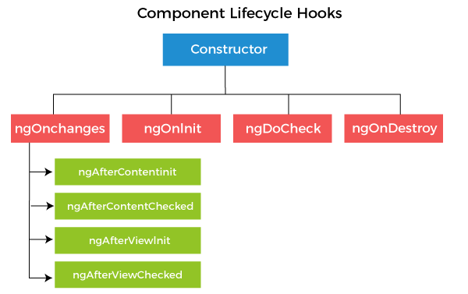

**ngOnChanges( ):** This method is called when one or more input properties of the component are changed. The hook receives a SimpleChanges object containing the previous and current values of the property.

**ngOnInit( ):** This is the second lifecycle hook. It is called once, after the ngOnChanges hook. It is used to initialize the component and sets the input properties of the component.

**ngDoCheck( ):** This hook is called after ngOnChanges and ngOnInit and is used to detect and act on changes that Angular cannot detect. In this hook, we can implement our change detection algorithm.

**ngAfterContentInit( ):** This hook is called after the first ngDoCheck hook. This hook responds after the content gets projected inside the component.

**ngAfterContentChecked( ):** This hook is called after ngAfterContentInit and every subsequent ngDoCheck. It responds after the projected content is checked.

**ngAfterViewInit( ):** This hook is called after a component's view or initializing a child component's view.

**ngAfterViewChecked( ):** This hook is called after ngAfterViewInit. It responds after the component's view or when the child component's view is checked.

**ngOnDestroy( ):** This hook is called just before Angular destroys the component. This is used to clean up the code and detach event handlers.

In the above hooks we have described, the ngOnInit hook is the most often used hook. Let's see how to use the ngOnInit hook. If you have to process a lot of data during component creation, it's better to do it inside the ngOnInit hook rather than the constructor:

**See the example:**

1. **import** { Component, OnInit } from '@angular/core';
2. @Component({
3. selector: 'app-test',
4. templateUrl: './test.component.html',
5. styleUrls: ['./test.component.css']
6. })
7. export **class** TestComponent **implements** OnInit {
8. constructor() { }
9. ngOnInit() {
10. **this**.processData();
11. }
12. processData(){
13. // Do something..
14. }
15. }

In the above code, you can see that we have imported OnInit, but we have used the ngOnInit function. This is how we can use the rest of the hooks as well.

### 13) What is AOT in Angular?

In Angular, AOT stands for Ahead-Of-Time compiler. It is used to convert your Angular HTML and TypeScript code into efficient JavaScript code during the build phase before the browser downloads and runs that code. By compiling the application during the build process provides a faster rendering in the browser.

### 14) What is the reason for using the AOT compiler in Angular?

An Angular application is made of several components and their HTML templates. Because of these Angular components and templates, the browsers are not able to understand them directly. So, Angular applications require a compilation process before they run in a browser. That's why AOT compilers are required.

### 15) What are the biggest advantages of AOT in Angular?

Following are the advantages of using the AOT compiler in Angular:

**The rendering is faster:** When we use the AOT compiler, the browser gets a pre-compiled version of the application to download. Here, the browser loads executable code to render the application immediately, without waiting to compile the app first.

**The Angular framework's download size is smaller:** AOT facilitates you not to download the Angular compiler if the app is already compiled. The compiler is roughly half of Angular itself, so omitting it dramatically reduces the application payload.

**Fewer asynchronous requests:** The compiler is used to inline external HTML templates and CSS style sheets within the application JavaScript so, it eliminates separate AJAX requests for those source files.

**Detect template errors earlier:** While using the AOT compiler, developers can easily detect and report template binding errors during the build step before users can see them.

**Better security:** AOT provides better security because it compiles HTML templates and components into JavaScript files before they are served to the client. Because there are no templates to read and no risky client-side HTML or JavaScript evaluation, so the chances for injection attacks are very rare.

### 16) What is JIT in Angular?

In Angular, JIT stands for Just-in-Time compiler. The JIT compiler provides a dynamic translation or run-time compilation, which provides a way of executing computer code that involves compilation during the execution of a program at run time rather than before execution.

### 17) What is the main difference between JIT and AOT in Angular?

Following are the main differences between JIT and AOT compiler in Angular:

* Just-in-Time (JIT) compiler compiles our app in the browser at run-time while Ahead-of-Time (AOT) compiler is used to compile your app at build time on the server.
* The JIT compilation runs by default when you run the ng build (build only), or ng serve (build and serve locally) CLI commands. This is used for development. On the other hand, we have to include the --aot option with the ng build or ng serve command for AOT compilation.
* JIT and AOT are both two ways used to compile code in an Angular project. JIT compiler is used in development mode while AOT is used for production mode.
* JIT is easy to use. We can easily implement features and debug in JIT mode because here we have a map file while AOT does not. On the other hand, the biggest advantage of using AOT for production is that it reduces the bundle size for faster rendering.

### 18) What is the concept of scope hierarchy in Angular?

Angular provides the $scope objects into a hierarchy that is typically used by views. This is called the scope hierarchy in Angular. It has a root scope that can further contain one or several scopes called child scopes.

In a scope hierarchy, each view has its own $scope. Hence, the variables set by a view's view controller will remain hidden to other view controllers.

**Following is the typical representation of a Scope Hierarchy:**

1. Root $scope
2. $scope for Controller 1
3. $scope for Controller 2
4. ...
5. ..
6. .
7. $scope for Controller n

### 19) What are the main building blocks of an Angular application? Explain with the pictorial diagram of Angular architecture.

Following are the main building blocks of an Angular application. You can see them in the following picture:

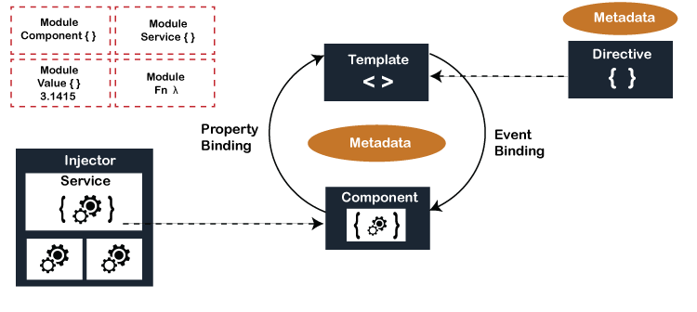

### 20) What is the difference between Observables and Promises in Angular?

In Angular, as soon as we make a promise, the execution takes place, but this is not the case with observables because they are lazy. It means nothing happens until a subscription is made.

|  |  |
| --- | --- |
| **Promise** | **Observable** |
| It emits a single value. | It emits multiple values over a period of time. |
| Not Lazy | Lazy. An observable is not called until we subscribe to the observable. |
| We can not cancel it. | We can cancel it by using the unsubscribe() method. |
|  | Observable provides operators like map, forEach, filter, reduce, retry, retryWhen etc. |

**Let's understand it by an example:**

1. const observable = rxjs.Observable.create(observer =**>** {
2. console.log('This is what inside an observable');
3. observer.next('Hello JavaTpoint');
4. observer.complete();
5. });
6. console.log('Before subscribing an Observable');
7. observable.subscribe((message)=**>** console.log(message));

When you run the above Observable, you can see the following messages displayed in the following order:

1. Before subscribing an Observable
2. This is what inside an observable
3. Hello JavaTpoint

Here, you can see that observables are lazy. Observable runs only when someone subscribes to them. That's why the message "Before subscribing an Observable" is displayed ahead of the message inside the observable.

**Now see the example of a Promise:**

1. const promise = new Promise((resolve, reject) =**>** {
2. console.log('This is what written inside promise');
3. resolve('Hello JavaTpoint');
4. });
5. console.log('Before calling then method on Promise');
6. greetingPoster.then(message =**>** console.log(message));

When you run the above Promise, you will see the messages displayed in the following order:

1. This is what written inside Promise
2. Before calling then method on Promise
3. Hello JavaTpoint

Here, you can see that the message inside Promise is displayed first. This means that the Promise runs first, and then the method is called.

The next difference between them is that Promises are always asynchronous; even when the Promise is immediately resolved. On the other hand, an Observable can be both synchronous and asynchronous.

In the case of the above example, observable is synchronous. Let's see the case where an observable can be asynchronous:

1. const observable = rxjs.Observable.create(observer =**>** {
2. setTimeout(()=**>**{
3. observer.next('Hello JavaTpoint');
4. observer.complete();
5. },3000)
6. });
7. console.log('Before calling subscribe on an Observable');
8. observable.subscribe((data)=**>** console.log(data));
9. console.log('After calling subscribe on an Observable');

When you run the above observable, you will see the messages in the following order:

1. Before calling subscribe on an Observable
2. After calling subscribe on an Observable
3. Hello JavaTpoint

### 22) What are directives in Angular?

A directive is a class in Angular that is declared with a @Directive decorator. Every directive has its own behavior, and you can import them into various components of an application.

### 23) What were the main reasons behind introducing client-side frameworks like Angular?

Before Angular was introduced, the web developers used VanillaJS and jQuery to develop dynamic websites, but the biggest drawback of these technologies is that as the logic of the website grew, the code became more and more complex to maintain. For websites and applications that use complex logic, developers had to put in extra effort to maintain the separation of concerns for the app. Also, jQuery did not provide facilities for data handling across views.

The client-side frameworks like Angular were introduced to overcome the above problems. It provides developers many benefits over VanilaJS and jQuery by providing a new feature called components for handling separation of concerns and dividing code into smaller bits of information.

Client-side frameworks such as Angular facilitate developers to develop advanced web applications like Single-Page-Applications. So, the main reasons behind introducing Angular were to create fast, dynamic, and scalable web applications easily.

#### **Note: We can also develop dynamic websites and SPAs (Single Page Applications) using VanillaJS, and jQuery but by doing so, the development process becomes slower.**

### 24) What is Angular CLI?

Angular CLI is a short form for Angular Command Line Interface. It is a command-line interface to scaffold and build angular apps using node.js style modules.

To use Angular CLI, we have to install it by using the following **npm** command:

1. npm install @angular/cli@latest

**Following is a list of some useful commands which would be very helpful while creating angular projects:**

* **Creating New Project:** ng new
* **Generating Components, Directives & Services:** ng generate/g
* **Running the Project:** ng serve

### 25) What is lazy loading in Angular?

Lazy loading is one of the most powerful and useful concepts of Angular Routing. It makes the web pages easy to download by downloading them in chunks instead of downloading everything in a big bundle. Lazy loading facilitates asynchronously loading the feature module for routing whenever required using the property loadChildren.

See the following example where we are going to load both Employee and Order feature modules lazily.

**See the example:**

1. **const** routes: Routes = [
2. {
3. path: 'employees',
4. loadChildren: () => **import**('./employees/employees.module').then(module => module.EmployeesModule)
5. },
6. {
7. path: 'orders',
8. loadChildren: () => **import**('./orders/orders.module').then(module => module.OrdersModule)
9. },
10. {
11. path: '',
12. redirectTo: '',
13. pathMatch: 'full'
14. }
15. ];

### 26) What is Angular Router?

Angular Router is a mechanism that facilitates users to navigate from one view to the next as users perform application tasks. It follows the concept model of browser's application navigation.

### 27) What do you understand by the router imports?

The Angular Router, representing a particular component view for a given URL, is not part of Angular Core. It is available in a library named @angular/router, and we have to import the required router components. This process is called router imports.

See the following example of how we can import them in the app module:

1. **import** { RouterModule, Routes } from '@angular/router';

### 28) What do you understand by RouterOutlet and RouterLink?

A RouterOutlet is a directive from the router library that acts as a placeholder. It marks the spot in the template where the Router should display the components for that outlet. Router outlet is used as a component.

**Syntax:**

1. <router-outlet></router-outlet>

On the other hand, a RouterLink is a directive on the anchor tags that gives the router control over those elements. Since the navigation paths are fixed, you can assign string values to router-link directive as below,

**Syntax:**

1. **<h1>**Angular Router**</h1>**
2. **<nav>**
3. **<a** routerLink="/todosList" **>**List of todos**</a>**
4. **<a** routerLink="/completed" **>**Completed todos**</a>**
5. **</nav>**
6. **<router-outlet></router-outlet>**

### 29) What are the different router events used in Angular Router?

During each navigation, the Router emits navigation events through the Router.events property. It allows us to track the lifecycle of the route.

**Following is the list of different router events in sequence:**

* NavigationStart
* RouteConfigLoadStart
* RouteConfigLoadEnd
* RoutesRecognized
* GuardsCheckStart
* ChildActivationStart
* ActivationStart
* GuardsCheckEnd
* ResolveStart
* ResolveEnd
* ActivationEnd
* ChildActivationEnd
* NavigationEnd
* NavigationCancel
* NavigationError

### 30) What do you understand by the RouterLinkActive?

The RouterLinkActive is a directive used to toggle CSS classes for active RouterLink bindings based on the current RouterState. i.e., the Router will add CSS classes when this link is active and remove them when the link is inactive.

For example, you can add them to RouterLinks as follows:

1. <h1>Angular Router</h1>
2. <nav>
3. <a routerLink="/todosList" routerLinkActive="active">List of todos</a>
4. <a routerLink="/completed" routerLinkActive="active">Completed todos</a>
5. </nav>
6. <router-outlet></router-outlet>

### 31) What do you understand by the RouterState?

The RouterState is a tree of activated routes. Every node in this tree knows about the "consumed" URL segments, the extracted parameters, and the resolved data. We can access the current RouterState from anywhere in the application by using the Router service and the routerState property.

1. @Component({templateUrl:'template.html'})
2. **class** MyComponent {
3. constructor(router: Router) {
4. **const** state: RouterState = router.routerState;
5. **const** root: ActivatedRoute = state.root;
6. **const** child = root.firstChild;
7. **const** id: Observable<string> = child.params.map(p => p.id);
8. //...
9. }
10. }

### 32) What is HttpClient, and what are the advantages of it?

Most front-end applications use either XMLHttpRequest interface or the fetch() API to communicate with backend services over HTTP protocol. For the same purpose, Angular provides a simplified client HTTP API known as HttpClient. This is based on top of XMLHttpRequest interface. This HttpClient is available in the @angular/common/http package, which you can import in your root module as follows:

1. **import** { HttpClientModule } from '@angular/common/http';

**Following are some of the crucial advantages of HttpClient:**

* HttpClient contains testability features.
* It provides typed request and response objects.
* It can intercept requests and responses.
* It supports Observalbe APIs.
* HttpClient also supports streamlined error handling.

### 33) By default, Angular uses client-side rendering for its applications. Is it possible to make an Angular application to render on the server-side?

Yes, it is possible to make an Angular application to render on the server-side. Angular provides a technology called Angular Universal that can be used to render applications on the server-side.

The crucial advantages of using Angular Universal are as follows:

* Making an Angular application render on the server-side can provide a better user experience. By using this, first-time users can instantly see a view of the application. So, it can be used to provide better UI.
* It can lead to a better SEO for your application. The reason is that many search engines expect pages in plain HTML. So, Angular Universal can ensure that your content is available on every search engine, and it is good for better SEO.
* The server-side rendered applications load faster than normal pages. It is because the rendered pages are available to the browser sooner.

### 34) What is the best way to perform Error handling in Angular?

Error is when the request fails on the server or fails to reach the server due to network issues. In this condition, HttpClient returns an error object instead of a successful response. To resolve this issue, we must handle the component by passing the error object as a second callback to the subscribe() method.

**See the following example to understand how we handle in the component:**

1. fetchUser() {
2. **this**.userService.getProfile()
3. .subscribe(
4. (data: User) => **this**.userProfile = { ...data }, // success path
5. error => **this**.error = error // error path
6. );
7. }

You can write an error message to give the user some meaningful feedback instead of displaying the raw error object returned from HttpClient.

### 35) What do you understand by Angular bootstrapping?

Angular bootstrapping is nothing but to allow developers to initialize or start the Angular application. Angular supports two types of bootstrapping:

* Manual bootstrapping
* Automatic bootstrapping

**Manual bootstrapping:** Manual bootstrapping provides more control to developers and facilitates them regarding how and when they need to initialize the Angular app. It is useful when professionals wish to perform other tasks and operations before Angular compiles the page.

**Automatic bootstrapping:** As the name specifies, automatic bootstrapping is started automatically to start the Angular app. The developers need to add the ng-app directive to the application's root if they want Angular to bootstrap the application automatically. Angular loads the associated module once it finds the ng-app directive and, further, compiles the DOM.

### 36) What is the digest cycle process in Angular?

The digest cycle process in Angular is the process that is used to monitor the watchlist to track changes in the watch variable value. There is a comparison between the present and the previous versions of the scope model values in each digest cycle.

### 37) What are the key differences between a Component and a Directive in Angular?

A Component is a directive that uses shadow DOM to create encapsulated visual behavior. Usually, components are used to create UI widgets by breaking up the application into smaller parts. In short, we can say that a component (@component) is a directive-with-a-template.

**A list of the major differences between a Component and a Directive in Angular:**

|  |  |
| --- | --- |
| **Component** | **Directive** |
| Components are generally used for creating UI widgets. | Directives are generally used for adding behavior to an existing DOM element. |
| We use @Component meta-data annotation attributes to register a component. | We use @Directive meta-data annotation attributes to register directives. |
| It is used to break up the application into smaller parts called components. | It is used to design re-usable components. |
| Only one component is allowed to be used per DOM element. | Multiple directives are allowed to be used per DOM element. |
| @View decorator or templateurl/template is mandatory in a component. | A Directive doesn't use View. |
| A component is used to define pipes. | In a directive, it is not possible to define Pipes. |

### 38) What do you understand by Angular MVVM architecture?

The MVVM architecture or **Model-View-ViewModel** architecture is a software architectural pattern that provides a facility to developers to separate the development of the graphical user interface (the View) from the development of the business logic or back-end logic (the Model). By using this architecture, the view is not dependent on any specific model platform.

The Angular MVVM architecture consists of the following three parts:

* Model
* View
* ViewModel

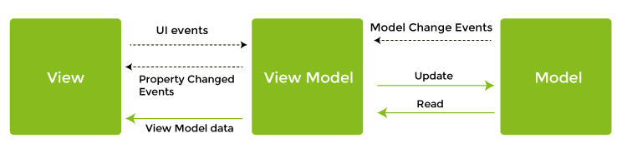

**Model:** The Model consists of the structure of an entity and specifies the approach. In simple words, we can say that the model contains data of an object.

**View:** The View is the visual layer of the application. It specifies the structure, layout, and appearance of what a user sees on the screen. It displays the data inside the Model, represents the model, and receives the user's interaction with the view in the form of mouse clicks, keyboard input, screen tap gestures, etc., and forwards these to the ViewModel via the data binding properties. In Angular terms, the View contains the HTML template of a component.

**ViewModel:** The ViewModel is an abstract layer of the application. It is used to handle the logic of the application. It also manages the data of a model and displays it in the view. View and ViewModel are connected with two-way data-binding. If you make any changes in the view, the ViewModel takes a note and changes the appropriate data inside the model.

### 39) What is the purpose of AsyncPipe in Angular?

The AsyncPipe is used to subscribe to an observable or promise and return the latest value it has emitted. When a new value is emitted, the pipe marks the component that has been checked for changes.

See the following example where a time observable continuously updates the view for every 2 seconds with the current time.

**Example:**

1. @Component({
2. selector: 'async-observable-pipe',
3. template: `<div><code>observable|async</code>:
4. Time: {{ time | async }}</div>`
5. })
6. export **class** AsyncObservablePipeComponent {
7. time = **new** Observable(observer =>
8. setInterval(() => observer.next(**new** Date().toString()), 2000)
9. );
10. }

### 40) What do you understand by services in Angular?

In Angular, services are singleton objects that get instantiated only once during the lifetime of an application. An Angular service contains methods that are used to maintain the data throughout the life of an application. Angular services are used to organize as well as share business logic, models, or data and functions with various components of an Angular application.

Angular services offer some functions that can be invoked from an Angular component, such as a controller or directive.

### 41) What is the key difference between a constructor and ngOnInit?

Constructor is a default method in TypeScript classes that are normally used for the initialization purpose. On the other hand, the ngOnInit is specifically an Angular method and is used to define Angular bindings. Even though constructors are getting called first, it is always preferred to move all of your Angular bindings to the ngOnInit method.

See the following example how we can use ngOnInit by implementing OnInit interface as follows:

1. export **class** App **implements** OnInit{
2. constructor(){
3. //called first time before the ngOnInit()
4. }
5. ngOnInit(){
6. //called after the constructor and called  after the first ngOnChanges()
7. }
8. }

### 42) What do you understand by observable and observer in Angular?

**Observable:** An observable is a unique object just like a promise that that is used to manage async code. Observables are not part of the JavaScript language so the developers have to rely on a popular Observable library called RxJS. The observables are created using the new keyword.

See a simple example of observable to understand it better:

1. **import** { Observable } from 'rxjs';
2. **const** observable = **new** Observable(observer => {
3. setTimeout(() => {
4. observer.next('This is a message from Observable!');
5. }, 1000);
6. });

**Observer:** Any object that has to be notified when the state of another object changes is called an observer. An observer is an interface for push-based notifications delivered by an Observable.

**See the structure of an observer:**

1. **interface** Observer<T> {
2. closed?: **boolean**;
3. next: (value: T) => **void**;
4. error: (err: any) => **void**;
5. complete: () => **void**;
6. }

The handler that implements the observer interface for receiving observable notifications is passed as a parameter for observable as follows:

1. myObservable.subscribe(myObserver);

#### **Note: If you don't use a handler for a notification type, the observer ignores notifications of that type.**

### 43) How do you categorize data binding types in Angular?

In Angular, we can categorize data binding types in three categories distinguished by the direction of data flow. These data binding categories are:

* From the source-to-view
* From view-to-source
* View-to-source-to-view

Let's see their possible binding syntax:

|  |  |  |
| --- | --- | --- |
| **Data direction** | **Syntax** | **Type** |
| From the source-to-view(One-way data binding) | 1. {{expression}} 2. [target]="expression" 3. bind-target="expression" | Interpolation, Property, Attribute, Class, Style |
| From view-to-source(One-way data binding) | 1. (target)="statement" 2. on-target="statement" | Event |
| View-to-source-to-view(Two-way data binding) | 1. [(target)]="expression" 2. bindon-target="expression" | Two-way data binding |

### 44) What is multicasting in Angular?

Multicasting or Multi-casting is the practice of broadcasting to a list of multiple subscribers in a single execution.

Let's take a simple example to demonstrate the multi-casting feature:

1. var source = Rx.Observable.from([1, 2, 3]);
2. var subject = **new** Rx.Subject();
3. var multicasted = source.multicast(subject);
4. // These are, under the hood, `subject.subscribe({...})`:
5. multicasted.subscribe({
6. next: (v) => console.log('observerA: ' + v)
7. });
8. multicasted.subscribe({
9. next: (v) => console.log('observerB: ' + v)
10. });

### 45) What do you understand by Angular Material?

Angular Material is a UI component library that is used by professionals to develop consistent, attractive, and completely functional websites, web pages, and web applications. It follows the modern principles of web designing, such as graceful degradation and browser probability, and is capable of doing a lot of fascinating things in website and application development.

### 46) What is lazy loading in Angular? Why is it used?

In Angular, the by default tendency of NgModules is eagerly loaded. It means that as soon as the app loads, all the NgModules are loaded, whether or not they are immediately necessary. That's why lazy loading is required. Lazy loading is mandatory for large apps with lots of routes. This design pattern makes the app load NgModules when they are only required. Lazy loading helps keep initial bundle sizes smaller, which in turn helps decrease load times.

### 47) What is the use of Angular filters? What are its distinct types?

Filters are an essential part of Angular that helps in formatting the expression value to show it to the users. We can easily add filters to services, directives, templates, or controllers. We can also create personalized filters as per requirements. These filters allow us to organize the data in such a way that only the data that meets the respective criteria are displayed. Filters are placed after the pipe symbol ( | ) while used in expressions.

**A list of various types of filters used in Angular:**

* **currency:** It is used to convert numbers to the currency format.
* **filter:** It is used to select a subset containing items from the given array.
* **date:** It is used to convert a date into a necessary format.
* **lowercase:** It is used to convert the given string into lowercase.
* **uppercase:** It is used to convert the given string into uppercase.
* **orderBy: It** is used to arrange an array by the given expression.
* **json:** It is used to format any object into a JSON string.
* **number:** It is used to convert a numeric value into a string.
* **limitTo:** It is used to restrict the limit of a given string or array to a particular number of elements or strings.

### 48) When do we use a directive in Angular?

If you create an Angular application where multiple components need to have similar functionalities, you have to do it by adding this functionality individually to every component. This is not a very easy task. Directives are used to cope up with this situation. Here, we can create a directive with the required functionality and then import the directive to components that require this functionality.

### 49) What are the different types of directives in Angular?

There are mainly three types of directives in Angular:

**Component Directives:** The component directives are used to form the main class in directives. To declare these directives, we have to use the @Component decorator instead of @Directive decorator. These directives have a view, a stylesheet and a selector property.

**Structural directives:** These directives are generally used to manipulate DOM elements. The structural directive has a ' \* ' sign before them. We can apply these directives to any DOM element.

**Following are some example of built-in structural directives:**

**\*ngIf Structural Directive:** \*ngIf is used to check a Boolean value and if it's truthy, the div element will be displayed.

1. **<div** \*ngIf="isReady" class="display\_name"**>**
2. {{name}}
3. **</div>**

**\*ngFor Structural Directive:** \*ngFor is used to iterate over a list and display each item of the list.

1. **<div** class="details" \*ngFor="let x of details" **>**
2. **<p>**{{x.name}}**</p>**
3. **<p>** {{x.address}}**</p>**
4. **<p>**{{x.age}}**</p>**
5. **</div>**

**Attribute Directives:** The attribute directives are used to change the look and behavior of a DOM element. Let's create an attribute directive to understand it well:

**This is how we can create a custom directive:**

Go to the command terminal, navigate to the directory of the angular app and type the following command to generate a directive:

1. ng g directive yellowBackground

This will generate the following directive. Manipulate the directive to look like this:

1. **import** { Directive, ElementRef } from '@angular/core';
2. @Directive({
3. selector: '[appYellowBackground]'
4. })
5. export **class** YellowBackgroundDirective {
6. constructor(el:ElementRef) {
7. el.nativeElement.style.backgroundColor = "yellow";
8. }
9. }

Now, you can easily apply the above directive to any DOM element:

1. **<p** appYellowBackground**>**Hello JavaTpoint**</p>**

### 50) What are string interpolation and property binding in Angular?

String interpolation and property binding are parts of data-binding in Angular. Data-binding is a feature of Angular, which is used to provide a way to communicate between the component (Model) and its view (HTML template). There are two ways of data-binding, one-way data binding and two-way data binding. In Angular, data from the component can be inserted inside the HTML template. Any changes in the component will directly reflect inside the HTML template in one-way binding, but vice-versa is not possible. On the other hand, it is possible in two-way binding.

String interpolation and property binding both are examples of one-way data binding. They allow only one-way data binding.

**String Interpolation:** String interpolation uses the double curly braces {{ }} to display data from the component. Angular automatically runs the expression written inside the curly braces. For example, {{ 5+5 }} will be evaluated by Angular, and the output will be 10. This output will be displayed inside the HTML template.

**Property Binding:** Property binding is used to bind the DOM properties of an HTML element to a component's property. In property binding, we use the square brackets [ ] syntax.

### 51) Is it possible to make an angular application to render on the server-side?

Yes, we can make an angular application to render on the server-side. Angular provides a technology Angular Universal that makes you able to render applications on the server-side.

**Following are the benefits of using Angular Universal:**

**Better User Experience:** It enables users to see the view of the application instantly.

**Better SEO:** Angular Universal ensures that the content is available on every search engine leading to better SEO.

**Load Faster:** Angular Universal ensures that the render pages available to the browsers sooner to make the loading faster server-side application loads faster.

### 52) What is Dependency Injection in Angular?

Dependency injection is an application design pattern that is implemented by Angular. It is used to form the core concepts of Angular. Dependencies are services in Angular which have some specific functionality. Various components and directives in an application can need these functionalities of the service. Angular provides a smooth mechanism by which these dependencies are injected into components and directives.

### 53) Can you demonstrate navigation between different routes in an Angular application?

You can demonstrate the navigation between different routes in an Angular app in the following way. See the following code to demonstrate navigation in an Angular app named "My First App."

1. **import** from "@angular/router";
2. .
3. .
4. .
5. @Component({
6. selector: 'app-header',
7. template: `
8. <nav **class**="navbar navbar-light bg-faded">
9. <a **class**="navbar-brand" (click)="goHome()">My First App</a>
10. <ul **class**="nav navbar-nav">
11. <li **class**="nav-item">
12. <a **class**="nav-link" (click)="goHome()">Home</a>
13. </li>
14. <li **class**="nav-item">
15. <a **class**="nav-link" (click)="goSearch()">Search</a>
16. </li>
17. </ul>
18. </nav>
19. })
20. **class** HeaderComponent {
21. constructor(**private** router: Router) {}
22. goHome() {
23. **this**.router.navigate(['']);
24. }
25. goSearch() {
26. **this**.router.navigate(['search']);
27. }
28. }

### 54) What is the difference between Angular and Backbone.js?

Following are the various notable differences between Angular and Backbone.js:

|  |  |  |
| --- | --- | --- |
| **Comparison Parameter** | **Angular** | **Backbone.js** |
| **Architecture** | Angular works on the MVC architecture and makes use of two-way data binding for driving application activity. | Backbone.js makes use of the MVP architecture and doesn't provide any data binding process. |
| **Type** | Angular is an open-source JavaScript-based front-end web application framework that extends HTML with new attributes. | Backbone.js is a lightweight JavaScript library that uses a RESTful JSON interface and MVP framework. |
| **Data Binding** | Angular is a little bit complex because it uses a two-way data binding process. | On the other hand, Backbone.js has a simple API because it doesn't have any data binding process. |
| **DOM** | Angular's main focus is on valid HTML and dynamic elements that imitate the underlying data for rebuilding the DOM as per the specified rules and then work on the updated data records. | Backbone.js follows the direct DOM manipulation approach for representing data and application architecture changes. |
| **Performance** | Because of its two-way data binding functionality, Angular provides powerful performance for both small and large projects. | Backbone.js is quite a significant upper hand in performance over Angular in small data sets or small web pages. It is not recommended for larger web pages or large data sets due to the absence of any data binding process. |
| **Templating** | Angular supports templating via dynamic HTML attributes. You can add them to the document to develop an easy to understand application at a functional level. | Backbone.js uses Underscore.js templates that aren't fully-featured as Angular templates. |
| **Testing Approach** | The testing approach is lengthy for Angular because it is preferred for building large applications. It uses unit testing. | The testing approach is completely different for Backbone.js because it is ideal for developing smaller webpages or applications. |
| **Community Support** | The angular framework is developed and maintained by Google, so it receives great community support. Here, extensive documentation is available. | Backbone.js also receives a good level of community support, but it only documents on Underscore.js templates, not much else. |

Reverse of a string using efficient time complexity

**Q1: What is the most efficient way to reverse a string in Java?**  
The most efficient way to reverse a string is to convert it to a character array and then swap the characters from the beginning and end of the array. This approach has a time complexity of O(n/2) due to the swapping process.

public static String reverse(String str) {

String rev = "";

char[] finalarray = str.toCharArray();

for (int i = finalarray.length - 1; i >= 0; i--)

rev += finalarray[i];

return rev;

}

//Sample Input- "PrepBytes"

//Sample Output-"setyBperP"

write a factory desige patern .

**Design Pattern - Factory Pattern**

1. Create an interface. ...
2. Create concrete classes implementing the same interface. ...
3. Create a Factory to generate object of concrete class based on given information. ...
4. Use the Factory to get object of concrete class by passing an information such as type. ...
5. Verify the output.

Factory pattern is one of the most used design patterns in Java. This type of design pattern comes under creational pattern as this pattern provides one of the best ways to create an object.

In Factory pattern, we create object without exposing the creation logic to the client and refer to newly created object using a common interface.

## **Implementation**

We're going to create a *Shape* interface and concrete classes implementing the *Shape* interface. A factory class *ShapeFactory* is defined as a next step.

*FactoryPatternDemo*, our demo class will use *ShapeFactory* to get a *Shape* object. It will pass information (*CIRCLE / RECTANGLE / SQUARE*) to *ShapeFactory* to get the type of object it needs.

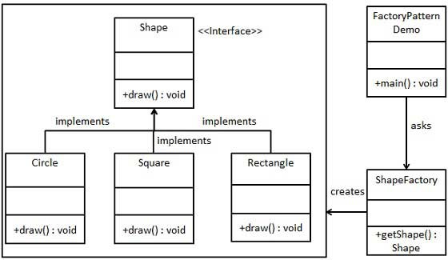

## **Step 1**

Create an interface.

*Shape.java*

public interface Shape {

void draw();

}

## **Step 2**

Create concrete classes implementing the same interface.

*Rectangle.java*

public class Rectangle implements Shape {

@Override

public void draw() {

System.out.println("Inside Rectangle::draw() method.");

}

}

*Square.java*

public class Square implements Shape {

@Override

public void draw() {

System.out.println("Inside Square::draw() method.");

}

}

*Circle.java*

public class Circle implements Shape {

@Override

public void draw() {

System.out.println("Inside Circle::draw() method.");

}

}

## **Step 3**

Create a Factory to generate object of concrete class based on given information.

*ShapeFactory.java*

public class ShapeFactory {

//use getShape method to get object of type shape

public Shape getShape(String shapeType){

if(shapeType == null){

return null;

}

if(shapeType.equalsIgnoreCase("CIRCLE")){

return new Circle();

} else if(shapeType.equalsIgnoreCase("RECTANGLE")){

return new Rectangle();

} else if(shapeType.equalsIgnoreCase("SQUARE")){

return new Square();

}

return null;

}

}

## **Step 4**

Use the Factory to get object of concrete class by passing an information such as type.

*FactoryPatternDemo.java*

public class FactoryPatternDemo {

public static void main(String[] args) {

ShapeFactory shapeFactory = new ShapeFactory();

//get an object of Circle and call its draw method.

Shape shape1 = shapeFactory.getShape("CIRCLE");

//call draw method of Circle

shape1.draw();

//get an object of Rectangle and call its draw method.

Shape shape2 = shapeFactory.getShape("RECTANGLE");

//call draw method of Rectangle

shape2.draw();

//get an object of Square and call its draw method.

Shape shape3 = shapeFactory.getShape("SQUARE");

//call draw method of square

shape3.draw();

}

}

## **Step 5**

Verify the output.

Inside Circle::draw() method.

Inside Rectangle::draw() method.

Inside Square::draw() method.

write curd operration in RestController class

# **Spring Boot CRUD Operations**

## **What is the CRUD operation?**

The **CRUD** stands for **Create, Read/Retrieve, Update,** and **Delete**. These are the four basic functions of the persistence storage.

The CRUD operation can be defined as user interface conventions that allow view, search, and modify information through computer-based forms and reports. CRUD is data-oriented and the standardized use of **HTTP action verbs**. HTTP has a few important verbs.

* **POST:** Creates a new resource
* **GET:** Reads a resource
* **PUT:** Updates an existing resource
* **DELETE:** Deletes a resource

Within a database, each of these operations maps directly to a series of commands. However, their relationship with a RESTful API is slightly more complex.

## **Standard CRUD Operation**

* **CREATE Operation:** It performs the INSERT statement to create a new record.
* **READ Operation:** It reads table records based on the input parameter.
* **UPDATE Operation:** It executes an update statement on the table. It is based on the input parameter.
* **DELETE Operation:** It deletes a specified row in the table. It is also based on the input parameter.

## **How CRUD Operations Works**

CRUD operations are at the foundation of the most dynamic websites. Therefore, we should differentiate **CRUD** from the **HTTP** **action verbs**.

Suppose, if we want to **create** a new record, we should use HTTP action verb **POST**. To **update** a record, we should use the **PUT** verb. Similarly, if we want to **delete** a record, we should use the **DELETE**verb. Through CRUD operations, users and administrators have the right to retrieve, create, edit, and delete records online.

We have many options for executing CRUD operations. One of the most efficient choices is to create a set of stored procedures in SQL to execute operations.

The CRUD operations refer to all major functions that are implemented in relational database applications. Each letter of the CRUD can map to a SQL statement and HTTP methods.

|  |  |  |  |
| --- | --- | --- | --- |
| **Operation** | **SQL** | **HTTP verbs** | **RESTful Web Service** |
| **Create** | INSERT | PUT/POST | POST |
| **Read** | SELECT | GET | GET |
| **Update** | UPDATE | PUT/POST/PATCH | PUT |
| **Delete** | DELETE | DELETE | DELETE |

## **Spring Boot CrudRepository**

Spring Boot provides an interface called **CrudRepository**that contains methods for CRUD operations. It is defined in the package **org.springframework.data.repository**. It extends the Spring Data**Repository** interface. It provides generic Crud operation on a repository. If we want to use CrudRepository in an application, we have to create an interface and extend the **CrudRepository**.

**Syntax**

1. **public** **interface** CrudRepository<T,ID> **extends** Repository<T,ID>

where,

* **T** is the domain type that repository manages.
* **ID** is the type of the id of the entity that repository manages.

For example:

1. **public** **interface** StudentRepository **extends** CrudRepository<Student, Integer>
2. {
3. }

In the above example, we have created an interface named **StudentRepository** that extends CrudRepository. Where **Student** is the repository to manage, and **Integer** is the type of Id that is defined in the Student repository.

## **Spring Boot JpaRepository**

JpaRepository provides JPA related methods such as flushing, persistence context, and deletes a record in a batch. It is defined in the package **org.springframework.data.jpa.repository.**JpaRepository extends both **CrudRepository** and **PagingAndSortingRepository.**

For example:

1. **public** **interface** BookDAO **extends** JpaRepository
2. {
3. }

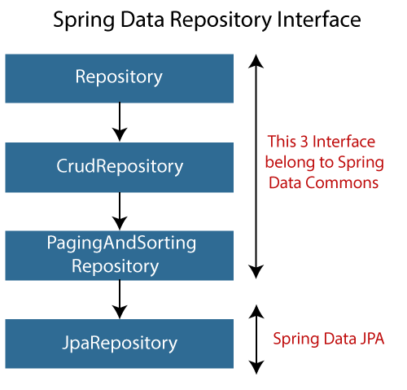

## **Why should we use these interfaces?**

* The interfaces allow Spring to find the repository interface and create proxy objects for that.
* It provides methods that allow us to perform some common operations. We can also define custom methods as well.

## **CrudRepository vs. JpaRepository**

|  |  |
| --- | --- |
| **CrudRepository** | **JpaRepository** |
| CrudRepository does not provide any method for pagination and sorting. | JpaRepository extends PagingAndSortingRepository. It provides all the methods for implementing the pagination. |
| It works as a **marker** interface. | JpaRepository extends both **CrudRepository** and **PagingAndSortingRepository**. |
| It provides CRUD function only. For example **findById(), findAll(),** etc. | It provides some extra methods along with the method of PagingAndSortingRepository and CrudRepository. For example, **flush(), deleteInBatch().** |
| It is used when we do not need the functions provided by JpaRepository and PagingAndSortingRepository. | It is used when we want to implement pagination and sorting functionality in an application. |

## **Spring Boot CRUD Operation Example**

Let's set up a Spring Boot application and perform CRUD operation.

**Step 1:** Open Spring Initializr [http://start.spring.io](http://start.spring.io/).

**Step 2:** Select the Spring Boot version **2.3.0.M1.**

**Step 2:** Provide the **Group** name. We have provided **com.javatpoint.**

**Step 3:** Provide the **Artifact** Id. We have provided **spring-boot-crud-operation.**

**Step 5:** Add the dependencies **Spring Web, Spring Data JPA,**and**H2 Database.**

**Step 6:** Click on the **Generate** button. When we click on the Generate button, it wraps the specifications in a **Jar** file and downloads it to the local system.

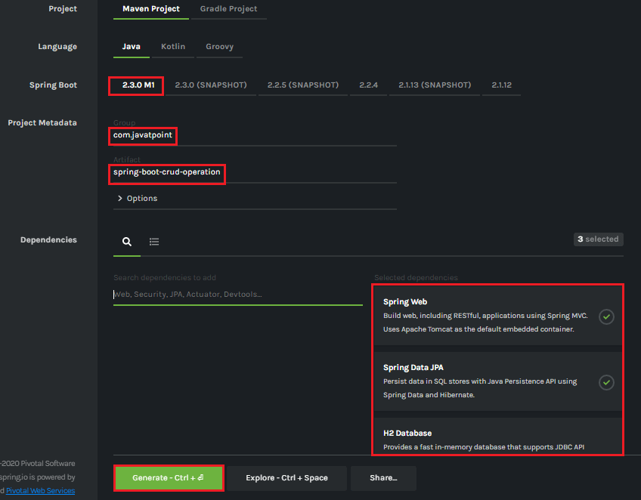

**Step 7: Extract** the Jar file and paste it into the STS workspace.

**Step 8: Import** the project folder into STS.

File -> Import -> Existing Maven Projects -> Browse -> Select the folder spring-boot-crud-operation -> Finish

It takes some time to import.

**Step 9:** Create a package with the name **com.javatpoint.model**in the folder **src/main/java.**

**Step 10:** Create a model class in the package **com.javatpoint.model.**We have created a model class with the name **Books.**In the Books class, we have done the following:

* Define four variable **bookid, bookname, author,**and
* Generate Getters and Setters.  
  Right-click on the file -> Source -> Generate Getters and Setters.
* Mark the class as an **Entity** by using the annotation **@Entity.**
* Mark the class as **Table** name by using the annotation **@Table.**
* Define each variable as **Column** by using the annotation **@Column.**

**Books.java**

1. **package** com.javatpoint.model;
2. **import** javax.persistence.Column;
3. **import** javax.persistence.Entity;
4. **import** javax.persistence.Id;
5. **import** javax.persistence.Table;
6. //mark class as an Entity
7. @Entity
8. //defining class name as Table name
9. @Table
10. **public** **class** Books
11. {
12. //Defining book id as primary key
13. @Id
14. @Column
15. **private** **int** bookid;
16. @Column
17. **private** String bookname;
18. @Column
19. **private** String author;
20. @Column
21. **private** **int** price;
22. **public** **int** getBookid()
23. {
24. **return** bookid;
25. }
26. **public** **void** setBookid(**int** bookid)
27. {
28. **this**.bookid = bookid;
29. }
30. **public** String getBookname()
31. {
32. **return** bookname;
33. }
34. **public** **void** setBookname(String bookname)
35. {
36. **this**.bookname = bookname;
37. }
38. **public** String getAuthor()
39. {
40. **return** author;
41. }
42. **public** **void** setAuthor(String author)
43. {
44. **this**.author = author;
45. }
46. **public** **int** getPrice()
47. {
48. **return** price;
49. }
50. **public** **void** setPrice(**int** price)
51. {
52. **this**.price = price;
53. }
54. }

**Step 11:** Create a package with the name **com.javatpoint.controller**in the folder **src/main/java.**

**Step 12:** Create a Controller class in the package **com.javatpoint.controller.**We have created a controller class with the name **BooksController.**In the BooksController class, we have done the following:

* Mark the class as **RestController**by using the annotation**@RestController.**
* Autowire the **BooksService** class by using the annotation **@Autowired**.
* Define the following methods:
  + **getAllBooks():** It returns a List of all Books.
  + **getBooks():** It returns a book detail that we have specified in the path variable. We have passed bookid as an argument by using the annotation @PathVariable. The annotation indicates that a method parameter should be bound to a URI template variable.
  + **deleteBook():** It deletes a specific book that we have specified in the path variable.
  + **saveBook():** It saves the book detail. The annotation @RequestBody indicates that a method parameter should be bound to the body of the web request.
  + **update():** The method updates a record. We must specify the record in the body, which we want to update. To achieve the same, we have used the annotation @RequestBody.

**BooksController.java**

1. **package** com.javatpoint.controller;
2. **import** java.util.List;
3. **import** org.springframework.beans.factory.annotation.Autowired;
4. **import** org.springframework.web.bind.annotation.DeleteMapping;
5. **import** org.springframework.web.bind.annotation.GetMapping;
6. **import** org.springframework.web.bind.annotation.PathVariable;
7. **import** org.springframework.web.bind.annotation.PostMapping;
8. **import** org.springframework.web.bind.annotation.PutMapping;
9. **import** org.springframework.web.bind.annotation.RequestBody;
10. **import** org.springframework.web.bind.annotation.RestController;
11. **import** com.javatpoint.model.Books;
12. **import** com.javatpoint.service.BooksService;
13. //mark class as Controller
14. @RestController
15. **public** **class** BooksController
16. {
17. //autowire the BooksService class
18. @Autowired
19. BooksService booksService;
20. //creating a get mapping that retrieves all the books detail from the database
21. @GetMapping("/book")
22. **private** List<Books> getAllBooks()
23. {
24. **return** booksService.getAllBooks();
25. }
26. //creating a get mapping that retrieves the detail of a specific book
27. @GetMapping("/book/{bookid}")
28. **private** Books getBooks(@PathVariable("bookid") **int** bookid)
29. {
30. **return** booksService.getBooksById(bookid);
31. }
32. //creating a delete mapping that deletes a specified book
33. @DeleteMapping("/book/{bookid}")
34. **private** **void** deleteBook(@PathVariable("bookid") **int** bookid)
35. {
36. booksService.delete(bookid);
37. }
38. //creating post mapping that post the book detail in the database
39. @PostMapping("/books")
40. **private** **int** saveBook(@RequestBody Books books)
41. {
42. booksService.saveOrUpdate(books);
43. **return** books.getBookid();
44. }
45. //creating put mapping that updates the book detail
46. @PutMapping("/books")
47. **private** Books update(@RequestBody Books books)
48. {
49. booksService.saveOrUpdate(books);
50. **return** books;
51. }
52. }

**Step 13:** Create a package with the name **com.javatpoint.service**in the folder **src/main/java.**

**Step 14:** Create a **Service** class. We have created a service class with the name **BooksService**in the package **com.javatpoint.service.**

**BooksService.java**

1. **package** com.javatpoint.service;
2. **import** java.util.ArrayList;
3. **import** java.util.List;
4. **import** org.springframework.beans.factory.annotation.Autowired;
5. **import** org.springframework.stereotype.Service;
6. **import** com.javatpoint.model.Books;
7. **import** com.javatpoint.repository.BooksRepository;
8. //defining the business logic
9. @Service
10. **public** **class** BooksService
11. {
12. @Autowired
13. BooksRepository booksRepository;
14. //getting all books record by using the method findaAll() of CrudRepository
15. **public** List<Books> getAllBooks()
16. {
17. List<Books> books = **new** ArrayList<Books>();
18. booksRepository.findAll().forEach(books1 -> books.add(books1));
19. **return** books;
20. }
21. //getting a specific record by using the method findById() of CrudRepository
22. **public** Books getBooksById(**int** id)
23. {
24. **return** booksRepository.findById(id).get();
25. }
26. //saving a specific record by using the method save() of CrudRepository
27. **public** **void** saveOrUpdate(Books books)
28. {
29. booksRepository.save(books);
30. }
31. //deleting a specific record by using the method deleteById() of CrudRepository
32. **public** **void** delete(**int** id)
33. {
34. booksRepository.deleteById(id);
35. }
36. //updating a record
37. **public** **void** update(Books books, **int** bookid)
38. {
39. booksRepository.save(books);
40. }
41. }

**Step 15:** Create a package with the name **com.javatpoint.repository**in the folder **src/main/java.**

**Step 16:** Create a **Repository** interface. We have created a repository interface with the name **BooksRepository**in the package **com.javatpoint.repository.**It extends the **Crud Repository** interface.

**BooksRepository.java**

1. **package** com.javatpoint.repository;
2. **import** org.springframework.data.repository.CrudRepository;
3. **import** com.javatpoint.model.Books;
4. //repository that extends CrudRepository
5. **public** **interface** BooksRepository **extends** CrudRepository<Books, Integer>
6. {
7. }

Now we will configure the datasource **URL, driver class name, username,**and**password,**in the **application.properties**file.

**Step 17:** Open the **application.properties** file and configure the following properties.

**application.properties**

1. spring.datasource.url=jdbc:h2:mem:books\_data
2. spring.datasource.driverClassName=org.h2.Driver
3. spring.datasource.username=sa
4. spring.datasource.password=
5. spring.jpa.database-platform=org.hibernate.dialect.H2Dialect
6. #enabling the H2 console
7. spring.h2.console.enabled=**true**

#### **Note: Do not forget to enable the H2 console.**

After creating all the classes and packages, the project directory looks like the following.

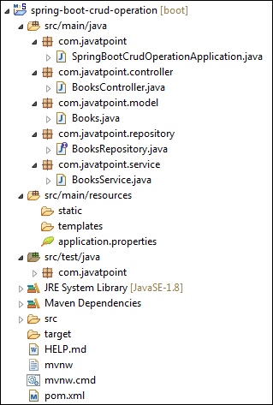

Now we will run the application.

**Step 18:** Open **SpringBootCrudOperationApplication.java**file and run it as Java Application.

**SpringBootCrudOperationApplication.java**

1. **package** com.javatpoint;
2. **import** org.springframework.boot.SpringApplication;
3. **import** org.springframework.boot.autoconfigure.SpringBootApplication;
4. @SpringBootApplication
5. **public** **class** SpringBootCrudOperationApplication
6. {
7. **public** **static** **void** main(String[] args)
8. {
9. SpringApplication.run(SpringBootCrudOperationApplication.**class**, args);
10. }
11. }

#### **Note: In the next steps we will use rest client Postman. So, ensure that the Postman application is already installed in your system.**

**Step 19:** Open the **Postman**and do the following:

* Select the **POST**
* Invoke the URL http://localhost:8080/books.
* Select the **Body**
* Select he Content-Type **JSON (application/json).**
* Insert the data. We have inserted the following data in the Body:

1. {
2. "bookid": "5433",
3. "bookname": "Core and Advance Java",
4. "author": "R. Nageswara Rao",
5. "price": "800"
6. }

* Click on the **Send**

When the request is successfully executed, it shows the **Status:200 OK**. It means the record has been successfully inserted in the database.

Similarly, we have inserted the following data.

1. {
2. "bookid": "0982",
3. "bookname": "Programming with Java",
4. "author": "E. Balagurusamy",
5. "price": "350"
6. }
7. {
8. "bookid": "6321",
9. "bookname": "Data Structures and Algorithms in Java",
10. "author": "Robert Lafore",
11. "price": "590"
12. }
13. {
14. "bookid": "5433",
15. "bookname": "Effective Java",
16. "author": "Joshua Bloch",
17. "price": "670"
18. }

Let's access the H2 console to see the data.

**Step 20:** Open the browser and invoke the URL http://localhost:8080/h2-console. Click on the **Connect** button, as shown below.

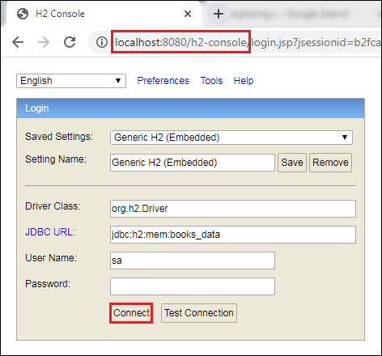

After clicking on the **Connect** button, we see the **Books** table in the database, as shown below.

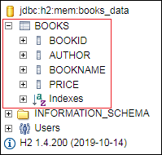

**Step 21:** Click on the **Books** table and then click on the **Run** button. The table shows the data that we have inserted in the body.

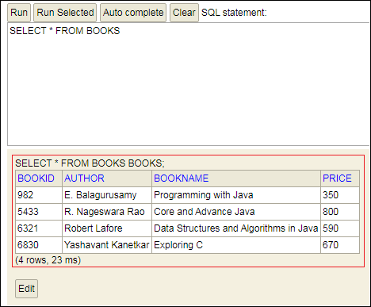

**Step 22:** Open the **Postman** and send a **GET** request with the URL http://localhost:8080/books. It returns the data that we have inserted in the database.

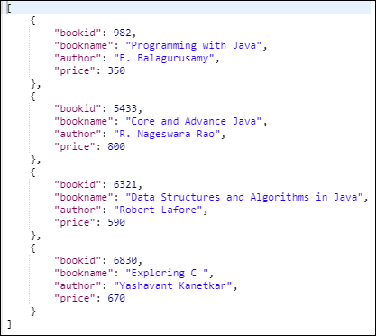

Let's send a **GET** request with the URL http://localhost:8080/book/{bookid}. We have specified the **bookid 6830**. It returns the detail of the book whose id is 6830.

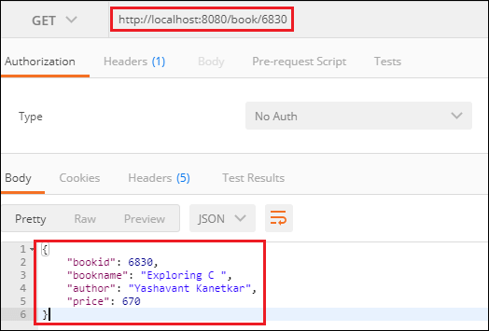

Similarly, we can also send a **DELETE** request to delete a record. Suppose we want to delete a book record whose id is **5433**.

Select the **DELETE** method and invoke the URL http://localhost:8080/book/5433. Again, execute the **Select** query in the H2 console. We see that the book whose id is **5433** has been deleted from the database.

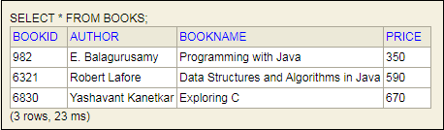

Similarly, we can also update a record by sending a **PUT** request. Let's update the price of the book whose id is **6321**.

* Select the **PUT**
* In the request body, paste the record which you want to update and make the changes. In our case, we want to update the record of the book whose id is 6321. In the following record, we have changed the price of the book.

1. {
2. "bookid": "6321",
3. "bookname": "Data Structures and Algorithms in Java",
4. "author": "Robert Lafore",
5. "price": "500"
6. }

* Click on the **Send**

Now, move to the H2 console and see the changes have reflected or not. We see that the price of the book has been changed, as shown below.

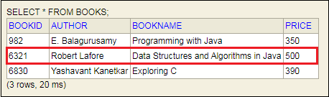

[Download CRUD Operation Project](https://static.javatpoint.com/springboot/download/spring-boot-crud-operation.zip)

Different between TreMap and HashMap.

HashMap allows storing at most one null key and many null values. However, TreeMap doesn't allow a null key but may contain many null values. If we're using a TreeMap with a user-defined Comparator, then it depends on the implementation of the compare() method how null values get handled.

**HashMap**java.util.HashMap class is a Hashing based implementation. In HashMap, we have a key and a value pair<Key, Value>.

HashMap<K, V> hmap = new HashMap<K, V>();

Let us consider below example where we have to count occurrences of each integer in given array of integers.

Input: arr[] = {10, 3, 5, 10, 3, 5, 10};

Output: Frequency of 10 is 3

Frequency of 3 is 2

Frequency of 5 is 2

**Example:**

* Java

|  |
| --- |
| /\* Java program to print frequencies of all elements using     HashMap \*/  **import** java.util.\*;    **class** Main  {      // This function prints frequencies of all elements  **static** **void** printFreq(**int** arr[])      {          // Creates an empty HashMap          HashMap<Integer, Integer> hmap =  **new** HashMap<Integer, Integer>();            // Traverse through the given array  **for** (**int** i = 0; i < arr.length; i++)          {              Integer c = hmap.get(arr[i]);                // If this is first occurrence of element  **if** (hmap.get(arr[i]) == **null**)                 hmap.put(arr[i], 1);                // If elements already exists in hash map  **else**                hmap.put(arr[i], ++c);          }            // Print result  **for** (Map.Entry m:hmap.entrySet())            System.out.println("Frequency of " + m.getKey() +                               " is " + m.getValue());      }        // Driver method to test above method  **public** **static** **void** main (String[] args)      {  **int** arr[] = {10, 34, 5, 10, 3, 5, 10};          printFreq(arr);      }  } |

Output:

Frequency of 34 is 1

Frequency of 3 is 1

Frequency of 5 is 2

Frequency of 10 is 3

**Key Points**

* HashMap does not maintain any order neither based on key nor on basis of value, If we want the keys to be maintained in a sorted order, we need to use TreeMap.
* **Complexity**: get/put/containsKey() operations are O(1) in average case but we can’t guarantee that since it all depends on how much time does it take to compute the hash.

**Application:** HashMap is basically an implementation of [hashing](https://www.geeksforgeeks.org/what-is-hashing/). So wherever we need hashing with key value pairs, we can use HashMap. For example, in Web Applications username is stored as a key and user data is stored as a value in the HashMap, for faster retrieval of user data corresponding to a username.

**TreeMap**TreeMap can be a bit handy when we only need to store unique elements in a sorted order. Java.util.TreeMap uses a [red-black tree](https://www.geeksforgeeks.org/red-black-tree-set-1-introduction-2/) in the background which makes sure that there are no duplicates; additionally it also maintains the elements in a sorted order.

TreeMap<K, V> hmap = new TreeMap<K, V>();

Below is TreeMap based implementation of same problem. This solution has more time complexity O(nLogn) compared to previous one which has O(n). The advantage of this method is, we get elements in sorted order.

Recommended Problem

TreeMap Operations

[Java](https://practice.geeksforgeeks.org/explore?page=1&category%5b%5d=Java&sortBy=submissions)

[Java-Collections](https://practice.geeksforgeeks.org/explore?page=1&category%5b%5d=Java-Collections&sortBy=submissions)

[Solve Problem](https://practice.geeksforgeeks.org/problems/java-collection-set-4-treemap/1?utm_source=gfg&utm_medium=article&utm_campaign=bottom_sticky_on_article" \o "Permalink to TreeMap Operations)

Submission count: 3.4K

* Java

|  |
| --- |
| /\* Java program to print frequencies of all elements using     TreeMap \*/  **import** java.util.\*;    **class** Main  {      // This function prints frequencies of all elements  **static** **void** printFreq(**int** arr[])      {          // Creates an empty TreeMap          TreeMap<Integer, Integer> tmap =  **new** TreeMap<Integer, Integer>();            // Traverse through the given array  **for** (**int** i = 0; i < arr.length; i++)          {              Integer c = tmap.get(arr[i]);                // If this is first occurrence of element  **if** (tmap.get(arr[i]) == **null**)                 tmap.put(arr[i], 1);                // If elements already exists in hash map  **else**                tmap.put(arr[i], ++c);          }            // Print result  **for** (Map.Entry m:tmap.entrySet())            System.out.println("Frequency of " + m.getKey() +                               " is " + m.getValue());      }        // Driver method to test above method  **public** **static** **void** main (String[] args)      {  **int** arr[] = {10, 34, 5, 10, 3, 5, 10};          printFreq(arr);      }  } |

Output:

Frequency of 3 is 1

Frequency of 5 is 2

Frequency of 10 is 3

Frequency of 34 is 1

**Key Points**

* For operations like add, remove, containsKey, time complexity is O(log n where n is number of elements present in TreeMap.
* TreeMap always keeps the elements in a sorted(increasing) order, while the elements in a HashMap have no order. TreeMap also provides some cool methods for first, last, floor and ceiling of keys.

**Difference between HashMap and TreeMap:**

|  | **HashMap** | **TreeMap** |
| --- | --- | --- |
| **1.** | It does not provide any order for elements. | It provides orders for elements. |
| **2.** | It’s speed is fast. | It’s speed is slow. |
| **3.** | It allows one key as null and also allows multiple values. | It does not allow key as null but it allows multiple null values. |
| **4.** | It consumes more memory space. | It consumes less memory space. |
| **5.** | It has only basic features. | It has advanced features. |
| **6.** | For comparing keys, equals() is used. | For comparing keys, compare or compareTo() is used. |
| **7.** | It’s complexity is O(1). | It’s complexity is O(log n). |

Diferent between ArrayList and Linked List,

Key Difference Between ArrayList vs LinkedListArrayList uses an array, which allows for fast random access but slow insertion and deletion. While LinkedList uses a doubly linked list, which allows for fast insertion and deletion but slow random access. Also one of the major difference lies in the access time.

# **Difference Between ArrayList and LinkedList**

ArrayList and LinkedList both implement the List interface and maintain insertion order. Both are non-synchronized classes.

However, there are many differences between the ArrayList and LinkedList classes that are given below.

|  |  |
| --- | --- |
| **ArrayList** | **LinkedList** |
| 1) ArrayList internally uses a **dynamic array** to store the elements. | LinkedList internally uses a **doubly linked list** to store the elements. |
| 2) Manipulation with ArrayList is **slow** because it internally uses an array. If any element is removed from the array, all the other elements are shifted in memory. | Manipulation with LinkedList is **faster** than ArrayList because it uses a doubly linked list, so no bit shifting is required in memory. |
| 3) An ArrayList class can **act as a list** only because it implements List only. | LinkedList class can **act as a list and queue** both because it implements List and Deque interfaces. |
| 4) ArrayList is **better for storing and accessing** data. | LinkedList is **better for manipulating** data. |
| 5) The memory location for the elements of an ArrayList is contiguous. | The location for the elements of a linked list is not contagious. |
| 6) Generally, when an ArrayList is initialized, a default capacity of 10 is assigned to the ArrayList. | There is no case of default capacity in a LinkedList. In LinkedList, an empty list is created when a LinkedList is initialized. |
| 7) To be precise, an ArrayList is a resizable array. | LinkedList implements the doubly linked list of the list interface. |

// Java program to Illustrate Working of an ArrayList

// Importing required classes

import java.io.\*;

import java.util.\*;

// Main class

class GFG {

// Main driver method

public static void main(String[] args)

{

// Creating an ArrayList of Integer type

ArrayList<Integer> arrli

= new ArrayList<Integer>();

// Appending the new elements

// at the end of the list

// using add () method via for loops

for (int i = 1; i <= 5; i++)

arrli.add(i);

// Printing the ArrayList

System.out.println(arrli);

// Removing an element at index 3

// from the ArrayList

// using remove() method

arrli.remove(3);

// Printing the ArrayList after

// removing the element

System.out.println(arrli);

}

}

// Java program to Demonstrate Working of a LinkedList

// Importing required classes

import java.util.\*;

// Main class

class GFG {

// main driver method

public static void main(String args[])

{

// Creating an object of the

// class linked list

LinkedList<String> object

= new LinkedList<String>();

// Adding the elements to the object created

// using add() and addLast() method

// Custom input elements

object.add("A");

object.add("B");

object.addLast("C");

// Print the current LinkedList

System.out.println(object);

// Removing elements from the List object

// using remove() and removeFirst() method

object.remove("B");

object.removeFirst();

System.out.println("Linked list after "

+ "deletion: " + object);

}

}

can we apply binary search in linked list .

Binary Search is divide and conquer approach to search an element from the list of sorted element. In Linked List we can do binary search but it has time complexity O(n) that is same as what we have for linear search which makes Binary Search inefficient to use in Linked List

// Java code to implement binary search

// on Singly Linked List

// Node Class

class Node

{

int data;

Node next;

// Constructor to create a new node

Node(int d)

{

data = d;

next = null;

}

}

class BinarySearch

{

// function to insert a node at the beginning

// of the Singly Linked List

static Node push(Node head, int data)

{

Node newNode = new Node(data);

newNode.next = head;

head = newNode;

return head;

}

// Function to find middle element

// using Fast and Slow pointers

static Node middleNode(Node start, Node last)

{

if (start == null)

return null;

Node slow = start;

Node fast = start.next;

while (fast != last)

{

fast = fast.next;

if (fast != last)

{

slow = slow.next;

fast = fast.next;

}

}

return slow;

}

// function to insert a node at the beginning

// of the Singly Linked List

static Node binarySearch(Node head, int value)

{

Node start = head;

Node last = null;

do

{

// Find Middle

Node mid = middleNode(start, last);

// If middle is empty

if (mid == null)

return null;

// If value is present at middle

if (mid.data == value)

return mid;

// If value is less than mid

else if (mid.data > value)

{

last = mid;

}

// If the value is more than mid.

else

start = mid.next;

} while (last == null || last != start);

// value not present

return null;

}

// Driver Code

public static void main(String[] args)

{

Node head = null;

// Using push() function to

// convert singly linked list

// 10 -> 9 -> 8 -> 7 -> 4 -> 1

head = push(head, 1);

head = push(head, 4);

head = push(head, 7);

head = push(head, 8);

head = push(head, 9);

head = push(head, 10);

int value = 7;

if (binarySearch(head, value) == null)

{

System.out.println("Value not present");

}

else

{

System.out.println("Present");

}

}

}

// This code is contributed by Vivekkumar Singh

can we overload static method .

Can We Overload Static Methods In Java? Yes, we can overload static methods in Java. Method overloading in Java allows us to have multiple methods with the same name in a class, but they must have different parameter lists.

public class Main {

**// Static method with no parameters**

    public static void fun( ) {

        System.out.println(“PhysicsWallah”);

    }

**// Static method with an integer parameter**

    public static void fun(int a) {

        System.out.println(“PhysicsWallah with int parameter: ” + a);

    }

**// Main method**

public static void main(String[] args) {

**// Calling the overloaded static methods**

        Main.fun();

        Main.fun(5);

    }

}

How many types of indexing in DB.

# Indexing in DBMS: What is, Types of Indexes with EXAMPLES

By :[[](https://www.guru99.com/author/richard)Richard Peterson](https://www.guru99.com/author/richard)

UpdatedOctober 3, 2023

## What is Indexing?

**Indexing** is a data structure technique which allows you to quickly retrieve records from a database file. An Index is a small table having only two columns. The first column comprises a copy of the primary or candidate key of a table. Its second column contains a set of [pointers](https://www.guru99.com/c-pointers.html) for holding the address of the disk block where that specific key value stored.

An index –

* Takes a search key as input
* Efficiently returns a collection of matching records.

**Table of Content:**

## Types of Indexing in DBMS

[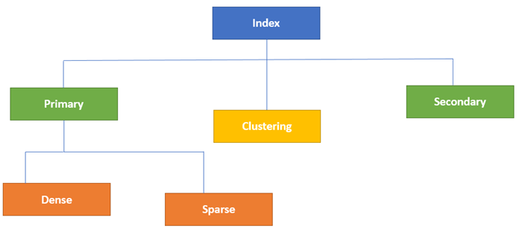](https://www.guru99.com/images/1/070119_0833_IndexinginD1.png)Type of Indexes in Database

Indexing in Database is defined based on its indexing attributes. Two main types of indexing methods are:

* Primary Indexing
* Secondary Indexing

## Primary Index in DBMS

Primary Index is an ordered file which is fixed length size with two fields. The first field is the same a primary key and second, filed is pointed to that specific data block. In the primary Index, there is always one to one relationship between the entries in the index table.

The primary Indexing in DBMS is also further divided into two types.

* Dense Index
* Sparse Index

### Dense Index

In a dense index, a record is created for every search key valued in the database. This helps you to search faster but needs more space to store index records. In this Indexing, method records contain search key value and points to the real record on the disk.

[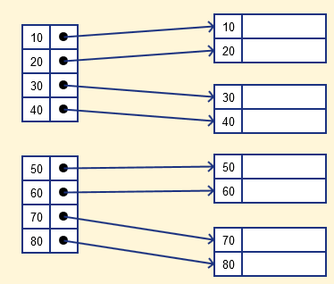](https://www.guru99.com/images/1/070119_0833_IndexinginD2.png)

### Sparse Index

It is an index record that appears for only some of the values in the file. Sparse Index helps you to resolve the issues of dense Indexing in [DBMS](https://www.guru99.com/dbms-tutorial.html). In this method of indexing technique, a range of index columns stores the same data block address, and when data needs to be retrieved, the block address will be fetched.

However, sparse Index stores index records for only some search-key values. It needs less space, less maintenance overhead for insertion, and deletions but It is slower compared to the dense Index for locating records.

Below is an database index Example of Sparse Index

[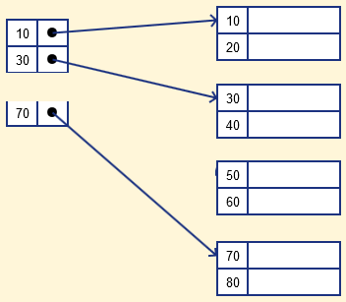](https://www.guru99.com/images/1/070119_0833_IndexinginD3.png)

## Secondary Index in DBMS

The secondary Index in DBMS can be generated by a field which has a unique value for each record, and it should be a candidate key. It is also known as a non-clustering index.

This two-level database indexing technique is used to reduce the mapping size of the first level. For the first level, a large range of numbers is selected because of this; the mapping size always remains small.

### Secondary Index Example

Let’s understand secondary indexing with a database index example:

In a bank account database, data is stored sequentially by acc\_no; you may want to find all accounts in of a specific branch of ABC bank.

Here, you can have a secondary index in DBMS for every search-key. Index record is a record point to a bucket that contains pointers to all the records with their specific search-key value.

[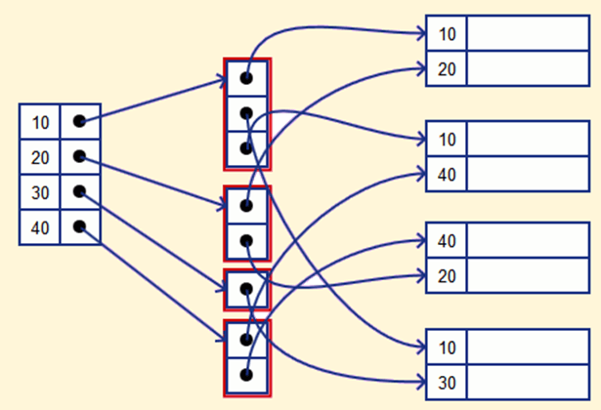](https://www.guru99.com/images/1/070119_0833_IndexinginD4.png)

## Clustering Index in DBMS

In a clustered index, records themselves are stored in the Index and not pointers. Sometimes the Index is created on non-primary key columns which might not be unique for each record. In such a situation, you can group two or more columns to get the unique values and create an index which is called clustered Index. This also helps you to identify the record faster.

**Example:**

Let’s assume that a company recruited many employees in various departments. In this case, clustering indexing in DBMS should be created for all employees who belong to the same dept.

It is considered in a single cluster, and index points point to the cluster as a whole. Here, Department \_no is a non-unique key.

## What is Multilevel Index?

Multilevel Indexing in [Database](https://www.guru99.com/introduction-to-database-sql.html) is created when a primary index does not fit in memory. In this type of indexing method, you can reduce the number of disk accesses to short any record and kept on a disk as a sequential file and create a sparse base on that file.

[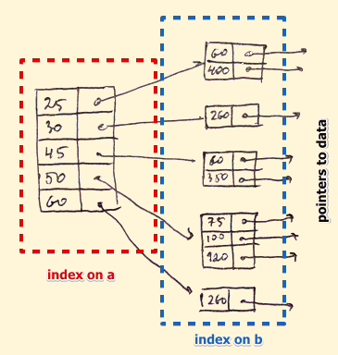](https://www.guru99.com/images/1/070119_0833_IndexinginD5.png)

## B-Tree Index

B-tree index is the widely used data structures for tree based indexing in DBMS. It is a multilevel format of tree based indexing in DBMS technique which has balanced [binary search trees](https://www.guru99.com/binary-search-tree-data-structure.html). All leaf nodes of the B tree signify actual data pointers.

Moreover, all leaf nodes are interlinked with a link list, which allows a B tree to support both random and sequential access.

[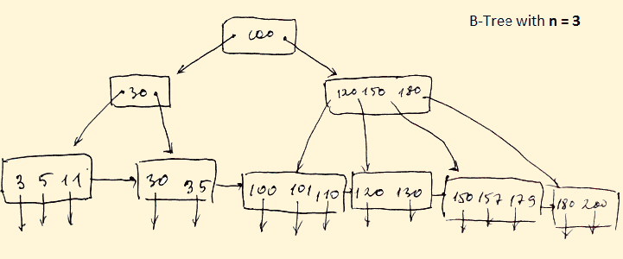](https://www.guru99.com/images/1/070119_0833_IndexinginD6.png)

* Lead nodes must have between 2 and 4 values.
* Every path from the root to leaf are mostly on an equal length.
* Non-leaf nodes apart from the root node have between 3 and 5 children nodes.
* Every node which is not a root or a leaf has between n/2] and n children.

## Advantages of Indexing

Important pros/ advantage of Indexing are:

* It helps you to reduce the total number of I/O operations needed to retrieve that data, so you don’t need to access a row in the database from an index structure.
* Offers Faster search and retrieval of data to users.
* Indexing also helps you to reduce tablespace as you don’t need to link to a row in a table, as there is no need to store the ROWID in the Index. Thus you will able to reduce the tablespace.
* You can’t sort data in the lead nodes as the value of the primary key classifies it.

## Disadvantages of Indexing

Important drawbacks/cons of Indexing are:

* To perform the indexing database management system, you need a primary key on the table with a unique value.
* You can’t perform any other indexes in Database on the Indexed data.
* You are not allowed to partition an index-organized table.
* SQL Indexing Decrease performance in INSERT, DELETE, and UPDATE query.

## Summary

* Indexing is a small table which is consist of two columns.
* Two main types of indexing methods are 1)Primary Indexing 2) Secondary Indexing.
* Primary Index is an ordered file which is fixed length size with two fields.
* The primary Indexing is also further divided into two types 1)Dense Index 2)Sparse Index.
* In a dense index, a record is created for every search key valued in the database.
* A sparse indexing method helps you to resolve the issues of dense Indexing.
* The secondary Index in DBMS is an indexing method whose search key specifies an order different from the sequential order of the file.
* Clustering index is defined as an order data file.
* Multilevel Indexing is created when a primary index does not fit in memory.
* The biggest benefit of Indexing is that it helps you to reduce the total number of I/O operations needed to retrieve that data.
* The biggest drawback to performing the indexing database management system, you need a primary key on the table with a unique value.

OOPS concepts with real time examples

In this article, I am going to discuss OOP concepts with real-world examples. First of all, let's see what is OOP?

## What is OOP?

OOP - Object-Oriented Programming is a programming paradigm that is based on objects. (Objects - real-world entities like book, vehicle, tree, etc..)

Now let's see what are OOP concepts.

There are 4 OOP concepts. They are,

1. Polymorphism
2. Inheritance
3. Encapsulation
4. Abstraction

Let's discuss it one by one.

## 1. Polymorphism

Polymorphism is the ability to exist in many forms.

Example 1: We can take a boy as a real-world example. This boy can be a student, a player, and a writer. So that this boy can exist in different ways in different situations.

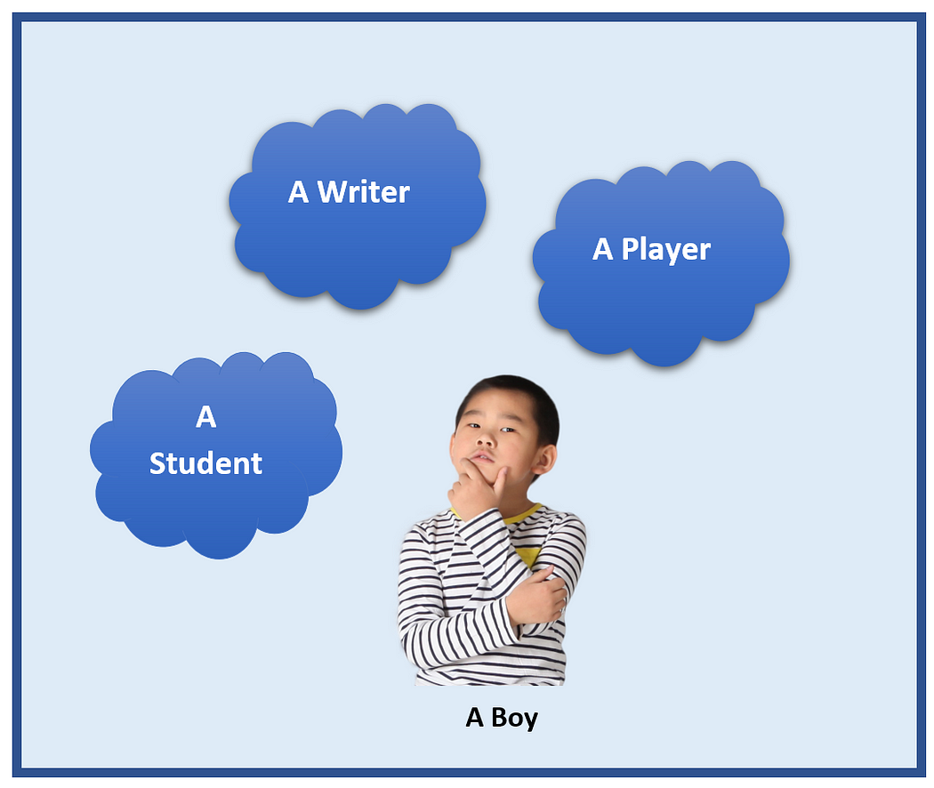

Example 2: Sound of animals. People have the same sound but different animals make different sounds. The following diagram shows few different sounds make by animals.

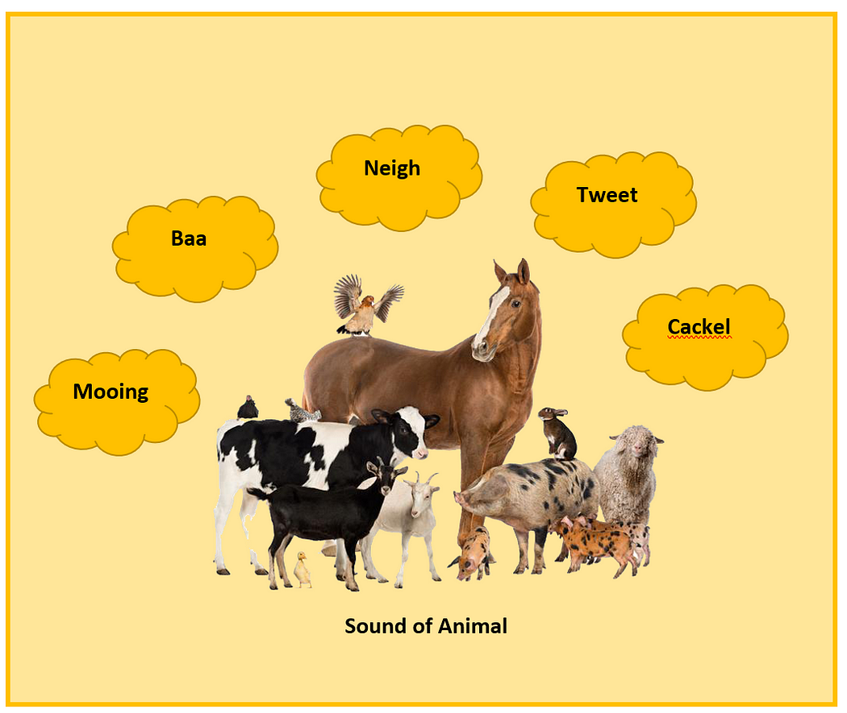

This what we called as polymorphism.

## 2. Inheritance

Inheritance means it allows classes to inherit common properties from the parent class.

Example 1: let's assume that there is a class as Vehicle. All vehicles are not the same. We can inherit common properties like color, size, type from the parent vehicle class and create classes like Car, Bus, Bike.



Example 2: let's take another parent class as Animals. Here also we can inherit common properties like name, sound, color, breed from Animal class and create classes like Dog, Cat, Horse and etc.



## 3. Encapsulation

Encapsulation means it binds data and code together into one unit.

Example1; the most commonly used example is the medical capsule. This capsule mixes few types of medicines and stored in one capsule.

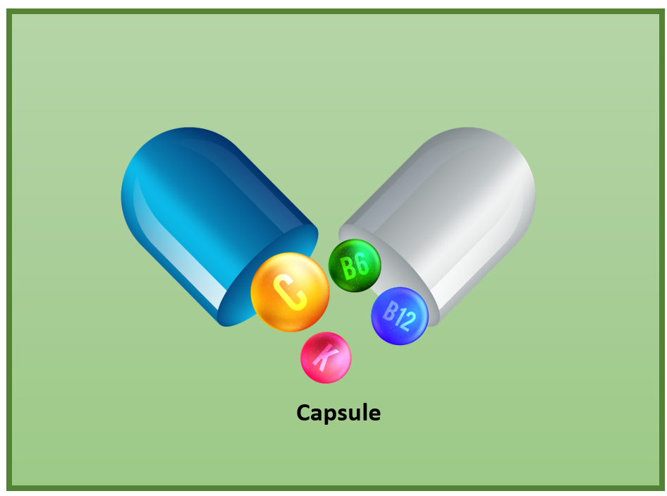

Example 2: another example for encapsulation is a large organization. An organization is consists of several departments like the production department, purchase department, sales department, and Accounts department. It combines all these departments together and had formed the organization.

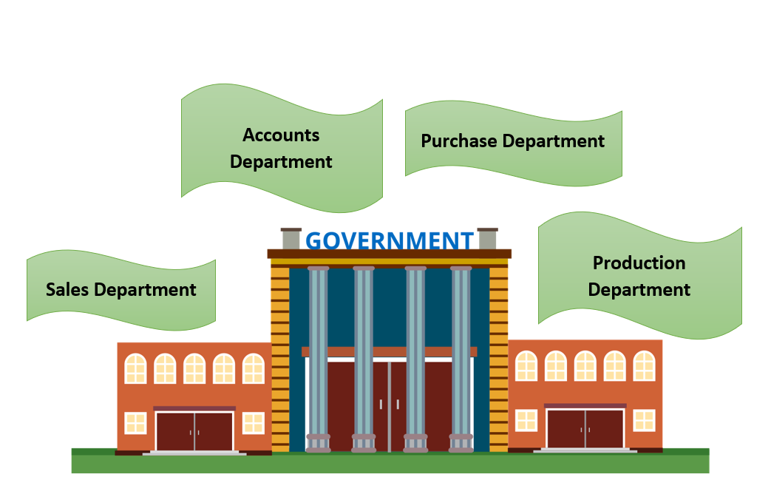

This is what we called as encapsulation.

## 4. Abstraction

In abstraction, it displays only the important information by hiding the implementation part.

Example 1: Let's take the ATM machine. In an ATM machine, we can perform functions like withdraw cash, deposit cash, check balance, print bills, and so on. Even though it performs a lot of actions it doesn’t show us the process. It has hidden its process by showing only the main things like getting inputs and giving the output.

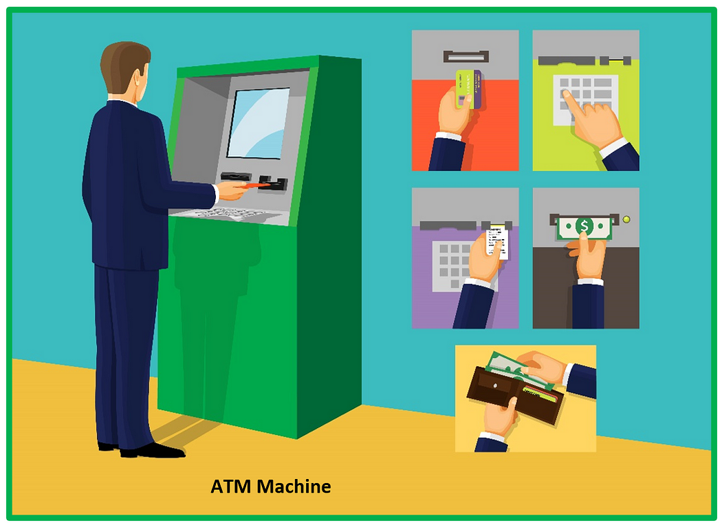

Example 2: The next example is the most commonly used mobile phones. On a mobile phone, we can perform so many actions like making a call, sending messages, take pictures, download software and etc. We perform a lot of things but here also we don't know the inside process of these things. Which means the implementation parts are hidden.



This is what we called as an abstraction

So that's about OOP concepts with real-world examples. I hope you got a clear idea about these concepts.

Thank you for reading my article.

This keyword in java

Definition and UsageThe this keyword refers to the current object in a method or constructor. The most common use of the this keyword is to eliminate the confusion between class attributes and parameters with the same name (because a class attribute is shadowed by a method or constructor parameter).

1. **class** Student{
2. **int** rollno;
3. String name;
4. **float** fee;
5. Student(**int** rollno,String name,**float** fee){
6. **this**.rollno=rollno;
7. **this**.name=name;
8. **this**.fee=fee;
9. }
10. **void** display(){System.out.println(rollno+" "+name+" "+fee);}
11. }
13. **class** TestThis2{
14. **public** **static** **void** main(String args[]){
15. Student s1=**new** Student(111,"ankit",5000f);
16. Student s2=**new** Student(112,"sumit",6000f);
17. s1.display();
18. s2.display();
19. }}

**How can we create immutable classes ?**

**Creating an Immutable Class in Java**

1. Declare the class as final so it can't be extended.
2. Make all of the fields private so that direct access is not allowed.
3. Don't provide setter methods for variables.
4. Make all mutable fields final so that a field's value can be assigned only once.

## [Creating an Immutable Class in Java](https://www.digitalocean.com/community/tutorials/how-to-create-immutable-class-in-java#creating-an-immutable-class-in-java)

To create an immutable class in Java, you need to follow these general principles:

1. Declare the class as final so it can’t be extended.
2. Make all of the fields private so that direct access is not allowed.
3. Don’t provide setter methods for variables.
4. Make all mutable fields final so that a field’s value can be assigned only once.
5. Initialize all fields using a [constructor](https://www.digitalocean.com/community/tutorials/constructor-in-java) method performing deep copy.
6. Perform [cloning](https://www.digitalocean.com/community/tutorials/java-clone-object-cloning-java) of objects in the getter methods to return a copy rather than returning the actual object reference.

import java.util.HashMap;

import java.util.Iterator;

public final class FinalClassExample {

// fields of the FinalClassExample class

private final int id;

private final String name;

private final HashMap<String,String> testMap;

public int getId() {

return id;

}

public String getName() {

return name;

}

// Getter function for mutable objects

public HashMap<String, String> getTestMap() {

return (HashMap<String, String>) testMap.clone();

}

// Constructor method performing deep copy

public FinalClassExample(int i, String n, HashMap<String,String> hm){

System.out.println("Performing Deep Copy for Object initialization");

// "this" keyword refers to the current object

this.id=i;

this.name=n;

HashMap<String,String> tempMap=new HashMap<String,String>();

String key;

Iterator<String> it = hm.keySet().iterator();

while(it.hasNext()){

key=it.next();

tempMap.put(key, hm.get(key));

}

this.testMap=tempMap;

}

// Test the immutable class

public static void main(String[] args) {

HashMap<String, String> h1 = new HashMap<String,String>();

h1.put("1", "first");

h1.put("2", "second");

String s = "original";

int i=10;

FinalClassExample ce = new FinalClassExample(i,s,h1);

// print the ce values

System.out.println("ce id: "+ce.getId());

System.out.println("ce name: "+ce.getName());

System.out.println("ce testMap: "+ce.getTestMap());

// change the local variable values

i=20;

s="modified";

h1.put("3", "third");

// print the values again

System.out.println("ce id after local variable change: "+ce.getId());

System.out.println("ce name after local variable change: "+ce.getName());

System.out.println("ce testMap after local variable change: "+ce.getTestMap());

HashMap<String, String> hmTest = ce.getTestMap();

hmTest.put("4", "new");

System.out.println("ce testMap after changing variable from getter methods: "+ce.getTestMap());

}

}

Garbage Collectors & How many types

four types

There are four types of the garbage collector in Java that can be used according to the requirement: Serial Garbage Collector. Parallel Garbage Collector. Concurrent Mark Sweep (CMS) Garbage Collector.

## **Types of Garbage Collector**

There are **four** types of the garbage collector in [Java](https://www.javatpoint.com/java-tutorial) that can be used according to the requirement:

* Serial Garbage Collector
* Parallel Garbage Collector
* Concurrent Mark Sweep (CMS) Garbage Collector
* Garbage First (G1) Garbage Collector

The performance and working of each garbage collector are completely different. It has its own pros and cons. Java allows us to choose any one garbage collector that is to be used by the [JVM](https://www.javatpoint.com/jvm-java-virtual-machine). For the selection of GC, we need to pass JVM arguments. It is difficult to select the right garbage collector for the application. Let's discuss each garbage collector one by one.

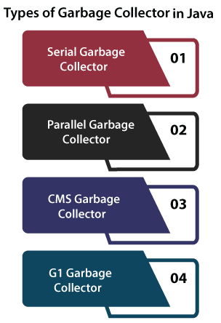

### Serial Garbage Collector

Serial Garbage collector is well-matched for **single-threaded environments**. It uses the **only** thread for garbage collection. It works by holding all the threads of an application. It means that threads of the application **freeze** by the serial garbage collector during the garbage collection process and the process is known as **stop the world event**. Avoid the use of serial GC in the server environment. We can use it for simple programs. If you want to use the serial garbage collector, execute the **-XX:+UseSerialGC** JVM argument to activate it.

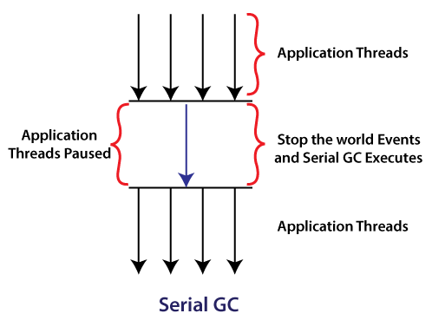

### Parallel Garbage Collector

Parallel Garbage Collector is the **default GC** used by the JVM. The working of the parallel garbage collector is the same as the serial garbage collector. The only difference between serial and parallel garbage collector is that serial garbage collector uses a **single** thread for garbage collection process while the parallel garbage collector uses **multiple** threads for the garbage collection. Parallel GC can use multiple CPUs to speed up the application throughput. So, it is also known as **throughput collector**. It is used if we want to execute a long process (like batch processing) and where long pauses are acceptable. If you want to use the parallel garbage collector, execute the **-XX:+UseParallelGC** JVM argument to activate it.

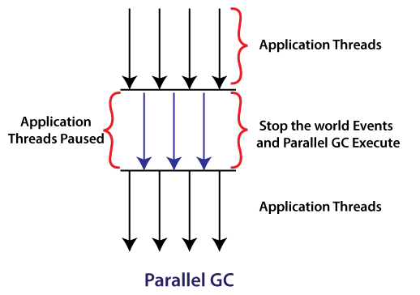

We can also use the following JVM arguments in parallel GC:

|  |  |
| --- | --- |
| **JVM Argument** | **Description** |
| -XX:ParallelGCThreads=<n> | It controls the number of GC threads (n). |
| -XX:MaxGCPauseMillis=<t> | It specifies the maximum pause time\*. |
| -XX:GCTimeRatio=<n> | It specifies the maximum throughput target\*\*. |

**\*Pause Time:**The gap between two GC.

**\*\*Throughput Target:** The time spent during the garbage collection versus the time spent outside of garbage collection is called throughput target.

### Concurrent Mark and Sweep (CMS) Garbage Collector

CMS uses multiple threads that scan the heap and during the scanning, it marks the instances for eviction, after scanning, it sweeps the marked instances. It does not freeze the application's threads during the garbage collection. GC threads concurrently execute with the application's threads. For this reason, it uses more CPU in comparison to other GC. It is also known as the **concurrent low pause collector**. It also freezes all the threads of the application only if it satisfies the following two scenarios:

* while marking the referenced objects in the tenured generation region.
* if any change is made to the heap memory in parallel during the garbage collection process.

We can use multiple CPUs for better application throughput. We should use a CMS garbage collector if we have more CPUs for use. Hence, it has an advantage over the parallel garbage collector. If you want to use a CMS garbage collector, execute the **-XX:+USeParNewGC**JVM argument to activate it. We can also set the number of GC threads by using the **-XX:ParallelCMSThreads=<n>** JVM argument.

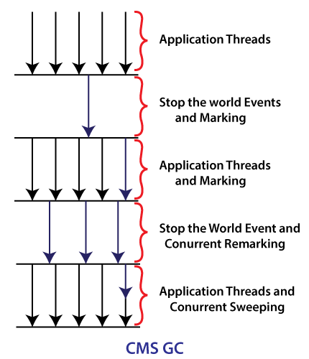

#### **Note: The JVM argument -XX:+UseConcMarkSweepGC has been deprecated because a warning message is issued when it is requested on the command line.**

### Garbage First (G1) Garbage Collector

The G1 garbage collector is used if we have a large (more than 4GB) memory (heap space). It divides the heap into equal-sized (usually 1MB to 32MB) chunks, prioritizes them, and then performs the parallel garbage collection on that chunks based on the priority.

The Eden, survivors, and old areas use this equal-sized region for the memory allocation of the objects. Apart from these memory regions, there are two more types of regions presented in the G1 GC:

* **Humongous:** It is used if the object sized is large.
* **Available:** It represents the unoccupied space.

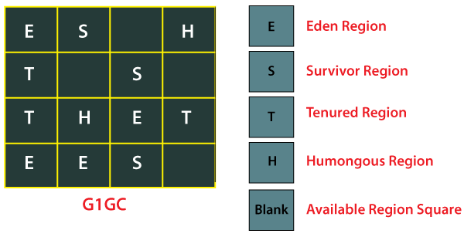

G1 GC shows a concurrent global marking phase to determine the live and dead objects throughout the heap. After the completion of the mark phase, G1 collects the information of regions that contains the most garbage objects. After that these regions are swept first. If you want to use the G1 garbage collector, execute the **-XX:+UseG1GC** JVM argument to activate it.

## **Stop the World Event**

It is a situation when the garbage collector performs the garbage collection (GC) and stops all the application's threads until the GC process is not completed. The process is known as **Stop the World (STW)**events.

## **Improvement in Garbage Collector Since Java 8**

In Java 8, the G1 garbage collector has been updated. The updated GC provides the **-XX:+UseStringDeduplication** JVM argument that optimizes the heap memory. It removes the duplicate String values to a single char[] array.

## **Garbage Collection JVM Options**

Java garbage collection key options are as follows:

### JVM Arguments

The table describes the arguments that can be used to instruct the JVM.

|  |  |
| --- | --- |
| **Option** | **Description** |
| -XX:+UseSerialGC | Serial Garbage Collector |
| -XX:+UseParallelGC | Parallel Garbage Collector |
| -XX:+UseConcMarkSweepGC | CMS Garbage Collector |
| -XX:ParallelCMSThreads= | CMS Collector - number of threads to use |
| -XX:+UseG1GC | G1 Garbage Collector |
| **Some Other Important Arguments** | |
| -XX:InitiatingHeapOccupancyPercent=<n> | It controls the **heap occupancy** after starting the concurrent cycle. Here, n is the percentage of heap space. The default percentage is **45**. |
| -XX:G1MixedGCLiveThresholdPercent=<t> | If a live object in the OLD region exists with a value greater than or equal to this option, it is excluded from the GC object. Here, t is the time in **milliseconds**. The default value is **65**. |
| -XX:G1HeapWastePercent=<r> | It specifies how many **regions** are allowed to be wasted. Here, r is the number of regions. The default value is **10**. |

### GC Optimization Options

|  |  |
| --- | --- |
| **Option** | **Description** |
| -Xms | It specifies the initial heap size. |
| -Xmx | It maximizes the heap size. |
| -Xmn | It is used to specify the size of the Young Generation. |
| -XX:PermSize | Initial Permanent Generation size |
| -XX:MaxPermSize | It is used to specify the maximum size of Permanent Generation (PermGen). |

### Usage of JVM GC Options

1. java -Xmx12m -Xms3m -Xmn1m -XX:PermSize=20m -XX:MaxPermSize=20m -XX:+UseSerialGC -jar java-application.jar

We have discussed all four types of Java garbage collectors. But it is difficult to select one because it depends on the application scenario, availability of hardware, and throughput requirements.

what is diffarence b/w Java SE and Java EE.

While Java SE provides basic programming functionality, the latter offers a standardized set of APIs and other features for building large-scale applications. In addition to this, J2EE is designed to support the development of server applications.

## What’s the Difference Between Java SE and Java EE?

Both Java EE and Java SE are high-level programming languages that are popularly used for web applications. While Java SE provides basic programming functionality, the latter offers a standardized set of APIs and other features for building large-scale applications. In addition to this, J2EE is designed to support the development of server applications. Earlier known as Java 2 Platform, Standard Edition, J2EE is based on the Java programming language.

There are a number of major differences between Java SE and Java EE. While Java SE contains all of the Java APIs and classes, Java EE has a more complete platform. Java EE has several APIs and services connected to RMI, JMS, and XML. Because of the increased functionality of the Java platform, Java EE is easier to implement and maintain, but both languages are used for similar purposes.

## Java vs. Java EE Compared

A comparison of Java vs. Java EE identifies the differences between the two languages. Java EE provides many new libraries for creating large, distributed, and fault-tolerant applications. Among the features of Java EE are the Enterprise JavaBeans (EJB) framework, messaging and Web Services, and XML processing. Spring, a framework for J2EE, is easier to use and targets Java EE development. Using Spring, developers can create enterprise-class applications using POJOs.

Generally, Java is a general-purpose programming language related to C++, a direct descendant of the original C language. While Java and C++ share many of the same syntax, they are quite different in scope. In addition, Java was developed to solve some of the challenges associated with C++. Sun Microsystems created both Java EE. Java EE (formerly J2EE) is an industry standard for developing web-based server-side applications.

transient key working in threads.

# transient keyword in Java

• **Read**

• Discuss

• Practice

**transient** is a variables modifier used in [serialization](https://www.geeksforgeeks.org/serialization-in-java/). At the time of serialization, if we don’t want to save value of a particular variable in a file, then we use **transient** keyword. When JVM comes across **transient**keyword, it ignores original value of the variable and save default value of that variable data type.

**transient** keyword plays an important role to meet security constraints. There are various real-life examples where we don’t want to save private data in file. Another use of **transient** keyword is not to serialize the variable whose value can be calculated/derived using other serialized objects or system such as age of a person, current date, etc.  
Practically we serialized only those fields which represent a state of instance, after all serialization is all about to save state of an object to a file. It is good habit to use **transient** keyword with private confidential fields of a class during serialization.

|  |
| --- |
| // A sample class that uses transient keyword to  // skip their serialization.  **class** Test **implements** Serializable  {      // Making password transient for security  **private** **transient** String password;        // Making age transient as age is auto-      // computable from DOB and current date.  **transient** **int** age;        // serialize other fields  **private** String username, email;      Date dob;        // other code  } |

**transient and static :**Since **static** fields are not part of state of the object, there is no use/impact of using **transient** keyword with static variables. However there is no compilation error.

**transient and final :**final variables are directly serialized by their values, so there is no use/impact of declaring final variable as **transient**. There is no compile-time error though.

|  |
| --- |
| // Java program to demonstrate transient keyword  // Filename Test.java  **import** java.io.\*;  **class** Test **implements** Serializable  {      // Normal variables  **int** i = 10, j = 20;        // Transient variables  **transient** **int** k = 30;        // Use of transient has no impact here  **transient** **static** **int** l = 40;  **transient** **final** **int** m = 50;    **public** **static** **void** main(String[] args) **throws** Exception      {          Test input = **new** Test();            // serialization          FileOutputStream fos = **new** FileOutputStream("abc.txt");          ObjectOutputStream oos = **new** ObjectOutputStream(fos);          oos.writeObject(input);            // de-serialization          FileInputStream fis = **new** FileInputStream("abc.txt");          ObjectInputStream ois = **new** ObjectInputStream(fis);          Test output = (Test)ois.readObject();          System.out.println("i = " + output.i);          System.out.println("j = " + output.j);          System.out.println("k = " + output.k);          System.out.println("l = " + output.l);          System.out.println("m = " + output.m);      }  } |

Output :

i = 10

j = 20

k = 0

l = 40

m = 50

If you like GeeksforGeeks and would like to contribute, you can also write an article using [write.geeksforgeeks.org](http://write.geeksforgeeks.org/) or mail your article to review-team@geeksforgeeks.org. See your article appearing on the GeeksforGeeks main page and help other Geeks.

Why/How Java achieve Platform independence?

Java is platform-independent because it uses a virtual machine. The Java programming language and all APIs are compiled into bytecodes. Bytecodes are effectively platform-independent. The virtual machine takes care of the differences between the bytecodes for the different platforms

The availability of object-oriented programming ([OOP](https://www.upgrad.com/blog/a-complete-guide-on-oops-concepts-in-python/)) made java stand out from all other remaining languages at its time. Java was developed to use OOP at its core and it was one of a reason for being a most used language. This concept increases reusability, seamless execution. At this moment, there may be a question in our mind “why should we use an object?”.

Objects in Java are similar to structures in c language, where we are binding similar methods and variables together. Along with that Java also provides abstraction, encapsulation, inheritance, and polymorphism which encourages the user to implement objects. You can also consider doing our [Java Bootcamp course from upGrad.](https://www.upgrad.com/learn-java-coding-online/?utm_source=blog_details&utm_medium=BODY&utm_campaign=TV_JV_UPG_BLOG_BODY_96501)

Java plays a dominant role in many domains like app development, [web development](https://www.upgrad.com/blog/career-in-web-development/), building software tools. It also has a rich number of libraries which makes things easier. Also, the availability of IDE plays a crucial role in gaining the attention of developers. IDEs like Eclipse, IntelliJ, NetBeans are frequently used by many developers. Java has the asset to move over different computer systems, it is basically Write Once Run Anywhere. Java is portable which makes a big difference in its being better than the C language.

## What is a Platform, and What is a Platform-Independent Language?

A platform combines hardware and software on which computer programs run. It encompasses the operating system, hardware architecture, and various software components that provide an environment for executing applications. Different platforms can have different hardware architectures, operating systems, and other software configurations. Each platform may have its own set of libraries, APIs, and system resources.

Moreover, if you talk about Platform-Independent Language, it is a programming language that is designed to be executable on different platforms without requiring major modifications to the code. In other words, programs written in a platform-independent language can run on various platforms without significant changes or adaptations.

Java is a prime example of a platform-independent language. It achieves platform independence through the Java Virtual Machine (JVM).

Platform-independent languages like Java offer several advantages. Some of them are: –

### Portability

Programs can be written once and executed on multiple platforms, reducing development effort and maintenance.

### Reduced Compatibility Issues

Since the JVM handles platform-specific details, developers don’t need to worry about low-level platform differences.

### Cost Savings

Developing separate program versions for each platform can be time-consuming and costly. A platform-independent language can reduce these expenses.

### Wider Audience

Platform-independent programs can reach a broader audience as they are not limited to a specific operating system or hardware architecture.

### Consistency

The program’s behavior remains consistent across different platforms, ensuring a predictable user experience.

## How does a program execute in Java?

In Java, a program is executed through a series of steps that involve compilation and execution by the Java Virtual Machine (JVM). Here’s a high-level overview of how a Java program is executed:

### Writing the Java Code

You start by writing your Java code using a text editor or an Integrated Development Environment (IDE).

### Compilation

Once you’ve written your Java code, save it with a .java extension. To execute the code, you must compile it into bytecode, a platform-independent intermediate representation. You use the Javac command (Java Compiler) to compile your .java files. Compilation generates .class files containing bytecode.

### Bytecode Generation

During compilation, the Java compiler translates your human-readable source code into bytecode instructions that represent the operations your program should perform.

### Class Loading

The Java Class Loader subsystem loads the compiled .class files. The Class Loader loads the classes into memory when they are first accessed. The class loading process also involves loading referenced classes.

### Bytecode Verification

Before the bytecode is executed, the JVM performs a verification step to ensure that the bytecode is well-formed and doesn’t violate security constraints. This helps prevent runtime errors and security vulnerabilities.

### Execution

The JVM’s execution engine processes the bytecode instructions one by one. It uses Just-In-Time (JIT) compilation techniques to convert some or all of the bytecode into native machine code for the specific platform on which the program is running. This improves execution speed.

### Runtime

While the program runs, the JVM manages memory, thread execution, and other runtime aspects. It also provides various runtime services like garbage collection for memory management.

### Execution Completion or Termination

The program continues to execute until it reaches the main method’s end or an explicit termination condition is met. Once the program’s execution completes, the JVM performs any necessary cleanup operations and terminates.

It’s important to note that why java is platform independent is achieved through the JVM. You write your code once and compile it into bytecode, which can be executed on any platform with a compatible JVM implementation.

Overall, the combination of compilation and execution stages within the JVM allows Java programs to be efficient, secure, and portable across different platforms.

**Check Out upGrad’s**[**Full Stack Development Bootcamp**](https://www.upgrad.com/full-stack-development-bootcamp/?utm_source=blog_details&utm_medium=BODY&utm_campaign=TV_SEFS_BT_BLOG_BODY_96501)

### Compiling a Code

Whenever we write a code, we follow the syntaxes of a programming language, which would have a fair amount of readability. And it contains few words, phrases, variable names, method names, etc. All these things are considered to be human-readable and human-understandable text. Join our [fullstack development bootcamp course](https://www.upgrad.com/full-stack-development-bootcamp/?utm_source=blog_details&utm_medium=BODY&utm_campaign=TV_SEFS_BT_BLOG_BODY_96501) if you are interested in fullstack.

So a machine uses a compiler to convert the source code into a machine-readable code which is also referred to as machine-level language. The compiler builds the machine-level code in a specific presentation such that it can be easily understood by the CPU and hence execute it seamlessly.

**Check Out upGrad’s**[**Advanced Certification in Cloud Computing**](https://www.upgrad.com/cloud-computing-certification-pgc-iiitb/?utm_source=blog_details&utm_medium=BODY&utm_campaign=TV_SECL_PGC_BLOG_BODY_96501)

This building of machine-level language differs by each programming language and each operating system. For example, c/c++ generates a .exe file that is not the same for two machines if they are running on a different operating system.

And here arises the problem!

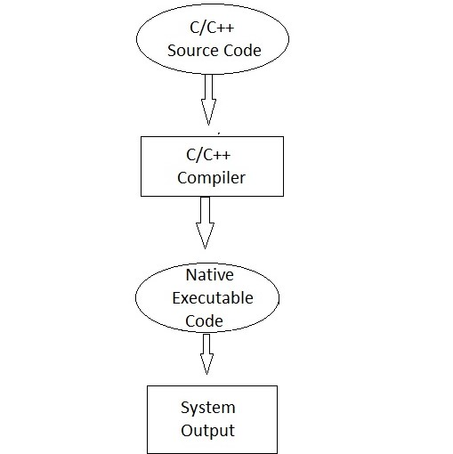

This building of machine-level language differs by each programming language and each operating system. For example, c/c++ generates a .exe file that is not the same for two machines if they are running on a different operating system.

And here arises the problem!

When a machine level language differs by each operating system, then we cannot run a code that is compiled in a different machine in a new machine, unless both of the systems operate on the same operating system. This feels like crap for many programmers and developers.

But Java makes things easier, and java has a solution for this. Let’s get started.

## Java is Platform Independent

So what happens when we compile code in java?

Whenever we enter a statement “javac filename.java” or compile a code in java, javac compiles the code. And it creates an intermediate code called Byte Code.

Bytecode adds this important feature in Java of being independent/ portable as this bytecode is independent of the platforms. This dependency eases the tasks as it can be used in various environments with lesser planning and translation.

This is where java makes difference between all different programming languages. It creates a .class file, which is considered as byte code. Whereas languages like c/c++ will create a natively executable code when they are compiled and thus makes them platform dependent.

Hold on, this is too early for celebration. This byte code is not executable. We need a translator for executing this byte code. And JVM does this job. Generally, JVM resides in the main memory of our computer. Java Virtual Machine acts as an interpreter and then executes the byte code generated by javac.

And now we are done, our code gets executed successfully.

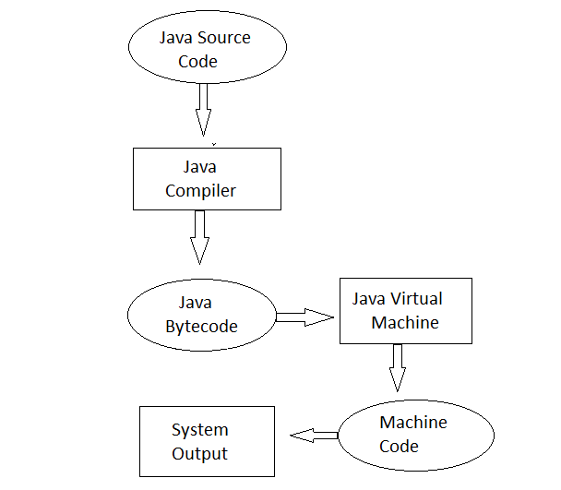

So how does java going to manage it all alone?

And the answer would be, it’s because of the JVM. The byte code generated by source code compilation would run in any operating system, but the JVM present in a machine differs for each operating system. And this is how java is considered a platform-independent programming language.

To understand it properly, let’s understand the architecture and working of the JVM.

**Our learners also read:** [Java free online courses](https://www.upgrad.com/blog/java-free-online-course/)!

***upGrad’s Exclusive Software and Tech Webinar for you –***

SAAS Business – What is So Different?

## JVM Architecture

JVM is part of the java runtime environment and is responsible for converting a .java file into a .class file. When we compile a java code JVM calls the main method in the source code.

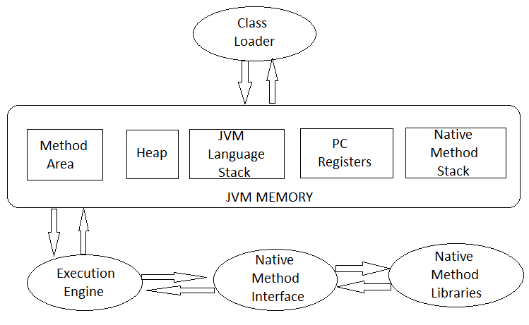

*JVM Architecture*

## Explore Our Software Development Free Courses

|  |  |  |
| --- | --- | --- |
| [**Fundamentals of Cloud Computing**](https://www.upgrad.com/fundamentals-of-cloud-computing-free-course/?utm_source=blog_details&utm_medium=TABLE&utm_campaign=ALL_FREE_TV_BLOG_TABLE) | [**JavaScript Basics from the scratch**](https://www.upgrad.com/basics-ofjavascript-free-course/?utm_source=blog_details&utm_medium=TABLE&utm_campaign=ALL_FREE_TV_BLOG_TABLE) | [**Data Structures and Algorithms**](https://www.upgrad.com/data-structures-and-algorithm-free-course/?utm_source=blog_details&utm_medium=TABLE&utm_campaign=ALL_FREE_TV_BLOG_TABLE) |
| [**Blockchain Technology**](https://www.upgrad.com/introduction-to-blockchain-technology-free-course/?utm_source=blog_details&utm_medium=TABLE&utm_campaign=ALL_FREE_TV_BLOG_TABLE) | [**React for Beginners**](https://www.upgrad.com/reactjs-for-beginners-free-course/?utm_source=blog_details&utm_medium=TABLE&utm_campaign=ALL_FREE_TV_BLOG_TABLE) | [**Core Java Basics**](https://www.upgrad.com/core-java-basics-free-course/?utm_source=blog_details&utm_medium=TABLE&utm_campaign=ALL_FREE_TV_BLOG_TABLE) |
| [**Java**](https://www.upgrad.com/object-oriented-principles-in-java-free-course/?utm_source=blog_details&utm_medium=TABLE&utm_campaign=ALL_FREE_TV_BLOG_TABLE) | [**Node.js for Beginners**](https://www.upgrad.com/nodejs-for-beginners-free-course/?utm_source=blog_details&utm_medium=TABLE&utm_campaign=ALL_FREE_TV_BLOG_TABLE) | [**Advanced JavaScript**](https://www.upgrad.com/advanced-javascript-free-course/?utm_source=blog_details&utm_medium=TABLE&utm_campaign=ALL_FREE_TV_BLOG_TABLE) |

## ClassLoader

It is a subsystem in the java virtual machine. It loads the .class file, checks if there are any exceptions and it is the reason for few runtime exceptions. And after checking it allocates the memory for the variables and the methods present, assign default values to variables and arrays. It also executes the static methods or variables present in the code.

The classes are loaded on demand and the java run time is not necessarily supposed to know of the file and its systems as the work is supposed to be done by the classloader.

There are 3 built-in class loaders inJVMm, bootstrap classloader, Extension classloader, Application classloader.

Just to briefly mention the workings of these classes-

1. Bootstrap Classloader- Loads the libraries of Java.
2. Extension Classloader- Load the codes in the directories of extensions or any other directory commanded by the system property.
3. Application Classloader- Loads code found on java.class.path eventually mapping these java.class.path to CLASSPATH environment variable.

## Memory Areas in JVM

### Method/Class Area

It stores information like class names, method names, variables. It is a shared resource for all the methods and variables in a class. It works as a memory that stores information important to execute the task. It is shared on all the virtual machine threads. Its size depends upon the computation either fixed or expandable.

### Heap

It stores the information of all the data stored in the heap area. It stores the data in a certain amount which will not be known until the program runs. It is used throughout the application. It is used for dynamic memory allocation. The creation of new objects happens in the heap area.

## In-Demand Software Development Skills

|  |  |  |
| --- | --- | --- |
| [**JavaScript Courses**](https://www.upgrad.com/software-engineering-course/javascript/) | [**Core Java Courses**](https://www.upgrad.com/software-engineering-course/core-java/) | [**Data Structures Courses**](https://www.upgrad.com/software-engineering-course/data-structures/) |
| [**Node.js Courses**](https://www.upgrad.com/software-engineering-course/nodejs/) | [**SQL Courses**](https://www.upgrad.com/software-engineering-course/sql/) | [**Full stack development Courses**](https://www.upgrad.com/software-engineering-course/full-stack-development/) |
| [**NFT Courses**](https://www.upgrad.com/software-engineering-course/nft-non-fungible-tokens/) | [**DevOps Courses**](https://www.upgrad.com/software-engineering-course/devops/) | [**Big Data Courses**](https://www.upgrad.com/software-engineering-course/big-data/) |
| [**React.js Courses**](https://www.upgrad.com/software-engineering-course/react-js/) | [**Cyber Security Courses**](https://www.upgrad.com/software-engineering-course/cyber-security/) | [**Cloud Computing Courses**](https://www.upgrad.com/software-engineering-course/cloud-computing/) |
| [**Database Design Courses**](https://www.upgrad.com/software-engineering-course/database-design/) | [**Python Courses**](https://www.upgrad.com/software-engineering-course/python/) | [**Cryptocurrency Courses**](https://www.upgrad.com/software-engineering-course/cryptocurrency/) |

### JVM Language Stack

It stores the information in blocks also called stack-frames/frames, which stores the current information when there is a function call, stores local variables, it also plays a dominant role in thread management.

### PC Register

It stores the address of the instruction which is currently being executed. It is useful in a multi-thread execution situation.

**Also Read:**[Java Project Ideas & Topics](https://www.upgrad.com/blog/java-project-ideas-topics-for-beginners/)

### Native Method Stack

It stores all the information of about the native methods used. It can access system-specific functions not available directly in Java. The main objective of this is to improve the system performance by memory-level communication.

Also visit [upGrad’s Degree Counselling](https://www.upgrad.com/degree-counseling/?utm_source=blog_details&utm_medium=BODY&utm_campaign=DGV_ALL_UPG_BLOG_BODY_96501) page for all undergraduate and postgraduate programs.

## Execution Engine

The Execution engine will execute the byte code, and it removes the allocated memory to the objects which are unreachable or unreferenced. The interpreter in the execution engine will execute the byte code by reading it in a stream and interpreting line by line.

It also has an exciting part called JIT compiler (Just In Time Compiler), where it creates a native executable code for methods, so if there are multiple function calls then the JVM need not interpret it again, rather directly use the native executable code. Hence it improves the performance of execution.

## Native Method Interface

This interface is used by java for interacting with the applications implemented in different languages like C/C++. The interaction is bidirectional, where the JVM may call those applications or can be called by those applications. It limits the portability due to the system-specific application of code. It facilitates interaction between native code (written in C/ C++) with other codes ( written in Java or other programming languages). This is also what makes Java platform independent.

*Learn*[*Software Development Courses online*](https://www.upgrad.com/software-engineering-course/)*from the World’s top Universities. Earn Executive PG Programs, Advanced Certificate Programs, or Masters Programs to fast-track your career.*

## Native Method Libraries

It keeps track of the native language libraries, which may be used by the execution engine. They are classified as the compilation of codes written for a specific architecture. They are platform-specific files.

Now that we’ve understood the architecture of the JVM let’s get back to our discussion. So this JVM is different for different operating systems, but the output generated by those JVMs will be the same for the same byte code provided.

[](https://www.upgrad.com/full-stack-developer-course-pgd-iiitb/?utm_source=blog_details&utm_medium=BODY&utm_campaign=TV_FSD_PGD_BLOG_BODY_POPULAR)

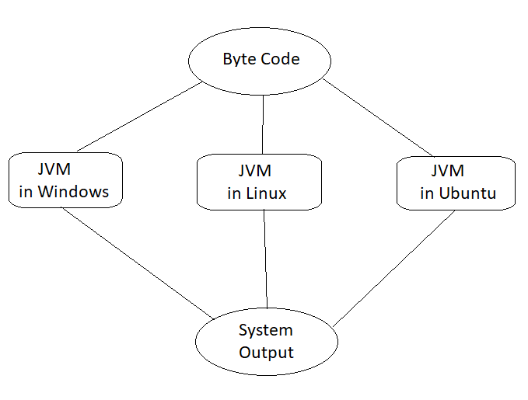

## Read our Popular Articles related to Software Development

|  |  |  |
| --- | --- | --- |
| [**Why Learn to Code? How Learn to Code?**](https://www.upgrad.com/blog/why-learn-to-code-now-and-how/) | [**How to Install Specific Version of NPM Package?**](https://www.upgrad.com/blog/npm-install-specific-version/) | [**Types of Inheritance in C++ What Should You Know?**](https://www.upgrad.com/blog/types-of-inheritance-in-c-plus-plus/) |

## Conclusion

In this article we have discussed how is java platform independent. We’ve gone through a few unique features of java, understood what happens when we compile code in languages like C/C++ and understood the difference between natively executable code and byte code. We’ve walked through the explanation of why java is considered a platform-independent language and understood that JVM is the reason behind java’s platform independence. We had a look at JVM architecture for a better understanding. This article must have cleared the understanding if java is platform dependent or independent.

Now that you are aware of the reason why java is platform-independent, explore other unique features of java and start utilizing them!

If you’re interested to learn more about Java, full-stack software development, check out upGrad & IIIT-B’s [Executive PG Program in Full-stack Software Development](https://www.upgrad.com/full-stack-developer-course-pgd-iiitb/?utm_source=blog_details&utm_medium=BODY&utm_campaign=TV_FSD_PGD_BLOG_BODY_82495) which is designed for working professionals and offers 500+ hours of rigorous training, 9+ projects, and assignments, IIIT-B Alumni status, practical hands-on capstone projects & job assistance with top firms.



#### [Rohan Vats](https://www.upgrad.com/blog/author/rohan/)

Blog Author

Software Engineering Manager @ upGrad. Passionate about building large scale web apps with delightful experiences. In pursuit of transforming engineers into leaders.

**Get Free Consultation**

Top of Form

First name\*

Last name\*

Select Course

Course\*

Email\*

+91

Phone\*

City\*

Submit

By clicking 'Submit' you Agree to    
[UpGrad's Terms & Conditions](https://www.upgrad.com/terms/)

Bottom of Form

#### Our Trending Software Engineering Courses5

* [Master of Science in Computer Science from LJMU](https://www.upgrad.com/software-engineering-mcs-ljmu/?utm_source=blog_details&utm_medium=SIDEBAR&utm_campaign=TV_SE_MS_BLOG_SIDEBAR_TRENDING_1)
* [Executive PG Program in Software Development Specialisation in Full Stack Development from IIIT-B](https://www.upgrad.com/full-stack-developer-course-pgd-iiitb/?utm_source=blog_details&utm_medium=SIDEBAR&utm_campaign=TV_FSD_PGD_BLOG_SIDEBAR_TRENDING_2)
* [Advanced Certificate Programme in Cyber Security from IIITB](https://www.upgrad.com/cyber-security-certification-pgc-iiitb/?utm_source=blog_details&utm_medium=SIDEBAR&utm_campaign=TV_SECS_PGC_BLOG_SIDEBAR_TRENDING_3)
* [Full Stack Software Development Bootcamp](https://www.upgrad.com/bootcamps/fullstack-development/?utm_source=blog_details&utm_medium=SIDEBAR&utm_campaign=TV_FSD_BT_BLOG_SIDEBAR_TRENDING_4)
* [Software Engineering Bootcamp from upGrad](https://www.upgrad.com/bootcamps/software-engineering-bootcamp/?utm_source=blog_details&utm_medium=SIDEBAR&utm_campaign=TV_SE_BT_BLOG_SIDEBAR_TRENDING_5)

#### Our Popular Software Engineering Courses

[](https://www.upgrad.com/full-stack-developer-course-pgd-iiitb/?utm_source=blog_details&utm_medium=FOOTER&utm_campaign=TV_FSD_PGD_BLOG_SIDEBAR_POPULAR" \t "_blank)

#### Popular Software Development Skills17

* [React Courses](https://www.upgrad.com/software-engineering-course/react-js/)
* [Javascript Courses](https://www.upgrad.com/software-engineering-course/javascript/)
* [Core Java Courses](https://www.upgrad.com/software-engineering-course/core-java/)
* [Data Structures Courses](https://www.upgrad.com/software-engineering-course/data-structures/)
* [ReactJS Courses](https://www.upgrad.com/software-engineering-course/react-js/)
* [NodeJS Courses](https://www.upgrad.com/software-engineering-course/nodejs/)
* [Blockchain Courses](https://www.upgrad.com/software-engineering-course/blockchain/)
* [SQL Courses](https://www.upgrad.com/software-engineering-course/sql/)
* [Full Stack Development Courses](https://www.upgrad.com/software-engineering-course/full-stack-development/)
* [Big Data Courses](https://www.upgrad.com/software-engineering-course/big-data/)
* [Devops Courses](https://www.upgrad.com/software-engineering-course/devops/)
* [NFT Courses](https://www.upgrad.com/software-engineering-course/nft-non-fungible-tokens/)
* [Cyber Security Courses](https://www.upgrad.com/software-engineering-course/cyber-security/)
* [Cloud Computing Courses](https://www.upgrad.com/software-engineering-course/cloud-computing/)
* [Database Design Courses](https://www.upgrad.com/software-engineering-course/database-design/)
* [Crypto Courses](https://www.upgrad.com/software-engineering-course/cryptocurrency/)
* [Python Courses](https://www.upgrad.com/software-engineering-course/python/)

## Frequently Asked Questions (FAQs)

**1. What are the advantages of Java over other languages?**

There are many advantages of Java over other languages. Let's start with the topmost advantage, Java is platform independent. Java code can run on any hardware platform, operating system, and browser. It can run on any device. This means that once you have written your application in Java, you can run it on any device. It's as simple as that! Also, once you have written your code, it's very easy to debug and fix bugs. Finally, Java is object-oriented. This means that you need to use smaller programs and code. This will make your code easier to work with. If any modifications are needed, the code is less prone to errors. It has features like Multithreading, Memory Management, Platform independence, Security, Virtual Machine i.e., bytecode, Collection Framework, Garbage Collector, Layered architecture, etc.

**2. Why is Java platform-independent?**

Java is platform-independent because it uses a virtual machine. The Java programming language and all APIs are compiled into bytecodes. Bytecodes are effectively platform-independent. The virtual machine takes care of the differences between the bytecodes for the different platforms. The run-time requirements for Java are therefore very small. The Java virtual machine takes care of all hardware-related issues so that no code has to be compiled for different hardware.

**3. What is automatic garbage collection in Java?**

Automatic garbage collection is a garbage collection technique in which the garbage collector runs automatically, without the programmer having to write code for it. In Java, garbage collection is done by putting the Java Virtual Machine into a special mode. The garbage collector will run when it sees an opportunity to do so. Some garbage collectors use a stop-the-world approach, and the Java Virtual Machine must stop executing the program to do garbage collection. Garbage Collection isn’t an easy concept, but once you get it, there’s no looking back. And Java’s garbage collection is one of the easiest to understand.

**4. What is JVM and is its platform independent?**

JVM stands for Java Virtual Machine, it performs many functions such as loading, verifying, and executing the Java bytecode. It is considered the core of Java programming. It makes the Java platform independent.

**5. What is meant by platform independence?**

It means software can be run on multiple platforms. Platform independence reduces the efforts that go into planning, executing, and translations during the application. It is not dependent on other platforms to run. In Java, programs are compiled into bytecode, these bytecodes are platform independent. This aspect is platform-independent in Java.

**6. What is platform independent in Java?**

Bytecode is platform-independent in Java. These compiled codes can be run on any platform. JVM is also a contributing factor behind the platform's independence as JVM differentiates between the bytecodes for different platforms. This is what makes the java platform independent.

**7. Why is Java platform independent whereas C++ is not?**

C++ is faster than Java but not platform independent. The reason is the ability of C++ to turn the source code into machine code. C++ programs are compiled to machine level only created for a particular machine. Rather bytecode and JVM are the main reason why java is platform independent.

What are Generics in Java? What advantages it provide to java & How? Examples?

Generics in Java allow you to write code that is more reusable. By specifying a type parameter in a generic class, method, or interface, you can create code that can work with multiple data types. This reduces code duplication, improves code maintainability, and makes your code more efficient.

### Code reuse:

Generics in Java allow you to write code that is more reusable. By specifying a type parameter in a generic class, method, or interface, you can create code that can work with multiple data types. This reduces code duplication, improves code maintainability, and makes your code more efficient.

### Compile-time checking:

Another significant advantage of using generics in Java is that it enables compile-time checking of your code. This means that errors can be detected early in the development process, rather than at runtime. This not only improves the reliability of your program but also saves time and effort in debugging.

### Improved performance:

Generics in Java can also improve the performance of your program. By using generics, the compiler can optimize your code, reducing the number of casts and improving the overall performance of your program.

### Greater flexibility:

Generics in Java provide greater flexibility in your programming. By allowing you to specify the type of data that a class, method, or interface can work with, generics make it possible to create highly adaptable and flexible code. This can be especially useful when working with complex data structures or when you need to write code that can work with multiple data types.

### Better documentation:

Finally, generics in Java can improve the documentation of your code. By specifying the type parameter of a generic class, method, or interface, you can make it clear to other developers what data types the code can work with. This makes your code more readable, easier to understand, and more maintainable.

### Avoiding casting:

Generics in Java allow you to avoid casting, which is a common source of bugs and errors in Java programs. By specifying the type of data that a class, method, or interface can work with, generics eliminate the need for casting, making your code more concise, readable, and maintainable.

### Easier debugging:

Generics in Java can also make debugging easier. By providing more information about the data types that your code can work with, generics can help you identify errors and bugs more quickly and accurately. This can save you time and effort in the debugging process, improving the overall quality of your code.

### Interoperability:

Generics in Java also make it easier to write code that can work with other Java libraries and frameworks. By using generics, you can ensure that your code is compatible with other Java code that uses generics, making it easier to integrate your code with other software and systems.

### Cleaner code:

Finally, generics in Java can help you write cleaner, more elegant code. By using generics to create type-safe classes, methods, and interfaces, you can avoid messy code that relies on casting, type checking, and other error-prone techniques. This can make your code more readable, maintainable, and efficient, and can improve the overall quality of your Java programs.

In summary, generics in Java provide a wide range of benefits, from improving type safety and code reuse to enabling compile-time checking and better documentation. By mastering generics, you can write more efficient, reliable, and maintainable Java code that can work with a variety of data types and systems. Generics in Java provide a powerful tool for creating type-safe, reusable, and flexible code. By enabling compile-time checking, improving performance, and providing greater flexibility, generics can help you create more efficient, reliable, and maintainable code. Whether you're a beginner or an experienced Java developer, mastering generics is essential to writing high-quality Java code.

Replace the existing particular value in map<Integer,String> with java8

Map<String, Integer> map = new HashMap<>();

for (int i = 0; i < 10; i++) {

map.put("count", map.getOrDefault("count", 0) + 1);

}

System.out.println(map.get("count"));

// Java program to demonstrate

// replace(K key, V value) method

import java.util.\*;

public class GFG {

// Main method

public static void main(String[] args)

{

// Create a HashMap and add some values

HashMap<String, Integer> map

= new HashMap<>();

map.put("a", 100);

map.put("b", 300);

map.put("c", 300);

map.put("d", 400);

// print map details

System.out.println("HashMap: "

+ map.toString());

// provide value for the key which has

// to replace it's current value,

// using replace(K key, V value) method

map.replace("b", 200);

// print new mapping

System.out.println("New HashMap: "

+ map.toString());

}

}

how many way to overload.

two ways

In java, we do method overloading in two ways: By changing the number of parameters. By changing data types.

class Demo { void multiply(int a, int b) { System.out.printIn("Result is"+(a\*b)) ; } void multiply(int a, int b,int c) { System.out.printIn("Result is"+(a\*b\*c)); } public static void main(String[] args) { Demo obj = new Demo(); obj.multiply(8,5); obj.multiply(4,6,2); } }

overriding

Conclusion. In Java, method overriding occurs when a subclass (child class) has the same method as the parent class. In other words, method overriding occurs when a subclass provides a particular implementation of a method declared by one of its parent classes.

## **Conclusion**

In Java, method overriding occurs when a subclass (child class) has the same method as the parent class. In other words, method overriding occurs when a subclass provides a particular implementation of a method declared by one of its parent classes. The ability for a subclass to override a method allows a class to inherit from a superclass with "near enough" actions and then change it as required. The name, number, and type of parameters, and return type of the overriding method are identical to those of the method it overrides.

If you want to master web application creation for every [programming](https://www.simplilearn.com/how-to-learn-programming-article) platform, then our [Post Graduate Program in Full Stack Web Development](https://www.simplilearn.com/pgp-full-stack-web-development-certification-training-course?source=GhPreviewCoursepages) is for you. This course will provide you with a solid understanding of Java, the most widely used [programming language](https://www.simplilearn.com/best-programming-languages-start-learning-today-article) in software development.

Have any questions for us? Leave them in the comments section of this article, and our experts will get back to you on them, as soon as possible!

Abstraction

Abstraction in Java refers to hiding the implementation details of a code and exposing only the necessary information to the user. It provides the ability to simplify complex systems by ignoring irrelevant details and reducing complexity.

## **Abstract Classes and Methods**

Data **abstraction** is the process of hiding certain details and showing only essential information to the user.  
Abstraction can be achieved with either **abstract classes** or [**interfaces**](https://www.w3schools.com/java/java_interface.asp) (which you will learn more about in the next chapter).

The abstract keyword is a non-access modifier, used for classes and methods:

* **Abstract class:** is a restricted class that cannot be used to create objects (to access it, it must be inherited from another class).

* **Abstract method:** can only be used in an abstract class, and it does not have a body. The body is provided by the subclass (inherited from).

An abstract class can have both abstract and regular methods:

abstract class Animal {

public abstract void animalSound();

public void sleep() {

System.out.println("Zzz");

}

}

From the example above, it is not possible to create an object of the Animal class:

Animal myObj = new Animal(); // will generate an error

To access the abstract class, it must be inherited from another class. Let's convert the Animal class we used in the [Polymorphism](https://www.w3schools.com/java/java_polymorphism.asp) chapter to an abstract class:

Remember from the [Inheritance chapter](https://www.w3schools.com/java/java_inheritance.asp) that we use the extends keyword to inherit from a class.

### Example[Get your own Java Server](https://www.w3schools.com/java/java_server.asp)

// Abstract class

abstract class Animal {

// Abstract method (does not have a body)

public abstract void animalSound();

// Regular method

public void sleep() {

System.out.println("Zzz");

}

}

// Subclass (inherit from Animal)

class Pig extends Animal {

public void animalSound() {

// The body of animalSound() is provided here

System.out.println("The pig says: wee wee");

}

}

class Main {

public static void main(String[] args) {

Pig myPig = new Pig(); // Create a Pig object

myPig.animalSound();

myPig.sleep();

}

}

[Try it Yourself »](https://www.w3schools.com/java/tryjava.asp?filename=demo_abstract)

Interface

An **Interface in Java** programming language is defined as an abstract type used to specify the behavior of a class. An interface in Java is a blueprint of a behavior. A Java interface contains static constants and abstract methods.

## What are Interfaces in Java?

The interface in Java is a mechanism to achieve [abstraction](https://www.geeksforgeeks.org/abstraction-in-java-2/). There can be only abstract methods in the Java interface, not the method body. It is used to achieve abstraction and [multiple inheritances in Java using Interface](https://www.geeksforgeeks.org/java-and-multiple-inheritance/). In other words, you can say that interfaces can have abstract methods and variables. It cannot have a method body. Java Interface also **represents the IS-A relationship**.

When we decide on a type of entity by its behavior and not via attribute we should define it as an interface.

### ****Syntax for Java Interfaces****

interface {  
  
 // declare constant fields  
 // declare methods that abstract   
 // by default.   
}

To declare an interface, use the interface keyword. It is used to provide total abstraction. That means all the methods in an interface are declared with an empty body and are public and all fields are public, static, and final by default. A class that implements an interface must implement all the methods declared in the interface. To implement the interface use the implements keyword.

### Uses of Interfaces in Java

*Uses of Interfaces in Java are mentioned below:*

* *It is used to achieve total abstraction.*
* *Since java does not support multiple inheritances in the case of class, by using an interface it can achieve multiple inheritances.*
* *Any class can extend only 1 class but can any class implement an infinite number of interface.*
* *It is also used to achieve loose coupling.*
* *Interfaces are used to implement abstraction.*

**So the question arises why use interfaces when we have abstract classes?**

The reason is, abstract classes may contain non-final variables, whereas variables in the interface are final, public, and static.

// A simple interface  
  
interface Player  
{  
 final int id = 10;  
 int move();  
}

## Relationship Between Class and Interface

A class can extend another class similar to this an interface can extend another interface. But only a class can extend to another interface, and vice-versa is not allowed.

## Difference Between Class and Interface

Although Class and Interface seem the same there have certain differences between Classes and Interface. The major differences between a class and an interface are mentioned below:

| **Class** | **Interface** |
| --- | --- |
| In class, you can instantiate variables and create an object. | In an interface, you can’t instantiate variables and create an object. |
| A class can contain concrete(with implementation) methods | The interface cannot contain concrete(with implementation) methods |
| The access specifiers used with classes are private, protected, and public. | In Interface only one specifier is used- Public. |

***Implementation:****To implement an interface we use the keyword****implements***

* Java

|  |
| --- |
| // Java program to demonstrate working of  // interface    **import** java.io.\*;    // A simple interface  **interface** In1 {        // public, static and final  **final** **int** a = 10;        // public and abstract  **void** display();  }    // A class that implements the interface.  **class** TestClass **implements** In1 {        // Implementing the capabilities of      // interface.  **public** **void** display(){        System.out.println("Geek");      }        // Driver Code  **public** **static** **void** main(String[] args)      {          TestClass t = **new** TestClass();          t.display();          System.out.println(a);      }  } |

**Output**

Geek

10

## Java Interfaces Examples

Let’s consider the example of vehicles like bicycles, cars, bikes, etc they have common functionalities. So we make an interface and put all these common functionalities. And lets Bicycle, Bike, car, etc implement all these functionalities in their own class in their own way.

**Below is the implementation of the above topic:**

* Java

|  |
| --- |
| // Java program to demonstrate the  // real-world example of Interfaces    **import** java.io.\*;    **interface** Vehicle {        // all are the abstract methods.  **void** changeGear(**int** a);  **void** speedUp(**int** a);  **void** applyBrakes(**int** a);  }    **class** Bicycle **implements** Vehicle{    **int** speed;  **int** gear;        // to change gear      @Override  **public** **void** changeGear(**int** newGear){            gear = newGear;      }        // to increase speed      @Override  **public** **void** speedUp(**int** increment){            speed = speed + increment;      }        // to decrease speed      @Override  **public** **void** applyBrakes(**int** decrement){            speed = speed - decrement;      }    **public** **void** printStates() {          System.out.println("speed: " + speed              + " gear: " + gear);      }  }    **class** Bike **implements** Vehicle {    **int** speed;  **int** gear;        // to change gear      @Override  **public** **void** changeGear(**int** newGear){            gear = newGear;      }        // to increase speed      @Override  **public** **void** speedUp(**int** increment){            speed = speed + increment;      }        // to decrease speed      @Override  **public** **void** applyBrakes(**int** decrement){            speed = speed - decrement;      }    **public** **void** printStates() {          System.out.println("speed: " + speed              + " gear: " + gear);      }    }  **class** GFG {    **public** **static** **void** main (String[] args) {            // creating an instance of Bicycle          // doing some operations          Bicycle bicycle = **new** Bicycle();          bicycle.changeGear(2);          bicycle.speedUp(3);          bicycle.applyBrakes(1);            System.out.println("Bicycle present state :");          bicycle.printStates();            // creating instance of the bike.          Bike bike = **new** Bike();          bike.changeGear(1);          bike.speedUp(4);          bike.applyBrakes(3);            System.out.println("Bike present state :");          bike.printStates();      }  } |

**Output**

Bicycle present state :

speed: 2 gear: 2

Bike present state :

speed: 1 gear: 1

## Advantages of Interfaces in Java

The advantages of using interfaces in Java are as follows:

1. Without bothering about the implementation part, we can achieve the security of the implementation.
2. In Java, multiple inheritances are not allowed, however, you can use an interface to make use of it as you can implement more than one interface.

## Multiple Inheritance in Java Using Interface

Multiple Inheritance is an OOPs concept that can’t be implemented in Java using classes. But we can use multiple inheritances in Java using Interface. let us check this with an example.

**Example:**

* Java

|  |
| --- |
| // Java program to demonstrate How Diamond Problem  // Is Handled in case of Default Methods    // Interface 1  **interface** API {      // Default method  **default** **void** show()      {            // Print statement          System.out.println("Default API");      }  }    // Interface 2  // Extending the above interface  **interface** Interface1 **extends** API {  }    // Interface 3  // Extending the above interface  **interface** Interface2 **extends** API {  }    // Main class  // Implementation class code  **class** TestClass **implements** Interface1, Interface2 {      // Main driver method  **public** **static** **void** main(String args[])      {          // Creating object of this class          // in main() method          TestClass d = **new** TestClass();            // Now calling the function defined in interface 1          // from whom Interface 2and 3 are deriving          d.show();      }  } |

**Output**

Default API

## New Features Added in Interfaces in JDK 8

There are certain features added to Interfaces in JDK 8 update mentioned below:

***1.***Prior to JDK 8, the interface could not define the implementation. We can now add default implementation for interface methods. This default implementation has a special use and does not affect the intention behind interfaces.

Suppose we need to add a new function to an existing interface. Obviously, the old code will not work as the classes have not implemented those new functions. So with the help of default implementation, we will give a default body for the newly added functions. Then the old codes will still work.

**Below is the implementation of the above point:**

* Java

|  |
| --- |
| // Java program to show that interfaces can  // have methods from JDK 1.8 onwards    **interface** In1  {  **final** **int** a = 10;  **default** **void** display()      {          System.out.println("hello");      }  }    // A class that implements the interface.  **class** TestClass **implements** In1  {      // Driver Code  **public** **static** **void** main (String[] args)      {          TestClass t = **new** TestClass();          t.display();      }  } |

**Output**

hello

***2.***Another feature that was added in JDK 8 is that we can now define static methods in interfaces that can be called independently without an object.

**Note:** these methods are not inherited.

* Java

|  |
| --- |
| // Java Program to show that interfaces can  // have methods from JDK 1.8 onwards    **interface** In1  {  **final** **int** a = 10;  **static** **void** display()      {          System.out.println("hello");      }  }    // A class that implements the interface.  **class** TestClass **implements** In1  {      // Driver Code  **public** **static** **void** main (String[] args)      {          In1.display();      }  } |

**Output**

hello

## Extending Interfaces

One interface can inherit another by the use of keyword extends. When a class implements an interface that inherits another interface, it must provide an implementation for all methods required by the interface inheritance chain.

**Program 1:**

* Java

|  |
| --- |
| **interface** A {  **void** method1();  **void** method2();  }  // B now includes method1 and method2  **interface** B **extends** A {  **void** method3();  }  // the class must implement all method of A and B.  **class** gfg **implements** B {  **public** **void** method1()      {          System.out.println("Method 1");      }  **public** **void** method2()      {          System.out.println("Method 2");      }  **public** **void** method3()      {          System.out.println("Method 3");      }  } |

**Program 2:**

* Java

|  |
| --- |
| **interface** Student  {  **public** **void** data();    }  **class** avi **implements** Student  {  **public** **void** data ()      {          String name="avinash";  **int** rollno=68;          System.out.println(name);          System.out.println(rollno);      }  }  **public** **class** inter\_face  {  **public** **static** **void** main (String args [])      {          avi h= **new** avi();          h.data();      }  } |

**Output**

avinash

68

In a Simple way, the interface contains multiple abstract methods, so write the implementation in implementation classes. If the implementation is unable to provide an implementation of all abstract methods, then declare the implementation class with an abstract modifier, and complete the remaining method implementation in the next created child classes. It is possible to declare multiple child classes but at final we have completed the implementation of all abstract methods.

In general, the development process is step by step:

*1. Level 1-  interfaces: It contains the service details.*

*2. Level 2 – abstract classes: It contains partial implementation.*

*3. Level 3 – implementation classes: It contains all implementation.*

*4. Level 4 – Final Code / Main Method: It have access of all interfaces data.*

**Example:**

* Java

|  |
| --- |
| // Java Program for  // implementation Level wise  **import** java.io.\*;  **import** java.lang.\*;  **import** java.util.\*;    // Level 1  **interface** Bank {  **void** deposit();  **void** withdraw();  **void** loan();  **void** account();  }    // Level 2  **abstract** **class** Dev1 **implements** Bank {  **public** **void** deposit()      {          System.out.println("Your deposit Amount :" + 100);      }  }    **abstract** **class** Dev2 **extends** Dev1 {  **public** **void** withdraw()      {          System.out.println("Your withdraw Amount :" + 50);      }  }    // Level 3  **class** Dev3 **extends** Dev2 {  **public** **void** loan() {}  **public** **void** account() {}  }    // Level 4  **class** GFG {  **public** **static** **void** main(String[] args)      {          Dev3 d = **new** Dev3();          d.account();          d.loan();          d.deposit();          d.withdraw();      }  } |

**Output**

Your deposit Amount :100

Your withdraw Amount :50

## New Features Added in Interfaces in JDK 9

From Java 9 onwards, interfaces can contain the following also:

1. Static methods
2. Private methods
3. Private Static methods

## Important Points in Java Interfaces

In the article, we learn certain important points about interfaces as mentioned below:

* *We can’t create an instance(interface can’t be instantiated) of the interface but we can make the reference of it that refers to the Object of its implementing class.*
* *A class can implement more than one interface.*
* *An interface can extend to another interface or interface (more than one interface).*
* *A class that implements the interface must implement all the methods in the interface.*
* *All the methods are public and abstract. And all the fields are public, static, and final.*
* *It is used to achieve multiple inheritances.*
* *It is used to achieve loose coupling.*
* *Inside the Interface not possible to declare instance variables because by default variables are****public static final.***
* *Inside the Interface, constructors are not allowed.*
* *Inside the interface main method is not allowed.*
* *Inside the interface, static, final, and private methods declaration are not possible.*

## Frequently Asked Questions in Interfaces

### 1. What is a marker or tagged interface?

*Tagged Interfaces are interfaces without any methods they serve as a marker without any capabilities.*

### 2. ****How many Types of interface in Java?****

*Types of interfaces in Java are mentioned below:*

1. *Functional Interface*
2. *Marker interface*

### 3.  Why multiple inheritance is not supported through class in Java?

*Multiple Inheritance is not supported through class in Java so to avoid certain challenges like Ambiguity and diamond problems.*

## Must Read:

* [Access Specifier of Methods in Interfaces](https://www.geeksforgeeks.org/g-fact-73/)
* [Access Specifiers for Classes or Interfaces in Java](https://www.geeksforgeeks.org/access-specifiers-for-classes-or-interfaces-in-java/)
* [Abstract Classes in Java](https://www.geeksforgeeks.org/abstract-classes-in-java/)
* [Comparator Interface in Java](https://www.geeksforgeeks.org/comparator-interface-java/)
* [Java Interface Methods](https://www.geeksforgeeks.org/g-fact-47-java-interface-methods/)
* [Nested Interface in Java](https://www.geeksforgeeks.org/interface-nested-class-another-interface/)

Whether you're preparing for your first job interview or aiming to upskill in this ever-evolving tech landscape, [GeeksforGeeks Courses](https://www.geeksforgeeks.org/courses?utm_source=geeksforgeeks&utm_medium=article_bottom_text&utm_campaign=courses) are your key to success. We provide top-quality content at affordable prices, all geared towards accelerating your growth in a time-bound manner. Join the millions we've already empowered, and we're here to do the same for you. Don't miss out - [check it out now!](https://www.geeksforgeeks.org/courses?utm_source=geeksforgeeks&utm_medium=article_bottom_text&utm_campaign=courses)

**Last Updated :**26 Sep, 2023

411

Similar Reads

[[](https://www.geeksforgeeks.org/access-modifiers-for-classes-or-interfaces-in-java/)](https://www.geeksforgeeks.org/access-modifiers-for-classes-or-interfaces-in-java/)

[Access modifiers for classes or interfaces in Java](https://www.geeksforgeeks.org/access-modifiers-for-classes-or-interfaces-in-java/)

[[](https://www.geeksforgeeks.org/callback-using-interfaces-java/)](https://www.geeksforgeeks.org/callback-using-interfaces-java/)

[Callback using Interfaces in Java](https://www.geeksforgeeks.org/callback-using-interfaces-java/)

[[](https://www.geeksforgeeks.org/private-methods-java-9-interfaces/)](https://www.geeksforgeeks.org/private-methods-java-9-interfaces/)

[Private Methods in Java 9 Interfaces](https://www.geeksforgeeks.org/private-methods-java-9-interfaces/)

[[](https://www.geeksforgeeks.org/why-java-interfaces-cannot-have-constructor-but-abstract-classes-can-have/)](https://www.geeksforgeeks.org/why-java-interfaces-cannot-have-constructor-but-abstract-classes-can-have/)

[Why Java Interfaces Cannot Have Constructor But Abstract Classes Can Have?](https://www.geeksforgeeks.org/why-java-interfaces-cannot-have-constructor-but-abstract-classes-can-have/)

[[](https://www.geeksforgeeks.org/generic-constructors-and-interfaces-in-java/)](https://www.geeksforgeeks.org/generic-constructors-and-interfaces-in-java/)

[Generic Constructors and Interfaces in Java](https://www.geeksforgeeks.org/generic-constructors-and-interfaces-in-java/)

[[](https://www.geeksforgeeks.org/interfaces-and-polymorphism-in-java/)](https://www.geeksforgeeks.org/interfaces-and-polymorphism-in-java/)

[Interfaces and Polymorphism in Java](https://www.geeksforgeeks.org/interfaces-and-polymorphism-in-java/)

[[](https://www.geeksforgeeks.org/which-java-types-can-implement-interfaces/)](https://www.geeksforgeeks.org/which-java-types-can-implement-interfaces/)

[Which Java Types Can Implement Interfaces?](https://www.geeksforgeeks.org/which-java-types-can-implement-interfaces/)

[[](https://www.geeksforgeeks.org/match-lambdas-to-interfaces-in-java/)](https://www.geeksforgeeks.org/match-lambdas-to-interfaces-in-java/)

[Match Lambdas to Interfaces in Java](https://www.geeksforgeeks.org/match-lambdas-to-interfaces-in-java/)

[[](https://www.geeksforgeeks.org/types-of-interfaces-in-java/)](https://www.geeksforgeeks.org/types-of-interfaces-in-java/)

[Types of Interfaces in Java](https://www.geeksforgeeks.org/types-of-interfaces-in-java/)

[How to Implement Multiple Inheritance by Using Interfaces in Java?](https://www.geeksforgeeks.org/how-to-implement-multiple-inheritance-by-using-interfaces-in-java/)

static keyword and default keyword

In this program, the printMessage() method is static, meaning that it belongs to the Demo class and can be called directly without creating an instance. 2. Default keyword is used in the context of interfaces in Java. It defines a default implementation of a method in an interface

According to Oracle's Javadocs −

Default methods enable you to add new functionality to the [**interfaces**](https://www.tutorialspoint.com/java/java_interfaces.htm) of your libraries and ensure binary compatibility with code written for older versions of those interfaces.

A [**static method**](https://www.tutorialspoint.com/Java-static-method) is a method that is associated with the class in which it is defined rather than with any object. Every instance of the class shares its static methods.

Static method in interface are part of the interface class can’t implement or override it whereas class can override the default method.

| **Sr. No.** | **Key** | **Static Interface Method** | **Default Method** |
| --- | --- | --- | --- |
| 1 | Basic | It is a static method which belongs to the interface only. We can write implementation of this method in interface itself | It is a method with default keyword and class can override this method |
| 2 | Method Invocation | Static method can invoke only on  interface class not on class. | It can be invoked on interface as well as class |
| 3 | Method Name | Interface and implementing class , both can have static method with the same name without overriding each other. | We can override the default method in implementing class |
| 4. | Use Case | It can be used as a utility method | It can be used to provide common functionality in all implementing classes |

### Example of Default and Static method in interface

public interface DefaultStaticExampleInterface {

   default void show() {

      System.out.println("In Java 8- default method - DefaultStaticExampleInterface");

   }

   static void display() {

      System.out.println("In DefaultStaticExampleInterface I");

   }

}

public class DefaultStaticExampleClass implements DefaultStaticExampleInterface {

}

public class Main {

   static void main(String args[]) {

      // Call interface static method on Interface

      DefaultStaticExampleInterface.display();

      DefaultStaticExampleClass defaultStaticExampleClass = new DefaultStaticExampleClass();

      // Call default method on Class

      defaultStaticExampleClass.show();

   }

}

Threads, purpose of using it, Multithreading

Threads allows a program to operate more efficiently by doing multiple things at the same time. Threads can be used to perform complicated tasks in the background without interrupting the main program.

## **Java Threads**

Threads allows a program to operate more efficiently by doing multiple things at the same time.

Threads can be used to perform complicated tasks in the background without interrupting the main program.

## **Creating a Thread**

There are two ways to create a thread.

It can be created by extending the Thread class and overriding its run() method:

### Extend Syntax[Get your own Java Server](https://www.w3schools.com/java/java_server.asp)

public class Main extends Thread {

public void run() {

System.out.println("This code is running in a thread");

}

}

Another way to create a thread is to implement the Runnable interface:

### Implement Syntax

public class Main implements Runnable {

public void run() {

System.out.println("This code is running in a thread");

}

}

## **Running Threads**

If the class extends the Thread class, the thread can be run by creating an instance of the class and call its start() method:

### Extend Example

public class Main extends Thread {

public static void main(String[] args) {

Main thread = new Main();

thread.start();

System.out.println("This code is outside of the thread");

}

public void run() {

System.out.println("This code is running in a thread");

}

}

[Try it Yourself »](https://www.w3schools.com/java/tryjava.asp?filename=demo_threads)

If the class implements the Runnable interface, the thread can be run by passing an instance of the class to a Thread object's constructor and then calling the thread's start() method:

### Implement Example

public class Main implements Runnable {

public static void main(String[] args) {

Main obj = new Main();

Thread thread = new Thread(obj);

thread.start();

System.out.println("This code is outside of the thread");

}

public void run() {

System.out.println("This code is running in a thread");

}

}

Garbage collection in Java, types of it

**7 kinds of garbage collection for Java**

* Serial GC. Image by: ...
* Parallel GC. Image by: ...
* Concurrent Mark Sweep (CMS) Image by: ...
* G1 (Garbage First) GC. Image by: ...
* Epsilon GC. This GC was introduced in 11u and is a no-op (do nothing) GC. ...
* Shenandoah. Shenandoah was introduced in JDK 12, and is a CPU intensive GC. ...
* ZGC. ...
* 1 Comment.

An application written using programming languages like C and C++ requires you to program the destruction of objects in memory when they're no longer needed. The more your application grows, the great the probability that you'll overlook releasing unused objects. This leads to a memory leak and eventually the system memory gets used up, and at some point there's no further memory to allocate. This results in a situation where the application fails with an OutOfMemoryError. But in the case of Java, Garbage Collection (GC) happens automatically during application execution, so it alleviates the task of manual deallocation and possible memory leaks.

Garbage Collection isn't a single task. The Java Virtual Machine (JVM) has eight different kinds of Garbage Collection, and it's useful to understand each one's purpose and strength.

## 1. Serial GC

[*Opensource.com*](https://opensource.com/node/69046)

A primitive implementation of GC using just a single thread. When Garbage Collection happens, it pauses the application (commonly known as a "stop the world" event.) This is suitable for applications that can withstand small pauses. Garbage Collection has a small footprint, so this is the preferred GC type for embedded applications. This Garbage Collection style can be enabled at runtime:

$ java -XX:+UseSerialGC

## 2. Parallel GC

[*Opensource.com*](https://opensource.com/node/69046)

Like Serial GC, this also uses a "stop the world" method. That means that while GC is happening, application threads are paused. But in this case, there are multiple threads performing GC operation. This type of GC is suitable for applications with medium to large data sets running in a multithreaded and multiprocessor environment.

This is the default GC in JVM, and is also known as the Throughput Collector. Various GC parameters, like throughput, pause time, number of threads, and footprint, can be tuned with suitable JVM flags:

* Number of threads: -XX:ParallelGCThreads=<N>
* Pause time: -XX:MaxGCPauseMillis=<N>
* Throughput (time spent for GC compared to actual application execution): -XX:GCTimeRatio=<N>
* Maximum heap footprint: -Xmx<N>
* Parallel GC can be explicitly enabled: java -XX:+UseParallelGC. With this option, minor GC in the young generation is done with multiple threads, but GC and compaction is done with a single thread in the old generation.

There's also a version of Parallel GC called Parallel Old GC, which uses multiple threads for both young and old generations:

$ java -XX:+UseParallelOldGC

## 3. Concurrent Mark Sweep (CMS)

[*Opensource.com*](https://opensource.com/node/69046)

Concurrent Mark Sweep (CMS) garbage collection is run alongside an application. It uses multiple threads for both minor and major GC. Compaction for live objects isn't performed in CMS GC after deleting the unused objects, so the time paused is less than in other methods. This GC runs concurrently with the application, which slows the response time of the application. This is suitable for applications with low pause time. This GC was deprecated in Java 8u, and completely removed from 14u onwards. If you're still using a Java version that has it, though, you can enable it with:

$ java -XX:+UseConcMarkSweepGC

In the case of CMS GC, the application is paused twice. It's paused first when it marks a live object that's directly reachable. This pause is known as the initial-mark. It's paused a second time at the end of the CMS GC phase, to account for the objects that were missed during the concurrent cycle, when application threads updated the objects after CMS GC were completed. This is known as the remark phase.

## 4. G1 (Garbage First) GC

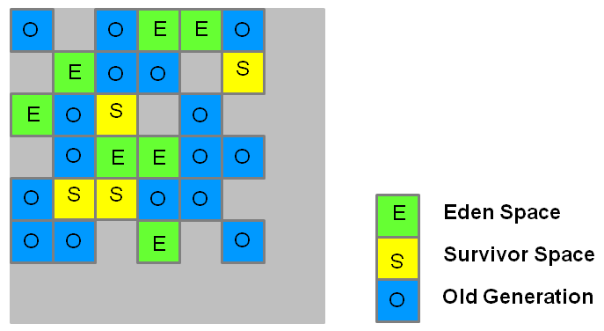

[*Opensource.com*](https://opensource.com/node/69046)

[**SKIP TO CONTENT**](https://opensource.com/article/22/7/garbage-collection-java)[**SKIP TO BOTTOM OF LIST**](https://opensource.com/article/22/7/garbage-collection-java#bottom-list)

**More on Java**

[**What is enterprise Java programming?**](https://developers.redhat.com/topics/enterprise-java/?intcmp=7013a000002Cxq6AAC)

[**An open source alternative to Oracle JDK**](https://www.redhat.com/en/engage/open-source-alternative-s-202104291240?intcmp=7013a000002Cxq6AAC)

[**Java cheat sheet**](https://opensource.com/downloads/java-cheat-sheet?intcmp=7013a000002Cxq6AAC)

[**Red Hat build of OpenJDK**](https://developers.redhat.com/products/openjdk/overview?intcmp=7013a000002Cxq6AAC)

[**Free online course: Developing cloud-native applications with microservices**](https://www.redhat.com/en/services/training/do092-developing-cloud-native-applications-microservices-architectures?intcmp=7013a000002Cxq6AAC)

[**Register for your free Red Hat account**](https://console.redhat.com/?intcmp=7016000000127cYAAQ)

[**Fresh Java articles**](https://opensource.com/tags/java?intcmp=7013a000002Cxq6AAC)

Garbage first (G1) was meant to replace CMS. G1 GC is parallel, concurrent, and incrementally compacting, with low pause-time. G1 uses a different memory layout than CMS, dividing the heap memory into equal sized regions. G1 triggers a global mark phase with multiple threads. After the mark phase is complete, G1 knows which region might be mostly empty and chooses that region for a sweep/deletion phase first.

In the case of G1, an object that's more than half a region size is considered a "humongous object." These objects are placed in the Old generation, in a region appropriately called the humongous region. To enable G1:

$ java -XX:+UseG1GC

## 5. Epsilon GC

This GC was introduced in 11u and is a no-op (do nothing) GC. Epsilon just manages memory allocation. It doesn’t do any actual memory reclamation. Epsilon is intended only when you know the exact memory footprint of your application, and knows that it is garbage collection free.

$ java -XX:+UnlockExperimentalVMOptions -XX:+UseEpsilonGC

## 6. Shenandoah

Shenandoah was introduced in JDK 12, and is a CPU intensive GC. It performs compaction, deletes unused objects, and release free space to the OS immediately. All of this happens in parallel with the application thread itself. To enable Shenandoah:

$ java -XX:+UnlockExperimentalVMOptions \

-XX:+UseShenandoahGC

## 7. ZGC

ZGC is designed for applications that have low latency requirements and use large heaps. ZGC allows a Java application to continue running while it performs all garbage collection operations. ZGC was introduced in JDK 11u and improved in JDK 12. Both Shenandoah and ZGC have been moved out of the experimental stage as of JDK 15. To enable ZGC:

$ java -XX:+UnlockExperimentalVMOptions -XX:+UseZGC

## Flexible garbage collection

Java provides flexibility for memory management. It's useful to get familiar with the different methods available so you can choose what's best for the application you're developing or running.

Shallow copying and deep copying

In this section, we will discuss the key difference between **shallow copy and deep copy in Java.** Let's understand the shallow and deep copy.

## **Shallow Copy**

When we do a copy of some entity to create two or more than two entities such that changes in one entity are reflected in the other entities as well, then we can say we have done a shallow copy. In shallow copy, new memory allocation never happens for the other entities, and the only reference is copied to the other entities. The following example demonstrates the same.

**FileName:** ShallowCopyExample.java

1. **class** ABC
2. {
3. // instance variable of the class ABC
4. **int** x = 30;
5. }
6. **public** **class** ShallowCopyExample
7. {
8. // main method
9. **public** **static** **void** main(String argvs[])
10. {
11. // creating an object of the class ABC
12. ABC obj1 = **new** ABC();
14. // it will copy the reference, not value
15. ABC obj2 = obj1;
17. // updating the value to 6
18. // using the reference variable obj2
19. obj2.x = 6;
21. // printing the value of x using reference variable obj1
22. System.out.println("The value of x is: " + obj1.x);
23. }
24. }

**Output:**

The value of x is: 6

**Explanation:** In the above example, we are updating the value of x using the reference variable obj2 and displaying the value of x using the reference variable obj1. In the output, we see the updated value 6 and not the original value 30. It is because obj1 and obj2 are referring to the same memory location. Therefore, whatever update we do use the reference variable obj2, the same changes will be reflected using the reference variable obj1.

## **Deep Copy**

When we do a copy of some entity to create two or more than two entities such that changes in one entity are not reflected in the other entities, then we can say we have done a deep copy. In the deep copy, a new memory allocation happens for the other entities, and reference is not copied to the other entities. Each entity has its own independent reference. The following example demonstrates the same.

**FileName:** DeepCopyExample.java

1. **class** ABC
2. {
3. // instance variable of the class ABC
4. **int** x = 30;
5. }
6. **public** **class** DeepCopyExample
7. {
8. // main method
9. **public** **static** **void** main(String argvs[])
10. {
11. // creating an object of the class ABC
12. ABC obj1 = **new** ABC();
14. // it will copy the reference, not value
15. ABC obj2 = **new** ABC();
17. // updating the value to 6
18. // using the reference variable obj2
19. obj2.x = 6;
21. // printing the value of x using reference variable obj1
22. System.out.println("The value of x is: " + obj1.x);
23. }
24. }

**Output:**

The value of x is: 30

**Explanation:** In the above example, we are updating the value of x using the reference variable obj2 and displaying the value of x using the reference variable obj1. In the output, we see the original value 30, not the updated value 6. It is because obj1 and obj2 are referring to different memory locations. Therefore, whatever update we do use the reference variable obj2, the same is not reflected using the reference variable obj1.

## **Differences Between Shallow Copy and Deep Copy**

After learning about shallow and deep copy, let's see the differences between shallow and deep copy.

|  |  |
| --- | --- |
| **Shallow Copy** | **Deep Copy** |
| It is fast as no new memory is allocated. | It is slow as new memory is allocated. |
| Changes in one entity is reflected in other entity. | Changes in one entity are not reflected in changes in another identity. |
| The default version of the clone() method supports shallow copy. | In order to make the clone() method support the deep copy, one has to override the clone() method. |
| A shallow copy is less expensive. | Deep copy is highly expensive. |
| Cloned object and the original object are not disjoint. | Cloned object and the original object are disjoint. |

## **Scenarios where deep and shallow copies are similar**

Although there are differences between deep and shallow copy, there are some scenarios where it makes no sense to consider whether the copy is deep or shallow.

### In Strings

Let's learn what will happen when doing a copy of the string. We all know strings are considered as the objects of the class String present in java.lang package. So, similar to other objects, when we do the copy, the reference is copied.

**FileName:** StringCopyExample.java

1. **public** **class** StringCopyExample
2. {
3. // main method
4. **public** **static** **void** main(String argvs[])
5. {
6. // an object of the String class is created
7. String obj1 = **new** String("JavaTpoint is a very good site.");
9. // copying obj1 to obj2
10. String obj2 = obj1;
12. // printing the hash code using the reference variable obj1.
13. System.out.println("The hash code is: " + obj1.hashCode());
15. // printing the hash code using the reference variable obj2.
16. System.out.println("The hash code is: " + obj2.hashCode());
17. }
18. }

**Output:**

The hash code is: -2026030341

The hash code is: -2026030341

**Explanation:** The output of the program shows that the hash code shown by the reference variables obj1 and obj2 are the same. It means that the same memory location is referenced by the reference variables obj1 and obj2. But the question is, can we say that we have done the shallow copy in the above program, as the reference is the same? The answer is no. The following example gives us enough evidence to validate the given answer.

**FileName:** StringCopyExample1.java

1. **public** **class** StringCopyExample
2. {
3. // main method
4. **public** **static** **void** main(String argvs[])
5. {
6. // an object of the String class is created
7. String obj1 = **new** String("JavaTpoint is a very good site.");
9. // copying obj1 to obj2
10. String obj2 = obj1;
11. // we have updated the string for reference variable obj2
12. obj2 = "JavaTpoint is very good.";
14. // printing the hash code using the reference variable obj1.
15. System.out.println("The hash code is: " + obj1.hashCode());
16. // printing the string
17. System.out.println("The string is: " + obj1 + "\n");

20. // printing the hash code using the reference variable obj2.
21. System.out.println("The hash code is: " + obj2.hashCode());
22. // printing the string
23. System.out.println("The string is: " + obj2);
24. }
25. }

**Output:**

The hash code is: -2026030341

The string is: JavaTpoint is a very good site.

The hash code is: 1724527163

The string is: JavaTpoint is very good.

**Explanation:** The output of the program tells us that the hash code shown by the reference variable obj1 is not equal to the hash code shown by the reference variable obj2. Also, the changes done using the reference variable obj2 is not shown by the reference variable obj1. It is because **strings in Java are always immutable**. Therefore, when obj2 changes the content of obj1, it ends up creating an entirely new string. Thus, the previous string remains untouched, and the reference variable obj2 points to a new memory location where the new string object is sitting.

We have seen that a change in a string results in the creation of a new string object implicitly. Therefore, copying a string can neither be termed as the deep nor as the shallow copy. In fact, there is no difference between deep and shallow copy when we are dealing with strings in Java.

### In Primitive Data Types

Let's learn what will happen when doing a copy of primitive data types. Unlike strings, the primitive data types are not objects. However, similar to strings, there is no concept of deep or shallow copy in the primitive data types. Observe the following example.

**FileName:** DataTypeCopyExample.java

1. **public** **class** DataTypeCopyExample
2. {
3. // main method
4. **public** **static** **void** main(String argvs[])
5. {
6. **int** x = 9;
7. **int** y = x;
9. System.out.println("The value of x & y are: " + x + ", " + y);
11. // updating the value of y
12. y = 10;
14. System.out.println("The value of x & y are: " + x + ", " + y);
16. **boolean** b1 = **false**;
18. // copying the value of b1 in b2
19. **boolean** b2 = b1;
21. System.out.println("The value of b1 & b2 are: " + b1 + ", " + b2);
23. // updating the value of b2
24. b2 = **true**;
25. System.out.println("The value of b1 & b2 are: " + b1 + ", " + b2);
27. }
28. }

**Output:**

The value of x & y are: 9, 9

The value of x & y are: 9, 10

The value of b1 & b2 are: false, false

The value of b1 & b2 are: false, true

**Explanation:** When the value of y is updated, it is not impacting the value of x. It is because y already has its own memory allocation. It is not referring to the memory location of x. Therefore, the statement y = x; only copies the value of x in y. Therefore, any update in y never impacts x. A similar concept can be applied to the other primitive data types as well. Here, memory allocation for y as well for b2 is happening implicitly.

In Java, there is no rule stating that when to use shallow copy and when to use the deep copy. It is up to the programmers or developers to decide what they want to use. Therefore, it is recommended to understand the requirement then decide judiciously between deep and shallow copy.

Apart from deep and shallow copy, there is another term called **lazy copy**. Lazy copy is, in fact, the mixture of the deep and shallow copy. In lazy copy, the shallow copy is used at the starting stage. When one modifies the original content, the program checks whether the content is shared among the other objects or not with the help of a counter. If the content is shared, then the deep copy mechanism is applied.

how to clone an object

Creating a copy using the clone() methodThe class whose object's copy is to be made must have a public clone method in it or in one of its parent classes. Every class that implements clone() should call super. clone() to obtain the cloned object reference. The class must also implement java

### ****reating a copy using the clone() method****

The class whose object’s copy is to be made must have a public clone method in it or in one of its parent classes.

* Every class that implements clone() should call super.clone() to obtain the cloned object reference.
* The class must also implement java.lang.Cloneable interface whose object clone we want to create otherwise it will throw CloneNotSupportedException when the clone method is called on that class’s object.

**Syntax:**

protected Object clone() throws CloneNotSupportedException

### ****i) Usage of clone() method -Shallow Copy****

**Note** – In the below code example the clone() method does create a completely new object with a different hashCode value, which means its in a separate memory location. But due to the Test object c being inside Test2, the primitive types have achieved deep copy but this Test object c is still shared between t1 and t2. To overcome that we explicitly do a deep copy for object variable c, which is discussed later.

* Java

|  |
| --- |
| // A Java program to demonstrate  // shallow copy using clone()  **import** java.util.ArrayList;    // An object reference of this class is  // contained by Test2  **class** Test {  **int** x, y;  }    // Contains a reference of Test and  // implements clone with shallow copy.  **class** Test2 **implements** Cloneable {  **int** a;  **int** b;      Test c = **new** Test();  **public** Object clone() **throws** CloneNotSupportedException      {  **return** **super**.clone();      }  }    // Driver class  **public** **class** Main {  **public** **static** **void** main(String args[])  **throws** CloneNotSupportedException      {          Test2 t1 = **new** Test2();          t1.a = 10;          t1.b = 20;          t1.c.x = 30;          t1.c.y = 40;            Test2 t2 = (Test2)t1.clone();            // Creating a copy of object t1          // and passing it to t2          t2.a = 100;            // Change in primitive type of t2 will          // not be reflected in t1 field          t2.c.x = 300;            // Change in object type field will be          // reflected in both t2 and t1(shallow copy)          System.out.println(t1.a + " " + t1.b + " " + t1.c.x                             + " " + t1.c.y);          System.out.println(t2.a + " " + t2.b + " " + t2.c.x                             + " " + t2.c.y);      }  } |

**Output**

10 20 300 40

100 20 300 40

In the above example, t1.clone returns the shallow copy of the object t1. To obtain a deep copy of the object certain modifications have to be made in the clone method after obtaining the copy.

### ****ii) Usage of clone() method – Deep Copy****

* If we want to create a deep copy of object X and place it in a new object Y then a new copy of any referenced objects fields are created and these references are placed in object Y. This means any changes made in referenced object fields in object X or Y will be reflected only in that object and not in the other. In the below example, we create a deep copy of the object.
* A deep copy copies all fields and makes copies of dynamically allocated memory pointed to by the fields. A deep copy occurs when an object is copied along with the objects to which it refers.
* Java

|  |
| --- |
| // A Java program to demonstrate  // deep copy using clone()    // An object reference of this  // class is contained by Test2  **class** Test {  **int** x, y;  }    // Contains a reference of Test and  // implements clone with deep copy.  **class** Test2 **implements** Cloneable {  **int** a, b;        Test c = **new** Test();    **public** Object clone() **throws** CloneNotSupportedException      {          // Assign the shallow copy to          // new reference variable t          Test2 t = (Test2)**super**.clone();            // Creating a deep copy for c          t.c = **new** Test();          t.c.x = c.x;          t.c.y = c.y;            // Create a new object for the field c          // and assign it to shallow copy obtained,          // to make it a deep copy  **return** t;      }  }    **public** **class** Main {  **public** **static** **void** main(String args[])  **throws** CloneNotSupportedException      {          Test2 t1 = **new** Test2();          t1.a = 10;          t1.b = 20;          t1.c.x = 30;          t1.c.y = 40;            Test2 t3 = (Test2)t1.clone();          t3.a = 100;            // Change in primitive type of t2 will          // not be reflected in t1 field          t3.c.x = 300;            // Change in object type field of t2 will          // not be reflected in t1(deep copy)          System.out.println(t1.a + " " + t1.b + " " + t1.c.x                             + " " + t1.c.y);          System.out.println(t3.a + " " + t3.b + " " + t3.c.x                             + " " + t3.c.y);      }  } |

**Output**

10 20 30 40

100 20 300 40

In the above example, we can see that a new object for the Test class has been assigned to copy an object that will be returned to the clone method. Due to this t3 will obtain a deep copy of the object t1. So any changes made in the ‘c’ object fields by t3, will not be reflected in t1.

## **Deep Copy vs Shallow Copy**

***There are certain differences between using clone() as a deep copy vs that as a shallow copy as mentioned below:***

* ***Shallow copy****is the method of copying an object and is followed by default in cloning. In this method, the fields of an old object X are copied to the new object Y. While copying the object type field the reference is copied to Y i.e object Y will point to the same location as pointed out by X. If the field value is a primitive type it copies the value of the primitive type.*
* *Therefore, any changes made in referenced objects in object X or Y will be reflected in other objects.*

*Shallow copies are cheap and simple to make. In the above example, we created a shallow copy of the object.*

### *Why use the clone method() or*****Advantages of the Clone Method****

* If we use the assignment operator to assign an object reference to another reference variable then it will point to the same address location of the old object and no new copy of the object will be created. Due to this any changes in the reference variable will be reflected in the original object.
* If we use a copy constructor, then we have to copy all the data over explicitly i.e. we have to reassign all the fields of the class in the constructor explicitly. But in the clone method, this work of creating a new copy is done by the method itself. So to avoid extra processing we use object cloning.

If you like GeeksforGeeks and would like to contribute. See your article appearing on the GeeksforGeeks main page and help other Geeks. Please write comments if you find anything incorrect, or if you want to share more information about the topic discussed above

Whether you're preparing for your first job interview or aiming to upskill in this ever-evolving tech landscape, [GeeksforGeeks Courses](https://www.geeksforgeeks.org/courses?utm_source=geeksforgeeks&utm_medium=article_bottom_text&utm_campaign=courses) are your key to success. We provide top-quality content at affordable prices, all geared towards accelerating your growth in a time-bound manner. Join the millions we've already empowered, and we're here to do the same for you. Don't miss out - [check it out now!](https://www.geeksforgeeks.org/courses?utm_source=geeksforgeeks&utm_medium=article_bottom_text&utm_campaign=courses)

How to find if two objects have same hashcode

Java hashCode()An object hash code value can change in multiple executions of the same application. If two objects are equal according to equals() method, then their hash code must be same. If two objects are unequal according to equals() method, their hash code are not required to be different

**public** **class** **HashcodeConcept** {

**public** **static** **void** main(**String**... hashcodeExample) {

**Simpson** homer = **new** **Simpson**(1, "Homer");

**Simpson** bart = **new** **Simpson**(2, "Homer");

**boolean** isHashcodeEquals = homer.hashCode() == bart.hashCode();

**if** (isHashcodeEquals) {

**System**.**out**.println("Should compare with equals method too.");

} **else** {

**System**.**out**.println("Should not compare with equals method because " +

"the id is different, that means the objects are not equals for sure.");

}

}

**static** **class** **Simpson** {

**int** id;

**String** name;

**public** **Simpson**(**int** id, **String** name) {

**this**.id = id;

**this**.name = name;

}

@Override

**public** **boolean** equals(**Object** o) {

**if** (**this** == o) **return** **true**;

**if** (o == **null** || getClass() != o.getClass()) **return** **false**;

**Simpson** simpson = (**Simpson**) o;

**return** id == simpson.id &&

name.equals(simpson.name);

}

@Override

**public** **int** hashCode() {

**return** id;

}

}

}

Exceptions hierarchy and what are all the exceptions you know

### Exception Hierarchy

All exception and error types are subclasses of the class **Throwable**, which is the base class of the hierarchy. One branch is headed by **Exception**. This class is used for exceptional conditions that user programs should catch. NullPointerException is an example of such an exception. Another branch, **Error** is used by the Java run-time system([JVM](https://www.geeksforgeeks.org/jvm-works-jvm-architecture/)) to indicate errors having to do with the run-time environment itself(JRE). StackOverflowError is an example of such an error.

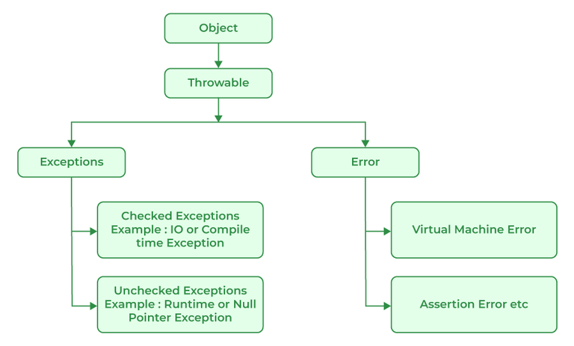

*Java Exception Hierarchy*

## Types of Exceptions

Java defines several types of exceptions that relate to its various class libraries. Java also allows users to define their own exceptions.

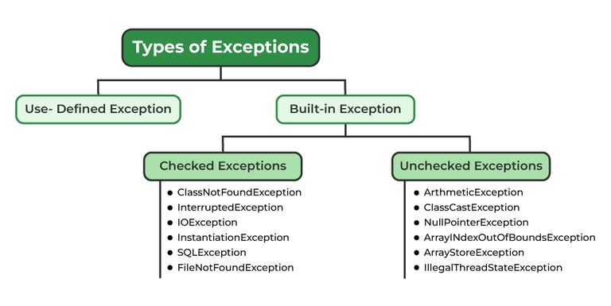

**Exceptions can be categorized in two ways:**

1. **Built-in Exceptions**
   * Checked Exception
   * Unchecked Exception
2. **User-Defined Exceptions**

Let us discuss the above-defined listed exception that is as follows:

### ****1. Built-in Exceptions****

Built-in exceptions are the exceptions that are available in Java libraries. These exceptions are suitable to explain certain error situations.

* **Checked Exceptions:**Checked exceptions are called compile-time exceptions because these exceptions are checked at compile-time by the compiler.
* **Unchecked Exceptions:**The unchecked exceptions are just opposite to the checked exceptions. The compiler will not check these exceptions at compile time. In simple words, if a program throws an unchecked exception, and even if we didn’t handle or declare it, the program would not give a compilation error.

***Note:****For checked vs unchecked exception, see*[*Checked vs Unchecked Exceptions*](https://www.geeksforgeeks.org/checked-vs-unchecked-exceptions-in-java/)

### ****2. User-Defined Exceptions:****

Sometimes, the built-in exceptions in Java are not able to describe a certain situation. In such cases, users can also create exceptions, which are called ‘user-defined Exceptions’.

The ***advantages of Exception Handling in Java***are as follows:

1. Provision to Complete Program Execution
2. Easy Identification of Program Code and Error-Handling Code
3. Propagation of Errors
4. Meaningful Error Reporting
5. Identifying Error Types

**Methods to print the Exception information:**

#### **1. printStackTrace()**

This method prints exception information in the format of the Name of the exception: description of the exception, stack trace.

**Example:**

* Java

|  |
| --- |
| //program to print the exception information using printStackTrace() method    **import** java.io.\*;    **class** GFG {  **public** **static** **void** main (String[] args) {  **int** a=5;  **int** b=0;  **try**{            System.out.println(a/b);          }  **catch**(ArithmeticException e){          e.printStackTrace();        }      }  } |

**Output**

java.lang.ArithmeticException: / by zero  
at GFG.main(File.java:10)

#### **2. toString()**

The toString() method prints exception information in the format of the Name of the exception: description of the exception.

**Example:**

* Java

|  |
| --- |
| //program to print the exception information using toString() method    **import** java.io.\*;    **class** GFG1 {  **public** **static** **void** main (String[] args) {  **int** a=5;  **int** b=0;  **try**{            System.out.println(a/b);          }  **catch**(ArithmeticException e){          System.out.println(e.toString());        }      }  } |

**Output**

java.lang.ArithmeticException: / by zero

#### **3. getMessage()**

The getMessage() method prints only the description of the exception.

**Example:**

* Java

|  |
| --- |
| //program to print the exception information using getMessage() method    **import** java.io.\*;    **class** GFG1 {  **public** **static** **void** main (String[] args) {  **int** a=5;  **int** b=0;  **try**{            System.out.println(a/b);          }  **catch**(ArithmeticException e){          System.out.println(e.getMessage());        }      }  } |

**Output**

/ by zero

## How Does JVM Handle an Exception?

**Default Exception Handling:**Whenever inside a method, if an exception has occurred, the method creates an Object known as an Exception Object and hands it off to the run-time system(JVM). The exception object contains the name and description of the exception and the current state of the program where the exception has occurred. Creating the Exception Object and handling it in the run-time system is called throwing an Exception. There might be a list of the methods that had been called to get to the method where an exception occurred. This ordered list of methods is called **Call Stack**. Now the following procedure will happen.

* The run-time system searches the call stack to find the method that contains a block of code that can handle the occurred exception. The block of the code is called an **Exception handler**.
* The run-time system starts searching from the method in which the exception occurred and proceeds through the call stack in the reverse order in which methods were called.
* If it finds an appropriate handler, then it passes the occurred exception to it. An appropriate handler means the type of exception object thrown matches the type of exception object it can handle.
* If the run-time system searches all the methods on the call stack and couldn’t have found the appropriate handler, then the run-time system handover the Exception Object to the **default exception handler**, which is part of the run-time system. This handler prints the exception information in the following format and terminates the program **abnormally**.

Exception in thread "xxx" Name of Exception : Description  
... ...... .. // Call Stack

Look at the below diagram to understand the flow of the call stack.

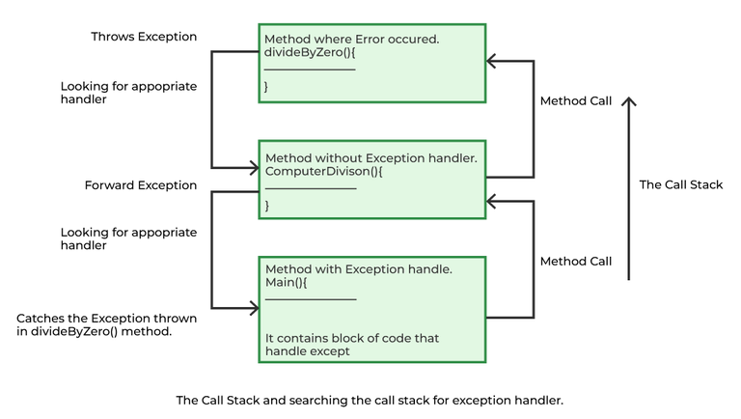

**Illustration:**

* Java

|  |
| --- |
| // Java Program to Demonstrate How Exception Is Thrown    // Class  // ThrowsExecp  **class** GFG {        // Main driver method  **public** **static** **void** main(String args[])      {          // Taking an empty string          String str = **null**;          // Getting length of a string          System.out.println(str.length());      }  } |

**Output**

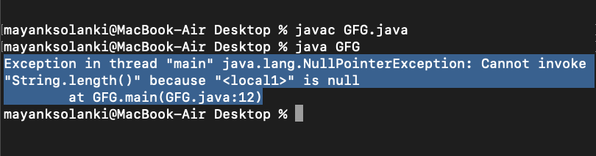

Let us see an example that illustrates how a run-time system searches for appropriate exception handling code on the call stack.

**Example:**

* Java

|  |
| --- |
| // Java Program to Demonstrate Exception is Thrown  // How the runTime System Searches Call-Stack  // to Find Appropriate Exception Handler    // Class  // ExceptionThrown  **class** GFG {        // Method 1      // It throws the Exception(ArithmeticException).      // Appropriate Exception handler is not found      // within this method.  **static** **int** divideByZero(**int** a, **int** b)      {            // this statement will cause ArithmeticException          // (/by zero)  **int** i = a / b;    **return** i;      }        // The runTime System searches the appropriate      // Exception handler in method also but couldn't have      // found. So looking forward on the call stack  **static** **int** computeDivision(**int** a, **int** b)      {    **int** res = 0;            // Try block to check for exceptions  **try** {                res = divideByZero(a, b);          }            // Catch block to handle NumberFormatException          // exception Doesn't matches with          // ArithmeticException  **catch** (NumberFormatException ex) {              // Display message when exception occurs              System.out.println(                  "NumberFormatException is occurred");          }  **return** res;      }        // Method 2      // Found appropriate Exception handler.      // i.e. matching catch block.  **public** **static** **void** main(String args[])      {    **int** a = 1;  **int** b = 0;            // Try block to check for exceptions  **try** {  **int** i = computeDivision(a, b);          }            // Catch block to handle ArithmeticException          // exceptions  **catch** (ArithmeticException ex) {                // getMessage() will print description              // of exception(here / by zero)              System.out.println(ex.getMessage());          }      }  } |

**Output**

/ by zero

## How Programmer Handle an Exception?

**Customized Exception Handling:**Java exception handling is managed via five keywords: **try**, **catch**, [**throw**](https://www.geeksforgeeks.org/throw-throws-java/), [**throws**](https://www.geeksforgeeks.org/throw-throws-java/), and **finally**. Briefly, here is how they work. Program statements that you think can raise exceptions are contained within a try block. If an exception occurs within the try block, it is thrown. Your code can catch this exception (using catch block) and handle it in some rational manner. System-generated exceptions are automatically thrown by the Java run-time system. To manually throw an exception, use the keyword throw. Any exception that is thrown out of a method must be specified as such by a throws clause. Any code that absolutely must be executed after a try block completes is put in a finally block.

***Tip:****One must go through*[*control flow in try catch finally block for better understanding.*](https://www.geeksforgeeks.org/flow-control-in-try-catch-finally-in-java/)

### Need for try-catch clause(Customized Exception Handling)

Consider the below program in order to get a better understanding of the try-catch clause.

**Example:**

* Java

|  |
| --- |
| // Java Program to Demonstrate  // Need of try-catch Clause    // Class  **class** GFG {        // Main driver method  **public** **static** **void** main(String[] args)      {          // Taking an array of size 4  **int**[] arr = **new** **int**[4];            // Now this statement will cause an exception  **int** i = arr[4];            // This statement will never execute          // as above we caught with an exception          System.out.println("Hi, I want to execute");      }  } |

**Output**

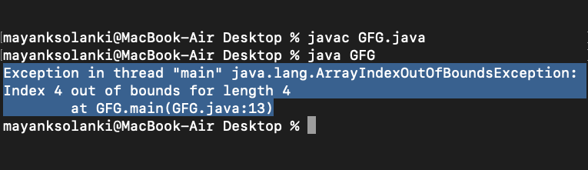

**Output explanation:**In the above example, an array is defined with size i.e. you can access elements only from index 0 to 3. But you trying to access the elements at index 4(by mistake) that’s why it is throwing an exception. In this case, JVM terminates the program**abnormally**. The statement System.out.println(“Hi, I want to execute”); will never execute. To execute it, we must handle the exception using try-catch. Hence to continue the normal flow of the program, we need a try-catch clause.

### ****How to Use the Try-catch Clause?****

try {  
 // block of code to monitor for errors  
 // the code you think can raise an exception  
} catch (ExceptionType1 exOb) {  
 // exception handler for ExceptionType1  
} catch (ExceptionType2 exOb) {  
 // exception handler for ExceptionType2  
}  
// optional  
finally { // block of code to be executed after try block ends   
}

Certain key points need to be remembered that are as follows: 

* In a method, there can be more than one statement that might throw an exception, So put all these statements within their own **try** block and provide a separate exception handler within their own **catch** block for each of them.
* If an exception occurs within the **try** block, that exception is handled by the exception handler associated with it. To associate the exception handler, we must put a **catch** block after it. There can be more than one exception handler. Each **catch** block is an exception handler that handles the exception to the type indicated by its argument. The argument, ExceptionType declares the type of exception that it can handle and must be the name of the class that inherits from the **Throwable** class.
* For each try block, there can be zero or more catch blocks, but **only one** final block.
* The finally block is optional. It always gets executed whether an exception occurred in try block or not. If an exception occurs, then it will be executed after **try and catch blocks.** And if an exception does not occur, then it will be executed after the **try** block. The finally block in Java is used to put important codes such as clean-up code e.g., closing the file or closing the connection.
* If we write System.exit in the try block, then finally block will not be executed.

The summary is depicted via visual aid below as follows:

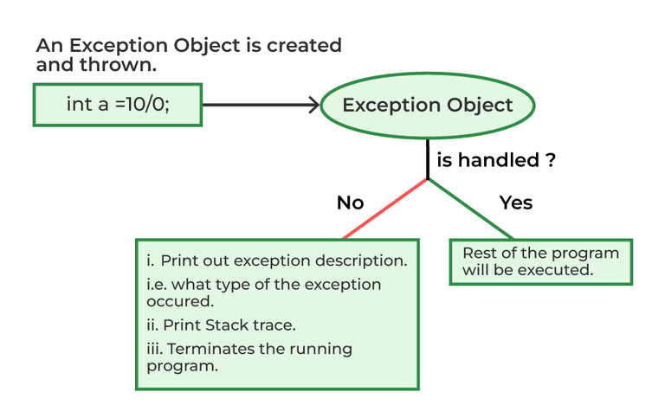

**Related Articles:**

* [Types of Exceptions in Java](https://www.geeksforgeeks.org/types-of-exception-in-java-with-examples/)
* [Checked vs Unchecked Exceptions](https://www.geeksforgeeks.org/checked-vs-unchecked-exceptions-in-java/)
* [Throw-Throws in Java](https://www.geeksforgeeks.org/throw-throws-java/)

[**Related Courses**](https://practice.geeksforgeeks.org/courses)

### [*Java Programming Foundation – Self Paced Course*](https://practice.geeksforgeeks.org/courses/Java-Foundation?utm_source=article&utm_medium=article&utm_campaign=java-foundation-article)

*Find the right course for you to start learning Java Programming Foundation from the industry experts having years of experience. This*[Java Programming Foundation – Self Paced Course](https://practice.geeksforgeeks.org/courses/Java-Foundation?utm_source=article&utm_medium=article&utm_campaign=java-foundation-article)*covers the fundamentals of the****Java programming language, data types, operators and flow control, loops, strings****, and much more. No more waiting! Start Learning JAVA Now and Become a Complete Java Engineer!*

Whether you're preparing for your first job interview or aiming to upskill in this ever-evolving tech landscape, [GeeksforGeeks Courses](https://www.geeksforgeeks.org/courses?utm_source=geeksforgeeks&utm_medium=article_bottom_text&utm_campaign=courses) are your key to success. We provide top-quality content at affordable prices, all geared towards accelerating your growth in a time-bound manner. Join the millions we've already empowered, and we're here to do the same for you. Don't miss out - [check it out now!](https://www.geeksforgeeks.org/courses?utm_source=geeksforgeeks&utm_medium=article_bottom_text&utm_campaign=courses)

**Last Updated :**07 Aug, 2023

282

Similar Reads

[[](https://www.geeksforgeeks.org/catching-base-and-derived-classes-as-exceptions-in-cpp-and-java/)](https://www.geeksforgeeks.org/catching-base-and-derived-classes-as-exceptions-in-cpp-and-java/)

[Catching Base and Derived Classes as Exceptions in C++ and Java](https://www.geeksforgeeks.org/catching-base-and-derived-classes-as-exceptions-in-cpp-and-java/)

[[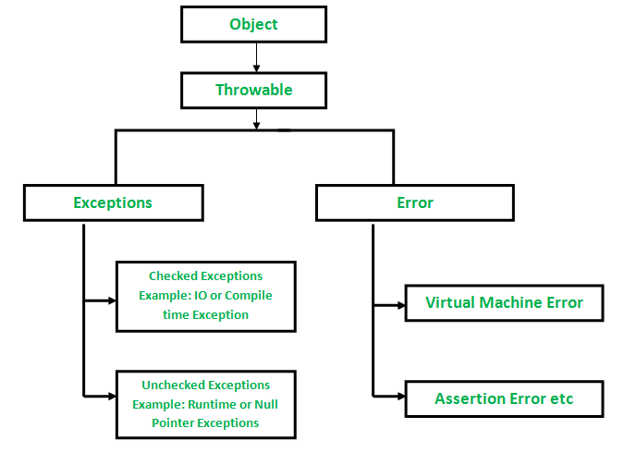](https://www.geeksforgeeks.org/checked-vs-unchecked-exceptions-in-java/)](https://www.geeksforgeeks.org/checked-vs-unchecked-exceptions-in-java/)

[Checked vs Unchecked Exceptions in Ja](https://www.geeksforgeeks.org/checked-vs-unchecked-exceptions-in-java/)

how to create customised exceptions

In order to create a custom exception, we need to extend the Exception class that belongs to java. lang package. Example: We pass the string to the constructor of the superclass- Exception which is obtained using the “getMessage()” function on the object created.

***ollowing are a few of the reasons to use custom exceptions:***

* To catch and provide specific treatment to a subset of existing Java exceptions.
* Business logic exceptions: These are the exceptions related to business logic and workflow. It is useful for the application users or the developers to understand the exact problem.

In order to create a custom exception, we need to extend the Exception class that belongs to **java.lang package.**

**Example:**We pass the string to the constructor of the superclass- Exception which is obtained using the “getMessage()” function on the object created.

* Java

|  |
| --- |
| // A Class that represents use-defined exception    **class** MyException **extends** Exception {  **public** MyException(String s)      {          // Call constructor of parent Exception  **super**(s);      }  }    // A Class that uses above MyException  **public** **class** Main {      // Driver Program  **public** **static** **void** main(String args[])      {  **try** {              // Throw an object of user defined exception  **throw** **new** MyException("GeeksGeeks");          }  **catch** (MyException ex) {              System.out.println("Caught");                // Print the message from MyException object              System.out.println(ex.getMessage());          }      }  } |

**Output**

Caught

GeeksGeeks

In the above code, the constructor of MyException requires a string as its argument. The string is passed to the parent class Exception’s constructor using super(). The constructor of the Exception class can also be called without a parameter and the call to super is not mandatory.

* Java

|  |
| --- |
| // A Class that represents use-defined exception    **class** MyException **extends** Exception {  }    // A Class that uses above MyException  **public** **class** setText {      // Driver Program  **public** **static** **void** main(String args[])      {  **try** {              // Throw an object of user defined exception  **throw** **new** MyException();          }  **catch** (MyException ex) {              System.out.println("Caught");              System.out.println(ex.getMessage());          }      }  } |

**Output**

Caught

null

If you like GeeksforGeeks and would like to contribute, you can also write an article and mail your article to review-team@geeksforgeeks.org. See your article appearing on the GeeksforGeeks main page and help other Geeks.

Whether you're preparing for your first job interview or aiming to upskill in this ever-evolving tech landscape, [GeeksforGeeks Courses](https://www.geeksforgeeks.org/courses?utm_source=geeksforgeeks&utm_medium=article_bottom_text&utm_campaign=courses) are your key to success. We provide top-quality content at affordable prices, all geared towards accelerating your growth in a time-bound manner. Join the millions we've already empowered, and we're here to do the same for you. Don't miss out - [check it out now!](https://www.geeksforgeeks.org/courses?utm_source=geeksforgeeks&utm_medium=article_bottom_text&utm_campaign=courses)

Purpose of try, catch, finally and can try exist without catch? Can try exist alone? Etc..

The finally block in Java is used to define a block of code that will be executed regardless of whether an exception is thrown or not. The finally block is optional, but it is often used in combination with a try-catch block to ensure that certain code is always executed, even if an exception is thrown.

es, It is possible to have a try block without a catch block by using a [**final block**](https://www.tutorialspoint.com/final-finally-and-finalize-in-Java).

As we know, a final block will always execute even there is an exception occurred in a try block, except [**System.exit()**](https://www.tutorialspoint.com/java/lang/system_exit.htm) it will execute always.

## **Example 1**

public class TryBlockWithoutCatch {

   public static void main(String[] args) {

      try {

         System.out.println("Try Block");

      } finally {

         System.out.println("Finally Block");

      }

   }

}

## **Output**

Try Block

Finally Block

A final block will always execute even though the method has a return type and try block returns some value.

## **Example 2**

public class TryWithFinally {

   public static int method() {

      try {

         System.out.println("Try Block with return type");

         return 10;

      } finally {

         System.out.println("Finally Block always execute");

      }

   }

   public static void main(String[] args) {

      System.out.println(method());

   }

}

## **Output**

Try Block with return type

Finally Block always execute

10

Why do we need collections framework? Difference between Array and Arraylist

In Java, array is a basic functionality whereas ArrayList is a part of the collection framework. Array members can be accessed using [], while ArrayList can access elements using a set of methods and modify them.

# **Difference between Array and ArrayList**

In Java, **array** and **ArrayList** are the well-known data structures. An array is a basic functionality provided by Java, whereas **ArrayList** is a class of Java Collections framework. It belongs to **java.util** package.

## **Java Array**

An **array** is a dynamically-created object. It serves as a container that holds the constant number of values of the same type. It has a contiguous memory location. Once an array is created, we cannot change its size. We can create an array by using the following statement:

1. **int** array[]=**new** **int**[size];

The above statement creates an array of the specified size. When we try to add more than its size, it throws **ArrayIndexOutOfBoundsException**. For example:

1. **int** arr[]=**new** **int**[3];   //specified size of array is 3
2. //adding 4 elements into array
3. arr[0]=12;
4. arr[1]=2;
5. arr[2]=15;
6. arr[3]=67;

## **Java ArrayList class**

In Java, **ArrayList** is a class of Collections framework. It implements **List<E>, Collection<E>, Iterable<E>, Cloneable, Serializable**, and **RandomAccess** interfaces. It extends **AbstractList<E>** class.

We can create an instance of ArrayList by using the following statement:

1. ArrayList<Type> arrayList=**new** ArrayList<Type>();

ArrayList is internally backed by the array in Java. The resize operation in ArrayList slows down the performance as it involves new array and copying content from an old array to a new array. It calls the native implemented method **System.arraycopy(sec, srcPos, dest, destPos, length)**.

We cannot store primitive type in ArrayList. So, it stores only objects. It automatically converts primitive type to object. For example, we have create an ArrayList object,

1. ArrayList <Integer> list=**new** ArrayList<Integer>();  //object of ArrayList
2. arrayObj.add(12);   //trying to add integer primitive to the ArrayList

The JVM converts it into Integer object through auto-boxing.

1. ArrayList arrayObj=**new** ArrayList()//object of ArrayList
2. arrayObj(**new** Integer(12)); //converts integer primitive to Integer object and added to ArrayList object

## **Similarities**

* Array and ArrayList both are used for storing elements.
* Array and ArrayList both can store null values.
* They can have duplicate values.
* They do not preserve the order of elements.

The following table describes the key differences between array and ArrayList:

|  |  |  |
| --- | --- | --- |
| **Basis** | **Array** | **ArrayList** |
| **Definition** | An **array** is a dynamically-created object. It serves as a container that holds the constant number of values of the same type. It has a contiguous memory location. | The **ArrayList** is a class of Java **Collections** framework. It contains popular classes like **Vector, HashTable**, and **HashMap**. |
| **Static/ Dynamic** | Array is **static** in size. | ArrayList is **dynamic** in size. |
| **Resizable** | An array is a **fixed-length** data structure. | ArrayList is a **variable-length** data structure. It can be resized itself when needed. |
| **Initialization** | It is mandatory to provide the size of an array while initializing it directly or indirectly. | We can create an instance of ArrayList without specifying its size. Java creates ArrayList of default size. |
| **Performance** | It performs **fast** in comparison to ArrayList because of fixed size. | ArrayList is internally backed by the array in Java. The resize operation in ArrayList slows down the performance. |
| **Primitive/ Generic type** | An array can store both **objects** and **primitives** type. | We cannot store **primitive** type in ArrayList. It automatically converts primitive type to object. |
| **Iterating Values** | We use **for** loop or **for each** loop to iterate over an array. | We use an **iterator** to iterate over ArrayList. |
| **Type-Safety** | We cannot use generics along with array because it is not a convertible type of array. | ArrayList allows us to store only **generic/ type, that's why it is type-safe.** |
| **Length** | Array provides a **length** variable which denotes the length of an array. | ArrayList provides the **size()** method to determine the size of ArrayList. |
| **Adding Elements** | We can add elements in an array by using the **assignment**operator. | Java provides the **add()** method to add elements in the ArrayList. |
| **Single/ Multi-Dimensional** | Array can be **multi-dimensional**. | ArrayList is always **single-dimensional**. |

## **Example of Array in Java**

In the following example, we have simply created an array of length four.

1. **public** **class** ArrayExample
2. {
3. **public** **static** **void** main(String args[])
4. {
5. //creating an array of integer type
6. **int** arr[]=**new** **int**[4];
7. //adding elements into array
8. arr[0]=12;
9. arr[1]=2;
10. arr[2]=15;
11. arr[3]=67;
12. **for**(**int** i=0;i<arr.length;i++)
13. {
14. System.out.println(arr[i]);
15. }
16. }
17. }

**Output:**

12

2

15

67

## **Example of ArrayList in Java**

In the following example, we have created an instance of ArrayList and performing iteration over the ArrayList.

1. **import** java.util.\*;
2. **public** **class** ArrayListExample
3. {
4. **public** **static** **void** main(String args[])
5. {
6. //creating an instance of ArrayList
7. List<Float> list = **new** ArrayList<Float>();
8. //adding element to arraylist
9. list.add(12.4f);
10. list.add(34.6f);
11. list.add(56.8f);
12. list.add(78.9f);
13. //iteration over ArrayList using for-each loop
14. **for**(Float f:list)
15. {
16. System.out.println(f);
17. }
18. }
19. }

**Output:**

12.4

34.6

56.8

78.9

Purpose of equals and hashcode methods

So, we have just seen that the equals() and hashCode() methods work together inside the HashMap to get and put the data: hashCode() is used to compute the bucket number and equals() is used to find the Entry with the same key. Now we know more than enough to implement the hashCode() and equals() methods

Different ways of creating object in java

There are several ways by which we can create objects of a class in java as we all know a class provides the blueprint for objects, you create an object from a class. This concept is under-rated and sometimes proves to be beneficial as this concept is bypassed by many programmers and sometimes even do ask from interview perceptive.

**Methods:**

There are many different ways to create objects in Java. Let us list them later discussinglater taking individually with the help of programs to illustrate internal working by which we can create objects in Java.

1. Using new keyword
2. Using new instance
3. Using clone() method
4. Using deserialization
5. Using newInstance() method of Constructor class

Let us discuss them one by one and implement the same by appending a clean java program for the same.

**Method 1:**Using new keyword

Using the [new keyword in java](https://www.geeksforgeeks.org/new-operator-java/) is the most basic way to create an object. This is the most common way to create an object in java. Almost 99% of objects are created in this way. By using this method we can call any constructor we want to call (no argument or parameterized constructors).

**Example**

* Java

|  |
| --- |
| // Java program to Illustrate Creation of Object  // Using new keyword    // Main class  **class** GFG {        // Declaring and initializing string      // Custom input string      String name = "GeeksForGeeks";        // Main driver method  **public** **static** **void** main(String[] args)      {          // As usual and most generic used we will          // be creating object of class inside main()          // using new keyword          GFG obj = **new** GFG();            // Print and display the object          System.out.println(obj.name);      }  } |

**Output**

GeeksForGeeks

**Method 2:**[**Using new instance**](https://www.geeksforgeeks.org/new-operator-vs-newinstance-method-java/)

If we know the name of the class & if it has a public default constructor we can create an object **Class.forName**. We can use it to create the Object of a Class. Class.forName actually loads the Class in Java but doesn’t create any Object. To create an Object of the Class you have to use the new Instance Method of the Class.

**Example**

* Java

|  |
| --- |
| // Java program to Illustrate Creation of Object  // Using new Instance    // Main class  **class** GFG {        // Declaring and initializing string      String name = "GeeksForGeeks";        // Main driver method  **public** **static** **void** main(String[] args)      {          // Try block to check for exceptions  **try** {                Class cls = Class.forName("GFG");                // Creating object of main class              // using instance method              GFG obj = (GFG)cls.newInstance();                // Print and display              System.out.println(obj.name);          }            // Catch block to handle the exceptions            // Catch block 1          // Handling ClassNotFound Exception  **catch** (ClassNotFoundException e) {                // Display the exception along with line number              // using printStacktrace() method              e.printStackTrace();          }            // Catch block 2          // Handling InstantiationException  **catch** (InstantiationException e) {                e.printStackTrace();          }            // Catch block 2          // Handling IllegalAccessException  **catch** (IllegalAccessException e) {                e.printStackTrace();          }      }  } |

**Output:**

GeeksForGeeks

**Method 3:**[Using clone() method](https://www.geeksforgeeks.org/clone-method-in-java-2/)

Whenever clone() is called on any object, the JVM actually creates a new object and copies all content of the previous object into it. Creating an object using the clone method does not invoke any constructor. In order to use the clone() method on an object we need to implement [Cloneable](https://www.geeksforgeeks.org/cloneable-interface-in-java/) and define the [*clone() method*](https://www.geeksforgeeks.org/clone-method-in-java-2/) in it.

**Example**

* Java

|  |
| --- |
| // Java program to Illustrate Creation of Object  // Using clone() method    // Main class  // Implementing Cloneable interface  **class** GFG **implements** Cloneable {        // Method 1      @Override  **protected** Object clone()  **throws** CloneNotSupportedException      {          // Super() keyword refers to parent class  **return** **super**.clone();      }        // Declaring and initializing string      String name = "GeeksForGeeks";        // Method 2      // main driver method  **public** **static** **void** main(String[] args)      {          GFG obj1 = **new** GFG();            // Try block to check for exceptions  **try** {                // Using the clone() method              GFG obj2 = (GFG)obj1.clone();                // Print and display the main class object              // as created above              System.out.println(obj2.name);          }            // Catch block to handle the exceptions  **catch** (CloneNotSupportedException e) {                // Display the exception              // using printStackTrace() method              e.printStackTrace();          }      }  } |

**Output**

GeeksForGeeks

***Note:***

* *Here we are creating the clone of an existing Object and not any new Object.*
* *Class need to implement Cloneable Interface otherwise it will throw****CloneNotSupportedException****.*

**Method 4:**[Using deserialization](https://www.geeksforgeeks.org/serialization-in-java/)

Whenever we serialize and then deserialize an object, JVM creates a separate object. In **deserialization**, JVM doesn’t use any constructor to create the object. To deserialize an object we need to implement the Serializable interface in the class.

**Example 1**

* Java

|  |
| --- |
| // Java Program Illustrate Serializing an Object    // Importing input output classes  **import** java.io.\*;    // Main class  // Implementing the Serializable interface  **class** GFG **implements** Serializable {        // Member variables  **private** String name;      GFG(String name)      {          // This keyword refers to current object itself  **this**.name = name;      }        // Main driver method  **public** **static** **void** main(String[] args)      {          // Try block to check for exceptions  **try** {              // Creating object of class in main() method              GFG d = **new** GFG("GeeksForGeeks");                FileOutputStream f                  = **new** FileOutputStream("file.txt");              ObjectOutputStream oos                  = **new** ObjectOutputStream(f);              oos.writeObject(d);              oos.close();                // Freeing up memory resources              f.close();          }            // Catch block to handle the exceptiona  **catch** (Exception e) {              // Display the exception along with line number              // using printStacktrace() method              e.printStackTrace();          }      }  } |

**Output:**

GeeksForGeeks

*Object of DeserializationExample class is serialized using writeObject() method and written to file.txt file.*

**Example 2**

* Java

|  |
| --- |
| // Java Program Illustrate Creation of Object  // Using Deserialization    // Importing input output classes  **import** java.io.\*;    // Main class  **public** **class** GFG {        // Main driver method  **public** **static** **void** main(String[] args)      {            // Try block to check for exceptions  **try** {                GFG d;                // Creating FileInputStream class object              FileInputStream f                  = **new** FileInputStream("file.txt");                // Creating ObjectInputStream class object              ObjectInputStream oos                  = **new** ObjectInputStream(f);              d = (DeserializationExample)oos.readObject();          }            // Catch block to handle the exceptions  **catch** (Exception e) {                // Display the exception on console              // using printStacjtrace() method              e.printStackTrace();          }            System.out.println(d.name);      }  } |

**Output:**

GeeksForGeeks

**Method 5:**[Using newInstance() method of the constructor class](https://www.geeksforgeeks.org/constructor-newinstance-method-in-java-with-examples/)

This is similar to the newInstance() method of a class. There is one newInstance() method in the[**java.lang.reflect.Constructor class**](https://www.geeksforgeeks.org/java-lang-reflect-constructor-class-in-java/) which we can use to create objects. It can also call the parameterized constructor, and private constructor by using this newInstance() method. Both newInstance() methods are known as reflective ways to create objects. In fact newInstance() method of Class internally uses newInstance() method of Constructor class.

**Example**

* Java

|  |
| --- |
| // Java program to illustrate creation of Object  // using newInstance() method of Constructor class    // Importing required classes from java.lang package  **import** java.lang.reflect.\*;    // Main class  **class** GFG {        // Member variables of this class  **private** String name;        // Constructor of this class      GFG() {}        // Method 1      // To set name ofthe string  **public** **void** setName(String name)      {          // This method refers to current object itself  **this**.name = name;      }        // Main driver method  **public** **static** **void** main(String[] args)      {          // Try block to check for exceptions  **try** {              Constructor<GFG> constructor                  = GFG.**class**.getDeclaredConstructor();                GFG r = constructor.newInstance();                // Custom passing              r.setName("GeeksForGeeks");              System.out.println(r.name);          }            // Catch block to handle the exceptions  **catch** (Exception e) {                // Display the exception on console              // using printStackTrace() method              e.printStackTrace();          }      }  } |

**Output:**

GeeksForGeeks

If you like GeeksforGeeks and would like to contribute, you can also write an article using [write.geeksforgeeks.org](https://write.geeksforgeeks.org/) or mail your article to review-team@geeksforgeeks.org. See your article appearing on the GeeksforGeeks main page and help other Geeks. Please write comments if you find anything incorrect, or if you want to share more information about the topic discussed above.

Whether you're preparing for your first job interview or aiming to upskill in this ever-evolving tech landscape, [GeeksforGeeks Courses](https://www.geeksforgeeks.org/courses?utm_source=geeksforgeeks&utm_medium=article_bottom_text&utm_campaign=courses) are your key to success. We provide top-quality content at affordable prices, all geared towards accelerating your growth in a time-bound manner. Join the millions we've already empowered, and we're here to do the same for you. Don't miss out - [check it out now!](https://www.geeksforgeeks.org/courses?utm_source=geeksforgeeks&utm_medium=article_bottom_text&utm_campaign=courses)

What is Reflection used for

Reflection is a feature in the Java programming language. It allows an executing Java program to examine or "introspect" upon itself, and manipulate internal properties of the program. For example, it's possible for a Java class to obtain the names of all its members and display them.

# **Using Java Reflection**

By Glen McCluskey  
January 1998

* [Java](https://www.oracle.com/java/)
* [Technical Details](https://www.oracle.com/java/technologies/)

# **Technical Article**

Reflection is a feature in the Java programming language. It allows an executing Java program to examine or "introspect" upon itself, and manipulate internal properties of the program. For example, it's possible for a Java class to obtain the names of all its members and display them.

The ability to examine and manipulate a Java class from within itself may not sound like very much, but in other programming languages this feature simply doesn't exist. For example, there is no way in a Pascal, C, or C++ program to obtain information about the functions defined within that program.

One tangible use of reflection is in JavaBeans, where software components can be manipulated visually via a builder tool. The tool uses reflection to obtain the properties of Java components (classes) as they are dynamically loaded.

### A Simple Example

To see how reflection works, consider this simple example:

Copy

Copied to Clipboard

Error: Could not Copy

import java.lang.reflect.\*;

public class DumpMethods {

public static void main(String args[])

{

try {

Class c = Class.forName(args[0]);

Method m[] = c.getDeclaredMethods();

for (int i = 0; i < m.length; i++)

System.out.println(m[i].toString());

}

catch (Throwable e) {

System.err.println(e);

}

}

}

For an invocation of:

java DumpMethods java.util.Stack

the output is:

Copy

Copied to Clipboard

Error: Could not Copy

public java.lang.Object java.util.Stack.push(

java.lang.Object)

public synchronized

java.lang.Object java.util.Stack.pop()

public synchronized

java.lang.Object java.util.Stack.peek()

public boolean java.util.Stack.empty()

public synchronized

int java.util.Stack.search(java.lang.Object)

That is, the method names of class java.util.Stack are listed, along with their fully qualified parameter and return types.

This program loads the specified class using class.forName, and then calls getDeclaredMethods to retrieve the list of methods defined in the class. java.lang.reflect.Method is a class representing a single class method.

### Setting Up to Use Reflection

The reflection classes, such as Method, are found in java.lang.reflect. There are three steps that must be followed to use these classes. The first step is to obtain a java.lang.Class object for the class that you want to manipulate. java.lang.Class is used to represent classes and interfaces in a running Java program.

One way of obtaining a Class object is to say:

Class c = Class.forName("java.lang.String"); to get the Class object for String. Another approach is to use: Class c = int.class; or Class c = Integer.TYPE; to obtain Class information on fundamental types. The latter approach accesses the predefined TYPE field of the wrapper (such as Integer) for the fundamental type.

The second step is to call a method such as getDeclaredMethods, to get a list of all the methods declared by the class.

Once this information is in hand, then the third step is to use the reflection API to manipulate the information. For example, the sequence:

Class c = Class.forName("java.lang.String"); Method m[] = c.getDeclaredMethods(); System.out.println(m[0].toString());

will display a textual representation of the first method declared in String.

In the examples below, the three steps are combined to present self contained illustrations of how to tackle specific applications using reflection.

### Simulating the instanceof Operator

Once Class information is in hand, often the next step is to ask basic questions about the Class object. For example, the Class.isInstance method can be used to simulate the instanceof operator:

Copy

Copied to Clipboard

Error: Could not Copy

class A {}

public class instance1 {

public static void main(String args[])

{

try {

Class cls = Class.forName("A");

boolean b1

= cls.isInstance(new Integer(37));

System.out.println(b1);

boolean b2 = cls.isInstance(new A());

System.out.println(b2);

}

catch (Throwable e) {

System.err.println(e);

}

}

}

In this example, a Class object for A is created, and then class instance objects are checked to see whether they are instances of A. Integer(37) is not, but new A() is.

### Finding Out About Methods of a Class

One of the most valuable and basic uses of reflection is to find out what methods are defined within a class. To do this the following code can be used:

Copy

Copied to Clipboard

Error: Could not Copy

import java.lang.reflect.\*;

public class method1 {

private int f1(

Object p, int x) throws NullPointerException

{

if (p == null)

throw new NullPointerException();

return x;

}

public static void main(String args[])

{

try {

Class cls = Class.forName("method1");

Method methlist[]

= cls.getDeclaredMethods();

for (int i = 0; i < methlist.length;

i++) {

Method m = methlist[i];

System.out.println("name

= " + m.getName());

System.out.println("decl class = " +

m.getDeclaringClass());

Class pvec[] = m.getParameterTypes();

for (int j = 0; j < pvec.length; j++)

System.out.println("

param #" + j + " " + pvec[j]);

Class evec[] = m.getExceptionTypes();

for (int j = 0; j < evec.length; j++)

System.out.println("exc #" + j

+ " " + evec[j]);

System.out.println("return type = " +

m.getReturnType());

System.out.println("-----");

}

}

catch (Throwable e) {

System.err.println(e);

}

}

}

The program first gets the Class description for method1, and then calls getDeclaredMethods to retrieve a list of Method objects, one for each method defined in the class. These include public, protected, package, and private methods. If you use getMethods in the program instead of getDeclaredMethods, you can also obtain information for inherited methods.

Once a list of the Method objects has been obtained, it's simply a matter of displaying the information on parameter types, exception types, and the return type for each method. Each of these types, whether they are fundamental or class types, is in turn represented by a Class descriptor. The output of the program is:

Copy

Copied to Clipboard

Error: Could not Copy

name = f1

decl class = class method1

param #0 class java.lang.Object

param #1 int

exc #0 class java.lang.NullPointerException

return type = int

-----

name = main

decl class = class method1

param #0 class [Ljava.lang.String;

return type = void

-----

### Obtaining Information About Constructors

A similar approach is used to find out about the constructors of a class. For example:

Copy

Copied to Clipboard

Error: Could not Copy

import java.lang.reflect.\*;

public class constructor1 {

public constructor1()

{

}

protected constructor1(int i, double d)

{

}

public static void main(String args[])

{

try {

Class cls = Class.forName("constructor1");

Constructor ctorlist[]

= cls.getDeclaredConstructors();

for (int i = 0; i < ctorlist.length; i++) {

Constructor ct = ctorlist[i];

System.out.println("name

= " + ct.getName());

System.out.println("decl class = " +

ct.getDeclaringClass());

Class pvec[] = ct.getParameterTypes();

for (int j = 0; j < pvec.length; j++)

System.out.println("param #"

+ j + " " + pvec[j]);

Class evec[] = ct.getExceptionTypes();

for (int j = 0; j < evec.length; j++)

System.out.println(

"exc #" + j + " " + evec[j]);

System.out.println("-----");

}

}

catch (Throwable e) {

System.err.println(e);

}

}

}

There is no return-type information retrieved in this example, because constructors don't really have a true return type.

When this program is run, the output is:

Copy

Copied to Clipboard

Error: Could not Copy

name = constructor1

decl class = class constructor1

-----

name = constructor1

decl class = class constructor1

param #0 int

param #1 double

-----

### Finding Out About Class Fields

It's also possible to find out which data fields are defined in a class. To do this, the following code can be used:

Copy

Copied to Clipboard

Error: Could not Copy

import java.lang.reflect.\*;

public class field1 {

private double d;

public static final int i = 37;

String s = "testing";

public static void main(String args[])

{

try {

Class cls = Class.forName("field1");

Field fieldlist[]

= cls.getDeclaredFields();

for (int i

= 0; i < fieldlist.length; i++) {

Field fld = fieldlist[i];

System.out.println("name

= " + fld.getName());

System.out.println("decl class = " +

fld.getDeclaringClass());

System.out.println("type

= " + fld.getType());

int mod = fld.getModifiers();

System.out.println("modifiers = " +

Modifier.toString(mod));

System.out.println("-----");

}

}

catch (Throwable e) {

System.err.println(e);

}

}

}

This example is similar to the previous ones. One new feature is the use of Modifier. This is a reflection class that represents the modifiers found on a field member, for example "private int". The modifiers themselves are represented by an integer, and Modifier.toString is used to return a string representation in the "official" declaration order (such as "static" before "final"). The output of the program is:

Copy

Copied to Clipboard

Error: Could not Copy

name = d

decl class = class field1

type = double

modifiers = private

-----

name = i

decl class = class field1

type = int

modifiers = public static final

-----

name = s

decl class = class field1

type = class java.lang.String

modifiers =

-----

As with methods, it's possible to obtain information about just the fields declared in a class (getDeclaredFields), or to also get information about fields defined in superclasses (getFields).

### Invoking Methods by Name

So far the examples that have been presented all relate to obtaining class information. But it's also possible to use reflection in other ways, for example to invoke a method of a specified name.

To see how this works, consider the following example:

Copy

Copied to Clipboard

Error: Could not Copy

import java.lang.reflect.\*;

public class method2 {

public int add(int a, int b)

{

return a + b;

}

public static void main(String args[])

{

try {

Class cls = Class.forName("method2");

Class partypes[] = new Class[2];

partypes[0] = Integer.TYPE;

partypes[1] = Integer.TYPE;

Method meth = cls.getMethod(

"add", partypes);

method2 methobj = new method2();

Object arglist[] = new Object[2];

arglist[0] = new Integer(37);

arglist[1] = new Integer(47);

Object retobj

= meth.invoke(methobj, arglist);

Integer retval = (Integer)retobj;

System.out.println(retval.intValue());

}

catch (Throwable e) {

System.err.println(e);

}

}

}

Suppose that a program wants to invoke the add method, but doesn't know this until execution time. That is, the name of the method is specified during execution (this might be done by a JavaBeans development environment, for example). The above program shows a way of doing this.

getMethod is used to find a method in the class that has two integer parameter types and that has the appropriate name. Once this method has been found and captured into a Method object, it is invoked upon an object instance of the appropriate type. To invoke a method, a parameter list must be constructed, with the fundamental integer values 37 and 47 wrapped in Integer objects. The return value (84) is also wrapped in an Integer object.

### Creating New Objects

There is no equivalent to method invocation for constructors, because invoking a constructor is equivalent to creating a new object (to be the most precise, creating a new object involves both memory allocation and object construction). So the nearest equivalent to the previous example is to say:

Copy

Copied to Clipboard

Error: Could not Copy

import java.lang.reflect.\*;

public class constructor2 {

public constructor2()

{

}

public constructor2(int a, int b)

{

System.out.println(

"a = " + a + " b = " + b);

}

public static void main(String args[])

{

try {

Class cls = Class.forName("constructor2");

Class partypes[] = new Class[2];

partypes[0] = Integer.TYPE;

partypes[1] = Integer.TYPE;

Constructor ct

= cls.getConstructor(partypes);

Object arglist[] = new Object[2];

arglist[0] = new Integer(37);

arglist[1] = new Integer(47);

Object retobj = ct.newInstance(arglist);

}

catch (Throwable e) {

System.err.println(e);

}

}

}

which finds a constructor that handles the specified parameter types and invokes it, to create a new instance of the object. The value of this approach is that it's purely dynamic, with constructor lookup and invocation at execution time, rather than at compilation time.

### Changing Values of Fields

Another use of reflection is to change the values of data fields in objects. The value of this is again derived from the dynamic nature of reflection, where a field can be looked up by name in an executing program and then have its value changed. This is illustrated by the following example:

Copy

Copied to Clipboard

Error: Could not Copy

import java.lang.reflect.\*;

public class field2 {

public double d;

public static void main(String args[])

{

try {

Class cls = Class.forName("field2");

Field fld = cls.getField("d");

field2 f2obj = new field2();

System.out.println("d = " + f2obj.d);

fld.setDouble(f2obj, 12.34);

System.out.println("d = " + f2obj.d);

}

catch (Throwable e) {

System.err.println(e);

}

}

}

In this example, the d field has its value set to 12.34.

### Using Arrays

One final use of reflection is in creating and manipulating arrays. Arrays in the Java language are a specialized type of class, and an array reference can be assigned to an Object reference.

To see how arrays work, consider the following example:

Copy

Copied to Clipboard

Error: Could not Copy

import java.lang.reflect.\*;

public class array1 {

public static void main(String args[])

{

try {

Class cls = Class.forName(

"java.lang.String");

Object arr = Array.newInstance(cls, 10);

Array.set(arr, 5, "this is a test");

String s = (String)Array.get(arr, 5);

System.out.println(s);

}

catch (Throwable e) {

System.err.println(e);

}

}

}

This example creates a 10-long array of Strings, and then sets location 5 in the array to a string value. The value is retrieved and displayed.

A more complex manipulation of arrays is illustrated by the following code:

Copy

Copied to Clipboard

Error: Could not Copy

import java.lang.reflect.\*;

public class array2 {

public static void main(String args[])

{

int dims[] = new int[]{5, 10, 15};

Object arr

= Array.newInstance(Integer.TYPE, dims);

Object arrobj = Array.get(arr, 3);

Class cls =

arrobj.getClass().getComponentType();

System.out.println(cls);

arrobj = Array.get(arrobj, 5);

Array.setInt(arrobj, 10, 37);

int arrcast[][][] = (int[][][])arr;

System.out.println(arrcast[3][5][10]);

}

}

This example creates a 5 x 10 x 15 array of ints, and then proceeds to set location [3][5][10] in the array to the value 37. Note here that a multi-dimensional array is actually an array of arrays, so that, for example, after the first Array.get, the result in arrobj is a 10 x 15 array. This is peeled back once again to obtain a 15-long array, and the 10th slot in that array is set using Array.setInt.

Note that the type of array that is created is dynamic, and does not have to be known at compile time.

### Summary

Java reflection is useful because it supports dynamic retrieval of information about classes and data structures by name, and allows for their manipulation within an executing Java program. This feature is extremely powerful and has no equivalent in other conventional languages such as C, C++, Fortran, or Pascal.

Glen McCluskey has focused on programming languages since 1988. He consults in the areas of Java and C++ performance, testing, and technical documentation.

Two list of objects and want to filter something based on some attribute data and insert/create another object mapping fields.

//a List of authors who are of that age

List<Author> agedResults = authorList.stream()

.filter(p -> p.getAge() == age)

.collect(Collectors.toList());

//a list of IDs that belong to authors of that age

List<String> agedIds = agedResults.stream()

.map(Author::getId)

.collect(Collectors.toList());

Streams : How it works internally

Java 8 has been out  since 2014, but many of the original features have remained relevant today. One of the most prominent of these is Java streams. In this blog, we answer what are Java streams, explain when to use them, troubleshoot Java streams issues, and give you a brief rundown of common Java streams operations.

## What Are Streams in Java?

Java streams enable functional-style operations on streams of elements. A stream is an abstraction of a non-mutable collection of functions applied in some order to the data. A stream is not a collection where you can store elements.

The most important difference between a stream and a structure is that a stream doesn’t hold the data. For example, you cannot point to a location in the stream where a certain element exists. You can only specify the functions that operate on that data. And when performing operations on a stream, it will affect the original stream.

As a note, the streams in this blog are not to be confused with streams in Java I/O package like InputStream, OutputStream, etc.

**Related Reading:**[Java Streams Cheat Sheet](https://www.jrebel.com/blog/java-streams-cheat-sheet)

## When to Use Java Streams

Java streams represent a pipeline through which data will flow and the functions to operate on the data. A pipeline in this instance consists of a stream source, followed by zero or more intermediate operations, and a terminal operation.

As such, streams can be used in any number of applications that involve data-driven functions. In the example below, the Java stream is used as a fancy iterator:

List numbers = Arrays.asList(1, 2, 3, 4);

List result = numbers.stream()

.filter(e -> (e % 2) == 0)

.map(e -> e \* 2)

.collect(toList());

In this example we select only even values, by using the filter method and doubled them by mapping the function that doubles the input. What does this provide us? The streams API gives us the power to specify a sequence of operations on the data in individual steps. We don’t specify any conditional processing code, we are not tempted to write large complex functions, we don’t care about the data flow.

In fact, we only bother ourselves with one data processing step at a time: we compose the functions and the data flows through the functions by itself by the power of the streams framework. The example above shows one of the most important pattern you’ll end up using with the streams:

* Raise a collection to a stream.
* Ride the stream: filter values, transform values, limit the output.
* Compose small individual operations.
* Collect the result back into a concrete collection.

#### **Use streams and see your changes instantly.** [**Use JRebel to skip redeploys. Try it now >>**](https://www.jrebel.com/products/jrebel/free-trial)

## Common Operations in Java Streams

In Java 8 and up, you can easily obtain a stream from any collection by calling the stream() method. After that there are a couple of fundamental functions that you’ll encounter all the time.

Here are some common operations in Java streams:

* **Filter:**Returns a new stream that contains some of the elements of the original. It accepts the predicate to compute which elements should be returned in the new stream and removes the rest. In the imperative code we would employ the conditional logic to specify what should happen if an element satisfies the condition. In the functional style we don’t bother with ifs, we filter the stream and work only on the values we require.
* **Map:** Transforms the stream elements into something else, it accepts a function to apply to each and every element of the stream and returns a stream of the values the parameter function produced. This is the bread and butter of the Java streaming API. Map allows you to perform a computation on the data inside a stream.
* **Reduce:** (also sometimes called a fold) Performs a reduction of the stream to a single element. If you want to sum all the integer values in the stream, you want to use the reduce function. If you want to find the maximum in the stream, reduce is your friend.
* **Collect:** This is the way to get out of the streams world and obtain a concrete collection of values, like a list in the example above.

You won't use all of these functions every time you encounter a stream, but you have them available to use at will.

## Java Stream Example: Potential Issues to Avoid

There are some caveats of using the Java streaming API though, and sometimes stream processing can get out of hand. Imagine we have the follow class Person:

class Person {

Gender gender; String name;

public Gender getGender() { return gender; }

public String getName() { return name; }

}

enum Gender { MALE, FEMALE, OTHER }

This is a typical Java bean with some getters on the fields. Now, suppose we have a list of these persons and want to get the list of uppercase names of all the “FEMALE” people in that list. Sounds easy, right?

List names = new ArrayList();

List people = …

people.stream()

.filter(p -> p.getGender() == Gender.FEMALE)

.map(Person::getName)

.map(String::toUpperCase)

.forEach(name -> names.add(name));

We follow the specification of what we must do at every step, but the problem is in the mutation of the shared state. We know nothing of the nature of the stream and if the stream is parallel, the concurrent addition of the elements into the stream can lead to errors.

Another gotcha to avoid: If only an intermediate operation is specified and the terminal operation is inadvertently missed out, then nothing is displayed in the output. This is because intermediate operations are executed only when a terminal operation is present.

For example, the following snippet does not print any output:

Stream.of("Cathy","Alba","Beth")

.filter(s -> {

System.out.println("filter: " + s);

return true;

});

The ordering of output is somewhat surprising as each element passes through all the operations (unlike what some programmers may assume - that all elements are first passed through filter () and then forEach() ). For example:

Stream.of("Cathy", "Alba", "Beth").

filter(s -> {

System.out.println("filter: " + s);

return true;

})

.forEach(s -> System.out.println("forEach: " + s));

The output is:

filter: Cathy

forEach: Cathy

filter: Alba

forEach: Alba

filter: Beth

forEach: Beth

### Using Java Stream Collect to Avoid Concurrency Errors

Instead, we should have collected the stream into the resulting list, so that concurrency and mutability is the responsibility of the streams framework. Here’s the example of how to do so:

List people = …

List names = people.stream()

.filter(p -> p.getGender() == Gender.FEMALE)

.map(Person::getName)

.map(String::toUpperCase)

.collect(Collectors.toList());

In general, the Collectors class provides almost all necessary primitives to transform a stream into a concrete collection. One example is the toMap() collector. You might be confused about how can an element be transformed into a key-value pair required for the map.

To do this, you specify a function that turns the element into the key and another function that creates the value. Here’s an example that collects the same stream of people into a map:

List people = …

Map<String, Person> names = people.stream()

.collect(Collectors.toMap(p -> p.getName(), p -> p));

The first function given to the toMap method transforms the element into the key and the second to the value for the map.

## Java Stream Intermediate and Terminal Operations

One of the virtues of Java streams is that they are lazily evaluated. Some operations on the streams, particularly the functions that return an instance of the stream: filter, map, are called **intermediate**. This means they aren’t evaluated when they are specified. This means that they won’t be evaluated when they are specified. Instead, the computation will happen when the result of that operation is necessary.

This means that if we just specify the code like:

Stream names = people.stream()

.filter(p -> p.getGender() == Gender.FEMALE)

.map(Person::getName)

.map(String::toUpperCase);

None of the names will be immediately collected and made into the upper case. So, when does the computation occur? When a **terminal** operation is called.

All operations that return something other than a stream are terminal. Operations like forEach, collect, reduce are terminal. This makes streams particularly efficient at handling large amounts of data.

From a performance perspective, the ordering of intermediate operations is critical.

For example, if map() is specified before filter() then map() will be called multiple times. However, if filter() is specified before map() then map() is called only once, leading to high performance.

Stream.of("Cathy", "Alba", "Beth")

.map(s -> {

System.out.println("map: " + s);

return s.toUpperCase();

})

.filter(s -> {

System.out.println("filter: " + s);

return s.startsWith("A");

})

.forEach(s -> System.out.println("forEach: " + s));

Here map() is called multiple times, which is sub-optimal. However, in this example, map() is called only once, leading to improved performance.

Stream.of("Cathy", "Alba", "Beth")

.filter(s -> {

System.out.println("filter: " + s);

return s.startsWith("A");

})

.map(s -> {

System.out.println("map: " + s);

return s.toUpperCase();

})

.forEach(s -> System.out.println("forEach: " + s));

On top of that, one can almost always try to parallelize the stream processing by converting the stream into a parallel stream by calling the parallel() method. Note, that although the stream doesn’t have to be parallelizable, the method to parallelize it is always there. So depending on the internal nature of the stream you can get the performance benefits.

## Final Thoughts on Java Streams API

There are pitfalls of running every stream operation in parallel; most streams implementations use the default ForkJoinPool to perform the operations in background. Thus, you can easily make the particular stream processing a bit faster, but instead sacrifice the performance of the whole JVM without even realizing it.

Solving the problems using functional programming requires a different way of thinking. But with a bit of experimentation, you can get the hang of it.

And often, you may struggle to find a functional solution, but once you get it, you realize that it’s not particularly complicated. And then the next time solving a similar problem will be much easier.

## Learn About the Latest in Java

Want to learn more about the latest features in Java? Be sure to visit our resource hub, [Exploring New Features in Java](https://www.jrebel.com/resources/new-features-java). It covers everything from JEPs, to JDK enhancement projects for releases since Java 8.

### JRebel for All Java Versions

Whether you are working in Java 8 or Java 21, JRebel can save you time and boost performance. JRebel helps developers to save time during application development by skipping rebuilds and redeploys while maintaining application state.

Try JRebel for free for 14 days and see how much Java development time your team could save.

Parallel Streams: How many threads will be created and how does it distribute our collections internally, Can we define our logic for data separation

In the case of Parallel stream,4 threads are spawned simultaneously and it internally using Fork and Join pool to create and manage threads. Parallel streams create ForkJoinPool instance via static ForkJoinPool.

In the case of [Parallel stream](http://www.java67.com/2018/10/java-8-stream-and-functional-programming-interview-questions-answers.html),4 threads are spawned simultaneously and it internally using Fork and Join pool to create and manage threads.Parallel streams create ForkJoinPool instance via static ForkJoinPool.commonPool() method.

Parallel Stream takes benefits of all available CPU cores and processes the tasks in parallel. If the number of tasks exceeds the number of cores, then remaining tasks wait for currently running task to complete.

# Parallel Streams are cool, so should you use it always?

**A big No!!**  
It is easy to convert sequential [Stream](https://java2blog.com/java-8-stream-filter-examples/) to parallel Stream just by adding .parallel, does not mean you should always use it.  
There are lots of factors you need to consider while using parallel streams otherwise you will suffer from negative impacts of parallel Streams.

Parallel Stream has much higher overhead than [sequential Stream](http://www.java67.com/2014/04/java-8-stream-examples-and-tutorial.html) and it takes a good amount of time to coordinate between threads.  
You need to consider parallel Stream if and only if:

* You have a large dataset to process.
* As you know that Java uses [ForkJoinPool](http://javarevisited.blogspot.sg/2016/12/difference-between-executor-framework-and-ForkJoinPool-in-Java.html)to achieve parallelism, ForkJoinPool forks sources stream and submit for execution, so your source stream should be splittable.  
  For example:  
  [ArrayList](https://javarevisited.blogspot.com/2011/05/example-of-arraylist-in-java-tutorial.html) is very easy to split, as we can find a middle element by its index and split it but LinkedList is very hard to split and does not perform very well in most of the cases.
* You are actually suffering from performance issues.
* You need to make sure that all the shared resources between threads need to be synchronized properly otherwise it might produce unexpected results.

The simplest formula for measuring parallelism is “NQ” model as provided by **Brian Goetz** in his presentation.

**NQ Model**:

N x Q >10000

where,  
N = number of items in the dataset  
Q = amount of work per item

It means if you have a large number of datasets and less work per item(For example: Sum), parallelism might help you run program faster and vice versa is also true. So if you have less number of datasets and more work per item(doing some computational work), then also parallelism might help you in achieving results faster.

Let’s see with the help of another example.

In this example, we are going to see how CPU behaves when you perform long computations in case of parallel Stream and sequential stream. We are doing some arbit calculations to make the CPU busy.

When you run the above program, you will get below output.

*117612733  
Time taken to complete:6 minutes*

But we are not interested in output here, but how CPU behaved when the above operation performed.

Fail Fast Vs Fail Safe: Based on what condition we can define whether a collection is fail fast or fail safe?

The iterators can be either fail-safe or fail-fast. Fail-safe iterators means they will not throw any exception even if the collection is modified while iterating over it. Whereas Fail-fast iterators throw an exception(ConcurrentModificationException) if the collection is modified while iterating over it.

Using iterations we can traverse over the collections objects. The iterators can be either fail-safe or fail-fast.  
Fail-safe iterators means they will not throw any exception even if the collection is modified while iterating over it.  
Whereas Fail-fast iterators throw an exception(ConcurrentModificationException) if the collection is modified while iterating over it.

Consider an example:

ArrayList<Integer> integers = new ArrayList<>();  
integers.add(1);  
integers.add(2);  
integers.add(3);  
Iterator<Integer> itr = integers.iterator();  
while (itr.hasNext()) {  
 Integer a = itr.next();  
 integers.remove(a);  
}

As arrayLists are fail-fast above code will throw an exception.  
First a will have value = 1, and then 1 will be removed in same iteration.  
Next when a will try to get next(), as the modification is made to the list, it will throw an exception here.

However if we use an fail-safe collection e.g. **CopyOnWriteArrayList**then no exception will occur:

List<Integer> integers = new CopyOnWriteArrayList<>();  
integers.add(1);  
integers.add(2);  
integers.add(3);  
Iterator<Integer> itr = integers.iterator();  
while (itr.hasNext()) {  
 Integer a = itr.next();  
 integers.remove(a);  
}

Here if we print the element a, then all the elements will be printed.

## Fail-Fast Iterators internal working:

Every fail fast collection has a **modCount**field, to represent how many times the collection has changed/modified.  
So at every modification of this collection we increment the modCount value. For example the modCount is incremented in below cases:  
1. When one or more elements are removed.  
2. When one or more elements are added.  
3. When the collection is replaced with other collection.  
4. When the collection is sorted.  
So everytime there is some change in the collection structure, the mod count is incremented.

Now the iterator stores the modCount value in the initialization as below:

int expectedModCount = modCount;

Now while the iteration is going on, expectedModCount will have old value of modCount.  
If there is any change made in the collection, the modCOunt will change and then an exception is thrown using:

if (modCount != expectedModCount)  
 throw new ConcurrentModificationException();

This code is used in most of the iterator methods e.g.  
1. next()  
2. remove()  
3. add()

So if we make any changes to the collection, the modCount will change, and expectedModCount will not be hence equal to the modCount. Then if we use any of the above methods of iterator, the ConcurrentModificationException will be thrown.

***Note****: If we remove/add the element using the remove() or add() of iterator instead of collection, then in that case no exception will opccur. It is because the remove/add methods of iterators call the remove/add method of collection internally, and also it reasigns the expectedModCount to new modCount value.*

ArrayList.this.remove(lastRet);  
cursor = lastRet;  
lastRet = -1;  
expectedModCount = modCount;andArrayList.this.add(i, e);  
expectedModCount = modCount;

So the below code is safe as we are removing the element from the iterator here:

Iterator<Integer> itr = integers.iterator();  
while (itr.hasNext()) {  
 if (itr.next() == 2) {  
 // will not throw Exception  
 itr.remove();  
 }  
}

Whereas the below code will throw an exception as we are removing the element from the collection here:

Iterator<Integer> itr = integers.iterator();  
while (itr.hasNext()) {  
 if (itr.next() == 3) {  
 // will throw Exception on  
 // next call of next() method  
 integers.remove(3);  
 }  
}

## Fail-Safe Iterators internal working:

Unlike the fail-fast iterators, these iterators traverse over the clone of the collection. So even if the original collection gets structurally modified, no exception will be thrown.

E.g. in case of CopyOnWriteArrayList the original collections is passed and is stored in the iterator:

public Iterator<E> iterator() {  
 return new COWIterator<E>(getArray(), 0);  
}

here iterator() method returns the iterator of the CopyOnWriteArrayList. As we can see, it passes the getArray() in the constructor of the iterator. This getArray() has all the collection elements.  
Now the iterator(COWIterator here) will save this to traverse upon as:

COWIterator(Object[] elements, int initialCursor) {  
 cursor = initialCursor;  
 snapshot = elements;  
}

So the original collection elements are saved in the snapshot field variable.

So all the iterator methods will work on this snapshot method. So even if there is any change in the original collection, no exception will be thrown. But note the the iterator will not reflect the latest state of the collection.

Iterator<Integer> itr = integers.iterator();  
while (itr.hasNext()) {  
 int a = itr.next();  
 if (a == 1) {  
 integers.remove(Integer.valueOf(a));  
 }  
 System.out.print(a);  
}

So as we are removing the element from the collection. the collection now has only elements **2 and 3** in it. But the iterator will print all the elements **1,2,3**because it traverses over the snapshot of the collection elements.

We can print the collection elements after the above code. It will print only **2,3** as:

Iterator<Integer> itr = integers.iterator();  
while (itr.hasNext()) {  
 int a = itr.next();  
 System.out.print(a);  
}

***Note:****although it does not throw any exception, but the downsides of this iterator are:  
1. They will not reflect the latest state of the collection.  
2. It requires extra memory as it clones the collection.*

Thread Pool : Runnable, Callable, Exector service

Use Thread with Runnable to create a new thread that performs an operation, but doesn't return anything. If you want to use multiple threads, prefer ExecutorService . If you want to return something, use it with Callable

[*java.lang.Runnable*](https://www.geeksforgeeks.org/runnable-interface-in-java/) is an interface that is to be implemented by a class whose instances are intended to be executed by a thread. There are two ways to start a new Thread – Subclass Thread and implement Runnable. There is no need of sub-classing Thread when a task can be done by overriding only *run(*) method of Runnable.

[*Callable interface*](https://www.geeksforgeeks.org/callback-using-interfaces-java/)*and*[*Runnable interface*](https://www.geeksforgeeks.org/runnable-interface-in-java/)*are used to encapsulate tasks supposed to be executed by another thread.*

*However, Runnable instances can be run by Thread class as well as ExecutorService but Callable instances can only be executed via ExecutorService.*

Let us discuss differences between the two above interfaces as defined by discussing them individually later on concluding to major differences in a tabular format.

**Callable Interface**

In a callable interface that basically throws a checked exception and returns some results. This is one of the major differences between the upcoming Runnable interface where no value is being returned. In this interface*,* it simply computes a result else throws an exception if unable to do so.

public interface Callable<V>

{

V call() throws exception ;

}

1. It is declared in the ‘[*java.util.concurrent*](https://www.geeksforgeeks.org/java-util-concurrent-package/)*‘* package.
2. This interface also contains a single, no-argument method, called *call()* method
3. We can’t create a thread by passing callable as a parameter.
4. Callable can return results. Callable’s call() method contains the “throws Exception” clause, so we can easily propagate checked exceptions further.

**Example:**

* Java

|  |
| --- |
| // Java Program to illustrate Callable interface    // Importing classes from java.util package  **import** java.util.Random;  **import** java.util.concurrent.Callable;  **import** java.util.concurrent.Future;  **import** java.util.concurrent.ExecutorService;  **import** java.util.concurrent.Executors;    // Class  // Implementing the Callable interface  **class** CallableMessage **implements** Callable<String>{  **public** String call() **throws** Exception{  **return** "Hello World!";    }  }    **public** **class** CallableExample{  **static** ExecutorService executor = Executors.newFixedThreadPool(2);  **public** **static** **void** main(String[] args) **throws** Exception{          CallableMessage task = **new** CallableMessage();           Future<String> message = executor.submit(task);           System.out.println(message.get().toString());      }  } |

**Output:**

Hello World

**Runnable interface**

When an object implementing this interface is used to create a thread, starting the thread causes the object run method to be called in a separately executing thread. The general. contract of this run() method is that it may take any action whatsoever.

public interface Runnable

{

public abstract void run();

}

* *java.lang.Runnable* is an interface and defines only one method called *run().*
* It represents a task in Java that is executed by Thread.
* There are two ways to start a new thread using Runnable, one is by implementing the Runnable interface and another one is by subclassing the Thread class.
* Runnable cannot return the result of computation which is essential if you are performing some computing task in another thread, and Runnable cannot throw checked exceptions.

**Example**

* Java

|  |  |
| --- | --- |
| // Java Program to implement Runnable interface    // Importing FileNotFound class from  // input output classes bundle  **import** java.io.FileNotFoundException;  **import** java.util.concurrent.\*;    // Class  // Implementing the Runnable interface  **class** RunnableImpl **implements** Runnable {    **public** **void** run()    {      System.out.println("Hello World from a different thread than Main");    }  }  **public** **class** RunnableExample{  **static** ExecutorService executor = Executors.newFixedThreadPool(2);  **public** **static** **void** main(String[] args){            // Creating and running runnable task using Thread class            RunnableImpl task = **new** RunnableImpl();          Thread thread = **new** Thread(task);            thread.start();            // Creating and running runnable task using Executor Service.            executor.submit(task);      }  } | |
| **Runnable interface** | **Callable interface** | |
| It is a part of [*java.lang*](https://www.geeksforgeeks.org/object-class-in-java/) package since Java 1.0 | It is a part of the [*java.util.concurrent*](https://www.geeksforgeeks.org/java-util-concurrent-package/)package since Java 1.5. | |
| It cannot return the result of computation. | It can return the result of the parallel processing of a task. | |
| It cannot throw a checked Exception. | It can throw a checked Exception. | |
| In a runnable interface, one needs to override the run() method in Java. | In order to use Callable, you need to override the call() | |

Whether you're preparing for your first job interview or aiming to upskill in this ever-evolving tech landscape, [GeeksforGeeks Courses](https://www.geeksforgeeks.org/courses?utm_source=geeksforgeeks&utm_medium=article_bottom_text&utm_campaign=courses) are your key to success. We provide top-quality content at affordable prices, all geared towards accelerating your growth in a time-bound manner. Join the millions we've already empowered, and we're here to do the same for you. Don't miss out - [check it out now!](https://www.geeksforgeeks.org/courses?utm_source=geeksforgeeks&utm_medium=article_bottom_text&utm_campaign=courses)

What happens internally when we submit a thread pool to executor service

Tasks are submitted to a thread pool via an internal queue called the Blocking Queue. If there are more tasks than the number of active threads, they are inserted into the blocking queue for waiting until any thread becomes available. If the blocking queue is full than new tasks are rejected

## **Instantiating**ExecutorService

### ****2.1. Factory Methods of the****Executors****Class****

The easiest way to create ExecutorService is to use one of the factory methods of the Executors class.

For example, the following line of code will create a thread pool with 10 threads:

**ExecutorService** executor = Executors.newFixedThreadPool(10);Copy

There are several other factory methods to create a predefined ExecutorService that meets specific use cases. To find the best method for your needs, consult [Oracle’s official documentation](https://docs.oracle.com/en/java/javase/17/docs/api/java.base/java/util/concurrent/Executors.html).

### ****2.2. Directly Create an****ExecutorService

Because ExecutorService is an interface, an instance of any its implementations can be used. There are several implementations to choose from in the [*java.util.concurrent*](https://docs.oracle.com/en/java/javase/17/docs/api/java.base/java/util/concurrent/Executors.html) package, or you can create your own.

For example, the ThreadPoolExecutor class has a few constructors that we can use to configure an executor service and its internal pool:

**ExecutorService** executorService =

**new** **ThreadPoolExecutor**(1, 1, 0L, TimeUnit.MILLISECONDS,

**new** **LinkedBlockingQueue**<Runnable>());Copy

You may notice that the code above is very similar to the [source code](https://github.com/openjdk-mirror/jdk7u-jdk/blob/master/src/share/classes/java/util/concurrent/Executors.java#L133) of the factory method newSingleThreadExecutor(). For most cases, a detailed manual configuration isn’t necessary.

## **3. Assigning Tasks to the**ExecutorService

ExecutorService can execute Runnable and Callable tasks. To keep things simple in this article, two primitive tasks will be used. Notice that we use lambda expressions here instead of anonymous inner classes:

**Runnable** runnableTask = () -> {

**try** {

TimeUnit.MILLISECONDS.sleep(300);

} **catch** (InterruptedException e) {

e.printStackTrace();

}

};

Callable<String> callableTask = () -> {

TimeUnit.MILLISECONDS.sleep(300);

**return** "Task's execution";

};

List<Callable<String>> callableTasks = **new** **ArrayList**<>();

callableTasks.add(callableTask);

callableTasks.add(callableTask);

callableTasks.add(callableTask);Copy

We can assign tasks to the ExecutorService using several methods including execute(), which is inherited from the Executor interface, and also submit(), invokeAny() and invokeAll().

The **execute()** method is void and doesn’t give any possibility to get the result of a task’s execution or to check the task’s status (is it running):

executorService.execute(runnableTask);Copy

**submit()** submits a Callable or a Runnable task to an ExecutorService and returns a result of type Future:

Future<String> future =

executorService.submit(callableTask);Copy

**invokeAny()** assigns a collection of tasks to an ExecutorService, causing each to run, and returns the result of a successful execution of one task (if there was a successful execution):

**String** result = executorService.invokeAny(callableTasks);Copy

***invokeAll()*** assigns a collection of tasks to an ExecutorService, causing each to run, and returns the result of all task executions in the form of a list of objects of type Future:

List<Future<String>> futures = executorService.invokeAll(callableTasks);Copy

Before going further, we need to discuss two more items: shutting down an ExecutorService and dealing with Future return types.

## **4. Shutting Down an**ExecutorService

In general, the ExecutorService will not be automatically destroyed when there is no task to process. It will stay alive and wait for new work to do.

In some cases this is very helpful, such as when an app needs to process tasks that appear on an irregular basis or the task quantity is not known at compile time.

On the other hand, an app could reach its end but not be stopped because a waiting ExecutorService will cause the JVM to keep running.

To properly shut down an ExecutorService, we have the shutdown() and shutdownNow() APIs.

The ***shutdown()*** method doesn’t cause immediate destruction of the ExecutorService. It will make the ExecutorService stop accepting new tasks and shut down after all running threads finish their current work:

executorService.shutdown();Copy

The **shutdownNow()** method tries to destroy the ExecutorService immediately, but it doesn’t guarantee that all the running threads will be stopped at the same time:

List<Runnable> notExecutedTasks = executorService.shutDownNow();Copy

This method returns a list of tasks that are waiting to be processed. It is up to the developer to decide what to do with these tasks.

One good way to shut down the ExecutorService (which is also [recommended by Oracle](https://docs.oracle.com/en/java/javase/17/docs/api/java.base/java/util/concurrent/ExecutorService.html)) is to use both of these methods combined with the **awaitTermination()** method:

executorService.shutdown();

**try** {

**if** (!executorService.awaitTermination(800, TimeUnit.MILLISECONDS)) {

executorService.shutdownNow();

}

} **catch** (InterruptedException e) {

executorService.shutdownNow();

}Copy

With this approach, the ExecutorService will first stop taking new tasks and then wait up to a specified period of time for all tasks to be completed. If that time expires, the execution is stopped immediately.

## **5. The**Future**Interface**

The submit() and invokeAll() methods return an object or a collection of objects of type Future, which allows us to get the result of a task’s execution or to check the task’s status (is it running).

The Future interface provides a special blocking method get(), which returns an actual result of the Callable task’s execution or null in the case of a Runnable task:

Future<String> future = executorService.submit(callableTask);

**String** result = null;

**try** {

result = future.get();

} **catch** (InterruptedException | ExecutionException e) {

e.printStackTrace();

}Copy

Calling the get() method while the task is still running will cause execution to block until the task properly executes and the result is available.

With very long blocking caused by the get() method, an application’s performance can degrade. If the resulting data is not crucial, it is possible to avoid such a problem by using timeouts:

**String** result = future.get(200, TimeUnit.MILLISECONDS);Copy

If the execution period is longer than specified (in this case, 200 milliseconds), a TimeoutException will be thrown.

We can use the isDone() method to check if the assigned task already processed or not.

The Future interface also provides for canceling task execution with the cancel() method and checking the cancellation with the isCancelled() method:

**boolean** canceled = future.cancel(true);

**boolean** isCancelled = future.isCancelled();Copy

## **6. The**ScheduledExecutorService**Interface**

The ScheduledExecutorService runs tasks after some predefined delay and/or periodically.

Once again, the best way to instantiate a ScheduledExecutorService is to use the factory methods of the Executors class.

For this section, we use a ScheduledExecutorService with one thread:

**ScheduledExecutorService** executorService = Executors

.newSingleThreadScheduledExecutor();Copy

To schedule a single task’s execution after a fixed delay, use the scheduled() method of the ScheduledExecutorService.

Two scheduled() methods allow you to execute Runnable or Callable tasks:

Future<String> resultFuture =

executorService.schedule(callableTask, 1, TimeUnit.SECONDS);Copy

The scheduleAtFixedRate() method lets us run a task periodically after a fixed delay. The code above delays for one second before executing callableTask.

The following block of code will run a task after an initial delay of 100 milliseconds. And after that, it will run the same task every 450 milliseconds:

executorService.scheduleAtFixedRate(runnableTask, 100, 450, TimeUnit.MILLISECONDS);Copy

If the processor needs more time to run an assigned task than the period parameter of the scheduleAtFixedRate() method, the ScheduledExecutorService will wait until the current task is completed before starting the next.

If it is necessary to have a fixed length delay between iterations of the task, scheduleWithFixedDelay() should be used.

For example, the following code will guarantee a 150-millisecond pause between the end of the current execution and the start of another one:

executorService.scheduleWithFixedDelay(task, 100, 150, TimeUnit.MILLISECONDS);Copy

According to the scheduleAtFixedRate() and scheduleWithFixedDelay() method contracts, period execution of the task will end at the termination of the ExecutorService or if an exception is thrown during task execution.

## **7.**ExecutorService**vs Fork/Join**

After the release of Java 7, many developers decided to replace the ExecutorService framework with the fork/join framework.

This is not always the right decision, however. Despite the simplicity and frequent performance gains associated with fork/join, it reduces developer control over concurrent execution.

ExecutorService gives the developer the ability to control the number of generated threads and the granularity of tasks that should be run by separate threads. The best use case for ExecutorService is the processing of independent tasks, such as transactions or requests according to the scheme “one thread for one task.”

In contrast, [according to Oracle’s documentation](https://docs.oracle.com/javase/tutorial/essential/concurrency/forkjoin.html), fork/join was designed to speed up work that can be broken into smaller pieces recursively.

## **8. Conclusion**

Despite the relative simplicity of ExecutorService, there are a few common pitfalls.

Let’s summarize them:

**Keeping an unused ExecutorService alive**: See the detailed explanation in Section 4 on how to shut down an ExecutorService.

**Wrong thread-pool capacity while using fixed length thread pool**: It is very important to determine how many threads the application will need to run tasks efficiently. A too-large thread pool will cause unnecessary overhead just to create threads that will mostly be in the waiting mode. Too few can make an application seem unresponsive because of long waiting periods for tasks in the queue.

**Calling a Future‘s get() method after task cancellation**: Attempting to get the result of an already canceled task triggers a CancellationException.

**Unexpectedly long blocking with Future‘s get() method**: We should use timeouts to avoid unexpected waits.

As always, the code for this article is available in [the GitHub repository](https://github.com/eugenp/tutorials/tree/master/core-java-modules/core-java-concurrency-simple).

How does thread pool handles internally

In this case , ThreadPool can create new thread upto the MaxPoolSize limit. Case 2 : Suppose that CorePoolSize = 4 , Active thread Count = 4 , Queue Size = 10 and queue count = 8 . Now a new task is submitted . In this case , ThreadPool will not create new thread until queue is full.

*Have you ever wondered!, how thread pool internally implemented in Java? Starting from the internal implementation of the thread pool, going till creating your own customizable thread pool, I will cover everything in this blog. Stay Tuned!*

**What is a thread pool?**

Factory of threads**/**Group of threads aligned for important work**/**Family of threads.

Let me ask you an important question. Why do you need a thread pool? If you have already a Thread class and Runnable & Callable interface. You can easily create threads when required. Yes, Right!

Hold on, Just think for a moment! If you have plenty of asynchronous tasks that need to be executed in parallel and you don’t wanna manage creating, destroying, and stopping threads, Then you need thread pools.

**Coming to the point now. Threadpool basically solves two problems of a programmer. One is bounding and managing the resources, the other is improved performance when executing large no of asynchronous tasks, due to reduced per-task invocation overhead.**

Now, We are clear on why do we need thread pools. My second question is how thread pools are implemented in Java?

Before understanding this, let’s understand some basic properties of ThreadPool.

1. **CorePoolSize**: A thread pool executor will automatically adjust the pool size according to the bounds set by core pool size. Suppose that the core pool size is 4. So, if the programmer submits a new task by “submit method” of executor service, Then thread pool checks if there are fewer than core pool size threads active, a new thread is created to handle the request.
2. **MaxPoolSize:**It is the maximum no of threads that can be created in the thread pool. If there are more than core pool size but less than max pool size threads are running then a new thread is created only if the **queue** is full.

Let's understand this with one example :

**Case 1 :** Suppose that CorePoolSize = 4 , Active thread Count=4 , Queue Size = 10 and queue count = 10 i.e queue is full and Now a new task is submitted . In this case , ThreadPool can create new thread upto the MaxPoolSize limit.

**Case 2 :** Suppose that CorePoolSize = 4 , Active thread Count = 4 , Queue Size = 10 and queue count = 8 . Now a new task is submitted . In this case , ThreadPool will not create new thread until queue is full.

**Case 3 :**Suppose that MaxPoolSize = 10 , CorePoolSize = 4 , Active thread Count = 4, Queue Size = 10 , Queue Count = 10 . Now , 6 new tasks submitted , Threadpool expands its corePoolSize to MaxPoolSize i.e corePoolSize will become 10. Now Active thread count = 10 . Now , 1 new task submitted , As queue is full and CorePoolSize also expanded to max limit . **Now threadpool will reject the task.**

Let’s understand the internal working of the thread pool by a flow diagram.

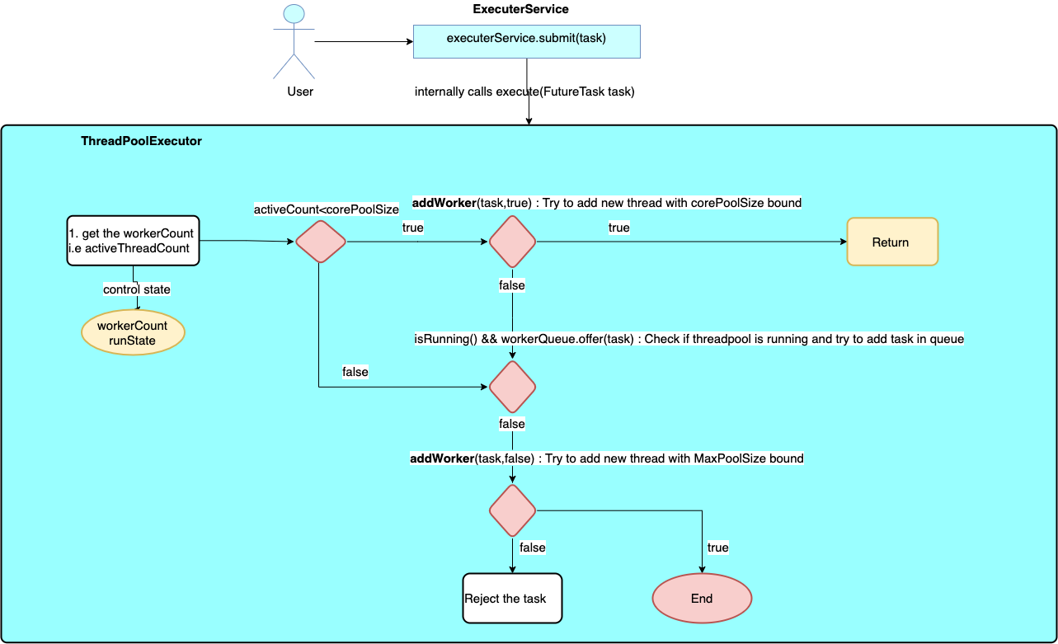

After, going through the above diagram, you must be able to understand thread management at a high level. Let’s go deep and understand, how the addWorker method works.

private boolean addWorker(Runnable firstTask, boolean core) {……}

if the core is true, that means worker thread can be created up to the core pool size limit, else worker thread can be created up to max pool size limit.

Let’s understand the addWorker method by a flow diagram.

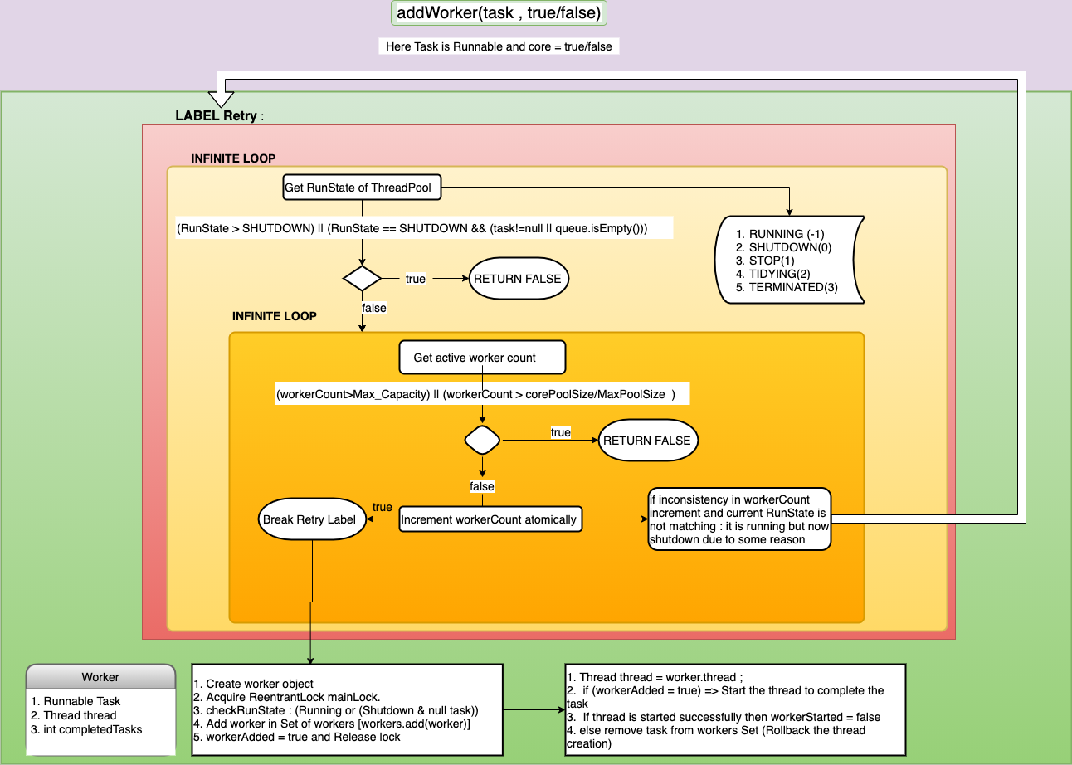

I think you have got some doubts after going through this flow diagram. Let me describe to you the states of the thread pool.

***RUNNING****: Accept new tasks and process queued tasks.*

***SHUTDOWN****: Don’t accept new tasks, but process queued tasks*

***STOP****: Don’t accept new tasks, don’t process queued tasks,  
and interrupt in-progress tasks*

***TIDYING****: All tasks have terminated, worker count is zero, the thread transitioning to state TIDYING will run the terminated() hook method*

***TERMINATED****: terminated() has completed*

As per my promise, I will cover how can we create our own customizable thread pool. Isn’t it interesting! Let me take one real-life example and create customizable thread pools.

*Suppose, I have a website like Flipkart and I have to handle n number of requests in case of a big billion days. My idea is, I will create thread pools according to the category of the inventory. Categories are like Grocery , Mobiles , fashion , electronics , appliances and others. So , here goes my threadpools*

Suppose, mobile phones and fashion items have maximum sales as per data then I will give pool size maximum to these thread pools.

1. MobileThreadPool -> corePoolSize = 16 , maximumPoolSize =20 , queueCapacity = 100 .
2. FashionThreadPool -> corePoolSize = 16 , maximumPoolSize =20, queueCapacity = 100 .
3. ElectronicsThreadPool -> corePoolSize = 8, maximumPoolSize =16 , queueCapacity = 100 .
4. AppliancesThreadPool -> corePoolSize = 8, maximumPoolSize =16 , queueCapacity = 100 .
5. OthersThreadPool -> corePoolSize = 8, maximumPoolSize =16 , queueCapacity = 100 .

ThreadPoolExecutor mobileTP = new ThreadPoolExecutor(16,20,0L,TimeUnit.milliseconds , new LinkedBlockingQueue<Runnable>(100));Here , OL is the keepAliveTime of the thread and last one is linkedBlockingQueue with 100 capacity.**BlockingQueue** basically best for multithreading as it blocks thread from adding the elements in the queue until queue has one empty space , same in case of removing the element , it blocks thread from removing the elements from the queue until queue becomes non-empty.

Here, By using multithreading we are categorizing our threads by using different thread pools for different inventory categories.

Please ask as many questions, as you got after reading this blog. I have not covered **BlockingQueue** here, which is used in the thread pool internally. Let me describe it in the next blog.

***To understand executorService and factory design pattern go through my another blog:***

## [Multithreading: ExecuterService an example of factory design pattern](https://12shankar12ravi.medium.com/multithreading-executerservice-an-example-of-factory-design-pattern-7b3c5d0f49d9?source=post_page-----904f1e87fea--------------------------------" \t "_blank)

### [Have you ever wonder, how factory design pattern is used in the Java concurrency library. I will give you a complete…](https://12shankar12ravi.medium.com/multithreading-executerservice-an-example-of-factory-design-pattern-7b3c5d0f49d9?source=post_page-----904f1e87fea--------------------------------" \t "_blank)

[12shankar12ravi.medium.com](https://12shankar12ravi.medium.com/multithreading-executerservice-an-example-of-factory-design-pattern-7b3c5d0f49d9?source=post_page-----904f1e87fea--------------------------------" \t "_blank)

***Meet you soon in the next blog. By that time, Stay Safe and Stay Home as the covid-19 is spreading too much everywhere.***

what is abstraction?

Abstraction in Java refers to hiding the implementation details of a code and exposing only the necessary information to the user. It provides the ability to simplify complex systems by ignoring irrelevant details and reducing complexity.

diffference between object and reference ?

What is difference between references and objects in java? A reference is an entity which provides a way to access object of its type. An object is an entity which provides a way to access the members of it's class or type. Generally, You can't access an object without a reference to it.

class GUI

{

void aMethod()

{

// some business logic.

}

}

You can call aMethod with or without a reference. but you definitely need an object.

Without Reference:

new GUI().aMethod();

// you can't reuse the object

// bad way to code.

With Reference:

GUI aGUIReference = new GUI();

aGUIReference.aMethod();

// Now, the object can be reused.

// Preferred way to code

what is list , difference between list and set?

In Java, when comparing “list vs set” a list supports ordered collections and allows duplicates, whereas a set emphasizes uniqueness without any specific order. Lists allow duplicate values while Sets don't. Lists allow positional indexing. The same is not allowed in sets.

what is binary search, hashSet, Arraylist

Binary search implies a sorted container. A set is either unordered ( HashSet ), in which case a binary search cannot be performed, or it is ordered ( TreeSet ), in which case its lookup operation is already as efficient as a binary search (i.e. O(Log2(N)) ). Binary search works on ordered collection.

Returns index of key in sorted list sorted in

// ascending order

public static int binarySearch(List slist, T key)

// Returns index of key in sorted list sorted in

// order defined by Comparator c.

public static int binarySearch(List slist, T key, Comparator c)

If key is not present, the it returns "(-(insertion point) - 1)".

The insertion point is defined as the point at which the key

would be inserted into the list.

The method throws **ClassCastException** if elements of list are not comparable using the specified comparator, or the search key is not comparable with the elements.  
**Searching an int key in a list sorted in ascending order:** 

* Java

|  |
| --- |
| // Java program to demonstrate working of Collections.  // binarySearch()  **import** java.util.ArrayList;  **import** java.util.Collections;  **import** java.util.List;    **public** **class** GFG {  **public** **static** **void** main(String[] args)      {          List<Integer> al = **new** ArrayList<Integer>();          al.add(1);          al.add(2);          al.add(3);          al.add(10);          al.add(20);            // 10 is present at index 3.  **int** index = Collections.binarySearch(al, 10);          System.out.println(index);            // 13 is not present. 13 would have been inserted          // at position 4. So the function returns (-4-1)          // which is -5.          index = Collections.binarySearch(al, 13);          System.out.println(index); |

difference between arraylist & array , throw & throws, try catch finally

**Difference between throw and throws** keyword on Exception handling in Java is a [popular core java interview question](http://javarevisited.blogspot.com/2011/04/top-20-core-java-interview-questions.html). Exception handling being an important part of Java programming language, complete knowledge of all keywords related to exception handling e.g. **try**, **catch**, **finally**, **throw** and **throws** is important*. Main difference between throw and throws* is in there usage and functionality. where throws is used in method signature to declare Exception possibly thrown by any method, throw is actually used to throw Exception in Java code, here is an example of both throw and throws keyword which makes it easy to understand difference between them.

 public void **shutdown**() throws **IOException**{

        throw new IOException("Unable to shutdown");

 }

if you see the code above, throws keyword is used to declare Exception thrown by this method shutdwon(), by looking at method signature we know that its throwing IOException. while inside method code throw keyword is actually used to throw instance of IOException. here are couple of more differences between throw and throws keyword in java:

## Difference between throw and throws in Exception handling - Java Example

1) You can declare multiple exceptions thrown by the method in throws keyword by separating them in common e.g. throws IOException, ArrayIndexBoundException, etc, while you can only throw one instance of exception using throw keyword e.g. throw new IOException("not able to open connection").

2) **throws** keyword gives a method flexibility of throwing an Exception rather than handling it. with throws keyword, in the method signature, a method suggesting its caller to prepare for Exception declared in the throws clause, especially in case of [checked Exception](http://javarevisited.blogspot.com/2011/12/checked-vs-unchecked-exception-in-java.html) and provide sufficient handling of them.   
  
On the other hand, **throw keyword** transfer control of execution to the caller by throwing an instance of Exception. throw keyword can also be used in place of return as shown in the below example:

 private static boolean shutdown() {

        throw new UnsupportedOperationException("Not yet implemented");

    }

as in the below method shutdown should return boolean but having throw in place compiler understand that this method will always **throw an exception** .

3) throws keyword cannot be used anywhere exception method signature while **throw keyword** can be used inside a method or static initializer block provided sufficient exception handling as shown in the example.

static{

        try {

            throw new Exception("Not able to initialized");

        } catch (Exception ex) {

            Logger.getLogger(ExceptionTest.class.getName()).log(Level.SEVERE, null, ex);

        }

    }

worth remembering is that the [static initializer block](http://javarevisited.blogspot.com/2011/11/static-keyword-method-variable-java.html) should complete normally.

4) **throw keyword** can also be used to break a switch statement without using break keyword as shown in below example:

int number = 5;

switch(number){

            case 1:

                throw new RuntimeException("Exception number 1");

            case 2:

                throw new RuntimeException("Exception number 2");

        }

And here is a nice table to remember the difference between throw and throws in Java:

[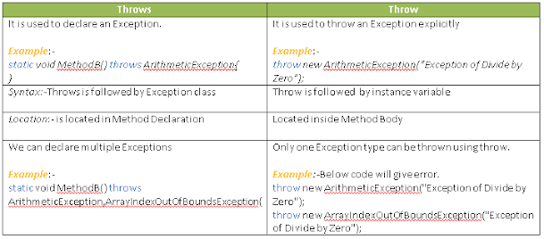](https://1.bp.blogspot.com/-39NguHACC6U/X0TrBvUw99I/AAAAAAAAijE/t_blS5eGpeEm9YRl1CxaWYyUIdtenScwwCLcBGAsYHQ/s1600/Throws%2Bvs%2BThrow.png)

We have seen differences between throw and throws in Java and they should be used accordingly. Let me know if you come across any other **difference on throw vs throws in java**.

Read more: <https://javarevisited.blogspot.com/2012/02/difference-between-throw-and-throws-in.html#ixzz8IV8QyH3W>

Java 1.8 features on concurrent Hashmap

Java 8 provides Stream support in the ConcurrentHashMap as well. Unlike most stream methods, the bulk (sequential and parallel) operations allow concurrent modification safely. ConcurrentModificationException won't be thrown, which also applies to its iterators

### ****3.3. Stream Support****

Java 8 provides Stream support in the ConcurrentHashMap as well.

Unlike most stream methods, the bulk (sequential and parallel) operations allow concurrent modification safely. ConcurrentModificationException won’t be thrown, which also applies to its iterators. Relevant to streams, several forEach\*, search, and reduce\* methods are also added to support richer traversal and map-reduce operations.

### ****3.4. Performance****

**Under the hood, ConcurrentHashMap is somewhat similar to HashMap**, with data access and update based on a hash table (though more complex).

And of course, the ConcurrentHashMap should yield much better performance in most concurrent cases for data retrieval and update.

Let’s write a quick micro-benchmark for get and put performance and compare that to Hashtable and Collections.synchronizedMap, running both operations for 500,000 times in 4 threads.

@Test

**public** **void** **givenMaps\_whenGetPut500KTimes\_thenConcurrentMapFaster**()

**throws** Exception {

Map<String, Object> hashtable = **new** **Hashtable**<>();

Map<String, Object> synchronizedHashMap =

Collections.synchronizedMap(**new** **HashMap**<>());

Map<String, Object> concurrentHashMap = **new** **ConcurrentHashMap**<>();

**long** hashtableAvgRuntime = timeElapseForGetPut(hashtable);

**long** syncHashMapAvgRuntime =

timeElapseForGetPut(synchronizedHashMap);

**long** concurrentHashMapAvgRuntime =

timeElapseForGetPut(concurrentHashMap);

assertTrue(hashtableAvgRuntime > concurrentHashMapAvgRuntime);

assertTrue(syncHashMapAvgRuntime > concurrentHashMapAvgRuntime);

}

**private** **long** **timeElapseForGetPut**(Map<String, Object> map)

**throws** InterruptedException {

**ExecutorService** executorService =

Executors.newFixedThreadPool(4);

**long** startTime = System.nanoTime();

**for** (**int** i = 0; i < 4; i++) {

executorService.execute(() -> {

**for** (**int** j = 0; j < 500\_000; j++) {

**int** value = ThreadLocalRandom

.current()

.nextInt(10000);

**String** key = String.valueOf(value);

map.put(key, value);

map.get(key);

}

});

}

executorService.shutdown();

executorService.awaitTermination(1, TimeUnit.MINUTES);

**return** (System.nanoTime() - startTime) / 500\_000;

}Copy

Keep in mind micro-benchmarks are only looking at a single scenario and aren’t always a good reflection of real world performance.

That being said, on an OS X system with an average dev system, we’re seeing an average sample result for 100 consecutive runs (in nanoseconds):

Hashtable: 1142.45

SynchronizedHashMap: 1273.89

ConcurrentHashMap: 230.2Copy

In a multi-threading environment, where multiple threads are expected to access a common Map, the ConcurrentHashMap is clearly preferable.

However, when the Map is only accessible to a single thread, HashMap can be a better choice for its simplicity and solid performance.

### ****3.5. Pitfalls****

Retrieval operations generally do not block in ConcurrentHashMap and could overlap with update operations. So for better performance, they only reflect the results of the most recently completed update operations, as stated in the [official Javadoc](https://docs.oracle.com/en/java/javase/17/docs/api/java.base/java/util/concurrent/ConcurrentHashMap.html).

There are several other facts to bear in mind:

* results of aggregate status methods including size, isEmpty, and containsValue are typically useful only when a map is not undergoing concurrent updates in other threads:

@Test

**public** **void** **givenConcurrentMap\_whenUpdatingAndGetSize\_thenError**()

**throws** InterruptedException {

**Runnable** collectMapSizes = () -> {

**for** (**int** i = 0; i < MAX\_SIZE; i++) {

mapSizes.add(concurrentMap.size());

}

};

**Runnable** updateMapData = () -> {

**for** (**int** i = 0; i < MAX\_SIZE; i++) {

concurrentMap.put(String.valueOf(i), i);

}

};

executorService.execute(updateMapData);

executorService.execute(collectMapSizes);

executorService.shutdown();

executorService.awaitTermination(1, TimeUnit.MINUTES);

assertNotEquals(MAX\_SIZE, mapSizes.get(MAX\_SIZE - 1).intValue());

assertEquals(MAX\_SIZE, concurrentMap.size());

}Copy

If concurrent updates are under strict control, aggregate status would still be reliable.

Although these **aggregate status methods do not guarantee the real-time accuracy, they may be adequate for monitoring or estimation purposes**.

Note that usage of size() of ConcurrentHashMap should be replaced by mappingCount(), for the latter method returns a long count, although deep down they are based on the same estimation.

* **hashCode matters**: note that using many keys with exactly the same hashCode() is a sure way to slow down a performance of any hash table.

To ameliorate impact when keys are Comparable, ConcurrentHashMap may use comparison order among keys to help break ties. Still, we should avoid using the same hashCode() as much as we can.

* iterators are only designed to use in a single thread as they provide weak consistency rather than fast-fail traversal, and they will never throw ConcurrentModificationException.
* the default initial table capacity is 16, and it’s adjusted by the specified concurrency level:

**public** **ConcurrentHashMap**(

**int** initialCapacity, **float** loadFactor, **int** concurrencyLevel) {

//...

**if** (initialCapacity < concurrencyLevel) {

initialCapacity = concurrencyLevel;

}

//...

}Copy

* caution on remapping functions: though we can do remapping operations with provided compute and merge\* methods, we should keep them fast, short and simple, and focus on the current mapping to avoid unexpected blocking.
* keys in ConcurrentHashMap are not in sorted order, so for cases when ordering is required, ConcurrentSkipListMap is a suitable choice.

## **4.**ConcurrentNavigableMap

For cases when ordering of keys is required, we can use ConcurrentSkipListMap, a concurrent version of TreeMap.

As a supplement for ConcurrentMap, ConcurrentNavigableMap supports total ordering of its keys (in ascending order by default) and is concurrently navigable. Methods that return views of the map are overridden for concurrency compatibility:

* subMap
* headMap
* tailMap
* subMap
* headMap
* tailMap
* descendingMap

keySet() views’ iterators and spliterators are enhanced with weak-memory-consistency:

* navigableKeySet
* keySet
* descendingKeySet

## **5.**ConcurrentSkipListMap

Previously, we have covered NavigableMap interface and its implementation [TreeMap](https://www.baeldung.com/java-treemap). ConcurrentSkipListMap can be seen a scalable concurrent version of TreeMap.

In practice, there’s no concurrent implementation of the red-black tree in Java. A concurrent variant of [SkipLists](https://en.wikipedia.org/wiki/Skip_list) is implemented in ConcurrentSkipListMap, providing an expected average log(n) time cost for the containsKey, get, put and remove operations and their variants.

In addition to TreeMap‘s features, key insertion, removal, update and access operations are guaranteed with thread-safety. Here’s a comparison to TreeMap when navigating concurrently:

@Test

**public** **void** **givenSkipListMap\_whenNavConcurrently\_thenCountCorrect**()

**throws** InterruptedException {

NavigableMap<Integer, Integer> skipListMap

= **new** **ConcurrentSkipListMap**<>();

**int** count = countMapElementByPollingFirstEntry(skipListMap, 10000, 4);

assertEquals(10000 \* 4, count);

}

@Test

**public** **void** **givenTreeMap\_whenNavConcurrently\_thenCountError**()

**throws** InterruptedException {

NavigableMap<Integer, Integer> treeMap = **new** **TreeMap**<>();

**int** count = countMapElementByPollingFirstEntry(treeMap, 10000, 4);

assertNotEquals(10000 \* 4, count);

}

**private** **int** **countMapElementByPollingFirstEntry**(

NavigableMap<Integer, Integer> navigableMap,

**int** elementCount,

**int** concurrencyLevel) **throws** InterruptedException {

**for** (**int** i = 0; i < elementCount \* concurrencyLevel; i++) {

navigableMap.put(i, i);

}

**AtomicInteger** counter = **new** **AtomicInteger**(0);

**ExecutorService** executorService

= Executors.newFixedThreadPool(concurrencyLevel);

**for** (**int** j = 0; j < concurrencyLevel; j++) {

executorService.execute(() -> {

**for** (**int** i = 0; i < elementCount; i++) {

**if** (navigableMap.pollFirstEntry() != null) {

counter.incrementAndGet();

}

}

});

}

executorService.shutdown();

executorService.awaitTermination(1, TimeUnit.MINUTES);

**return** counter.get();

}Copy

A full explanation of the performance concerns behind the scenes is beyond the scope of this article. The details can be found in ConcurrentSkipListMap’s Javadoc, which is located under java/util/concurrent in the src.zip file.

## **6. Conclusion**

In this article, we mainly introduced the ConcurrentMap interface and the features of ConcurrentHashMap and covered on ConcurrentNavigableMap being key-ordering required.

The full source code for all the examples used in this article can be found [in the GitHub project](https://github.com/eugenp/tutorials/tree/master/core-java-modules/core-java-concurrency-collections).

What are Java 8 Features

**Some of the important Java 8 features are;**

* forEach() method in Iterable interface.
* default and static methods in Interfaces.
* Functional Interfaces and Lambda Expressions.
* Java Stream API for Bulk Data Operations on Collections.
* Java Time API.
* Collection API improvements.
* Concurrency API improvements.
* Java IO improvements.

Java 8 is the most awaited release of Java programming language development because, in the entire history of Java, it never release that many major features. It consists of major features of Java. It is a new version of Java and was released by Oracle on 18 March 2014. Java provided support for functional programming, new Java 8 APIs, a new JavaScript engine, new Java 8 streaming API, functional interfaces, default methods, date-time API changes, etc.

This Tutorial covers all the important Java 8 features like Java 8 APIs, Java arrays, Java 8 ArrayList, and many more included in Java 8 programming language.

## Java 8 Features

* [Lambda Expressions](https://www.geeksforgeeks.org/java-8-features/#lambda)
* [Functional Interfaces](https://www.geeksforgeeks.org/java-8-features/#functional)
* [Method Reference](https://www.geeksforgeeks.org/java-8-features/#reference)
* [Streams](https://www.geeksforgeeks.org/java-8-features/#streams)
* [Comparable and Comparator](https://www.geeksforgeeks.org/java-8-features/#comp)
* [Optional Class](https://www.geeksforgeeks.org/java-8-features/#optional)
* [Date/Time API](https://www.geeksforgeeks.org/java-8-features/#datetime)
* [Miscellaneous](https://www.geeksforgeeks.org/java-8-features/#misc)

## Lambda Expressions

Lambda Expression basically expresses an instance of the functional interface, in other words, you can say it provides a clear and concise way to represent a method of the functional interface using an expression. Lambda Expressions are added in Java 8.

* [Lambda Expressions in Java 8](https://www.geeksforgeeks.org/lambda-expressions-java-8/)
* [Lambda Expressions Parameters](https://www.geeksforgeeks.org/java-lambda-expressions-parameters/)
* [Java Lambda Expression with Collections](https://www.geeksforgeeks.org/java-lambda-expression-with-collections/)
* [Lambda Expression Variable Capturing with Examples](https://www.geeksforgeeks.org/java-lambda-expression-variable-capturing-with-examples/)
* [How to Create Thread using Lambda Expressions in Java?](https://www.geeksforgeeks.org/how-to-create-thread-using-lambda-expressions-in-java/)
* [Serialization of Lambda Expression in Java](https://www.geeksforgeeks.org/serialization-of-lambda-expression-in-java/)
* [Block Lambda Expressions in Java](https://www.geeksforgeeks.org/block-lambda-expressions-in-java/)
* [Match Lambdas to Interfaces in Java](https://www.geeksforgeeks.org/match-lambdas-to-interfaces-in-java/)
* [Converting ArrayList to HashMap in Java 8 using a Lambda Expression](https://www.geeksforgeeks.org/converting-arraylist-to-hashmap-in-java-8-using-a-lambda-expression/)
* [Check if a String Contains Only Alphabets in Java Using Lambda Expression](https://www.geeksforgeeks.org/check-if-a-string-contains-only-alphabets-in-java-using-lambda-expression/)
* [Remove Elements From a List that Satisfy a Given Predicate in Java](https://www.geeksforgeeks.org/remove-elements-from-a-list-that-satisfy-given-predicate-in-java/)

## Functional Interfaces

An interface that contains only one abstract method is known as a functional interface, but there is no restriction, you can have **n**number of default and static methods inside a functional interface.

* [Functional Interfaces in Java](https://www.geeksforgeeks.org/functional-interfaces-java/)
* [Consumer Interface in Java with Examples](https://www.geeksforgeeks.org/java-8-consumer-interface-in-java-with-examples/)
* [BiConsumer Interface in Java with Examples](https://www.geeksforgeeks.org/java-8-biconsumer-interface-in-java-with-examples/)
* [Predicate Interface with Examples](https://www.geeksforgeeks.org/java-8-predicate-with-examples/)
* [Function Interface in Java with Examples](https://www.geeksforgeeks.org/function-interface-in-java-with-examples/)
* [Supplier Interface in Java with Examples](https://www.geeksforgeeks.org/supplier-interface-in-java-with-examples/)

## Method Reference

Method reference is a shorthand notation of a lambda expression to call a method. There are four types of method references that are as follows:

* Static Method Reference
* Instance Method Reference of a particular object
* Instance Method Reference of an arbitrary object of a particular type
* Constructor Reference.

**Example:**

numList.stream().filter(n -> n > 5).sorted().forEach(System.out::println);

* [Method References in Java with examples](https://www.geeksforgeeks.org/method-references-in-java-with-examples/)
* [Converting ArrayList to HashMap using Method Reference in Java 8](https://www.geeksforgeeks.org/converting-arraylist-to-hashmap-using-method-reference-in-java-8/)

## Streams

Stream API is introduced in Java 8 and is used to process collections of objects with the functional style of coding using the lambda expression. So to understand what stream API is, you must have knowledge of both lambda and functional interfaces.

* [Java 8 Stream](https://www.geeksforgeeks.org/java-8-stream-tutorial/)
* [Difference Between Streams and Collections in Java](https://www.geeksforgeeks.org/difference-between-streams-and-collections-in-java/)
* [Implement Filter Function using Reduce in Java 8 Streams](https://www.geeksforgeeks.org/implement-filter-function-using-reduce-in-java-8-streams/)
* [Java Stream API – Filters](https://www.geeksforgeeks.org/java-stream-api-filters/)
* [Parallel vs Sequential Stream in Java](https://www.geeksforgeeks.org/parallel-vs-sequential-stream-in-java/)
* [Functional Programming in Java 8+ using the Stream API with Example](https://www.geeksforgeeks.org/functional-programming-in-java-8-using-the-stream-api-with-example/)
* [Intermediate Methods of Stream in Java](https://www.geeksforgeeks.org/intermediate-methods-of-stream-in-java/)
* [Difference Between map() And flatMap() In Java Stream](https://www.geeksforgeeks.org/difference-between-map-and-flatmap-in-java-stream/)
* [Array to Stream in Java](https://www.geeksforgeeks.org/array-stream-java/)
* [10 Ways to Create a Stream in Java](https://www.geeksforgeeks.org/10-ways-to-create-a-stream-in-java/)
* [How to Print Elements of a Stream in Java 8](https://www.geeksforgeeks.org/how-to-print-elements-of-a-stream-in-java-8/)
* [Collecting a Stream to an Immutable Collection in Java](https://www.geeksforgeeks.org/collecting-a-stream-to-an-immutable-collection-in-java/)
* [Comparing Streams to Loops in Java](https://www.geeksforgeeks.org/comparing-streams-to-loops-in-java/)
* [Why You Need to Close the Java Streams in Finally Block?](https://www.geeksforgeeks.org/why-you-need-to-close-the-java-streams-in-finally-block/)
* [Convert an Iterable to Stream in Java](https://www.geeksforgeeks.org/convert-an-iterable-to-stream-in-java/)
* [Convert an Iterator to Stream in Java](https://www.geeksforgeeks.org/convert-an-iterator-to-stream-in-java/)
* [Difference Between Stream.of() and Arrays.stream() method in Java](https://www.geeksforgeeks.org/difference-between-stream-of-and-arrays-stream-method-in-java/)
* [Convert Stream to Set in Java](https://www.geeksforgeeks.org/convert-stream-set-java/)
* [Convert a Set to Stream in Java](https://www.geeksforgeeks.org/convert-set-stream-java/)
* [Streams on Arrays in Java 8](https://www.geeksforgeeks.org/streams-arrays-java-8/)

## Java Stream Programs

* [Program to Convert a Map to a Stream in Java](https://www.geeksforgeeks.org/program-to-convert-a-map-to-a-stream-in-java/)
* [Program to Convert Boxed Array to Stream in Java](https://www.geeksforgeeks.org/program-to-convert-boxed-array-to-stream-in-java/)
* [Program to Convert Primitive Array to Stream in Java](https://www.geeksforgeeks.org/program-to-convert-primitive-array-to-stream-in-java/)
* [Program to Convert a Set to Stream in Java using Generics](https://www.geeksforgeeks.org/program-to-convert-a-set-to-stream-in-java-using-generics/)
* [Program to Convert List to Stream in Java](https://www.geeksforgeeks.org/program-to-convert-list-to-stream-in-java/)
* [Program to Convert Stream to an Array in Java](https://www.geeksforgeeks.org/program-to-convert-stream-to-an-array-in-java/)
* [How to get Slice of a Stream in Java](https://www.geeksforgeeks.org/how-to-get-slice-of-a-stream-in-java/)
* [Flattening Nested Collections in Java](https://www.geeksforgeeks.org/flattening-nested-collections-in-java/)
* [How to Convert a Stream into a Map in Java](https://www.geeksforgeeks.org/how-to-convert-a-stream-into-a-map-in-java/)
* [Find the First Element of a Stream in Java](https://www.geeksforgeeks.org/find-the-first-element-of-a-stream-in-java/)
* [Find the Last Element of a Stream in Java](https://www.geeksforgeeks.org/find-the-last-element-of-a-stream-in-java/)
* [How to Find Duplicate Elements in a Stream in Java](https://www.geeksforgeeks.org/how-to-find-duplicate-elements-in-a-stream-in-java/)
* [Count the Occurrence of a Given Character in a String Using Stream API in Java](https://www.geeksforgeeks.org/count-occurrence-of-a-given-character-in-a-string-using-stream-api-in-java/)
* [Reverse Elements of a Parallel Stream in Java](https://www.geeksforgeeks.org/reverse-elements-of-a-parallel-stream-in-java/)
* [How to Get ArrayList From Stream in Java 8](https://www.geeksforgeeks.org/how-to-get-arraylist-from-stream-in-java-8/)
* [Generate Infinite Stream of Double in Java](https://www.geeksforgeeks.org/generate-infinite-stream-of-double-in-java/)
* [Generate Infinite Stream of Integers in Java](https://www.geeksforgeeks.org/generate-infinite-stream-of-integers-in-java/)
* [Program to Iterate over a Stream with Indices in Java 8](https://www.geeksforgeeks.org/program-to-iterate-over-a-stream-with-indices-in-java-8/)
* [Flatten a Stream of Arrays in Java using forEach loop](https://www.geeksforgeeks.org/flatten-a-stream-of-arrays-in-java-using-foreach-loop/)
* [Flatten a Stream of Lists in Java using forEach loop](https://www.geeksforgeeks.org/flatten-a-stream-of-lists-in-java-using-foreach-loop/)
* [Flatten a Stream of Map in Java using forEach loop](https://www.geeksforgeeks.org/flatten-a-stream-of-map-in-java-using-foreach-loop/)
* [Convert a String to a List of Characters in Java](https://www.geeksforgeeks.org/convert-a-string-to-a-list-of-characters-in-java/)
* [Initialize a List in a Single Line with a Specified Value using Java Stream](https://www.geeksforgeeks.org/initialize-a-list-in-a-single-line-with-a-specified-value-using-java-stream/)

## Java Stream Methods

* [Stream forEach() method in Java with Examples](https://www.geeksforgeeks.org/stream-foreach-method-java-examples/)
* [Stream forEachOrdered() Method in Java with Examples](https://www.geeksforgeeks.org/stream-foreachordered-method-java-examples/)
* [foreach() loop vs Stream foreach() vs Parallel Stream foreach()](https://www.geeksforgeeks.org/foreach-loop-vs-stream-foreach-vs-parallel-stream-foreach/)
* [Stream of() method in Java](https://www.geeksforgeeks.org/stream-of-method-in-java/)
* [Java Stream findAny() with Examples](https://www.geeksforgeeks.org/java-stream-findany-with-examples/)
* [Stream anyMatch() in Java with Examples](https://www.geeksforgeeks.org/stream-anymatch-java-examples/)
* [Stream allMatch() in Java with Examples](https://www.geeksforgeeks.org/stream-allmatch-java-examples/)
* [Stream filter() in Java with Examples](https://www.geeksforgeeks.org/stream-filter-java-examples/)
* [Stream sorted (Comparator comparator) Method in Java](https://www.geeksforgeeks.org/stream-sorted-comparator-comparator-method-java/)
* [Stream sorted() in Java](https://www.geeksforgeeks.org/stream-sorted-in-java/)
* [Stream.distinct() in Java](https://www.geeksforgeeks.org/stream-distinct-java/)
* [Stream.concat() in Java](https://www.geeksforgeeks.org/stream-concat-java/)
* [Stream.reduce() in Java with Examples](https://www.geeksforgeeks.org/stream-reduce-java-examples/)
* [stream.limit() method in Java](https://www.geeksforgeeks.org/stream-limit-method-in-java/)
* [Stream ofNullable(T) method in Java with Examples](https://www.geeksforgeeks.org/stream-ofnullablet-method-in-java-with-examples/)
* [Stream dropWhile() method in Java with Examples](https://www.geeksforgeeks.org/stream-dropwhile-method-in-java-with-examples/)
* [Stream iterate(T,Predicate,UnaryOperator) Method in Java with Examples](https://www.geeksforgeeks.org/stream-iteratetpredicateunaryoperator-method-in-java-with-examples/)
* [Stream takeWhile() method in Java with Examples](https://www.geeksforgeeks.org/stream-takewhile-method-in-java-with-examples/)
* [concat() Method of Stream Interface in Java API](https://www.geeksforgeeks.org/concat-method-of-stream-interface-in-java-api/)
* [Stream findFirst() in Java with Examples](https://www.geeksforgeeks.org/stream-findfirst-java-examples/)
* [DoubleStream mapToObj() in Java](https://www.geeksforgeeks.org/doublestream-maptoobj-in-java/)
* [Stream.Builder accept() Method in Java](https://www.geeksforgeeks.org/stream-builder-accept-method-in-java/)
* [IntStream.Builder add() Method in Java](https://www.geeksforgeeks.org/intstream-builder-add-method-in-java/)
* [DoubleStream.Builder build() in Java](https://www.geeksforgeeks.org/doublestream-builder-build-in-java/)
* [Stream.Builder build() in Java](https://www.geeksforgeeks.org/stream-builder-java-examples/)
* [Collectors.joining() Method with Examples](https://www.geeksforgeeks.org/java-8-streams-collectors-joining-method-with-examples/)
* [Stream builder() in Java with Examples](https://www.geeksforgeeks.org/stream-builder-java-examples/)
* [Stream empty() in Java with Examples](https://www.geeksforgeeks.org/stream-empty-java-examples/)
* [LongStream flatMap(LongFunction mapper) in Java](https://www.geeksforgeeks.org/longstream-flatmaplongfunction-mapper-java/)
* [LongStream filter() in Java with Examples](https://www.geeksforgeeks.org/longstream-filter-java-examples/)

## Comparable and Comparator

* [Comparable vs Comparator in Java](https://www.geeksforgeeks.org/comparable-vs-comparator-in-java/)
* [Comparator Interface in Java with Examples](https://www.geeksforgeeks.org/comparator-interface-java/)
* [Why to Use Comparator Interface Rather than Comparable Interface in Java?](https://www.geeksforgeeks.org/why-to-use-comparator-interface-rather-than-comparable-interface-in-java/)
* [Sort an Array of Triplet using Java Comparable and Comparator](https://www.geeksforgeeks.org/sort-an-array-of-triplet-using-java-comparable-and-comparator/)
* [Java Program to Sort LinkedList using Comparable](https://www.geeksforgeeks.org/java-program-to-sort-linkedlist-using-comparable/)
* [How to Sort HashSet Elements using Comparable Interface in Java?](https://www.geeksforgeeks.org/how-to-sort-hashset-elements-using-comparable-interface-in-java/)
* [Sort LinkedHashMap by Values using Comparable Interface in Java](https://www.geeksforgeeks.org/sort-linkedhashmap-by-values-using-comparable-interface-in-java/)
* [Sort LinkedHashMap by Keys using Comparable Interface in Java](https://www.geeksforgeeks.org/sort-linkedhashmap-by-keys-using-comparable-interface-in-java/)
* [How to Sort LinkedHashSet Elements using Comparable Interface in Java?](https://www.geeksforgeeks.org/how-to-sort-linkedhashset-elements-using-comparable-interface-in-java/)

## Optional Class

* [Java 8 Optional Class](https://www.geeksforgeeks.org/java-8-optional-class/)
* [Optional ofNullable() Method in Java with Examples](https://www.geeksforgeeks.org/optional-ofnullable-method-in-java-with-examples/)
* [Optional orElse() Method in Java with Examples](https://www.geeksforgeeks.org/optional-orelse-method-in-java-with-examples/)
* [Optional ifPresentOrElse() Method in Java with Examples](https://www.geeksforgeeks.org/optional-ifpresentorelse-method-in-java-with-examples/)
* [Optional orElseGet() Method in Java with Examples](https://www.geeksforgeeks.org/optional-orelseget-method-in-java-with-examples/)
* [Optional filter() Method in Java with Examples](https://www.geeksforgeeks.org/optional-filter-method-in-java-with-examples/)
* [Optional empty() Method in Java with Examples](https://www.geeksforgeeks.org/optional-empty-method-in-java-with-examples/)
* [Optional hashCode() Method in Java with Examples](https://www.geeksforgeeks.org/optional-hashcode-method-in-java-with-examples/)
* [Optional toString() Method in Java with Examples](https://www.geeksforgeeks.org/optional-tostring-method-in-java-with-examples/)
* [Optional equals() Method in Java with Examples](https://www.geeksforgeeks.org/optional-equals-method-in-java-with-examples/)
* [Optional stream() Method in Java with examples](https://www.geeksforgeeks.org/optional-stream-method-in-java-with-examples/)
* [Optional or() Method in Java with Examples](https://www.geeksforgeeks.org/optional-or-method-in-java-with-examples/)
* [Optional get() Method in Java with Examples](https://www.geeksforgeeks.org/optional-get-method-in-java-with-examples/)
* [Optional isPresent() Method in Java with Examples](https://www.geeksforgeeks.org/optional-ispresent-method-in-java-with-examples/)
* [Optional orElseThrow() Method in Java with Examples](https://www.geeksforgeeks.org/optional-orelsethrow-method-in-java-with-examples/)
* [Optional of() method in Java with Examples](https://www.geeksforgeeks.org/optional-of-method-in-java-with-examples/)

## Date/Time API

* [Date-Time API in Java 8](https://www.geeksforgeeks.org/new-date-time-api-java8/)
* [java.time.LocalDate Class in Java](https://www.geeksforgeeks.org/java-time-localdate-class-in-java/)
* [java.time.LocalTime Class in Java](https://www.geeksforgeeks.org/java-time-localtime-class-in-java/)
* [java.time.LocalDateTime Class in Java](https://www.geeksforgeeks.org/java-time-localdatetime-class-in-java/)
* [java.time.MonthDay Class in Java](https://www.geeksforgeeks.org/java-time-monthday-class-in-java/)
* [java.time.OffsetTime Class in Java](https://www.geeksforgeeks.org/java-time-offsettime-class-in-java/)
* [java.time.OffsetDateTime Class in Java](https://www.geeksforgeeks.org/java-time-offsetdatetime-class-in-java/)
* [java.time.Clock Class in Java](https://www.geeksforgeeks.org/java-time-clock-class-in-java/)
* [java.time.ZonedDateTime Class in Java](https://www.geeksforgeeks.org/java-time-zoneddatetime-class-in-java/)
* [java.time.ZoneId Class in Java](https://www.geeksforgeeks.org/java-time-zoneid-class-in-java/)
* [java.time.ZoneOffset Class in Java](https://www.geeksforgeeks.org/java-time-zoneoffset-class-in-java/)
* [java.time.Year Class in Java](https://www.geeksforgeeks.org/java-time-year-class-in-java/)
* [java.time.YearMonth Class in Java](https://www.geeksforgeeks.org/java-time-yearmonth-class-in-java/)
* [java.time.Period Class in Java](https://www.geeksforgeeks.org/java-time-period-class-in-java/)
* [java.time.Duration Class in Java](https://www.geeksforgeeks.org/java-time-duration-class-in-java/)
* [java.time.Instant Class in Java](https://www.geeksforgeeks.org/java-time-instant-class-in-java/)
* [Java 8 Clock instant() method with Examples](https://www.geeksforgeeks.org/java-8-clock-instant-method-with-examples/)
* [Java 8 Clock fixed() method with Examples](https://www.geeksforgeeks.org/java-8-clock-fixed-method-with-examples/)

## Miscellaneous

* [Default Methods In Java 8](https://www.geeksforgeeks.org/default-methods-java/)
* [Static method in Interface in Java](https://www.geeksforgeeks.org/static-method-in-interface-in-java/)
* [Can We Override Default Method in Java?](https://www.geeksforgeeks.org/can-we-override-default-method-in-java/)
* [forEach() method in Java](https://www.geeksforgeeks.org/arraylist-foreach-method-in-java/)
* [Nashorn JavaScript Engine in Java with Examples](https://www.geeksforgeeks.org/nashorn-javascript-engine-in-java-with-examples/)
* [MetaSpace in Java 8 with Examples](https://www.geeksforgeeks.org/metaspace-in-java-8-with-examples/)
* [Java class dependency analyzer in Java 8 with Examples](https://www.geeksforgeeks.org/java-class-dependency-analyzer-in-java-8-with-examples/)
* [LongUnaryOperator Interface in Java](https://www.geeksforgeeks.org/longunaryoperator-interface-in-java/)
* [IntUnaryOperator Interface in Java](https://www.geeksforgeeks.org/intunaryoperator-interface-in-java/)
* [DoubleUnaryOperator Interface in Java](https://www.geeksforgeeks.org/doubleunaryoperator-interface-in-java/)
* [UnaryOperator Interface in Java](https://www.geeksforgeeks.org/unaryoperator-interface-in-java/)
* [ObjLongConsumer Interface with Example](https://www.geeksforgeeks.org/java-8-objlongconsumer-interface-with-example/)
* [ObjIntConsumer Interface with Example](https://www.geeksforgeeks.org/java-8-objintconsumer-interface-with-example/)
* [ObjDoubleConsumer Interface with Example](https://www.geeksforgeeks.org/java-8-objdoubleconsumer-interface-with-example/)
* [DoubleSupplier Interface with Examples](https://www.geeksforgeeks.org/java-8-doublesupplier-interface-with-examples/)
* [BooleanSupplier Interface with Examples](https://www.geeksforgeeks.org/java-8-booleansupplier-interface-with-examples/)
* [IntSupplier Interface with Examples](https://www.geeksforgeeks.org/java-8-intsupplier-interface-with-examples/)
* [LongSupplier Interface with Examples](https://www.geeksforgeeks.org/java-8-longsupplier-interface-with-examples/)
* [LongConsumer Interface in Java with Examples](https://www.geeksforgeeks.org/longconsumer-interface-in-java-with-examples/)
* [DoubleConsumer Interface in Java with Examples](https://www.geeksforgeeks.org/doubleconsumer-interface-in-java-with-examples/)
* [IntConsumer Interface in Java with Examples](https://www.geeksforgeeks.org/intconsumer-interface-in-java-with-examples/)
* [LongFunction Interface in Java with Examples](https://www.geeksforgeeks.org/longfunction-interface-in-java-with-examples/)
* [IntFunction Interface in Java with Examples](https://www.geeksforgeeks.org/intfunction-interface-in-java-with-examples/)
* [ToDoubleFunction Interface in Java with Examples](https://www.geeksforgeeks.org/todoublefunction-interface-in-java-with-examples/)
* [DoubleFunction Interface in Java with Examples](https://www.geeksforgeeks.org/doublefunction-interface-in-java-with-examples/)
* [ToIntFunction Interface in Java with Examples](https://www.geeksforgeeks.org/tointfunction-interface-in-java-with-examples/)
* [LongToIntFunction Interface in Java with Examples](https://www.geeksforgeeks.org/longtointfunction-interface-in-java-with-examples/)
* [ToLongFunction Interface in Java with Examples](https://www.geeksforgeeks.org/tolongfunction-interface-in-java-with-examples/)
* [LongToDoubleFunction Interface in Java with Examples](https://www.geeksforgeeks.org/longtodoublefunction-interface-in-java-with-examples/)
* [ToLongBiFunction Interface in Java with Examples](https://www.geeksforgeeks.org/tolongbifunction-interface-in-java-with-examples/)
* [ToIntBiFunction Interface in Java with Examples](https://www.geeksforgeeks.org/tointbifunction-interface-in-java-with-examples/)
* [ToDoubleBiFunction Interface in Java with Examples](https://www.geeksforgeeks.org/todoublebifunction-interface-in-java-with-examples/)
* [DoubleToLongFunction Interface in Java with Examples](https://www.geeksforgeeks.org/java-8-doubletolongfunction-interface-in-java-with-examples/)
* [IntToDoubleFunction Interface in Java with Examples](https://www.geeksforgeeks.org/java-8-inttodoublefunction-interface-in-java-with-examples/)
* [IntToLongFunction Interface in Java with Examples](https://www.geeksforgeeks.org/java-8-inttolongfunction-interface-in-java-with-examples/)
* [DoubleToIntFunction Interface in Java with Example](https://www.geeksforgeeks.org/java-8-doubletointfunction-interface-in-java-with-example/)
* [ArrayDeque removeIf() method in Java with Examples](https://www.geeksforgeeks.org/java-8-arraydeque-removeif-method-in-java-with-examples/)

## FAQs on Java 8

### Q1: ****What are the features of java8?****

* *default and static methods*
* *Functional Interfaces and Lambda Expressions*
* *Collection API*
* *Java Time API*
* *forEach() method*
* *Concurrency API*
* *Java Stream API*

### Q2: What advantages does Java 8 bring?

* *Code is more concise and readable*
* *Code is more reusable*
* *Code is more testable and maintainable*
* *Code is now both callable and concurrent*
* *Users can write parallel code*
* *Users can write database-like operations*
* *Applications now perform better*
* *Code is far more productive*

### Q3: What is a functional interface?

*A functional interface is an interface that contains just one abstract method.*

### Q4: How are functional interfaces and Lambda Expressions related?

*Lambda expressions are applied only to the functional interface’s abstract method.*

Stream Api in Java

Introduced in Java 8, Stream API is used to process collections of objects. A stream in Java is a sequence of objects that supports various methods which can be pipelined to produce the desired result.

### Use of Stream in Java

*There uses of Stream in Java are mentioned below:*

1. *Stream API is a way to express and process collections of objects.*
2. *Enable us to perform operations like filtering, mapping,reducing and sorting.*

## How to Create Java Stream?

Java Stream Creation is one of the most basic steps before considering the functionalities of the Java Stream. Below is the syntax given on how to declare Java Stream.

### Syntax

Stream<T> stream;

Here T is either a class, object, or data type depending upon the declaration.

## Java Stream Features

The features of Java stream are mentioned below:

* A stream is not a data structure instead it takes input from the Collections, Arrays or I/O channels.
* Streams don’t change the original data structure, they only provide the result as per the pipelined methods.
* Each intermediate operation is lazily executed and returns a stream as a result, hence various intermediate operations can be pipelined. Terminal operations mark the end of the stream and return the result.

## Different Operations On Streams

There are two types of Operations in Streams:

1. Intermediate Operations
2. Terminate Operations

## **Intermediate Operations**

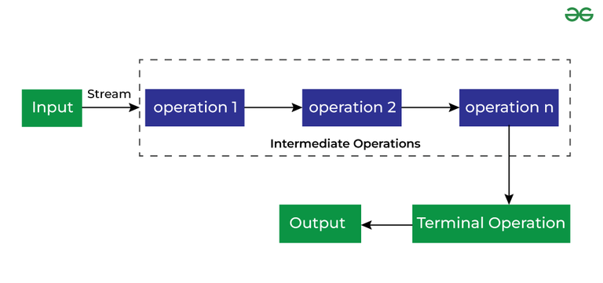

Intermediate Operations are the types of operations in which multiple methods are chained in a row.

#### Characteristics of Intermediate Operations

1. Methods are chained together.
2. Intermediate operations transform a stream into another stream.
3. It enables the concept of filtering where one method filters data and passes it to another method after processing.

### Important Intermediate Operations

There are a few Intermediate Operations mentioned below:

#### **1. map()**

The map method is used to return a stream consisting of the results of applying the given function to the elements of this stream.

List number = Arrays.asList(2,3,4,5);

List square = number.stream().map(x->x\*x).collect(Collectors.toList());

#### **2. filter()**

The filter method is used to select elements as per the Predicate passed as an argument.

List names = Arrays.asList("Reflection","Collection","Stream");

List result = names.stream().filter(s->s.startsWith("S")).collect(Collectors.toList());

#### **3. sorted()**

The sorted method is used to sort the stream.

List names = Arrays.asList("Reflection","Collection","Stream");

List result = names.stream().sorted().collect(Collectors.toList());

## **Terminal Operations**

Terminal Operations are the type of Operations that return the result. These Operations are not processed further just return a final result value.

### Important Terminal Operations

There are a few Terminal Operations mentioned below:

#### **1. collect()**

The collect method is used to return the result of the intermediate operations performed on the stream.

List number = Arrays.asList(2,3,4,5,3);

Set square = number.stream().map(x->x\*x).collect(Collectors.toSet());

#### **2. forEach()**

The forEach method is used to iterate through every element of the stream.

List number = Arrays.asList(2,3,4,5);

number.stream().map(x->x\*x).forEach(y->System.out.println(y));

#### **3. reduce()**

The reduce method is used to reduce the elements of a stream to a single value. The reduce method takes a BinaryOperator as a parameter.

List number = Arrays.asList(2,3,4,5);

int even = number.stream().filter(x->x%2==0).reduce(0,(ans,i)-> ans+i);

Here ans variable is assigned 0 as the initial value and i is added to it.

***Note:****Intermediate Operations are running based on the concept of Lazy Evaluation, which ensures that every method returns a fixed value(Terminal operation) before moving to the next method.*

## Example of Java Stream

* Java

|  |
| --- |
| // Java program to demonstrate  // the use of stream in java  **import** java.util.\*;  **import** java.util.stream.\*;    **class** Demo {  **public** **static** **void** main(String args[])      {          // create a list of integers          List<Integer> number = Arrays.asList(2, 3, 4, 5);            // demonstration of map method          List<Integer> square            = number.stream()              .map(x -> x \* x)              .collect(Collectors.toList());            // create a list of String          List<String> names = Arrays.asList(              "Reflection", "Collection", "Stream");            // demonstration of filter method          List<String> result            = names.stream()              .filter(s -> s.startsWith("S"))              .collect(Collectors.toList());            System.out.println(result);            // demonstration of sorted method          List<String> show            = names.stream()              .sorted()              .collect(Collectors.toList());            System.out.println(show);            // create a list of integers          List<Integer> numbers              = Arrays.asList(2, 3, 4, 5, 2);            // collect method returns a set          Set<Integer> squareSet            = numbers.stream()              .map(x -> x \* x)              .collect(Collectors.toSet());            System.out.println(squareSet);            // demonstration of forEach method          number.stream()              .map(x -> x \* x)              .forEach(y -> System.out.println(y));            // demonstration of reduce method  **int** even            = number.stream()              .filter(x -> x % 2 == 0)              .reduce(0, (ans, i) -> ans + i);            System.out.println(even);      }  } |

**Output**

[4, 9, 16, 25]

[Stream]

[Collection, Reflection, Stream]

[16, 4, 9, 25]

4

9

16

25

6

## **Important Points/Observations of Java Stream**

1. A stream consists of a source followed by zero or more intermediate methods combined together (pipelined) and a terminal method to process the objects obtained from the source as per the methods described.
2. Stream is used to compute elements as per the pipelined methods without altering the original value of the object.

Java 8 Version features and which using in project, from Basics to Scenario .

**Java 8: Features and Examples**

* Lambda Expressions.
* Functional Interface.
* forEach() Method.
* Default method.
* Stream Application Programming Interface (Stream API)
* Java Date Time API.
* Nashorn.

Benefits of using Stream API? He was more interested into the time and space complexity or optimization kind of answers.

# Using Java Streams in Java 8 and Beyond

JAVA TOOLS

JAVA APPLICATION DEVELOPMENT

Java 8 has been out  since 2014, but many of the original features have remained relevant today. One of the most prominent of these is Java streams. In this blog, we answer what are Java streams, explain when to use them, troubleshoot Java streams issues, and give you a brief rundown of common Java streams operations.

## What Are Streams in Java?

Java streams enable functional-style operations on streams of elements. A stream is an abstraction of a non-mutable collection of functions applied in some order to the data. A stream is not a collection where you can store elements.

The most important difference between a stream and a structure is that a stream doesn’t hold the data. For example, you cannot point to a location in the stream where a certain element exists. You can only specify the functions that operate on that data. And when performing operations on a stream, it will affect the original stream.

As a note, the streams in this blog are not to be confused with streams in Java I/O package like InputStream, OutputStream, etc.

**Related Reading:**[Java Streams Cheat Sheet](https://www.jrebel.com/blog/java-streams-cheat-sheet)

## When to Use Java Streams

Java streams represent a pipeline through which data will flow and the functions to operate on the data. A pipeline in this instance consists of a stream source, followed by zero or more intermediate operations, and a terminal operation.

As such, streams can be used in any number of applications that involve data-driven functions. In the example below, the Java stream is used as a fancy iterator:

List numbers = Arrays.asList(1, 2, 3, 4);

List result = numbers.stream()

.filter(e -> (e % 2) == 0)

.map(e -> e \* 2)

.collect(toList());

In this example we select only even values, by using the filter method and doubled them by mapping the function that doubles the input. What does this provide us? The streams API gives us the power to specify a sequence of operations on the data in individual steps. We don’t specify any conditional processing code, we are not tempted to write large complex functions, we don’t care about the data flow.

In fact, we only bother ourselves with one data processing step at a time: we compose the functions and the data flows through the functions by itself by the power of the streams framework. The example above shows one of the most important pattern you’ll end up using with the streams:

* Raise a collection to a stream.
* Ride the stream: filter values, transform values, limit the output.
* Compose small individual operations.
* Collect the result back into a concrete collection.

#### **Use streams and see your changes instantly.** [**Use JRebel to skip redeploys. Try it now >>**](https://www.jrebel.com/products/jrebel/free-trial)

## Common Operations in Java Streams

In Java 8 and up, you can easily obtain a stream from any collection by calling the stream() method. After that there are a couple of fundamental functions that you’ll encounter all the time.

Here are some common operations in Java streams:

* **Filter:**Returns a new stream that contains some of the elements of the original. It accepts the predicate to compute which elements should be returned in the new stream and removes the rest. In the imperative code we would employ the conditional logic to specify what should happen if an element satisfies the condition. In the functional style we don’t bother with ifs, we filter the stream and work only on the values we require.
* **Map:** Transforms the stream elements into something else, it accepts a function to apply to each and every element of the stream and returns a stream of the values the parameter function produced. This is the bread and butter of the Java streaming API. Map allows you to perform a computation on the data inside a stream.
* **Reduce:** (also sometimes called a fold) Performs a reduction of the stream to a single element. If you want to sum all the integer values in the stream, you want to use the reduce function. If you want to find the maximum in the stream, reduce is your friend.
* **Collect:** This is the way to get out of the streams world and obtain a concrete collection of values, like a list in the example above.

You won't use all of these functions every time you encounter a stream, but you have them available to use at will.

## Java Stream Example: Potential Issues to Avoid

There are some caveats of using the Java streaming API though, and sometimes stream processing can get out of hand. Imagine we have the follow class Person:

class Person {

Gender gender; String name;

public Gender getGender() { return gender; }

public String getName() { return name; }

}

enum Gender { MALE, FEMALE, OTHER }

This is a typical Java bean with some getters on the fields. Now, suppose we have a list of these persons and want to get the list of uppercase names of all the “FEMALE” people in that list. Sounds easy, right?

List names = new ArrayList();

List people = …

people.stream()

.filter(p -> p.getGender() == Gender.FEMALE)

.map(Person::getName)

.map(String::toUpperCase)

.forEach(name -> names.add(name));

We follow the specification of what we must do at every step, but the problem is in the mutation of the shared state. We know nothing of the nature of the stream and if the stream is parallel, the concurrent addition of the elements into the stream can lead to errors.

Another gotcha to avoid: If only an intermediate operation is specified and the terminal operation is inadvertently missed out, then nothing is displayed in the output. This is because intermediate operations are executed only when a terminal operation is present.

For example, the following snippet does not print any output:

Stream.of("Cathy","Alba","Beth")

.filter(s -> {

System.out.println("filter: " + s);

return true;

});

The ordering of output is somewhat surprising as each element passes through all the operations (unlike what some programmers may assume - that all elements are first passed through filter () and then forEach() ). For example:

Stream.of("Cathy", "Alba", "Beth").

filter(s -> {

System.out.println("filter: " + s);

return true;

})

.forEach(s -> System.out.println("forEach: " + s));

The output is:

filter: Cathy

forEach: Cathy

filter: Alba

forEach: Alba

filter: Beth

forEach: Beth

### Using Java Stream Collect to Avoid Concurrency Errors

Instead, we should have collected the stream into the resulting list, so that concurrency and mutability is the responsibility of the streams framework. Here’s the example of how to do so:

List people = …

List names = people.stream()

.filter(p -> p.getGender() == Gender.FEMALE)

.map(Person::getName)

.map(String::toUpperCase)

.collect(Collectors.toList());

In general, the Collectors class provides almost all necessary primitives to transform a stream into a concrete collection. One example is the toMap() collector. You might be confused about how can an element be transformed into a key-value pair required for the map.

To do this, you specify a function that turns the element into the key and another function that creates the value. Here’s an example that collects the same stream of people into a map:

List people = …

Map<String, Person> names = people.stream()

.collect(Collectors.toMap(p -> p.getName(), p -> p));

The first function given to the toMap method transforms the element into the key and the second to the value for the map.

## Java Stream Intermediate and Terminal Operations

One of the virtues of Java streams is that they are lazily evaluated. Some operations on the streams, particularly the functions that return an instance of the stream: filter, map, are called **intermediate**. This means they aren’t evaluated when they are specified. This means that they won’t be evaluated when they are specified. Instead, the computation will happen when the result of that operation is necessary.

This means that if we just specify the code like:

Stream names = people.stream()

.filter(p -> p.getGender() == Gender.FEMALE)

.map(Person::getName)

.map(String::toUpperCase);

None of the names will be immediately collected and made into the upper case. So, when does the computation occur? When a **terminal** operation is called.

All operations that return something other than a stream are terminal. Operations like forEach, collect, reduce are terminal. This makes streams particularly efficient at handling large amounts of data.

From a performance perspective, the ordering of intermediate operations is critical.

For example, if map() is specified before filter() then map() will be called multiple times. However, if filter() is specified before map() then map() is called only once, leading to high performance.

Stream.of("Cathy", "Alba", "Beth")

.map(s -> {

System.out.println("map: " + s);

return s.toUpperCase();

})

.filter(s -> {

System.out.println("filter: " + s);

return s.startsWith("A");

})

.forEach(s -> System.out.println("forEach: " + s));

Here map() is called multiple times, which is sub-optimal. However, in this example, map() is called only once, leading to improved performance.

Stream.of("Cathy", "Alba", "Beth")

.filter(s -> {

System.out.println("filter: " + s);

return s.startsWith("A");

})

.map(s -> {

System.out.println("map: " + s);

return s.toUpperCase();

})

.forEach(s -> System.out.println("forEach: " + s));

On top of that, one can almost always try to parallelize the stream processing by converting the stream into a parallel stream by calling the parallel() method. Note, that although the stream doesn’t have to be parallelizable, the method to parallelize it is always there. So depending on the internal nature of the stream you can get the performance benefits.

## Final Thoughts on Java Streams API

There are pitfalls of running every stream operation in parallel; most streams implementations use the default ForkJoinPool to perform the operations in background. Thus, you can easily make the particula

r stream processing a bit faster, but instead sacrifice the performance of the whole JVM without even realizing it.

Solving the problems using functional programming requires a different way of thinking. But with a bit of experimentation, you can get the hang of it.

And often, you may struggle to find a functional solution, but once you get it, you realize that it’s not particularly complicated. And then the next time solving a similar problem will be much easier.

## Learn About the Latest in Java

Want to learn more about the latest features in Java? Be sure to visit our resource hub, [Exploring New Features in Java](https://www.jrebel.com/resources/new-features-java). It covers everything from JEPs, to JDK enhancement projects for releases since Java 8.

Which one the more efficient forEach() loop or Stream()forEach()?

## Overview

There are several options to iterate over a collection in Java. **In this short tutorial, we’ll look at two similar looking approaches — Collection.stream().forEach() and Collection.forEach().**

In most cases, both will yield the same results, but we’ll look at some subtle differences.

## 2. A Simple List

First, let’s create a list to iterate over:

List<String> list = Arrays.asList("A", "B", "C", "D");Copy

The most straightforward way is using the enhanced for-loop:

**for**(String s : list) {

//do something with s

}

Copy

If we want to use functional-style Java, we can also use forEach().

We can do so directly on the collection:

Consumer<String> consumer = s -> { System.out::println };

list.forEach(consumer);

Copy

Or we can call forEach() on the collection’s stream:

list.stream().forEach(consumer);

Copy

Both versions will iterate over the list and print all elements:

ABCD ABCDCopy

In this simple case, it doesn’t make a difference which forEach() we use.

## 3. Execution Order

**Collection.forEach() uses the collection’s iterator (if one is specified), so the processing order of the items is defined. In contrast, the processing order of Collection.stream().forEach() is undefined.**

In most cases, it doesn’t make a difference which of the two we choose.

### 3.1. Parallel Streams

Parallel streams allow us to execute the stream in multiple threads, and in such situations, the execution order is undefined. Java only requires all threads to finish before any terminal operation, such as Collectors.toList(), is called.

Let’s look at an example where we first call forEach() directly on the collection, and second, on a parallel stream:

list.forEach(System.out::print);

System.out.print(" ");

list.parallelStream().forEach(System.out::print);

Copy

**If we run the code several times, we see that list.forEach() processes the items in insertion order, while list.parallelStream().forEach() produces a different result at each run.**

Here is one possible output:

ABCD CDBACopy

And this is another:

ABCD DBCACopy

### 3.2. Custom Iterators

Let’s define a list with a custom iterator to iterate over the collection in reversed order:

**class** **ReverseList** **extends** **ArrayList**<String> {

@Override

**public** Iterator<String> **iterator**() {

**int** startIndex = this.size() - 1;

List<String> list = this;

Iterator<String> it = **new** **Iterator**<String>() {

**private** **int** currentIndex = startIndex;

@Override

**public** **boolean** **hasNext**() {

**return** currentIndex >= 0;

}

@Override

**public** String **next**() {

**String** next = list.get(currentIndex);

currentIndex--;

**return** next;

}

@Override

**public** **void** **remove**() {

**throw** **new** **UnsupportedOperationException**();

}

};

**return** it;

}

}

Copy

Then we’ll iterate over the list again with forEach() directly on the collection and then on the stream:

List<String> myList = **new** **ReverseList**();

myList.addAll(list);

myList.forEach(System.out::print);

System.out.print(" ");

myList.stream().forEach(System.out::print);

Copy

And we get different results:

DCBA ABCD

Copy

The reason for the different results is that forEach() used directly on the list uses the custom iterator, **while stream().forEach() simply takes elements one by one from the list, ignoring the iterator.**

## 4. Modification of the Collection

Many collections (e.g. *ArrayList* or *HashSet*) shouldn’t be structurally modified while iterating over them. If an element is removed or added during an iteration, we’ll get a ConcurrentModification exception.

Furthermore, collections are designed to fail fast, which means that the exception is thrown as soon as there’s a modification.

**Similarly, we’ll get a *ConcurrentModification* exception when we add or remove an element during the execution of the stream pipeline. However, the exception will be thrown later.**

Another subtle difference between the two forEach() methods is that Java explicitly allows modifying elements using the iterator. Streams, in contrast, should be non-interfering.

Let’s look at removing and modifying elements in more detail.

### 4.1. Removing an Element

Let’s define an operation that removes the last element (“D”) of our list:

Consumer<String> removeElement = s -> {

System.out.println(s + " " + list.size());

**if** (s != null && s.equals("A")) {

list.remove("D");

}

};Copy

When we iterate over the list, the last element is removed after the first element (“A”) is printed:

list.forEach(removeElement);Copy

**Since forEach() is fail-fast, we stop iterating and see an exception before the next element is processed**:

A 4

Exception in thread "main" java.util.ConcurrentModificationException

at java.util.ArrayList.forEach(ArrayList.java:1252)

at ReverseList.main(ReverseList.java:1)Copy

Let’s see what happens if we use *stream().forEach()* instead:

list.stream().forEach(removeElement);Copy

**Here we continue iterating over the whole list before we see an exception**:

A 4

B 3

C 3

null 3

Exception in thread "main" java.util.ConcurrentModificationException

at java.util.ArrayList$ArrayListSpliterator.forEachRemaining(ArrayList.java:1380)

at java.util.stream.ReferencePipeline$Head.forEach(ReferencePipeline.java:580)

at ReverseList.main(ReverseList.java:1)Copy

However, Java does not guarantee that a [ConcurrentModificationException](https://docs.oracle.com/en/java/javase/17/docs/api/java.base/java/util/ConcurrentModificationException.html) is thrown at all. **That means we should never write a program that depends on this exception.**

### 4.2. Changing Elements

We can change an element while iterating over a list:

list.forEach(e -> {

list.set(3, "E");

});Copy

But while there is no problem with doing this using either Collection.forEach() or stream().forEach(), Java requires an operation on a stream to be non-interfering. This means that elements shouldn’t be modified during the execution of the stream pipeline.

The reason behind this is that the stream should facilitate parallel execution. **Here, modifying elements of a stream could lead to unexpected behavior.**

## 5. Conclusion

In this article, we saw some examples that show the subtle differences between Collection.forEach() and Collection.stream().forEach().

It’s important to note that all the examples shown above are trivial and meant to only compare the two ways of iterating over a collection. We shouldn’t write code whose correctness relies on the shown behavior.

**If we don’t require a stream but only want to iterate over a collection, the first choice should be using forEach() directly on the collection.**

The source code for the examples in this article [is available over on GitHub](https://github.com/eugenp/tutorials/tree/master/core-java-modules/core-java-streams-3).

What is Fuctinal Interface. And stream questions on transfer methods.

## 

# Functional Interfaces in Java

• **Read**

• Discuss

• Practice

Java has forever remained an Object-Oriented Programming language. By object-oriented programming language, we can declare that everything present in the Java programming language rotates throughout the Objects, except for some of the primitive data types and primitive methods for integrity and simplicity. There are no solely functions present in a programming language called Java. Functions in the Java programming language are part of a class, and if someone wants to use them, they have to use the class or object of the class to call any function.

## Java Functional Interfaces

A **functional interface** is an interface that contains only one abstract method. They can have only one functionality to exhibit. From Java 8 onwards, [lambda expressions](https://www.geeksforgeeks.org/lambda-expressions-java-8/) can be used to represent the instance of a functional interface. A functional interface can have any number of default methods. ***Runnable***, ***ActionListener***,*and****Comparable*** are some of the examples of functional interfaces.

Functional Interface is additionally recognized as **Single Abstract Method Interfaces**. In short, they are also known as **SAM interfaces**. Functional interfaces in Java are the new feature that provides users with the approach of fundamental programming.

Functional interfaces are included in Java SE 8 with Lambda expressions and Method references in order to make code more readable, clean, and straightforward. Functional interfaces are interfaces that ensure that they include precisely only one abstract method. Functional interfaces are used and executed by representing the interface with an **annotation called *@FunctionalInterface***. As described earlier, functional interfaces can contain only one abstract method. However, they can include any quantity of default and static methods.

In Functional interfaces, there is no need to use the abstract keyword as it is optional to use the abstract keyword because, by default, the method defined inside the interface is abstract only. We can also call Lambda expressions as the instance of functional interface.

### Java Functional Interfaces Example

**Example 1:**

Before Java 8, we had to create anonymous inner class objects or implement these interfaces.

* Java

|  |
| --- |
| // Java program to demonstrate functional interface    **class** Test {  **public** **static** **void** main(String args[])      {          // create anonymous inner class object  **new** Thread(**new** Runnable() {              @Override **public** **void** run()              {                  System.out.println("New thread created");              }          }).start();      }  } |

**Output**

New thread created

**Example 2:**

Java 8 onwards, we can assign [lambda expression](https://www.geeksforgeeks.org/lambda-expressions-java-8/) to its functional interface object like this:

* Java

|  |
| --- |
| // Java program to demonstrate Implementation of  // functional interface using lambda expressions    **class** Test {  **public** **static** **void** main(String args[])      {            // lambda expression to create the object  **new** Thread(() -> {              System.out.println("New thread created");          }).start();      }  } |

**Output**

New thread created

### @FunctionalInterface Annotation

@FunctionalInterface annotation is used to ensure that the functional interface can’t have more than one abstract method. In case more than one abstract methods are present, the compiler flags an ‘Unexpected @FunctionalInterface annotation’ message. However, it is not mandatory to use this annotation.

**Below is the implementation of the above topic:**

* Java

|  |
| --- |
| // Java program to demonstrate lambda expressions to  // implement a user defined functional interface.    @FunctionalInterface    **interface** Square {  **int** calculate(**int** x);  }    **class** Test {  **public** **static** **void** main(String args[])      {  **int** a = 5;            // lambda expression to define the calculate method          Square s = (**int** x) -> x \* x;            // parameter passed and return type must be          // same as defined in the prototype  **int** ans = s.calculate(a);          System.out.println(ans);      }  } |

**Output**

25

## Some Built-in Java Functional Interfaces

Since Java SE 1.8 onwards, there are many interfaces that are converted into functional interfaces. All these interfaces are annotated with @FunctionalInterface. These interfaces are as follows –

* **Runnable –>** This interface only contains the run() method.
* **Comparable –>** This interface only contains the compareTo() method.
* **ActionListener –>** This interface only contains the actionPerformed() method.
* **Callable –>** This interface only contains the call() method.

**Java SE 8 included four main kinds of functional interfaces**which can be applied in multiple situations as mentioned below:

1. **Consumer**
2. **Predicate**
3. **Function**
4. **Supplier**

Amidst the previous four interfaces, the first three interfaces,i.e., Consumer, Predicate, and Function, likewise have additions that are provided beneath –

1. Consumer -> Bi-Consumer
2. Predicate -> Bi-Predicate
3. Function -> Bi-Function, Unary Operator, Binary Operator

## 1. Consumer

The consumer interface of the functional interface is the one that accepts only one argument or a gentrified argument. The consumer interface has no return value. It returns nothing. There are also functional variants of the Consumer — DoubleConsumer, IntConsumer, and LongConsumer. These variants accept primitive values as arguments.

Other than these variants, there is also one more variant of the Consumer interface known as Bi-Consumer.

**Bi-Consumer –**Bi-Consumer is the most exciting variant of the Consumer interface. The consumer interface takes only one argument, but on the other side, the Bi-Consumer interface takes two arguments. Both, Consumer and Bi-Consumer have no return value. It also returns nothing just like the Consumer interface. It is used in iterating through the entries of the map.

**Syntax / Prototype of Consumer Functional Interface –**

Consumer<Integer> consumer = (value) -> System.out.println(value);

This implementation of the Java Consumer functional interface prints the value passed as a parameter to the print statement. This implementation uses the Lambda function of Java.

## 2. Predicate

In scientific logic, a function that accepts an argument and, in return, generates a boolean value as an answer is known as a predicate. Similarly, in the Java programming language, a predicate functional interface of Java is a type of function that accepts a single value or argument and does some sort of processing on it, and returns a boolean (True/ False) answer. The implementation of the Predicate functional interface also encapsulates the logic of filtering (a process that is used to filter stream components on the base of a provided predicate) in Java.

Just like the Consumer functional interface, Predicate functional interface also has some extensions. These are IntPredicate, DoublePredicate, and LongPredicate. These types of predicate functional interfaces accept only primitive data types or values as arguments.

**Bi-Predicate –**Bi-Predicate is also an extension of the Predicate functional interface, which, instead of one, takes two arguments, does some processing, and returns the boolean value.

**Syntax of Predicate Functional Interface –**

public interface Predicate<T> {

   boolean test(T t);

}

The predicate functional interface can also be implemented using a class. The syntax for the implementation of predicate functional interface using a class is given below –

public class CheckForNull implements Predicate {

   @Override

   public boolean test(Object o) {

       return o != null;

   }

}

The Java predicate functional interface can also be implemented using Lambda expressions. An example of the implementation of the Predicate functional interface is given below –

Predicate predicate = (value) -> value != null;

This implementation of functional interfaces in Java using Java Lambda expressions is more manageable and effective than the one implemented using a class as both the implementations are doing the same work, i.e., returning the same output.

## 3. Function

A function is a type of functional interface in Java that receives only a single argument and returns a value after the required processing. There are many versions of Function interfaces because a primitive type can’t imply a general type argument, so we need these versions of function interfaces. Many different versions of the function interfaces are instrumental and are commonly used in primitive types like double, int, long. The different sequences of these primitive types are also used in the argument.

These versions are:

### ****Bi-Function****

The Bi-Function is substantially related to a Function. Besides, it takes two arguments, whereas Function accepts one argument.

**The prototype and syntax of Bi-Function is given below –**

@FunctionalInterface

public interface BiFunction<T, U, R>

{

  R apply(T t, U u);

   .......

}

In the above code of interface, T and U are the inputs, and there is only one output which is R.

### ****Unary Operator and Binary Operator****

There are also two other functional interfaces which are named Unary Operator and Binary Operator. They both extend the Function and Bi-Function, respectively. In simple words, Unary Operator extends Function, and Binary Operator extends Bi-Function.

**The prototype of the Unary Operator and Binary Operator is mentioned below :**

### ****i. Unary Operator****

@FunctionalInterface

public interface UnaryOperator<T> extends Function<T, U>

{

   ……...

}

### ii****. Binary Operator****

@FunctionalInterface

public interface BinaryOperator<T> extends BiFunction<T, U, R>

{

   ……...

}

We can understand front the above example that the Unary Operator accepts only one argument and returns a single argument only. Still, in Unary Operator both the input and output values must be identical and of the same type.

On the other way, Binary Operator takes two values and returns one value comparable to Bi- Function but similar to a Unary Operator, the input and output value types must be identical and of the same type.

## 4. Supplier

The Supplier functional interface is also a type of functional interface that does not take any input or argument and yet returns a single output. This type of functional interface is generally used in the lazy generation of values. Supplier functional interfaces are also used for defining the logic for the generation of any sequence. For example – The logic behind the Fibonacci Series can be generated with the help of the Stream. generate method, which is implemented by the Supplier functional Interface.

The different extensions of the Supplier functional interface hold many other suppliers functions like BooleanSupplier, DoubleSupplier, LongSupplier, and IntSupplier. The return type of all these further specializations is their corresponding primitives only.

**Syntax / Prototype of Supplier Functional Interface is –**

@FunctionalInterface

public interface Supplier<T>{

// gets a result

………….

// returns the specific result

…………

T.get();

}

**Below is the implementation of the above topic:**

* Java

|  |
| --- |
| // A simple program to demonstrate the use  // of predicate interface  **import** java.util.\*;  **import** java.util.function.Predicate;    **class** Test {  **public** **static** **void** main(String args[])      {          // create a list of strings          List<String> names = Arrays.asList(              "Geek", "GeeksQuiz", "g1", "QA", "Geek2");            // declare the predicate type as string and use          // lambda expression to create object          Predicate<String> p = (s) -> s.startsWith("G");            // Iterate through the list  **for** (String st : names) {              // call the test method  **if** (p.test(st))                  System.out.println(st);          }      }  } |

**Output**

Geek

GeeksQuiz

Geek2

#### Important Points/Observatio**ns:**

*Here are some significant points regarding Functional interfaces in Java:*

1. *In functional interfaces, there is only one abstract method supported. If the annotation of a functional interface, i.e., @FunctionalInterface is not implemented or written with a function interface, more than one abstract method can be declared inside it. However, in this situation with more than one functions, that interface will not be called a functional interface. It is called a non-functional interface.*
2. *There is no such need for the @FunctionalInterface annotation as it is voluntary only. This is written because it helps in checking the compiler level. Besides this, it is optional.*
3. *An infinite number of methods (whether static or default) can be added to the functional interface. In simple words, there is no limit to a functional interface containing static and default methods.*
4. *Overriding methods from the parent class do not violate the rules of a functional interface in Java.*
5. *The****java.util.function****package contains many built-in functional interfaces in Java 8.*

Java8 Like functional interface,Lamda Expression

Java 8 brought a powerful new syntactic improvement in the form of lambda expressions. A lambda is an anonymous function that we can handle as a first-class language citizen. For instance, we can pass it to or return it from a method

Check for Balanced Brackets in an expression (well-formedness) Input: exp = “[()]{}{[()()]()}”

Given an expression string **exp**, write a program to examine whether the pairs and the orders of “{“, “}”, “(“, “)”, “[“, “]” are correct in the given expression.

**Example**:

***Input****: exp = “[()]{}{[()()]()}”****Output****: Balanced****Explanation:****all the brackets are well-formed*

***Input****: exp = “[(])”****Output****: Not Balanced****Explanation: 1****and****4****brackets are not balanced because   
there is a closing ‘]’ before the closing ‘(‘*

## **Check for Balanced Bracket expression using**[**Stack**](https://www.geeksforgeeks.org/introduction-to-stack-data-structure-and-algorithm-tutorials/)**:**

*The idea is to put all the opening brackets in the stack. Whenever you hit a closing bracket, search if the top of the stack is the opening bracket of the same nature. If this holds then pop the stack and continue the iteration. In the end if the stack is empty, it means all brackets are balanced or well-formed. Otherwise, they are not balanced.*

**Illustration:**  
Below is the illustration of the above approach.

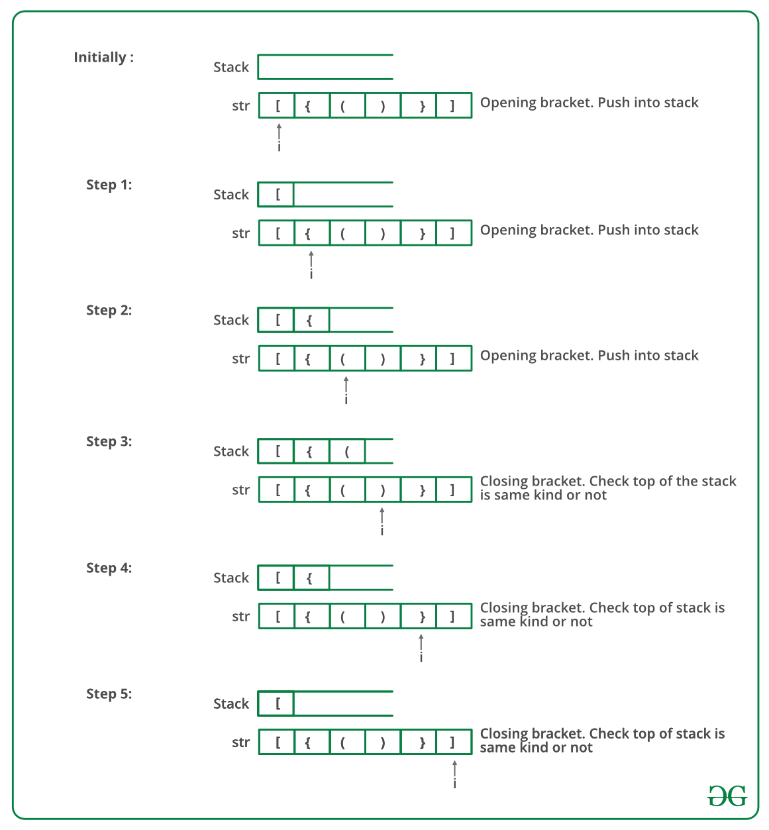

Follow the steps mentioned below to implement the idea:

* Declare a character [stack](https://www.geeksforgeeks.org/stack-data-structure/) (say **temp**).
* Now traverse the string exp.
  + If the current character is a starting bracket ( **‘(‘ or ‘{‘  or ‘[‘**) then push it to stack.
  + If the current character is a closing bracket ( **‘)’ or ‘}’ or ‘]’**) then pop from the stack and if the popped character is the matching starting bracket then fine.
  + Else brackets are**Not Balanced**.
* After complete traversal, if some starting brackets are left in the stack then the expression is **Not balanced**, else **Balanced**.

Below is the implementation of the above approach:

* C++
* C
* Java
* Python3
* C#
* Javascript

|  |
| --- |
| // Java program for checking  // balanced brackets  **import** java.util.\*;    **public** **class** BalancedBrackets {        // function to check if brackets are balanced  **static** **boolean** areBracketsBalanced(String expr)      {          // Using ArrayDeque is faster than using Stack class          Deque<Character> stack              = **new** ArrayDeque<Character>();            // Traversing the Expression  **for** (**int** i = 0; i < expr.length(); i++) {  **char** x = expr.charAt(i);    **if** (x == '(' || x == '[' || x == '{') {                  // Push the element in the stack                  stack.push(x);  **continue**;              }                // If current character is not opening              // bracket, then it must be closing. So stack              // cannot be empty at this point.  **if** (stack.isEmpty())  **return** **false**;  **char** check;  **switch** (x) {  **case** ')':                  check = stack.pop();  **if** (check == '{' || check == '[')  **return** **false**;  **break**;    **case** '}':                  check = stack.pop();  **if** (check == '(' || check == '[')  **return** **false**;  **break**;    **case** ']':                  check = stack.pop();  **if** (check == '(' || check == '{')  **return** **false**;  **break**;              }          }            // Check Empty Stack  **return** (stack.isEmpty());      }        // Driver code  **public** **static** **void** main(String[] args)      {          String expr = "([{}])";            // Function call  **if** (areBracketsBalanced(expr))              System.out.println("Balanced ");  **else**              System.out.println("Not Balanced ");      }  } |

**Output**

Balanced

**Time Complexity:** O(N), Iteration over the string of size N one time.  
**Auxiliary Space:** O(N) for the stack.

## Check for Balanced Bracket expression without using stack :

Following are the steps to be followed:

* Initialize a variable **i** with **-1**.
* Iterate through the string and
  + If it is an open bracket then increment the counter by 1 and replace **ith** character of the string with the opening bracket.
  + Else if it is a closing bracket of the same corresponding opening bracket (opening bracket stored in **exp[i]**) then decrement **i** by 1.
* At last, if we get **i = -1**, then the string is balanced and we will return true. Otherwise, the function will return false.

Below is the implementation of the above approach:

* C++
* Java
* C#
* Python3
* Javascript

|  |
| --- |
| **public** **class** GFG {  **public** **static** **boolean** areBracketsBalanced(String s)      {  **int** i = -1;  **char**[] stack = **new** **char**[s.length()];  **for** (**char** ch : s.toCharArray()) {  **if** (ch == '(' || ch == '{' || ch == '[')                  stack[++i] = ch;  **else** {  **if** (i >= 0                      && ((stack[i] == '(' && ch == ')')                          || (stack[i] == '{' && ch == '}')                          || (stack[i] == '[' && ch == ']')))                      i--;  **else**  **return** **false**;              }          }  **return** i == -1;      }    **public** **static** **void** main(String[] args)      {          String expr = "{()}[]";            // Function call  **if** (areBracketsBalanced(expr))              System.out.println("Balanced");  **else**              System.out.println("Not Balanced");      }  } |

**Output**

Balanced

**Time Complexity**: O(N), Iteration over the string of size N one time.  
**Auxiliary Space**: O(1)

Feeling lost in the world of random DSA topics, wasting time without progress? It's time for a change! Join our DSA course, where we'll guide you on an exciting journey to master DSA efficiently and on schedule.  
Ready to dive in? Explore our Free Demo Content and join our DSA course, trusted by over 100,000 geeks!

* [DSA in C++](https://www.geeksforgeeks.org/courses/dsa-self-paced?utm_source=geeksforgeeks&utm_medium=article_bottom_text&utm_campaign=courses)
* [DSA in Java](https://www.geeksforgeeks.org/courses/dsa-self-paced?utm_source=geeksforgeeks&utm_medium=article_bottom_text&utm_campaign=courses)
* [DSA in Python](https://www.geeksforgeeks.org/courses/Data-Structures-With-Python?utm_source=geeksforgeeks&utm_medium=article_bottom_text&utm_campaign=courses)
* [DSA in JavaScript](https://www.geeksforgeeks.org/courses/data-structures-and-algorithms-in-javascript?utm_source=geeksforgeeks&utm_medium=article_bottom_text&utm_campaign=courses)

Why we use serilizable in Java. Explain in detail

Serialization in Java allows us to convert an Object to stream that we can send over the network or save it as file or store in DB for later usage. Deserialization is the process of converting Object stream to actual Java Object to be used in our program.

**Serialization in Java** is a mechanism of writing the state of an object into a byte-stream. It is mainly used in Hibernate, RMI, JPA, EJB and JMS technologies.

The reverse operation of serialization is called deserialization where byte-stream is converted into an object. The serialization and deserialization process is platform-independent, it means you can serialize an object on one platform and deserialize it on a different platform.

For serializing the object, we call the **writeObject()** method of ObjectOutputStream class, and for deserialization we call the **readObject()** method of ObjectInputStream class.

We must have to implement the Serializable interface for serializing the object.

### Advantages of Java Serialization

It is mainly used to travel object's state on the network (that is known as marshalling).

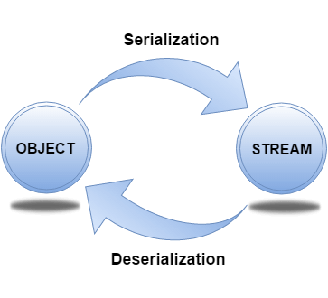

## **java.io.Serializable interface**

**Serializable** is a marker interface (has no data member and method). It is used to "mark" Java classes so that the objects of these classes may get a certain capability. The **Cloneable** and **Remote** are also marker interfaces.

The **Serializable** interface must be implemented by the class whose object needs to be persisted.

The String class and all the wrapper classes implement the java.io.Serializable interface by default.

Let's see the example given below:

**Student.java**

1. **import** java.io.Serializable;
2. **public** **class** Student **implements** Serializable{
3. **int** id;
4. String name;
5. **public** Student(**int** id, String name) {
6. **this**.id = id;
7. **this**.name = name;
8. }
9. }

In the above example, **Student** class implements Serializable interface. Now its objects can be converted into stream. The main class implementation of is showed in the next code.

### ObjectOutputStream class

The ObjectOutputStream class is used to write primitive data types, and Java objects to an OutputStream. Only objects that support the java.io.Serializable interface can be written to streams.

**Constructor**

|  |  |
| --- | --- |
| 1) public ObjectOutputStream(OutputStream out) throws IOException {} | It creates an ObjectOutputStream that writes to the specified OutputStream. |

**Important Methods**

|  |  |
| --- | --- |
| **Method** | **Description** |
| 1) public final void writeObject(Object obj) throws IOException {} | It writes the specified object to the ObjectOutputStream. |
| 2) public void flush() throws IOException {} | It flushes the current output stream. |
| 3) public void close() throws IOException {} | It closes the current output stream. |

### ObjectInputStream class

An ObjectInputStream deserializes objects and primitive data written using an ObjectOutputStream.

**Constructor**

|  |  |
| --- | --- |
| 1) public ObjectInputStream(InputStream in) throws IOException {} | It creates an ObjectInputStream that reads from the specified InputStream. |

**Important Methods**

|  |  |
| --- | --- |
| **Method** | **Description** |
| 1) public final Object readObject() throws IOException, ClassNotFoundException{} | It reads an object from the input stream. |
| 2) public void close() throws IOException {} | It closes ObjectInputStream. |

## **Example of Java Serialization**

In this example, we are going to serialize the object of **Student** class from above code. The writeObject() method of ObjectOutputStream class provides the functionality to serialize the object. We are saving the state of the object in the file named f.txt.

**Persist.java**

1. **import** java.io.\*;
2. **class** Persist{
3. **public** **static** **void** main(String args[]){
4. **try**{
5. //Creating the object
6. Student s1 =**new** Student(211,"ravi");
7. //Creating stream and writing the object
8. FileOutputStream fout=**new** FileOutputStream("f.txt");
9. ObjectOutputStream out=**new** ObjectOutputStream(fout);
10. out.writeObject(s1);
11. out.flush();
12. //closing the stream
13. out.close();
14. System.out.println("success");
15. }**catch**(Exception e){System.out.println(e);}
16. }
17. }

**Output:**

success

[download this example of serialization](https://static.javatpoint.com/src/serialization/serialization.zip)

### Example of Java Deserialization

Deserialization is the process of reconstructing the object from the serialized state. It is the reverse operation of serialization. Let's see an example where we are reading the data from a deserialized object.

Deserialization is the process of reconstructing the object from the serialized state. It is the reverse operation of serialization. Let's see an example where we are reading the data from a deserialized object.

**Depersist.java**

1. **import** java.io.\*;
2. **class** Depersist{
3. **public** **static** **void** main(String args[]){
4. **try**{
5. //Creating stream to read the object
6. ObjectInputStream in=**new** ObjectInputStream(**new** FileInputStream("f.txt"));
7. Student s=(Student)in.readObject();
8. //printing the data of the serialized object
9. System.out.println(s.id+" "+s.name);
10. //closing the stream
11. in.close();
12. }**catch**(Exception e){System.out.println(e);}
13. }
14. }

**Output:**

211 ravi

[download this example of deserialization](https://static.javatpoint.com/src/serialization/deserialization.zip)

## **Java Serialization with Inheritance (IS-A Relationship)**

If a class implements **Serializable interface** then all its sub classes will also be serializable. Let's see the example given below:

**SerializeISA.java**

1. **import** java.io.Serializable;
2. **class** Person **implements** Serializable{
3. **int** id;
4. String name;
5. Person(**int** id, String name) {
6. **this**.id = id;
7. **this**.name = name;
8. }
9. }
10. **class** Student **extends** Person{
11. String course;
12. **int** fee;
13. **public** Student(**int** id, String name, String course, **int** fee) {
14. **super**(id,name);
15. **this**.course=course;
16. **this**.fee=fee;
17. }
18. }
19. **public** **class** SerializeISA
20. {
21. **public** **static** **void** main(String args[])
22. {
23. **try**{
24. //Creating the object
25. Student s1 =**new** Student(211,"ravi","Engineering",50000);
26. //Creating stream and writing the object
27. FileOutputStream fout=**new** FileOutputStream("f.txt");
28. ObjectOutputStream out=**new** ObjectOutputStream(fout);
29. out.writeObject(s1);
30. out.flush();
31. //closing the stream
32. out.close();
33. System.out.println("success");
34. }**catch**(Exception e){System.out.println(e);}
35. **try**{
36. //Creating stream to read the object
37. ObjectInputStream in=**new** ObjectInputStream(**new** FileInputStream("f.txt"));
38. Student s=(Student)in.readObject();
39. //printing the data of the serialized object
40. System.out.println(s.id+" "+s.name+" "+s.course+" "+s.fee);
41. //closing the stream
42. in.close();
43. }**catch**(Exception e){System.out.println(e);}
44. }
45. }

**Output:**

success

211 ravi Engineering 50000

The SerializeISA class has serialized the Student class object that extends the Person class which is Serializable. Parent class properties are inherited to subclasses so if parent class is Serializable, subclass would also be.

## **Java Serialization with Aggregation (HAS-A Relationship)**

If a class has a reference to another class, all the references must be Serializable otherwise serialization process will not be performed. In such case, NotSerializableException is thrown at runtime.

**Address.java**

1. **class** Address{
2. String addressLine,city,state;
3. **public** Address(String addressLine, String city, String state) {
4. **this**.addressLine=addressLine;
5. **this**.city=city;
6. **this**.state=state;
7. }
8. }

**Student.java**

1. **import** java.io.Serializable;
2. **public** **class** Student **implements** Serializable{
3. **int** id;
4. String name;
5. Address address;//HAS-A
6. **public** Student(**int** id, String name) {
7. **this**.id = id;
8. **this**.name = name;
9. }
10. }

Since Address is not Serializable, you cannot serialize the instance of the Student class.

#### **Note: All the objects within an object must be Serializable.**

## **Java Serialization with the static data member**

If there is any static data member in a class, it will not be serialized because static is the part of class not object.

**Employee.java**

1. **class** Employee **implements** Serializable{
2. **int** id;
3. String name;
4. **static** String company="SSS IT Pvt Ltd";//it won't be serialized
5. **public** Student(**int** id, String name) {
6. **this**.id = id;
7. **this**.name = name;
8. }
9. }

## **Java Serialization with array or collection**

Rule: In case of array or collection, all the objects of array or collection must be serializable. If any object is not serialiizable, serialization will be failed.

## **Externalizable in java**

The Externalizable interface provides the facility of writing the state of an object into a byte stream in compress format. It is not a marker interface.

The Externalizable interface provides two methods:

* **public void writeExternal(ObjectOutput out) throws IOException**
* **public void readExternal(ObjectInput in) throws IOException**

## **Java Transient Keyword**

If you don't want to serialize any data member of a class, you can mark it as transient.

**Employee.java**

1. **class** Employee **implements** Serializable{
2. **transient** **int** id;
3. String name;
4. **public** Student(**int** id, String name) {
5. **this**.id = id;
6. **this**.name = name;
7. }
8. }

Now, id will not be serialized, so when you deserialize the object after serialization, you will not get the value of id. It will return default value always. In such case, it will return 0 because the data type of id is an integer.

Visit next page for more details.

## **SerialVersionUID**

The serialization process at runtime associates an id with each Serializable class which is known as SerialVersionUID. It is used to verify the sender and receiver of the serialized object. The sender and receiver must be the same. To verify it, SerialVersionUID is used. The sender and receiver must have the same SerialVersionUID, otherwise, **InvalidClassException** will be thrown when you deserialize the object. We can also declare our own SerialVersionUID in the Serializable class. To do so, you need to create a field SerialVersionUID and assign a value to it. It must be of the long type with static and final. It is suggested to explicitly declare the serialVersionUID field in the class and have it private also. For example:

1. **private** **static** **final** **long** serialVersionUID=1L;

Now, the Serializable class will look like this:

**Employee.java**

1. **import** java.io.Serializable;
2. **class** Employee **implements** Serializable{
3. **private** **static** **final** **long** serialVersionUID=1L;
4. **int** id;
5. String name;
6. **public** Student(**int** id, String name) {
7. **this**.id = id;
8. **this**.name = name;
9. }
10. }

Difference between overriding and overloading, Which one among this is related to Polymorphism

Method overloading is a compile-time polymorphism. Method overriding is a run-time polymorphism. Method overloading helps to increase the readability of the program. Method overriding is used to grant the specific implementation of the method which is already provided by its parent class or superclass.

# Method Overriding in Java

• **Read**

• Discuss

The differences between Method Overloading and Method Overriding in Java are as follows:

| **Method Overloading** | **Method Overriding** |
| --- | --- |
| Method overloading is a compile-time polymorphism. | Method overriding is a run-time polymorphism. |
| Method overloading helps to increase the readability of the program. | Method overriding is used to grant the specific implementation of the method which is already provided by its parent class or superclass. |
| It occurs within the class. | It is performed in two classes with inheritance relationships. |
| Method overloading may or may not require inheritance. | Method overriding always needs inheritance. |
| In method overloading, methods must have the same name and different signatures. | In method overriding, methods must have the same name and same signature. |
| In method overloading, the return type can or can not be the same, but we just have to change the parameter. | In method overriding, the return type must be the same or co-variant. |
| Static binding is being used for overloaded methods. | Dynamic binding is being used for overriding methods. |
| Poor Performance due to compile time polymorphism. | It gives better performance. The reason behind this is that the binding of overridden methods is being done at runtime. |
| Private and final methods can be overloaded. | Private and final methods can’t be overridden. |
| The argument list should be different while doing method overloading. | The argument list should be the same in method overriding. |

### Method Overloading in Java

[Method Overloading](https://www.geeksforgeeks.org/different-ways-method-overloading-java/)is a **Compile time polymorphism**. In method overloading, more than one method shares the same method name with a different signature in the class. In method overloading, the return type can or can not be the same, but we have to change the parameter because, in java, we can not achieve method overloading by changing only the return type of the method.

**Example of Method Overloading:**

* Java

|  |
| --- |
| // Java Program to Implement  // Method Overloading  **import** java.io.\*;    **class** MethodOverloadingEx {    **static** **int** add(**int** a, **int** b) { **return** a + b; }    **static** **int** add(**int** a, **int** b, **int** c)      {  **return** a + b + c;      }        // Main Function  **public** **static** **void** main(String args[])      {          System.out.println("add() with 2 parameters");          // Calling function with 2 parameters          System.out.println(add(4, 6));            System.out.println("add() with 3 parameters");          // Calling function with 3 Parameters          System.out.println(add(4, 6, 7));      }  } |

**Output**

add() with 2 parameters

10

add() with 3 parameters

17

### Method Overriding in Java

[Method Overriding](https://www.geeksforgeeks.org/overriding-in-java/) is a **Run time polymorphism**. In method overriding, the derived class provides the specific implementation of the method that is already provided by the base class or parent class. In method overriding, the return type must be the same or co-variant (return type may vary in the same direction as the derived class).

**Example of Method Overriding:**

* Java

|  |
| --- |
| // Java Program to implement  // Method Overriding  **import** java.io.\*;    // Base Class  **class** Animal {  **void** eat()      {          System.out.println("eat() method of base class");          System.out.println("eating.");      }  }    // Inherited Class  **class** Dog **extends** Animal {  **void** eat()      {          System.out.println("eat() method of derived class");          System.out.println("Dog is eating.");      }  }    **class** MethodOverridingEx {      // Main Function  **public** **static** **void** main(String args[])      {          Dog d1 = **new** Dog();          Animal a1 = **new** Animal();            d1.eat();          a1.eat();            Animal animal = **new** Dog();          // eat() method of animal class is overridden by          // base class eat()          animal.eat();      }  } |

**Output**

eat() method of derived class

Dog is eating.

eat() method of base class

eating.

eat() method of derived class

Dog is eating.

**Output explanation:** Here, we can see that a method eat() has overridden in the derived class name **Dog** that is already provided by the base class name **Animal**. When we create the instance of class Dog and call the eat() method, we see that only derived class eat() method run instead of base class method eat(), and When we create the instance of class Animal and call the eat() method, we see that only base class eat() method run instead of derived class method eat().

Definition of Hashmap and Hashtable, how these are working internally

A hashmap uses a hashtable, however, it is internally implemented using two data structures namely an array and a linked list. Whenever you declare a hashmap, internally, it will create an array of buckets. The buckets are referred to as nodes or you can say a linked list. A node can represent : Hashcode.

***What if we try to store multiple values with the same key in a HashMap ?***

*Well, the answer is No! You can’t store multiple values with the same key in HashMap. If you try to do so, then overriding will happen, i.e, the old key-value pair will be replaced with the new key-value pair.*

**Internal Working of a HashMap :**

A hashmap uses a hashtable, however, it is internally implemented using two data structures namely an array and a linked list. Whenever you declare a hashmap, internally, it will create an array of buckets. The buckets are referred to as nodes or you can say a linked list. A node can represent :

* Hashcode
* Key
* Value
* Address of the next node

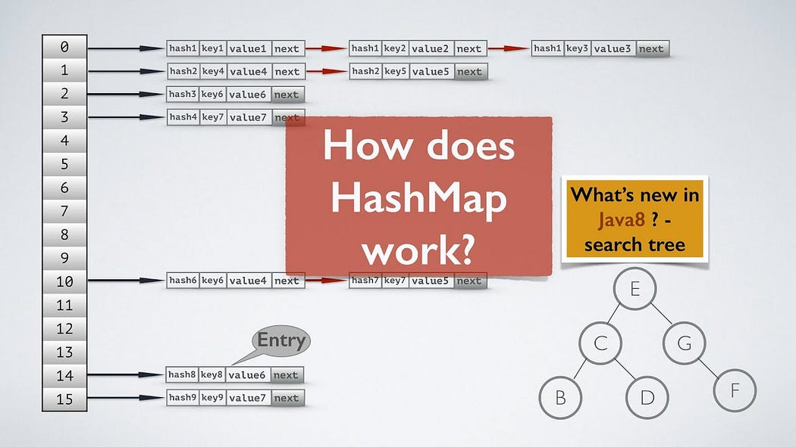

Internal Working of HashMap

Now, when you insert values in a key using put() method of the HashMap class, the hashcode will be generated by the put() method. Hashcode makes the process of receiving values faster and easier. And this hashcode is further computed and it will generate the index for storing the value.

The value of our key will be stored at the index given by the hashcode in the form of a Linked list.

To make retrieval of the key-value pairs more efficient, Java 8 introduced Binary Search Tree (BST) to use in place of a linked list.

Now, let’s see how the index is calculated for storing the value.

***Index Calculation in HashMap :***

Hashcode of the key may be very large to create an array. Hashcode generated may be in the range of integer and if we create arrays for such a long range, then it could be memory consuming task.

**index = hashCode(key) & (length-1)**

The expression **hashcode & (length-1)** does a bit-wise **AND** on **hashcode** using **length-1**, which is like a bit-mask, to return only the low-order bits of **hashcode**, thereby making for a super-fast variant of **hashcode % length**.

*In Hashmap put (insertion), remove (deletion) and get (search) operations are performed at constant time i.e, time complexity is****O(1)****with the assumption that key-value pairs are well distributed across the buckets.*

**Collision in a HashMap :**

A Hash Collision is a situation where for two or more distinct records, the hash function returns the same bucket position in the HashTable. This is the main disadvantage of using hashmap.

HashMap uses these two methods to handle collision:

1. Separate Chaining
2. Open Addressing

Data Structures used for Separate Chaining are -

1. Linked List
2. Self Balancing Binary Search Tree
3. Dynamic Sized Array

In chaining, all key-value pairs mapping to the same index will be stored in the linked list of that index. Similarly, binary search trees can also be used for chaining.

Collision is a very important topic to learn about. I’ll share one dedicated article on this.

This is all I’ve learned about HashMap till now. If you find this article useful then give it a clap.

Happy Learning!!!

Composition, Real life usecase and difference between inheritance and composition

# Difference between Inheritance and Composition in Java

• **Read**

• Discuss

• Practice

[**Inheritance**](https://www.geeksforgeeks.org/inheritance-in-c/)**:**   
When we want to create a new class and there is already a class that includes some of the code that we want, we can derive our new class from the existing class. In doing this, we can reuse the fields and methods of the existing class without having to write them ourself.

A subclass inherits all the members (fields, methods, and nested classes) from its superclass. Constructors are not members, so they are not inherited by subclasses, but the constructor of the superclass can be invoked from the subclass.

Types of Inheritance are:

1. Single inheritance
2. Multi-level inheritance
3. Multiple inheritances
4. Hybrid inheritance
5. Hierarchical inheritance

**Example of Inheritance:**

* Java

|  |
| --- |
| **class** A {  **int** a, b;  **public** **void** add(**int** x, **int** y)      {          a = x;          b = y;          System.out.println(              "addition of a + b is:"              + (a + b));      }  }    **class** B **extends** A {  **public** **void** sum(**int** x, **int** y)      {          add(x, y);      }        // Driver Code  **public** **static** **void** main(String[] args)      {          B b1 = **new** B();          b1.sum(5, 6);      }  } |

**Output:**

addition of a+b is:11

Here, class B is the derived class which inherit the property(**add method**) of the base class A.

[**Composition**](https://www.geeksforgeeks.org/association-composition-aggregation-java/)**:**   
The composition also provides code reusability but the difference here is we do not extend the class for this.

**Example of Composition:**   
Let us take an example ofthe **Library**.

* Java

|  |
| --- |
| // Java program to illustrate  // the concept of Composition    **import** java.io.\*;  **import** java.util.\*;    // class book  **class** Book {    **public** String title;  **public** String author;        Book(String title, String author)      {    **this**.title = title;  **this**.author = author;      }  }    // Library class contains  // list of books.  **class** Library {        // reference to refer to the list of books.  **private** **final** List<Book> books;        Library(List<Book> books)      {  **this**.books = books;      }    **public** List<Book> getTotalBooksInLibrary()      {    **return** books;      }  }    // main method  **class** GFG {  **public** **static** **void** main(String[] args)      {            // Creating the Objects of Book class.          Book b1 = **new** Book(              "EffectiveJ Java",              "Joshua Bloch");          Book b2 = **new** Book(              "Thinking in Java",              "Bruce Eckel");          Book b3 = **new** Book(              "Java: The Complete Reference",              "Herbert Schildt");            // Creating the list which contains the          // no. of books.          List<Book> books = **new** ArrayList<Book>();          books.add(b1);          books.add(b2);          books.add(b3);            Library library = **new** Library(books);            List<Book> bks = library.getTotalBooksInLibrary();  **for** (Book bk : bks) {                System.out.println("Title : "                                 + bk.title + " and "                                 + " Author : "                                 + bk.author);          }      }  } |

**Output:**

Title : EffectiveJ Java and Author : Joshua Bloch

Title : Thinking in Java and Author : Bruce Eckel

Title : Java: The Complete Reference and Author : Herbert Schildt

**Difference between Inheritance and Composition:**

| **S.NO** | **Inheritance** | **Composition** |
| --- | --- | --- |
| 1. | In inheritance, we define the class which we are inheriting(super class) and most importantly it cannot be changed at runtime | Whereas in composition we only define a type which we want to use and which can hold its different implementation also it can change at runtime. Hence, Composition is much more flexible than Inheritance. |
| 2. | Here we can only extend one class, in other words more than one class can’t be extended as java do not support multiple inheritance. | Whereas composition allows to use functionality from different class. |
| 3. | In inheritance we need parent class in order to test child class. | Composition allows to test the implementation of the classes we are using independent of parent or child class. |
| 4. | Inheritance cannot extend final class. | Whereas composition allows code reuse even from final classes. |
| 5. | It is an **is-a** relationship. | While it is a **has-a** relationship. |

Concurrent hashing

The**ConcurrentHashMap** class is introduced in JDK 1.5 belongs to **java.util.concurrent**package, which implements ConcurrentMap as well as to Serializable interface also. ConcurrentHashMap is an enhancement of HashMap as we know that while dealing with Threads in our application HashMap is not a good choice because performance-wise HashMap is not up to the mark.

ConcurrentHashMap is a thread-safe implementation of the Map interface in Java, which means multiple threads can access it simultaneously without any synchronization issues. It’s part of the java.util.concurrent package and was introduced in Java 5 as a scalable alternative to the traditional HashMap class.

One of the key features of the ConcurrentHashMap is that it provides fine-grained locking, meaning that it locks only the portion of the map being modified, rather than the entire map. This makes it highly scalable and efficient for concurrent operations. Additionally, the ConcurrentHashMap provides various methods for atomic operations such as putIfAbsent(), replace(), and remove().

### Here is a simple example of how to use a ConcurrentHashMap:

* Java

|  |
| --- |
| **import** java.util.concurrent.ConcurrentHashMap;    **public** **class** Main {  **public** **static** **void** main(String[] args) {          ConcurrentHashMap<String, Integer> map = **new** ConcurrentHashMap<>();            // Adding elements to the map          map.put("A", 1);          map.put("B", 2);          map.put("C", 3);            System.out.println("Map size: " + map.size());            // Getting values from the map  **int** valueA = map.get("A");          System.out.println("Value of A: " + valueA);            // Removing elements from the map          map.remove("B");          System.out.println("Map size: " + map.size());      }  } |

**Output**

Map size: 3

Value of A: 1

Map size: 2

**Key points of ConcurrentHashMap:**

* The underlined data structure for ConcurrentHashMap is [Hashtable](https://www.geeksforgeeks.org/hashtable-in-java/).
* ConcurrentHashMap class is thread-safe i.e. multiple threads can operate on a single object without any complications.
* At a time any number of threads are applicable for a read operation without locking the ConcurrentHashMap object which is not there in HashMap.
* In ConcurrentHashMap, the Object is divided into a number of segments according to the concurrency level.
* The default concurrency-level of ConcurrentHashMap is 16.
* In ConcurrentHashMap, at a time any number of threads can perform retrieval operation but for updated in the object, the thread must lock the particular segment in which the thread wants to operate. This type of locking mechanism is known as **Segment locking or bucket locking**. Hence at a time, 16 update operations can be performed by threads.
* Inserting null objects is not possible in ConcurrentHashMap as a key or value.

**Declaration:**

*public class ConcurrentHashMap<K,​V> extends AbstractMap<K,​V> implements ConcurrentMap<K,​V>, Serializable*

Here, **K** is the key Object type and **V** is the value Object type.

**The Hierarchy of ConcurrentHashMap**

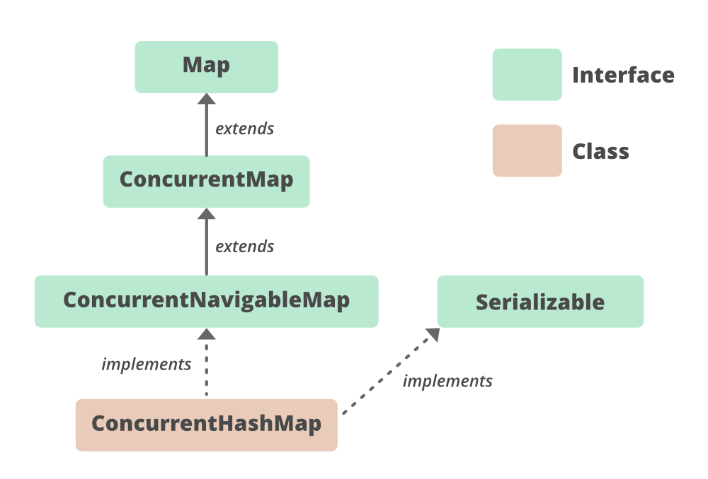

It implements **Serializable**, [ConcurrentMap<K,​ V>](https://www.geeksforgeeks.org/concurrentmap-interface-java/), [Map<K,​ V>](https://www.geeksforgeeks.org/map-interface-java-examples/) interfaces and extends  **AbstractMap<K, ​V>** class.

**Constructors of ConcurrentHashMap**

* **Concurrency-Level:**It is the number of threads concurrently updating the map. The implementation performs internal sizing to try to accommodate this many threads.
* **Load-Factor:** It’s a threshold, used to control resizing.
* **Initial Capacity:** Accommodation of a certain number of elements initially provided by the implementation. if the capacity of this map is 10. It means that it can store 10 entries.

**1. ConcurrentHashMap()**: Creates a new, empty map with a default initial capacity (16), load factor (0.75) and concurrencyLevel (16).

*ConcurrentHashMap<K, V> chm = new ConcurrentHashMap<>();*

**2. ConcurrentHashMap(int initialCapacity)**: Creates a new, empty map with the specified initial capacity, and with default load factor (0.75) and concurrencyLevel (16).

*ConcurrentHashMap<K, V> chm = new ConcurrentHashMap<>(int initialCapacity);*

**3. ConcurrentHashMap(int initialCapacity, float loadFactor)**: Creates a new, empty map with the specified initial capacity and load factor and with the default concurrencyLevel (16).

*ConcurrentHashMap<K, V> chm = new ConcurrentHashMap<>(int initialCapacity, float loadFactor);*

**4. ConcurrentHashMap(int initialCapacity, float loadFactor, int concurrencyLevel)**: Creates a new, empty map with the specified initial capacity, load factor, and concurrency level.

*ConcurrentHashMap<K, V> chm = new ConcurrentHashMap<>(int initialCapacity, float loadFactor, int concurrencyLevel);*

**5. ConcurrentHashMap(Map m)**: Creates a new map with the same mappings as the given map.

*ConcurrentHashMap<K, V> chm = new ConcurrentHashMap<>(Map m);*

**Example:**

* Java

|  |
| --- |
| // Java program to demonstrate working of ConcurrentHashMap    **import** java.util.concurrent.\*;    **class** ConcurrentHashMapDemo {    **public** **static** **void** main(String[] args)      {          // create an instance of          // ConcurrentHashMap          ConcurrentHashMap<Integer, String> m              = **new** ConcurrentHashMap<>();            // Insert mappings using          // put method          m.put(100, "Hello");          m.put(101, "Geeks");          m.put(102, "Geeks");            // Here we cant add Hello because 101 key          // is already present in ConcurrentHashMap object          m.putIfAbsent(101, "Hello");            // We can remove entry because 101 key          // is associated with For value          m.remove(101, "Geeks");            // Now we can add Hello          m.putIfAbsent(103, "Hello");            // We cant replace Hello with For          m.replace(101, "Hello", "For");          System.out.println(m);      }  } |

**Output**

{100=Hello, 102=Geeks, 103=Hello}

**Basic Operations on ConcurrentHashMap**

**1. Adding Elements**

To insert mappings into a ConcurrentHashMap, we can use [put()](https://www.geeksforgeeks.org/concurrenthashmap-put-method-in-java/#:~:text=The%20put()%20method%20of,gets%20inserted%20as%20a%20whole.) or [putAll()](https://www.geeksforgeeks.org/concurrenthashmap-putall-method-in-java/) methods. The below example code explains these two methods.

* Java

|  |
| --- |
| // Java program to demonstrate adding  // elements to the ConcurrentHashMap    **import** java.util.\*;  **import** java.util.concurrent.ConcurrentHashMap;    **public** **class** AddingElementsToConcuurentHashMap {    **public** **static** **void** main(String[] args)      {          // Creating ConcurrentHashMap          ConcurrentHashMap<String, String> my\_cmmap              = **new** ConcurrentHashMap<String, String>();            // Adding elements to the map          // using put() method          my\_cmmap.put("1", "1");          my\_cmmap.put("2", "1");          my\_cmmap.put("3", "1");          my\_cmmap.put("4", "1");          my\_cmmap.put("5", "1");          my\_cmmap.put("6", "1");            // Printing the map          System.out.println("Mappings of my\_cmmap : "                             + my\_cmmap);            // create another concurrentHashMap          ConcurrentHashMap<String, String> new\_chm              = **new** ConcurrentHashMap<>();            // copy mappings from my\_cmmap to new\_chm          new\_chm.putAll(my\_cmmap);            // Displaying the new map          System.out.println("New mappings are: " + new\_chm);      }  } |

**Output**

Mappings of my\_cmmap : {1=1, 2=1, 3=1, 4=1, 5=1, 6=1}

New mappings are: {1=1, 2=1, 3=1, 4=1, 5=1, 6=1}

**2. Removing Elements**

To remove a mapping, we can use [remove(Object key)](https://www.geeksforgeeks.org/concurrenthashmap-remove-method-in-java/?ref=rp) method of class ConcurrentHashmap. If the key does not exist in the map, then this function does nothing. To clear the entire map, we can use the [clear()](https://www.geeksforgeeks.org/java-concurrenthashmap-clear/) method.

* Java

|  |
| --- |
| // Java program to demonstrate removing  // elements from ConcurrentHashMap    **import** java.util.\*;  **import** java.util.concurrent.ConcurrentHashMap;    **public** **class** RemoveElementsFromConcurrentHashMap {    **public** **static** **void** main(String[] args)      {          // Creating ConcurrentHashMap          Map<String, String> my\_cmmap              = **new** ConcurrentHashMap<String, String>();            // Adding elements to the map          // using put() method          my\_cmmap.put("1", "1");          my\_cmmap.put("2", "1");          my\_cmmap.put("3", "1");          my\_cmmap.put("4", "1");          my\_cmmap.put("5", "1");          my\_cmmap.put("6", "1");            // Printing the map          System.out.println("Map: " + my\_cmmap);          System.out.println();            // Removing the mapping          // with existing key 6          // using remove() method          String valueRemoved = my\_cmmap.remove("6");            // Printing the map after remove()          System.out.println(              "After removing mapping with key 6:");          System.out.println("Map: " + my\_cmmap);          System.out.println("Value removed: "                             + valueRemoved);          System.out.println();            // Removing the mapping          // with non-existing key 10          // using remove() method          valueRemoved = my\_cmmap.remove("10");            // Printing the map after remove()          System.out.println(              "After removing mapping with key 10:");          System.out.println("Map: " + my\_cmmap);          System.out.println("Value removed: "                             + valueRemoved);          System.out.println();            // Now clear the map using clear()          my\_cmmap.clear();            // Print the clea Map          System.out.println("Map after use of clear(): "                             + my\_cmmap);      }  } |

**Output**

Map: {1=1, 2=1, 3=1, 4=1, 5=1, 6=1}

After removing mapping with key 6:

Map: {1=1, 2=1, 3=1, 4=1, 5=1}

Value removed: 1

After removing mapping with key 10:

Map: {1=1, 2=1, 3=1, 4=1, 5=1}

Value removed: null

Map after use of clear(): {}

**3. Accessing the Elements**

We can access the elements of a ConcurrentHashMap using the [get()](https://www.geeksforgeeks.org/concurrenthashmap-get-method-in-java/) method, the example of this is given below.

* Java

|  |
| --- |
| // Java Program Demonstrate accessing  // elements of ConcurrentHashMap    **import** java.util.concurrent.\*;    **class** AccessingElementsOfConcurrentHashMap {    **public** **static** **void** main(String[] args)      {            // create an instance of ConcurrentHashMap          ConcurrentHashMap<Integer, String> chm              = **new** ConcurrentHashMap<Integer, String>();            // insert mappings using put method          chm.put(100, "Geeks");          chm.put(101, "for");          chm.put(102, "Geeks");          chm.put(103, "Contribute");            // Displaying the HashMap          System.out.println("The Mappings are: ");          System.out.println(chm);            // Display the value of 100          System.out.println("The Value associated to "                             + "100 is : " + chm.get(100));            // Getting the value of 103          System.out.println("The Value associated to "                             + "103 is : " + chm.get(103));      }  } |

**Output**

The Mappings are:

{100=Geeks, 101=for, 102=Geeks, 103=Contribute}

The Value associated to 100 is : Geeks

The Value associated to 103 is : Contribute

**4. Traversing**

We can use the [Iterator](https://www.geeksforgeeks.org/iterators-in-java/) interface to traverse over any structure of the Collection Framework. Since Iterators work with one type of data we use Entry< ? , ? > to resolve the two separate types into a compatible format. Then using the next() method we print the elements of the ConcurrentHashMap.

* Java

|  |
| --- |
| // Java Program for traversing a  // ConcurrentHashMap  **import** java.util.\*;  **import** java.util.concurrent.\*;    **public** **class** TraversingConcurrentHashMap {    **public** **static** **void** main(String[] args)      {            // create an instance of ConcurrentHashMap          ConcurrentHashMap<Integer, String> chmap              = **new** ConcurrentHashMap<Integer, String>();            // Add elements using put()          chmap.put(8, "Third");          chmap.put(6, "Second");          chmap.put(3, "First");          chmap.put(11, "Fourth");            // Create an Iterator over the          // ConcurrentHashMap          Iterator<ConcurrentHashMap.Entry<Integer, String> >              itr = chmap.entrySet().iterator();            // The hasNext() method is used to check if there is          // a next element The next() method is used to          // retrieve the next element  **while** (itr.hasNext()) {              ConcurrentHashMap.Entry<Integer, String> entry                  = itr.next();              System.out.println("Key = " + entry.getKey()                                 + ", Value = "                                 + entry.getValue());          }      }  } |

**Output**

Key = 3, Value = First

Key = 6, Value = Second

Key = 8, Value = Third

Key = 11, Value = Fourth

**Methods of ConcurrentHashMap**

* **K** – The type of the keys on the map.
* **V** – The type of values mapped in the map.

| **METHOD** | **DESCRIPTION** |
| --- | --- |
| [clear()](https://www.geeksforgeeks.org/java-concurrenthashmap-clear/) | Removes all of the mappings from this map. |
| [compute​(K key, BiFunction<? super K,​? super V,​? extends V> remappingFunction)](https://www.geeksforgeeks.org/concurrenthashmap-compute-method-in-java-with-examples/) | Attempts to compute a mapping for the specified key and its current mapped value (or null if there is no current mapping). |
| [computeIfAbsent​(K key, Function<? super K,​? extends V> mappingFunction)](https://www.geeksforgeeks.org/concurrenthashmap-computeifabsent-method-in-java-with-examples/) | If the specified key is not already associated with a value, attempts to compute its value using the given mapping function and enters it into this map unless null. |
| computeIfPresent​(K key, BiFunction<? super K,​? super V,​? extends V> remappingFunction) | If the value for the specified key is present, attempts to compute a new mapping given the key and its current mapped value. |
| [contains​(Object value)](https://www.geeksforgeeks.org/concurrenthashmap-contains-method-in-java-with-examples/) | Tests if some keymaps into the specified value in this table. |
| [containsKey​(Object key)](https://www.geeksforgeeks.org/concurrenthashmap-containskey-method-in-java/) | Tests if the specified object is a key in this table. |
| [containsValue​(Object value)](https://www.geeksforgeeks.org/concurrenthashmap-containsvalue-method-in-java/) | Returns true if this map maps one or more keys to the specified value. |
| [elements()](https://www.geeksforgeeks.org/concurrenthashmap-elements-method-in-java-with-examples/) | Returns an enumeration of the values in this table. |
| [entrySet()](https://www.geeksforgeeks.org/concurrenthashmap-entryset-method-in-java-with-examples/) | Returns a Set view of the mappings contained in this map. |
| equals​(Object o) | Compares the specified object with this map for equality. |
| forEach​(long parallelismThreshold, BiConsumer<? super K,​? super V> action) | Performs the given action for each (key, value). |
| forEach​(long parallelismThreshold, BiFunction<? super K,​? super V,​? extends U> transformer, Consumer<? super U> action) | Performs the given action for each non-null transformation of each (key, value). |
| forEachEntry​(long parallelismThreshold, Consumer<? super Map.Entry<K,​V>> action) | Performs the given action for each entry. |
| forEachEntry​(long parallelismThreshold, Function<Map.Entry<K,​V>,​? extends U> transformer, Consumer<? super U> action) | Performs the given action for each non-null transformation of each entry. |
| forEachKey​(long parallelismThreshold, Consumer<? super K> action) | Performs the given action for each key. |
| forEachKey​(long parallelismThreshold, Function<? super K,​? extends U> transformer, Consumer<? super U> action) | Performs the given action for each non-null transformation of each key. |
| forEachValue​(long parallelismThreshold, Consumer<? super V> action) | Performs the given action for each value. |
| forEachValue​(long parallelismThreshold, Function<? super V,​? extends U> transformer, Consumer<? super U> action) | Performs the given action for each non-null transformation of each value. |
| [get​(Object key)](https://www.geeksforgeeks.org/concurrenthashmap-get-method-in-java/) | Returns the value to which the specified key is mapped, or null if this map contains no mapping for the key. |
| getOrDefault​(Object key, V defaultValue) | Returns the value to which the specified key is mapped, or the given default value if this map contains no mapping for the key. |
| hashCode() | Returns the hash code value for this Map, i.e., the sum of, for each key-value pair in the map, key.hashCode() ^ value.hashCode(). |
| [keys()](https://www.geeksforgeeks.org/concurrenthashmap-keys-method-in-java-with-examples/) | Returns an enumeration of the keys in this table. |
| [keySet()](https://www.geeksforgeeks.org/concurrenthashmap-keyset-method-in-java-with-examples/) | Returns a Set view of the keys contained in this map. |
| keySet​(V mappedValue) | Returns a Set view of the keys in this map, using the given common mapped value for any additions (i.e., Collection.add(E) and Collection.addAll(Collection)). |
| mappingCount() | Returns the number of mappings. |
| merge​(K key, V value, BiFunction<? super V,​? super V,​? extends V> remappingFunction) | If the specified key is not already associated with a (non-null) value, associates it with the given value. |
| newKeySet() | Creates a new Set backed by a ConcurrentHashMap from the given type to Boolean.TRUE. |
| newKeySet​(int initialCapacity) | Creates a new Set backed by a ConcurrentHashMap from the given type to Boolean.TRUE. |
| [put​(K key, V value)](https://www.geeksforgeeks.org/concurrenthashmap-put-method-in-java/#:~:text=The%20put()%20method%20of,gets%20inserted%20as%20a%20whole.) | Maps the specified key to the specified value in this table. |
| [putAll​(Map<? extends K,​? extends V> m)](https://www.geeksforgeeks.org/concurrenthashmap-putall-method-in-java/) | Copies all of the mappings from the specified map to this one. |
| [putIfAbsent​(K key, V value)](https://www.geeksforgeeks.org/concurrenthashmap-putifabsent-method-in-java/) | If the specified key is not already associated with a value, associates it with the given value. |
| reduce​(long parallelismThreshold, BiFunction<? super K,​? super V,​? extends U> transformer, BiFunction<? super U,​? super U,​? extends U> reducer) | Returns the result of accumulating the given transformation of all (key, value) pairs using the given reducer to combine values, or null if none. |
| reduceEntries​(long parallelismThreshold, BiFunction<Map.Entry<K,​V>,​Map.Entry<K,​V>,​? extends Map.Entry<K,​V>> reducer) | Returns the result of accumulating all entries using the given reducer to combine values, or null if none. |
| reduceEntries​(long parallelismThreshold, Function<Map.Entry<K,​V>,​? extends U> transformer, BiFunction<? super U,​? super U,​? extends U> reducer) | Returns the result of accumulating the given transformation of all entries using the given reducer to combine values, or null if none. |
| reduceEntriesToDouble​(long parallelismThreshold, ToDoubleFunction<Map.Entry<K,​V>> transformer, double basis, DoubleBinaryOperator reducer) | Returns the result of accumulating the given transformation of all entries using the given reducer to combine values, and the given basis as an identity value. |
| reduceEntriesToInt​(long parallelismThreshold, ToIntFunction<Map.Entry<K,​V>> transformer, int basis, IntBinaryOperator reducer) | Returns the result of accumulating the given transformation of all entries using the given reducer to combine values, and the given basis as an identity value. |
| reduceEntriesToLong​(long parallelismThreshold, ToLongFunction<Map.Entry<K,​V>> transformer, long basis, LongBinaryOperator reducer) | Returns the result of accumulating the given transformation of all entries using the given reducer to combine values, and the given basis as an identity value. |
| reduceKeys​(long parallelismThreshold, BiFunction<? super K,​? super K,​? extends K> reducer) | Returns the result of accumulating all keys using the given reducer to combine values, or null if none. |
| reduceKeys​(long parallelismThreshold, Function<? super K,​? extends U> transformer, BiFunction<? super U,​? super U,​? extends U> reducer) | Returns the result of accumulating the given transformation of all keys using the given reducer to combine values, or null if none. |
| reduceKeysToDouble​(long parallelismThreshold, ToDoubleFunction<? super K> transformer, double basis, DoubleBinaryOperator reducer) | Returns the result of accumulating the given transformation of all keys using the given reducer to combine values, and the given basis as an identity value. |
| reduceKeysToInt​(long parallelismThreshold, ToIntFunction<? super K> transformer, int basis, IntBinaryOperator reducer) | Returns the result of accumulating the given transformation of all keys using the given reducer to combine values, and the given basis as an identity value. |
| reduceKeysToLong​(long parallelismThreshold, ToLongFunction<? super K> transformer, long basis, LongBinaryOperator reducer) | Returns the result of accumulating the given transformation of all keys using the given reducer to combine values, and the given basis as an identity value. |
| reduceToDouble​(long parallelismThreshold, ToDoubleBiFunction<? super K,​? super V> transformer, double basis, DoubleBinaryOperator reducer) | Returns the result of accumulating the given transformation of all (key, value) pairs using the given reducer to combine values, and the given basis as an identity value. |
| reduceToInt​(long parallelismThreshold, ToIntBiFunction<? super K,​? super V> transformer, int basis, IntBinaryOperator reducer) | Returns the result of accumulating the given transformation of all (key, value) pairs using the given reducer to combine values, and the given basis as an identity value. |
| reduceToLong​(long parallelismThreshold, ToLongBiFunction<? super K,​? super V> transformer, long basis, LongBinaryOperator reducer) | Returns the result of accumulating the given transformation of all (key, value) pairs using the given reducer to combine values, and the given basis as an identity value. |
| reduceValues​(long parallelismThreshold, BiFunction<? super V,​? super V,​? extends V> reducer) | Returns the result of accumulating all values using the given reducer to combine values, or null if none. |
| reduceValues​(long parallelismThreshold, Function<? super V,​? extends U> transformer, BiFunction<? super U,​? super U,​? extends U> reducer) | Returns the result of accumulating the given transformation of all values using the given reducer to combine values, or null if none. |
| reduceValuesToDouble​(long parallelismThreshold, ToDoubleFunction<? super V> transformer, double basis, DoubleBinaryOperator reducer) | Returns the result of accumulating the given transformation of all values using the given reducer to combine values, and the given basis as an identity value. |
| reduceValuesToInt​(long parallelismThreshold, ToIntFunction<? super V> transformer, int basis, IntBinaryOperator reducer) | Returns the result of accumulating the given transformation of all values using the given reducer to combine values, and the given basis as an identity value. |
| reduceValuesToLong​(long parallelismThreshold, ToLongFunction<? super V> transformer, long basis, LongBinaryOperator reducer) | Returns the result of accumulating the given transformation of all values using the given reducer to combine values, and the given basis as an identity value. |
| [remove​(Object key)](https://www.geeksforgeeks.org/concurrenthashmap-remove-method-in-java/) | Removes the key (and its corresponding value) from this map. |
| [remove​(Object key, Object value)](https://www.geeksforgeeks.org/concurrenthashmap-remove-method-in-java/) | Removes the entry for a key only if currently mapped to a given value. |
| replace​(K key, V value) | Replaces the entry for a key only if currently mapped to some value. |
| replace​(K key, V oldValue, V newValue) | Replaces the entry for a key only if currently mapped to a given value. |
| search​(long parallelismThreshold, BiFunction<? super K,​? super V,​? extends U> searchFunction) | Returns a non-null result from applying the given search function on each (key, value), or null if none. |
| searchEntries​(long parallelismThreshold, Function<Map.Entry<K,​V>,​? extends U> searchFunction) | Returns a non-null result from applying the given search function on each entry, or null if none. |
| searchKeys​(long parallelismThreshold, Function<? super K,​? extends U> searchFunction) | Returns a non-null result from applying the given search function on each key, or null if none. |
| searchValues​(long parallelismThreshold, Function<? super V,​? extends U> searchFunction) | Returns a non-null result from applying the given search function on each value, or null if none. |
| toString() | Returns a string representation of this map. |
| [values()](https://www.geeksforgeeks.org/concurrenthashmap-values-method-in-java-with-examples/) | Returns a Collection view of the values contained in this map. |

**Methods declared in class java.util.AbstractMap**

| **METHOD** | **DESCRIPTION** |
| --- | --- |
| clone() | Returns a shallow copy of this AbstractMap instance: the keys and values themselves are not cloned. |
| [isEmpty()](https://www.geeksforgeeks.org/abstractmap-isempty-method-in-java-with-examples/) | Returns true if this map contains no key-value mappings. |
| [size()](https://www.geeksforgeeks.org/abstractmap-size-method-in-java-with-examples/#:~:text=The%20AbstractMap.,or%20mappings%20in%20the%20Map.) | Returns the number of key-value mappings in this map. |

**Methods declared in interface java.util.concurrent.ConcurrentMap**

| **METHOD** | **DESCRIPTION** |
| --- | --- |
| forEach​(BiConsumer<? super K,​? super V> action) | Performs the given action for each entry in this map until all entries have been processed or the action throws an exception. |
| replaceAll​(BiFunction<? super K,​? super V,​? extends V> function) | Replaces each entry’s value with the result of invoking the given function on that entry until all entries have been processed or the function throws an exception. |

**Must Read:**[Difference between HashMap and ConcurrentHashMap](https://www.geeksforgeeks.org/difference-hashmap-concurrenthashmap/)

**ConcurrentHashMap vs Hashtable**

**HashTable**

* **Hashtable** is an implementation of Map data structure
* This is a legacy class in which all methods are synchronized on Hashtable instances using the synchronized keyword.
* Thread-safe as it’s method are synchronized

**ConcurrentHashMap**

* **ConcurrentHashMap** implements Map data structure and also provide thread safety like Hashtable.
* It works by dividing complete hashtable array into segments or portions and allowing parallel access to those segments.
* The locking is at a much finer granularity at a hashmap bucket level.
* Use **ConcurrentHashMap** when you need very high concurrency in your application.
* It is a thread-safe without synchronizing the whole map.
* Reads can happen very fast while the write is done with a lock on segment level or bucket level.
* There is no locking at the object level.
* ConcurrentHashMap doesn’t throw a **ConcurrentModificationException** if one thread tries to modify it while another is iterating over it.
* ConcurrentHashMap does not allow NULL values, so the key can not be null in **ConcurrentHashMap**
* ConcurrentHashMap doesn’t throw a **ConcurrentModificationException** if one thread tries to modify it, while another is iterating over it.

| **Properties** | **Hashtable** | **ConcurrentHashMap** |
| --- | --- | --- |
| Creation | Map ht = new Hashtable(); | Map chm = new ConcurrentHashMap(); |
| Is Null Key Allowed ? | No | No |
| Is Null Value Allowed ? | No | No (does not allow either null keys or values) |
| Is Thread Safe ? | Yes | Yes, Thread safety is ensured by having separate locks for separate buckets, resulting in better performance. Performance is further improved by providing read access concurrently without any blocking. |
| Performance | Slow due to synchronization overhead. | Faster than Hashtable. ConcurrentHashMap is a better choice when there are **more reads than writes**. |
| Iterator | Hashtable uses enumerator to iterate the values of Hashtable object. Enumerations returned by the Hashtable keys and elements methods are not fail-fast. | Fail-safe iterator: Iterator provided by the ConcurrentHashMap is fail-safe, which means it will not throw **ConcurrentModificationException**. |

**Conclusion:**

If a thread-safe highly-concurrent implementation is desired, then it is recommended to use **ConcurrentHashMap** in place of **Hashtable**.

### Advantages of ConcurrentHashMap:

1. Thread-safe: ConcurrentHashMap is designed to be used by multiple threads simultaneously, making it an ideal choice for applications that need to handle concurrent access to data.
2. Fine-grained locking: Unlike other synchronization mechanisms that lock the entire data structure, ConcurrentHashMap uses fine-grained locking to lock only the portion of the map being modified. This makes it highly scalable and efficient for concurrent operations.
3. Atomic operations: ConcurrentHashMap provides several methods for performing atomic operations, such as putIfAbsent(), replace(), and remove(), which can be useful for implementing complex concurrent algorithms.
4. High performance: Due to its fine-grained locking mechanism, ConcurrentHashMap is able to achieve high performance, even under heavy concurrent access.

### Disadvantages of ConcurrentHashMap:

1. Higher memory overhead: The fine-grained locking mechanism used by ConcurrentHashMap requires additional memory overhead compared to other synchronization mechanisms.
2. Complexity: The fine-grained locking mechanism used by ConcurrentHashMap can make the code more complex, especially for developers who are not familiar with concurrent programming.

is it better to use array or any collection classes?

Arrays can hold both object and primitive type data. On the other hand, collection can hold only object types but not the primitive type of data. Arrays due to its storage and internal implementation better in performance. Collection on the other hand with respect to performance is not recommended to use

# Difference between Arrays and Collection in Java

[Java 8](https://www.tutorialspoint.com/articles/category/Java-8)[Object Oriented Programming](https://www.tutorialspoint.com/articles/category/Object-Oriented-Programming)[Programming](https://www.tutorialspoint.com/articles/category/Programming)

In order to store multiple values or objects of the same type, Java provides two types of data structures namely Array and Collection.

The following are the important differences between Arrays and Collection.

| **Sr. No.** | **Key** | **Arrays** | **Collection** |
| --- | --- | --- | --- |
| 1 | Size | Arrays are fixed in size i.e once the array with the specific size is declared then we can't alter its size afterward. | The collection is dynamic in size i.e based on requirement size could be get altered even after its declaration. |
| 2 | Memory Consumption | Arrays due to fast execution consumes more memory and has better performance. | Collections, on the other hand, consume less memory but also have low performance as compared to Arrays. |
| 3 | Data type | Arrays can hold the only the same type of data in its collection i.e only homogeneous data types elements are allowed in case of arrays. | Collection, on the other hand, can hold both homogeneous and heterogeneous elements. |
| 4 | Primitives storage | Arrays can hold both object and primitive type data. | On the other hand, collection can hold only object types but not the primitive type of data. |
| 5 | Performance | Arrays due to its storage and internal implementation better in performance. | Collection on the other hand with respect to performance is not recommended to use. |

SOLID principles

**SOLID design is an acronym for the following five principles:**

* Single Responsibility Principle.
* Open-Closed Principle.
* Liskov Substitution Principle.
* Interface Segregation Principle.
* Dependency Inversion Principle.

In Java, **SOLID principles** are an object-oriented approach that are applied to software structure design. It is conceptualized by **Robert C. Martin** (also known as Uncle Bob). These five principles have changed the world of object-oriented programming, and also changed the way of writing software. It also ensures that the software is modular, easy to understand, debug, and refactor. In this section, we will discuss **SOLID principles in Java** with proper example**.**

The word SOLID acronym for:

* Single Responsibility Principle (SRP)
* Open-Closed Principle (OCP)
* Liskov Substitution Principle (LSP)
* Interface Segregation Principle (ISP)
* Dependency Inversion Principle (DIP)

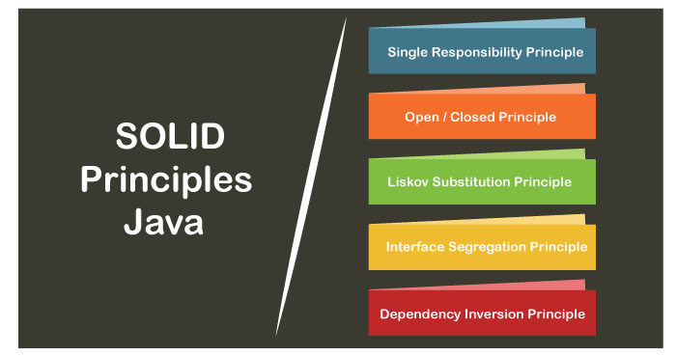

Let's explain the principles one by one in detail.

## **Single Responsibility Principle**

The single responsibility principle states that **every Java class must perform a single functionality**. Implementation of multiple functionalities in a single class mashup the code and if any modification is required may affect the whole class. It precise the code and the code can be easily maintained. Let's understand the single responsibility principle through an example.

Suppose, **Student** is a class having three methods namely **printDetails(), calculatePercentage(),** and **addStudent().** Hence, the Student class has three responsibilities to print the details of students, calculate percentages, and database. By using the single responsibility principle, we can separate these functionalities into three separate classes to fulfill the goal of the principle.

**Student.java**

1. **public** **class** Student
2. {
3. **public** **void** printDetails();
4. {
5. //functionality of the method
6. }
7. pubic **void** calculatePercentage();
8. {
9. //functionality of the method
10. }
11. **public** **void** addStudent();
12. {
13. //functionality of the method
14. }
15. }

The above code snippet violates the single responsibility principle. To achieve the goal of the principle, we should implement a separate class that performs a single functionality only.

**Student.java**

1. **public** **class** Student
2. {
3. **public** **void** addStudent();
4. {
5. //functionality of the method
6. }
7. }

**PrintStudentDetails.java**

1. **public** **class** PrintStudentDetails
2. {
3. **public** **void** printDetails();
4. {
5. //functionality of the method
6. }
7. }

**Percentage.java**

1. **public** **class** Percentage
2. {
3. **public** **void** calculatePercentage();
4. {
5. //functionality of the method
6. }
7. }

Hence, we have achieved the goal of the single responsibility principle by separating the functionality into three separate classes.

## **Open-Closed Principle**

The application or module entities the methods, functions, variables, etc. The open-closed principle states that according to new requirements **the module should be open for extension but closed for modification.** The extension allows us to implement new functionality to the module. Let's understand the principle through an example.

Suppose, **VehicleInfo** is a class and it has the method **vehicleNumber()** that returns the vehicle number.

**VehicleInfo.java**

1. **public** **class** VehicleInfo
2. {
3. **public** **double** vehicleNumber(Vehicle vcl)
4. {
5. **if** (vcl **instanceof** Car)
6. {
7. **return** vcl.getNumber();
8. **if** (vcl **instanceof** Bike)
9. {
10. **return** vcl.getNumber();
11. }
12. }

If we want to add another subclass named Truck, simply, we add one more if statement that violates the open-closed principle. The only way to add the subclass and achieve the goal of principle by overriding the **vehicleNumber()** method, as we have shown below.

**VehicleInfo.java**

1. **public** **class** VehicleInfo
2. {
3. **public** **double** vehicleNumber()
4. {
5. //functionality
6. }
7. }
8. **public** **class** Car **extends** VehicleInfo
9. {
10. **public** **double** vehicleNumber()
11. {
12. **return** **this**.getValue();
13. }
14. **public** **class** Car **extends** Truck
15. {
16. **public** **double** vehicleNumber()
17. {
18. **return** **this**.getValue();
19. }

Similarly, we can add more vehicles by making another subclass extending from the vehicle class. the approach would not affect the existing application.

## **Liskov Substitution Principle**

The Liskov Substitution Principle (LSP) was introduced by **Barbara Liskov**. It applies to inheritance in such a way that the **derived classes must be completely substitutable for their base classes**. In other words, if class A is a subtype of class B, then we should be able to replace B with A without interrupting the behavior of the program.

It extends the open-close principle and also focuses on the behavior of a superclass and its subtypes. We should design the classes to preserve the property unless we have a strong reason to do otherwise. Let's understand the principle through an example.

**Student.java**

1. **public** **class** Student
2. {
3. **private** **double** height;
4. **private** **double** weight;
5. **public** **void** setHeight(**double** h)
6. {
7. height = h;
8. }
9. **public** **void** setWeight(**double** w)
10. {
11. weight= w;
12. }
13. ...
14. }
15. **public** **class** StudentBMI **extends** Student
16. {
17. **public** **void** setHeight(**double** h)
18. {
19. **super**.setHeight(h);
20. **super**.setWeight(w);
21. }
22. **public** **void** setWeight(**double** h)
23. {
24. **super**.setHeight(h);
25. **super**.setWeight(w);
26. }
27. }

The above classes violated the Liskov substitution principle because the StudentBMI class has extra constraints i.e. height and weight that must be the same. Therefore, the Student class (base class) cannot be replaced by StudentBMI class (derived class).

Hence, substituting the class Student with StudentBMI class may result in unexpected behavior.

## **Interface Segregation Principle**

The principle states that the larger interfaces split into smaller ones. Because the implementation classes use only the methods that are required. We should not force the client to use the methods that they do not want to use.

The goal of the interface segregation principle is similar to the single responsibility principle. Let's understand the principle through an example.

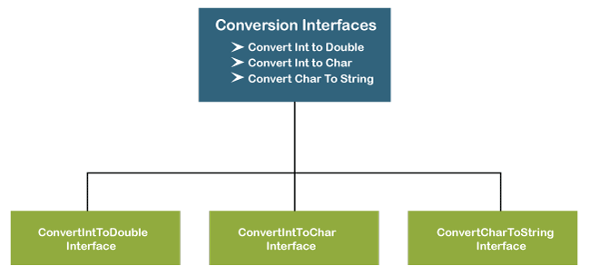

Suppose, we have created an interface named **Conversion** having three methods **intToDouble(), intToChar(),** and **charToString()**.

1. **public** **interface** Conversion
2. {
3. **public** **void** intToDouble();
4. **public** **void** intToChar();
5. **public** **void** charToString();
6. }

The above interface has three methods. If we want to use only a method intToChar(), we have no choice to implement the single method. To overcome the problem, the principle allows us to split the interface into three separate ones.

1. **public** **interface** ConvertIntToDouble
2. {
3. **public** **void** intToDouble();
4. }
5. **public** **interface** ConvertIntToChar
6. {
7. **public** **void** intToChar();
8. }
9. **public** **interface** ConvertCharToString
10. {
11. **public** **void** charToString();
12. }

Now we can use only the method that is required. Suppose, we want to convert the integer to double and character to string then, we will use only the methods **intToDouble()** and **charToString().**

1. **public** **class** DataTypeConversion **implements** ConvertIntToDouble, ConvertCharToString
2. {
3. **public** **void** intToDouble()
4. {
5. //conversion logic
6. }
7. **public** **void** charToString()
8. {
9. //conversion logic
10. }
11. }

## **Dependency Inversion Principle**

The principle states that we must use abstraction (abstract classes and interfaces) instead of concrete implementations. High-level modules should not depend on the low-level module but both should depend on the abstraction. Because the abstraction does not depend on detail but the detail depends on abstraction. It decouples the software. Let's understand the principle through an example.

1. **public** **class** WindowsMachine
2. {
3. //functionality
4. }

It is worth, if we have not keyboard and mouse to work on Windows. To solve this problem, we create a constructor of the class and add the instances of the keyboard and monitor. After adding the instances, the class looks like the following:

1. **public** **class** WindowsMachine
2. {
3. **public** **final** keyboard;
4. **public** **final** monitor;
5. **public** WindowsMachine()
6. {
7. monitor = **new** monitor();  //instance of monitor class
8. keyboard = **new** keyboard(); //instance of keyboard class
9. }
10. }

Now we can work on the Windows machine with the help of a keyboard and mouse. But we still face the problem. Because we have tightly coupled the three classes together by using the new keyword. It is hard o test the class windows machine.

To make the code loosely coupled, we decouple the WindowsMachine from the keyboard by using the Keyboard interface and this keyword.

**Keyboard.java**

1. **public** **interface** Keyboard
2. {
3. //functionality
4. }

**WindowsMachine.java**

1. **public** **class** WindowsMachine
2. {
3. **private** **final** Keyboard keyboard;
4. **private** **final** Monitor monitor;
5. **public** WindowsMachine(Keyboard keyboard, Monitor monitor)
6. {
7. **this**.keyboard = keyboard;
8. **this**.monitor = monitor;
9. }
10. }

In the above code, we have used the dependency injection to add the keyboard dependency in the WindowsMachine class. Therefore, we have decoupled the classes.

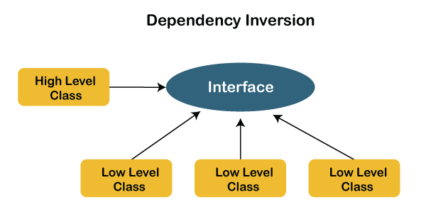

## **Why should we use SOLID principles?**

* It reduces the dependencies so that a block of code can be changed without affecting the other code blocks.
* The principles intended to make design easier, understandable.
* By using the principles, the system is maintainable, testable, scalable, and reusable.
* It avoids the bad design of the software.

Next time when you design software, keeps these five principles in mind. By applying these principles, the code will be much more clear, testable, and expendable.

how will you implement custom logging framework

If you want to create a custom logger implementation in Java, you should create a class that implements the System. Logger interface, which contains the following methods: getName() isLoggable()

## **Introduction**

In this tutorial, we’ll explore the newly introduced Logging API in Java 9 and implement some examples to cover the most common cases.

This API has been introduced in Java to**provide a common mechanism to handle all the platform logs and to expose a service interface that can be customized by libraries and applications.** This way, the JDK platform logs can use the same logging framework as the application, and the project dependencies can be reduced.

## **2. Creating a Custom Implementation**

In this section, we’re going to show the main classes of the Logging API that we have to implement to create a new logger. We’ll do so by implementing a simple logger that prints all the logs to the console.

### ****2.1. Creating the****Logger

The main class that we have to create is the Logger. This class has to implement the System.Logger interface and these four methods at least:

* getName(): returns the name of the logger. It’ll be used by the JDK to create loggers by name
* isLoggable(): indicates what levels the logger is enabled for
* log(): it’s the method that prints the log to whatever underlying system the application is using- the console in our case. There are 2 log() methods to implement, each of them receiving different parameters

Let’s see how our implementation will look like:

**public** **class** **ConsoleLogger** **implements** **System**.Logger {

@Override

**public** String **getName**() {

**return** "ConsoleLogger";

}

@Override

**public** **boolean** **isLoggable**(Level level) {

**return** true;

}

@Override

**public** **void** **log**(Level level, ResourceBundle bundle, String msg, Throwable thrown) {

System.out.printf("ConsoleLogger [%s]: %s - %s%n", level, msg, thrown);

}

@Override

**public** **void** **log**(Level level, ResourceBundle bundle, String format, Object... params) {

System.out.printf("ConsoleLogger [%s]: %s%n", level,

MessageFormat.format(format, params));

}

}Copy

Our ConsoleLogger class overrides the four methods mentioned. The getName() method returns a String, while the isLoggable() method returns true in all cases. Finally, we have the 2 log() method that output to the console.

### 2.2. Creating the LoggerFinder

Once we have our logger created, **we need to implement a LoggerFinder that creates instances of our ConsoleLogger.**

To do so, we have to extend the abstract class System.LoggerFinder and implement the getLogger() method:

**public** **class** **CustomLoggerFinder** **extends** **System**.LoggerFinder {

@Override

**public** System.Logger **getLogger**(String name, Module **module**) {

**return** **new** **ConsoleLogger**();

}

}Copy

In this case, we’re always returning our ConsoleLogger.

**Finally, we need to register our LoggerFinder as a Service so it can be discovered by the JDK**. If we don’t provide an implementation, the SimpleConsoleLogger will be used by default.

The mechanism used by the JDK to load the implementations is the ServiceLoader. You can find more information about it in [this tutorial](https://www.baeldung.com/java-spi).

Since we’re using Java 9, we’ll package our class in a module and register our service in the module-info.java file:

**module** com.baeldung.logging {

provides java.lang.System.LoggerFinder

with com.baeldung.logging.CustomLoggerFinder;

**exports** com.baeldung.logging;

}Copy

For more information about Java modules, check out [this other tutorial](https://www.baeldung.com/java-9-modularity).

### ****2.3. Testing Our Example****

To test our example, let’s create another module that will act as an application. This will only contain the Main class that uses our service implementation.

This class will get an instance of our ConsoleLogger by calling the System.getLogger() method:

**public** **class** **MainApp** {

**private** **static** System.**Logger** LOGGER = System.getLogger("MainApp");

**public** **static** **void** **main**(String[] args) {

LOGGER.log(Level.ERROR, "error test");

LOGGER.log(Level.INFO, "info test");

}

}Copy

**Internally, the JDK will pick up our CustomLoggerFinder implementation and create an instance of our ConsoleLogger.**

After that, let’s create the module-info file for this module:

**module** com.baeldung.logging.app {

}Copy

At this point, our project structure will look like this:

├── src

│   ├── modules

│   │   ├── com.baeldung.logging

│   │   │   ├── com

│   │   │   │   └── baeldung

│   │   │   │   └── logging

│   │   │   │   ├── ConsoleLogger.java

│   │   │   │   └── CustomLoggerFinder.java

│   │   │   └── module-info.java

│   │   ├── com.baeldung.logging.app

│   │   │   ├── com

│   │   │   │   └── baeldung

│   │   │   │   └── logging

│   │   │   │   └── app

│   │   │   │   └── MainApp.java

│   │   │   └── module-info.java

└──Copy

Finally, we’re going to compile our two modules, and we’ll place them in a mods directory:

javac --module-path mods -d mods/com.baeldung.logging \

src/modules/com.baeldung.logging/module-info.java \

src/modules/com.baeldung.logging/com/baeldung/logging/\*.java

javac --module-path mods -d mods/com.baeldung.logging.app \

src/modules/com.baeldung.logging.app/module-info.java \

src/modules/com.baeldung.logging.app/com/baeldung/logging/app/\*.javaCopy

Finally, let’s run the Main class of the app module:

java --module-path mods \

-m com.baeldung.logging.app/com.baeldung.logging.app.MainAppCopy

If we take a look at the console output we can see that our logs are printed using our ConsoleLogger:

ConsoleLogger [ERROR]: error test

ConsoleLogger [INFO]: info testCopy

## **3. Adding an External Logging Framework**

In our previous example, we were logging all our messages to the console, which is the same as what the default logger does.**One of the most useful uses of the Logging API in Java 9 is to let applications route the JDK logs to the same logging framework the application is using**, and that’s what we’re going to do in this section.

We’ll create a new module that uses SLF4J as logging facade and Logback as logging framework.

Since we’ve already explained the basics in the previous section, now we can focus on how to add an external logging framework.

### ****3.1. Custom Implementations Using SLF4J****

First, we’ll implement another Logger that will create a new SLF4J logger for each instance:

**public** **class** **Slf4jLogger** **implements** **System**.Logger {

**private** **final** String name;

**private** **final** Logger logger;

**public** **Slf4jLogger**(String name) {

this.name = name;

logger = LoggerFactory.getLogger(name);

}

@Override

**public** String **getName**() {

**return** name;

}

//...

}Copy

**Notice that this Logger is an org.slf4j.Logger.**

For the rest of the methods, **we’ll rely on the implementation on the SLF4J logger instance**. Therefore, our Logger will be enabled if the SLF4J logger is enabled:

@Override

**public** **boolean** **isLoggable**(Level level) {

**switch** (level) {

**case** OFF:

**return** false;

**case** TRACE:

**return** logger.isTraceEnabled();

**case** DEBUG:

**return** logger.isDebugEnabled();

**case** INFO:

**return** logger.isInfoEnabled();

**case** WARNING:

**return** logger.isWarnEnabled();

**case** ERROR:

**return** logger.isErrorEnabled();

**case** ALL:

**default**:

**return** true;

}

}Copy

And the log methods will call the appropriate SLF4J logger method depending on the log level used:

@Override

**public** **void** **log**(Level level, ResourceBundle bundle, String msg, Throwable thrown) {

**if** (!isLoggable(level)) {

**return**;

}

**switch** (level) {

**case** TRACE:

logger.trace(msg, thrown);

**break**;

**case** DEBUG:

logger.debug(msg, thrown);

**break**;

**case** INFO:

logger.info(msg, thrown);

**break**;

**case** WARNING:

logger.warn(msg, thrown);

**break**;

**case** ERROR:

logger.error(msg, thrown);

**break**;

**case** ALL:

**default**:

logger.info(msg, thrown);

}

}

@Override

**public** **void** **log**(Level level, ResourceBundle bundle, String format, Object... params) {

**if** (!isLoggable(level)) {

**return**;

}

**String** message = MessageFormat.format(format, params);

**switch** (level) {

**case** TRACE:

logger.trace(message);

**break**;

// ...

// same as the previous switch

}

}Copy

Finally, let’s create a new LoggerFinder that uses our Slf4jLogger:

**public** **class** **Slf4jLoggerFinder** **extends** **System**.LoggerFinder {

@Override

**public** System.Logger **getLogger**(String name, Module **module**) {

**return** **new** **Slf4jLogger**(name);

}

}Copy

### ****3.2. Module Configuration****

Once we have all our classes implemented, let’s register our service in our module and add the dependency of the SLF4J module:

**module** com.baeldung.logging.slf4j {

**requires** org.slf4j;

provides java.lang.System.LoggerFinder

with com.baeldung.logging.slf4j.Slf4jLoggerFinder;

**exports** com.baeldung.logging.slf4j;

}Copy

This module will have the following structure:

├── src

│   ├── modules

│   │   ├── com.baeldung.logging.slf4j

│   │   │   ├── com

│   │   │   │   └── baeldung

│   │   │   │   └── logging

│   │   │   │   └── slf4j

│   │   │   │   ├── Slf4jLoggerFinder.java

│   │   │   │   └── Slf4jLogger.java

│   │   │   └── module-info.java

└──Copy

Now we can compile this module into the mods directory as we did in the previous section.

**Notice that we have to place the slf4j-api jar in the mods directory to compile this module. Also, keep in mind to use a modularized version of the library.** The latest version can be found in [Maven Central](https://mvnrepository.com/artifact/org.slf4j/slf4j-api).

### ****3.3. Adding Logback****

We’re almost done, but we still need to add the Logback dependencies and configuration. To do so, place the logback-classic and logback-core jars in the mods directory.

**As before, we have to make sure we’re using a modularized version of the library**. Again, the latest version can be found in [Maven Central](https://mvnrepository.com/artifact/ch.qos.logback).

Finally, let’s create a Logback configuration file and place it in our mods directory:

<**configuration**>

<**appender** name="STDOUT" class="ch.qos.logback.core.ConsoleAppender">

<**encoder** class="ch.qos.logback.classic.encoder.PatternLayoutEncoder">

<**pattern**>

%d{yyyy-MM-dd HH:mm:ss} [%thread] %-5level %logger{36} -- %msg%n

</**pattern**>

</**encoder**>

</**appender**>

<**root**>

<**appender-ref** ref="STDOUT"/>

</**root**>

</**configuration**>Copy

### ****3.4. Running Our Application****

At this point, we can run our app using our SLF4J module.

In this case, **we also need to specify our Logback configuration file**:

java --module-path mods \

-Dlogback.configurationFile=mods/logback.xml \

-m com.baeldung.logging.app/com.baeldung.logging.app.MainAppCopy

Finally, if we check the output we can see that our logs are printed using our Logback configuration:

2018-08-25 14:02:40 [main] ERROR MainApp -- error test

2018-08-25 14:02:40 [main] INFO MainApp -- info testCopy

## **4. Conclusion**

We’ve shown in this article how to create a custom logger in Java 9 by using the new Platform Logging API. Also, we’ve implemented an example using an external logging framework, which is one of the most useful use cases of this new API.

As always, the full source code of the examples is available [over on GitHub](https://github.com/eugenp/tutorials/tree/master/core-java-modules/core-java-9-new-features).

Asked me to write a block of code for filter, map and forEach using Lambda Expression

[[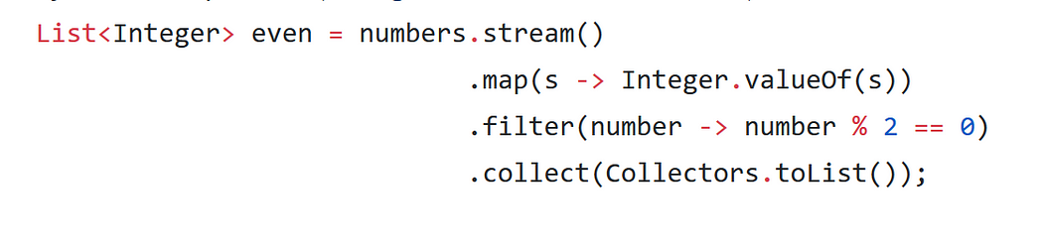](https://www.java67.com/2018/11/10-examples-of-collectors-in-java-8.html)](https://www.java67.com/2018/11/10-examples-of-collectors-in-java-8.html)

List<Entry> updatedEntries =

entryList.stream()

.peek(e -> e.setTempId(tempId))

.collect (Collectors.toList());

List<String> items = new ArrayList<>();

items.add("A");

items.add("B");

items.add("C");

items.add("D");

items.add("E");

//lambda

//Output : A,B,C,D,E

items.forEach(item->System.out.println(item));

//Output : C

items.forEach(item->{

System.out.println(item);

System.out.println(item.toLowerCase());

}

});

EntryList.forEach(e->e.setTempId(tempId));

List<Entry> updatedEntries = entryList.stream()

.map(e->entityManager.update(entry, entry.getId()))

.collect(toList());

entryList.stream()

.peek(entry -> entry.setTempId(tempId))

.forEach(updatedEntries.add(entityManager.update(entry, entry.getId())));

entryList.stream()

.forEach(

((Consumer<Entry>) entry -> entry.setTempId(tempId))

.andThen(entry -> updatedEntries.add(entityManager.update(entry, entry.getId())))

);

What are functional interfaces and why were they introduced?

Functional interfaces are included in Java SE 8 with Lambda expressions and Method references in order to make code more readable, clean, and straightforward. Functional interfaces are interfaces that ensure that they include precisely only one abstract method

Java has forever remained an Object-Oriented Programming language. By object-oriented programming language, we can declare that everything present in the Java programming language rotates throughout the Objects, except for some of the primitive data types and primitive methods for integrity and simplicity. There are no solely functions present in a programming language called Java. Functions in the Java programming language are part of a class, and if someone wants to use them, they have to use the class or object of the class to call any function.

## Java Functional Interfaces

A **functional interface** is an interface that contains only one abstract method. They can have only one functionality to exhibit. From Java 8 onwards, [lambda expressions](https://www.geeksforgeeks.org/lambda-expressions-java-8/) can be used to represent the instance of a functional interface. A functional interface can have any number of default methods. ***Runnable***, ***ActionListener***,*and****Comparable*** are some of the examples of functional interfaces.

Functional Interface is additionally recognized as **Single Abstract Method Interfaces**. In short, they are also known as **SAM interfaces**. Functional interfaces in Java are the new feature that provides users with the approach of fundamental programming.

Functional interfaces are included in Java SE 8 with Lambda expressions and Method references in order to make code more readable, clean, and straightforward. Functional interfaces are interfaces that ensure that they include precisely only one abstract method. Functional interfaces are used and executed by representing the interface with an **annotation called *@FunctionalInterface***. As described earlier, functional interfaces can contain only one abstract method. However, they can include any quantity of default and static methods.

In Functional interfaces, there is no need to use the abstract keyword as it is optional to use the abstract keyword because, by default, the method defined inside the interface is abstract only. We can also call Lambda expressions as the instance of functional interface.

### Java Functional Interfaces Example

**Example 1:**

Before Java 8, we had to create anonymous inner class objects or implement these interfaces.

* Java

|  |
| --- |
| // Java program to demonstrate functional interface    **class** Test {  **public** **static** **void** main(String args[])      {          // create anonymous inner class object  **new** Thread(**new** Runnable() {              @Override **public** **void** run()              {                  System.out.println("New thread created");              }          }).start();      }  } |

**Output**

New thread created

**Example 2:**

Java 8 onwards, we can assign [lambda expression](https://www.geeksforgeeks.org/lambda-expressions-java-8/) to its functional interface object like this:

* Java

|  |
| --- |
| // Java program to demonstrate Implementation of  // functional interface using lambda expressions    **class** Test {  **public** **static** **void** main(String args[])      {            // lambda expression to create the object  **new** Thread(() -> {              System.out.println("New thread created");          }).start();      }  } |

**Output**

New thread created

### @FunctionalInterface Annotation

@FunctionalInterface annotation is used to ensure that the functional interface can’t have more than one abstract method. In case more than one abstract methods are present, the compiler flags an ‘Unexpected @FunctionalInterface annotation’ message. However, it is not mandatory to use this annotation.

**Below is the implementation of the above topic:**

* Java

|  |
| --- |
| // Java program to demonstrate lambda expressions to  // implement a user defined functional interface.    @FunctionalInterface    **interface** Square {  **int** calculate(**int** x);  }    **class** Test {  **public** **static** **void** main(String args[])      {  **int** a = 5;            // lambda expression to define the calculate method          Square s = (**int** x) -> x \* x;            // parameter passed and return type must be          // same as defined in the prototype  **int** ans = s.calculate(a);          System.out.println(ans);      }  } |

**Output**

25

## Some Built-in Java Functional Interfaces

Since Java SE 1.8 onwards, there are many interfaces that are converted into functional interfaces. All these interfaces are annotated with @FunctionalInterface. These interfaces are as follows –

* **Runnable –>** This interface only contains the run() method.
* **Comparable –>** This interface only contains the compareTo() method.
* **ActionListener –>** This interface only contains the actionPerformed() method.
* **Callable –>** This interface only contains the call() method.

**Java SE 8 included four main kinds of functional interfaces**which can be applied in multiple situations as mentioned below:

1. **Consumer**
2. **Predicate**
3. **Function**
4. **Supplier**

Amidst the previous four interfaces, the first three interfaces,i.e., Consumer, Predicate, and Function, likewise have additions that are provided beneath –

1. Consumer -> Bi-Consumer
2. Predicate -> Bi-Predicate
3. Function -> Bi-Function, Unary Operator, Binary Operator

## 1. Consumer

The consumer interface of the functional interface is the one that accepts only one argument or a gentrified argument. The consumer interface has no return value. It returns nothing. There are also functional variants of the Consumer — DoubleConsumer, IntConsumer, and LongConsumer. These variants accept primitive values as arguments.

Other than these variants, there is also one more variant of the Consumer interface known as Bi-Consumer.

**Bi-Consumer –**Bi-Consumer is the most exciting variant of the Consumer interface. The consumer interface takes only one argument, but on the other side, the Bi-Consumer interface takes two arguments. Both, Consumer and Bi-Consumer have no return value. It also returns nothing just like the Consumer interface. It is used in iterating through the entries of the map.

**Syntax / Prototype of Consumer Functional Interface –**

Consumer<Integer> consumer = (value) -> System.out.println(value);

This implementation of the Java Consumer functional interface prints the value passed as a parameter to the print statement. This implementation uses the Lambda function of Java.

## 2. Predicate

In scientific logic, a function that accepts an argument and, in return, generates a boolean value as an answer is known as a predicate. Similarly, in the Java programming language, a predicate functional interface of Java is a type of function that accepts a single value or argument and does some sort of processing on it, and returns a boolean (True/ False) answer. The implementation of the Predicate functional interface also encapsulates the logic of filtering (a process that is used to filter stream components on the base of a provided predicate) in Java.

Just like the Consumer functional interface, Predicate functional interface also has some extensions. These are IntPredicate, DoublePredicate, and LongPredicate. These types of predicate functional interfaces accept only primitive data types or values as arguments.

**Bi-Predicate –**Bi-Predicate is also an extension of the Predicate functional interface, which, instead of one, takes two arguments, does some processing, and returns the boolean value.

**Syntax of Predicate Functional Interface –**

public interface Predicate<T> {

   boolean test(T t);

}

The predicate functional interface can also be implemented using a class. The syntax for the implementation of predicate functional interface using a class is given below –

public class CheckForNull implements Predicate {

   @Override

   public boolean test(Object o) {

       return o != null;

   }

}

The Java predicate functional interface can also be implemented using Lambda expressions. An example of the implementation of the Predicate functional interface is given below –

Predicate predicate = (value) -> value != null;

This implementation of functional interfaces in Java using Java Lambda expressions is more manageable and effective than the one implemented using a class as both the implementations are doing the same work, i.e., returning the same output.

## 3. Function

A function is a type of functional interface in Java that receives only a single argument and returns a value after the required processing. There are many versions of Function interfaces because a primitive type can’t imply a general type argument, so we need these versions of function interfaces. Many different versions of the function interfaces are instrumental and are commonly used in primitive types like double, int, long. The different sequences of these primitive types are also used in the argument.

These versions are:

### ****Bi-Function****

The Bi-Function is substantially related to a Function. Besides, it takes two arguments, whereas Function accepts one argument.

**The prototype and syntax of Bi-Function is given below –**

@FunctionalInterface

public interface BiFunction<T, U, R>

{

  R apply(T t, U u);

   .......

}

In the above code of interface, T and U are the inputs, and there is only one output which is R.

### ****Unary Operator and Binary Operator****

There are also two other functional interfaces which are named Unary Operator and Binary Operator. They both extend the Function and Bi-Function, respectively. In simple words, Unary Operator extends Function, and Binary Operator extends Bi-Function.

**The prototype of the Unary Operator and Binary Operator is mentioned below :**

### ****i. Unary Operator****

@FunctionalInterface

public interface UnaryOperator<T> extends Function<T, U>

{

   ……...

}

### ii****. Binary Operator****

@FunctionalInterface

public interface BinaryOperator<T> extends BiFunction<T, U, R>

{

   ……...

}

We can understand front the above example that the Unary Operator accepts only one argument and returns a single argument only. Still, in Unary Operator both the input and output values must be identical and of the same type.

On the other way, Binary Operator takes two values and returns one value comparable to Bi- Function but similar to a Unary Operator, the input and output value types must be identical and of the same type.

## 4. Supplier

The Supplier functional interface is also a type of functional interface that does not take any input or argument and yet returns a single output. This type of functional interface is generally used in the lazy generation of values. Supplier functional interfaces are also used for defining the logic for the generation of any sequence. For example – The logic behind the Fibonacci Series can be generated with the help of the Stream. generate method, which is implemented by the Supplier functional Interface.

The different extensions of the Supplier functional interface hold many other suppliers functions like BooleanSupplier, DoubleSupplier, LongSupplier, and IntSupplier. The return type of all these further specializations is their corresponding primitives only.

**Syntax / Prototype of Supplier Functional Interface is –**

@FunctionalInterface

public interface Supplier<T>{

// gets a result

………….

// returns the specific result

…………

T.get();

}

**Below is the implementation of the above topic:**

* Java

|  |
| --- |
| // A simple program to demonstrate the use  // of predicate interface  **import** java.util.\*;  **import** java.util.function.Predicate;    **class** Test {  **public** **static** **void** main(String args[])      {          // create a list of strings          List<String> names = Arrays.asList(              "Geek", "GeeksQuiz", "g1", "QA", "Geek2");            // declare the predicate type as string and use          // lambda expression to create object          Predicate<String> p = (s) -> s.startsWith("G");            // Iterate through the list  **for** (String st : names) {              // call the test method  **if** (p.test(st))                  System.out.println(st);          }      }  } |

**Output**

Geek

GeeksQuiz

Geek2

#### Important Points/Observatio**ns:**

*Here are some significant points regarding Functional interfaces in Java:*

1. *In functional interfaces, there is only one abstract method supported. If the annotation of a functional interface, i.e., @FunctionalInterface is not implemented or written with a function interface, more than one abstract method can be declared inside it. However, in this situation with more than one functions, that interface will not be called a functional interface. It is called a non-functional interface.*
2. *There is no such need for the @FunctionalInterface annotation as it is voluntary only. This is written because it helps in checking the compiler level. Besides this, it is optional.*
3. *An infinite number of methods (whether static or default) can be added to the functional interface. In simple words, there is no limit to a functional interface containing static and default methods.*
4. *Overriding methods from the parent class do not violate the rules of a functional interface in Java.*
5. *The****java.util.function****package contains many built-in functional interfaces in Java 8.*

Class A method1() initalize static variable in constructor and class B method2 call method2 inside method1 pass value and print it.

13. when we use abstract class and interface

If you are creating functionality that will be useful across a wide range of objects, then you must use an interface. Abstract classes, at the end of the day, should be used for objects that are closely related. But the interfaces are best suited for providing common functionality to unrelated cases.

Asked me to write a block of code for filter, map and forEach using Lambda Expression

class Counter { // wrapper class

private int count;

public int getCount() { return count; }

public void increaseCount() { count++; }

}

Counter counter = new Counter();

lines.stream().forEach( e -> {

System.out.println(e);

counter.increaseCounter(); // or i++; if you decided i is worth being a field

} );

Counter counter = new Counter();

lines.stream().forEach( counter::increaseCount );

or even

Counter counter = new Counter();

lines.stream().forEach( e -> counter.increaseCount(e) );

why have you declared local variables ? why not at instance variables ?

why have you declared local variables ? why not at instance variables ?

A variable is a name given to a memory location. It is the basic unit of storage in a program.

* The value stored in a variable can be changed during program execution.
* A variable is only a name given to a memory location. All the operations are done on the variable effects of a memory location.
* In Java, all the variables must be declared before use.

**Instance Variable:** These variables are declared within a class but outside a method, constructor, or block and always get a default value.

* These variables are usually created when we create an object and are destroyed when the object is destroyed.
* We may use an access specifier, for instance, variable, and if no access specifier is specified, then the default access specifier is used.
* Each and every object will have its own copy of instance variables.

**Example:**

class Taxes   
{   
 int count; // Count is an Instance variable   
 /\*...\*/   
}

**Local Variable:** These variables are declared within a method but do not get any default value.

* They are usually created when we enter a method or constructor and are destroyed after exiting the block or when the call returns from the method.
* Its scope is generally limited to a method and its scope starts from the line they are declared. Their scope usually remains there until the closing curly brace of the method comes.
* The initialization of the local variable is mandatory.

**Example:**

int area()   
{   
 int length = 10; // Local variable   
 int breadth = 5; // Local variable   
 int rectarea = length\*breadth; // Local variable   
 return rectarea;   
}

**Tabular difference between the instance variable vs local variable:**

| **Instance Variable** | **Local Variable** |
| --- | --- |
| They are defined in class but outside the body of methods. | They are defined as a type of variable declared within programming blocks or subroutines. |
| These variables are created when an object is instantiated and are accessible to all constructors, methods, or blocks in class. | These variables are created when a block, method or constructor is started and the variable will be destroyed once it exits the block, method, or constructor. |
| These variables are destroyed when the object is destroyed. | These variables are destroyed when the constructor or method is exited. |
| It can be accessed throughout the class. | Its access is limited to the method in which it is declared. |
| They are used to reserving memory for data that the class needs and that too for the lifetime of the object. | They are used to decreasing dependencies between components I.e., the complexity of code is decreased. |
| These variables are given a default value if it is not assigned by code. | These variables do not always have some value, so there must be a value assigned by code. |
| It is not compulsory to initialize instance variables before use. | It is important to initialize local variables before use. |
| It includes access modifiers such as private, public, protected, etc. | It does not include any access modifiers such as private, public, protected, etc. |

which class is not mutable ? what is actually immutability, Explain it ?

The immutable objects are objects whose value can not be changed after initialization. We can not change anything once the object is created. For example, primitive objects such as int, long, float, double, all legacy classes, Wrapper class, String class, etc. In a nutshell, immutable means unmodified or unchangeable.

# **Mutable and Immutable in Java**

Java is an object-oriented programming language. As it is an object-oriented programming language, it's all methods and mechanism revolves around the objects. One object-based concept is mutable and [immutable in Java](https://www.javatpoint.com/immutable-string). Objects in Java are either mutable or immutable; it depends on how the object can be iterated.

In this section, we will discuss mutable and immutable objects in Java. Further, we will see the difference between them.

### What are Mutable Objects

The mutable objects are objects whose value can be changed after initialization. We can change the object's values, such as field and states, after the object is created. For example, [**Java.util.Date**](https://www.javatpoint.com/java-util-date)**,**[**StringBuilder**](https://www.javatpoint.com/StringBuilder-class)**,**[**StringBuffer**](https://www.javatpoint.com/StringBuffer-class), etc.

When we made a change in existing mutable objects, no new object will be created; instead, it will alter the value of the existing object. These object's classes provide methods to make changes in it.

The Getters and Setters ( get() and set() methods ) are available in mutable objects. The Mutable object may or may not be thread-safe.

### What are Immutable Objects

The immutable objects are objects whose value can not be changed after initialization. We can not change anything once the object is created. For example, **primitive objects** such as [int](https://www.javatpoint.com/int-keyword-in-java), [long](https://www.javatpoint.com/long-keyword-in-java), [float](https://www.javatpoint.com/float-keyword-in-java), [double](https://www.javatpoint.com/double-keyword-in-java), **all**[**legacy classes**](https://www.javatpoint.com/legacy-class-in-java)**,**[**Wrapper class**](https://www.javatpoint.com/wrapper-class-in-java)**,**[**String class**](https://www.javatpoint.com/methods-of-string-class), etc.

In a nutshell, immutable means unmodified or unchangeable. Once the immutable objects are created, its object values and state can not be changed.

Only Getters ( get() method) are available not Setters ( set() method) for immutable objects.

Let's see how to create classes for mutable and immutable objects.

### How to Create a Mutable Class

The following two things are essential for creating a mutable class:

* Methods for modifying the field values
* Getters and Setters of the objects

Consider the below example of the mutable class:

1. **public** **class** JtpExample {
2. **private** String s;
3. JtpExample(String s) {
4. **this**.s = s;
5. }
6. **public** String getName() {
7. **return** s;
8. }
9. **public** **void** setName(String coursename) {
10. **this**.s = coursename;
11. }
12. **public** **static** **void** main(String[] args) {
13. JtpExample obj = **new** JtpExample("JavaTpoint");
14. System.out.println(obj.getName());
15. // Here, we can update the name using the setName method.
16. obj.setName("Java Training");
17. System.out.println(obj.getName());
18. }
19. }

**Output:**

JavaTpoint

Java Training

From the above example, we are changing the name value using the setName method.

### How to Create an Immutable Class

The following things are essential for creating an immutable class:

* Final class, which is declared as final so that it can't be extended.
* All fields should be private so that direct access to the fields is blocked.
* No Setters
* All mutable fields should be as final so that they can not be iterated once initialized.

Consider the below example:

1. **public** **class** JtpExample1 {
2. **private** **final** String s;
3. JtpExample1(**final** String s) {
4. **this**.s = s;
5. }
6. **public** **final** String getName() {
7. **return** s;
8. }
9. **public** **static** **void** main(String[] args) {
10. JtpExample obj = **new** JtpExample("Core Java Training");
11. System.out.println(obj.getName());
12. }
13. }

**Output:**

Core Java Training

Hence, we have discussed the mutable and immutable objects and classes. Let's discuss the differences between them:

## **Difference between Mutable and Immutable Objects**

The following are some key difference between mutable and immutable objects in [Java](https://www.javatpoint.com/java-tutorial):

* The mutable objects can be changed to any value or state without adding a new object. Whereas, the immutable objects can not be changed to its value or state once it is created. In the case of immutable objects, whenever we change the state of the object, a new object will be created.
* Mutable objects provide a method to change the content of the object. Comparatively, the immutable objects do not provide any method to change the values.
* The mutable objects support the setters and getters both. Comparatively, the immutable objects support only setters, not getters.
* The Mutable objects are may or may not be thread-safe, but the immutable objects are thread-safe by default.
* The mutable class examples are StringBuffer, Java.util.Date, StringBuilder, etc. Whereas the immutable objects are legacy classes, wrapper classes, String class, etc.

Consider the below table:

|  |  |
| --- | --- |
| **Mutable** | **Immutable** |
| We can change the value of mutable objects after initialization. | Once an immutable object is initiated; We can not change its values. |
| The state can be changed. | The state can not be changed. |
| In mutable objects, no new objects are formed. | In immutable objects, a new object is formed when the value of the object is altered. |
| It provides methods to change the object. | It does not provide any method to change the object value. |
| It supports get() and set() methods to dela with the object. | It only supports get() method to pass the value of the object. |
| Mutable classes are may or may not be thread-safe. | Immutable classes are thread-safe. |
| The essentials for creating a mutable class are methods for modifying fields, getters and setters. | The essentials for creating an immutable class are final class, private fields, final mutable objects. |

### Why are Strings in Java Immutable

String in Java is a very special class, as it is used almost in every Java program. That's why it is Immutable to enhance performance and security. Let's understand it in detail:

In Java, strings use the concept of literals. Suppose we have an object having many reference variables. In such a scenario, if we will change the value of a reference variable, it will affect the entire object and all of its values.

Apart from the above reasons, the following reasons are also responsible for making the String immutable:

Immutable objects are very simple; there is no need for synchronization and are inherently thread-safe. But, Immutable objects make good building blocks for other objects, so we have to provide them special care.

Most Developers make the String the final object so that it can not be altered later.

### Conclusion

We have discussed mutable and immutable objects in Java, now, we have a clear understanding of both mutable and immutable objects and classes. Further, we have seen how to create a mutable and immutable class.

It is noted that immutable objects can be changed to their value and state once initiated and may or may not be thread-safe. Comparatively, the immutable objects can not be changed to their state and value and default thread-safe.

Heap memory and stack memory explanation

Stack memory is short-lived whereas heap memory lives from the start till the end of application execution. We can use -Xms and -Xmx JVM option to define the startup size and maximum size of heap memory. We can use -Xss to define the stack memory size. When stack memory is full, Java runtime throws java.

**Stack Allocation:** The allocation happens on contiguous blocks of memory. We call it a stack memory allocation because the allocation happens in the function call stack. The size of memory to be allocated is known to the compiler and whenever a function is called, its variables get memory allocated on the stack. And whenever the function call is over, the memory for the variables is de-allocated. This all happens using some predefined routines in the compiler. A programmer does not have to worry about memory allocation and de-allocation of stack variables. This kind of memory allocation is also known as Temporary memory allocation because as soon as the method finishes its execution all the data belonging to that method flushes out from the stack automatically. This means any value stored in the stack memory scheme is accessible as long as the method hasn’t completed its execution and is currently in a running state.

**Key Points:**

* It’s a temporary memory allocation scheme where the data members are accessible only if the method( ) that contained them is currently running.
* It allocates or de-allocates the memory automatically as soon as the corresponding method completes its execution.
* We receive the corresponding error Java. lang.[StackOverFlowError](https://www.geeksforgeeks.org/stackoverflowerror-in-java-with-examples/)by [JVM](https://www.geeksforgeeks.org/jvm-works-jvm-architecture/), If the stack memory is filled completely.
* Stack memory allocation is considered safer as compared to heap memory allocation because the data stored can only be accessed by the owner thread.
* Memory allocation and de-allocation are faster as compared to Heap-memory allocation.
* Stack memory has less storage space as compared to Heap-memory.
* C++

|  |
| --- |
| **int** main()  {    // All these variables get memory    // allocated on stack  **int** a;  **int** b[10];  **int** n = 20;  **int** c[n];  } |

Write a proper immutable class?

**Creating an Immutable Class in Java**

1. Declare the class as final so it can't be extended.
2. Make all of the fields private so that direct access is not allowed.
3. Don't provide setter methods for variables.
4. Make all mutable fields final so that a field's value can be assigned only once.

Immutable class in java means that once an object is created, we cannot change its content. In Java, all the [wrapper classes](https://www.geeksforgeeks.org/wrapper-classes-java/) (like Integer, Boolean, Byte, Short) and String class is immutable. We can create our own immutable class as well. Prior to going ahead do go through characteristics of immutability in order to have a good understanding while implementing the same. Following are the requirements:

* The class must be declared as final so that child classes can’t be created.
* Data members in the class must be declared private so that direct access is not allowed.
* Data members in the class must be declared as final so that we can’t change the value of it after object creation.
* A parameterized constructor should initialize all the fields performing a deep copy so that data members can’t be modified with an object reference.
* Deep Copy of objects should be performed in the getter methods to return a copy rather than returning the actual object reference)

***Note:****There should be no setters or in simpler terms, there should be no option to change the value of the instance variable.*

**Example**

* Java

|  |
| --- |
| // Java Program to Create An Immutable Class    // Importing required classes  **import** java.util.HashMap;  **import** java.util.Map;    // Class 1  // An immutable class  **final** **class** Student {        // Member attributes of final class  **private** **final** String name;  **private** **final** **int** regNo;  **private** **final** Map<String, String> metadata;        // Constructor of immutable class      // Parameterized constructor  **public** Student(String name, **int** regNo,                     Map<String, String> metadata)      {            // This keyword refers to current instance itself  **this**.name = name;  **this**.regNo = regNo;            // Creating Map object with reference to HashMap          // Declaring object of string type          Map<String, String> tempMap = **new** HashMap<>();            // Iterating using for-each loop  **for** (Map.Entry<String, String> entry :               metadata.entrySet()) {              tempMap.put(entry.getKey(), entry.getValue());          }    **this**.metadata = tempMap;      }        // Method 1  **public** String getName() { **return** name; }        // Method 2  **public** **int** getRegNo() { **return** regNo; }        // Note that there should not be any setters        // Method 3      // User -defined type      // To get meta data  **public** Map<String, String> getMetadata()      {            // Creating Map with HashMap reference          Map<String, String> tempMap = **new** HashMap<>();    **for** (Map.Entry<String, String> entry :  **this**.metadata.entrySet()) {              tempMap.put(entry.getKey(), entry.getValue());          }  **return** tempMap;      }  }    // Class 2  // Main class  **class** GFG {        // Main driver method  **public** **static** **void** main(String[] args)      {            // Creating Map object with reference to HashMap          Map<String, String> map = **new** HashMap<>();            // Adding elements to Map object          // using put() method          map.put("1", "first");          map.put("2", "second");            Student s = **new** Student("ABC", 101, map);            // Calling the above methods 1,2,3 of class1          // inside main() method in class2 and          // executing the print statement over them          System.out.println(s.getName());          System.out.println(s.getRegNo());          System.out.println(s.getMetadata());            // Uncommenting below line causes error          // s.regNo = 102;            map.put("3", "third");          // Remains unchanged due to deep copy in constructor          System.out.println(s.getMetadata());          s.getMetadata().put("4", "fourth");          // Remains unchanged due to deep copy in getter          System.out.println(s.getMetadata());      }  } |

**Output**

ABC

101

{1=first, 2=second}

{1=first, 2=second}

{1=first, 2=second}

why we need Abstract class when we can have methods in interface

The short answer: An abstract class allows you to create functionality that subclasses can implement or override. An interface only allows you to define functionality, not implement it. And whereas a class can extend only one abstract class, it can take advantage of multiple interfaces.

what is the advantage of using lamda expressions

Lambda expressions and closures offer several advantages over traditional functions, such as improved readability and conciseness, enabling functional programming, increasing modularity and reusability, and enhancing flexibility and dynamism

# **Advantages of Lambda Expression in Java 8**

Java 8 introduced a number of new features to the programming language, one of the most significant being the lambda expression. Lambda expressions provide a concise way to express a method that can be passed around as an argument to another method, enabling functional programming paradigms in Java. In this article, we will discuss some of the advantages of using lambda expressions in Java 8.

* **Conciseness**

Functional interfaces can be succinctly represented using lambda expressions. Functional interfaces, which are interfaces with a single abstract method, are the fundamental units of Java 8's lambda expressions. We can more succinctly explain the implementation of the functional interface using a lambda expression than we can with an unnamed inner class.

* **Readability**

Lambda expressions make the code more readable by eliminating the need for boilerplate code that would typically be required for anonymous inner classes. This makes the code more expressive and easier to understand, as the programmer can focus on the intent of the code rather than the implementation details.

* **Flexibility**

We are able to develop more adaptable code with lambda expressions. We may quickly give behaviour to a method as a parameter by utilising functional interfaces and lambda expressions. As a result, our code is more modular and can be applied to various situations.

* **Parallelism**

The idea of streams, a potent tool for working with collections, was introduced in Java 8. The simplicity with which streams can be parallelized is one of its benefits. We may make use of multi-core processors and boost the efficiency of our programmes by using lambda expressions to define the behaviour of a stream operation.

* **Improved API**

Java API designers are now able to give developers a more useful API thanks to lambda expressions. The API can offer methods that take functions as parameters by employing lambda expressions, which makes the API more flexible and user-friendly. As a result, the API has become more simplified and expressive and is simpler to understand and use.

Here's an example program in Java that takes two integers as input from the user and calculates their sum, with comments explaining each step:

**SumCalculator.java**

1. **import** java.util.Scanner;
2. **public** **class** SumCalculator {
3. **public** **static** **void** main(String[] args) {
4. // Create a new Scanner object to read input from the user
5. Scanner inputScanner = **new** Scanner(System.in);
6. // Prompt the user to enter the first integer and read it from the input
7. System.out.print("Enter the first integer: ");
8. **int** firstInt = inputScanner.nextInt();
9. // Prompt the user to enter the second integer and read it from the input
10. System.out.print("Enter the second integer: ");
11. **int** secondInt = inputScanner.nextInt();
12. // Calculate the sum of the two integers
13. **int** sum = firstInt + secondInt;
14. // Output the sum to the user
15. System.out.println("The sum of " + firstInt + " and " + secondInt + " is " + sum + ".");
16. }
17. }

**Output:**

Enter the first integer: 5

Enter the second integer: 7

The sum of 5 and 7 is 12.

* The Scanner class from the java.util package, which offers a straightforward method to read input from the user, is imported by the programme.
* The main method is the entry point of the program, which is where the program execution begins.
* The program creates a new Scanner object called inputScanner to read input from the user.
* Using the System.out.print method, the application asks the user to enter the first integer. The input is then read using the inputScanner.nextInt() method and stored in the firstInt variable.
* The program then prompts the user to enter the second integer and reads the input into the secondInt variable.
* The program calculates the sum of the two integers by adding firstInt and secondInt, storing the result in the sum variable.
* Lastly, the software displays the result to the user by concatenating the message text and variables to create a comprehensible sentence using the System.out.println method.

Now, Java has a potent tool for functional programming thanks to lambda expressions. Lambda expressions enable clear and expressive code, which improves the readability and modularity of the code. Additionally, they give us flexibility in how we utilise our code and make it simple to reuse the same code in other circumstances. Lambda expressions have also enhanced the Java API, making it more usable and functional.

what is the difference between optemestic locing and pesemestic locking

There are two models for locking data in a database: Optimistic locking , where a record is locked only when changes are committed to the database. Pessimistic locking , where a record is locked while it is edited.

Overview of optimistic and pessimistic locking implementations in Rational® ClearQuest®.

There are two models for locking data in a database:

* Optimistic locking, where a record is locked only when changes are committed to the database
* Pessimistic locking, where a record is locked while it is edited

In both data-locking models, the lock is released after the changes are committed to the database.

By default, Rational ClearQuest uses optimistic locking.

Rational ClearQuest version 7.1 adds support for pessimistic locking, which provides a mechanism to prevent situations where multiple users may edit a record at the same time. By enforcing sequential record modification, the pessimistic locking model ensures that users who attempt to update the same record simultaneously will be locked out. To enable pessimistic locking, you must create or upgrade the schema repository and associated user databases to feature level 7, and the schema developer must add hook code to the desired record types in the schema. For more information about modifying the schema, see the Help for developing schemas with the Rational ClearQuest Designer and the Rational ClearQuest API reference.

The following sections describe the differences between optimistic locking and pessimistic locking in more detail.

## **Optimistic locking**

The optimistic locking model, also referred to as optimistic concurrency control, is a concurrency control method used in relational databases that does not use record locking. Optimistic locking allows multiple users to attempt to update the same record without informing the users that others are also attempting to update the record. The record changes are validated only when the record is committed. If one user successfully updates the record, the other users attempting to commit their concurrent updates are informed that a conflict exists.

An advantage of the optimistic locking model is that it avoids the overhead of locking a record for the duration of the action. If there are no simultaneous updates, then this model provides fast updates.

Optimistic locking is a useful approach when concurrent record updates are expected to be infrequent or the locking overhead is high. In the Rational ClearQuest implementation of optimistic locking, when multiple users edit a record concurrently, after one user's changes are committed, the other users' changes are rejected and data conflicts must be saved and manually merged.

## **Pessimistic locking**

The pessimistic locking model prevents simultaneous updates to records. As soon as one user starts to update a record, a lock is placed on it. Other users who attempt to update this record are informed that another user has an update in progress. The other users must wait until the first user has finished committing their changes, thereby releasing the record lock. Only then can another user make changes based on the previous user's changes.

An advantage of the pessimistic locking model is that it avoids the issue of conflict resolution by preventing conflicts. Updates are serialized and each subsequent update starts with the committed record changes from the previous user.

Pessimistic locking is a useful approach when subsequent updates can be delayed until a previous update is completed. This usually implies that updates occur in a short time interval.

* [**Find and remove abandoned locks and perform lock time-out operations**](https://www.ibm.com/docs/en/SSSH5A_7.1.1/com.ibm.rational.clearquest.admin.doc/topics/c_rec_lock_abandon_find_rm.htm)  
  Describes how to find and remove abandoned record locks and perform lock-timeout operations

What is the contract between hashcode the equals method?

hashCode() and equals() contractThe basic rule of the contract states that if two objects are equal to each other based on equals() method, then the hash code must be the same, but if the hash code is the same, then equals() can return false.

Difference between ArrayList and LinkedList

# **Difference Between ArrayList and LinkedList**

ArrayList and LinkedList both implement the List interface and maintain insertion order. Both are non-synchronized classes.

However, there are many differences between the ArrayList and LinkedList classes that are given below.

|  |  |
| --- | --- |
| **ArrayList** | **LinkedList** |
| 1) ArrayList internally uses a **dynamic array** to store the elements. | LinkedList internally uses a **doubly linked list** to store the elements. |
| 2) Manipulation with ArrayList is **slow** because it internally uses an array. If any element is removed from the array, all the other elements are shifted in memory. | Manipulation with LinkedList is **faster** than ArrayList because it uses a doubly linked list, so no bit shifting is required in memory. |
| 3) An ArrayList class can **act as a list** only because it implements List only. | LinkedList class can **act as a list and queue** both because it implements List and Deque interfaces. |
| 4) ArrayList is **better for storing and accessing** data. | LinkedList is **better for manipulating** data. |
| 5) The memory location for the elements of an ArrayList is contiguous. | The location for the elements of a linked list is not contagious. |
| 6) Generally, when an ArrayList is initialized, a default capacity of 10 is assigned to the ArrayList. | There is no case of default capacity in a LinkedList. In LinkedList, an empty list is created when a LinkedList is initialized. |
| 7) To be precise, an ArrayList is a resizable array. | LinkedList implements the doubly linked list of the list interface. |

### Example of ArrayList and LinkedList in Java

Let's see a simple example where we are using ArrayList and LinkedList both.

**FileName:** TestArrayLinked.java

1. **import** java.util.\*;
2. **class** TestArrayLinked{
3. **public** **static** **void** main(String args[]){
5. List<String> al=**new** ArrayList<String>();//creating arraylist
6. al.add("Ravi");//adding object in arraylist
7. al.add("Vijay");
8. al.add("Ravi");
9. al.add("Ajay");
11. List<String> al2=**new** LinkedList<String>();//creating linkedlist
12. al2.add("James");//adding object in linkedlist
13. al2.add("Serena");
14. al2.add("Swati");
15. al2.add("Junaid");
17. System.out.println("arraylist: "+al);
18. System.out.println("linkedlist: "+al2);
19. }
20. }

[**Test it Now**](https://www.javatpoint.com/opr/test.jsp?filename=TestArrayLinked)

**Output:**

arraylist: [Ravi,Vijay,Ravi,Ajay]

linkedlist: [James,Serena,Swati,Junaid]

## **Points to Remember**

The following are some important points to remember regarding an ArrayList and LinkedList.

* When the rate of addition or removal rate is more than the read scenarios, then go for the LinkedList. On the other hand, when the frequency of the read scenarios is more than the addition or removal rate, then ArrayList takes precedence over LinkedList.
* Since the elements of an ArrayList are stored more compact as compared to a LinkedList; therefore, the ArrayList is more cache-friendly as compared to the LinkedList. Thus, chances for the cache miss are less in an ArrayList as compared to a LinkedList. Generally, it is considered that a LinkedList is poor in cache-locality.
* Memory overhead in the LinkedList is more as compared to the ArrayList. It is because, in a LinkedList, we have two extra links (next and previous) as it is required to store the address of the previous and the next nodes, and these links consume extra space. Such links are not present in an ArrayList.

Difference between Hashmap vs Concurrent Hashmap

HashMap isn't thread-safe at all. Thus, it is non-synchronized in nature. The ConcurrentHashMap, on the other hand, is thread-safe. Due to non-synchronization, the performance of HashMap is relatively higher, and various threads are capable of performing simultaneously.

## HashMap Vs. ConcurrentHashMap: Find the Difference Between HashMap and ConcurrentHashMap

Both of these are classes in Java, but there is a fundamental difference between HashMap and ConcurrentHashMap. Here, HashMap is a type of class that comes under Traditional Collection, while ConcurrentHashMap is a type of class that comes under Concurrent Collections. There are more ways in which both of these differ, for instance:

* HashMap isn’t thread-safe at all. Thus, it is non-synchronized in nature. The ConcurrentHashMap, on the other hand, is thread-safe.
* Due to non-synchronization, the performance of HashMap is relatively higher, and various threads are capable of performing simultaneously. A similar case is not possible with ConcurrentHashMap. Its performance gets comparatively lower because some of the threads need to wait.
* If the other threads try to modify or add the contents to an object while a thread iterates the HashMap object, we receive a run-time exception that says ConcurrentModificationException. On the other hand, the ConcurrentHashMap doesn’t generate any such exception when we perform any kinds of moderations during iteration.

## Difference Between HashMap and ConcurrentHashMap

Here is a list of the differences between HashMap and ConcurrentHashMap.

| **Parameters** | **HashMap** | **ConcurrentHashMap** |
| --- | --- | --- |
| Thread Safe | It is not at all thread-safe. | It always remains thread-safe. |
| Synchronization | It does not stay synchronized because it is not thread-safe in nature. | It stays synchronized because it is thread-safe in nature. |
| Null Values | It allows the keys and values to be null. | It never allows a null value or key. In such a case, it will throw the NullPointerException. |
| Type of Iterator | The iterator in HashMap is fail-fast. In case a modification happens (concurrently) during iteration, the ArrayList throws an exception named ConcurrentModificationException. | It is pretty much fail-safe. Thus, a ConcurrentHashMap never throws any such exceptions during its iteration. |
| Performance | It is comparatively faster in performance than the ConcurrentHashMap. | It is comparatively much slower in performance as compared to the HashMap. |
| Occurrence since Java version | Version 1.2 | Version 1.5 |

Keep learning and stay tuned to get the latest updates on [GATE Exam](https://byjus.com/gate/gate-exam/) along with [GATE Eligibility Criteria](https://byjus.com/gate/gate-eligibility-criteria/), [GATE 2023](https://byjus.com/gate/), [GATE Admit Card](https://byjus.com/gate/gate-admit-card/), [GATE Application Form](https://byjus.com/gate/gate-application-form/), [GATE Syllabus](https://byjus.com/gate/gate-syllabus/), [GATE Cut off](https://byjus.com/gate/gate-cutoff/), [GATE Previous Year Question Paper](https://byjus.com/gate/previous-year-question-papers/), and more.

Set Vs List

The primary difference between list and set is that a list allows duplicate elements and maintains their order, while a set ensures element uniqueness without any guaranteed order. Since lists are ordered, position indexing is allowed in them. However, in unordered items like sets, positional indexing is not possible.

HashMap & internal working

HashMap is a specific implementation of a HashMap that stores the key-value pairs directly within an array. In an internal HashMap, the key-value pairs are stored in an array called a hash table. The array is indexed using a hash function that converts each key into an index in the array.

Using HashMap in multiple threads ? What are the consequences.

Generally, read only access to data is thread safe but you still have race conditions possible for the initial write, and who knows how the internal structure of a hashmap behaves under multithread. If there is any shared state there, you'll corrupt the map.

Internal working of array list

[ArrayList](https://www.geeksforgeeks.org/arraylist-in-java/) is a resizable array implementation in Java. ArrayList grows dynamically and ensures that there is always a space to add elements. The backing data structure of ArrayList is an array of Object classes. ArrayList class in Java has 3 constructors. It has its own version of readObject and writeObject methods. Object Array in ArrayList is [transient](https://www.geeksforgeeks.org/transient-keyword-java/). It implements RandomAccess, Cloneable, and java.io.Serializable (which are [Marker Interface in Java](https://www.geeksforgeeks.org/marker-interface-java/))

**Syntax:**

public class ArrayList<E>   
extends AbstractList<E>   
implements List<E>, RandomAccess, Cloneable, java.io.Serializable

Internally an ArrayList uses an Object[] Array which is an array of objects. All operation like deleting, adding, and updating the elements happens in this Object[] array.

/\*\*  
 \* The array buffer into which the elements of the ArrayList are stored.  
 \* The capacity of the ArrayList is the length of this array buffer. Any  
 \* empty ArrayList with elementData == DEFAULTCAPACITY\_EMPTY\_ELEMENTDATA  
 \* will be expanded to DEFAULT\_CAPACITY when the first element is added.  
 \*/  
transient Object[] elementData; // non-private to simplify nested class access

The above code is from Java 8 in Java 7 the array is declared as a Private transient Object but in Java 8 it’s not Private because non-private is to simplify access for a nested class like Itr, ListItr, SubList.

#### Initialization

List<String> arrayList = new ArrayList<String>();

while declaring ArrayList below code is executed as the default constructor of the ArrayList class is invoked.

**In Java 7**

public ArrayList() {  
 this(10);  
}

Hereby default capacity of the  Array size is 10.

**In Java 8**

private static final int DEFAULT\_CAPACITY = 10;\\ Default initial capacity.  
   
// Shared empty array instance used for empty instances.  
private static final Object[] EMPTY\_ELEMENTDATA = {};  
 /\*\*  
 \* Shared empty array instance used for default sized empty instances. We  
 \* distinguish this from EMPTY\_ELEMENTDATA to know how much to inflate when  
 \* first element is added.  
 \*/  
   
private static final Object[] DEFAULTCAPACITY\_EMPTY\_ELEMENTDATA = {};

Here, the List is initialized with a default capacity of 10. Array List with **elementData == DEFAULTCAPACITY\_EMPTY\_ELEMENTDATA**will be expanded to DEFAULT\_CAPACITY when the first element is inserted into the Array list ( Adding 1st element to ArrayList).

### ****Constructors****

To create an ArrayList, First need to create an object of the ArrayList class. ArrayList contains 3 types of constructors in Java 8

1. **ArrayList()**: This constructor is to initialize an empty List.
2. **ArrayList(int capacity):** In this constructor, we can pass capacity as a parameter, used to initialize the capacity by the user.
3. **ArrayList(Collection c):** In this constructor, we can pass a Collection c as a parameter, In which an Array list will contain the elements of Collection c.

**ArrayList():**This constructor is used to create an empty ArrayList with an initial capacity of 10 and this is a default constructor. We can create an empty Array list by reference name arr\_name object of ArrayList class as shown below.

ArrayList arr\_name = new ArrayList();

Below is the internal code for this constructor(In Java 8):

// Constructs an empty Arraylist with an initial capacity of ten.  
   
public ArrayList() {  
 this.elementData = DEFAULTCAPACITY\_EMPTY\_ELEMENTDATA;  
}

In the above code, DEFAULTCAPACITY\_EMPTY\_ELEMENTDATA will be changed to  DEFAULT\_CAPACITY when we add the first element into the array list. (DEFAULT\_CAPACITY =10).

**ArrayList(int capacity):**This constructor is used to create an ArrayList with the initial capacity given by the user. If we want to create an ArrayList with some specified size we can pass the value through this constructor. Internally Array of objects is created with the size given by the user. For Example, if a user wants the Array list size should be 7, then the value 7 can be  passed in the constructor, it can be created as shown here:

ArrayList arr = new ArrayList(7);

Below is the internal code for this constructor(In Java 8):

public ArrayList(int initialCapacity) {  
 if (initialCapacity > 0) {  
 this.elementData = new Object[initialCapacity];   
   
 } else if (initialCapacity == 0) {  
   
 this.elementData = EMPTY\_ELEMENTDATA;  
 } else {  
   
 throw new IllegalArgumentException("Illegal Capacity: "+ initialCapacity);  
 }  
}

In the above code, the size that can be passed into the constructor is greater than 0 (**initialCapacity>0**) the Array of objects created will be in the given capacity. If the capacity passed is equal to 0(**initialCapacity==0**)  then an empty Arraylist will be created. If the initial Capacity is less than 0 (**initialCapacity<0**)  then **IllegalArgumentException** will be thrown.

**ArrayList(Collection<? extends E> c ):**This constructor is used to create an array list initialized with the elements from the collection passed into the constructor (Collection c ). The object of the ArrayList can be created upon the specific collection passed into the constructor.

ArrayList<String> arrayList = new ArrayList<String>(new LinkedList());

  Below is the internal code for this constructor(In Java 8):

public ArrayList(Collection<? extends E> c) {  
 elementData = c.toArray();  
 if ((size = elementData.length) != 0) {  
   
 // c.toArray might (incorrectly) not return Object[]   
 if (elementData.getClass() != Object[].class)  
 elementData = Arrays.copyOf(elementData, size, Object[].class);  
 } else {  
   
 // replace with empty array.  
 this.elementData = EMPTY\_ELEMENTDATA;   
 }  
 }

The elements from the collection should be placed in the Array list. This code will check the size of the passed collection, If the size is greater than zero then **Arrays.copyOf()** method is used to copy the collection to the array. **NullPointerException** is thrown if the collection that passed into the constructor is null.

**Example:**

* Java

|  |
| --- |
| **import** java.util.ArrayList;  **import** java.util.Collection;    **public** **class** Main {  **public** **static** **void** main(String args[])      {          Collection<Integer> arr = **new** ArrayList<Integer>();          arr.add(1);          arr.add(2);          arr.add(3);          arr.add(4);          arr.add(5);          System.out.println("This is arr " + arr);            ArrayList<Integer> newList              = **new** ArrayList<Integer>(arr);            System.out.println("This is newList " + newList);          newList.add(7);          newList.add(700);            System.out.println(              "This is newList after adding elements "              + newList);      }  } |

**Output**

This is arr [1, 2, 3, 4, 5]

This is newList [1, 2, 3, 4, 5]

This is newList after adding elements [1, 2, 3, 4, 5, 7, 700]

Here the elements in the arr are passed to **newList**. So elements of arr were copied to newList this is shown in the above example.

### ****How the size of ArrayList grows dynamically?  [add() method]****

Let’s deep dive into **how to add method that works in Array list** with help of the [internal Java 8 code of ArrayList](https://hg.openjdk.java.net/jdk8/jdk8/jdk/file/tip/src/share/classes/java/util/ArrayList.java). If we try to add an element using the add() method in the array list Internally then it checks for the capacity to store the new element or not, If not then the new capacity is calculated as shown in the internal code of the add() method.

public boolean add(E e) {  
 ensureCapacityInternal(size + 1); // Size Increments  
 elementData[size++] = e;  
 return true;  
}

Here in the add(Object ) method object is passed and the size is increased. Internal capacity of the array is ensured by the ensureCapacityInternal() method

private void ensureCapacityInternal(int minCapacity) {  
 if (elementData == DEFAULTCAPACITY\_EMPTY\_ELEMENTDATA) {  
 minCapacity = Math.max(DEFAULT\_CAPACITY, minCapacity);  
 }  
 ensureExplicitCapacity(minCapacity);  
}

This ensureExplicitCapacity method determines what is the current size of elements and what is the maximum size of the array. here Minimum capacity will be the maximum of default capacity and mincapacity then goes for ensureExplicitCapacity method mincapacity as an argument.

private void ensureExplicitCapacity(int minCapacity) {  
 modCount++;  
   
 // overflow-conscious code  
 if (minCapacity - elementData.length > 0)  
 grow(minCapacity);  
}

Here if the (mincapacity – arraylength) is greater than 0(>0) then the Array size will grow by calling the grow() method and mincapacity as the argument passed.

/\*\*  
 \* Increases the capacity to ensure that it can hold at least the  
 \* number of elements specified by the minimum capacity argument.  
 \*  
 \* @param minCapacity the desired minimum capacity  
 \*/  
 private void grow(int minCapacity) {  
 // overflow-conscious code  
 int oldCapacity = elementData.length;  
 int newCapacity = oldCapacity + (oldCapacity >> 1);  
 if (newCapacity - minCapacity < 0)  
 newCapacity = minCapacity;  
 if (newCapacity - MAX\_ARRAY\_SIZE > 0)  
 newCapacity = hugeCapacity(minCapacity);  
 // minCapacity is usually close to size, so this is a win:  
 elementData = Arrays.copyOf(elementData, newCapacity);  
}

The grow method in the ArrayList class gives the new size array. **In Java 8 and later** The new capacity is calculated which is 50% more than the old capacity and the array is increased by that capacity. It uses Arrays.copyOf which gives the array increased to the new length by right shift operator also it will grow by 50% of old capacity.

int newCapacity = oldCapacity + (oldCapacity >> 1);

For example, if the Array size is 10 and already all the rooms were filled by the elements, while we are adding a new element now the array capacity will be increased as 10+ (10>>1) => 10+ 5 => 15. Here the size is increased from 10 to 15. To increase the size by **50%** we use the [right shift operator.](https://www.geeksforgeeks.org/bitwise-shift-operators-in-java/)While in **Java 6** it’s totally different from the above calculation on increasing the size of the Array, in java 6 the capacity increases by the amount to **1.5X**

int newCapacity = (oldCapacity \* 3)/2 + 1;

### ****How does****the ****remove method work in ArrayList?  [ArrayList shrinks****automatically****]****

To remove an element from ArrayList in Java  , we can use either remove(int i)  [0 index based] or remove(Object o) . while removing any element from an ArrayList, internally all the subsequent elements are to be shifted left to fill the gap created by the removed element in the array then subtracts one from their indices.  size of the array will be decreased by 1 ( **– – size**).

// Removes the element at the specified position in this list.  
// Shifts any subsequent elements to the left (subtracts one from their indices).  
public E remove(int index) {  
 rangeCheck(index);  
 modCount++;  
 E oldValue = elementData(index);  
 int numMoved = size - index - 1;  
 if (numMoved > 0)  
 System.arraycopy(elementData, index+1, elementData, index, numMoved);  
 elementData[--size] = null; // clear to let GC do its work  
 return oldValue;  
}

**System.arrayCopy**method is used for this purpose. Here index+1 is the initial position and index is the final position. Since the element at the position index is removed so elements starting from index+1 are copied to the destination starting from the index.

System.arraycopy(elementData, index+1, elementData, index, numMoved);

This is how ArrayList shrinks automatically.

### Best practices in creating ArrayList

Whenever an ArrayList exceeds the capacity of the internal array it creates a new internal array with 50% more capacity and copies all old elements from the old array to the new one. Repeated resizes will add load for memory allocation and garbage collection and the time to do the copy. If you have a clear idea of the eventual size of your ArrayList it is best to pass that size as the initialCapacity to the ArrayList constructor. However if you are copying another collection into the list it is better to pass that collection into the ArrayList constructor.

### Performance of ArrayList

The time complexity of the common operations in ArrayList java.

* **add():** For adding a single element O(1) . Adding n element in the array list takes O(n).
* **add(**index, element**):** adding element in particular index in average runs in O(n) time.
* **get():** is always a constant time O(1) operation.
* **remove():** runs in linear O(n) time. We have to iterate the entire array to find the element fit for removal.
* **indexOf():**  It runs over the whole array and iterates through each and every element worst case will be the size of the array n .so, it requires O(n) time.
* **contains():** implementation is based on indexOf(). So it will also run in O(n) time.
* The **size**, **isEmpty**, **set**, **iterator**, and **listIterator** operations run in constant time O(1)

***Note:***

* *ArrayList is a resizable array implementation in java.*
* *The backing data structure of ArrayList is an array of Object class.*
* *When creating an ArrayList you can provide initial capacity then the array is declared with the given capacity.*
* *The default capacity value is 10. If the initial capacity is not specified by the user then the default capacity is used to create an array of objects.*
* *When an element is added to an ArrayList it first checks whether the new element has room to fill or it needs to grow the size of the internal array, If capacity has to be increased then the new capacity is calculated which is 50% more than the old capacity and the array is increased by that capacity.*

What is Tree Set, Purpose of using it

TreeSet provides an implementation of the Set interface that uses a tree for storage. Objects are stored in a sorted and ascending order. Access and retrieval times are quite fast, which makes TreeSet an excellent choice when storing large amounts of sorted information that must be found quickly.

# Java - The TreeSet Class

TreeSet provides an implementation of the Set interface that uses a tree for storage. Objects are stored in a sorted and ascending order.

Access and retrieval times are quite fast, which makes TreeSet an excellent choice when storing large amounts of sorted information that must be found quickly.

Following is the list of the constructors supported by the TreeSet class.

|  |  |
| --- | --- |
| **Sr.No.** | **Constructor & Description** |
| 1 | **TreeSet( )**  This constructor constructs an empty tree set that will be sorted in an ascending order according to the natural order of its elements. |
| 2 | **TreeSet(Collection c)**  This constructor builds a tree set that contains the elements of the collection **c**. |
| 3 | **TreeSet(Comparator comp)**  This constructor constructs an empty tree set that will be sorted according to the given comparator. |
| 4 | **TreeSet(SortedSet ss)**  This constructor builds a TreeSet that contains the elements of the given SortedSet. |

Apart from the methods inherited from its parent classes, TreeSet defines the following methods −

|  |  |
| --- | --- |
| **Sr.No.** | **Method & Description** |
| 1 | **void add(Object o)**  Adds the specified element to this set if it is not already present. |
| 2 | **boolean addAll(Collection c)**  Adds all of the elements in the specified collection to this set. |
| 3 | **void clear()**  Removes all of the elements from this set. |
| 4 | **Object clone()**  Returns a shallow copy of this TreeSet instance. |
| 5 | **Comparator comparator()**  Returns the comparator used to order this sorted set, or null if this tree set uses its elements natural ordering. |
| 6 | **boolean contains(Object o)**  Returns true if this set contains the specified element. |
| 7 | **Object first()**  Returns the first (lowest) element currently in this sorted set. |
| 8 | **SortedSet headSet(Object toElement)**  Returns a view of the portion of this set whose elements are strictly less than toElement. |
| 9 | **boolean isEmpty()**  Returns true if this set contains no elements. |
| 10 | **Iterator iterator()**  Returns an iterator over the elements in this set. |
| 11 | **Object last()**  Returns the last (highest) element currently in this sorted set. |
| 12 | **boolean remove(Object o)**  Removes the specified element from this set if it is present. |
| 13 | **int size()**  Returns the number of elements in this set (its cardinality). |
| 14 | **SortedSet subSet(Object fromElement, Object toElement)**  Returns a view of the portion of this set whose elements range from fromElement, inclusive, to toElement, exclusive. |
| 15 | **SortedSet tailSet(Object fromElement)**  Returns a view of the portion of this set whose elements are greater than or equal to fromElement. |

## **Example**

The following program illustrates several of the methods supported by this collection −

[Live Demo](http://tpcg.io/lxgnjO)

import java.util.\*;

public class TreeSetDemo {

public static void main(String args[]) {

// Create a tree set

TreeSet ts = new TreeSet();

// Add elements to the tree set

ts.add("C");

ts.add("A");

ts.add("B");

ts.add("E");

ts.add("F");

ts.add("D");

System.out.println(ts);

}

}

This will produce the following result −

## **Output**

[A, B, C, D, E, F]

Internal working of Hashmap

In this article, we will see how the hashmap get and put method works internally. What operations are performed? How the hashing is done. How the value is fetched by key. How the key-value pair is stored.  
In the [previous article](https://www.geeksforgeeks.org/java-util-hashmap-in-java), HashMap contains an array of Node and Node can represent a class having the following objects :

1. int hash
2. K key
3. V value
4. Node next

Now we will see how this works. First, we will see the hashing process.

**Hashing**

Hashing is a process of converting an object into integer form by using the method hashCode(). It’s necessary to write the hashCode() method properly for better performance of HashMap. Here I am taking the key of my class so that I can override the hashCode() method to show different scenarios. My Key class is

//custom Key class to override hashCode()

// and equals() method

class Key

{

String key;

Key(String key)

{

this.key = key;

}

@Override

public int hashCode()

{

return (int)key.charAt(0);

}

@Override

public boolean equals(Object obj)

{

return key.equals((String)obj);

}

}

Here override hashCode() method returns the first character’s ASCII value as hash code. So whenever the first character of the key is same, the hash code will be the same. You should not approach these criteria in your program. It is just for demo purposes. As HashMap also allows a null key, so hash code of null will always be 0.

[**hashCode() method**](https://www.geeksforgeeks.org/equals-hashcode-methods-java/)**:**hashCode() method is used to get the hash code of an object. hashCode() method of the object class returns the memory reference of an object in integer form. Definition of hashCode() method is public native hashCode(). It indicates the implementation of hashCode() is native because there is not any direct method in java to fetch the reference of the object. It is possible to provide your implementation of hashCode().   
In HashMap, hashCode() is used to calculate the bucket and therefore calculate the index.

[**equals() method**](https://www.geeksforgeeks.org/equals-hashcode-methods-java/)**:**This method is used to check whether 2 objects are equal or not. This method is provided by the Object class. You can override this in your class to provide your implementation.   
HashMap uses equals() to compare the key to whether they are equal or not. If the equals() method return true, they are equal otherwise not equal.

**Buckets:**A bucket is an element of the HashMap array. It is used to store nodes. Two or more nodes can have the same bucket. In that case, a link list structure is used to connect the nodes. Buckets are different in capacity. A relation between bucket and capacity is as follows:

capacity = number of buckets \* load factor

A single bucket can have more than one node, it depends on the hashCode() method. The better your hashCode() method is, the better your buckets will be utilized.

**Index Calculation in Hashmap**

The Hash code of the key may be large enough to create an array. hash code generated may be in the range of integer and if we create arrays for such a range, then it will easily cause outOfMemoryException. So we generate an index to minimize the size of the array. The following operation is performed to calculate the index.

index = hashCode(key) & (n-1).

where n is the number of buckets or the size of the array. In our example, I will consider n as the default size which is 16.

**Why the above method is used to calculate the index**

Using a bitwise AND operator is similar to doing bit masking wherein only the lower bits of the hash integer is considered which in turn provides a very efficient method of calculating the modulus based on the length of the hashmap.

* **Initially Empty hashMap:** Here, the hashmap’s size is taken as 16.

HashMap map = new HashMap();

* HashMap :

[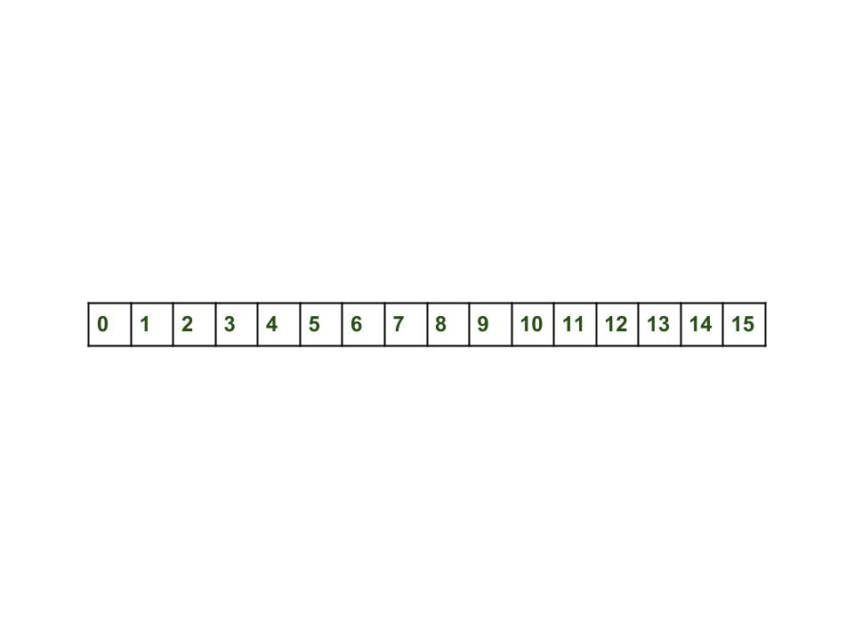](https://media.geeksforgeeks.org/wp-content/uploads/Hashmap_working.jpg)

* **Inserting Key-Value Pair:** Putting one key-value pair in the above HashMap

map.put(new Key("vishal"), 20);

* **Steps:**
  1. Calculate hash code of Key {“vishal”}. It will be generated as 118.
  2. Calculate index by using index method it will be 6.
  3. Create a node object as :

{

int hash = 118

// {"vishal"} is not a string but

// an object of class Key

Key key = {"vishal"}

Integer value = 20

Node next = null

}

1. Place this object at index 6, if no other object is presented there.

* **Inserting another Key-Value Pair:** Now, putting the other pair that is,

map.put(new Key("sachin"), 30);

* **Steps:**
  1. Calculate hashCode of Key {“sachin”}. It will be generated as 115.
  2. Calculate index by using index method it will be 3.
  3. Create a node object as :

{

int hash = 115

Key key = {"sachin"}

Integer value = 30

Node next = null

}

* **In Case of collision:** Now, putting another pair that is,

map.put(new Key("vaibhav"), 40);

* **Steps:**
  1. Calculate hash code of Key {“vaibhav”}. It will be generated as 118.
  2. Calculate index by using index method it will be 6.
  3. Create a node object as :

{

int hash = 118

Key key = {"vaibhav"}

Integer value = 40

Node next = null

}

1. Place this object at index 6 if no other object is presented there.
2. In this case, a node object is **found at index 6** – this is a case of collision.
3. In that case, check via the hashCode() and equals() method if both the keys are the same.
4. If keys are the same, replace the value with the current value.
5. Otherwise, connect this node object to the previous node object via linked list and both are stored at index 6.   
   Now HashMap becomes :

[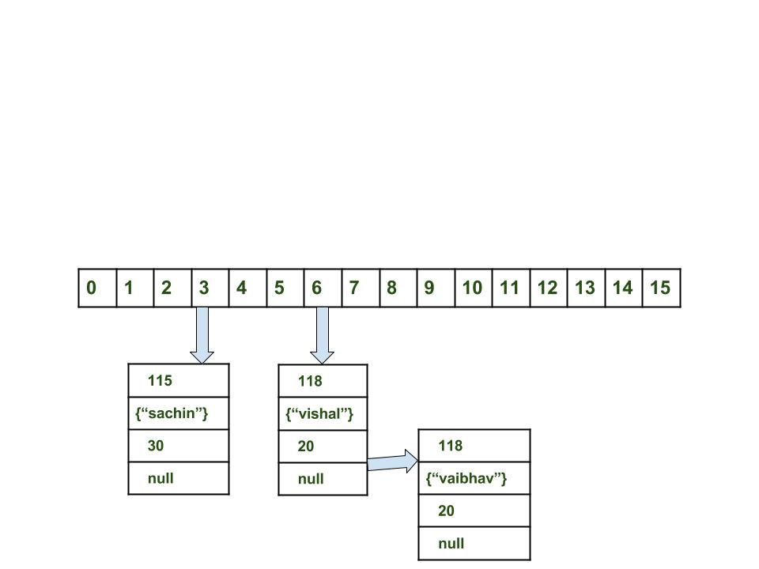](https://media.geeksforgeeks.org/wp-content/uploads/Hashmap_working_3.jpg)

**Using the get method()**

Now let’s try some get methods to get a value. get(K key) method is used to get a value by its key. If you don’t know the key then it is not possible to fetch a value.

* **Fetch the data for key sachin:**

map.get(new Key("sachin"));

* **Steps:**
  1. Calculate hash code of Key {“sachin”}. It will be generated as 115.
  2. Calculate index by using index method it will be 3.
  3. Go to index 3 of the array and compare the first element’s key with the given key. If both are equals then return the value, otherwise, check for the next element if it exists.
  4. In our case, it is found as the first element and the returned value is 30.
* Fetch the data for key vaibhav:

map.get(new Key("vaibhav"));

* **Steps:**
  1. Calculate hash code of Key {“vaibhav”}. It will be generated as 118.
  2. Calculate index by using index method it will be 6.
  3. Go to index 6 of the array and compare the first element’s key with the given key. If both are equals then return the value, otherwise, check for the next element if it exists.
  4. In our case, it is not found as the first element and the next node object is not null.
  5. If the next node is null then return null.
  6. If the next of node is not null traverse to the second element and repeat process 3 until the key is not found or next is not null.
  7. Time complexity is almost constant for the put and the get method until rehashing is not done.
  8. In case of collision, i.e. index of two or more nodes are the same, nodes are joined by a link list i.e. the second node is referenced by the first node and the third by the second, and so on.
  9. If the key given already exist in HashMap, the value is replaced with the new value.
  10. hash code of the null key is 0.
  11. When getting an object with its key, the linked list is traversed until the key matches or null is found on the next field.

Feeling lost in the world of random DSA topics, wasting time without progress? It's time for a change! Join our DSA course, where we'll guide you on an exciting journey to master DSA efficiently and on schedule.  
Ready to dive in? Explore our Free Demo Content and join our DSA course, trusted by over 100,000 geeks!

# Java - The TreeSet Class

TreeSet provides an implementation of the Set interface that uses a tree for storage. Objects are stored in a sorted and ascending order.

Access and retrieval times are quite fast, which makes TreeSet an excellent choice when storing large amounts of sorted information that must be found quickly.

Following is the list of the constructors supported by the TreeSet class.

|  |  |
| --- | --- |
| **Sr.No.** | **Constructor & Description** |
| 1 | **TreeSet( )**  This constructor constructs an empty tree set that will be sorted in an ascending order according to the natural order of its elements. |
| 2 | **TreeSet(Collection c)**  This constructor builds a tree set that contains the elements of the collection **c**. |
| 3 | **TreeSet(Comparator comp)**  This constructor constructs an empty tree set that will be sorted according to the given comparator. |
| 4 | **TreeSet(SortedSet ss)**  This constructor builds a TreeSet that contains the elements of the given SortedSet. |

Apart from the methods inherited from its parent classes, TreeSet defines the following methods −

|  |  |
| --- | --- |
| **Sr.No.** | **Method & Description** |
| 1 | **void add(Object o)**  Adds the specified element to this set if it is not already present. |
| 2 | **boolean addAll(Collection c)**  Adds all of the elements in the specified collection to this set. |
| 3 | **void clear()**  Removes all of the elements from this set. |
| 4 | **Object clone()**  Returns a shallow copy of this TreeSet instance. |
| 5 | **Comparator comparator()**  Returns the comparator used to order this sorted set, or null if this tree set uses its elements natural ordering. |
| 6 | **boolean contains(Object o)**  Returns true if this set contains the specified element. |
| 7 | **Object first()**  Returns the first (lowest) element currently in this sorted set. |
| 8 | **SortedSet headSet(Object toElement)**  Returns a view of the portion of this set whose elements are strictly less than toElement. |
| 9 | **boolean isEmpty()**  Returns true if this set contains no elements. |
| 10 | **Iterator iterator()**  Returns an iterator over the elements in this set. |
| 11 | **Object last()**  Returns the last (highest) element currently in this sorted set. |
| 12 | **boolean remove(Object o)**  Removes the specified element from this set if it is present. |
| 13 | **int size()**  Returns the number of elements in this set (its cardinality). |
| 14 | **SortedSet subSet(Object fromElement, Object toElement)**  Returns a view of the portion of this set whose elements range from fromElement, inclusive, to toElement, exclusive. |
| 15 | **SortedSet tailSet(Object fromElement)**  Returns a view of the portion of this set whose elements are greater than or equal to fromElement. |

## **Example**

The following program illustrates several of the methods supported by this collection −

[Live Demo](http://tpcg.io/lxgnjO)

import java.util.\*;

public class TreeSetDemo {

public static void main(String args[]) {

// Create a tree set

TreeSet ts = new TreeSet();

// Add elements to the tree set

ts.add("C");

ts.add("A");

ts.add("B");

ts.add("E");

ts.add("F");

ts.add("D");

System.out.println(ts);

}

}

This will produce the following result −

## **Output**

[A, B, C, D, E, F]

Internal working of Hashmap

in this article, we will see how the hashmap get and put method works internally. What operations are performed? How the hashing is done. How the value is fetched by key. How the key-value pair is stored.  
In the [previous article](https://www.geeksforgeeks.org/java-util-hashmap-in-java), HashMap contains an array of Node and Node can represent a class having the following objects :

1. int hash
2. K key
3. V value
4. Node next

Now we will see how this works. First, we will see the hashing process.

**Hashing**

Hashing is a process of converting an object into integer form by using the method hashCode(). It’s necessary to write the hashCode() method properly for better performance of HashMap. Here I am taking the key of my class so that I can override the hashCode() method to show different scenarios. My Key class is

//custom Key class to override hashCode()

// and equals() method

class Key

{

String key;

Key(String key)

{

this.key = key;

}

@Override

public int hashCode()

{

return (int)key.charAt(0);

}

@Override

public boolean equals(Object obj)

{

return key.equals((String)obj);

}

}

Here override hashCode() method returns the first character’s ASCII value as hash code. So whenever the first character of the key is same, the hash code will be the same. You should not approach these criteria in your program. It is just for demo purposes. As HashMap also allows a null key, so hash code of null will always be 0.

[**hashCode() method**](https://www.geeksforgeeks.org/equals-hashcode-methods-java/)**:**hashCode() method is used to get the hash code of an object. hashCode() method of the object class returns the memory reference of an object in integer form. Definition of hashCode() method is public native hashCode(). It indicates the implementation of hashCode() is native because there is not any direct method in java to fetch the reference of the object. It is possible to provide your implementation of hashCode().   
In HashMap, hashCode() is used to calculate the bucket and therefore calculate the index.

[**equals() method**](https://www.geeksforgeeks.org/equals-hashcode-methods-java/)**:**This method is used to check whether 2 objects are equal or not. This method is provided by the Object class. You can override this in your class to provide your implementation.   
HashMap uses equals() to compare the key to whether they are equal or not. If the equals() method return true, they are equal otherwise not equal.

**Buckets:**A bucket is an element of the HashMap array. It is used to store nodes. Two or more nodes can have the same bucket. In that case, a link list structure is used to connect the nodes. Buckets are different in capacity. A relation between bucket and capacity is as follows:

capacity = number of buckets \* load factor

A single bucket can have more than one node, it depends on the hashCode() method. The better your hashCode() method is, the better your buckets will be utilized.

**Index Calculation in Hashmap**

The Hash code of the key may be large enough to create an array. hash code generated may be in the range of integer and if we create arrays for such a range, then it will easily cause outOfMemoryException. So we generate an index to minimize the size of the array. The following operation is performed to calculate the index.

index = hashCode(key) & (n-1).

where n is the number of buckets or the size of the array. In our example, I will consider n as the default size which is 16.

**Why the above method is used to calculate the index**

Using a bitwise AND operator is similar to doing bit masking wherein only the lower bits of the hash integer is considered which in turn provides a very efficient method of calculating the modulus based on the length of the hashmap.

* **Initially Empty hashMap:** Here, the hashmap’s size is taken as 16.

HashMap map = new HashMap();

* HashMap :

[](https://media.geeksforgeeks.org/wp-content/uploads/Hashmap_working.jpg)

* **Inserting Key-Value Pair:** Putting one key-value pair in the above HashMap

map.put(new Key("vishal"), 20);

* **Steps:**
  1. Calculate hash code of Key {“vishal”}. It will be generated as 118.
  2. Calculate index by using index method it will be 6.
  3. Create a node object as :

{

int hash = 118

// {"vishal"} is not a string but

// an object of class Key

Key key = {"vishal"}

Integer value = 20

Node next = null

}

1. Place this object at index 6, if no other object is presented there.

* **Inserting another Key-Value Pair:** Now, putting the other pair that is,

map.put(new Key("sachin"), 30);

* **Steps:**
  1. Calculate hashCode of Key {“sachin”}. It will be generated as 115.
  2. Calculate index by using index method it will be 3.
  3. Create a node object as :

{

int hash = 115

Key key = {"sachin"}

Integer value = 30

Node next = null

}

* **In Case of collision:** Now, putting another pair that is,

map.put(new Key("vaibhav"), 40);

* **Steps:**
  1. Calculate hash code of Key {“vaibhav”}. It will be generated as 118.
  2. Calculate index by using index method it will be 6.
  3. Create a node object as :

{

int hash = 118

Key key = {"vaibhav"}

Integer value = 40

Node next = null

}

1. Place this object at index 6 if no other object is presented there.
2. In this case, a node object is **found at index 6** – this is a case of collision.
3. In that case, check via the hashCode() and equals() method if both the keys are the same.
4. If keys are the same, replace the value with the current value.
5. Otherwise, connect this node object to the previous node object via linked list and both are stored at index 6.   
   Now HashMap becomes :

[](https://media.geeksforgeeks.org/wp-content/uploads/Hashmap_working_3.jpg)

**Using the get method()**

Now let’s try some get methods to get a value. get(K key) method is used to get a value by its key. If you don’t know the key then it is not possible to fetch a value.

* **Fetch the data for key sachin:**

map.get(new Key("sachin"));

* **Steps:**
  1. Calculate hash code of Key {“sachin”}. It will be generated as 115.
  2. Calculate index by using index method it will be 3.
  3. Go to index 3 of the array and compare the first element’s key with the given key. If both are equals then return the value, otherwise, check for the next element if it exists.
  4. In our case, it is found as the first element and the returned value is 30.
* Fetch the data for key vaibhav:

map.get(new Key("vaibhav"));

* **Steps:**
  1. Calculate hash code of Key {“vaibhav”}. It will be generated as 118.
  2. Calculate index by using index method it will be 6.
  3. Go to index 6 of the array and compare the first element’s key with the given key. If both are equals then return the value, otherwise, check for the next element if it exists.
  4. In our case, it is not found as the first element and the next node object is not null.
  5. If the next node is null then return null.
  6. If the next of node is not null traverse to the second element and repeat process 3 until the key is not found or next is not null.
  7. Time complexity is almost constant for the put and the get method until rehashing is not done.
  8. In case of collision, i.e. index of two or more nodes are the same, nodes are joined by a link list i.e. the second node is referenced by the first node and the third by the second, and so on.
  9. If the key given already exist in HashMap, the value is replaced with the new value.
  10. hash code of the null key is 0.
  11. When getting an object with its key, the linked list is traversed until the key matches or null is found on the next field.

Feeling lost in the world of random DSA topics, wasting time without progress? It's time for a change! Join our DSA course, where we'll guide you on an exciting journey to master DSA efficiently and on schedule.  
Ready to dive in? Explore our Free Demo Content and join our DSA course, trusted by over 100,000 geeks!

ConcurrentHashmap and synchronizedMap difference

To provide thread-safety, synchronizedMap() allows all accesses to the backing Map via the returned Map. ConcurrentHashMap was introduced in JDK 1.5 as an enhancement of HashMap that supports high concurrency for retrievals as well as updates

The ConcurrentHashMap and SynchronizedHashMap both are the Collection classes which are thread-safe and can be used in multithreaded and concurrent java application. But there are few differences that exists between them. In this article, we have tried to cover all these differences between them.

**1.**[**ConcurrentHashMap**](https://www.geeksforgeeks.org/concurrenthashmap-in-java/)**:**ConcurrentHashMap is a class which implements the ConcurrentMap interface. It uses [Hashtable](https://www.geeksforgeeks.org/hashtable-in-java/), underlined data structure. As we know, while dealing with thread in our application [HashMap](https://www.geeksforgeeks.org/java-util-hashmap-in-java-with-examples/) is not a good choice because of the performance issue. To resolve this issue, we use ConcurrentHashMap in our application.  ConcurrentHashMap is thread-safe therefore multiple threads can operate on a single object without any problem. In ConcurrentHashMap, the Object is divided into a number of segments according to the concurrency level. By default, it allows 16 thread to read and write from the [Map](https://www.geeksforgeeks.org/map-interface-java-examples/) without any synchronization. In ConcurrentHashMap, at a time any number of threads can perform retrieval operation but for updating in the object, the thread must lock the particular segment in which the thread wants to operate. This type of locking mechanism is known as **Segment locking or bucket locking**. Hence, at a time16 update operations can be performed by threads.

**ConcurrentHashMap Demo:**

* Java

|  |
| --- |
| // Java Program to demonstrate the  // working of ConcurrentHashMap    **import** java.util.\*;  **import** java.util.concurrent.\*;    **public** **class** TraversingConcurrentHashMap {    **public** **static** **void** main(String[] args)      {            // create an instance of ConcurrentHashMap          ConcurrentHashMap<Integer, String> chmap              = **new** ConcurrentHashMap<Integer, String>();            // Add elements using put()          chmap.put(10, "Geeks");          chmap.put(20, "for");          chmap.put(30, "Geeks");          chmap.put(40, "Welcome");          chmap.put(50, "you");            // Create an Iterator over the          // ConcurrentHashMap          Iterator<ConcurrentHashMap.Entry<Integer, String> >              itr = chmap.entrySet().iterator();            // The hasNext() method is used to check if there is          // a next element and the next() method is used to          // retrieve the next element  **while** (itr.hasNext()) {              ConcurrentHashMap.Entry<Integer, String> entry                  = itr.next();              System.out.println("Key = " + entry.getKey()                                 + ", Value = "                                 + entry.getValue());          }      }  } |

**Output**

Key = 50, Value = you

Key = 20, Value = for

Key = 40, Value = Welcome

Key = 10, Value = Geeks

Key = 30, Value = Geeks

**2. Synchronized HashMap:**Java HashMap is a non-synchronized collection class. If we need to perform thread-safe operations on it then we must need to synchronize it explicitly. The [synchronizedMap()](https://www.geeksforgeeks.org/collections-synchronizedmap-method-in-java-with-examples/) method of [java.util.Collections](https://www.geeksforgeeks.org/collections-class-in-java/) class is used to synchronize it. It returns a synchronized (thread-safe) map backed by the specified map.

**Synchronized HashMap Demo:**

* Java

|  |
| --- |
| // Java program to demonstrate the  // working of Synchronized HashMap    **import** java.util.Collections;  **import** java.util.HashMap;  **import** java.util.Iterator;  **import** java.util.Map;  **import** java.util.Set;    **public** **class** SynchronizedHashMap {  **public** **static** **void** main(String args[])      {            // Creating a HashMap          HashMap<Integer, String> hmap              = **new** HashMap<Integer, String>();            // Adding the elements using put method          hmap.put(10, "Geeks");          hmap.put(20, "for");          hmap.put(30, "Geeks");          hmap.put(25, "Welcome");          hmap.put(40, "you");            // Creating a synchronized map          Map map = Collections.synchronizedMap(hmap);          Set set = map.entrySet();            // Synchronize on HashMap, not on set  **synchronized** (map)          {              Iterator i = set.iterator();              // Printing the elements  **while** (i.hasNext()) {                  Map.Entry me = (Map.Entry)i.next();                  System.out.print(me.getKey() + ": ");                  System.out.println(me.getValue());              }          }      }  } |

**Output**

20: for

40: you

25: Welcome

10: Geeks

30: Geeks

**Difference between ConcurrentHashMap and Synchronized HashMap:**

|  |  |
| --- | --- |
| ConcurrentHashMap | Synchronized HashMap |
| ConcurrentHashMap is a class that implements the ConcurrentMap and [serializable](https://www.geeksforgeeks.org/serializable-interface-in-java/) interface. | We can synchronize the HashMap by using the **synchronizedMap()**method of java.util.Collections class. |
| It locks some portion of the map. | It locks the whole map. |
| ConcurrentHashMap allows performing concurrent read and write operation. Hence, performance is relatively better than the Synchronized Map. | In Synchronized HashMap, multiple threads can not access the map concurrently. Hence, the performance is relatively less than the ConcurrentHashMap. |
| ConcuurentHashMap doesn’t allow inserting null as a key or value. | Synchronized HashMap allows inserting null as a key. |
| ConccurentHashMap doesn’t throw ConcurrentModificationException. | Synchronized HashMap throw **ConcurrentModificationException**. |

Internal working of HashSet? -> It follows HashMap. What is the key of HashSet?

HashSet is backed by a HashMap internally, but the element you are adding to the HashSet is used as the key in the backing HashMap . For the value, a dummy value is used. Therefore the HashSet 's contains(element) simply calls the backing HashMap 's containsKey(element) .

As we know that a set is a **well-defined** collection of distinct objects. Each member of a set is called an element of the set. So in other words, we can say that a **set will never contain duplicate elements**. But how in java [Set](https://www.geeksforgeeks.org/set-in-java/) interface implemented classes like [HashSet](https://www.geeksforgeeks.org/hashset-in-java/), [LinkedHashSet](https://www.geeksforgeeks.org/linkedhashset-class-in-java-with-examples/), [TreeSet](https://www.geeksforgeeks.org/treeset-class-java-examples/) etc. achieve this uniqueness. In this post, we will discuss the hidden truth behind this uniqueness.

**How HashSet works internally in Java?**

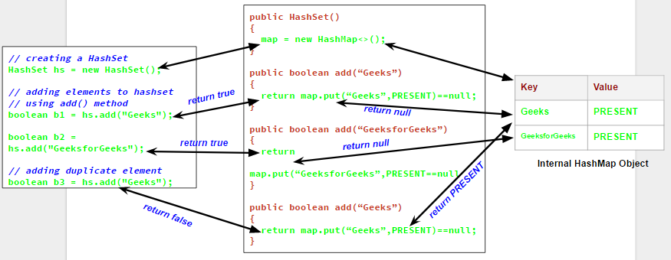  
We will understand this with an example.Let us see the output of the following program which try to add duplicate elements in a HashSet.

|  |
| --- |
| // Java program to demonstrate  // internal working of HashSet    **import** java.util.HashSet;    **class** Test  {  **public** **static** **void** main(String args[])      {          // creating a HashSet          HashSet hs = **new** HashSet();            // adding elements to hashset          // using add() method  **boolean** b1 = hs.add("Geeks");  **boolean** b2 = hs.add("GeeksforGeeks");            // adding duplicate element  **boolean** b3 = hs.add("Geeks");            // printing b1, b2, b3          System.out.println("b1 = "+b1);          System.out.println("b2 = "+b2);          System.out.println("b3 = "+b3);            // printing all elements of hashset          System.out.println(hs);        }  } |

Output:

b1 = true

b2 = true

b3 = false

[GeeksforGeeks, Geeks]

Now from the output, it is clear that when we try to add a duplicate element to a set using add() method, it returns false, and element is not added to hashset, as it is already present. Now the question comes, how add() method checks whether the set already contains the specified element or not. It will be more clear if we have a closer look on the add() method and default constructor in HashSet class.

// predefined HashSet class

public class HashSet

{

// A HashMap object

private transient HashMap map;

// A Dummy value(PRESENT) to associate with an Object in the Map

private static final Object PRESENT = new Object();

// default constructor of HashSet class

// It creates a HashMap by calling

// default constructor of HashMap class

public HashSet() {

map = new HashMap<>();

}

// add method

// it calls put() method on map object

// and then compares it's return value with null

public boolean add(E e) {

return map.put(e, PRESENT)==null;

}

// Other methods in Hash Set

}

Now as you can see that whenever we create a HashSet, it internally creates a [HashMap](https://www.geeksforgeeks.org/java-util-hashmap-in-java/) and if we insert an element into this HashSet using add() method, it actually call put() method on internally created HashMap object with element you have specified as it’s key and constant Object called **“PRESENT”** as it’s value. So we can say that **a Set achieves uniqueness internally through HashMap**. Now the whole story comes around [how a HashMap and put() method internally works](https://www.geeksforgeeks.org/internal-working-of-hashmap-java/).

As we know in a [HashMap](https://www.geeksforgeeks.org/java-util-hashmap-in-java/) each key is unique and when we call put(Key, Value) method, it returns the previous value associated with key, or null if there was no mapping for key. So in add() method we check the return value of map.put(key, value) method with null value.

1. If map.put(key, value) returns null, then the statement “map.put(e, PRESENT) == null” will return true and element is added to the HashSet(internally HashMap).
2. If map.put(key, value) returns old value of the key, then the statement “map.put(e, PRESENT) == null” will return false and element is not added to the HashSet(internally HashMap).

As LinkedHashSet extends HashSet, so it internally calls constructors of HashSet using [super()](https://www.geeksforgeeks.org/super-keyword/). Similarly creating an object of [TreeSet](https://www.geeksforgeeks.org/treeset-class-java-examples/) class internally creates object of [Navigable Map](https://www.geeksforgeeks.org/navigablemap-interface-in-java-with-example/)as backing map.

Why we use hashing in Hashmap

HashMap uses multiple buckets and each bucket points to a Singly Linked List where the entries (nodes) are stored. Once the bucket is identified by the hash function using hashcode, then hashCode is used to check if there is already a key with the same hashCode or not in the bucket(singly linked list).

HashMap vs ConcurrentHashMap

HashMap isn't thread-safe at all. Thus, it is non-synchronized in nature. The ConcurrentHashMap, on the other hand, is thread-safe. Due to non-synchronization, the performance of HashMap is relatively higher, and various threads are capable of performing simultaneously.

Why we use stack in question 1

A Stack can be used for evaluating expressions consisting of operands and operators. Stacks can be used for Backtracking, i.e., to check parenthesis matching in an expression. It can also be used to convert one form of expression to another form. It can be used for systematic Memory Management.

Concurrent HashMap VS Synchronised Hash Map : How they work internally

synchronizedMap() requires each thread to acquire a lock on the entire object for both read/write operations. By comparison, the ConcurrentHashMap allows threads to acquire locks on separate segments of the collection, and make modifications at the same time.

Hashmap vs HashTable, which is faster and why

HashMap is not synchronized, therefore it's faster and uses less memory than Hashtable. Generally, unsynchronized objects are faster than synchronized ones in a single threaded application.

[HashMap](https://www.geeksforgeeks.org/java-util-hashmap-in-java-with-examples/) and [Hashtable](https://www.geeksforgeeks.org/hashtable-in-java/) store key and value pairs in a hash table. When using a Hashtable or HashMap, we specify an object that is used as a key and the value that you want to be linked to that key. The key is then hashed, and the resulting hash code is used as the index at which the value is stored within the table. Now let us discuss with the help of an example.

**Hashmap vs Hashtable**

* HashMap is non-synchronized. It is not thread-safe and can’t be shared between many threads without proper synchronization code whereas Hashtable is synchronized. It is thread-safe and can be shared with many threads.
* HashMap allows one null key and multiple null values whereas Hashtable doesn’t allow any null key or value.
* HashMap is generally preferred over HashTable if thread synchronization is not needed.

### Difference Between Hashmap and Hashtable

| **S. No.** | **Hashmap** | **Hashtable** |
| --- | --- | --- |
| 1. | No method is synchronized. | Every method is synchronized. |
| 2. | Multiple threads can operate simultaneously and hence hashmap’s object is not thread-safe. | At a time only one thread is allowed to operate the Hashtable’s object. Hence it is thread-safe. |
| 3. | Threads are not required to wait and hence relatively performance is high. | It increases the waiting time of the thread and hence performance is low. |
| 4. | Null is allowed for both key and value. | Null is not allowed for both key and value. Otherwise, we will get a null pointer exception. |
| 5. | It is introduced in the 1.2 version. | It is introduced in the 1.0 version. |
| 6. | It is non-legacy. | It is a legacy. |

Now you must be wondering **why HashTable doesn’t allow null and HashMap do**?

The **answer**is simple. In order to successfully store and retrieve objects from a HashTable, the objects used as keys must implement the hashCode method and the equals method. Since null is not an object, it can’t implement these methods. HashMap is an advanced version and improvement on the Hashtable. HashMap was created later.

**Example:**

## Java

|  |
| --- |
| // Java program to demonstrate  // HashMap and HashTable  **import** java.util.\*;  **import** java.lang.\*;  **import** java.io.\*;    // Name of the class has to be "Main"  // only if the class is public  **class** Ideone  {  **public** **static** **void** main(String args[])      {          //----------hashtable -------------------------          Hashtable<Integer,String> ht=**new** Hashtable<Integer,String>();          ht.put(101," ajay");          ht.put(101,"Vijay");          ht.put(102,"Ravi");          ht.put(103,"Rahul");          System.out.println("-------------Hash table--------------");  **for** (Map.Entry m:ht.entrySet()) {              System.out.println(m.getKey()+" "+m.getValue());          }            //----------------hashmap--------------------------------          HashMap<Integer,String> hm=**new** HashMap<Integer,String>();          hm.put(100,"Amit");          hm.put(104,"Amit");          hm.put(101,"Vijay");          hm.put(102,"Rahul");          System.out.println("-----------Hash map-----------");  **for** (Map.Entry m:hm.entrySet()) {              System.out.println(m.getKey()+" "+m.getValue());          }      }  } |

**Output**

-------------Hash table--------------

103 Rahul

102 Ravi

101 Vijay

-----------Hash map-----------

100 Amit

101 Vijay

102 Rahul

104 Amit

This article is compiled by **Aditya Goel**. Please write comments if you find anything incorrect, or you want to share more information about the topic discussed above.

5.what are the data structures is used in java

What are Data Structures in Java? Data Structure in java is defined as the collection of data pieces that offers an effective means of storing and organising data in a computer. Linked List, Stack, Queue, and arrays are a few examples of java data structures.

6.difference bewteen treemap and hashmap

TreeMap implements NavigableMap, Cloneable, and Serializable interface. HashMap allows a single null key and multiple null values. TreeMap does not allow null keys but can have multiple null values. HashMap allows heterogeneous elements because it does not perform sorting on keys.

when to use linkedhashmap and when to use hashmap ?

As we have discussed, both HashMap and LinkedHashMap data structures; both are powerful data structure. The HashMap is useful for the general-purpose hashing based collection, and the LinkedHashmap is useful for managing the chaotic ordering of the elements.

# **LinkedHashMap vs HashMap**

The LinkedHashMap is quite similar to HashMap, with an additional feature of maintaining the order of the inserted element. HashMap provides an easy way to insert, delete, and search the elements, but it does not provide any way to maintain and track the order of the inserted elements. Here, LinkedHashmap came into the picture, which overcomes this issue.

HashMap is a powerful data structure in [Java](https://www.javatpoint.com/java-tutorial) used to store the key-pair values. It maps a value by its associated key. It allows us to store the null values and null keys. It is a non-synchronized class of Java collection. Whereas the LinkedHashMap is an alternative to HashMap that has the support of maintaining the order of the elements.

The [LinkedHashMap](https://www.javatpoint.com/java-linkedhashmap) inherits the [HashMap class](https://www.javatpoint.com/java-hashmap) and implements the Map interface of the [Java Collection frameworks](https://www.javatpoint.com/collections-in-java).

## **HashMap**

HashMap in Java is a powerful data structure that allows us to store the key-pair values. It allows us to store the null value objects. We can not insert the duplicate key; if we try, it will replace that element corresponding to the respected key. We can easily perform operations such as updation, deletion, etc., on the objects. The HashMap class can be found in java.util package.

**Declaration:**

The HashMap class is declared as follows:

1. **public** **class** HashMap<K,V> **extends** AbstractMap<K,V> **implements** Map<K,V>,
2. Cloneable, Serializable

Some key points about HashMap are as following:

* It contains key-pair values.
* It can not have duplicate keys.
* It may have one null key and multiple null values.
* It is non-synchronized.
* It does not provide a way to maintain the order of elements.
* The default capacity of the Java HashMap class is 16 with a load factor of 0.75.

**Example:**

Consider the below example to implement the HashMap and store the key-pair values:

1. //Java program to store the key-pair values using HashMap
2. **import** java.util.\*;
3. **public** **class** HashMapDemo {
4. **public** **static** **void** main(String args[]){
5. //HashMap implementation
6. HashMap<Integer,String> m=**new** HashMap<Integer,String>();
7. m.put(1,"Chris");  //Adding elements in Map
8. m.put(2,"Morris");
9. m.put(3,"Sam");
10. m.put(4,"Cruise");
11. System.out.println("Iterating Hashmap...");
12. **for**(Map.Entry me : m.entrySet()){
13. System.out.println(me.getKey()+" "+me.getValue());
14. }
15. }
16. }

**Output:**

Iterating Hashmap...

1 Chris

2 Morris

3 Sam

4 Cruise

## **LinkedHashMap**

The LinkedHashMap class is an alternative to the HashMap class. It is quite similar to the HashMap class. As it inherits the HashMap class, so it holds all the properties and methods of the HashMap class. Additionally. It provides an easy way to maintain the order of the elements. The LinkedHashMap inherits the HashMap class and implements the Map interface.

**Declaration:**

The LinkedHashMap class is declared as follows:

1. **public** **class** LinkedHashMap<K,V> **extends** HashMap<K,V> **implements** Map<K,V>

Some key points about the LinkedHashMap are as following:

* It stores the values in the key-pair combination.
* It can not have duplicate elements.
* It may have one null key and multiple null values.
* It is non synchronized.
* It provides an easy way to maintain the insertion order

**Example:**

Consider the below example to implement the LinkedHashMap and store vlaues in it:

1. // Java Program to Implement the LinkedHashMap and add elements in it
2. **import** java.util.\*;
3. **public** **class** LinkedHashMapDemo {
4. **public** **static** **void** main(String args[]){
5. //Implementation of the LinkedHashMap
6. LinkedHashMap<Integer,String> l=**new** LinkedHashMap<Integer,String>();
7. l.put(100,"John");  // Adding Elements
8. l.put(101,"Dev");
9. l.put(102,"Arya");
10. l.put(103,"Zoya");
11. **for**(Map.Entry m:l.entrySet()){
12. System.out.println(m.getKey()+" "+m.getValue());
13. }
14. }
15. }

**Output:**

100 John

101 Dev

102 Arya

103 Zoya

### Difference Between LinkedHashMap and HashMap

The LinkedHashMap is an alternative to HashMap with some additional features. The following are some major differences between LinkedHashMap and HashMap:

* The Major Difference between the HashMap and LinkedHashMap is the ordering of the elements. The LinkedHashMap provides a way to order and trace the elements. Comparatively, the HashMap does not support the ordering of the elements. In LinkedHashMap, if we iterate an element, we will get a key in the order in which the elements were inserted.
* The HashMap and LinkedHashMap both allow only one null key and multiple values.
* The HashMap extends AbstractMap class and implements Map interface, whereas the LinkedHashMap extends HashMap class and implements Map interface.
* Both LinkedHashMap and HashMap are non-synchronized, but they can be synchronized using the Collections.synchronizedMap() method.
* The HashMap uses a bucket to store the elements, which is an index of the array like bucket0 means index[0], bucket1 means index[1], and so on, of the array. Whereas the LinkedHashMap uses the same internal implementation as HashMap but, Apart from that, it also uses a doubly-linked through all of its entries. This linked list is useful for ordering the elements.
* The HashMap requires low memory than LinkedHashMap; because the LinkedHashMap uses the same implementation process as HashMap; additionally, it uses a doubly LinkedList to maintain the order of the elements.
* Both the LinkedHashMap and HashMap provides similar performance.

## **Comparison Table of LinkedHashMap and HashMap**

Consider the below comparison table of HashMap and LinkedHashMap:

|  |  |  |
| --- | --- | --- |
| **Property** | **HashMap** | **LinkedHashMap** |
| Order of Iteration | No guarantee order | Insertion order |
| Implements (Interface) | Map | Map |
| Null key/values | Only one null key & multiple values | Only one null key & multiple values |
| Implementation | Buckets | Double-linked buckets |
| Synchronized | Non-synchronized | non-synchronized |
| Performance | Fast | Almost Similar to HashMap |
| Extends | AbstractMap class | HashMap class |
| Memory | Low Memory | More memory as compared to HashMap. |
| Thread-safety | Non-thread-safe | Non-thread-safe |

**Summary:**

As we have discussed, both HashMap and LinkedHashMap data structures; both are powerful data structure. The HashMap is useful for the general-purpose hashing based collection, and the LinkedHashmap is useful for managing the chaotic ordering of the elements.

which two data structures are used in hashMap class.

HashMap contains an array of the nodes, and the node is represented as a class. It uses an array and LinkedList data structure internally for storing Key and Value.

## **What is Hashing**

It is the process of converting an object into an integer value. The integer value helps in indexing and faster searches.

## **What is HashMap**

HashMap is a part of the Java collection framework. It uses a technique called Hashing. It implements the map interface. It stores the data in the pair of Key and Value. HashMap contains an array of the nodes, and the node is represented as a class. It uses an array and LinkedList data structure internally for storing Key and Value. There are four fields in HashMap.

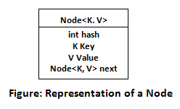

Before understanding the internal working of HashMap, you must be aware of hashCode() and equals() method.

* **equals():** It checks the equality of two objects. It compares the Key, whether they are equal or not. It is a method of the Object class. It can be overridden. If you override the equals() method, then it is mandatory to override the hashCode() method.
* **hashCode():** This is the method of the object class. It returns the memory reference of the object in integer form. The value received from the method is used as the bucket number. The bucket number is the address of the element inside the map. Hash code of null Key is 0.
* **Buckets:** Array of the node is called buckets. Each node has a data structure like a LinkedList. More than one node can share the same bucket. It may be different in capacity.

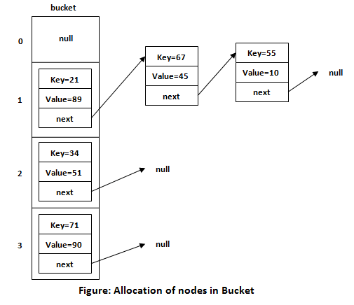

## **Insert Key, Value pair in HashMap**

We use put() method to insert the Key and Value pair in the HashMap. The default size of HashMap is 16 (0 to 15).

### Example

In the following example, we want to insert three (Key, Value) pair in the HashMap.

1. HashMap<String, Integer> map = **new** HashMap<>();
2. map.put("Aman", 19);
3. map.put("Sunny", 29);
4. map.put("Ritesh", 39);

Let's see at which index the Key, value pair will be saved into HashMap. When we call the put() method, then it calculates the hash code of the Key "Aman." Suppose the hash code of "Aman" is 2657860. To store the Key in memory, we have to calculate the index.

### Calculating Index

Index minimizes the size of the array. The Formula for calculating the index is:

1. Index = hashcode(Key) & (n-1)

Where n is the size of the array. Hence the index value for "Aman" is:

1. Index = 2657860 & (16-1) = 4

The value 4 is the computed index value where the Key and value will store in HashMap.

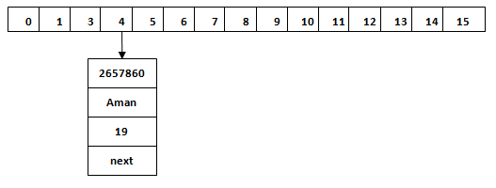

## **Hash Collision**

This is the case when the calculated index value is the same for two or more Keys. Let's calculate the hash code for another Key "Sunny." Suppose the hash code for "Sunny" is 63281940. To store the Key in the memory, we have to calculate index by using the index formula.

1. Index=63281940 & (16-1) = 4

The value 4 is the computed index value where the Key will be stored in HashMap. In this case, equals() method check that both Keys are equal or not. If Keys are same, replace the value with the current value. Otherwise, connect this node object to the existing node object through the LinkedList. Hence both Keys will be stored at index 4.

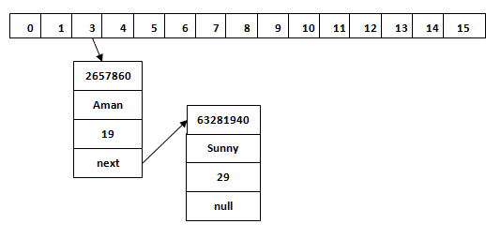

Similarly, we will store the Key "Ritesh." Suppose hash code for the Key is 2349873. The index value will be 1. Hence this Key will be stored at index 1.

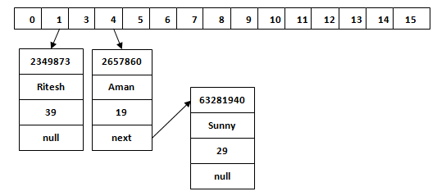

## **get() method in HashMap**

get() method is used to get the value by its Key. It will not fetch the value if you don't know the Key. When get(K Key) method is called, it calculates the hash code of the Key.

Suppose we have to fetch the Key "Aman." The following method will be called.

1. map.get(**new** Key("Aman"));

It generates the hash code as 2657860. Now calculate the index value of 2657860 by using index formula. The index value will be 4, as we have calculated above. get() method search for the index value 4. It compares the first element Key with the given Key. If both keys are equal, then it returns the value else check for the next element in the node if it exists. In our scenario, it is found as the first element of the node and return the value 19.

Let's fetch another Key "Sunny."

The hash code of the Key "Sunny" is 63281940. The calculated index value of 63281940 is 4, as we have calculated for put() method. Go to index 4 of the array and compare the first element's Key with the given Key. It also compares Keys. In our scenario, the given Key is the second element, and the next of the node is null. It compares the second element Key with the specified Key and returns the value 29. It returns null if the next of the node is null.

Two ways of implementing multithreading? Which one to prefer? Detailed ques. on this.

You can implement the Callable interface to any of your class that you want to get executed per thread. Callable interface is a part of Java concurrency API, and a new way to create threads. So each instance of the class implementing Callable interface that you create will be an independent thread, thereby enabling multi-threading in your application. Callable interface enables you to throw exceptions and return values from threads via the class implementing them, which is an advantage over the Runnable interface.

Next, you can create an instance of an ExecutorService which is also a part of the Java concurrency API and acts as a thread pool for managing multi-threading or concurrent threads to be in line with the Java concurrency API terminology. You can create ExecutorService instances (thread pool) to support N number of threads. It has various signatures for creating thread pools.

Once you create the thread pool for your threads, next comes the job of creating and assigning the threads to the ExecutorService instance (thread pool). You create instances of the class implementing the Callable interface that you want to run in a thread and submit it to the ExecutorService instance. You will be returned a Future<T> instance for each such thread submission to the ExecutorService instance. The type of Future instance will be akin to the return type from your thread class implementing the Callable interface. Each submitted thread will provide it’s own Future<T> instance that you need to collect into a list or a single variable depending on the number of threads you want.

These future instances from the list or variable will have to be accessed again to actually start the thread execution asynchronously. The Future<T> instance has a method called get() which will actually start the thread execution, similar to a Runnable’s start() method. The return type from Future<T> instance’s get() method will actually return the value expected from the thread post it’s execution. It will also throw any exceptions from the thread, both runtime and checked.

Ina nutshell, you create threads from classes implementing Callable. Create an ExecutorService which acts as a thread pool for managing the multi-threaded executions which is handled by Java itself. Submit the threads to the ExecutorService instance and get a reference for the execution of the thread which has to be collected and executed separately from the creation to have the threads run concurrently in asynchronous mode and get back the result from each thread.

executer framework

With the increase in the number of cores available in the processors nowadays, coupled with the ever-increasing need to achieve more throughput, multi-threading APIs are getting quite popular. Java provides its own multi-threading framework called the Java Executor Framework.

Java executor framework ([java.util.concurrent.Executor](https://www.geeksforgeeks.org/java-util-concurrent-executor-interface-with-examples/)), released with the JDK 5 is used to run the Runnable objects without creating new threads every time and mostly re-using the already created threads. We all know that there are two ways to create a thread in Java. If you want to read more about their comparison, read [how to create threads in Java.](https://www.geeksforgeeks.org/multithreading-in-java/)

The[java.util.concurrent.Executors](https://www.geeksforgeeks.org/java-util-concurrent-executor-interface-with-examples/) provide factory methods that are being used to create [ThreadPools](https://www.geeksforgeeks.org/thread-pools-java/) of worker threads. Thread pools overcome this issue by keeping the threads alive and reusing the threads. Any excess tasks flowing in, that the threads in the pool can’t handle are held in a Queue. Once any of the threads get free, they pick up the next task from this queue. This task queue is essentially unbounded for the out-of-box executors provided by the JDK.

**Some types of Java Executors are listed below:**

1. SingleThreadExecutor
2. FixedThreadPool(n)+
3. CachedThreadPool
4. ScheduledExecutor

Let us discuss these popular java executors to some details what exactly they do to get a better idea prior to implementing the same.

**Executor 1:** SingleThreadExecutor

A thread pool of single thread can be obtained by calling the static [newSingleThreadExecutor()](https://www.geeksforgeeks.org/difference-between-executorservice-execute-and-submit-method-in-java/) method of the Executors class. It is used to execute tasks sequentially.

**Syntax:**

ExecutorService executor = Executors.newSingleThreadExecutor();

**Executor 2:** FixedThreadPool(n)

As the name indicates, it is a thread pool of a fixed number of threads. The tasks submitted to the executor are executed by the n threads and if there is more task they are stored on a LinkedBlockingQueue. It uses Blocking Queue.

**Syntax:**

ExecutorService fixedPool = Executors.newFixedThreadPool(2);

**Executor 3:** CachedThreadPool

Creates a thread pool that creates new threads as needed, but will reuse previously constructed threads when they are available. Calls to execute will reuse previously constructed threads if available. If no existing thread is available, a new thread will be created and added to the pool. It uses a [SynchronousQueue](https://www.geeksforgeeks.org/java-program-to-implement-synchronousqueue-api/) queue.

ExecutorService executorService = Executors.newCachedThreadPool();

**Executor 4:**ScheduledExecutor

Scheduled executors are based on the interface [ScheduledExecutorService](https://www.geeksforgeeks.org/scheduledexecutorservice-interface-in-java/) which extends the [ExecutorService interface](https://www.geeksforgeeks.org/java-util-concurrent-executorservice-interface-with-examples/). This executor is used when we have a task that needs to be run at regular intervals or if we wish to delay a certain task.

ScheduledExecutorService scheduledExecService = Executors.newScheduledThreadPool(1);

* The tasks can be scheduled using either of the two methods:
  + **scheduleAtFixedRate**: Executes the task with a fixed interval, irrespective of when the previous task ended.
  + **scheduleWithFixedDelay**: This will start the delay countdown only after the current task completes.`

**Syntax:**

scheduledExecService.scheduleAtFixedRate  
(Runnable command, long initialDelay, long period, TimeUnit unit)

[*Future Object*](https://www.geeksforgeeks.org/future-and-futuretask-in-java/)

*The result of the task submitted for execution to an executor can be accessed using the java.util.concurrent.The future object returned by the executor. Future can be thought of as a promise made to the caller by the executor. The future interface is mainly used to get the results of Callable results. whenever the task execution is completed, it is set in this Future object by the executor.*

**Syntax:**

Future<String> result = executorService.submit(callableTask);

**Implementation:** Creating and Executing a Simple Executor in which we will create a task and execute it in a fixed pool

* The Task class implements Callable and is parameterized to String type. It is also declared to throw Exception.
* Now in order to execute task in class “Task” we have to instantiate the Task class and are passing it to the executor for execution.
* Print and display the result that is returned by the Future object

**Example**

* Java

|  |
| --- |
| // Java Program demonstrating Introduction to Java Executor  // Framework    // Importing concurrent classes from java.util package  **import** java.util.concurrent.\*;    // Class 1  // Helper Class implementing runnable interface Callable  **class** Task **implements** Callable<String> {      // Member variable of this class  **private** String message;        // Constructor of this class  **public** Task(String message)      {          // This keyword refers to current instance itself  **this**.message = message;      }        // Method of this Class  **public** String call() **throws** Exception      {  **return** "Hiiii " + message + "!";      }  }  // Class 2  // Main Class  // ExecutorExample  **public** **class** GFG {        // Main driver method  **public** **static** **void** main(String[] args)      {            // Creating an object of above class          // in the main() method          Task task = **new** Task("GeeksForGeeks");            // Creating object of ExecutorService class and          // Future object Class          ExecutorService executorService              = Executors.newFixedThreadPool(4);          Future<String> result              = executorService.submit(task);            // Try block to check for exceptions  **try** {              System.out.println(result.get());          }            // Catch block to handle the exception  **catch** (InterruptedException                 | ExecutionException e) {                // Display message only              System.out.println(                  "Error occurred while executing the submitted task");                // Print the line number where exception occurred              e.printStackTrace();          }            // Cleaning resource and shutting down JVM by          // saving JVM state using shutdown() method          executorService.shutdown();      }  } |

**Output:**

Hiiii GeeksForGeeks

***Conclusion:***

*Multi-threading is getting increasingly mainstream as the processor clock-speed is difficult to increase. However, handling the lifecycle of each thread is very difficult due to the complexity involved.*

Multi threading basics- ways to create Thread in Java

**How to Create a Java Thread**

1. public void run( )
2. public class MyClass implements Runnable { public void run(){ System. out. println("MyClass running"); ...
3. Thread t1 = new Thread(new MyClass ()); t1. start();
4. public class MyClass extends Thread { public void run(){ System. out. ...
5. MyClass t1 = new MyClass (); T1. start();

Multithreading is a Java feature that allows concurrent execution of two or more parts of a program for maximum utilization of CPU. Each part of such program is called a thread. So, threads are light-weight processes within a process.

Threads can be created by using two mechanisms :

1. Extending the Thread class
2. Implementing the Runnable Interface

**Thread creation by extending the Thread class**  
We create a class that extends the **java.lang.Thread** class. This class overrides the run() method available in the Thread class. A thread begins its life inside run() method. We create an object of our new class and call start() method to start the execution of a thread. Start() invokes the run() method on the Thread object.

* Java

|  |
| --- |
| // Java code for thread creation by extending  // the Thread class  **class** MultithreadingDemo **extends** Thread {  **public** **void** run()      {  **try** {              // Displaying the thread that is running              System.out.println(                  "Thread " + Thread.currentThread().getId()                  + " is running");          }  **catch** (Exception e) {              // Throwing an exception              System.out.println("Exception is caught");          }      }  }    // Main Class  **public** **class** Multithread {  **public** **static** **void** main(String[] args)      {  **int** n = 8; // Number of threads  **for** (**int** i = 0; i < n; i++) {              MultithreadingDemo object                  = **new** MultithreadingDemo();              object.start();          }      }  } |

**Output**

Thread 15 is running

Thread 14 is running

Thread 16 is running

Thread 12 is running

Thread 11 is running

Thread 13 is running

Thread 18 is running

Thread 17 is running

**Thread creation by implementing the Runnable Interface**  
We create a new class which implements java.lang.Runnable interface and override run() method. Then we instantiate a Thread object and call start() method on this object. 

* Java

|  |
| --- |
| // Java code for thread creation by implementing  // the Runnable Interface  **class** MultithreadingDemo **implements** Runnable {  **public** **void** run()      {  **try** {              // Displaying the thread that is running              System.out.println(                  "Thread " + Thread.currentThread().getId()                  + " is running");          }  **catch** (Exception e) {              // Throwing an exception              System.out.println("Exception is caught");          }      }  }    // Main Class  **class** Multithread {  **public** **static** **void** main(String[] args)      {  **int** n = 8; // Number of threads  **for** (**int** i = 0; i < n; i++) {              Thread object                  = **new** Thread(**new** MultithreadingDemo());              object.start();          }      }  } |

**Output**

Thread 13 is running

Thread 11 is running

Thread 12 is running

Thread 15 is running

Thread 14 is running

Thread 18 is running

Thread 17 is running

Thread 16 is running

**Thread Class vs Runnable Interface**

1. If we extend the Thread class, our class cannot extend any other class because Java doesn’t support multiple inheritance. But, if we implement the Runnable interface, our class can still extend other base classes.
2. We can achieve basic functionality of a thread by extending Thread class because it provides some inbuilt methods like yield(), interrupt() etc. that are not available in Runnable interface.
3. Using runnable will give you an object that can be shared amongst multiple threads.

Multi Threading- What is deadLock?

A deadlock occurs when two threads each lock a different variable at the same time and then try to lock the variable that the other thread already locked. As a result, each thread stops executing and waits for the other thread to release the variable

[**synchronized**](https://www.geeksforgeeks.org/synchronized-in-java/) keyword is used to make the class or method thread-safe which means only one thread can have lock of synchronized method and use it, other threads have to wait till the lock releases and anyone of them acquire that lock.   
It is important to use if our program is running in multi-threaded environment where two or more threads execute simultaneously. But sometimes it also causes a problem which is called [**Deadlock**](https://www.geeksforgeeks.org/introduction-of-deadlock-in-operating-system/). Below is a simple example of Deadlock condition. 

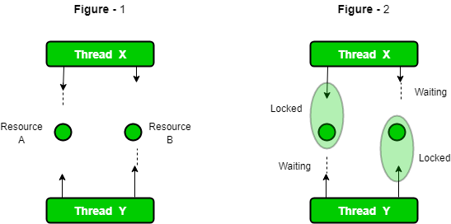

* Java

|  |
| --- |
| // Java program to illustrate Deadlock  // in multithreading.  **class** Util  {      // Util class to sleep a thread  **static** **void** sleep(**long** millis)      {  **try**          {              Thread.sleep(millis);          }  **catch** (InterruptedException e)          {              e.printStackTrace();          }      }  }    // This class is shared by both threads  **class** Shared  {      // first synchronized method  **synchronized** **void** test1(Shared s2)      {          System.out.println("test1-begin");          Util.sleep(1000);            // taking object lock of s2 enters          // into test2 method          s2.test2();          System.out.println("test1-end");      }        // second synchronized method  **synchronized** **void** test2()      {          System.out.println("test2-begin");          Util.sleep(1000);          // taking object lock of s1 enters          // into test1 method          System.out.println("test2-end");      }  }      **class** Thread1 **extends** Thread  {  **private** Shared s1;  **private** Shared s2;        // constructor to initialize fields  **public** Thread1(Shared s1, Shared s2)      {  **this**.s1 = s1;  **this**.s2 = s2;      }        // run method to start a thread      @Override  **public** **void** run()      {          // taking object lock of s1 enters          // into test1 method          s1.test1(s2);      }  }      **class** Thread2 **extends** Thread  {  **private** Shared s1;  **private** Shared s2;        // constructor to initialize fields  **public** Thread2(Shared s1, Shared s2)      {  **this**.s1 = s1;  **this**.s2 = s2;      }        // run method to start a thread      @Override  **public** **void** run()      {          // taking object lock of s2          // enters into test2 method          s2.test1(s1);      }  }      **public** **class** Deadlock  {  **public** **static** **void** main(String[] args)      {          // creating one object          Shared s1 = **new** Shared();            // creating second object          Shared s2 = **new** Shared();            // creating first thread and starting it          Thread1 t1 = **new** Thread1(s1, s2);          t1.start();            // creating second thread and starting it          Thread2 t2 = **new** Thread2(s1, s2);          t2.start();            // sleeping main thread          Util.sleep(2000);      }  } |

Output : test1-begin

test2-begin

It is not recommended to run the above program with online IDE. We can copy the source code and run it on our local machine. We can see that it runs for indefinite time, because threads are in deadlock condition and doesn’t let code to execute. Now let’s see step by step what is happening there. 

1. Thread t1 starts and calls test1 method by taking the object lock of s1.
2. Thread t2 starts and calls test1 method by taking the object lock of s2.
3. t1 prints test1-begin and t2 prints test-2 begin and both waits for 1 second, so that both threads can be started if any of them is not.
4. t1 tries to take object lock of s2 and call method test2 but as it is already acquired by t2 so it waits till it become free. It will not release lock of s1 until it gets lock of s2.
5. Same happens with t2. It tries to take object lock of s1 and call method test1 but it is already acquired by t1, so it has to wait till t1 release the lock. t2 will also not release lock of s2 until it gets lock of s1.
6. Now, both threads are in wait state, waiting for each other to release locks. Now there is a race around condition that who will release the lock first.
7. As none of them is ready to release lock, so this is the Dead Lock condition.
8. When you will run this program, it will be look like execution is paused.

**Detect Dead Lock condition**

We can also detect deadlock by running this program on cmd. We have to collect Thread Dump. Command to collect depends on OS type. If we are using Windows and Java 8, command is jcmd $PID Thread.print   
We can get PID by running jps command. Thread dump for above program is below:

jcmd 18692 Thread.print

18692:

2020-06-08 19:03:10

Full thread dump OpenJDK 64-Bit Server VM (11.0.4+10-b304.69 mixed mode, sharing):

Threads class SMR info:

\_java\_thread\_list=0x0000017f44b69f20, length=13, elements={

0x0000017f43f77000, 0x0000017f43f79800, 0x0000017f43f90000, 0x0000017f43f91000,

0x0000017f43f95000, 0x0000017f43fa5000, 0x0000017f43fb0800, 0x0000017f43f5b800,

0x0000017f44bc9000, 0x0000017f44afb000, 0x0000017f44bd7800, 0x0000017f44bd8800,

0x0000017f298c9000

}

"Reference Handler" #2 daemon prio=10 os\_prio=2 cpu=0.00ms elapsed=57.48s tid=0x0000017f43f77000 nid=0x6050 waiting on condition [0x0000005f800ff000]

java.lang.Thread.State: RUNNABLE

at java.lang.ref.Reference.waitForReferencePendingList(java.base@11.0.4/Native Method)

at java.lang.ref.Reference.processPendingReferences(java.base@11.0.4/Reference.java:241)

at java.lang.ref.Reference$ReferenceHandler.run(java.base@11.0.4/Reference.java:213)

"Finalizer" #3 daemon prio=8 os\_prio=1 cpu=0.00ms elapsed=57.48s tid=0x0000017f43f79800 nid=0x2824 in Object.wait() [0x0000005f801fe000]

java.lang.Thread.State: WAITING (on object monitor)

at java.lang.Object.wait(java.base@11.0.4/Native Method)

- waiting on (a java.lang.ref.ReferenceQueue$Lock)

at java.lang.ref.ReferenceQueue.remove(java.base@11.0.4/ReferenceQueue.java:155)

- waiting to re-lock in wait() (a java.lang.ref.ReferenceQueue$Lock)

at java.lang.ref.ReferenceQueue.remove(java.base@11.0.4/ReferenceQueue.java:176)

at java.lang.ref.Finalizer$FinalizerThread.run(java.base@11.0.4/Finalizer.java:170)

"Signal Dispatcher" #4 daemon prio=9 os\_prio=2 cpu=0.00ms elapsed=57.47s tid=0x0000017f43f90000 nid=0x1710 runnable [0x0000000000000000]

java.lang.Thread.State: RUNNABLE

"Attach Listener" #5 daemon prio=5 os\_prio=2 cpu=31.25ms elapsed=57.47s tid=0x0000017f43f91000 nid=0x4ff4 waiting on condition [0x0000000000000000]

java.lang.Thread.State: RUNNABLE

"C2 CompilerThread0" #6 daemon prio=9 os\_prio=2 cpu=46.88ms elapsed=57.47s tid=0x0000017f43f95000 nid=0x350c waiting on condition [0x0000000000000000]

java.lang.Thread.State: RUNNABLE

No compile task

"C1 CompilerThread0" #9 daemon prio=9 os\_prio=2 cpu=93.75ms elapsed=57.47s tid=0x0000017f43fa5000 nid=0x4900 waiting on condition [0x0000000000000000]

java.lang.Thread.State: RUNNABLE

No compile task

"Sweeper thread" #10 daemon prio=9 os\_prio=2 cpu=0.00ms elapsed=57.47s tid=0x0000017f43fb0800 nid=0x6120 runnable [0x0000000000000000]

java.lang.Thread.State: RUNNABLE

"Common-Cleaner" #11 daemon prio=8 os\_prio=1 cpu=0.00ms elapsed=57.44s tid=0x0000017f43f5b800 nid=0x5a4 in Object.wait() [0x0000005f807fe000]

java.lang.Thread.State: TIMED\_WAITING (on object monitor)

at java.lang.Object.wait(java.base@11.0.4/Native Method)

- waiting on (a java.lang.ref.ReferenceQueue$Lock)

at java.lang.ref.ReferenceQueue.remove(java.base@11.0.4/ReferenceQueue.java:155)

- waiting to re-lock in wait() (a java.lang.ref.ReferenceQueue$Lock)

at jdk.internal.ref.CleanerImpl.run(java.base@11.0.4/CleanerImpl.java:148)

at java.lang.Thread.run(java.base@11.0.4/Thread.java:834)

at jdk.internal.misc.InnocuousThread.run(java.base@11.0.4/InnocuousThread.java:134)

"Monitor Ctrl-Break" #12 daemon prio=5 os\_prio=0 cpu=15.63ms elapsed=57.36s tid=0x0000017f44bc9000 nid=0x5954 runnable [0x0000005f809fe000]

java.lang.Thread.State: RUNNABLE

at java.net.SocketInputStream.socketRead0(java.base@11.0.4/Native Method)

at java.net.SocketInputStream.socketRead(java.base@11.0.4/SocketInputStream.java:115)

at java.net.SocketInputStream.read(java.base@11.0.4/SocketInputStream.java:168)

at java.net.SocketInputStream.read(java.base@11.0.4/SocketInputStream.java:140)

at sun.nio.cs.StreamDecoder.readBytes(java.base@11.0.4/StreamDecoder.java:284)

at sun.nio.cs.StreamDecoder.implRead(java.base@11.0.4/StreamDecoder.java:326)

at sun.nio.cs.StreamDecoder.read(java.base@11.0.4/StreamDecoder.java:178)

- locked (a java.io.InputStreamReader)

at java.io.InputStreamReader.read(java.base@11.0.4/InputStreamReader.java:185)

at java.io.BufferedReader.fill(java.base@11.0.4/BufferedReader.java:161)

at java.io.BufferedReader.readLine(java.base@11.0.4/BufferedReader.java:326)

- locked (a java.io.InputStreamReader)

at java.io.BufferedReader.readLine(java.base@11.0.4/BufferedReader.java:392)

at com.intellij.rt.execution.application.AppMainV2$1.run(AppMainV2.java:64)

"Service Thread" #13 daemon prio=9 os\_prio=0 cpu=0.00ms elapsed=57.36s tid=0x0000017f44afb000 nid=0x6394 runnable [0x0000000000000000]

java.lang.Thread.State: RUNNABLE

"Thread-0" #14 prio=5 os\_prio=0 cpu=0.00ms elapsed=57.35s tid=0x0000017f44bd7800 nid=0x5304 waiting for monitor entry [0x0000005f80cfe000]

java.lang.Thread.State: BLOCKED (on object monitor)

at com.company.threads.Shared.test2(Deadlock.java:40)

- waiting to lock (a com.company.threads.Shared)

at com.company.threads.Shared.test1(Deadlock.java:33)

- locked (a com.company.threads.Shared)

at com.company.threads.Thread1.run(Deadlock.java:67)

"Thread-1" #15 prio=5 os\_prio=0 cpu=0.00ms elapsed=57.35s tid=0x0000017f44bd8800 nid=0xfa4 waiting for monitor entry [0x0000005f80dfe000]

java.lang.Thread.State: BLOCKED (on object monitor)

at com.company.threads.Shared.test2(Deadlock.java:40)

- waiting to lock (a com.company.threads.Shared)

at com.company.threads.Shared.test1(Deadlock.java:33)

- locked (a com.company.threads.Shared)

at com.company.threads.Thread2.run(Deadlock.java:90)

"DestroyJavaVM" #16 prio=5 os\_prio=0 cpu=171.88ms elapsed=55.35s tid=0x0000017f298c9000 nid=0x38ec waiting on condition [0x0000000000000000]

java.lang.Thread.State: RUNNABLE

"VM Thread" os\_prio=2 cpu=0.00ms elapsed=57.49s tid=0x0000017f43f73800 nid=0x52c4 runnable

"GC Thread#0" os\_prio=2 cpu=0.00ms elapsed=57.51s tid=0x0000017f298e1000 nid=0x47dc runnable

"G1 Main Marker" os\_prio=2 cpu=0.00ms elapsed=57.51s tid=0x0000017f29911000 nid=0x61c4 runnable

"G1 Conc#0" os\_prio=2 cpu=0.00ms elapsed=57.51s tid=0x0000017f29912000 nid=0x61c0 runnable

"G1 Refine#0" os\_prio=2 cpu=0.00ms elapsed=57.50s tid=0x0000017f43e0a800 nid=0x1fa8 runnable

"G1 Young RemSet Sampling" os\_prio=2 cpu=0.00ms elapsed=57.50s tid=0x0000017f43e0b000 nid=0x47a4 runnable

"VM Periodic Task Thread" os\_prio=2 cpu=0.00ms elapsed=57.36s tid=0x0000017f44b03800 nid=0x2408 waiting on condition

JNI global refs: 15, weak refs: 0

Found one Java-level deadlock:

=============================

"Thread-0":

waiting to lock monitor 0x0000017f43f87980 (object 0x000000008a2e9ce0, a com.company.threads.Shared),

which is held by "Thread-1"

"Thread-1":

waiting to lock monitor 0x0000017f43f87780 (object 0x000000008a2e9cd0, a com.company.threads.Shared),

which is held by "Thread-0"

Java stack information for the threads listed above:

===================================================

"Thread-0":

at com.company.threads.Shared.test2(Deadlock.java:40)

- waiting to lock (a com.company.threads.Shared)

at com.company.threads.Shared.test1(Deadlock.java:33)

- locked (a com.company.threads.Shared)

at com.company.threads.Thread1.run(Deadlock.java:67)

"Thread-1":

at com.company.threads.Shared.test2(Deadlock.java:40)

- waiting to lock (a com.company.threads.Shared)

at com.company.threads.Shared.test1(Deadlock.java:33)

- locked (a com.company.threads.Shared)

at com.company.threads.Thread2.run(Deadlock.java:90)

Found 1 deadlock.

As we can see there is clearly mentioned that found 1 deadlock. It is possible that the same message appears when you try on your machine.

**Avoid Dead Lock condition**

We can avoid dead lock condition by knowing its possibilities. It’s a very complex process and not easy to catch. But still if we try, we can avoid this. There are some methods by which we can avoid this condition. We can’t completely remove its possibility but we can reduce.

* **Avoid Nested Locks :**This is the main reason for dead lock. Dead Lock mainly happens when we give locks to multiple threads. Avoid giving lock to multiple threads if we already have given to one.
* **Avoid Unnecessary Locks :**We should have lock only those members which are required. Having lock on unnecessarily can lead to dead lock.
* **Using thread join :**Dead lock condition appears when one thread is waiting other to finish. If this condition occurs we can use Thread.join with maximum time you think the execution will take.

**Important Points :** 

* If threads are waiting for each other to finish, then the condition is known as Deadlock.
* Deadlock condition is a complex condition which occurs only in case of multiple threads.
* Deadlock condition can break our code at run time and can destroy business logic.
* We should avoid this condition as much as we can.

If you like GeeksforGeeks and would like to contribute, you can also write an article using [write.geeksforgeeks.org](http://write.geeksforgeeks.org/) or mail your article to review-team@geeksforgeeks.org. See your article appearing on the GeeksforGeeks main page and help other Geeks.  
Please write comments if you find anything incorrect, or you want to share more information about the topic discussed above.

Future Object

Future object. Using Java Future object, we can find out the status of the Callable task and get the returned Object. It provides get() method that can wait for the Callable to finish and then return the result. Java Future provides cancel() method to cancel the associated Callable task.

**The need for Callable**

There are two ways of creating threads – one by extending the Thread class and other by creating a thread with a Runnable. However, one feature lacking in  Runnable is that we cannot make a thread return result when it terminates, i.e. when run() completes. For supporting this feature, the Callable interface is present in Java.

**Callable vs Runnable**

* For implementing Runnable, the run() method needs to be implemented which does not return anything, while for a Callable, the call() method needs to be implemented which returns a result on completion. Note that a thread can’t be created with a Callable, it can only be created with a Runnable.
* Another difference is that the call() method can throw an exception whereas run() cannot.

Method signature that has to overridden for implementing Callable.

public Object call() throws Exception;

Here is the code for an example Callable, which will return a random number after a delay of around 0 – 4 seconds.

|  |
| --- |
| // Java program to illustrate Callable  // to return a random number  **import** java.util.Random;  **import** java.util.concurrent.Callable;  **import** java.util.concurrent.FutureTask;    **class** CallableExample **implements** Callable  {    **public** Object call() **throws** Exception      {          // Create random number generator          Random generator = **new** Random();            Integer randomNumber = generator.nextInt(5);            // To simulate a heavy computation,          // we delay the thread for some random time          Thread.sleep(randomNumber \* 1000);    **return** randomNumber;      }  } |

**Future**

When the call() method completes, answer must be stored in an object known to the main thread, so that the main thread can know about the result that the thread returned. How will the program store and obtain this result later? For this, a Future object can be used. Think of a Future as an object that holds the result – it may not hold it right now, but it will do so in the future (once the Callable returns). Thus, a Future is basically one way the main thread can keep track of the progress and result from other threads. To implement this interface, 5 methods have to be overridden, but as the example below uses a concrete implementation from the library, only the important methods are listed here.

Observe that Callable and Future do two different things – Callable is similar to Runnable, in that it encapsulates a task that is meant to run on another thread, whereas a Future is used to store a result obtained from a different thread. In fact, the Future can be made to work with Runnable as well, which is something that will become clear when Executors come into the picture.

* **public boolean cancel(boolean mayInterrupt):** Used to stop the task. It stops the task if it has not started. If it has started, it interrupts the task only if mayInterrupt is true.
* **public Object get() throws InterruptedException, ExecutionException:**Used to get the result of the task. If the task is complete, it returns the result immediately, otherwise it waits till the task is complete and then returns the result.
* **public boolean isDone():** Returns true if the task is complete and false otherwise

To create the thread, a Runnable is required. To obtain the result, a Future is required.

The Java library has the concrete type FutureTask, which implements Runnable and Future, combining both functionality conveniently.  
A FutureTask can be created by providing its constructor with a Callable. Then the FutureTask object is provided to the constructor of Thread to create the Thread object. Thus, indirectly, the thread is created with a Callable. For further emphasis, note that there is no way to create the thread directly with a Callable.

Here is the code for the full example using Callable and FutureTask.

|  |
| --- |
| // Java program to illustrate Callable and FutureTask  // for random number generation  **import** java.util.Random;  **import** java.util.concurrent.Callable;  **import** java.util.concurrent.FutureTask;    **class** CallableExample **implements** Callable  {    **public** Object call() **throws** Exception    {      Random generator = **new** Random();      Integer randomNumber = generator.nextInt(5);        Thread.sleep(randomNumber \* 1000);    **return** randomNumber;    }    }    **public** **class** CallableFutureTest  {  **public** **static** **void** main(String[] args) **throws** Exception    {        // FutureTask is a concrete class that      // implements both Runnable and Future      FutureTask[] randomNumberTasks = **new** FutureTask[5];    **for** (**int** i = 0; i < 5; i++)      {        Callable callable = **new** CallableExample();          // Create the FutureTask with Callable        randomNumberTasks[i] = **new** FutureTask(callable);          // As it implements Runnable, create Thread        // with FutureTask        Thread t = **new** Thread(randomNumberTasks[i]);        t.start();      }    **for** (**int** i = 0; i < 5; i++)      {        // As it implements Future, we can call get()        System.out.println(randomNumberTasks[i].get());          // This method blocks till the result is obtained        // The get method can throw checked exceptions        // like when it is interrupted. This is the reason        // for adding the throws clause to main      }    }  } |

Output:

4

2

3

3

0

All interaction with the thread after it starts is using the FutureTask object as it implements the Future interface. Hence, there is no need to store the Thread objects. Using the FutureTask object, one can cancel the task, check if it is complete or try to get the result.

Here is the code using only Runnable.

|  |
| --- |
| // Java program to illustrate Runnable  // for random number generation  **import** java.util.Random;  **import** java.util.concurrent.Callable;  **import** java.util.concurrent.FutureTask;    **class** RunnableExample **implements** Runnable  {      // Shared object to store result  **private** Object result = **null**;    **public** **void** run()      {          Random generator = **new** Random();          Integer randomNumber = generator.nextInt(5);            // As run cannot throw any Exception  **try**          {              Thread.sleep(randomNumber \* 1000);          }  **catch** (InterruptedException e)          {              e.printStackTrace();          }            // Store the return value in result when done          result = randomNumber;            // Wake up threads blocked on the get() method  **synchronized**(**this**)          {              notifyAll();          }      }    **public** **synchronized** Object get()  **throws** InterruptedException      {  **while** (result == **null**)              wait();    **return** result;      }  }    // Code is almost same as the previous example with a  // few changes made to use Runnable instead of Callable  **public** **class** RunnableTest  {  **public** **static** **void** main(String[] args) **throws** Exception      {          RunnableExample[] randomNumberTasks = **new** RunnableExample[5];    **for** (**int** i = 0; i < 5; i++)          {              randomNumberTasks[i] = **new** RunnableExample();              Thread t = **new** Thread(randomNumberTasks[i]);              t.start();          }    **for** (**int** i = 0; i < 5; i++)              System.out.println(randomNumberTasks[i].get());      }  } |

**Sample Output**

0

4

3

1

4

2

Asynchronous call

What is an Asynchronous call? A call which will not restrict a program from the execution of its code, and once the event is complete, the call returns back from the event to the CallBack function is known as an Asynchronous call.

In this article, we are going to study the Asynchronous call in the JAVA programming language. At the end of the article, we will get a clear picture of the Asynchronous call and how it differs from synchronous call in the JAVA programming language. Firstly, let us know what is a "CallBack" in the programming sense.

## **What is a CallBack in JAVA?**

The CallBack keyword is used to define a function in JAVA programming along with many other programming languages. A CallBack function is an argument that is passed down into some other function. The CallBack function will be executed after the firing of a particular event in the given program. The true motive of a CallBack function is to inform a particular class about the status of a work in another class.

The CallBack function is useful when we are working on some Asynchronous tasks. The callback is also useful while making use of " Event Handling ", as it is used to provide some sort of notification when a button is clicked by the user on the interface. So, we can understand that a CallBack function plays an essential role while performing routine tasks in a program, such as performing various operations and fetching some data from the web. As for the implementation of a CallBack function in the JAVA programming language, it can be implemented using an interface. Let us see the standard procedure for the implementation of the CallBack function in JAVA programming.

**A procedure that is followed for implementing the Callback function:**

1. We start by defining the methods that are in an interface which we want to invoke after the CallBack.
2. In order to implement the CallBack methods of the interface, define a class.
3. To register the CallBack Interface, define a reference in some random class.
4. Make use of the defined reference to invoke the CallBack method.

## **Types of CallBack in Java**

1. Synchronous call
2. Asynchronous call

### What is a Synchronous call?

A call which will restrict a program from the execution of its code, and once the event returns a response or is complete, the call returns back from the event to the CallBack function is known as a Synchronous call. All the operations are performed by the callback before returning to the statement.

The Synchronous calls wait for the execution, so the time taken for the completion of the program is more than the actual time. We can find a significant time lag within these types of programs. The tasks in the Synchronous calls are executed sequentially. So, the user can use the Synchronous call when the problem must be completed in sequential order and when the problem does not require much time. The execution of the code is paused, and the code waits for the event before being resumed. In this way, the process of Synchronous calls takes place. Now let us understand a Synchronous call with the help of a program in JAVA.

**Example2.java**

1. // This is a program in JAVA for understanding
2. // the implementation of " Asynchronous call ".
4. **interface** ExampleEventListener
5. {
7. // Any type of method
8. // can be defined below
9. **void** exampleEvent();
10. }
12. // define a random class
13. // in which the main section is also
14. // defined
15. **class** Example2
16. {
18. **private** ExampleEventListener mListener;
19. // this is the listener field
21. // Making the setup of Listener below using the public
22. // access and the void return data type
24. **public** **void** registerexampleEventListener(ExampleEventListener mListener)
25. {
26. **this**.mListener = mListener;
27. }
29. // this is my synchronous task
30. // which is needed to be performed.
31. **public** **void** myStuff()
32. {
34. // An Async task always executes within a new thread
35. // so a new thread must be created in order to execute.
37. System.out.print("The task that is being performed");
38. System.out.println(" here is synchronous task");
40. // Do check whether the
41. // listener is registered or not.
42. **if** (**this**.mListener != **null**)
43. {
45. // invoke the callback
46. // method of class Myclass
47. mListener.exampleEvent();
48. }
49. }
50. **public** **static** **void** main(String[] args)
51. {
52. Example2 obj = **new** Example2();
53. ExampleEventListener mListener = **new** Myclass();
54. obj.registerexampleEventListener(mListener);
55. obj.myStuff();
56. }
57. }
59. **class** Myclass **implements** ExampleEventListener
60. {
62. @Override
63. **public** **void** exampleEvent()
64. {
65. System.out.print("Performing callback after ");
66. System.out.print("the completion of Synchronous task");
67. // perform any random routine operation
68. }
69. // some class Myclass methods
70. }

**Output:**

The task that is being performed here is synchronous task

Performing callback after the completion of Synchronous task

**Explanation:**

By getting to know the above program, we can understand the role of a Synchronous call using the CallBack method in the JAVA programming language. We can observe that every step that is discussed is involved within the above program. As mentioned above, we used the Event listener interface in the program.

**When do we use Synchronous call?**

We use Synchronous call in situations in which there are several tasks that are supposed to be performed in a particular order, one after the other involved within the program. The tasks that consume less time are also considered to be called under the Synchronous type.

### What is an Asynchronous call?

A call which will not restrict a program from the execution of its code, and once the event is complete, the call returns back from the event to the CallBack function is known as an Asynchronous call. To avoid this, a new thread must be created, and the CallBack method should be invoked inside the thread in the JAVA programming context. It is not mandatory to invoke the CallBack method inside a thread. A CallBack may also create a new thread when invoked, thus making the call asynchronous.

The tasks in Asynchronous call are executed parallelly or simultaneously, i.e., if one task is executed at a particular time, the other task can also work within the same time without waiting for the completion of the previous task. So, the user or the programmer can use an Asynchronous call when the problem is very big, and the tasks must be completed parallelly in such a way that the tasks are not dependent on each other. The execution of the code is not asked to wait during this call. In this way, the process of Asynchronous call takes place. Now let us understand an Asynchronous call with the help of a program in JAVA.

1. // This is a program in JAVA for understanding the implementation of " Asynchronous call ".
2. **interface** examplecallEventListener {
3. // Any type of method can be defined below.
4. **void** examplecallEvent();
5. }
6. **class** Example1 {
8. **private** examplecallEventListener mListener;
9. // This is a Listener Field.
11. // Making the setup of Listener below using the public access
12. // and the void return data type
13. **public** **void** registerexamplecallEventListener(examplecallEventListener mListener)
14. {
15. **this**.mListener = mListener;
16. }
17. // this is my asynchronous task which is needed to be performed.
18. **public** **void** myStuff()
19. {
20. // An Async task always executes within a new thread
21. // so a new thread must be created in order to execute.
22. **new** Thread(**new** Runnable() {
23. **public** **void** run()
24. {
25. // perform any kind of operations and print.
26. System.out.println("This is Example and Tutorial here");
27. // Do check whether the listener is registered or not.
28. **if** (mListener != **null**) {
30. // invoke the callback method of class myclass
31. mListener.examplecallEvent();
32. }
33. }
34. }).start();
35. }
36. **public** **static** **void** main(String[] args)
37. {
38. example1 obj = **new** example1();
39. examplecallEventListener mListener = **new** myclass();
40. obj.registerexamplecallEventListener(mListener);
41. obj.myStuff();
42. }
43. }
45. **class** myclass **implements** examplecallEventListener {
47. @Override
48. **public** **void** examplecallEvent()
49. {
50. System.out.println("Performing callback after the completion of an Async Task");
51. // perform any of the routine operations
52. }
53. // some class myclass methods
54. }

**Output:**

This is Example and Tutorial here

Performing callback after the completion of an Async Task

**Explanation**

By getting to know the above program, we can understand the role of an Asynchronous call using the CallBack method in the JAVA programming language. We can observe that a new thread is created, and the CallBack is invoked inside this thread itself. As mentioned above, we made use of the Event listener interface in the program.

**When do we use Asynchronous call?**

We use Asynchronous call in situations in which the tasks that are involved within the program are not depending on each other so that the pause of execution in one task will not affect the other. The tasks that consume more time are also considered to be called under the Asynchronous type.

5.how to create thread

You can create threads by implementing the runnable interface and overriding the run() method. Then, you can create a thread object and call the start() method. Thread Class: The Thread class provides constructors and methods for creating and operating on threads.

Thread can be referred to as a lightweight process. Thread uses fewer resources to create and exist in the process; thread shares process resources. The main thread of Java is the thread that is started when the program starts. The slave thread is created as a result of the main thread. This is the last thread to complete execution.

 A thread can programmatically be created by:

1. Implementing the [java.lang.Runnable](https://www.geeksforgeeks.org/runnable-interface-in-java/) interface.
2. Extending the [java.lang.Thread](https://www.geeksforgeeks.org/java-lang-thread-class-java/) class.

You can create threads by implementing the runnable interface and overriding the run() method. Then, you can create a thread object and call the start() method.

**Thread Class:**

The Thread class provides constructors and methods for creating and operating on threads. The thread extends the Object and implements the Runnable interface.

// start a newly created thread.

// Thread moves from new state to runnable state

// When it gets a chance, executes the target run() method

public void start()

**Runnable interface:**

Any class with instances that are intended to be executed by a thread should implement the Runnable interface. The Runnable interface has only one method, which is called run().

// Thread action is performed

public void run()

**Benefits of creating threads :**

* When compared to processes, Java Threads are more lightweight; it takes less time and resources to create a thread.
* Threads share the data and code of their parent process.
* Thread communication is simpler than process communication.
* Context switching between threads is usually cheaper than switching between processes.

**Calling run() instead of start()**

The common mistake is starting a thread using run() instead of start() method.

Thread myThread = new Thread(MyRunnable());

myThread.run(); //should be start();

The run() method is not called by the thread you created. Instead, it is called by the thread that created the **myThread**.

**Example 1: By using Thread Class**

* Java

|  |
| --- |
| **import** java.io.\*;  **class** GFG **extends** Thread {  **public** **void** run()      {          System.out.print("Welcome to GeeksforGeeks.");      }  **public** **static** **void** main(String[] args)      {          GFG g = **new** GFG(); // creating thread          g.start(); // starting thread      }  } |

**Output**

Welcome to GeeksforGeeks.

**Example 2: By implementing Runnable interface**

* Java

|  |
| --- |
| **import** java.io.\*;  **class** GFG **implements** Runnable {  **public** **static** **void** main(String args[])      {          // create an object of Runnable target          GFG gfg = **new** GFG();            // pass the runnable reference to Thread          Thread t = **new** Thread(gfg, "gfg");            // start the thread          t.start();            // get the name of the thread          System.out.println(t.getName());      }      @Override **public** **void** run()      {          System.out.println("Inside run method");      }  } |

**Output**

gfg

Inside run method

1. have you worked on multi threading, how you will create threads

Java has been rated number one in TIOBE popular programming developers which are used by over 10 Million developers over 15 billion devices supporting Java. It is used for creating applications for trending technologies like Big Data to household devices like Mobiles and DTH Boxes, it is used everywhere in today’s information age.



Multithreading in Core Java(J2SE) is a very important topic from an interview point of view. It can lead you to become a ***Java Developer, Java Testing Engineer, Java Architect, Lead Analyst, Java Consultant,*** and most important a real good Java programmer enabling the confidence to dive in J2EE programming which stands for Java to enterprising edition or in layman language making you fit to work in corporate domain workflow directly. Perks wide varied in India for Java developers from ***300K to 25000K for as fresher*** based upon the level of intellect.

So, let’s get started with most asked Java Multithreading Interview Questions with their detailed answers.

**Q-1 What is multitasking?**

A multitasking operating system is an operating system that gives you the perception of 2 or more tasks/jobs/processes running at the same time. It does this by dividing system resources amongst these tasks/jobs/processes and switching between the tasks/jobs/processes while they are executing over and over again. Usually, the CPU processes only one task at a time but the switching is so fast that it looks like the CPU is executing multiple processes at a time. They can support either preemptive multitasking, where the OS provides time to applications (virtually all modern OS), or cooperative multitasking, where the OS waits for the program to give back control (Windows 3.x, Mac OS 9, and earlier), leading to hangs and crashes. Also known as Timesharing, multitasking is a logical extension of multiprogramming.

Multitasking programming is of two types which are as follows:

1. Process-based Multitasking
2. Thread-based Multitasking

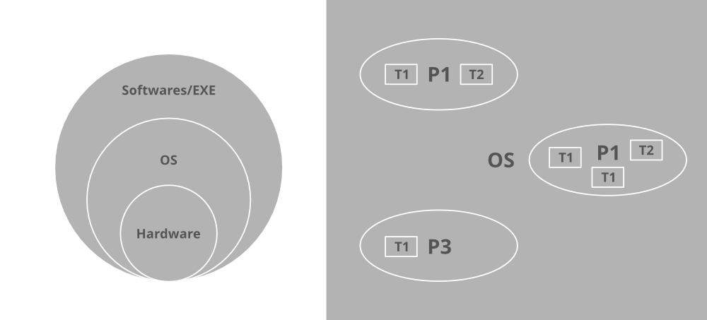

***Note:****Performing multiple tasks at one time is referred to as multithreading in java which is of two types namely Process-based multithreading and Thread based multithreading.*

**Q-2 How can you identify the process?**

Any program which is in a working state is referred to as a process. These processes do have threads that are single dispatchable units.

**Q-3 How do you see a thread?**

In order to see threads status let us take windows as an operating system, it illustrates then we’d have ProcessExplorer where you can see GUI shown below for windows operating systems.

This PC > OS > Users > GeeksforGeeks > Downloads > ProcessExplorer

**ProcessExplorer** is illustrated below in the windows operating systems

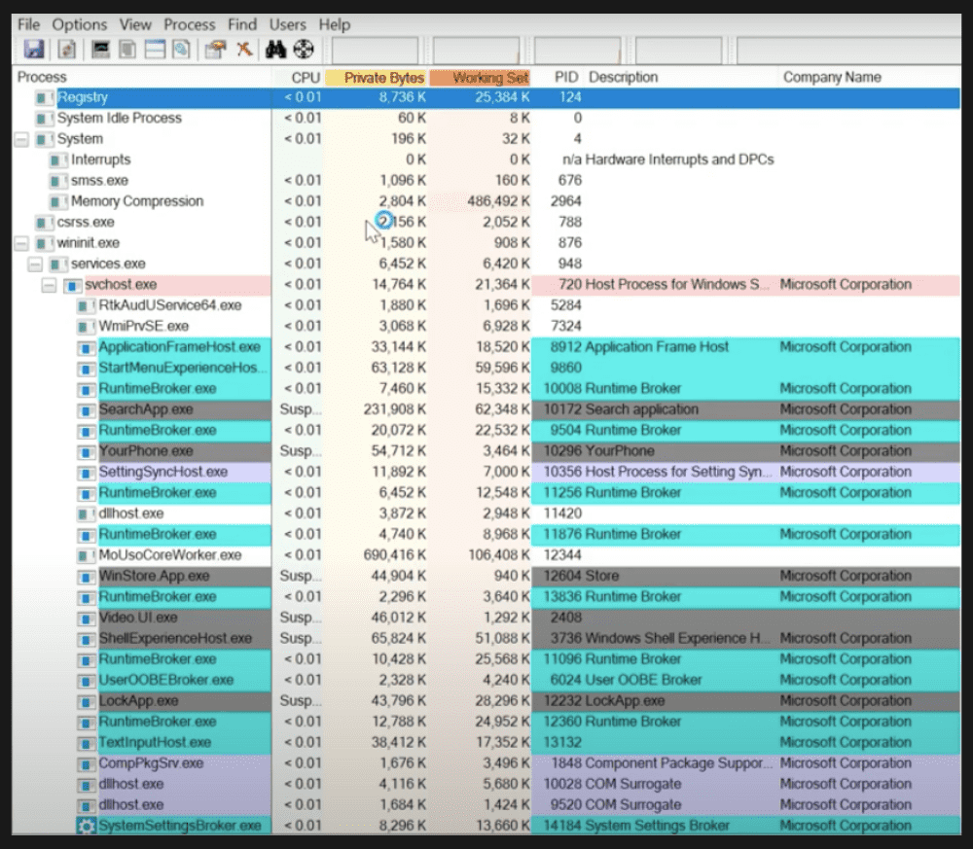

***Note:****All of them as listed in the above media are the processes as shown above where at a time many are running in parallel to each other henceforth illustrating multiprocessing in the Jwindows operating system.*

As we have seen threads do reside in a single process so we have to deep dive into a specific process to see them in order to show users how multithreading is going on in the computers at the backend. For example: let us pick a random process from the above media consisting of various processes say it be ‘chrome’. Now we need to right-click over the process and click the properties’ menu.

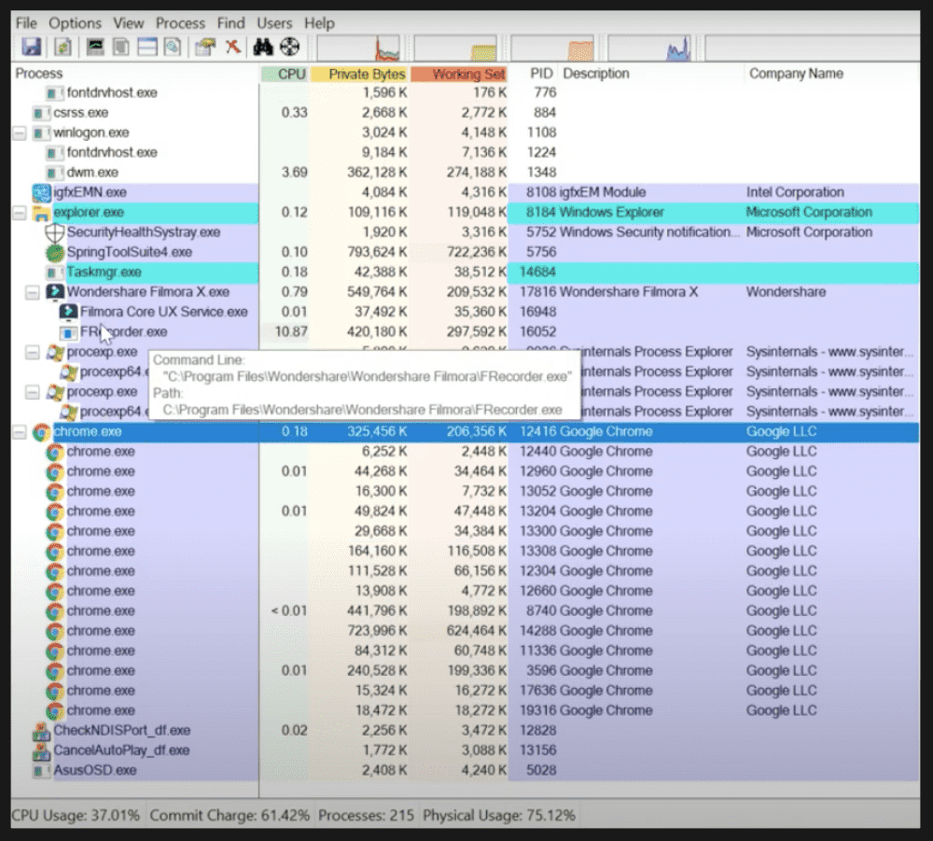

From the above media, it is clearly perceived that **chrome** is a process and after proceeding with the steps to figure out threads running inside the chrome process we go to properties of the process ‘chrome’ below pictorial output will be generated representing threads running in the process chrome.

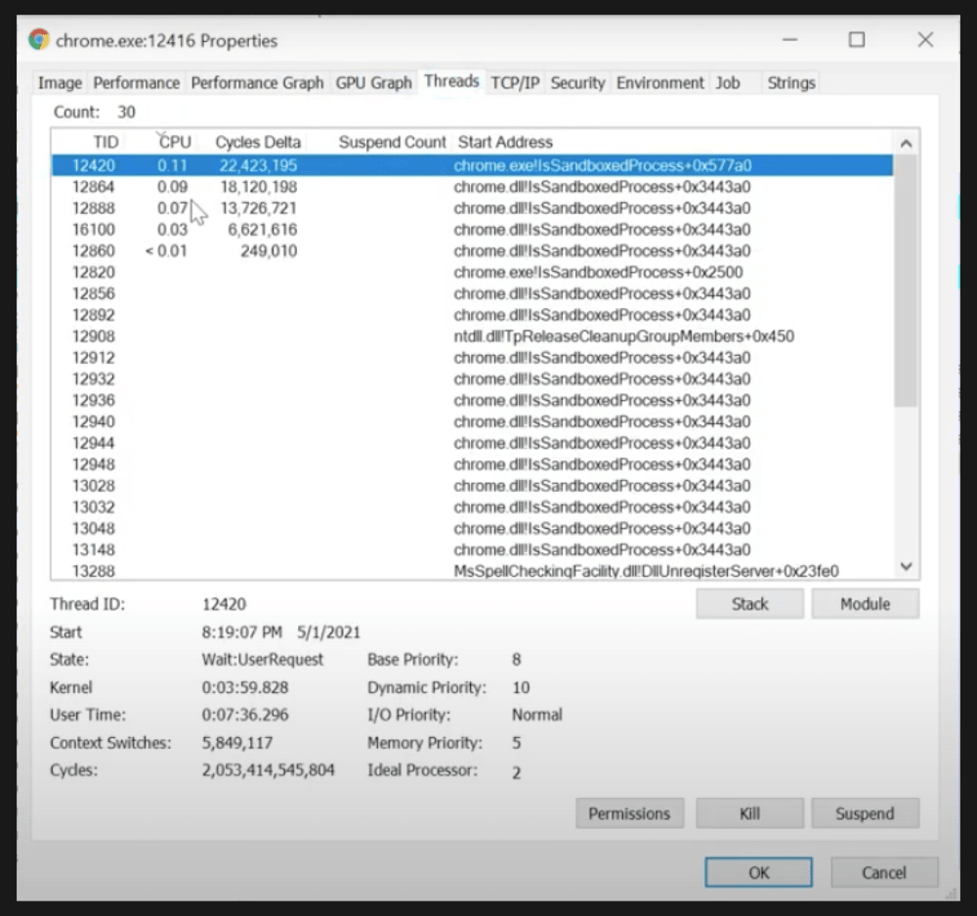

***Note:****If we look scroll way from up to down then it will be seeing some colors against a few of those threads. Here green color threads are associated as the newly created threads and red colors associated threads are representing the closed threads.*

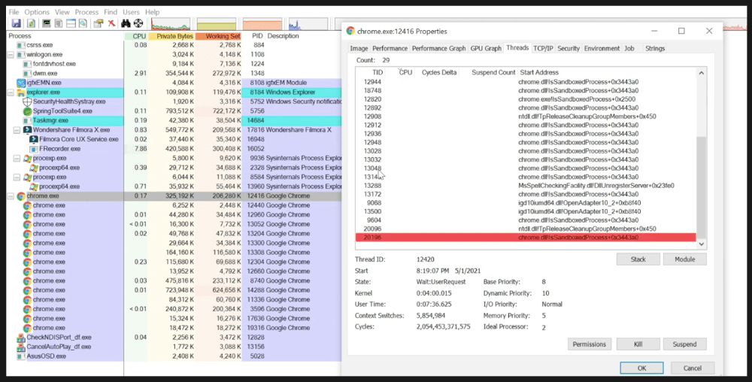

***Note:****So for chrome to increase the performance by reducing the response time that is referred to as Thread based multitasking.*

**Q-4 What is Multithreading and How it is Different from Multitasking?**

Multithreading is a specialized form of multitasking. **Process-based multitasking** refers to executing several tasks simultaneously where each task is a separate independent process is Process-based multitasking.

Example: Running Java IDE and running TextEdit at the same time. Process-based multitasking is represented by the below pictorial which is as follows:

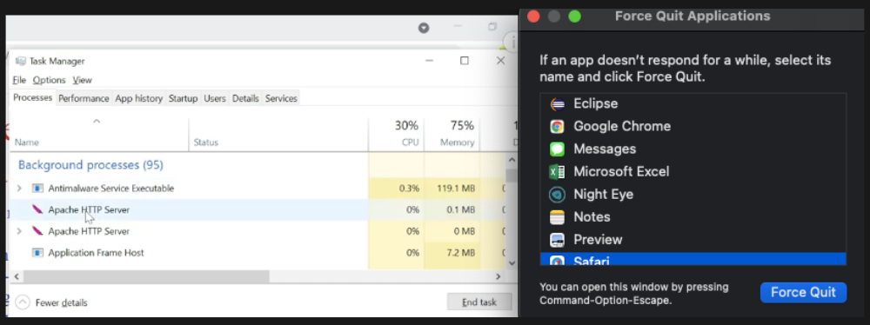

**Thread-based multitasking** refers to executing several tasks simultaneously where each task is a separate independent part of the same program known as a thread. For example, **JUnits** uses threads to run test cases in parallel. Henceforth, process-based multitasking is a bigger scenario handling process where threads handle the details. It is already discussed to deeper depth already with visual aids.

***For more details, please refer to*** [Process-based and Thread-based multitasking in Java](https://www.geeksforgeeks.org/process-based-and-thread-based-multitasking/)

**Q-5 Which Kind of Multitasking is Better and Why?**

Thread-based multitasking is better as multitasking of threads requires less overhead as compared to process multitasking because processes are heavyweight in turn requiring their own separate address space in memory while threads being very light-weight processes and share the same address space as cooperatively shared by heavyweight processes.

Switching is a secondary reason as inter-process communication is expensive and limited. Context switching from one process to another is cost hefty whereas inter-thread communication is inexpensive and context switching from one thread to another is lower in cost.

***Note:****However java programs make use of process-based multitasking environments, but this feature is not directly under Java’s direct control while multithreading is complete.*

**Q-6 What is a thread?**

Threads are lightweight processes within processes as seen. In java, there are two ways of creating threads namely via Thread class and via Runnable interface.

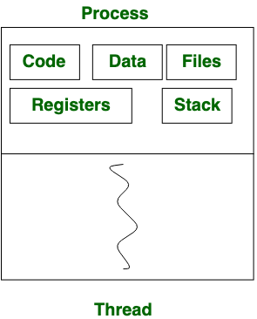

To read more about this, please refer [Thread class in Java](https://www.geeksforgeeks.org/java-lang-thread-class-java/), [Runnable interface in Java](https://www.geeksforgeeks.org/runnable-interface-in-java/)

**Q-7 What are the different states of a thread, or what is thread lifecycle?**

A thread in Java at any point of time exists in any one of the following states. A thread lies only in one of the shown states at any instant:

1. New
2. Runnable
3. Blocked
4. Waiting
5. Timed Waiting
6. Terminated

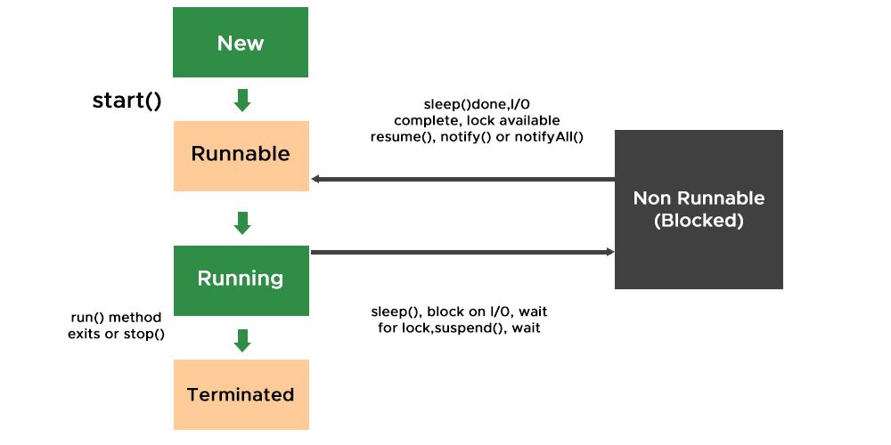

To read more about this, please refer [Lifecycle and States of a Thread in Java](https://www.geeksforgeeks.org/lifecycle-and-states-of-a-thread-in-java/)

**Q-8 What is the task of the main thread?**

All Java programs have at least one thread, known as the **main** thread which is created by JVM at the program start when the main() method is invoked with the main thread as depicted from the output perceived from pseudo-code illustration.

**Illustration:**

System.out.println(“Mayank Solanki”);

**Output:** Mayank Solanki

System.out.println(**Thread.currentthread().getname()**);

**Output:** main

**Q-9 What are the Different Types of threads in Java?**

There are two types of threads in Java as follows:

* User thread
* Daemon thread

User threads are created by java developers for example Main thread. All threads are created inside the main() method are by default non-daemon thread because the ‘main’ thread is non-daemon. **Daemon thread** is a low-priority thread that runs in the background to perform tasks such as garbage collection, etc. They do not prevent daemon threads from exiting when all user threads finish their execution. JVM terminates itself when all non-daemon threads finish their execution. JVM does not care whether a thread is running or not, if JVM finds a running daemon thread it terminates the thread and after that shutdown itself.

**Q-10 How to Create a User thread?**

As discussed earlier when the JVM starts it creates a main thread over which theprogram is run unless an additional thread is not created by the user. The first thing “Main” thread looks for ‘*public static void main(String [] args)*’ method to invoke it as it acts as an entry point to the program. All other threads created in main acts as child threads of the “Main” thread.

User thread can be implemented in two ways listed below:

1. Using Thread class by extending[java.lang.Thread class](https://www.geeksforgeeks.org/java-lang-thread-class-java/).
2. Using [Runnable Interface](https://www.geeksforgeeks.org/runnable-interface-in-java/)by implementing it.

**Q-11 How to set the name of the thread?**

We can name a thread by using amethod been already up there known as [***setName()***](https://www.geeksforgeeks.org/naming-thread-fetching-name-current-thread-java/)replacing default naming which was ‘Thread-0’, ‘Thread-1’, and so on.

thread\_class\_object.setName("Name\_thread\_here");

**Q-12 What is thread priority?**

**Priorities in threads** is a concept where each thread is having a priority which in layman’s language one can say every object is having priority here which is represented by numbers ranging from 1 to 10.

* The default priority is set to 5 as excepted.
* Minimum priority is set to 0.
* Maximum priority is set to 10.

Here 3 constants are defined in it namely as follows:

1. public static int NORM\_PRIORITY
2. public static int MIN\_PRIORITY
3. public static int MAX\_PRIORITY

To read more about this, please refer [Thread Priority in Multithreading in Java](https://www.geeksforgeeks.org/java-thread-priority-multithreading/)

**Q-13 How deadlock plays a important role in multithreading?**

If we do incorporate threads in operating systems one can perceive that the process scheduling algorithms in operating systems are strongly deep-down working on the same concept incorporating thread in **Gantt charts**. A few of the most popular are listed below which wraps up all of them and are used practically in software development.

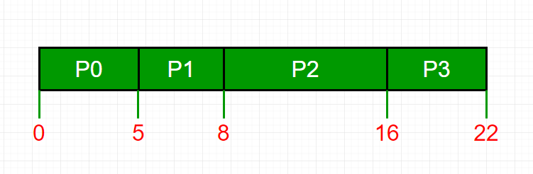

* First In First Out
* Last In First Out
* Round Robin Scheduling

Now one Imagine the concept of **Deadlock in operating systems** **with threads** by now how the switching is getting computed over internally if one only has an overview of them.



**Q-14 Why output is not ordered?**

Scheduling of threads involves two boundary scheduling,

* Scheduling of user-level threads (ULT) to kernel-level threads (KLT) via lightweight process (LWP) by the application developer.
* Scheduling of kernel-level threads by the system scheduler to perform different unique os functions.

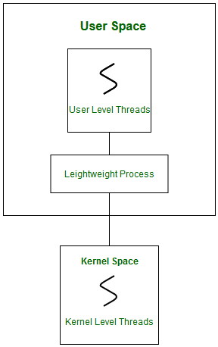

If multiple threads are waiting to execute then thread execution is decided by “ThreadScheduler” which is a part of JVM hence its vendor dependent resulting in unexpected execution of output order.

***Note:***

* *In multithreading, the guarantee of order is very less where we can predict possible outputs but not exactly one.*
* *Also, note that synchronization when incorporated with multithreading does affect our desired output simply by using the keyword ‘synchronized’.*

It is as illustrated in the below illustration which is as follows:

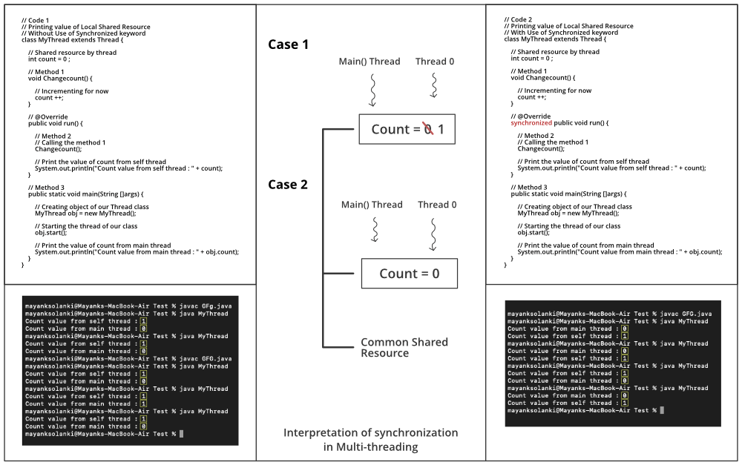

**Q-15 What is Daemon Thread in Java and explain their properties?**

Daemon thread is a low-priority thread that runs in the background to perform tasks such as garbage collection. It does possess certain specific properties as listed below:

* They can not prevent the JVM from exiting when all the user threads finish their execution.
* JVM terminates itself when all user threads finish their execution
* If JVM finds a running daemon thread, it terminates the thread and after that shutdown itself. JVM does not care whether the Daemon thread is running or not.
* It is an utmost low priority thread

***Note:****The main difference between user thread and daemon thread is that JVM does not wait for daemon thread  before exiting while it do waits for the user thread.*

To read more about this, please refer to [Daemon Thread in Java](https://www.geeksforgeeks.org/daemon-thread-java/)

**Q-16 How to Make User Thread to Daemon Thread?**

It is carried out with the help of two methods listed in ‘Thread class’ known as ***setDaemon()***and ***isDaemon()****.*First, the setDaemon() method converts user thread to daemon thread and vice-versa. This method can only be called before starting the thread using ***start() method***else is called after starting the thread with will throw **IllegalThreadStateException** After this, isDaemon() method is used which returns a boolean true if the thread is daemon else returns false if it is a non-daemon thread. 

**Q-17 What are the tasks of the** **start() method?**

The primary task of the *start() method* is to register the thread with the thread scheduler, so one can tell what child thread should perform, when, and how it will be scheduled that is handled by the **thread scheduler**. The secondary task is to call the corresponding run() method got the threads.

**Q-18 What is the difference between the start() and run() method?**

First**,** both methods are operated in general over the thread. So if we do use threadT1.start() then this method will look for the ***run() method*** to create a new thread. While in case of theadT1.run() method will be executed just likely the normal method by the “Main” thread without the creation of any new thread.

***Note:****If we do replace start() method with run() method then the entire program is carried by ‘main’ thread.*

**Q-19 Can we Overload run() method? What if we do not override the run() method?**

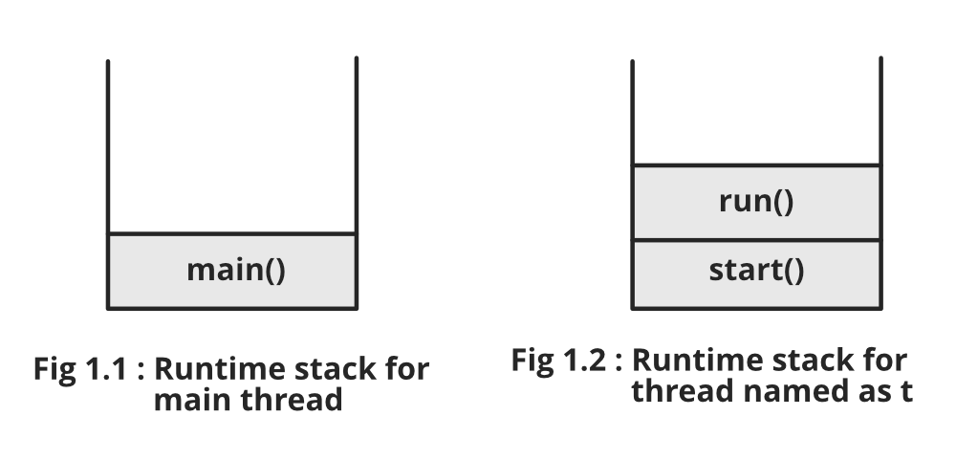

Yes, it is possible to overload run() by passing parameters to it and also keeping a check over to comment down @override from the run() method.

It should be as good as a thread wherein thread we do not have any arguments, so practice to overload is to comment on the call out for overloaded run() method. Now, so we need to acknowledge the same whether the output is the same or not if we have not overloaded it.

If we have overloaded the run() method, then we will observe that output is always the main method as can be perceived from the stack call from the above image. It is because if we debug the code as provided in the link below we see as soon as the start() method is called again, run() is called because we have not overridden the run() method.

For more refer to the [Implementation part of how the run() method is overloaded](https://practice.geeksforgeeks.org/problems/can-we-overload-run-method-while-using-threads-in-java)

***Conclusion:****We can overload the run() method but start() method will call no argument run() only. Hence, it will be of no help to us and is considered as bad practice.*

The compiler will simply execute the run() method of the Thread class, keeping a check that the run() method of the Thread class must have an empty implementation. Hence, it results out in no output corresponding to the thread. As we have discussed above already, if we try to do so, then the Thread class run() method will be called and we will never get our desired output.

***Note:****Geek initially we are requesting to create a thread for us and later the same thread is doing nothing for us which we have created. So it becomes completely meaningless to us by writing unwanted operations to our code fragments. Hence, it becomes useless not to override the run() method.*

**Q-20 Can we Override the start() method?**

Even if we override the start() method in the custom class then no initializations will be carried on by the Thread class for us. The run() method is also not called and even a new thread is also not created.

***Note:****We can not restart the same thread again as we will get*[*IllegalThreadStateException*](https://www.geeksforgeeks.org/daemon-thread-java/)*from java.lang package. Alongside we can not do this indirectly with usage of ‘super.start()’ method.*

1. we want to continue with main thread and pause other synchronized thread?

[Threads in java](https://www.geeksforgeeks.org/multithreading-in-java/) are the lightweight sub-processes that can be created by the user. It is used to perform complicated tasks in the background without disturbing the main program. In order to suspend the thread temporarily by making it go through from running state to waiting for the state. The concept used in achieving the goal is the [***suspend()***](https://www.geeksforgeeks.org/lifecycle-and-states-of-a-thread-in-c-sharp/)function.

**Method:**How the threads can be suspended temporarily

* Creating ‘*MyThread Class****‘*** which is extending the**‘***java.lang.Thread class****‘***. It has a [*run()*](https://www.geeksforgeeks.org/difference-between-thread-start-and-thread-run-in-java/) function which contains some code to perform.
* In the main function, a ‘*MyThread Class****‘*** object is created ‘thread’ which is named as ‘GFG’ by using the [*setName()*](https://www.geeksforgeeks.org/naming-thread-fetching-name-current-thread-java/) function.
* Start the thread to perform its tasks by calling the [*start()*](https://www.geeksforgeeks.org/start-function-multithreading-java/) function and it starts executing the code written in the run() function.

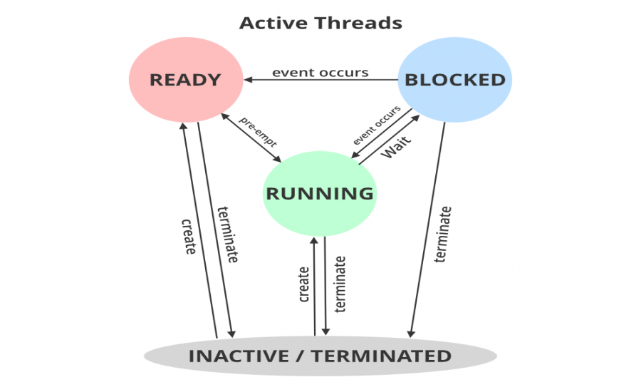

Sometimes there is an urgency to suspend these threads for some reasons. So here the program shows how the thread is suspended temporarily by using the [*suspend()*](https://www.geeksforgeeks.org/lifecycle-and-states-of-a-thread-in-c-sharp/) function. The thread will go from running state to *waiting* state. This function makes a thread temporarily cease execution. The thread will remain in waiting for thestate until we resume it. So, in this program the thread is kept suspended till the sleep time i.e. 5 seconds (taken in this program) is over, and then we resume it by using the resume() function.

**Syntax:** In order to get the ID number of the current thread is already created

Thread.currentThread( ).getId( ) ;

**Methods Used:**

1. [start()](https://www.geeksforgeeks.org/start-function-multithreading-java/): This is a method to start the functioning of a thread.
2. [setName()](https://www.geeksforgeeks.org/naming-thread-fetching-name-current-thread-java/): This is a method used to set the name of a thread that is created.
3. [sleep(time)](https://www.geeksforgeeks.org/sleep-in-python/): This is a method used to sleep the thread for some milliseconds time.
4. [suspend()](https://www.geeksforgeeks.org/green-vs-native-threads-and-deprecated-methods-in-java/): This is a method used to suspend the thread. The thread will remain suspended and won’t perform its tasks until it is resumed.
5. [resume()](https://www.geeksforgeeks.org/lifecycle-and-states-of-a-thread-in-c-sharp/): This is a method used to resume the suspended thread.

**Example:**

* Java

|  |
| --- |
| // Java program to suspend a thread temporarily    // Importing all classes from  // java.util package  **import** java.util.\*;    // Class- MyThread  **class** MyThread **extends** Thread {        // Remember : Method can be executed multiple times  **public** **void** run()      {            // Try block to check if any exception occurs  **try** {                // Print and display the running thread              // using currentThread() method              System.out.println(                  "Thread " + Thread.currentThread().getId()                  + " is running");          }            // Catch block to handle the exceptions  **catch** (Exception e) {                // Message to be printed if              // the exception is encountered              System.out.println("Exception is caught");          }      }  }    // Class-Main  **public** **class** GFG {        // Main Driver Method  **public** **static** **void** main(String[] args) **throws** Exception      {            // Creating a thread          MyThread thread = **new** MyThread();            // Naming thread as "GFG"          thread.setName("GFG");            // Start the functioning of a thread          thread.start();            // Sleeping thread for specific amount of time          Thread.sleep(500);            // Thread GFG suspended temporarily          thread.suspend();            // Display message          System.out.println(              "Thread going to sleep for 5 seconds");            // Sleeping thread for specific amount of time          Thread.sleep(5000);            // Display message          System.out.println("Thread Resumed");            // Thread GFG resumed          thread.resume();      }  } |

**Output :**

Thread 13 is running

Thread Suspended

Thread going to sleep for 5 seconds

Thread Resumed

Are wrapper classes and string thread safe ?

In addition, they are thread-safe, meaning they can be safely used in multi-threaded applications without the risk of corrupt data due to race conditions. By learning polymorphism in java, you can understand the concept of Wrapper classes better.

What is deadlock ?

A process in operating system uses resources in the following way.

1. Requests a resource
2. Use the resource
3. Releases the resource

A***deadlock***is a situation where a set of processes are blocked because each process is holding a resource and waiting for another resource acquired by some other process.

Consider an example when two trains are coming toward each other on the same track and there is only one track, none of the trains can move once they are in front of each other. A similar situation occurs in operating systems when there are two or more processes that hold some resources and wait for resources held by other(s). For example, in the below diagram, Process 1 is holding Resource 1 and waiting for resource 2 which is acquired by process 2, and process 2 is waiting for resource 1.

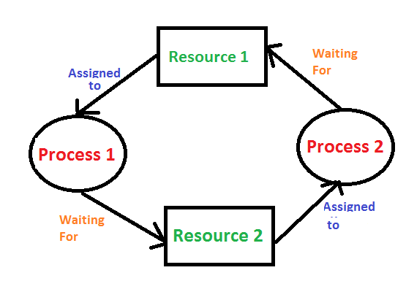

**Examples Of Deadlock**

1. The system has 2 tape drives. P1 and P2 each hold one tape drive and each needs another one.
2. Semaphores A and B, initialized to 1, P0, and P1 are in deadlock as follows:

* P0 executes wait(A) and preempts.
* P1 executes wait(B).
* Now P0 and P1 enter in deadlock.

| **P0** | **P1** |
| --- | --- |
| wait(A); | wait(B) |
| wait(B); | wait(A) |

       3.  Assume the space is available for allocation of 200K bytes, and the following sequence of events occurs.

| P0 | P1 |
| --- | --- |
| Request 80KB; | Request 70KB; |
| Request 60KB; | Request 80KB; |

       Deadlock occurs if both processes progress to their second request.

**Deadlock can arise if**the **following four conditions hold simultaneously (Necessary Conditions)**

***Mutual Exclusion:*** Two or more resources are non-shareable (Only one process can use at a time)   
***Hold and Wait:*** A process is holding at least one resource and waiting for resources.   
***No Preemption:*** A resource cannot be taken from a process unless the process releases the resource.   
***Circular Wait:*** A set of processes waiting for each other in circular form.

**Methods for handling deadlock**   
There are three ways to handle deadlock   
**1) Deadlock prevention or avoidance:**

**Prevention:**

The idea is to not let the system into a deadlock state. This system will make sure that above mentioned four conditions will not arise. These techniques are very costly so we use this in cases where our priority is making a system deadlock-free.  
One can zoom into each category individually, Prevention is done by negating one of the above-mentioned necessary conditions for deadlock. Prevention can be done in four different ways:

       1. Eliminate mutual exclusion                                        3. Allow preemption

       2. Solve hold and Wait                                                   4. Circular wait Solution

**Avoidance:**  
Avoidance is kind of futuristic. By using the strategy of “Avoidance”, we have to make an assumption. We need to ensure that all information about resources that the process will need is known to us before the execution of the process. We use Banker’s algorithm (Which is in turn a gift from Dijkstra) to avoid deadlock.

In prevention and avoidance, we get the correctness of data but performance decreases.

**2) Deadlock detection and recovery:**If Deadlock prevention or avoidance is not applied to the software then we can handle this by deadlock detection and recovery. which consist of two phases:

1. In the first phase, we examine the state of the process and check whether there is a deadlock or not in the system.
2. If found deadlock in the first phase then we apply the algorithm for recovery of the deadlock.

In Deadlock detection and recovery, we get the correctness of data but performance decreases.

**Recovery from Deadlock**

1. Manual Intervention:

When a deadlock is detected, one option is to inform the operator and let them handle the situation manually. While this approach allows for human judgment and decision-making, it can be time-consuming and may not be feasible in large-scale systems.

2. Automatic Recovery:

An alternative approach is to enable the system to recover from deadlock automatically. This method involves breaking the deadlock cycle by either aborting processes or preempting resources. Let’s delve into these strategies in more detail.

Recovery from Deadlock:**Process Termination**:

1. Abort all deadlocked processes:

This approach breaks the deadlock cycle, but it comes at a significant cost. The processes that were aborted may have executed for a considerable amount of time, resulting in the loss of partial computations. These computations may need to be recomputed later.

2. Abort one process at a time:

Instead of aborting all deadlocked processes simultaneously, this strategy involves selectively aborting one process at a time until the deadlock cycle is eliminated. However, this incurs overhead as a deadlock-detection algorithm must be invoked after each process termination to determine if any processes are still deadlocked.

Factors for choosing the termination order:

– The process’s priority

– Completion time and the progress made so far

– Resources consumed by the process

– Resources required to complete the process

– Number of processes to be terminated

– Process type (interactive or batch)

Recovery from Deadlock: **Resource Preemption**:

1. Selecting a victim:

Resource preemption involves choosing which resources and processes should be preempted to break the deadlock. The selection order aims to minimize the overall cost of recovery. Factors considered for victim selection may include the number of resources held by a deadlocked process and the amount of time the process has consumed.

2. Rollback:

If a resource is preempted from a process, the process cannot continue its normal execution as it lacks the required resource. Rolling back the process to a safe state and restarting it is a common approach. Determining a safe state can be challenging, leading to the use of total rollback, where the process is aborted and restarted from scratch.

3. Starvation prevention:

To prevent resource starvation, it is essential to ensure that the same process is not always chosen as a victim. If victim selection is solely based on cost factors, one process might repeatedly lose its resources and never complete its designated task. To address this, it is advisable to limit the number of times a process can be chosen as a victim, including the number of rollbacks in the cost factor.

**3) Deadlock ignorance:** If a deadlock is very rare, then let it happen and reboot the system. This is the approach that both Windows and UNIX take. we use the ostrich algorithm for deadlock ignorance.

In Deadlock, ignorance performance is better than the above two methods but the correctness of data.

**Safe State:**

A safe state can be defined as a state in which there is no deadlock. It is achievable if:

* If a process needs an unavailable resource, it may wait until the same has been released by a process to which it has already been allocated. if such a sequence does not exist, it is an unsafe state.
* All the requested resources are allocated to the process.

**Exercise:**   
**1)** Suppose n processes, P1, …. Pn shares m identical resource units, which can be reserved and released one at a time. The maximum resource requirement of process Pi is Si, where Si > 0. Which one of the following is a sufficient condition for ensuring that deadlock does not occur? (GATE CS 2005) 

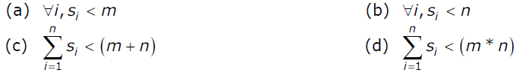

**(A)** A   
**(B)** B   
**(C)** C   
**(D)** D

Questions were related to managing the threads and its pool concept ? Several cross questions were there on this.

# 30 Java Multithreading Interview Questions And Answers

Indeed Editorial Team

Updated 27 January 2023

Multithreading is a crucial concept for Java developers to know. When employers interview for a Java developer position, they likely want to know the extent of your knowledge in multithreading. As part of your interview preparation, take time to review common interview questions about multithreading so you can display your experience and abilities to a hiring manager. In this article, we look at some frequently asked multithreading interview questions and provide you with example answers.

**Related:** [**What Is JavaScript?**](https://in.indeed.com/career-advice/career-development/what-is-javascript)

**Explore jobs on Indeed**

[**Part-time jobs**](https://in.indeed.com/jobs?cgtk=31b3bb82-4649-4a4d-bca4-26411deafcd5&from=careerguidepromo-IN&q=part%20time)

[**Full-time jobs**](https://in.indeed.com/jobs?cgtk=31b3bb82-4649-4a4d-bca4-26411deafcd5&from=careerguidepromo-IN&q=full%20time)

[**Remote jobs**](https://in.indeed.com/jobs?cgtk=31b3bb82-4649-4a4d-bca4-26411deafcd5&from=careerguidepromo-IN&q=remote%20jobs)

[**Urgently needed jobs**](https://in.indeed.com/jobs?cgtk=31b3bb82-4649-4a4d-bca4-26411deafcd5&from=careerguidepromo-IN&q=Urgently%20needed)

[**View more jobs on Indeed**](https://in.indeed.com/?cgtk=31b3bb82-4649-4a4d-bca4-26411deafcd5&from=careerguidepromo-IN)

## What Are Common Java Multithreading Interview Questions?

These are some common interview questions a hiring manager may ask about your knowledge of Java multithreading with example answers:

### 1. What is a thread?

The answer to this question should indicate your programming level and your familiarity with multithreading. Give the hiring manager a definition that shows you understand what a thread is and are able to explain the importance of it.

**Example:** '*A thread is a distinct execution path, or a subprocess. Within a process, you can have either a single thread or multiple threads sharing the same process resources.'*

### 2. What is the difference between a thread and a process?

By asking this, the interviewer wants to see that you understand fundamental multithreading concepts. Explain the concept clearly as if you are speaking to someone who does not have experience in this field.

**Example:** '*A process is a single application or program, whereas a thread is a subprocess within that application or program. Each process has its own address space in memory. Threads share their address space.'*

### 3. What are the benefits of multithreading?

Interviewers may ask this question to understand how well you know the advantages of multithreading and to assess your experience level.

**Example:** '*Because each thread runs concurrently, multithreading makes efficient use of the CPU. You can have background processes running while the application receives user input. Also, tasks can execute faster because each thread runs independently.'*

**Related:** [**Technical Skills: Definition and Examples**](https://in.indeed.com/career-advice/resumes-cover-letters/technical-skills)

### 4. What is a thread pool?

Interviewers may ask you this question to evaluate the performance efficiency of your code. Consider including an advantage to show your understanding.

**Example:** '*A thread pool is a collection of worker threads created at startup that you can assign tasks as needed, then put back in the pool when complete. The main advantage of using a thread pool is having a supply of already-created threads when you need them, which improves application performance.'*

### 5. What states can a thread go through in its lifetime?

An interviewer might ask this question to understand how well you know the operation of threads and related debugging mechanisms. Consider taking a pause to think of the states before answering.

**Example:** '*There are five states a thread can have: new, runnable, running, blocked and terminated.'*

### 6. What is a race condition?

Your answer to this question can illustrate your understanding of the dangers of multithreading.

**Example:** '*A race condition occurs when multiple concurrent threads race to be the first to run. If the thread that wins the race was not the one that was supposed to run first, the code may exhibit unexpected behaviour.* *You can resolve the problem with synchronisation.'*

### 7. What is the difference between synchronous and asynchronous programming?

Interviewers may ask you this question to understand whether you know how to code efficiently.

**Example:** '*Synchronous programming is when you assign a single task to a single thread. Asynchronous programming is when multiple threads share a single task.'*

### 8. What is synchronisation?

Your answer should illustrate your knowledge of ways to mitigate some dangers of multithreading.

**Example:** '*Synchronisation forces threads to run one at a time to prevent a race condition or multiple threads trying to perform the same task.'*

### 9. Why might you use a synchronised block?

This question can help you illustrate your understanding of synchronisation methods for managing multiple threads, further showcasing your knowledge of multithreading to an employer.

**Example:** '*A synchronised block allows you to designate a particular portion of a method as synchronised. It allows only a single thread to run until it completes, prioritising that thread above others.'*

### 10. Between synchronised method and synchronised block, which do you prefer?

This question lets you illustrate your knowledge of the differences between synchronised method and synchronised blocks.

**Example:***'Synchronised block is preferable because the object does not get locked. Synchronised methods can lead to the object getting locked and can stop the execution of multiple synchronisation blocks in the class.'*

### 11. What is context switching?

Your answer to this question should illustrate your knowledge of multithreading at the computational level.

**Example:** *'Context switching allows you to store the current state of a thread, or process, so that you can resume it at a later time. This enables a single CPU to manage multiple threads or processes.'*

### 12. What is a thread scheduler, and how is it related to thread priority?

Usually asked as an extension of the previous question, this question helps interviewers know how well you understand computational mechanisms.

**Example:** '*The thread scheduler allocates CPU time to threads and determines the order in which threads execute.'*

### 13. What is time slicing?

As a further extension, your answer to this question can show the interviewer you understand how the thread scheduler works.

**Example:** '*Time slicing is the process used by the thread scheduler to divide CPU time between the available active threads.'*

**Related:** [**50 Essential Java Interview Programs**](https://in.indeed.com/career-advice/interviewing/java-interview-programs)

## What Are Common Interview Questions About How You Use Java Multithreading?

These are some common interview questions an employer may ask about your use of Java multithreading with example answers:

### 1. Why is thread behaviour unpredictable?

Your answer to this question should illustrate the risks of multithreading when used in different CPUs.

**Example:** '*Because the CPU determines thread scheduling, different CPUs may give priority to different threads. This means two different CPUs may not run your threads in the same order, creating unpredictability in your code execution.'*

### 2. What is the busy spin technique?

Interviewers ask this question to understand how well versed you are in thread manipulation techniques.

**Example:** '*Busy spin is a technique in which you pause a thread by making it run an empty loop for a certain period. Unlike other methods, like wait() or sleep(), a busy spin does not give up CPU control and therefore preserves CPU cache.'*

### 3. What is thread starvation?

Your awareness of thread starvation can be useful for code debugging.

**Example:** '*Thread starvation is when there is insufficient CPU capacity to execute a thread. This can happen with low-priority threads or threads that are demoted in favour of other threads.'*

### 4. Can you start a thread twice?

This question shows you understand thread state and the life cycle of a thread.

**Example:** '*Once you execute a thread, it is considered dead. You cannot restart a dead thread.'*

### 5. What is a deadlock situation?

Deadlocks cause code to stall and malfunction. Employers may want to know if you know how to identify and resolve deadlocks.

**Example:** '*In a deadlock situation, multiple threads may wait on each other to release shared resources in order to run. This can happen when, for example, a single thread has exclusive priority but needs resources from a waiting thread.'*

### 6. What is a livelock?

Your answer to this question can illustrate your knowledge of the potential problems that multithreading can incur.

**Example:** '*A livelock is like a deadlock situation where the state of the threads changes without making progress. This can happen when all the threads are in infinite loops.'*

### 7. Explain how threads communicate with each other.

This question allows you to illustrate your knowledge of working with multiple threads and having them communicate with each other.

**Example:** '*There should be effective communication between threads when they use shared resources. Threads use the methods like notify(), wait() and notifyAll() in the object class to communicate the status of resources.'*

**Related:** [**Top 16 Interview Questions and Answers**](https://in.indeed.com/career-advice/interviewing/top-interview-questions-and-answers)

## Additional Java Multithreading Interview Questions

To assess the depth of your knowledge in multithreading, you may receive these questions:

* Why are the methods notify(), wait() and notifyAll() in object class?
* How are the methods wait() and sleep() different?
* What is a daemon thread?
* How do you create a daemon thread in Java?
* Why is it important to override the run() method in a thread class?
* How can you achieve thread safety?
* In Java, what does the keyword volatile mean?
* Explain how you would stop the execution of a thread in Java.
* Explain what ThreadLocal is.
* What is a timer class in Java?

## What Is Multithreading In Java?

In Java, multithreading is a feature that allows concurrent execution of multiple parts of a program. This maximises CPU utilisation. Each part that is executed is called a thread, and they act like components within a process.

Multithreading has many benefits and uses in the following real-time scenarios:

* Running background processes like Tomcat webserver
* Performing executions when there is a blocked input or output
* Developing video games in which every interactive element is a thread
* Programming reservation and ticketing systems to allow several users to interact with the system simultaneously

*Please note that none of the companies, institutions or organisations mentioned in this article are associated with Indeed.*  
  
**Related:**

* [What Is a Java Project? Explanation and Project Ideas](https://in.indeed.com/career-advice/career-development/what-is-java-project)
* [15 Java 8 Interview Questions (With Example Answers)](https://in.indeed.com/career-advice/interviewing/java-8-interview-questions)
* [Top 50 Java Interview Questions for Experienced Programmers](https://in.indeed.com/career-advice/interviewing/java-interview-questions-for-experienced)
* [13 JVM Interview Questions With Sample Answers (Plus Tips)](https://in.indeed.com/career-advice/interviewing/jvm-interview-questions)
* [33 Enterprise Java Interview Questions And Sample Answers](https://in.indeed.com/career-advice/interviewing/enterprise-java-interview-questions)
* [60 Java Collections Interview Questions (With Answers)](https://in.indeed.com/career-advice/interviewing/java-collections-interview-questions)
* [11 Advantages Of Java (Plus Definition And Importance)](https://in.indeed.com/career-advice/career-development/advantages-of-java)
* [100 Java Interview Questions For Freshers With Example Answers](https://in.indeed.com/career-advice/interviewing/java-interview-questions-for-freshers)
* [What Is Computer Programming? (With Definition And Types)](https://in.indeed.com/career-advice/career-development/what-is-computer-programming)

Volatile keyword

The volatile keyword indicates that a field might be modified by multiple threads that are executing at the same time. The compiler, the runtime system, and even hardware may rearrange reads and writes to memory locations for performance reasons

Using volatile is yet another way (like synchronized, atomic wrapper) of making class thread-safe. Thread-safe means that a method or class instance can be used by multiple threads at the same time without any problem. Consider the below example.

**class** SharedObj

{

// Changes made to sharedVar in one thread

// may not immediately reflect in other thread

**static int** sharedVar = 6;

}

Suppose that two threads are working on **SharedObj**. If two threads run on different processors each thread may have its own local copy of **sharedVariable**. If one thread modifies its value the change might not reflect in the original one in the main memory instantly. This depends on the write policy of cache. Now the other thread is not aware of the modified value which leads to data inconsistency.

The below diagram shows that if two threads are run on different processors, then the value of **sharedVariable** may be different in different threads.

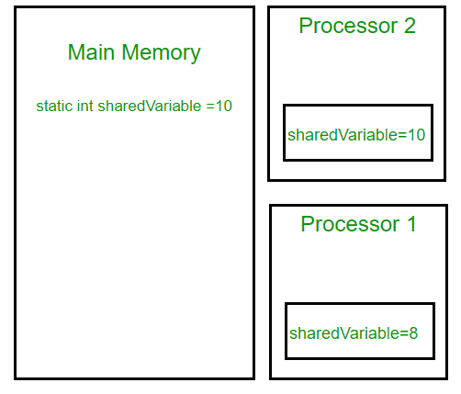

Note that writing of normal variables without any synchronization actions, might not be visible to any reading thread (this behavior is called [sequential consistency](https://en.wikipedia.org/wiki/Sequential_consistency)). Although most modern hardware provides good cache coherence, therefore, most probably the changes in one cache are reflected in another but it’s not a good practice to rely on hardware to ‘fix’ a faulty application.

class SharedObj

{

// volatile keyword here makes sure that

// the changes made in one thread are

// immediately reflect in other thread

static **volatile** int sharedVar = 6;

}

Note that volatile should not be confused with the static modifier. static variables are class members that are shared among all objects. There is only one copy of them in the main memory.

**volatile vs synchronized:** Before we move on let’s take a look at two important features of locks and synchronization.

1. **Mutual Exclusion:** It means that only one thread or process can execute a block of code (critical section) at a time.
2. **Visibility**: It means that changes made by one thread to shared data are visible to other threads.

Java’s synchronized keyword guarantees both mutual exclusion and visibility. If we make the blocks of threads that modify the value of the shared variable synchronized only one thread can enter the block and changes made by it will be reflected in the main memory. All other threads trying to enter the block at the same time will be blocked and put to sleep.

In some cases, we may only desire visibility and not atomicity. The use of synchronized in such a situation is overkill and may cause scalability problems. Here volatile comes to the rescue. Volatile variables have the visibility features of synchronized but not the atomicity features. The values of the volatile variable will never be cached and all writes and reads will be done to and from the main memory. However, the use of volatile is limited to a very restricted set of cases as most of the times atomicity is desired. For example, a simple increment statement such as x = x + 1; or x++ seems to be a single operation but is really a compound read-modify-write sequence of operations that must execute atomically.

* Java

|  |
| --- |
| // Java Program to demonstrate the  // use of Volatile Keyword in Java    **public** **class** VolatileTest {  **private** **static** **final** Logger LOGGER          = MyLoggerFactory.getSimplestLogger();  **private** **static** **volatile** **int** MY\_INT = 0;    **public** **static** **void** main(String[] args)      {  **new** ChangeListener().start();  **new** ChangeMaker().start();      }    **static** **class** ChangeListener **extends** Thread {          @Override **public** **void** run()          {  **int** local\_value = MY\_INT;  **while** (local\_value < 5) {  **if** (local\_value != MY\_INT) {                      LOGGER.log(                          Level.INFO,                          "Got Change for MY\_INT : {0}",                          MY\_INT);                      local\_value = MY\_INT;                  }              }          }      }    **static** **class** ChangeMaker **extends** Thread {          @Override **public** **void** run()          {  **int** local\_value = MY\_INT;  **while** (MY\_INT < 5) {                  LOGGER.log(Level.INFO,                             "Incrementing MY\_INT to {0}",                             local\_value + 1);                  MY\_INT = ++local\_value;  **try** {                      Thread.sleep(500);                  }  **catch** (InterruptedException e) {                      e.printStackTrace();                  }              }          }      }  } |

**Output (With the Volatile Keyword):**

Incrementing MY\_INT to 1

Got Change for MY\_INT : 1

Incrementing MY\_INT to 2

Got Change for MY\_INT : 2

Incrementing MY\_INT to 3

Got Change for MY\_INT : 3

Incrementing MY\_INT to 4

Got Change for MY\_INT : 4

Incrementing MY\_INT to 5

Got Change for MY\_INT : 5

**Output (Without the Volatile Keyword)**

Incrementing MY\_INT to 1

Incrementing MY\_INT to 2

Incrementing MY\_INT to 3

Incrementing MY\_INT to 4

Incrementing MY\_INT to 5

#### volatile in Java vs C/C++:

Volatile in Java is different from the [“volatile” qualifier in C/C++](https://www.geeksforgeeks.org/understanding-volatile-qualifier-in-c/). For Java, “volatile” tells the compiler that the value of a variable must never be cached as its value may change outside of the scope of the program itself. In C/C++, “volatile” is needed when developing embedded systems or device drivers, where you need to read or write a memory-mapped hardware device. The contents of a particular device register could change at any time, so you need the “volatile” keyword to ensure that such accesses aren’t optimized away by the compiler.

Please write comments if you find anything incorrect, or you want to share more information about the topic discussed above

what is RestAPI and implementations of GET, POST, PUT, DELETE using REST API with example

**Quick Overview:**  
The RESTful API has undergone significant updates and improvements over the years. There are now different versions to choose from: RestFul, RestEasy, and even Restlet. The [RESTful API](https://en.wikipedia.org/wiki/Overview_of_RESTful_API_Description_Languages) and REST API APIs both serve the purpose of building web applications. The RESTful API enables a server to be accessed through the HTTP protocol. It is a traditional client-server model that doesn’t require a lot of server logic. Typically, developers build RESTful APIs on top of HTTP.  
  
However, like all the different terms in programming languages, there are unique differences between them, which makes them more suitable to be used by other people.

**Table of Contents**

* [What is REST API?](https://positiwise.com/blog/difference-between-restapi-restful-api#What_is_REST_API)
  + [Main principles of REST (Representational State Transfer) APIs:](https://positiwise.com/blog/difference-between-restapi-restful-api#Main_principles_of_REST_Representational_State_Transfer_APIs)
* [What is RESTful API?](https://positiwise.com/blog/difference-between-restapi-restful-api#What_is_RESTful_API)
  + [The primary components of a RESTful API](https://positiwise.com/blog/difference-between-restapi-restful-api#The_primary_components_of_a_RESTful_API)
* [REST API VS RESTful API](https://positiwise.com/blog/difference-between-restapi-restful-api#REST_API_VS_RESTful_API)
* [REST API vs RESTful API: Which one is Best for Software Application Development?](https://positiwise.com/blog/difference-between-restapi-restful-api#REST_API_vs_RESTful_API_Which_one_is_Best_for_Software_Application_Development)
* [REST API vs RESTful API – Technical Difference](https://positiwise.com/blog/difference-between-restapi-restful-api#REST_API_vs_RESTful_API_%E2%80%93_Technical_Difference)
* [Final Words: REST API vs RESTful API](https://positiwise.com/blog/difference-between-restapi-restful-api#Final_Words_REST_API_vs_RESTful_API)

So, in this article, let’s quickly look at the difference between REST API and RESTful API.

## What is REST API?

**REST API** is a method of programming that allows you to communicate with a microservice quickly and efficiently. The client and server communicate through HTTP in a REST API, making it the most crucial aspect. Developers use the REST API as a software design pattern to create applications that interact with server-side web services via HTTP requests and responses.

The REST API has become the [standard for developing microservices](https://positiwise.com/blog/how-to-implement-microservices-architecture-with-net-development-services) today. It allows you to separate your functionality into many small services so that each service can be designed separately and independently from the other. REST stands for Representational State Transfer, an architectural style and design principle aiming to create self-describing and self-descriptive interfaces. REST is a software design pattern that uses the HTTP protocol to define a stateless interface. In other words, it’s a way to build web applications independent of specific server-side technology.

### Main principles of REST (Representational State Transfer) APIs:

* **Resource-based:** REST APIs access and manipulate resources (data entities) via URI endpoints. For example, https://api.example.com/users/1234 accesses the User resource with ID 1234.
* **Stateless:** REST API requests are standalone and unrelated. The server does not retain the client state between requests. The session state is maintained on the client side, often using cookies or tokens.
* **Cacheable:** REST API responses indicate if they are cacheable or not. This improves performance and scalability by avoiding redundant requests.
* **Uniform interface:** REST APIs use standard HTTP methods like GET, POST, PUT, and DELETE for CRUD operations on resources. This provides a universal and familiar interface.
* **Layered system:** REST APIs are client-server based. Clients don’t know if they are connected directly to the server or intermediaries like caches or load balancers. This abstracts infrastructure for scalability.
* **Code on demand (optional):** REST servers can optionally send executable code like JavaScript to clients. This enables further client functionality.

## What is RESTful API?

A **RESTful API** is an Application Programming Interface (API) that uses the Representational State Transfer (REST) architectural style for its implementation. It is a set of Rest API methods, status codes, and content types used to interact with resources (data) on the Internet via HTTP or other protocols.

A RESTful API allows your software application to communicate with another application or service using only HTTP requests and responses. This implies that your application doesn’t need to know about the internal implementation of the service it’s talking to; all it needs are your application’s endpoints.

The RESTful API software helps you access various applications, databases, and services that are connected through the rest of web services. You can use this tool to communicate with other users and systems via the HTTP request/response mechanism, making it ideal for building custom software applications.

### The primary components of a RESTful API

* **Resources:** These are the objects or data entities exposed by the API. For example, a “customer” or “account” resource.
* **URIs:** Each resource has a unique identifier known as a URI (Uniform Resource Identifier). For example, https://api.example.com/customers/1234 identifies the customer with ID 1234.
* **HTTP methods:** REST uses standard HTTP methods to perform operations on resources. Common ones include GET, POST, PUT, PATCH, and DELETE.
* Representations: Resources are represented in formats like JSON, XML. Clients specify the preferred format in requests.
* **HTTP status codes:** APIs use standard HTTP codes like 200, 400, and 404 to indicate request status. For example, 200 OK, 404 Not Found.
* **Headers: HTTP request and response headers provide metadata like authorization, content type**, cache settings, etc.
* **Hypermedia:** REST APIs use hypermedia links in responses to enable clients to discover additional actions/resources.
* **Stateless:** No client session state is stored on the server between requests. The session state is maintained by the client.

## REST API VS RESTful API

The working principle of these two REST APIs and RESTful APIs is very much similar. Both of them allow you to access data from the server, but they differ in how they fetch and format data. The RESTful API is more like a rest web service where you get the data, whereas the REST API is more like a database where you place your query and get back results.

The RESTful API allows software developers to access a set of resources through HTTP. The structure of the response is based on the reference resource. This means that each resource has its unique URI, and each call to the same help returns data with the same structure.

The RESTful API is an alternative to the [SOAP-based Web services](https://positiwise.com/blog/how-to-create-soap-services-using-asp-net-core) that were prevalent in the past. It uses HTTP methods like GET, POST, PUT, and DELETE to communicate with remote servers over the Internet. In addition, the RESTful API allows you to use your favorite rest programming language to write code for interacting with this type of service.

The working principle of REST API is to use HTTP for all interactions with the server. In a Restful API, developers typically encode the communication as JSON or [XML with a content-type header](https://positiwise.com/blog/how-to-disable-xmlrpc-in-wordpress) preceding it. The server then returns a representation of the data in this format, allowing the client to parse or transform it into another form if needed.

The RESTful API allows software developers to access a set of resources through HTTP. This type of API encodes communication as JSON or XML with a content-type header. The server returns data in this format, which the client can parse or transform into another form if necessary. With this approach, you can make your application work even if it runs on different platforms, such as Android or iOS devices, Windows desktops, etc.

## REST API vs RESTful API: Which one is Best for Software Application Development?

REST API or RESTful API is a service that allows you to develop web applications. RESTful API is a specification of how to use HTTP, XML, and JSON to access resources on a server. Developers often use RESTful APIs in websites and mobile apps because they offer fewer restrictions compared to SOAP APIs and are easier to use than raw HTTP requests.

The main advantage of using RESTful APIs over SOAP APIs is that they are less complex.

Using microservices also has the advantage that they are agnostic about the underlying implementation. This means there are no limitations on what services you can use for these systems. Hence, it is possible to create an API for your service as long as it conforms to specific standards such as OData or HAL.

A RESTful service enables clients to access data over HTTP requests using URIs (Uniform Resource Identifiers). It allows clients to utilize simple HTTP requests with standard URLs and responses, making it usable in any programming language or framework. It makes it easier to create applications without writing custom code.

REST API and Restful API is a [web app development service](https://positiwise.com/services/web-application-development) that provides access to its data and functions via HTTP restful services. REST describes the architecture of these services, which are based on the idea of using hypermedia as the engine of the application state. In other words, a RESTful API allows clients to access resources using the HTTP GET method and standard HTTP methods, including PUT, POST, DELETE, and others. As a result, web developers can use REST APIs in their applications to access data from third-party websites without having to write any code.

## REST API vs RESTful API – Technical Difference

|  | **REST API** | **RESTful API** |
| --- | --- | --- |
| **Design Philosophy** | Focuses purely on functionality and endpoints | Follows constraints of REST architectural style |
| **Resources** | Endpoints may not represent resources | Endpoints represent resources that can be manipulated |
| **HTTP Methods** | May use HTTP methods inconsistently | Properly uses HTTP methods like GET, POST, PUT, DELETE |
| **Statelessness** | Responses may not be cacheable, | Stateless between requests |
| **Cacheable** | Responses explicitly mark cache ability | The interface may vary between endpoints |
| **Uniform Interface** | Interface may vary between endpoints | Uniform interface provided by resources, representations |
| **Client-server** | May mix client and server code | Clear separation between client and server |
| **Layered System** | May bypass intermediate servers | Explicitly layered architecture |
| **Code on demand (Optional)** | May not allow downloadable code | May allow code download for client execution |

**Save Time and Resources with Custom-Built Web Apps**

Tired of piecing together disjointed systems? Our expert web developers build fully customized web apps to streamline your workflows seamlessly. Save time, cut costs, and drive efficiency with tailored solutions made for your unique needs.

[**Hire Dedicated Software Developers**](https://positiwise.com/hire-software-developers)



## Final Words: REST API vs RESTful API

Most companies are moving toward API because they are user-friendly and developer-friendly. REST API is relatively new, but the trend is picking up quickly. It is an application programming interface that allows you to create HTTP requests for accessing data over a network through XML or JSON objects. Rest API uses API resources that are nothing but endpoints.

Difference b/w path param and query param

PathParams are location-dependent, while QueryParams are passed as a key value pair and therefore their order is irrelevant to more than one QueryParam. Even though @PathVariable and @RequestParam are both used to extract values from the URL, their usage is largely determined by how a site is designed.

The annotations [@RequestParam](http://twitter.com/RequestParam), [@QueryParam](http://twitter.com/QueryParam) and [@PathVariable](http://twitter.com/PathVariable), PathParam are used to read values ​​from the request. But which one is used for what?  
The arrangement in the collection is deliberately grouped, as these are annotations that have the same task but come from different frameworks that often occur in combination.

**comparison**

As shown in the table, the difference lies in where a value is read out. **@PathParam**reads the value from a path part of the called URI. **@QueryParam** is used to read the values ​​from QueryParameters of a URI call. These are after? listed in a URI.  
PathParams are location-dependent, while QueryParams are passed as a key value pair and therefore their order is irrelevant to more than one QueryParam.

**example**  
As an example again both calls in a URI:

<http://www.xyz.ir/> <[@PathParam](http://twitter.com/PathParam)> /? queryParamName = <[@QueryParm](http://twitter.com/QueryParm)>

**@PathVariable**

This annotation is used on the method parameter we want to populate:

@RequestMapping(value = "/orders/{id}", method = RequestMethod.GET)  
@ResponseBody  
public String getOrder(@PathVariable final String id) {  
 return "Order ID: " + id;  
}

Even though @PathVariable and @RequestParam are both used to extract values from the URL, their usage is largely determined by how a site is designed.

The @PathVariable annotation is used for data passed in the URI (e.g. RESTful web services) while @RequestParam is used to extract the data found in query parameters.

Program to return list of string palindromes in ascending order.

Given an array of strings **arr[]** of size **N** where each string consists only of lowercase English letter. The task is to find all palindromic string in the array. Print -1 if no palindrome is present in the given array.

**Examples:**

***Input:****arr[] = {“abc”, “car”, “ada”, “racecar”, “cool”}****Output:****“ada”, “racecar”****Explanation:****These two are the only palindrome strings in the given array*

***Input:****arr[] = {“def”, “ab”}****Output:****-1****Explanation:****No palindrome string is present in the given array.*

**Approach:** The solution is based on [**greedy approach**](https://www.geeksforgeeks.org/greedy-algorithms/). Check every string of an array if it is palindrome or not and also keep track of the all palindrome string. Follow the steps below to solve the problem:

* Initialize a vector of string **ans**.
* Iterate over the range **[0, N)** using the variable **i** and If **arr[i]** is a palindrome, then add it to the **ans**.
* After performing the above steps, print the strings present in **ans** as the resultant strings.

Below is the implementation of the above approach.

* C++
* Java
* Python3
* C#
* Javascript

|  |
| --- |
| // Java code to find the maximum median  // of a sub array having length at least K.  **import** java.util.\*;  **public** **class** GFG  {      // Function to check if given string    // is Palindrome or not  **static** **boolean** isPalindrome(String str)    {        // Start from leftmost and rightmost corners of str  **int** l = 0;  **int** h = str.length() - 1;        // Keep comparing characters while they are same  **while** (h > l)      {  **if** (str.charAt(l++) != str.charAt(h--))        {  **return** **false**;        }      }  **return** **true**;    }      // Function to return all Palindrome string  **static** ArrayList<String> PalindromicStrings(String []arr,  **int** N)    {      ArrayList<String> ans = **new** ArrayList<String>();        // Loop to find palindrome string  **for** (**int** i = 0; i < N; i++) {          // Checking if given string is        // palindrome or not  **if** (isPalindrome(arr[i])) {            // Update answer variable          ans.add(arr[i]);        }      }  **return** ans;    }      // Driver Code  **public** **static** **void** main(String args[])    {        String []arr        = { "abc", "car", "ada", "racecar", "cool" };  **int** N = arr.length;        // Print required answer      ArrayList<String> s = PalindromicStrings(arr, N);  **if**(s.size() == 0)        System.out.print("-1");  **for** (String st : s)        System.out.print(st + " ");      }  }    // This code is contributed by Samim Hossain Mondal. |

Learn [Data Structures & Algorithms](https://www.geeksforgeeks.org/courses/category/ds-and-algorithms?itm_source=geeksforgeeks&itm_medium=article_code_block&itm_campaign=courses) with GeeksforGeeks

**Output**

ada racecar

what is difference between MySQL& PostgreSQL vs MongoDB.

PostgreSQL is a traditional RDBMS (relational database management system) SQL database, like Oracle and MySQL. PostgreSQL is free. MongoDB is a no-schema, noSQL, JSON database. MongoDB has a free version, but they also have hosted and enterprise paid versions.

When we use NoSQL and when to use RDBMS database

Relational vs. NoSQL: Requirements at a glance

|  |  |
| --- | --- |
| **When to Use NoSQL** | **When to Use a RDBMS** |
| High to low data/user activity | Moderate to low data/user activity |
| High to low online data volumes (e.g., requirement to retain data forever) | Moderate to low online data volumes |
| High-velocity data (devices, sensors, etc.) | Moderate velocity data |

Have you worked on Circuit Breaker and Rate Limiter.

[Write](https://medium.com/new-story?source=---two_column_layout_nav----------------------------------)



**[This member-only story is on us.](https://medium.com/plans?source=upgrade_membership---post_counter--431ccff6a120--------------------------------)**[Upgrade to access all of Medium.](https://medium.com/plans?source=upgrade_membership---post_counter--431ccff6a120--------------------------------)

Member-only story

# Micro In Action, Part 7: Circuit Breaker & Rate Limiter

[[](https://medium.com/@dche423?source=post_page-----431ccff6a120--------------------------------)](https://medium.com/@dche423?source=post_page-----431ccff6a120--------------------------------)

[[](https://itnext.io/?source=post_page-----431ccff6a120--------------------------------)](https://itnext.io/?source=post_page-----431ccff6a120--------------------------------)

[Che Dan](https://medium.com/@dche423?source=post_page-----431ccff6a120--------------------------------)

·

Follow

Published in

[ITNEXT](https://itnext.io/?source=post_page-----431ccff6a120--------------------------------)

·

6 min read

·

Feb 25, 2020

44

1



Micro In Action

This is the 7th article in the series of articles “Micro in Action”, discussing [Micro](https://micro.mu/). We’ll start from basic concepts and topics then move on to advanced features.

Today’s topic is Circuit Breaker and Rate Limiter.

Circuit Breaker and Rate Limiter are important topics in large system architectures. These topics became more important when we started to split the monolithic system into distributed microservices. Without Circuit Breaker and Rate Limiter, a system can easily encounter an “avalanche” effect due to the failure of a single component, which can lead to a crash of the entire system.

Under Micro’s pluggable architecture, the above mechanism can be introduced very easily. We know that Micro supports request wrapping with middleware. The two most critical ones of these middlewares are:

1. **micro.WrapClient,** which is used to wrap outbound requests, aka client-side wrapping
2. **micro.WrapHandler,** which is used to wrap inbound requests, aka server-side wrapping

These two types of middleware are suitable for the scenarios of Circuit Breaker and Rate Limiter respectively. Below we take examples to illustrate how to use these middlewares to improve system robustness.

# Circuit Breaker

In general, such a common functionality does not require us to develop it ourselves. There are already excellent open-source libraries in the community, such as [hystrix-go](https://github.com/afex/hystrix-go/), [gobreaker](https://github.com/sony/gobreaker).

In addition, Micro also provides plugins that adapt to the above libraries e.g. [hystrix plugin](https://github.com/micro/go-plugins/tree/master/wrapper/breaker/hystrix) and [gobreaker plugin](https://github.com/micro/go-plugins/tree/master/wrapper/breaker/gobreaker).

With the help of these plug-ins, using Circuit Breaker in Micro becomes very easy. Take hystrix as an example:

import (  
...  
 **"github.com/micro/go-plugins/wrapper/breaker/hystrix/v2"**  
...  
)func main(){  
...  
 // New Service  
 service := micro.NewService(  
 micro.Name("com.foo.breaker.example"),  
 **micro.WrapClient(hystrix.NewClientWrapper())**,  
 )  
 // Initialise service  
 service.Init()  
...  
}

All we need to do is to assign hystrix plugin during service creation,

From now on, all calls to the remote services will be tracked by the plugin. When the request times out or the number of concurrent reaches the limit, an error will be returned to the caller immediately.

So what are the default limits for concurrency and time out? The answer lays in the source code of the hystrix-go plugin. Looking over **github.com/afex/hystrix-go/hystrix/settings.go** you will see several package-level variables:

...  
 // DefaultTimeout is how long to wait for command to complete, in milliseconds  
 **DefaultTimeout** = 1000  
 // DefaultMaxConcurrent is how many commands of the same type can run at the same time  
 **DefaultMaxConcurrent** = 10  
...

So the default timeout is 1 second, and the default concurrent limit is 10.

Note: There’re more settings besides these two, but a discussion of all of them is beyond the scope of this post. If you are interested, you can go to the [official website](https://github.com/afex/hystrix-go/) of the hystrix-go library for detailed documentation.

If the default settings do not meet our requirements, you can modify them as follows:

import (  
...  
 **hystrixGo "github.com/afex/hystrix-go/hystrix"** "github.com/micro/go-plugins/wrapper/breaker/hystrix/v2"  
...  
)func main(){  
...  
 // New Service  
 service := micro.NewService(  
 micro.Name("com.foo.breaker.example"),  
 micro.WrapClient(hystrix.NewClientWrapper()),  
 )  
 // Initialise service  
 service.Init()  
 **hystrixGo.DefaultMaxConcurrent = 3**//change concurrrent to 3  
 **hystrixGo.DefaultTimeout = 200** //change timeout to 200 milliseconds...  
}

As shown in the codes, we can change the default timeout and concurrent limit

You may have a question about **DefaultMaxConcurrent**: What is the scope of it? Suppose there’re 3 services and each service has 3 different methods. And we want to call all these methods at the same time. Does it mean that we must set the **DefaultMaxConcurrent** to a number greater than 3\*3 to achieve completely concurrent?

To answer this question, two points need to be figured out:

First, what is the target of **DefaultMaxConcurrent**? As you can see from the hystrix documentation, it’s the **command** in hystrix:

*DefaultMaxConcurrent is how many commands of the same type can run at the same time*

Next, you need to know how the hystrix plugin handles the mapping between different methods and **commands**. Check out **github.com/micro/go-plugins/wrapper/breaker/hystrix/v2/hystrix.go**, you’ll find the relevant codes are as follows:

import(  
 "github.com/afex/hystrix-go/hystrix"  
 ...  
)  
...func (c \*clientWrapper) **Call**(ctx context.Context, req client.Request, rsp interface{}, opts ...client.CallOption) error {  
 return **hystrix.Do**(**req.Service()+"."+req.Endpoint()**, func() error {  
 return c.Client.Call(ctx, req, rsp, opts...)  
 }, nil)  
}  
...

Note the req.Service () + “.” + Req.Endpoint (), which IS the **command** of hystrix. And the **command** does not contain node information, this means that for the same service, there is no difference in single-node deployment or multiple nodes deployment, all nodes share one limitation.

At this point, it is clear: each method of each service counts independently and does not affect each other. The scope of **DefaultMaxConcurrent** is method-level, regardless of the number of nodes.

In practice, different methods may require different limitations. How to achieve that? From the source code above, we know that a service method is mapped to a hystrix **command**, and hystrix supports the independent control for different commands via hystrix.ConfigureCommand:

...  
hystrix.ConfigureCommand("**com.serviceA.methodFoo**",  
 hystrix.CommandConfig{  
 MaxConcurrentRequests: 50,  
 Timeout: 10,  
 })  
hystrix.ConfigureCommand("**com.serviceB.methodBar**",  
 hystrix.CommandConfig{  
 Timeout: 60,  
 })  
...

With the above codes, we set different limits for different methods. If any field of thehystrix.CommandConfig struct is not specified, the system default value will be used.

Summary: Circuit Breaker acts on the client. With an appropriate threshold, it can ensure that the client resources are not exhausted. Even if the service it depends on is unhealthy, the client will quickly return an error instead of leaving the caller wait for a long time.

# Rate Limiter

Similar to Circuit Breaker, rate-limiting is also a commonly used function in distributed systems. The difference is that Rate Limiter takes effect on the server-side, and its role is to protect the server: once the speed of request processing reaches a preset limit, the server no longer receives new requests until the in-processing request is completed. Rate Limiter can avoid the server crashing due to massive requests.

Here’s an analogy: suppose we operate a restaurant that can hold 10 guests. If 100 guests come for dinner at the same time, the best way to deal with it is to select the first 10 to serve and tell the other 90 guests: we are currently unable to serve, please come back another day. Although these 90 guests will be unhappy, we guarantee at least the first 10 guests can have a happy meal.

Without Rate Limiter, the result is that 100 guests enter the restaurant, the kitchen is too busy, and all guests have nowhere to sit. No one could get served. The entire restaurant was eventually paralyzed.

Using Rate Limiter in the Micro is very simple, too. We need just one line of code to achieve this. There are two Rate Limiter plug-ins available currently. This article uses the [uber rate limiter plug-in](https://github.com/micro/go-plugins/tree/master/wrapper/ratelimiter/uber) as an example (of course, if the existing plug-in does not meet the requirements, you can always develop a more suitable plug-in by yourself). Let’s modify the source file **hello-service/main.go**:

package mainimport (  
...  
 **limiter "github.com/micro/go-plugins/wrapper/ratelimiter/uber/v2"**  
...  
)func main() {  
 const QPS = 100  
 // New Service  
 service := micro.NewService(  
 micro.Name("com.foo.srv.hello"),  
 micro.Version("latest"),  
 **micro.WrapHandler(limiter.NewHandlerWrapper(**QPS**)),**  
 )...}

The above codes add server-side Rate Limiter to **hello-service**, with a QPS cap of 100. This limitation is shared by methods of all handlers in this service. In other words, the scope of this restriction is service-level.

# Final words

Both Circuit Breaker and Rate Limiter are important. Thanks to Micro’s pluggable architecture, we can easily apply these two important functionalities.

The role of Circuit Breaker is to protect the client from being dragged down by external service issues and always respond quickly (even if you get an error, it is better than waiting for a long time). Always avoid excessive consumption of resources.

While the role of Rate Limiter is to protect the server. Only handle the traffic within its capacity to achieve overload protection. An error is returned immediately when the traffic exceeds the preset limit.

The combination of Circuit Breaker and Rate Limiter reflects a philosophy of design: **always be responsible for yourself first,**a component should ensure its robustness regardless of the state of external dependencies.

When this philosophy is applied to every component of a distributed system, the system will become very strong and resilient and will not be overwhelmed by sudden traffic spikes.

Therefore, we should follow such a best practice in the development of distributed systems: **adding Circuit Breaker and Rate Limiter to every service**. In the beginning, it can be coarse-grained restrictions. As the business evolves, control can be gradually refined. Finally, every service will get a specific restriction policy matching with it.

To be continued.

Design and Implement Rate Limiter.

**Rate limiting** is an essential technique used in software systems to control the rate of incoming requests. It helps to prevent the overloading of servers by limiting the number of requests that can be made in a given time frame.

It helps to prevent a high volume of requests from overwhelming a server or API. Here is a basic design for a rate limiter API In this article, we will discuss the design of a rate limiter API, including its requirements, high-level design, and algorithms used for rate limiting.

## Why is rate limiting used?

* Avoid resource starvation due to a Denial of Service (DoS) attack.
* Ensure that servers are not overburdened. Using rate restriction per user
* ensures fair and reasonable use without harming other users.
* Control the flow of information, for example, prevent a single worker from
* accumulating a backlog of unprocessed items while other workers are idle.

## Requirements to Design a Rate Limiter API

The requirements of a rate limiter API can be classified into two categories: functional and non-functional.

### Functional requirements to Design a Rate Limiter API:

* The API should allow the definition of multiple rate-limiting rules.
* The API should provide the ability to customize the response to clients when rate limits are exceeded.
* The API should allow for the storage and retrieval of rate-limit data.
* The API should be implemented with proper error handling as in when the threshold limit of requests are crossed for a single server or across different combinations, the client should get a proper error message.

### Non-functional requirements to Design a Rate Limiter API:

* The API should be highly available and scalable. Availability is the main pillar in the case of request fetching APIs.
* The API should be secure and protected against malicious attacks.
* The API should be easy to integrate with existing systems.
* There should be low latency provided by the rate limiter to the system, as performance is one of the key factors in the case of any system.

## High Level Design (HLD) to Design a Rate Limiter API

### Where to place the Rate Limiter – Client Side or ****Server Side****?

*A rate limiter should generally be implemented on the****server side****rather than on the client side. This is because of the following points:*

* ***Positional Advantage:****The server is in a better position to enforce rate limits across all clients, whereas client-side rate limiting would require every client to implement their own rate limiter, which would be difficult to coordinate and enforce consistently.*
* ***Security:****Implementing rate limiting on the server side also provides better security, as it allows the server to prevent malicious clients from overwhelming the system with a large number of requests. If rate limiting were implemented on the client side, it would be easier for attackers to bypass the rate limit by just modifying or disabling the client-side code.*
* ***Flexible:****Server-side rate limiting allows more flexibility in adjusting the rate limits and managing resources. The server can dynamically adjust the rate limits based on traffic patterns and resource availability, and can also prioritize certain types of requests or clients over others. Thus, lends to better utilization of available resources, and also keeps performance good.*

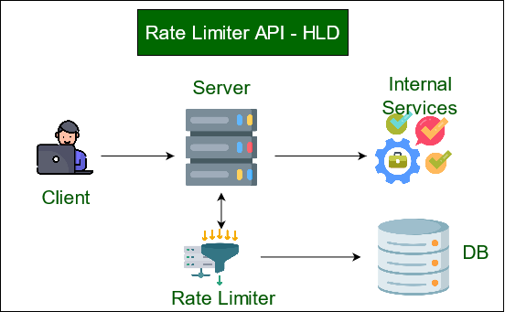

*HLD of Rate Limiter API – rate limiter placed at server side*

The overall basic structure of a rate limiter seems relatively simpler. We just need a counter associated with each user to track how many requests are being same submitted in a particular timeframe. The request is rejected if the counter value hits the limit.

### Memory Structure/Approximation

*Thus, now let’s think of the data structure which might help us. Since we need fast retrieval of the counter values associated with each user, we can use a****hash-table.****Considering we have a key-value pair. The key would contain hash value of each User Id, and the corresponding value would be the pair or structure of counter and the startTime, e.g.,****UserId****-> {****counter, startTime****}*

*Now, each UserId let’s say takes****8 bytes(long long)****and the counter takes****2 bytes(int)****, which for now can count to****50k(limit)****. Now for the time if we store only the minute and seconds, it will also take 2 bytes. So in total, we would need****12 bytes****to store each user’s data.*

*Now considering the overhead of 10 bytes for each record in our hash-table, we would be needing to track at least 5 million users at any time(traffic), so the total memory in need would be:****(12+10)bytes\*5 million****=****110 MB***

### Key Components in the Rate Limiter

* **Define the rate limiting policy**: The first step is to determine the policy for rate limiting. This policy should include the maximum number of requests allowed per unit of time, the time window for measuring requests, and the actions to be taken when a limit is exceeded (e.g., return an error code or delay the request).
* **Store request counts**: The rate limiter API should keep track of the number of requests made by each client. One way to do this is to use a database, such as Redis or Cassandra, to store the request counts.
* **Identify the client**: The API must identify each client that makes a request. This can be done using a unique identifier such as an IP address or an API key.
* **Handle incoming requests**: When a client makes a request, the API should first check if the client has exceeded their request limit within the specified time window. If the limit has been reached, the API can take the action specified in the rate-limiting policy (e.g., return an error code). If the limit has not been reached, the API should update the request count for the client and allow the request to proceed.
* **Set headers**: When a request is allowed, the API should set appropriate headers in the response to indicate the remaining number of requests that the client can make within the time window, as well as the time at which the limit will be reset.
* **Expose an endpoint**: Finally, the rate limiter API should expose an endpoint for clients to check their current rate limit status. This endpoint can return the number of requests remaining within the time window, as well as the time at which the limit will be reset.

### Where should we keep the counters?

*Due to the slowness of Database operations, it is not a smart option for us. This problem can be handled by an in-memory cache such as****Redis****. It is quick and supports the already implemented time-based expiration technique.*

*We can rely on two commands being used with in-memory storage,*

* ***INCR:****This is used for increasing the stored counter by 1.*
* ***EXPIRE:****This is used for setting the timeout on the stored counter. This counter is automatically deleted from the storage when the timeout expires.*

*In this design, client requests pass through a rate limiter middleware, which checks against the configured rate limits. The rate limiter module stores and retrieves rate limit data from a backend storage system. If a client exceeds a rate limit, the rate limiter module returns an appropriate response to the client.*

## Algorithms to Design a Rate Limiter API

Several algorithms are used for rate limiting, including

* The Token bucket,
* Leaky bucket,
* Sliding window logs, and
* Sliding window counters.

Let’s discuss each algorithm in detail:

### Token Bucket

The token bucket algorithm is a simple algorithm that uses a fixed-size token bucket to limit the rate of incoming requests. The token bucket is filled with tokens at a fixed rate, and each request requires a token to be processed. If the bucket is empty, the request is rejected.

The token bucket algorithm can be implemented using the following steps:

* Initialize the token bucket with a fixed number of tokens.
* For each request, remove a token from the bucket.
* If there are no tokens left in the bucket, reject the request.
* Add tokens to the bucket at a fixed rate.

Thus, by allocating a bucket with a predetermined number of tokens for each user, we are successfully limiting the number of requests per user per time unit. When the counter of tokens comes down to 0 for a certain user, we know that he or she has reached the maximum amount of requests in a particular timeframe. The bucket will be auto-refilled whenever the new timeframe starts.

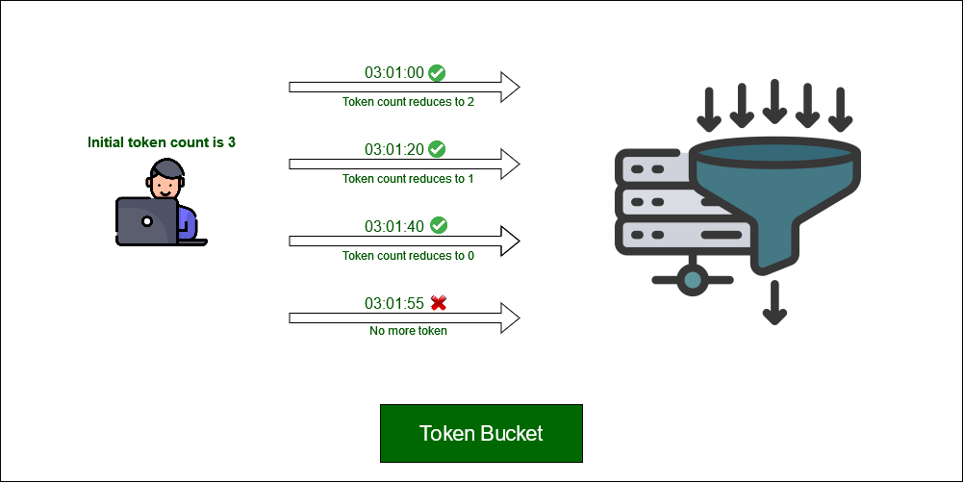

*Token  bucket example with initial bucket token count of 3 for each user in one minute*

### Leaky Bucket

It is based on the idea that if the average rate at which water is poured exceeds the rate at which the bucket leaks, the bucket will overflow.

The leaky bucket algorithm is similar to the token bucket algorithm, but instead of using a fixed-size token bucket, it uses a leaky bucket that empties at a fixed rate. Each incoming request adds to the bucket’s depth, and if the bucket overflows, the request is rejected.

One way to implement this is using a queue, which corresponds to the bucket that will contain the incoming requests. Whenever a new request is made, it is added to the queue’s end. If the queue is full at any time, then the additional requests are discarded.

The leaky bucket algorithm can be separated into the following concepts:

* Initialize the leaky bucket with a fixed depth and a rate at which it leaks.
* For each request, add to the bucket’s depth.
* If the bucket’s depth exceeds its capacity, reject the request.
* Leak the bucket at a fixed rate.

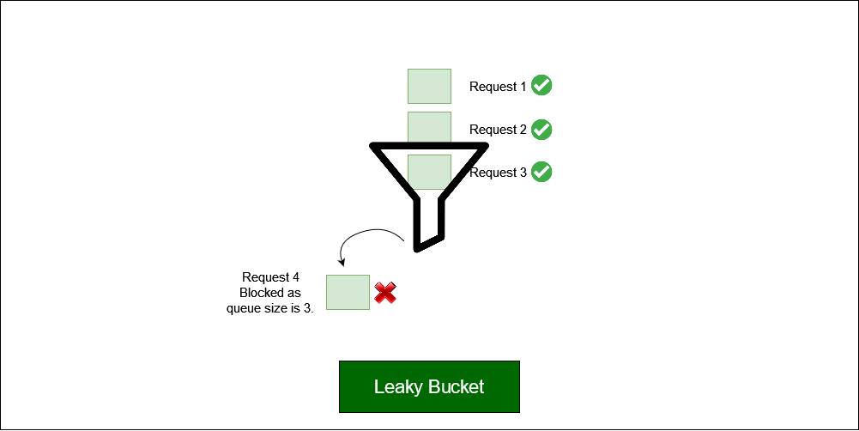

*Leaky bucket example with token count per user per minute is 3, which is the queue size.*

### Sliding Window Logs

Another approach to rate limiting is to use sliding window logs. This data structure involves a “window” of fixed size that slides along a timeline of events, storing information about the events that fall within the window at any given time.

The window can be thought of as a buffer of limited size that holds the most recent events or changes that have occurred. As new events or changes occur, they are added to the buffer, and old events that fall outside of the window are removed. This ensures that the buffer stays within its fixed size, and only contains the most recent events.

This rate limitation keeps track of each client’s request in a time-stamped log. These logs are normally stored in a time-sorted **hash set or table.**

The sliding window logs algorithm can be implemented using the following steps:

* A time-sorted queue or hash table of timestamps within the time range of the most recent window is maintained for each client making the requests.
* When a certain length of the queue is reached or after a certain number of minutes, whenever a new request comes, a check is done for any timestamps older than the current window time.
* The queue is updated with new timestamp of incoming request and if number of elements in queue does not exceed the authorised count, it is proceeded otherwise an exception is triggered.

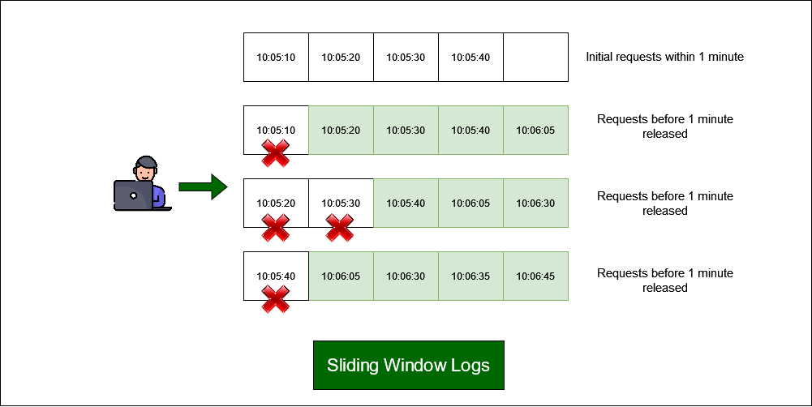

*Sliding window logs in a timeframe of 1 minute*

### Sliding Window Counters

The sliding window counter algorithm is an optimization over sliding window logs. As we can see in the previous approach, memory usage is high. For example, to manage numerous users or huge window timeframes, all the request timestamps must be kept for a window time, which eventually uses a huge amount of memory. Also, removing numerous timestamps older than a particular timeframe means high complexity of time as well.

To reduce surges of traffic, this algorithm accounts for a weighted value of the previous window’s request based on timeframe. If we have a one-minute rate limit, we can record the counter for each second and calculate the sum of all counters in the previous minute whenever we get a new request to determine the throttling limit.

The sliding window counters can be separated into the following concepts:

* Remove all counters which are more than 1 minute old.
* If a request comes which falls in the current bucket, the counter is increased.
* If a request comes when the current bucket has reached it’s throat limit, the request is blocked.

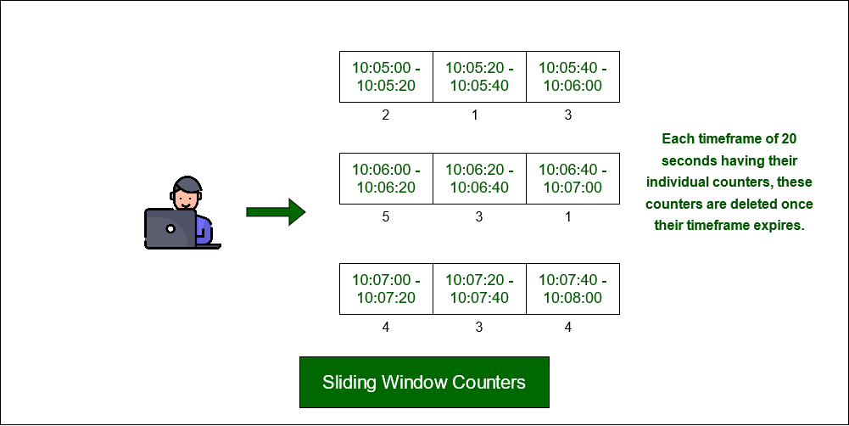

*sliding window counters with a timeframe of 20 seconds*

## Examples of Rate Limiting APIs used worldwide

* **Google Cloud Endpoints:**It is a platform for building APIs that includes a built-in rate limiter to help prevent excessive API usage.
* **AWS API Gateway:** Amazon Web Services (AWS) API Gateway includes a feature called Usage Plans that allows for rate limiting and throttling of API requests.
* **Akamai API Gateway:** Akamai API Gateway is a cloud-based platform that includes a rate limiter feature for controlling API requests.
* **Cloudflare Rate Limiting:** Cloudflare’s Rate Limiting feature helps prevent DDoS attacks and other types of abusive traffic by limiting the number of requests that can be made to an API.
* **Redis:**It is an in-memory data structure store that can be used as a database, cache, and message broker. It includes several features that make it useful for implementing a rate limiter, such as its ability to store data in memory for fast access and its support for atomic operations.

Diffirence between http request and webhook

A webhook is an HTTP request, triggered by an event in a source system and sent to a destination system, often with a payload of data. Webhooks are automated, in other words they are automatically sent out when their event is fired in the source system.

3) ASCII vs utf-8 vs utf-16

# Unicode, UTF-8, and ASCII encodings made easy

[[](https://medium.com/@apiltamang?source=post_page-----5bfbe3a1c45a--------------------------------)](https://medium.com/@apiltamang?source=post_page-----5bfbe3a1c45a--------------------------------)

[Apil Tamang](https://medium.com/@apiltamang?source=post_page-----5bfbe3a1c45a--------------------------------)

·

Follow

4 min read

·

Feb 3, 2018

1.1K

11

*So I have an announcement to make: if you are a programmer working in 2017 and you don’t know the basics of characters, character sets, encodings, and Unicode, and I*catch*you, I’m going to punish you by making you peel onions for 6 months in a submarine. I swear I will.* ***-****(Joel Spolsky. Cofounder of stack-overflow. Taken from article*[*here*](https://www.joelonsoftware.com/2003/10/08/the-absolute-minimum-every-software-developer-absolutely-positively-must-know-about-unicode-and-character-sets-no-excuses/)*)*

Truer words have not been spoken.

And let me add that after my doing my time in the submarine, peeling onions with red-shot eyes, you don’t want to be in the same boat (errr submarine) !

This post will really be a more condensed summary of what I’ve managed to gather from Joel’s [blog](https://www.joelonsoftware.com/2003/10/08/the-absolute-minimum-every-software-developer-absolutely-positively-must-know-about-unicode-and-character-sets-no-excuses/). Surprisingly after more than an hour of scouring the internet for more information on encodings, it was only by chance that I landed at this blog. It is by far the most concise and understandable read on the matter and deserves to be shared.

# ASCII

First there was the C programming language, then there was ASCII. **In ASCII, every letter, digits, and symbols that mattered (a-z, A-Z, 0–9, +, -, /, “, ! etc.) were represented as a number between 32 and 127**. Most computers used 8-bits bytes then. This meant each byte could store 2⁸-1= 255 numbers. So each byte (or unit of storage) had more than enough space to store the basic set of english characters.

Life was good. Heck they even sent people to the moon! That is if you spoke english.

# Unicode

**In order to accommodate the non-english characters, people started going a little crazy on how to use the numbers from 128 to 255**still available on a single byte**.** Different people would use different characters for the same numbers. Obviously, not only was it the wild wild west, but it quickly dawned that the extra available numbers could not even come close to represent the complete set of characters for some languages.

**The Unicode was a brave attempt to create a single character set that could represent every characters in every imaginable language systems.** This required a paradigm shift in how to interpret characters. And in this new paradigm, each character was an idealized abstract entity. Also in this system, rather than use a number, each character was represented as a **code-point.**The code-points were written as: **U+00639,**where U stands for ‘Unicode’, and the numbers are hexadecimal.

# UTF-8

The final piece we’re missing at this point is a system for storing and representing these code-points. **This is what the encoding standards serve**. After a couple of hits and misses, the UTF-8 encoding standard was born.

*In UTF-8, every code-point from 0–127 is stored in a single byte. Code points above 128 are stored using 2, 3, and in fact, up to 6 bytes.*

Remember that each byte consists of 8 bits, and the number of allowed information increases exponentially with the bits used for storage. Thus with 6 bytes (and not necessarily always 6), one could store as many as 2⁴⁸ characters. That would make for a very (very) large scrabble game!

Other benefits of UTF-8 meant that nothing changed from the ASCII so far as the basic english character-set was considered. Life continued to be good for english-speakers (a coincidence?). Everybody else had to hop some trains, but finally everybody agreed to use the same set of standards.

**Perhaps the single most important thing to remember from the discussions above is that there is NO string or text, without an accompanying encoding standard**. If you are a web-developer like me, you will occasionally encounter this text: Content-Type: text/plain; charset="UTF-8" in the code. This essentially tells the browsers (or any text parsers) the specific encoding being used.

# UTF-16

Now that we know what UTF-8 is, extrapolating our understanding to UTF-16 should be fairly straight-forward. UTF-8 is named for how it uses a minimum of 8 bits (or 1 byte) to store the unicode code-points. Remember that it can still use more bits, but does so only if it needs to.

**UTF-16, in the other hand, uses a minimum of 16 bits (or 2 bytes) to encode the unicode characters**. **Java**, whom I have a love-hate relationship with, natively uses this encoding. A **Java** char (Character) is thus a UTF-16 encoded unicode character and occupies a memory space of 2 bytes. The numerical value ranges from

* 0x0000 (numerical value: 0) to
* 0xFFFF (numerical value: 65,536)

This also means UTF-16 is NO longer backwards compatible with ASCII. Remember ASCII only used 1 byte or 8 bits.

# After thoughts

This post is meant more as a quick post-it note to help me rehash my understanding of the concept rather than regurgitating all the technical details. It is also meant for an easy morning or bedtime read. And oh, did I tell you how much it stinks to peel onions in a submarine! That alone, and above all, should be your prime motivation for learning the material.

sharding vs partitioning

Sharding and partitioning are techniques to divide and scale large databases. Sharding distributes data across multiple servers, while partitioning splits tables within one server.

# **Database Sharding vs. Partitioning**

Last updated: May 17, 2023



Written by:[Subham Datta](https://www.baeldung.com/cs/author/subhamdatta)

* [**Core Concepts**](https://www.baeldung.com/cs/category/core-concepts)
* [**Databases**](https://www.baeldung.com/cs/tag/databases)

## 1. Overview

In this tutorial, **we’ll discuss two methods for splitting databases into parts to manage them efficiently: sharding and partitioning.** Additionally, we’ll explore the basic concept of each method, along with an example. Furthermore, we’ll also list some advantages and disadvantages of each method.

Finally, we’ll highlight the core differences between them.

## 2. Database Sharding

### 2.1. Introduction

**Database sharding is a technique for horizontally partitioning a large database into smaller and more manageable subsets.** Additionally, each subset is called a shard. Furthermore, we can distribute them across multiple servers or nodes in a [cluster](https://www.baeldung.com/cs/computer-clusters-types). We can think of a shard as a little chunk of data. Moreover, the shards together make up the complete data set.

We often utilize sharding in large-scale [distributed systems](https://www.baeldung.com/cs/distributed-systems-guide) where traditional scaling methods, such as [vertical scaling](https://www.baeldung.com/cs/scaling-horizontally-vertically), may not be sufficient to handle the increasing data volume and traffic. Hence, by distributing the data across multiple servers, sharding can improve the performance, scalability, and availability of the database.

We can use different approaches to implement sharding. Furthermore, **some popular strategies utilized in sharding are range-based sharding, hash-based sharding, and composite sharding.**

In range-based sharding, we divide the data based on a range of values, such as a date range or alphabetical order. Furthermore, hash-based sharding involves dividing the data based on a [hash function](https://www.baeldung.com/cs/hashing) that maps the data to specific shards. Finally, composite sharding involves combining range-based and hash-based sharding techniques.

Let’s take a look at an example of hash-based sharding:

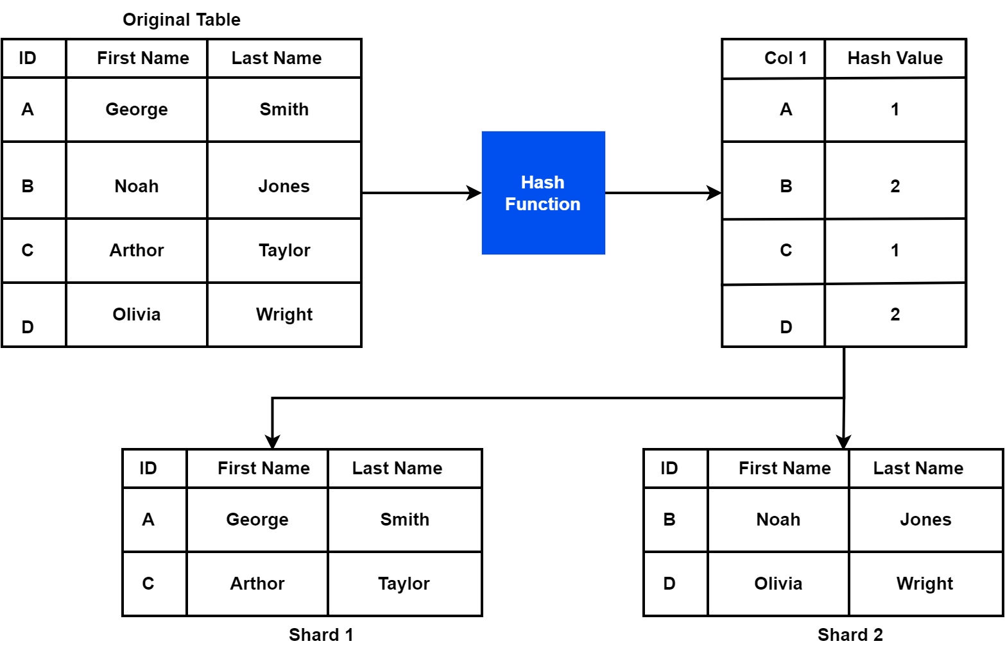

### 2.2. Advantages and Disadvantages

Let’s see some advantages and disadvantages of sharding:

### 2.3. Applications

Database sharding is commonly used in large-scale, high-traffic web applications and distributed systems. Additionally, we use sharding when traditional scaling methods are insufficient to handle large databases. Let’s discuss some common applications of database sharding.

[**E-commerce**](https://en.wikipedia.org/wiki/E-commerce)**websites use the sharding technique.** Specifically, it distributes product catalogs, orders, and customer information across multiple servers. Hence, it helps in improving the performance and availability of e-commerce platforms.

Furthermore, [social media](https://en.wikipedia.org/wiki/Social_media) platforms with millions of users generate massive amounts of data that need to be processed and stored. Therefore, we can use sharding to partition the data across multiple servers to improve performance and scalability.

Finally, **we can use sharding in online gaming.** Online games with large player bases generate significant data that needs to be stored and processed in real-time. Therefore, it can be used to distribute player profiles, game states, and scores across multiple servers to improve performance and availability.

## 3. Database Partitioning

### 3.1. Introduction

**Partitioning is a method for breaking down a massive database into small subsets.** Furthermore, each subset is known as a partition or segment. Additionally, each partition stores a subset of the data, and together they form the entire dataset.

Partitioning can improve the performance, scalability, and availability of the database by distributing the data across multiple servers or nodes. In addition, it may decrease the amount of data that must be processed to answer a certain query. Hence, it improves query response time.

Now, let’s discuss some techniques we can use to implement partitioning. **There’re several different techniques for partitioning a database, including range partitioning, list partitioning, and composite partitioning.**

Furthermore, range partitioning is the process of dividing data into partitions based on a specific range of values for a designated partitioning key. On the other hand, list partitioning is the method of splitting data into partitions based on a specific list of values for a designated partitioning key. Finally, composite partitioning divides data into partitions using a combination of range and list partitioning strategies.

Let’s take a look at an example of range-based database partitioning:

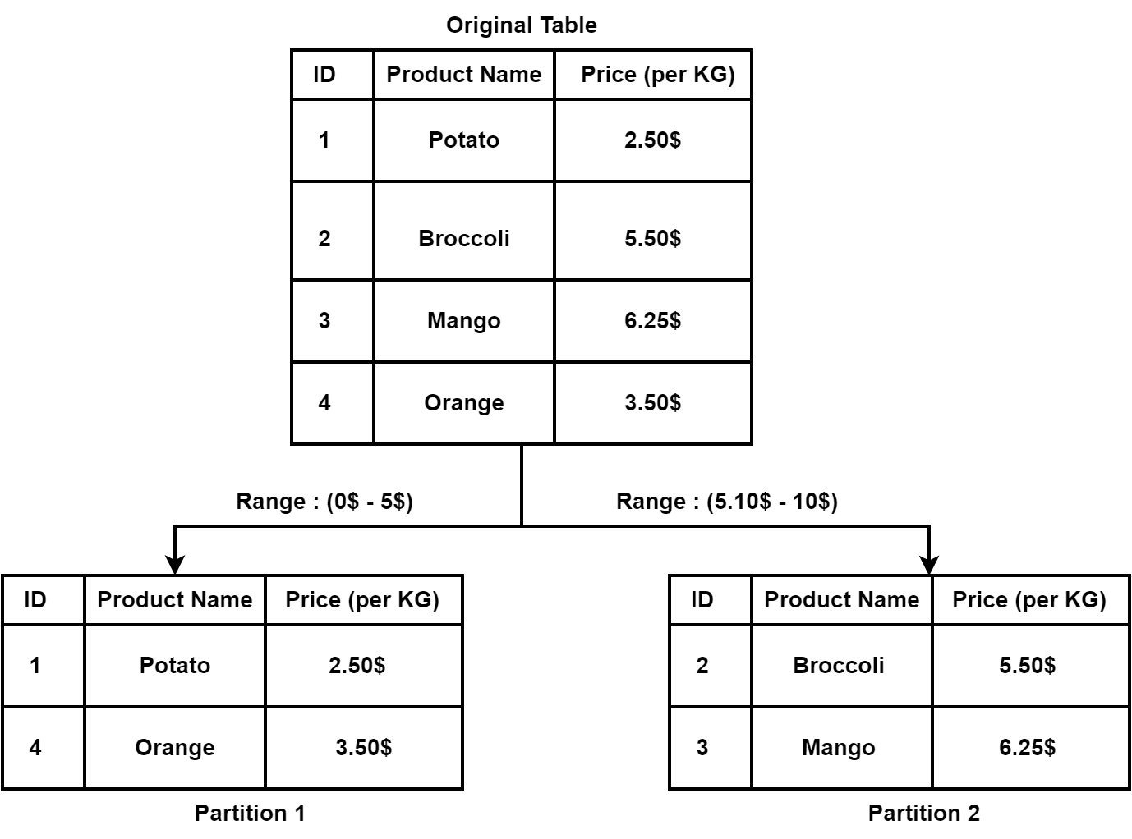

### 3.2. Advantages and Disadvantages

Let’s see some advantages and disadvantages of partitioning:

### 3.3. Applications

Database partitioning is widely used in various applications, especially in large-scale data-intensive applications. Let’s discuss some of the major applications of the partitioning method.

**We can use the partitioning technique in several financial services.** Furthermore, financial services applications often handle large amounts of transactional data, which can be partitioned based on transaction attributes, such as date range, account type, or transaction amount.

[IoT](https://en.wikipedia.org/wiki/Internet_of_things) devices and applications utilize the partitioning technique. Additionally, IoT applications generate large amounts of sensor data, which can be partitioned based on sensor type, location, or time range.

Finally, healthcare applications often store large amounts of patient data. In order to analyze the data, **we can partition based on patient attributes, such as geographic location, medical history, or treatment plan.**

## 4. Differences

Now let’s discuss the core differences between sharding and partitioning:

## 5. Conclusion

In this tutorial, we discussed two methods for splitting databases into parts to manage them efficiently: sharding and partitioning. Additionally, we explored the basic concept of each method, along with an example. Furthermore, we also listed some advantages and disadvantages of each method. Finally, we highlighted the core differences between them.

Comments are closed on this article!

How base 64 encoding works

**44**

# How Base64 Encoding Works

Base64 protects binary data against corruption in ASCII-only transfers

By

[Heinz Tschabitscher](https://www.lifewire.com/heinz-tschabitscher-1164024)

Updated on November 13, 2020

 Reviewed by

[Michael Barton Heine Jr](https://www.lifewire.com/michael-barton-heine-jr-4783679)

Top of Form

Bottom of Form

### IN THIS ARTICLE

**JUMP TO A SECTION**

* [Why Use Base64 Encoding](https://www.lifewire.com/base64-encoding-overview-1166412#toc-why-is-base64-encoding-used)
* [Base64 Encoding Logic](https://www.lifewire.com/base64-encoding-overview-1166412#toc-base64-encoding-logic)
* [Base64 Encoding Example](https://www.lifewire.com/base64-encoding-overview-1166412#toc-base64-encoding-example)
* [Base64 Encoding Table](https://www.lifewire.com/base64-encoding-overview-1166412#toc-base64-encoding-table)
* [Solving the Endgame](https://www.lifewire.com/base64-encoding-overview-1166412#toc-solving-the-endgame)

Base64 encoding is a process of converting binary data to an ASCII string format by converting that binary data into a 6-bit character representation. The Base64 method of encoding is used when binary data, such as images or video, is transmitted over systems that are designed to transmit data in a plain-text (ASCII) format.

## **Why Is Base64 Encoding Used?**

The need for Base64 encoding comes from the problems that occur when media is transmitted in [raw binary format](https://www.lifewire.com/how-to-read-binary-4692830) to text-based systems.

Since text-based systems (like [email](https://www.lifewire.com/electronic-mail-overview-1164107)) interpret binary data as a wide range of characters, including special command characters, much of the binary data that is transmitted to transfer media is misinterpreted by those systems and lost or corrupted in the transmission process.

Wutthichai Luemuang / EyeEm / Getty Images

One method of encoding this kind of binary data in a way that avoids such transmission problems is to send it as plain ASCII text in Base64 encoded format. This is one of the techniques employed by the MIME standard to send data other than plain text.

Many programming languages, such as PHP and Javascript, include Base64 encoding and decoding functions in order to interpret data transmitted using Base64 encoding.

## **Base64 Encoding Logic**

Base64 encoding breaks binary data into 6-bit segments of 3 full bytes and represents those as printable characters in ASCII standard. It does that in essentially two steps.

The first step is to break the binary string down into 6-bit blocks. Base64 only uses 6 bits (corresponding to 2^6 = 64 characters) to ensure encoded data is printable and humanly readable. None of the special characters available in ASCII are used.

The 64 characters (hence the name Base64) are 10 digits, 26 lowercase characters, 26 uppercase characters as well as the Plus sign (+) and the Forward Slash (/). There is also a 65th character known as a pad, which is the Equal sign (=). This character is used when the last segment of binary data doesn't contain a full 6 bits.

## **Base64 Encoding Example**

For example, take three ASCII numbers 155, 162, and 233. These three numbers constitute a binary stream of 100110111010001011101001. A binary file, like an image, contains a binary stream running for tens or hundreds of thousands of zeroes and ones.

A Base64 encoder starts by chunking the binary stream into groupings of six characters: 100110 111010 001011 101001. Each of these groupings translates into the numbers 38, 58, 11, and 41.

A six-character binary stream converts between binary (or base-2) to decimal (base-10) characters by squaring each value represented by a 1 in the binary sequence with its positional square. Starting from the right and moving left, and starting with zero, the values in the binary stream represent 2^0, then 2^1, then 2^2, then 2^3, then 2^4, then 2^5.

Here's another way to look at it. Starting from the left, each position is worth 1, 2, 4, 8, 16, and 32. If the binary number has a 1 in the slot, you add that value; if it has a 0 in the slot, you don't. The binary string 100110 converts to the decimal number 38: 0\*2^01 + 1\*2^1 + 1\*2^2 + 0\*2^3 + 0\*2^4 + 1\*2^5 = 0+2+4+0+0+32.

Base64 encoding takes this binary string and breaks it down into the 6-bit values 38, 58, 11 and 41.

Finally, these numbers are converted to ASCII characters using the Base64 encoding table. The 6-bit values of this example translate to the ASCII sequence **m6Lp**.

Using the Base64 conversion table:

* 38 is m
* 58 is 6
* 11 is L
* 41 is p

This two-step process is applied to the entire binary string that's encoded.

To ensure the encoded data can be properly printed and does not exceed any mail server's line length limit, newline characters are inserted to keep line lengths below 76 characters. The newline characters are encoded like all other data.

The entire purpose of Base64 encoding, from adding padding to preserve 3-byte binary segments to converting binary to text using the Base64 table, is to preserve the integrity of the transmitted binary information.

## **Base64 Encoding Table**

The following table translates all 64 characters used in Base64 encoding.

| **Base64 Encoding Table** | | | | | | | | | | |
| --- | --- | --- | --- | --- | --- | --- | --- | --- | --- | --- |
| **Value** | **Char** |  | **Value** | **Char** |  | **Value** | **Char** |  | **Value** | **Char** |
| 0 | A |  | 16 | Q |  | 32 | g |  | 48 | w |
| 1 | B |  | 17 | R |  | 33 | h |  | 49 | x |
| 2 | C |  | 18 | S |  | 34 | i |  | 50 | y |
| 3 | D |  | 19 | T |  | 35 | j |  | 51 | z |
| 4 | E |  | 20 | U |  | 36 | k |  | 52 | 0 |
| 5 | F |  | 21 | V |  | 37 | l |  | 53 | 1 |
| 6 | G |  | 22 | W |  | 38 | m |  | 54 | 2 |
| 7 | H |  | 23 | X |  | 39 | n |  | 55 | 3 |
| 8 | I |  | 24 | Y |  | 40 | o |  | 56 | 4 |
| 9 | J |  | 25 | Z |  | 41 | p |  | 57 | 5 |
| 10 | K |  | 26 | a |  | 42 | q |  | 58 | 6 |
| 11 | L |  | 27 | b |  | 43 | r |  | 59 | 7 |
| 12 | M |  | 28 | c |  | 44 | s |  | 60 | 8 |
| 13 | N |  | 29 | d |  | 45 | t |  | 61 | 9 |
| 14 | O |  | 30 | e |  | 46 | u |  | 62 | + |
| 15 | P |  | 31 | f |  | 47 | v |  | 63 | / |

## **Solving the Endgame**

At the end of the encoding process, there might be a problem. If the size of the original data in bytes is a multiple of three, everything works fine. If it is not, there may be empty bytes. For proper encoding, exactly 3-bytes of binary data is needed.

The solution is to append enough bytes with a value of 0 to create a 3-byte group. Two such values are appended if the data needs one extra byte of data, one is appended for two extra bytes.

Of course, these artificial trailing '0's cannot be encoded using the encoding table below. They must be represented by a 65th character. The Base64 padding character is the Equal sign (=) and is placed at the end of encoded data.

**Was this page helpful?**

Write sample program to generate Random String

Basically, you can use the generic method random(int count, boolean letters, boolean numbers). For example, the following code generates a 10-character random string that includes both letters and numbers: boolean useLetters = true; boolean useNumbers = true; String randomString = RandomStringUtils.

**public** **static** String randomStringSimple(**int** length) {

**byte**[] byteArray = **new** **byte**[length];

    Random random = **new** Random();

    random.nextBytes(byteArray);

**return** **new** String(byteArray, Charset.forName("UTF-8"));

}

**public** **static** String randomAlphanumericString(**int** length) {

    String alphanumericCharacters = "ABCDEFGHIJKLMNOPQRSTUVWXYZ0123456789abcdefghijklmnopqrstuv";

    StringBuffer randomString = **new** StringBuffer(length);

    Random random = **new** Random();

**for** (**int** i = 0; i < length; i++) {

**int** randomIndex = random.nextInt(alphanumericCharacters.length());

**char** randomChar = alphanumericCharacters.charAt(randomIndex);

        randomString.append(randomChar);

    }

**return** randomString.toString();

}

**public** **static** String randomAlphanumericString(**int** length) {

**char** startChar = 33;

**char** endChar = 126;

    StringBuffer randomString = **new** StringBuffer(length);

    Random random = **new** Random();

**for** (**int** i = 0; i < length; i++) {

**int** randomIndex = startChar + random.nextInt(endChar - startChar + 1);

        randomString.append((**char**) randomIndex);

    }

**return** randomString.toString();

}

Write String Reverse program without inbuilt string methods

public class Main{

    public static String reverse(String input) {

        if (input == null) return null;

        StringBuilder output = new StringBuilder();

        for (int i = input.length() - 1; i >= 0; i--) {

            output.append(input.charAt(i));

        }

        return output.toString();

    }

    public static void main(String[] args){

        String text = "educative";

        System.out.println("Original string - " + text);

        System.out.println("Reversed string - " + reverse(text));

    }

}

What is Inversion of Control?

Spring IoC (Inversion of Control) Container is the core of Spring Framework. It creates the objects, configures and assembles their dependencies, manages their entire life cycle. The Container uses Dependency Injection(DI) to manage the components that make up the application.

Spring IoC (Inversion of Control) Container is the core of [Spring Framework](https://www.geeksforgeeks.org/introduction-to-spring-framework/). It creates the objects, configures and assembles their dependencies, manages their entire life cycle. The Container uses Dependency Injection(DI) to manage the components that make up the application. It gets the information about the objects from a configuration file(XML) or Java Code or Java Annotations and Java POJO class. These objects are called Beans. Since the Controlling of Java objects and their lifecycle is not done by the developers, hence the name Inversion Of Control.  
**There are 2 types of IoC containers:**

* [BeanFactory](https://www.geeksforgeeks.org/spring-beanfactory/)
* [ApplicationContext](https://www.geeksforgeeks.org/spring-applicationcontext/)

That means if you want to use an IoC container in spring whether we need to use a BeanFactory or ApplicationContext. The BeanFactory is the most basic version of IoC containers, and the ApplicationContext extends the features of BeanFactory. The followings are some of the main features of Spring IoC,

* Creating Object for us,
* Managing our objects,
* Helping our application to be configurable,
* Managing dependencies

**Implementation:** So now let’s understand what is IoC in Spring with an example. Suppose we have one interface named Sim and it has some abstract methods calling() and data().

## Java

|  |
| --- |
| // Java Program to Illustrate Sim Interface  **public** **interface** Sim  {  **void** calling();  **void** data();  } |

Now we have created another two classes Airtel and Jio which implement the Sim interface and override the interface methods.

## Java

|  |
| --- |
| // Java Program to Illustrate Airtel Class    // Class  // Implementing Sim interface  **public** **class** Airtel **implements** Sim {        @Override **public** **void** calling()      {          System.out.println("Airtel Calling");      }        @Override **public** **void** data()      {          System.out.println("Airtel Data");      }  } |

## Java

|  |
| --- |
| // Java Program to Illustrate Jio Class    // Class  // Implementing Sim interface  **public** **class** Jio **implements** Sim{      @Override  **public** **void** calling() {          System.out.println("Jio Calling");      }        @Override  **public** **void** data() {          System.out.println("Jio Data");      }  } |

So let’s now call these methods inside the main method. So by implementing the [Run time polymorphism](https://www.geeksforgeeks.org/difference-between-compile-time-and-run-time-polymorphism-in-java/) concept we can do something like this

## Java

|  |
| --- |
| // Java Program to Illustrate Mobile Class    // Class  **public** **class** Mobile {        // Main driver method  **public** **static** **void** main(String[] args)      {            // Creating instance of Sim interface          // inside main() method          // with reference to Jio class constructor          // invocation          Sim sim = **new** Jio();            // Sim sim = new Airtel();            sim.calling();          sim.data();      }  } |

But what happens if in the future another new Sim Vodafone came and we need to change again to the child class name in the code, like this

Sim sim = new Vodafone();

So we have to do our configuration in the source code. So how to make it configurable? We don’t want to touch the source code of this. The source code should be constant. And how can we make it? Here Spring IoC comes into the picture. So in this example, we are going to use ApplicationContext to implement an IoC container. First, we have to create an XML file and name the file as “**beans.xml**“.

**Example:**beans.xml File

## XML

|  |
| --- |
| <?**xml** version="1.0" encoding="UTF-8"?>  <**beans** xmlns="<http://www.springframework.org/schema/beans>"         xmlns:xsi="<http://www.w3.org/2001/XMLSchema-instance>"         xsi:schemaLocation="<http://www.springframework.org/schema/beans>  <https://www.springframework.org/schema/beans/spring-beans.xsd>">      <**bean** id="sim" class="Jio"></**bean**>    </**beans**> |

**Output Explanation:**In the beans.xml file, we have created **beans**. So inside the id, we have to pass the unique id and inside the class, we have to pass the Class name for which you want to create the bean. Later on, inside the main method, we can tweek it out that will be described in the upcoming program.

***Bean Definition****: In Spring, the objects that form the backbone of your application and that are managed by the Spring IoC container are called beans. A bean is an object that is instantiated, assembled, and otherwise managed by a Spring IoC container.*

## Java

|  |
| --- |
| **import** org.springframework.context.ApplicationContext;  **import** org.springframework.context.support.ClassPathXmlApplicationContext;    **public** **class** Mobile {  **public** **static** **void** main(String[] args) {          // Using ApplicationContext tom implement Spring IoC          ApplicationContext applicationContext = **new** ClassPathXmlApplicationContext("beans.xml");            // Get the bean          Sim sim = applicationContext.getBean("sim", Sim.**class**);            // Calling the methods          sim.calling();          sim.data();      }  } |

**Output:**

Jio Calling

Jio Data

And now if you want to use the Airtel sim so you have to change only inside the **beans.xml** file. The main method is going to be the same.

<bean id="sim" class="Airtel"></bean>

## Java

|  |
| --- |
| **import** org.springframework.context.ApplicationContext;  **import** org.springframework.context.support.ClassPathXmlApplicationContext;    **public** **class** Mobile {  **public** **static** **void** main(String[] args) {            // Using ApplicationContext tom implement Spring IoC          ApplicationContext applicationContext = **new** ClassPathXmlApplicationContext("beans.xml");            // Get the bean          Sim sim = applicationContext.getBean("sim", Sim.**class**);            // Calling the methods          sim.calling();          sim.data();      }  } |

**Output:**

Airtel Calling

Airtel Data

how to make singleton class threadSafe.

Singleton is one of the most widely used creational design pattern to restrict the object created by applications. If you are using it in a multi-threaded environment, then the thread-safety of the singleton class is very important. In real-world applications, resources like Database connections or Enterprise Information Systems (EIS) are limited and should be used wisely to avoid any resource crunch. To achieve this, we can implement a [Singleton design pattern](https://www.digitalocean.com/community/tutorials/java-singleton-design-pattern-best-practices-examples). We can create a [wrapper class](https://www.digitalocean.com/community/tutorials/wrapper-class-in-java) for the resource and limit the number of objects created at runtime to one.

## [Thread Safe Singleton in Java](https://www.digitalocean.com/community/tutorials/thread-safety-in-java-singleton-classes#thread-safe-singleton-in-java)

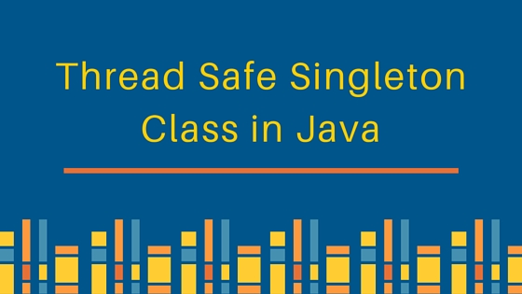In general, we follow the below steps to create a singleton class:

1. Create the private [constructor](https://www.digitalocean.com/community/tutorials/constructor-in-java) to avoid any new object creation with new operator.
2. Declare a private [static](https://www.digitalocean.com/community/tutorials/static-keyword-in-java) instance of the same class.
3. Provide a public static method that will return the singleton class instance variable. If the variable is not initialized then initialize it or else simply return the instance variable.

Using the above steps I have created a singleton class that looks like below. ASingleton.java

package com.journaldev.designpatterns;

public class ASingleton {

private static ASingleton instance = null;

private ASingleton() {

}

public static ASingleton getInstance() {

if (instance == null) {

instance = new ASingleton();

}

return instance;

}

}

In the above code, the getInstance() method is not thread-safe. Multiple threads can access it at the same time. For the first few threads when the instance variable is not initialized, multiple threads can enter the if loop and create multiple instances. It will break our singleton implementation.

## [How to achieve thread-safety in Singleton Class?](https://www.digitalocean.com/community/tutorials/thread-safety-in-java-singleton-classes#how-to-achieve-thread-safety-in-singleton-class)

There are three ways through which we can achieve thread safety.

1. **Create the instance variable at the time of class loading.** **Pros**:

* Thread safety without synchronization
* Easy to implement

**Cons**:

* Early creation of resource that might not be used in the application.
* The client application can’t pass any argument, so we can’t reuse it. For example, having a generic singleton class for database connection where client application supplies database server properties.

1. **Synchronize the getInstance() method**. **Pros**:

* Thread safety is guaranteed.
* Client application can pass parameters
* Lazy initialization achieved

**Cons**:

* Slow performance because of locking overhead.
* Unnecessary synchronization that is not required once the instance variable is initialized.

1. **Use synchronized block inside the if loop and volatile variable** **Pros**:

* Thread safety is guaranteed
* Client application can pass arguments
* Lazy initialization achieved
* Synchronization overhead is minimal and applicable only for first few threads when the variable is null.

**Cons**:

* Extra if condition

Looking at all the three ways to achieve thread-safety, I think the third one is the best option. In that case, the modified class will look like this:

package com.journaldev.designpatterns;

public class ASingleton {

private static volatile ASingleton instance;

private static Object mutex = new Object();

private ASingleton() {

}

public static ASingleton getInstance() {

ASingleton result = instance;

if (result == null) {

synchronized (mutex) {

result = instance;

if (result == null)

instance = result = new ASingleton();

}

}

return result;

}

}

The local variable result seems unnecessary. But, it’s there to improve the performance of our code. In cases where the instance is already initialized (most of the time), the volatile field is only accessed once (due to “return result;” instead of “return instance;”). This can improve the method’s overall performance by as much as 25 percent. If you think there are better ways to achieve this or if the thread-safety is compromised in the above implementation, please comment and share it with all of us.

## [Bonus Tip](https://www.digitalocean.com/community/tutorials/thread-safety-in-java-singleton-classes#bonus-tip)

[String](https://www.digitalocean.com/community/tutorials/java-string) is not a very good candidate to be used with synchronized keyword. It’s because they are stored in a [string pool](https://www.digitalocean.com/community/tutorials/what-is-java-string-pool) and we don’t want to lock a string that might be getting used by another piece of code. So I am using an Object variable. Learn more about synchronization and [thread safety in java](https://www.digitalocean.com/community/tutorials/thread-safety-in-java).

You can checkout more Java examples from our [GitHub Repository](https://github.com/journaldev/journaldev).

Thanks for learning with the DigitalOcean Community. Check out our offerings for compute, storage, networking, and managed databases.

[**Learn more about us**](https://www.digitalocean.com/)